

American International University-Bangladesh (AIUB)  
**Department of Computer Science and Engineering   
Faculty of Science &Technology (FST)  
Spring 20-21  
CSC 00191- Object Oriented Analysis And Design (OOAD)**

**Section: C**

**Project Title: Ride Sharing Management System**

**Submitted by:**

|  |  |
| --- | --- |
| **Name** | **ID** |
| Shovon Roy | 19-40023-1 |

**Submitted to:**

**MD. ANWARUL KABIR**

**Sr. Assistant Professor**

**Department of Computer Science**

**Project Overview**

A registered user needs to login to the app and the System manages all the login information. The user can send a request to hire a car or bike for a ride and then user needs to enter the type of ride they want and their desired destination. Then the ride request of the user gets added to list of all the nearby passengers which is viewed by the System. The System then chooses all the nearby Drivers and passes the passenger list to them. A Driver then accepts the ride request and the trip begins. After ending the trip, the User pays the Driver via cash or they can apply coupon codes. The transaction is monitored by the System. After ending the trip the User can leave a review of the Driver which can be viewed by the System.

**Advantages of Ride Sharing System**

* Time is saved due to advancement of the system.
* Multiple user requests can be processed at a time.
* Less hassle of finding a ride.
* The exact location of the user and the driver is displayed, so it is easier to find each other.
* The safety of the user and drivers are monitored by the system.
* The reviews help the other users to find the best ride for them.

**Use Case Diagram**

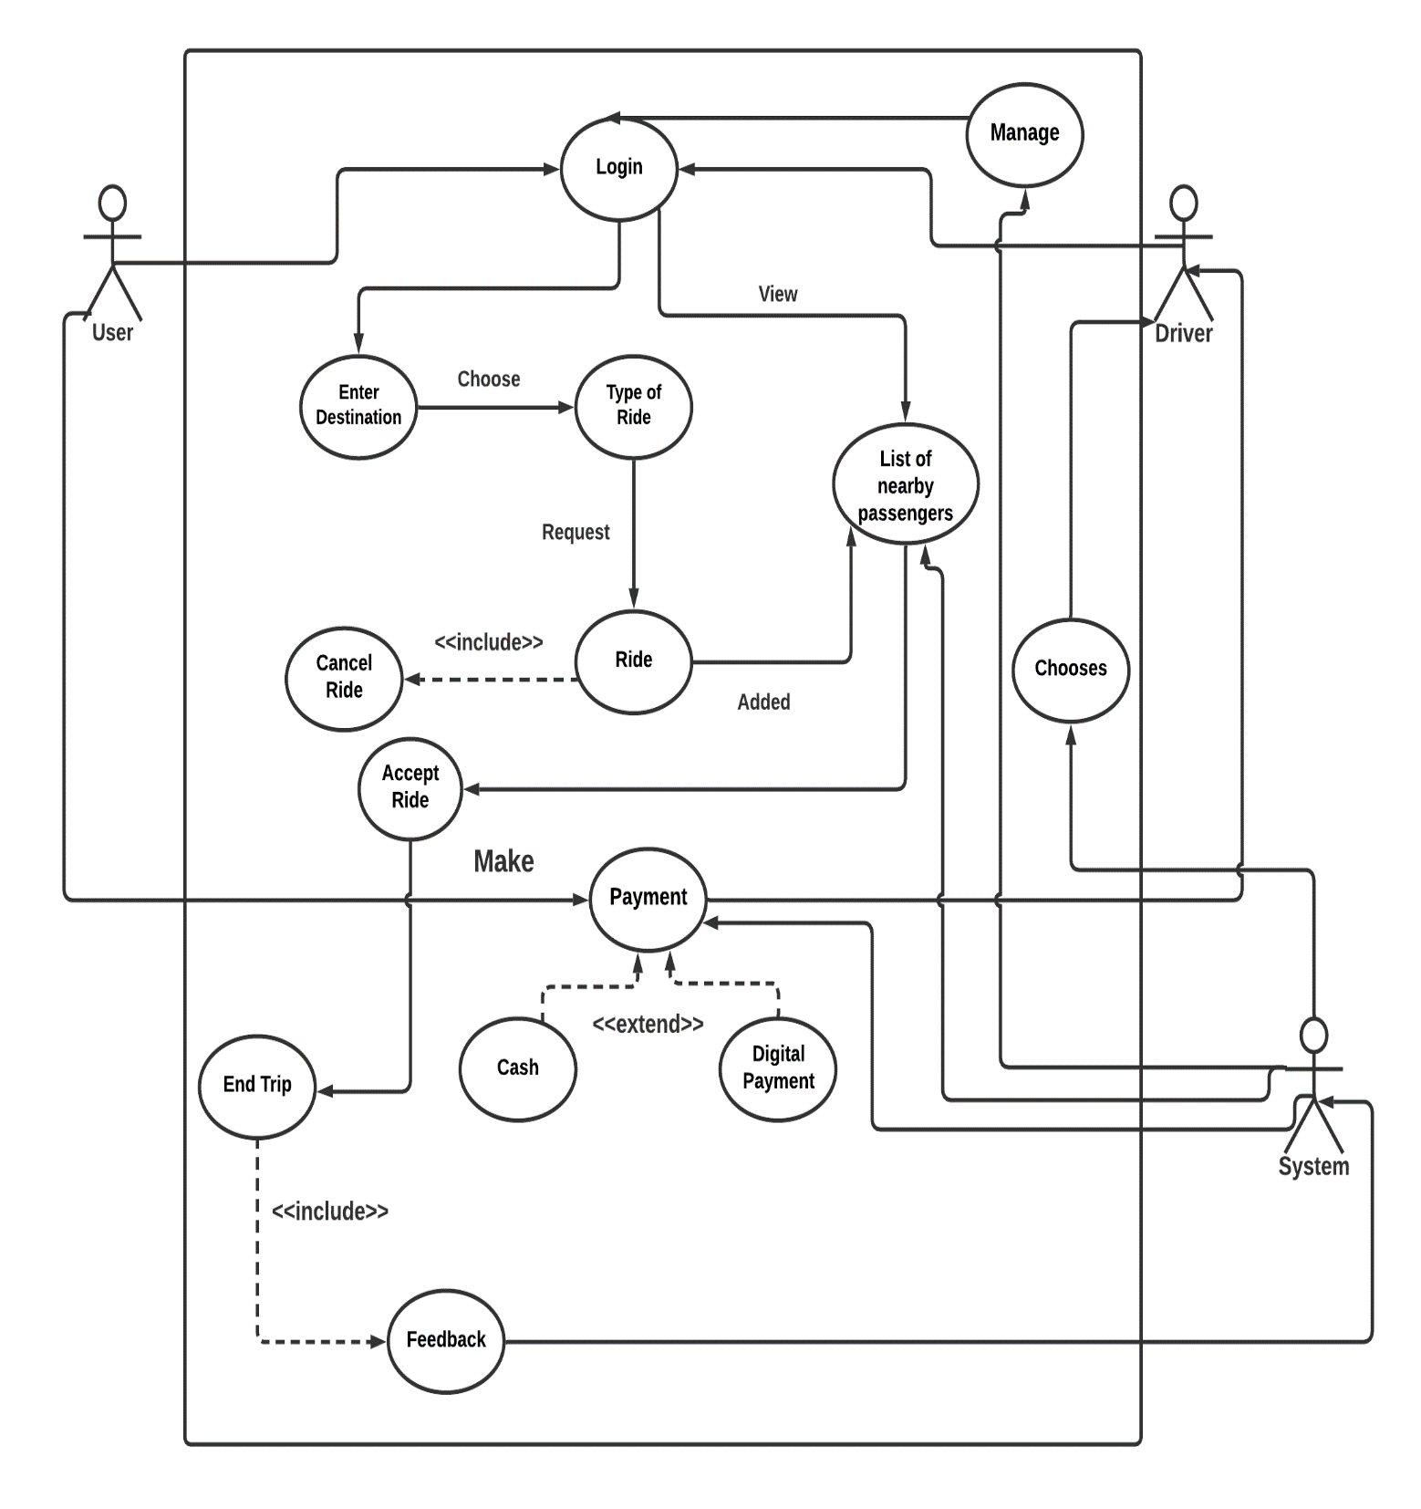

**Class Diagram**

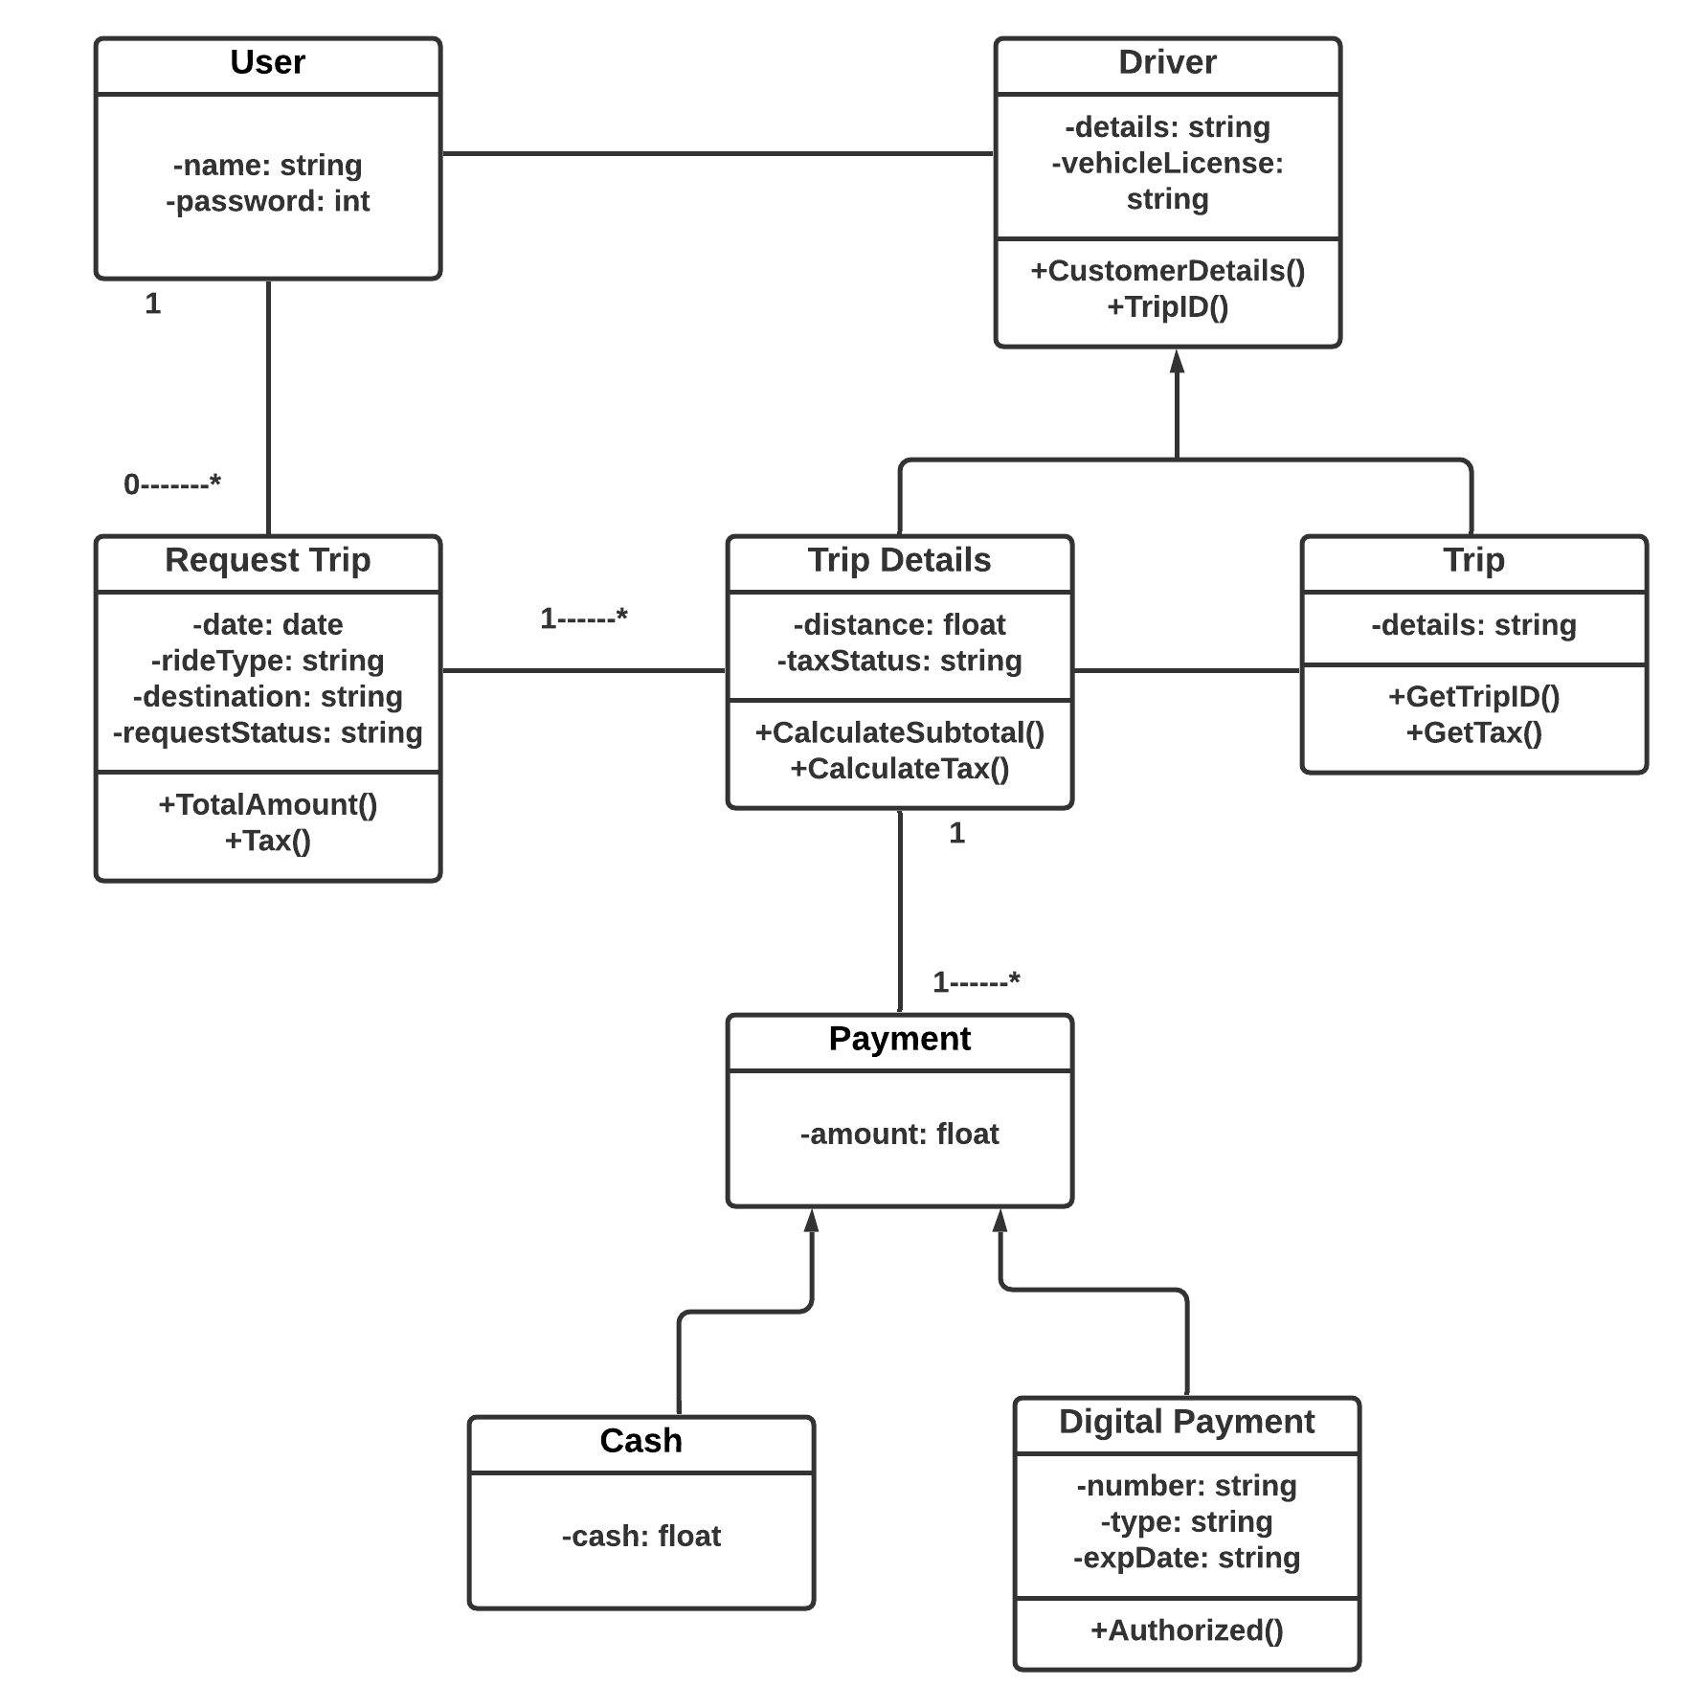

**Activity Diagram**

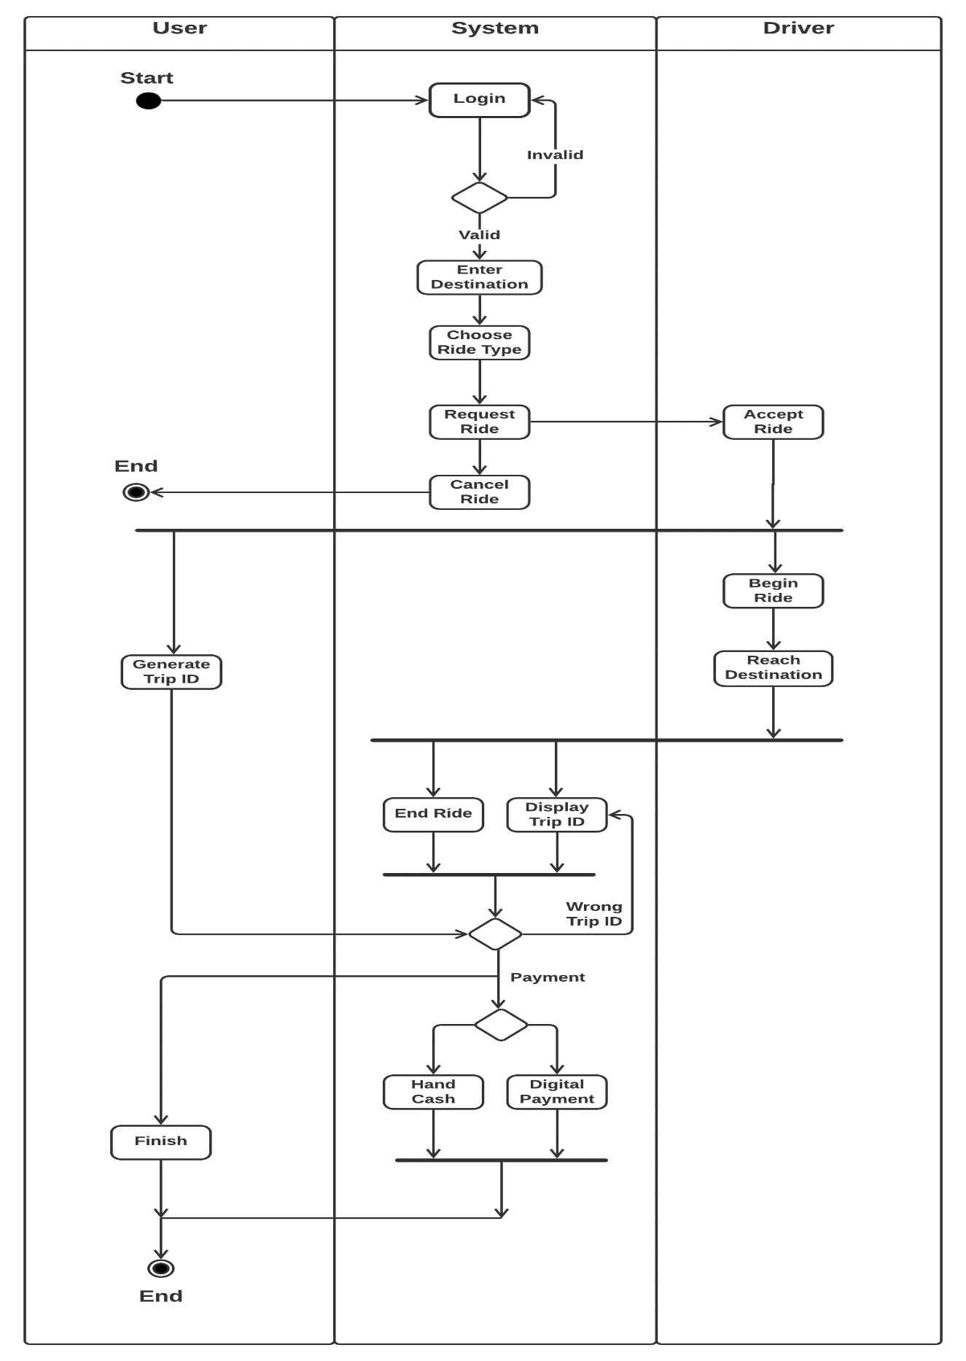

**Sequence Diagram**

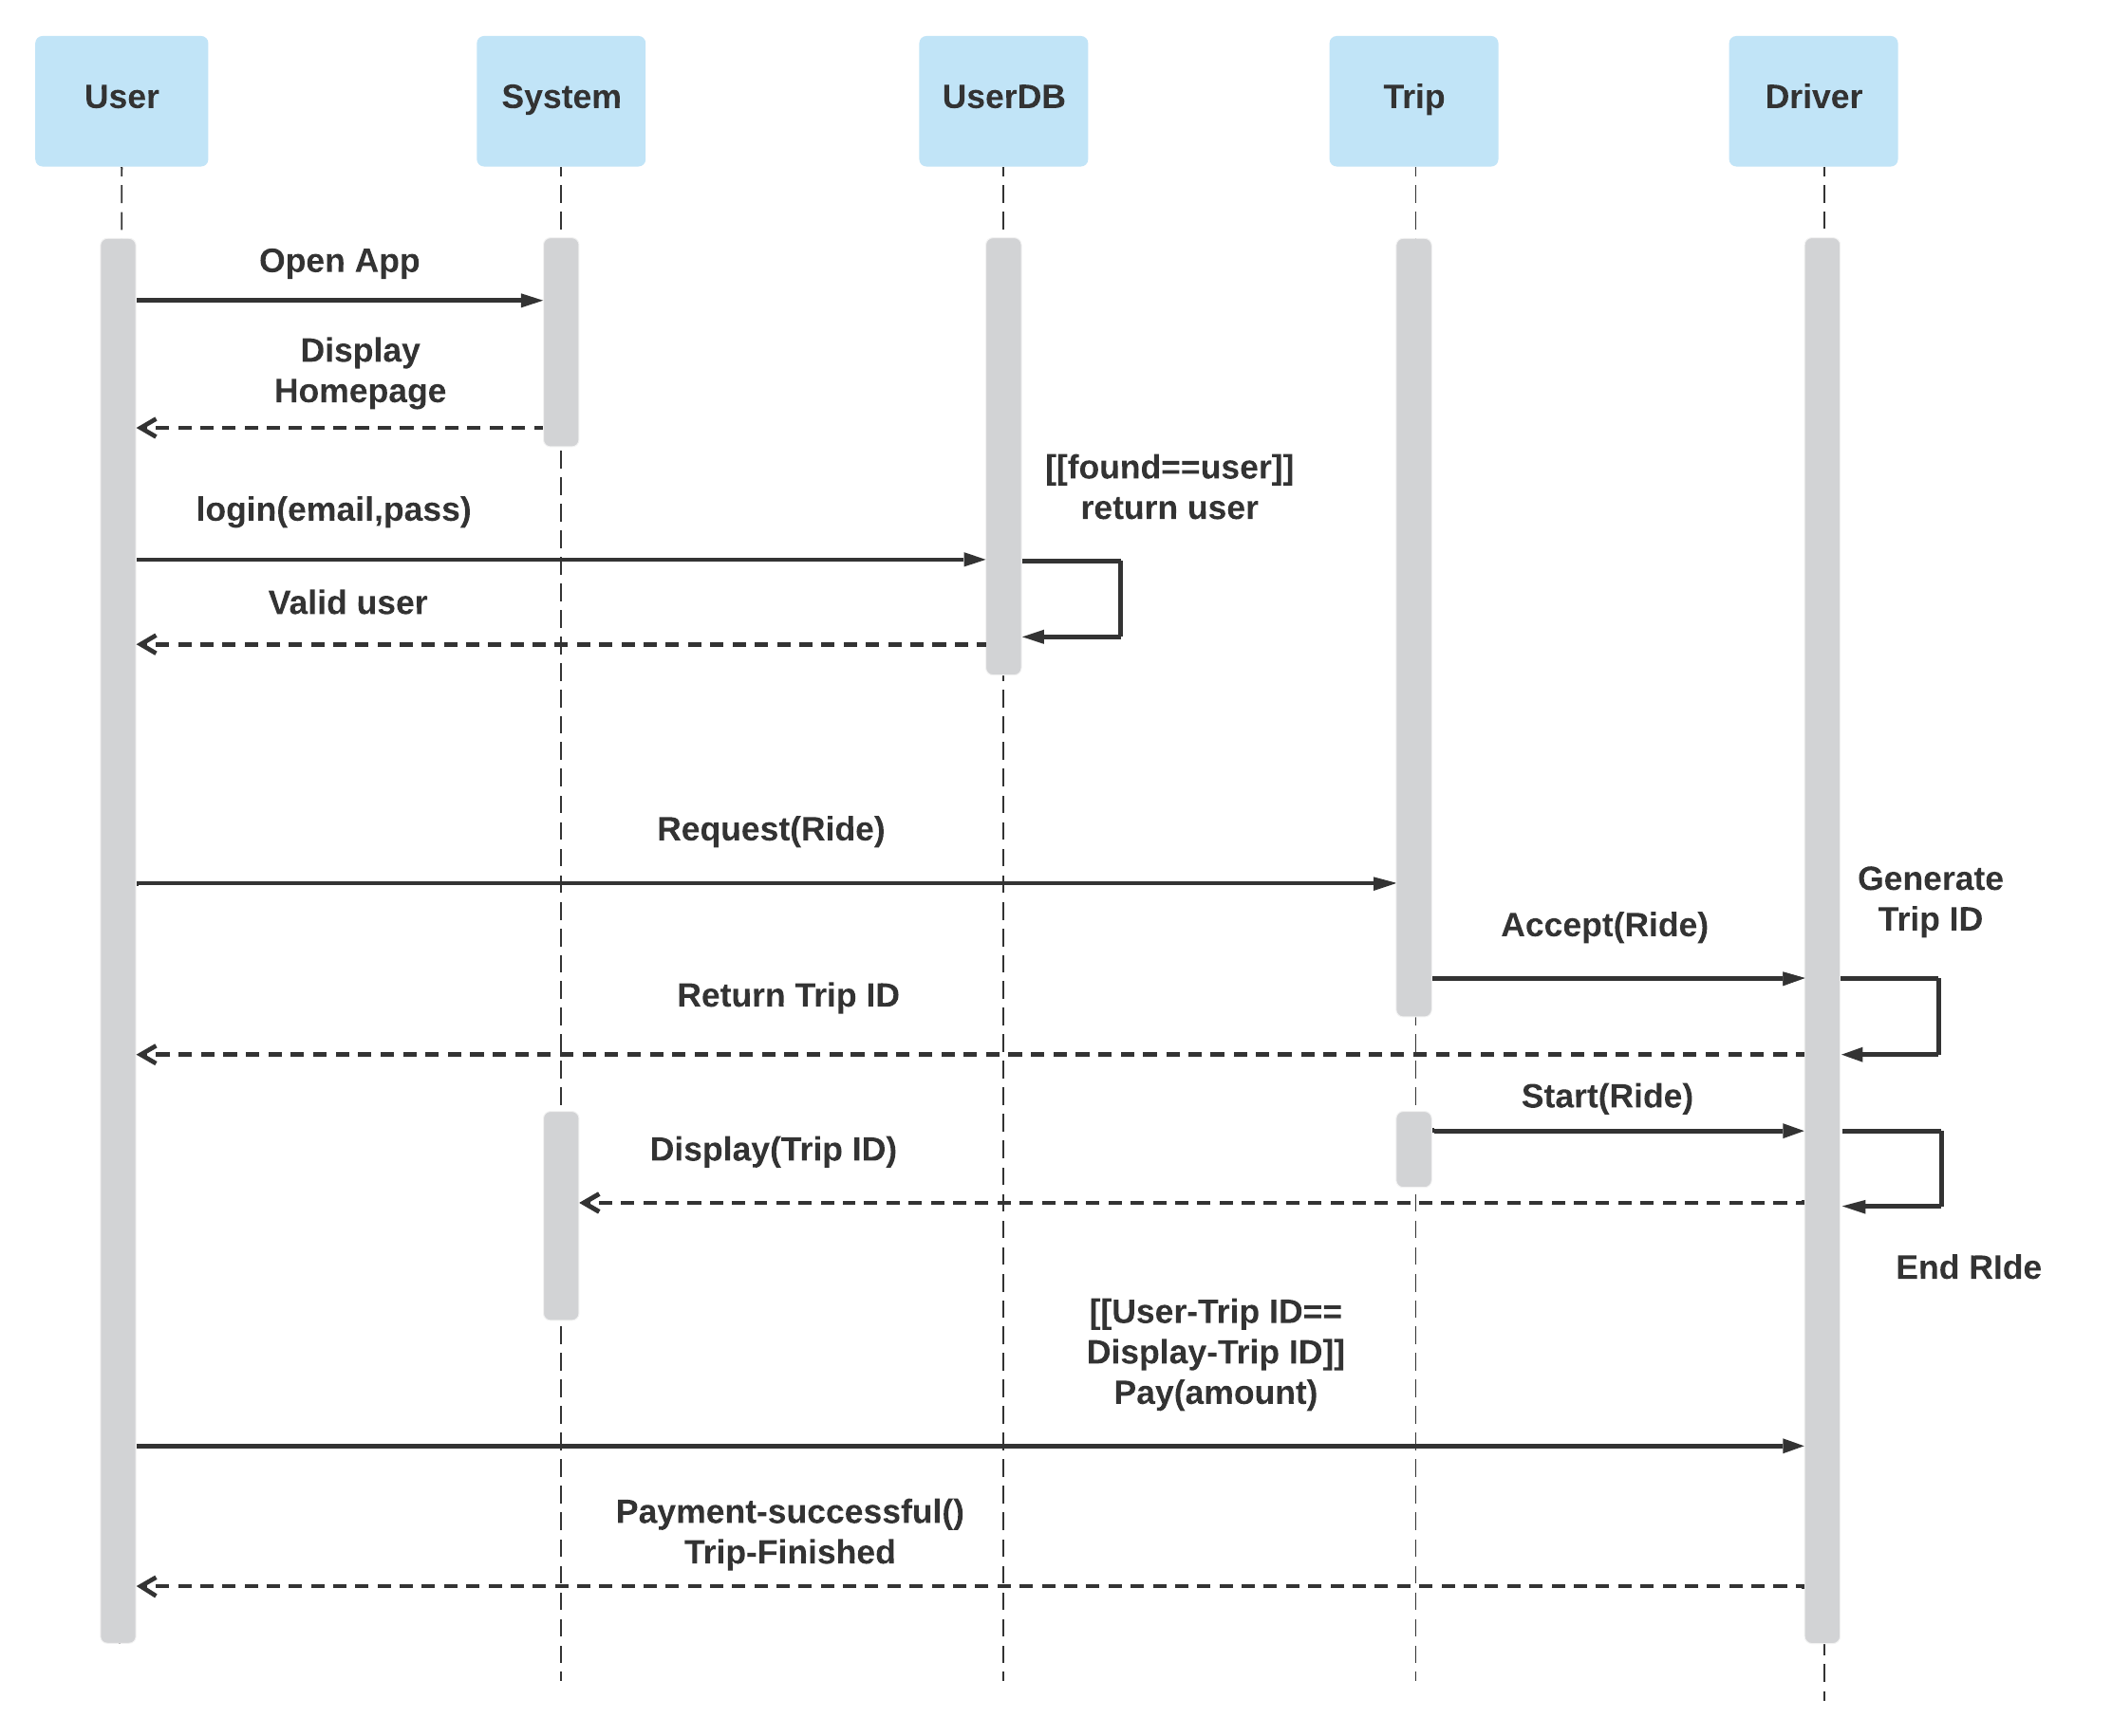

**Conclusion**

In the following system I developed a Ride Sharing Management System. In this project,

Class diagram- Class diagrams are the main building blocks and the static structure of a system. The class diagram shows how the classes are related to each other and how they form relationship between them.

Activity diagram- Activity diagram shows the activity flow from one actor to another actor.

Sequence diagram- Sequence diagram shows object flows from one state to another state and the flow of massages.