CREATE DATABASE customer_data;

CREATE SCHEMA staging;

CREATE SCHEMA core;

CREATE OR REPLACE TABLE staging.customers (

customer_id INT,

first_name varchar2(100),

last_name varchar2(100),

-- full_name STRING,

email varchar2(100),

phone varchar2(100),

address varchar2(100),

city varchar2(100),

state varchar2(100),

zip_code varchar2(100),

created_at varchar2(100),

updated_at varchar2(100)

);

SELECT * FROM CUSTOMER_DATA.STAGING.CUSTOMERS;

STAGING LAYER OUTPUT:

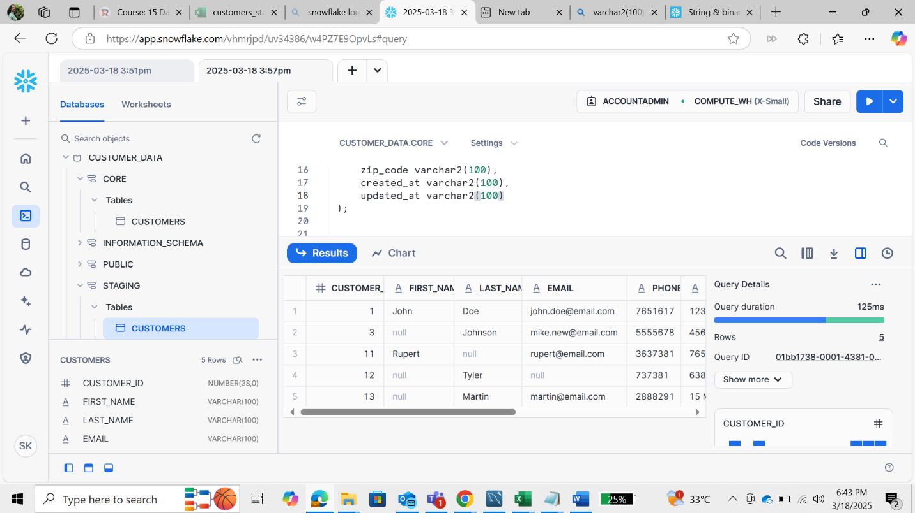

CREATE OR REPLACE TABLE core.customers (

customer_id INT PRIMARY KEY,

full_name STRING,

email STRING DEFAULT 'unknown@example.com',

phone STRING DEFAULT 'Not Provided',

address STRING DEFAULT 'Unknown Address',

city STRING DEFAULT 'Unknown City',

state STRING DEFAULT 'Unknown State',

zip_code STRING DEFAULT '00000',

created_at TIMESTAMP,

updated_at TIMESTAMP

);

MERGE INTO core.customers AS target

USING(

SELECT

customer_id,

CONCAT_WS(' ', COALESCE(first_name, ''), COALESCE(last_name, '')) AS full_name,

COALESCE(email, 'unknown@example.com') AS email,

COALESCE(phone, 'Not Provided') AS phone,

COALESCE(address, 'Unknown Address') AS address,

COALESCE(city, 'Unknown City') AS city,

COALESCE(state, 'Unknown State') AS state,

COALESCE(zip_code, '00000') AS zip_code,

created_at,

updated_at

FROM staging.customers

) AS source

ON target.customer_id = source.customer_id

WHEN MATCHED THEN

UPDATE SET

target.full_name = source.full_name,

target.email = source.email,

target.phone = source.phone,

target.address = source.address,

target.city = source.city,

target.state = source.state,

target.zip_code = source.zip_code,

target.updated_at = source.updated_at

WHEN NOT MATCHED THEN

INSERT (

customer_id, full_name, email, phone, address, city, state, zip_code, created_at, updated_at

)

VALUES (

source.customer_id, source.full_name, source.email, source.phone, source.address,

source.city, source.state, source.zip_code, source.created_at, source.updated_at

);

SELECT * FROM core.customers;

CORE LAYER OUTPUT:

create database datawarehouseProj;

use datawarehouseProj;

CREATE TABLE customers (

customer_id INT PRIMARY KEY,

first_name VARCHAR(50),

last_name VARCHAR(50),

email VARCHAR(100),

phone VARCHAR(20),

address VARCHAR(255),

city VARCHAR(50),

state VARCHAR(50),

zip_code VARCHAR(20),

created_at TIMESTAMP DEFAULT CURRENT_TIMESTAMP,

updated_at TIMESTAMP DEFAULT CURRENT_TIMESTAMP ON UPDATE CURRENT_TIMESTAMP

);

INSERT INTO customers (customer_id, first_name, last_name, email, phone, address, city, state, zip_code, created_at, updated_at)

VALUES

(1, 'John', 'Doe', 'john.doe@email.com', '7651617', '123 Main St', 'NY', 'NY', '10001', '2024-03-03 10:00:00', '2024-03-03 10:00:00'),

(3, NULL, 'Johnson', 'mike.new@email.com', '5555678', '456 Oak St', 'SF', 'CA', '94101', '2025-12-03 12:00:00', '2025-12-03 12:00:00'),

(11, 'Rupert', NULL, 'rupert@email.com', '3637381', '765 Cider St', 'Illinois', 'IL', '60001', '2024-12-23 14:00:00', '2024-12-23 14:00:00'),

(12, NULL, 'Tyler', NULL, '737381', '638 Cedar St', 'Seattle', 'WA', NULL, '2025-01-01 16:00:00', '2025-01-01 16:00:00'),

(13, NULL, 'Martin', 'martin@email.com', '2888291', '15 Maple St', 'Houston', 'TX', '77001', '2023-11-03 19:00:00', '2023-11-03 19:00:00');

