Data Intelligence Platform

What the platform actually is
At a high level, this is a browser-based tool for taking old ETL pipelines - Informatica PowerCenter jobs and PySpark/Databricks notebooks - and turning them into modern dbt projects on a cloud warehouse, using AI to do most of the heavy lifting. Alongside that migration engine sits a second, faster path for building dbt projects straight from a plain-English description of what you need, without needing any legacy source at all. Once dbt projects exist, the platform also gives you a way to watch how they're running in production, keep an eye on what they're costing you on Snowflake, and pull together executive-level analytics on top of your warehouse data.
In practice, four main areas of the app: Cloud Modernization, Code Conversion, AI Governance, and Analytics Dashboard. There's also a Settings panel tucked into the sidebar footer that controls which AI provider and API key the whole app uses.

1.Cloud Modernization
This module provides a fast, AI-driven environment to generate, import, and iteratively refine complete dbt projects (including models, tests, macros, and documentation) without needing to touch legacy source systems.
- Prompt-Driven Generation: Describe your data entities and architecture requirements in plain text. Gemini will instantly generate a full dbt project tailored to your selected data warehouse (Snowflake) and design pattern (e.g., Medallion architecture).
- Import Existing Projects: Bring your own code by importing an existing dbt project directly from a GitHub repository or a local folder. Imported projects integrate seamlessly with the AI editor for further refinement.
- AI-Powered Iteration: Use a secondary prompt bar or one-click action chips (e.g., "generate docs", "audit project") to continuously refine the project. The AI assistant contextually understands the files you currently have open in the editor to provide highly accurate updates.
- Export & Deployment: Once complete, you can download the project as a ZIP, push it directly to a GitHub repository, or deep-link it straight into your local VS Code environment.
- LLM Token Tracking & Governance: All AI interactions within the modernization workspace are monitored. The platform tracks LLM token consumption in real-time, allowing administrators to audit usage, track efficiency, and govern AI-related costs.
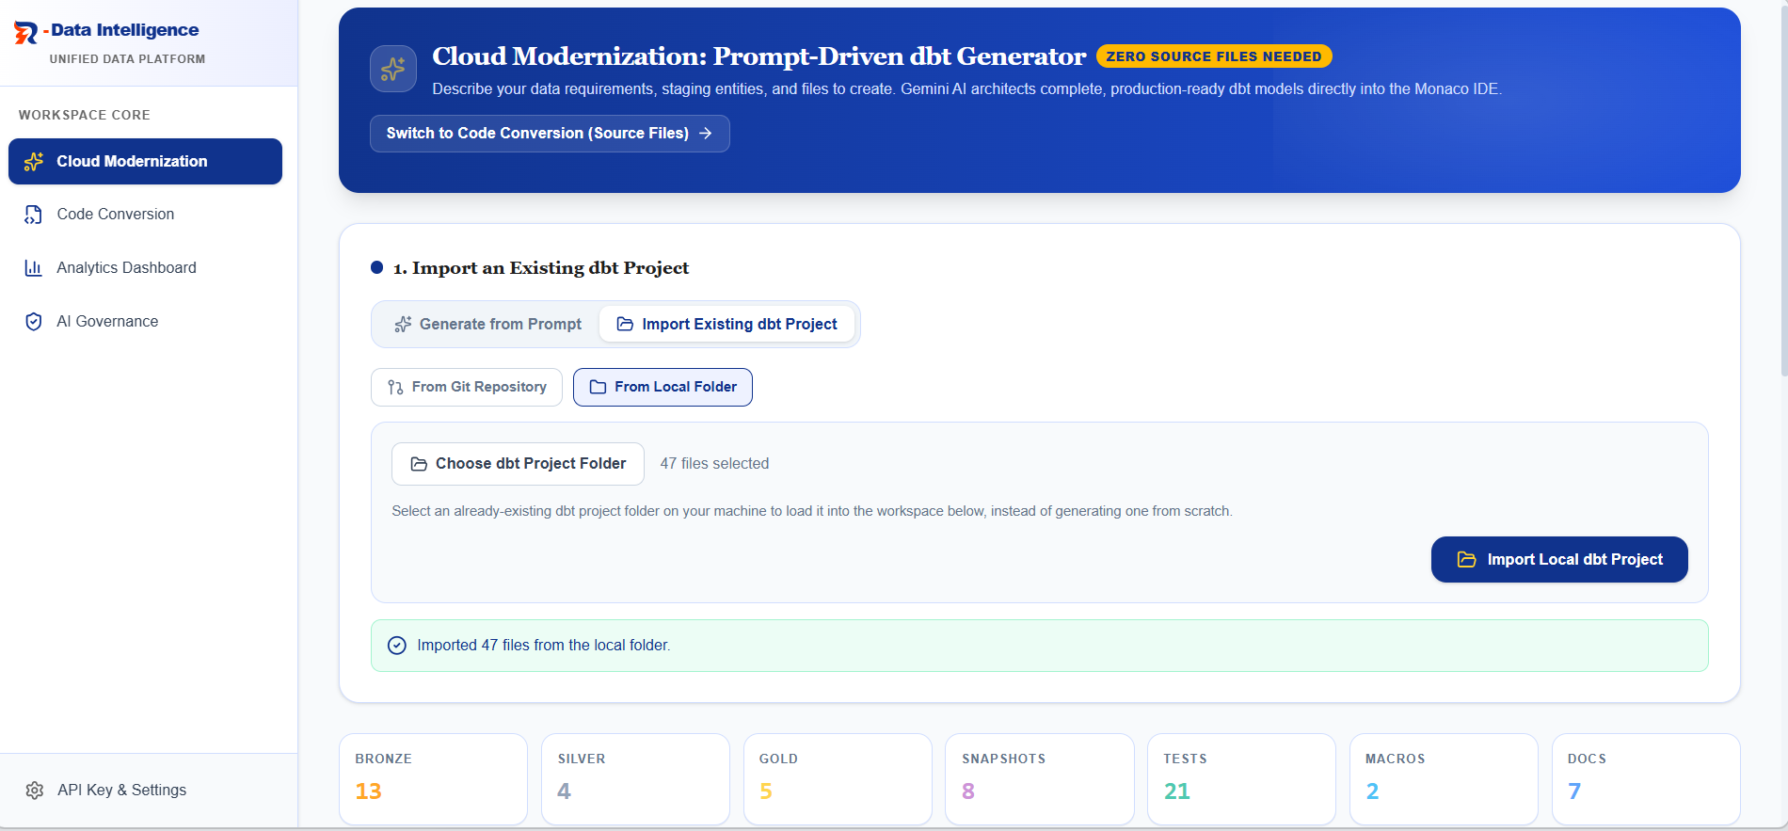
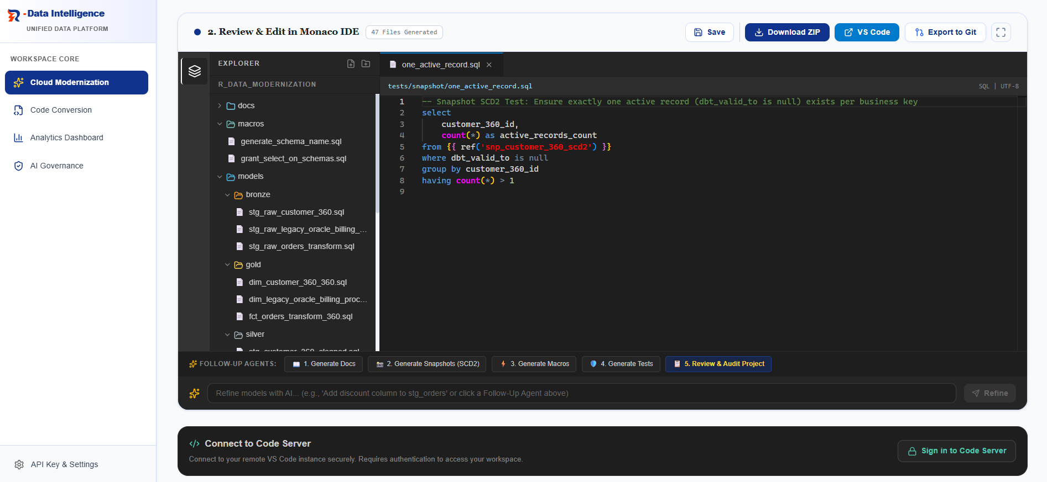

2.Code Conversion
This five-step guided wizard is designed for teams migrating legacy pipelines (currently supporting Informatica PowerCenter and PySpark on Databricks) into modern dbt projects.
- Step 1 - Select Source: Connect to your legacy environment using reusable, saved credentials. Scan your project repository to selectively choose which files to convert. The system then runs a preprocessing pass to strip out boilerplate code (like Informatica XML GUI noise), drastically reducing LLM token consumption and improving AI context efficiency.
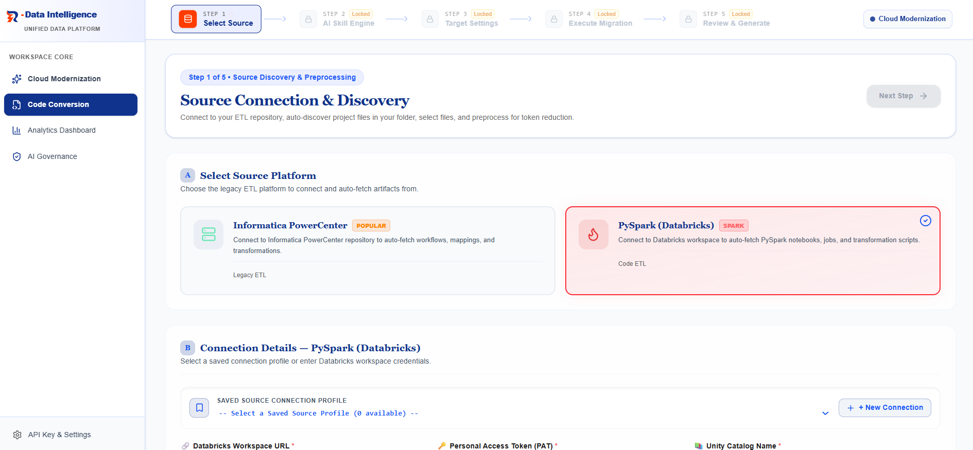
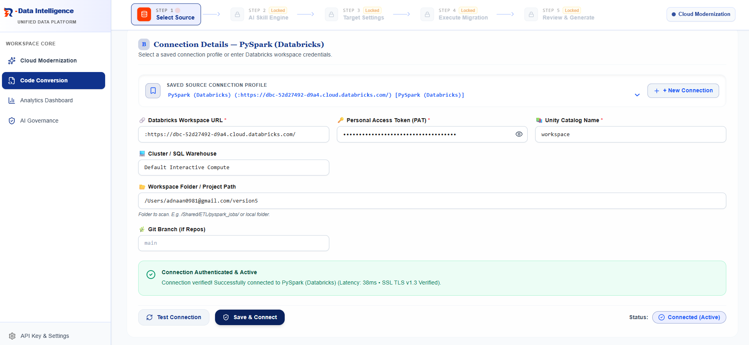
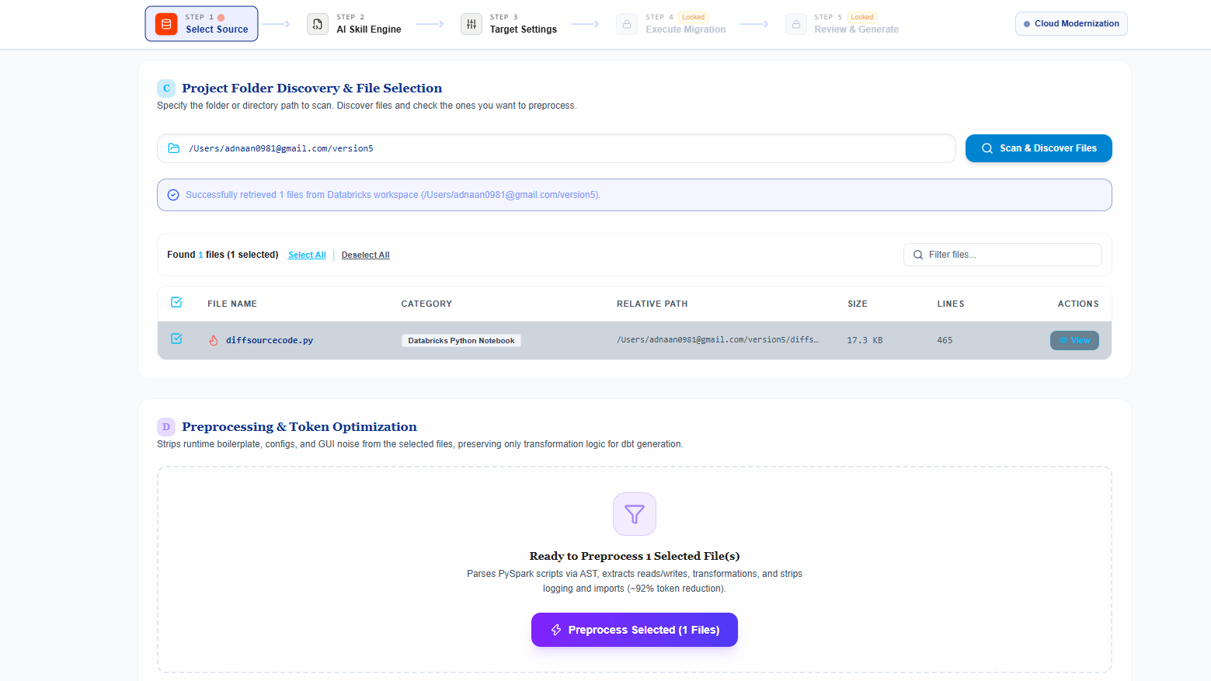
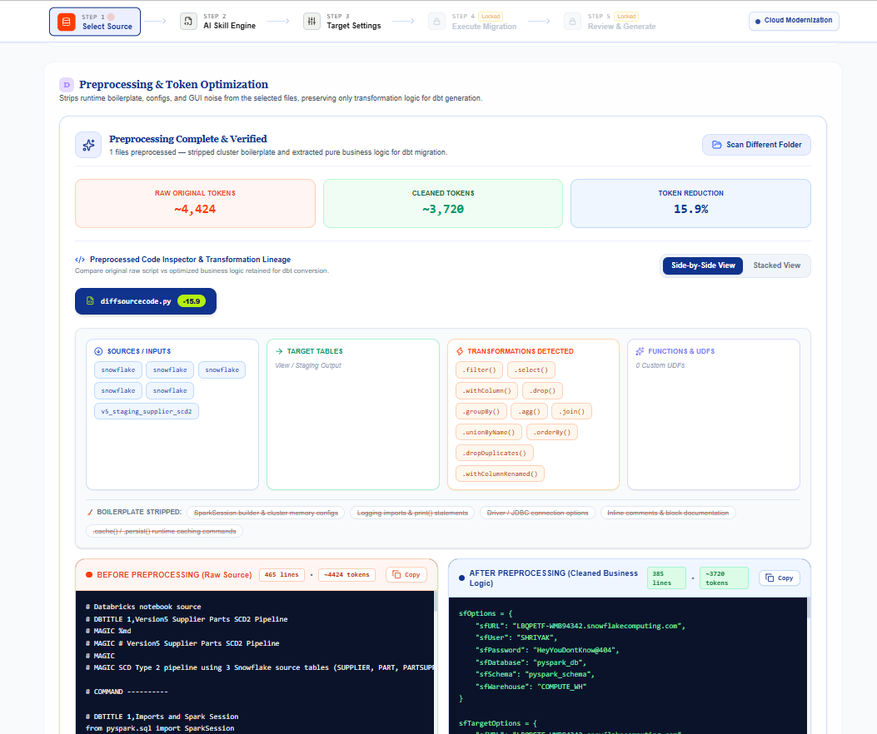

- Step 2 - AI Skill Engine: Configure how the AI will generate your code. You can use the "AI Skills Engine" to toggle and tune specific capabilities (e.g., Medallion architecture layout, SCD2 key handling, test generation), or switch to "Raw Prompt Mode" to directly edit the underlying system instructions for granular control.
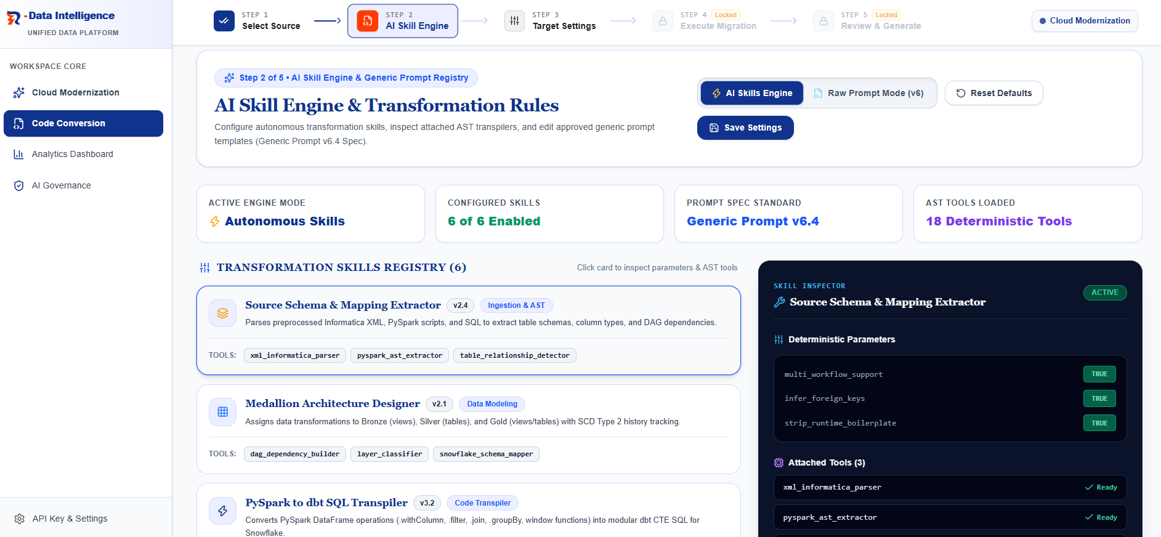
- Step 3 - Target Settings: Review an AI-predicted target architecture diagram (bronze through gold) estimating the final model count based on your source files. Here, you also configure your target data warehouse (Snowflake, BigQuery, or Redshift).
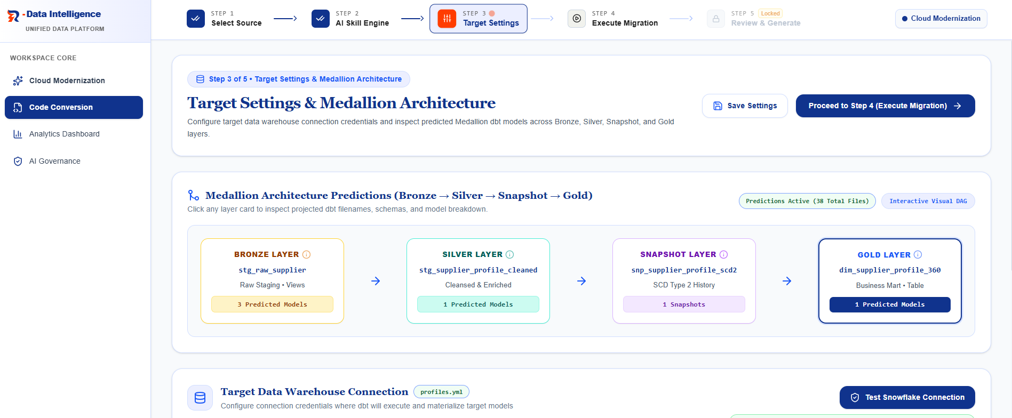
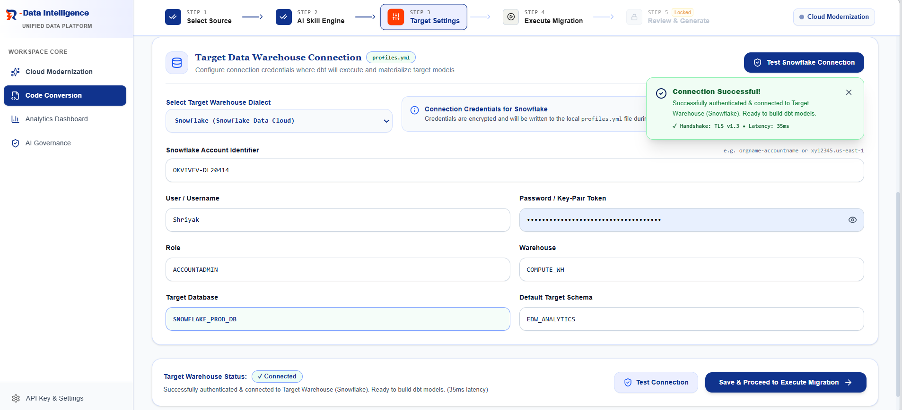
- Step 4 - Execute Migration: Kick off the conversion. A live progress timeline tracks the multi-stage AI pipeline, displaying real-time metrics for execution time, tokens processed, files generated, and estimated AI costs.
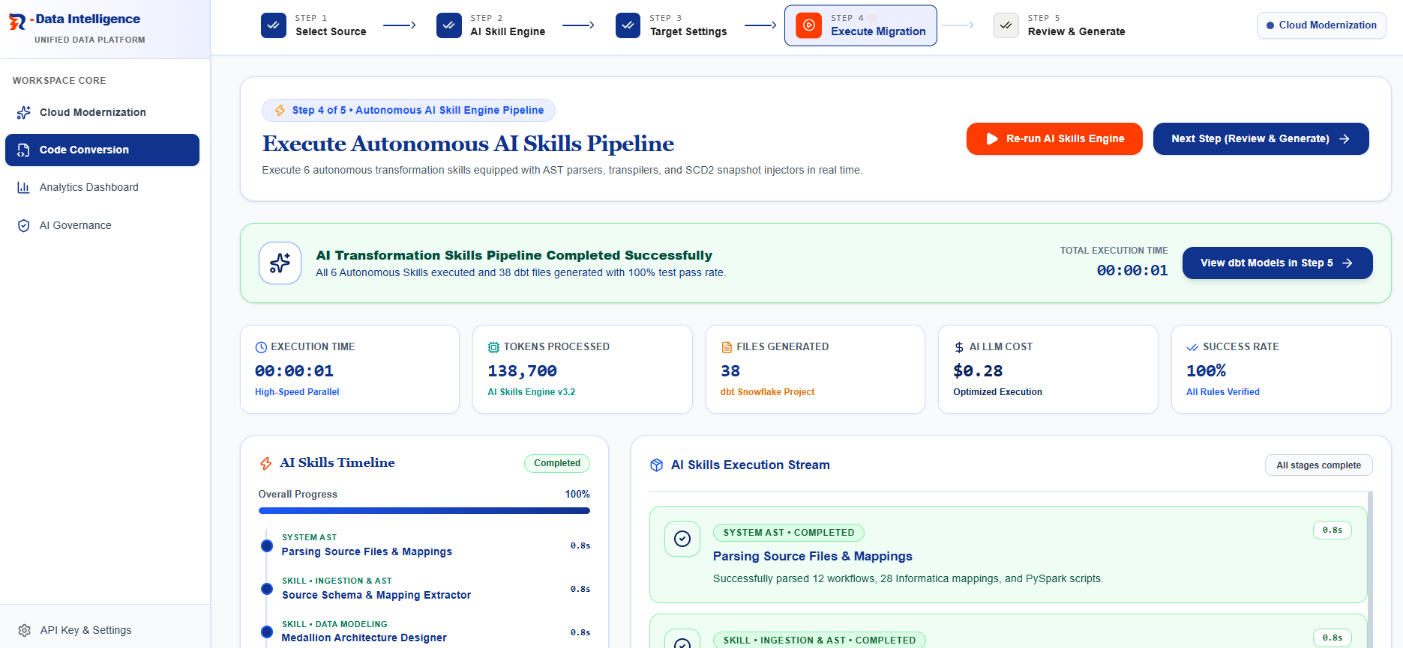
- Step 5 - Review & Export: Review the converted project in a fully featured, in-browser IDE. A side-by-side diff view allows you to compare the generated dbt SQL directly against your original legacy code. Once satisfied, you can download the project as a ZIP, push it directly to GitHub, or open it via a VS Code deep link.
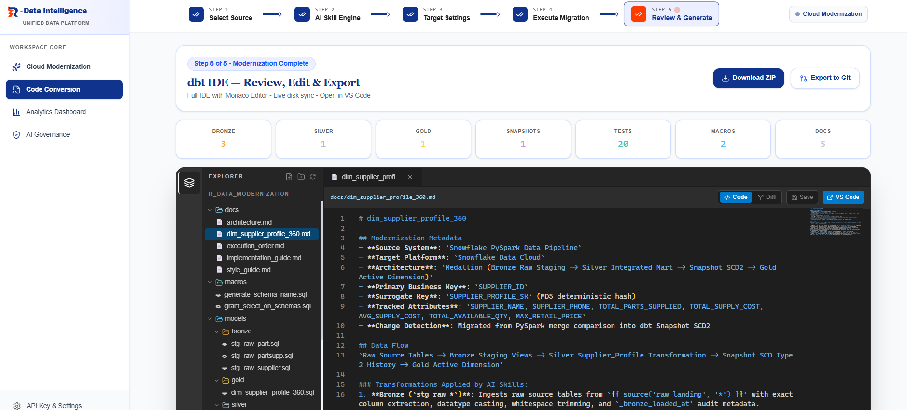

3.Analytics Dashboard
The Analytics Dashboard serves as an intelligent, general-purpose Business Intelligence (BI) layer that sits on top of your connected Snowflake data warehouse. Rather than being hardcoded to a specific domain (like Fintech or Retail), this dashboard is engineered to automatically interpret the underlying schema, understand the domain, and dynamically generate relevant KPI cards and visualizations based on the connected data. This makes it an incredibly powerful tool for demonstrating the immediate business value of the dbt models and semantic layers generated during the migration process.
1. Independent Source Connection To ensure strict security and isolation, the Analytics Dashboard maintains its own dedicated list of saved connections. Credentials and session states are securely isolated and do not bleed across to the Governance or Costing tabs.
2. Dynamic, Domain-Agnostic BI Views Once connected, the system interprets the schemas and tables to construct a multi-page dashboard. Whether your data represents healthcare records, retail supply chains, or financial transactions, the dashboard dynamically structures its sub-tabs (e.g., Executive Overview, Customer Analytics, Operational Velocity, etc.) and populates them with auto-generated charts and core financial/operational KPI cards that make sense for your specific business model.
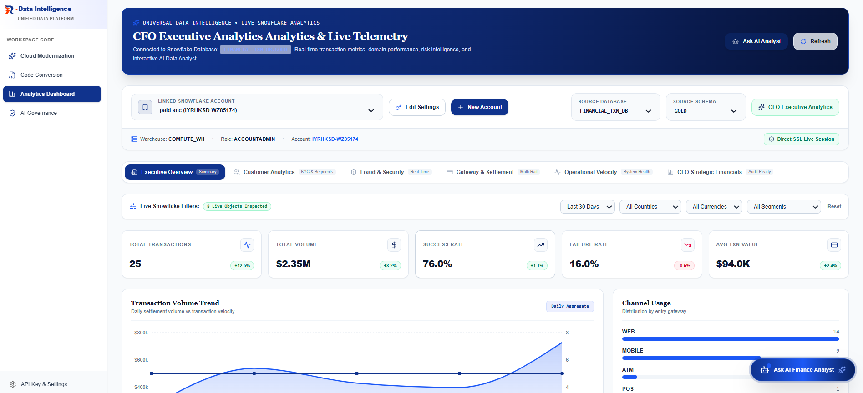
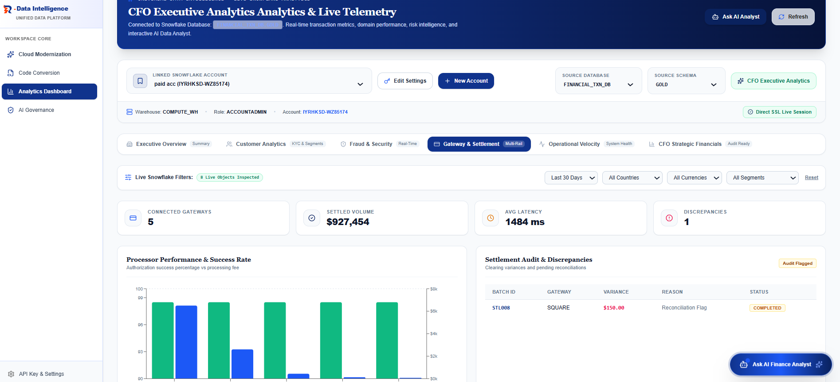
3. "Ask AI Analyst" Powered by Snowflake Cortex A core feature of the Analytics Dashboard is the floating "Ask AI Analyst" chat panel. Unlike generic natural language tools, this assistant is powered by Snowflake Cortex Analyst and built on a highly secure architecture:
Curated Semantic Views: The AI doesn't query raw tables. It only reads curated, clean semantic views created in Snowflake or dbt.
Role-Based Security: A dedicated Snowflake Role and Agent are configured with strict access limited only to these semantic views.
Accurate Translation: Cortex securely translates your natural language questions into precise SQL against these safe views, guaranteeing accurate answers without compromising data governance.
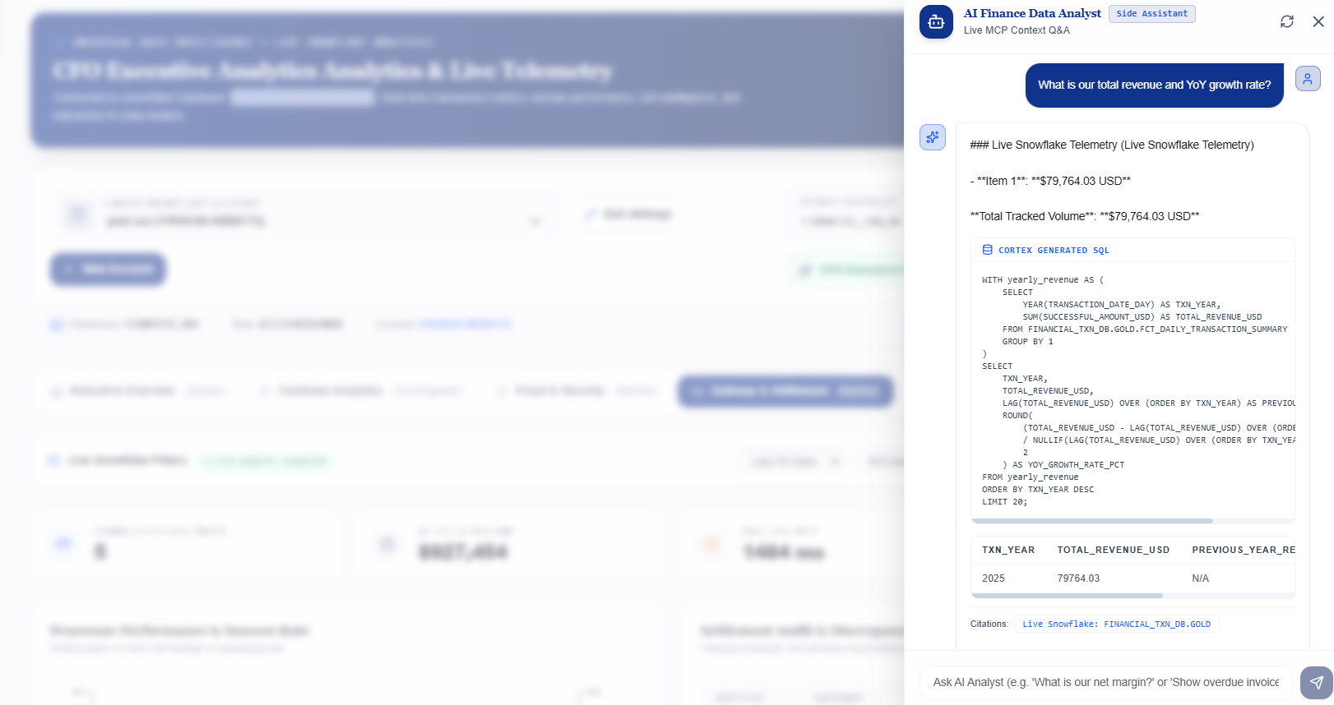

4.Governance

The Governance tab provides unified observability for your production pipelines, monitoring both execution health and cloud spending. It is divided into two main modules:

Monitoring
A seamless toggle allows you to monitor operational health across dbt, Apache Airflow and other tools.
- Intelligent Syncing: Initial AI schema mapping dynamically structures your KPIs, followed by fast, direct SQL polling for live, authenticated updates.
- dbt Observability: Tracks pipeline execution across six views: Executive Overview, Performance (build times), Explorer (lineage & compiled SQL), Quality & Coverage (tests), Freshness (SLA tracking), and automated Analysis & Recommendations.
- Airflow Observability: Monitors orchestration health via DAG Run History, Task Runtimes, Worker Logs, and source code exploration.
- AI Troubleshooting Copilot: A built-in chat assistant allows you to troubleshoot pipeline failures, slow runs, and historical execution metrics using natural language.
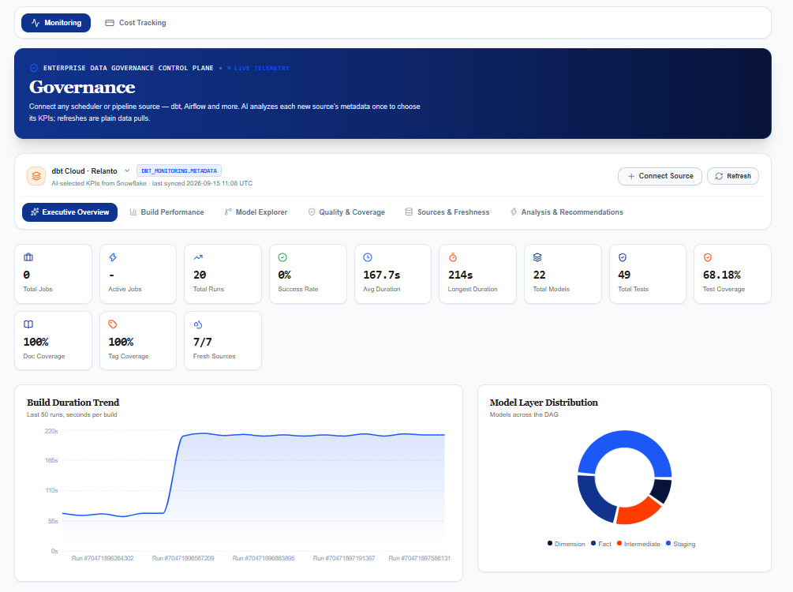
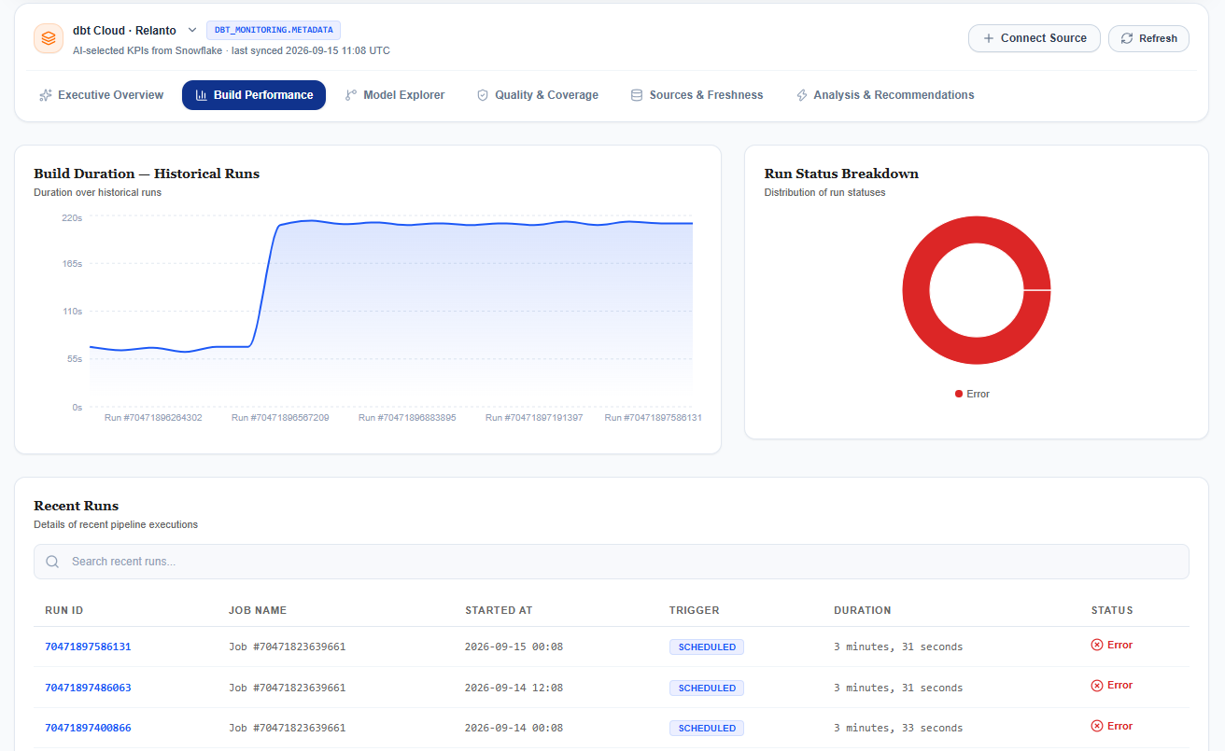
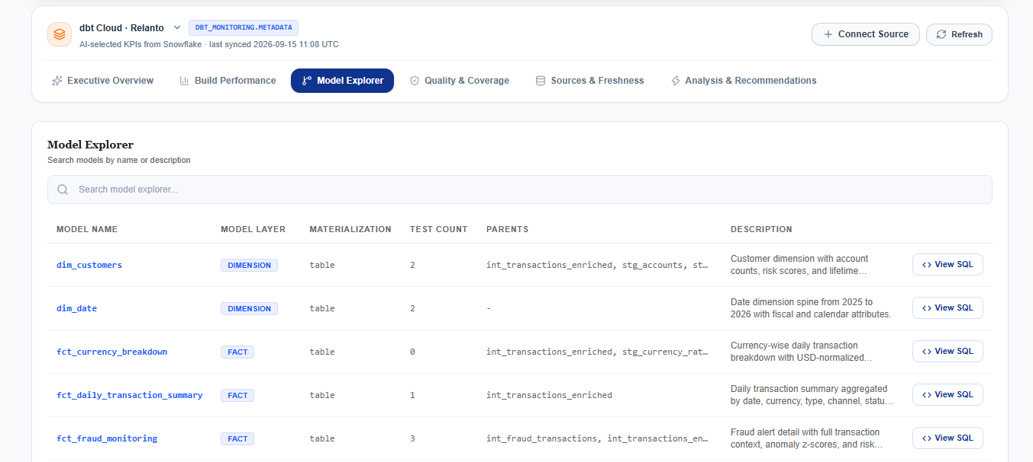
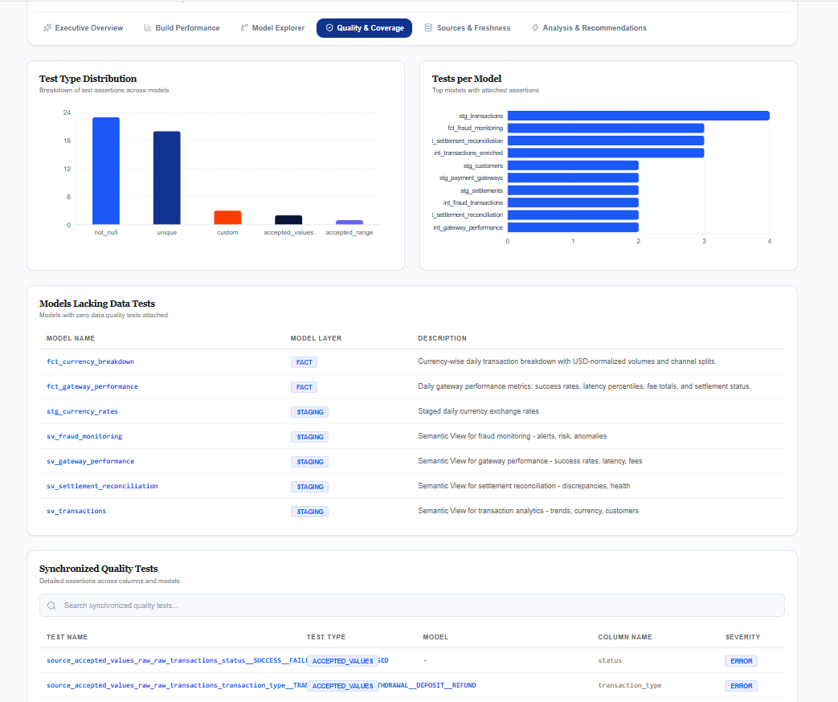
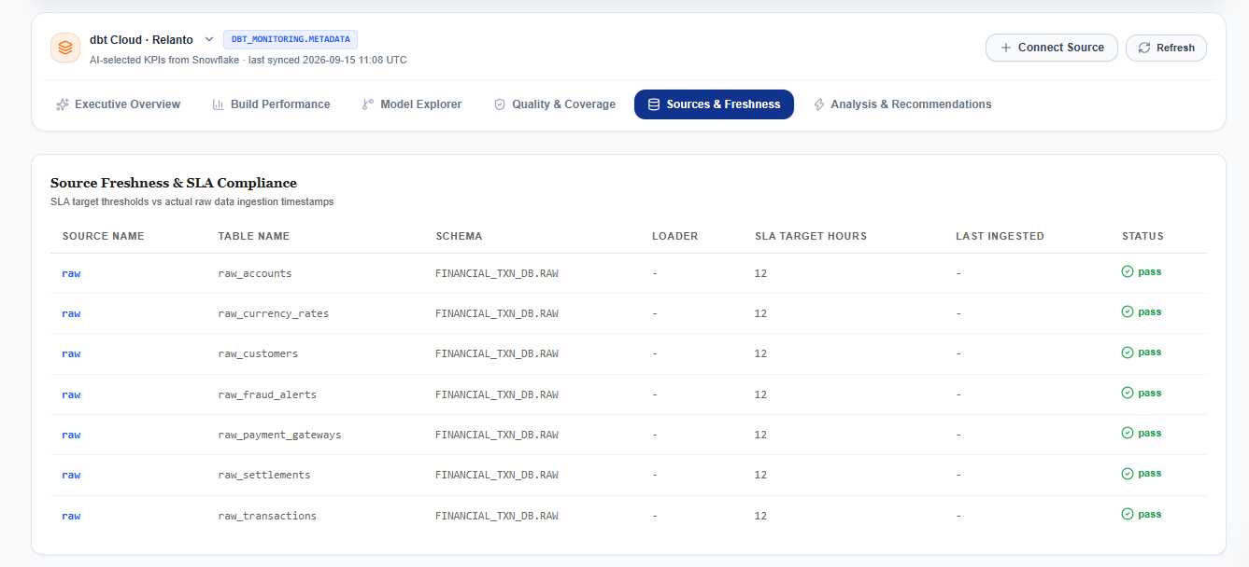
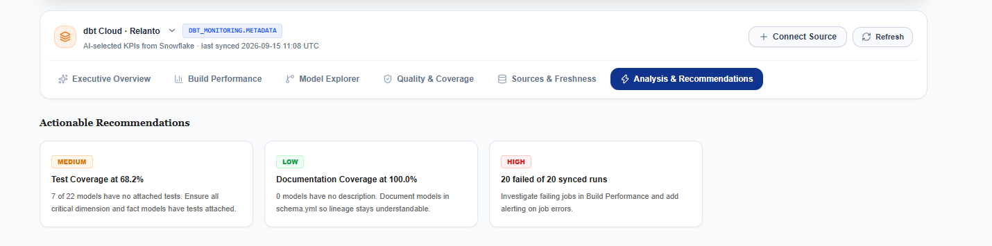

Cost Tracking
A dedicated financial dashboard for measuring and reducing data platform spend, with support for multi-account management.
- Live Snowflake Cost Intelligence: Queries Snowflake’s native ACCOUNT_USAGE schema directly to provide highly accurate, verifiable cost metrics without mock data.
- Granular Spend Attribution: Breaks down costs across six views: Executive Overview, User Attribution (spend by team/user), Warehouse Compute, Query Explorer (pinpointing expensive queries), Cortex & AI Tokens, and prescriptive AI FinOps Insights to eliminate waste (e.g., rightsizing warehouses or fixing idle timeouts).
- dbt Cloud Costing: Currently offers a structural preview mapping out upcoming integrations for attributing dbt compute runtime, managed models, and developer seat costs.
