J. P. DAWAR INSTITUTE OF INFORMATION AND
COMMUNICATION TECHNOLOGY
Veer Narmad South Gujarat University (VNSGU)
ACADEMIC YEAR 2026–2027
PRACTICAL ASSIGNMENT 3
Submitted To | Rupal Panchal Ma’am
Course / Subject | PHP and REST API Assignment
Name | PATEL SHRUTI MITESH
Roll No. | 52
Class | M.Sc. (ICT) – Semester 3
Academic Year | 2026–2027
Date | 19-10-2026
Department of Information & Communication Technology

QUESTION 1: DEVELOP A PHP SHOPPING CART
Develop a PHP shopping cart application with the following requirements:
Admin Site:
• Admin login
• Category management (Create, Read, Update and Delete)
• Product management with picture upload and image resizing
• Admin logout
User Site:
• List categories
• Display products for the selected category with pagination using AJAX
• User registration with CAPTCHA
• User login
OUTPUT SCREENSHOT:
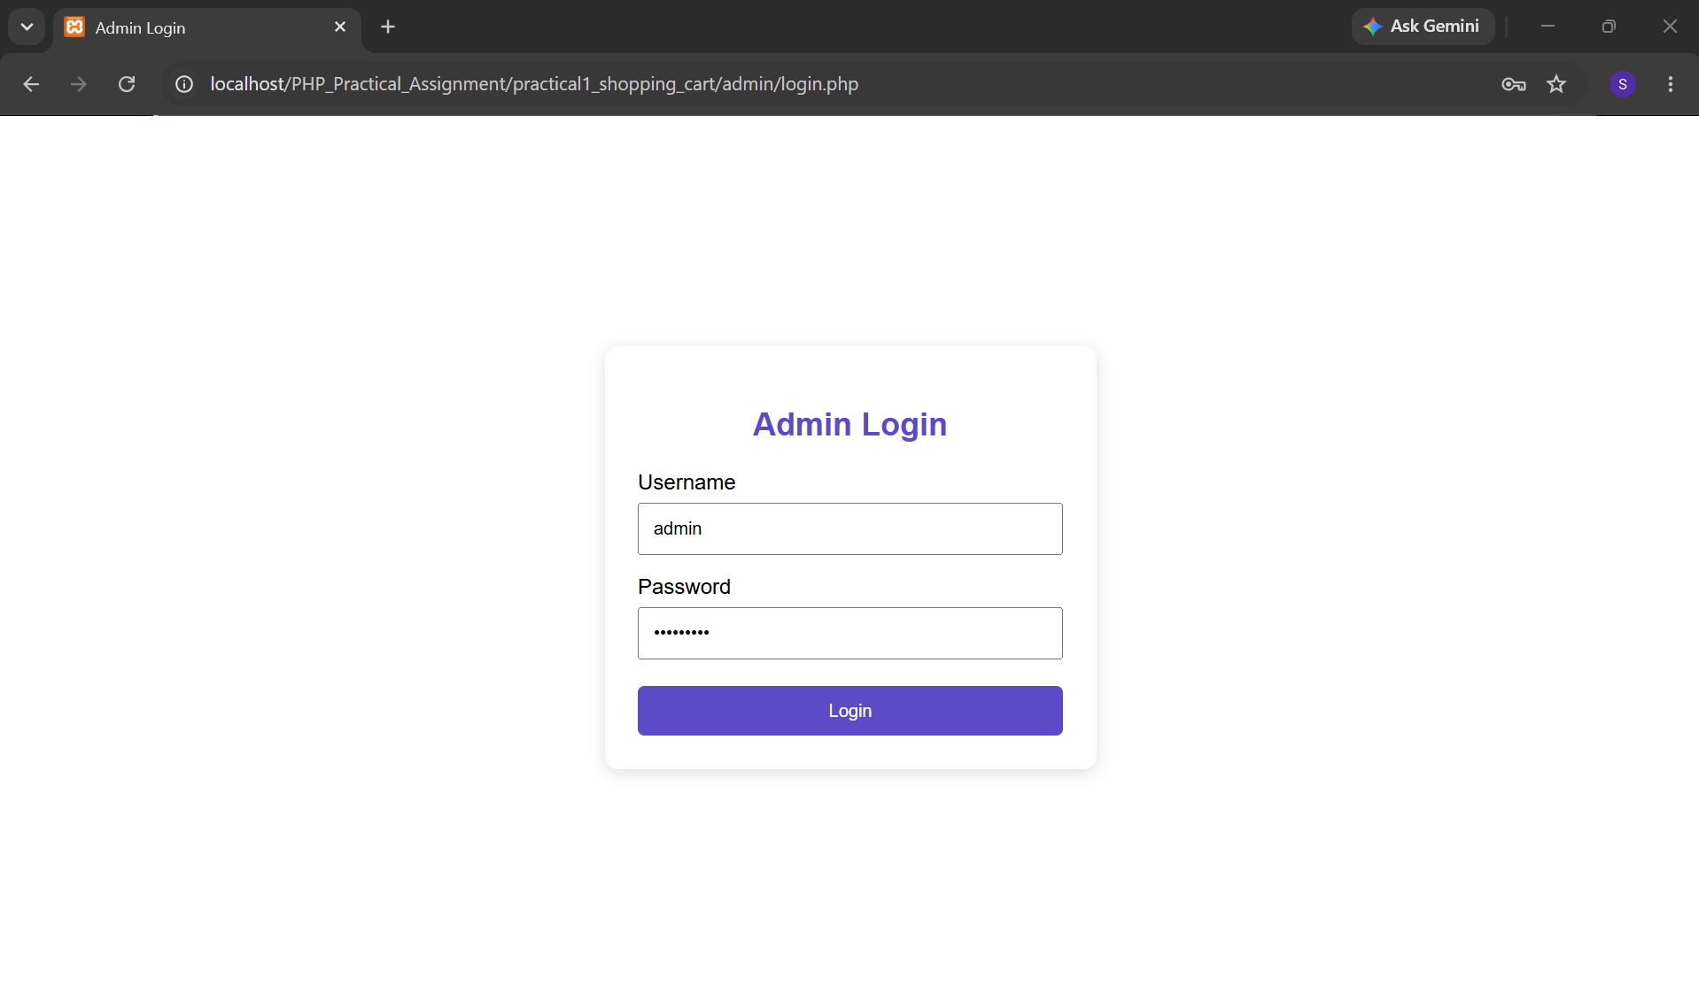
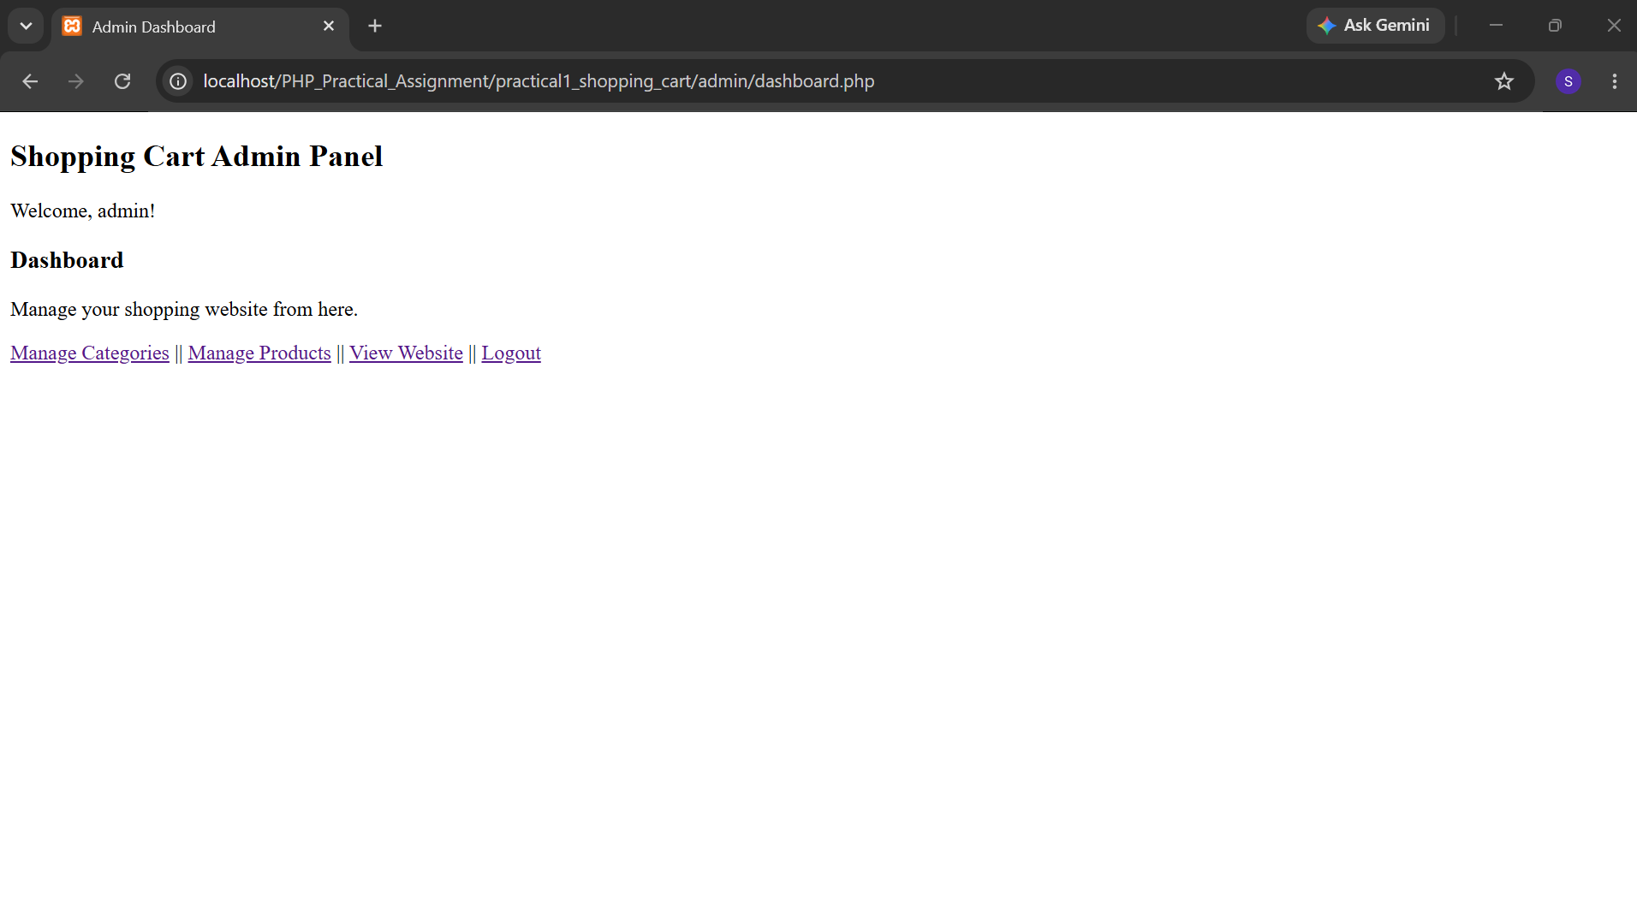
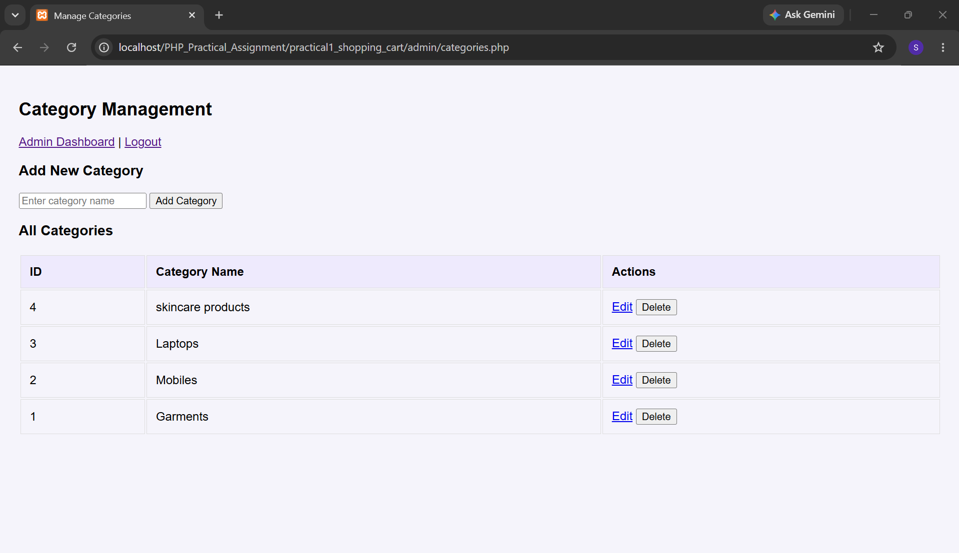
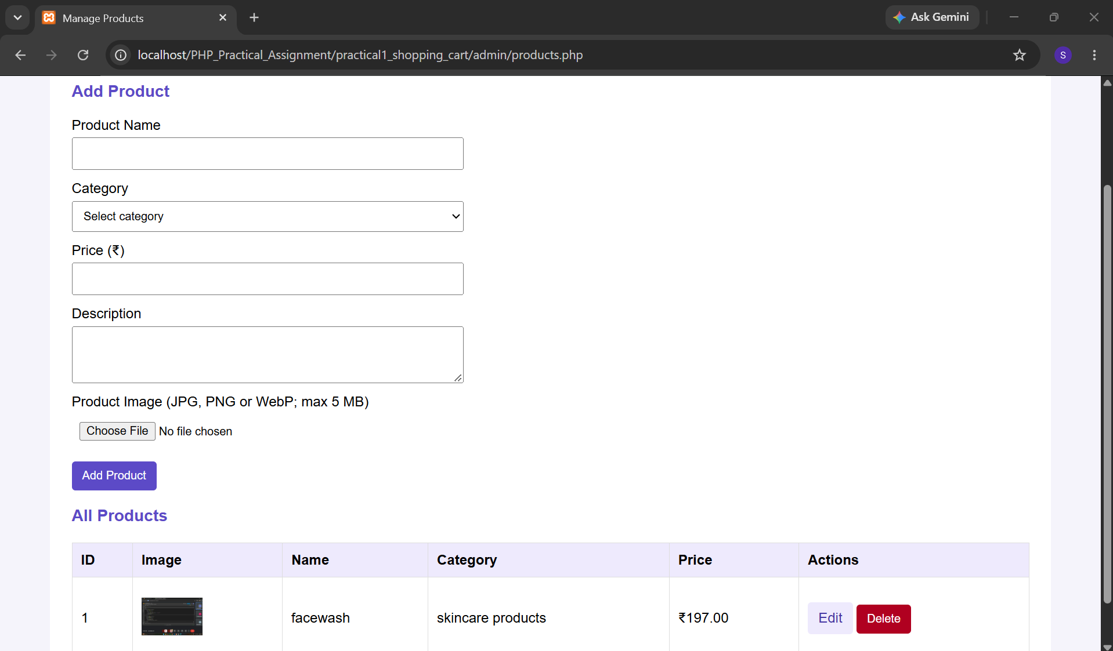
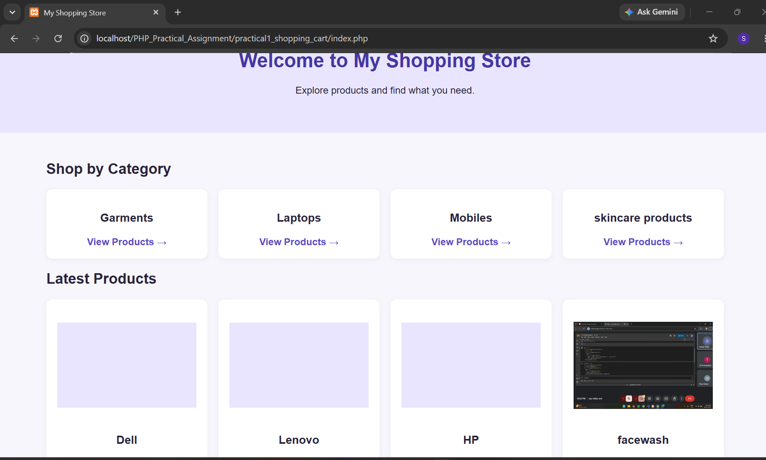
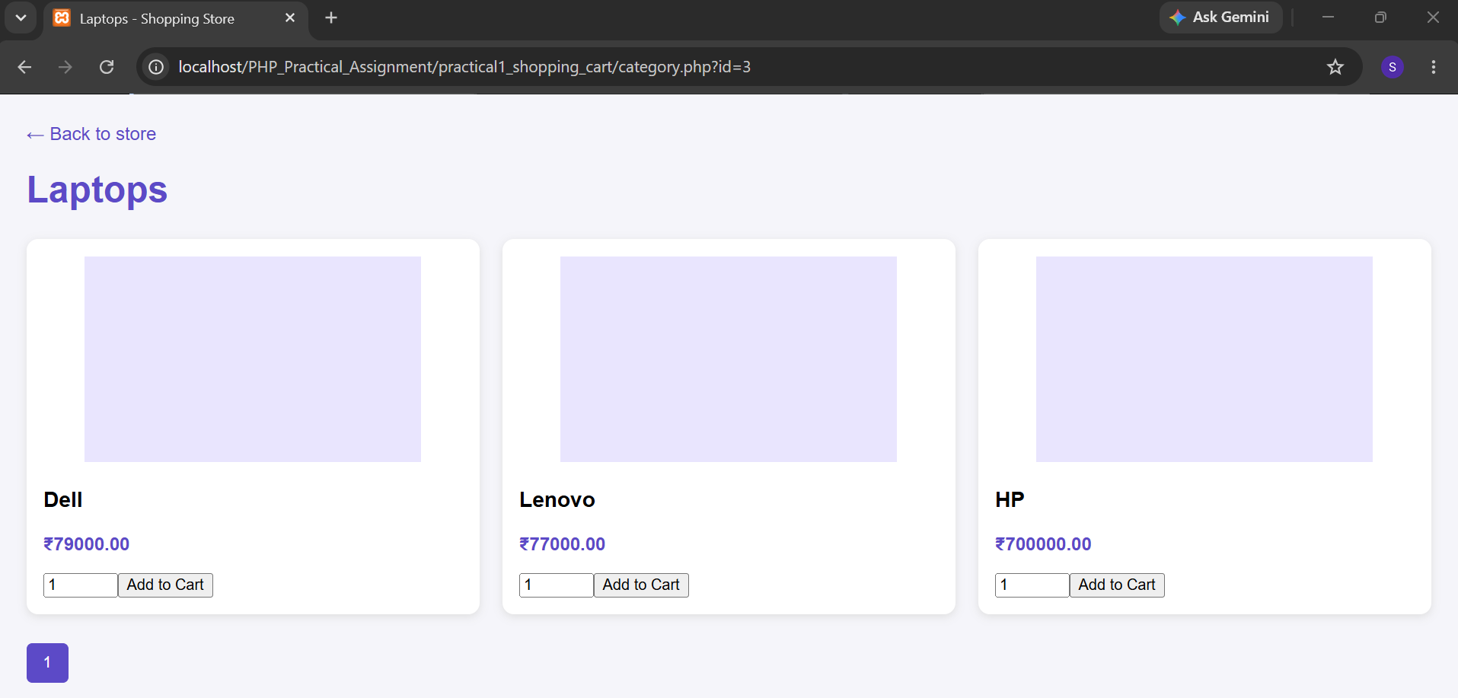
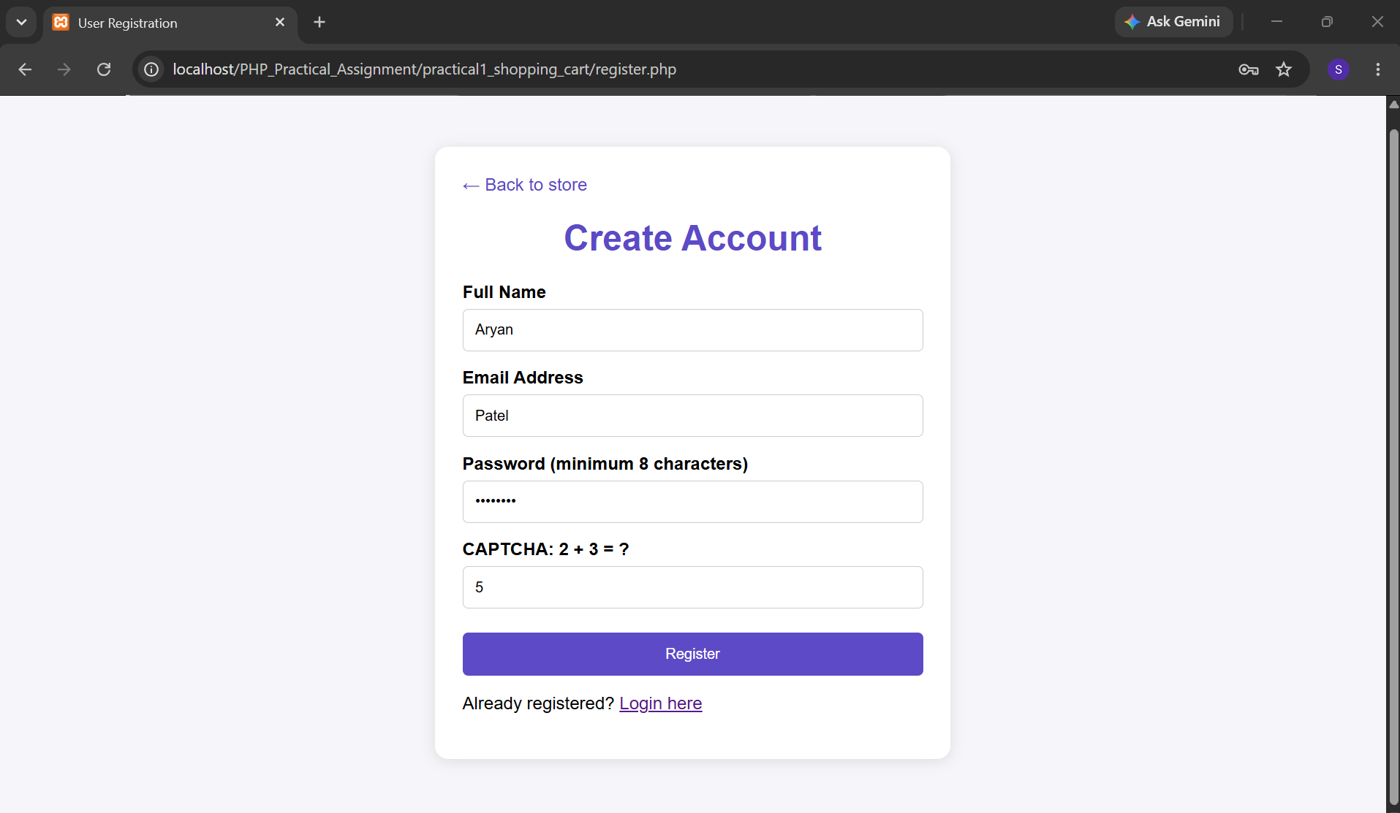
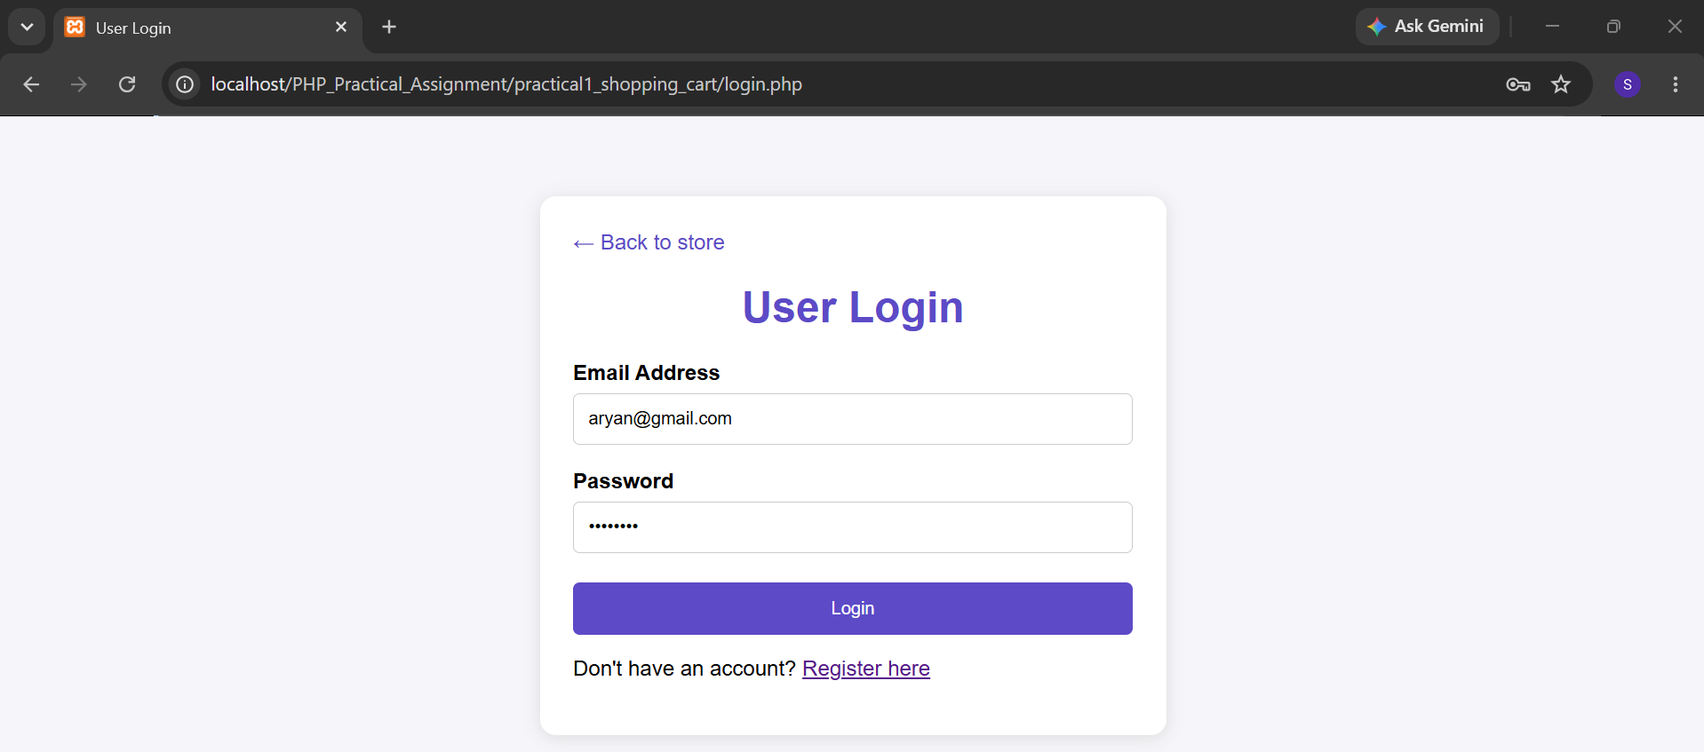

QUESTION 2: READ XML DATA AND STORE IT IN MYSQL
Read student data from students.xml and store the data in the MySQL students table.
OUTPUT SCREENSHOT:
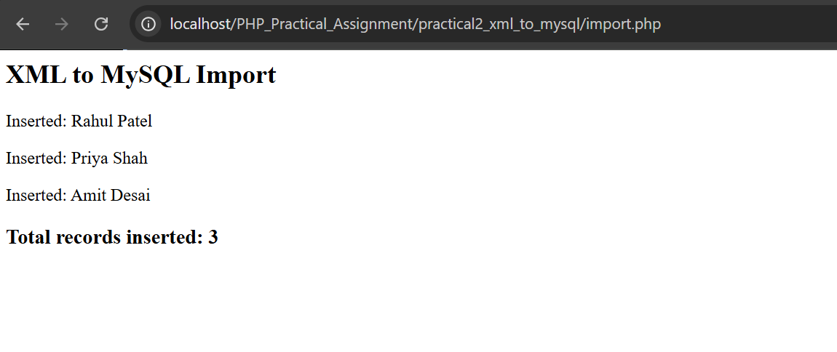

QUESTION 3: READ MYSQL DATA AND STORE IT IN XML
Read student data from the MySQL students table and store the data in students.xml.
OUTPUT SCREENSHOT:
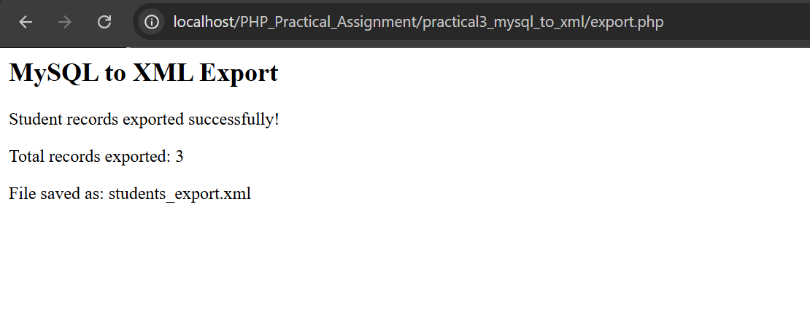

QUESTION 4: LIST FILES IN A DIRECTORY
Write a PHP program to list all files and folders in a directory.
OUTPUT SCREENSHOT:
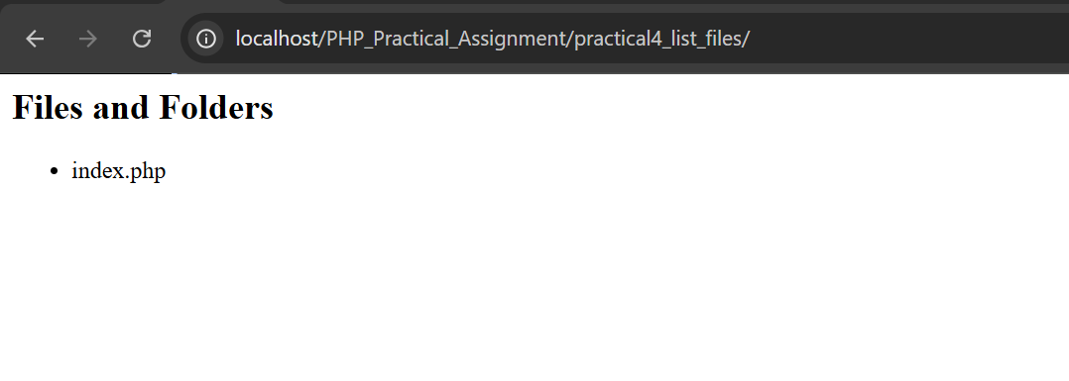

QUESTION 5: CALL EXPRESS REST API IN PHP
Write a PHP program to call an Express REST API and display the returned student data.
OUTPUT SCREENSHOT:
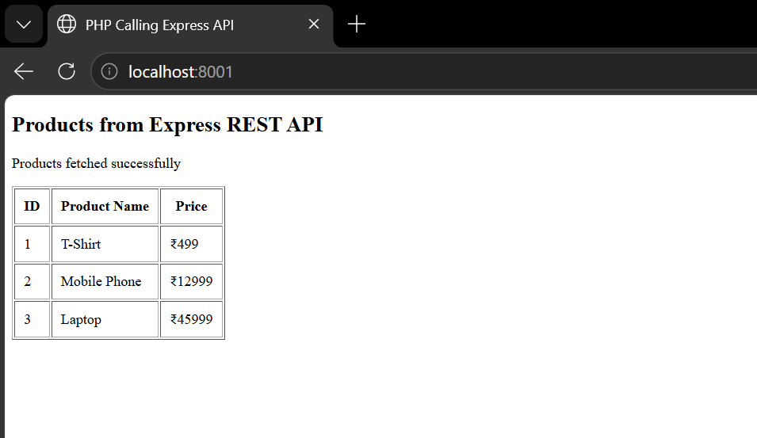

QUESTION 6: CALL PHP REST API IN EXPRESS
Write an Express application that calls a PHP REST API and displays the returned student data.
OUTPUT SCREENSHOT:
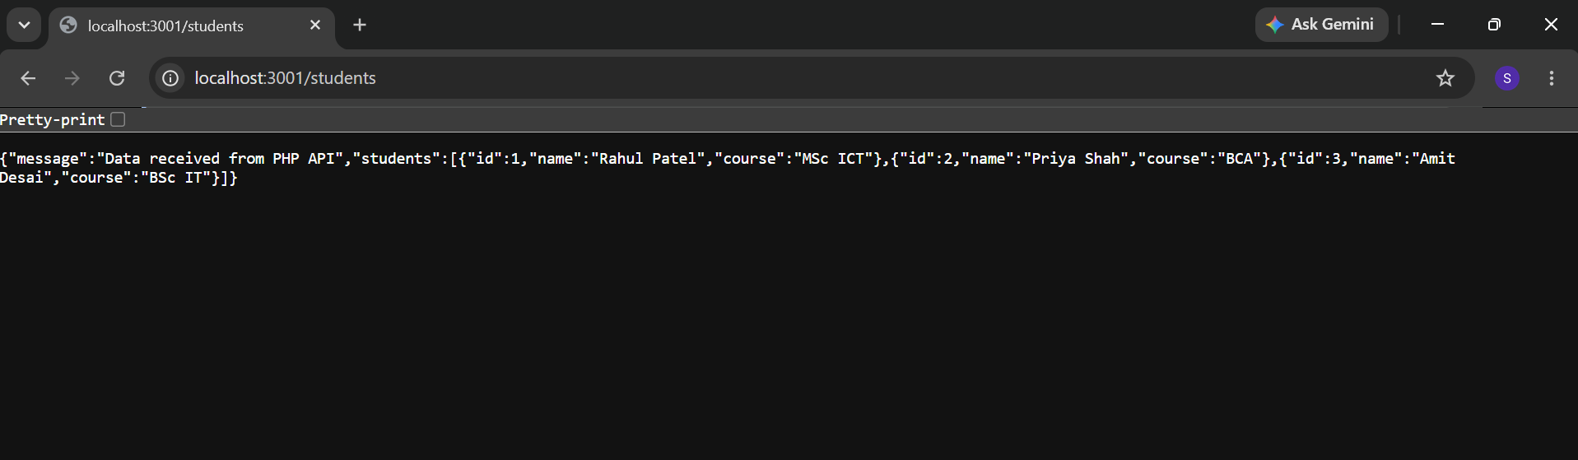

Code of question 1 to 6 :-
