**Laboratory Procedures   
DeVry University  
College of Engineering and Information Sciences**

## OBJECTIVES

1. Use Excel to solve a business problem.

## II. ASSUMPTIONS

1. In this lab, we will solve two business problems using Excel. The first one will be a step-by-step guide to familiarize you with Excel and its formulas. The second problem you will do on your own.

Problem 1:

1. You would like to open a day care facility and need to know how much it will cost to operate the business and how many children need to attend to break even and how many it will take to make a profit. You will use Excel for this lab and create formulas to solve this problem. The following is the information you need to solve the problem.
   1. You employ four teachers at $15/hr.
   2. You employ one manager at $20/hr.
   3. We will assume they will work 2,000 hours.
   4. Food/snacks will cost $3,000 per year.
   5. Supplies will cost $1,000 per year.
2. Create a spreadsheet to solve the following problems:
   1. How much will it cost to run the day care facility for a year?
   2. If you charge tuition of $8,000 per year, how many students do you need to break even?
   3. Assuming tuition is still $8000per year, how many students do you need to make a $25,000 profit?
   4. Create a pie chart showing the percentage of expenses for each category.

Problem 2:

1. You own a game company and would like to develop a new game. Your goal is to determine how much it costs to create a game, how many games you need to sell to break even and how many it will take to make a profit. You will use Excel for this lab and create formulas to solve this problem. The following is the information you need to solve the problem.
   1. You employ 60 programmers at $40/hr.
   2. You employ 10 managers at $55/hr.
   3. Marketing has requested $1,000,000 to market the game.
   4. Each employee will work 1 year (2,000 hours) to develop this game.
2. Create a spreadsheet to solve the following problems:
   1. How much will it cost to develop the game?
   2. If you sell the game for $55. How many games do you need to sell to break even?
3. Optional:
   1. Assuming the $55 price, how many games do you need to sell to make a $1,000,000 profit?
   2. Create a pie chart showing the percentage of expenses for each category.

## III. PROCEDURE

1. Open Microsoft Excel.
2. Watch the video explaining how to complete problem 1.
3. Create formulas to calculate the total costs for teachers and managers and calculate the total cost of the day care. Your formulas should be similar to the screenshot below.

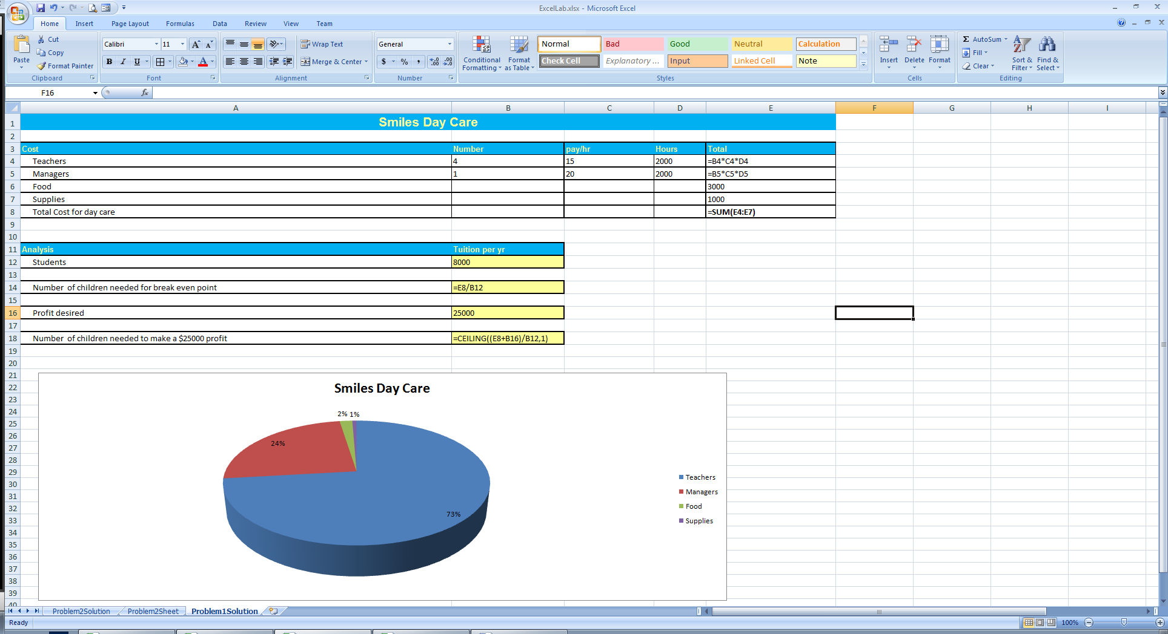

1. Next, do the analysis to determine the breakeven point and the number of students needed for a desired profit.

These formulas are below. You need the ceiling function to round up to the nearest integer.

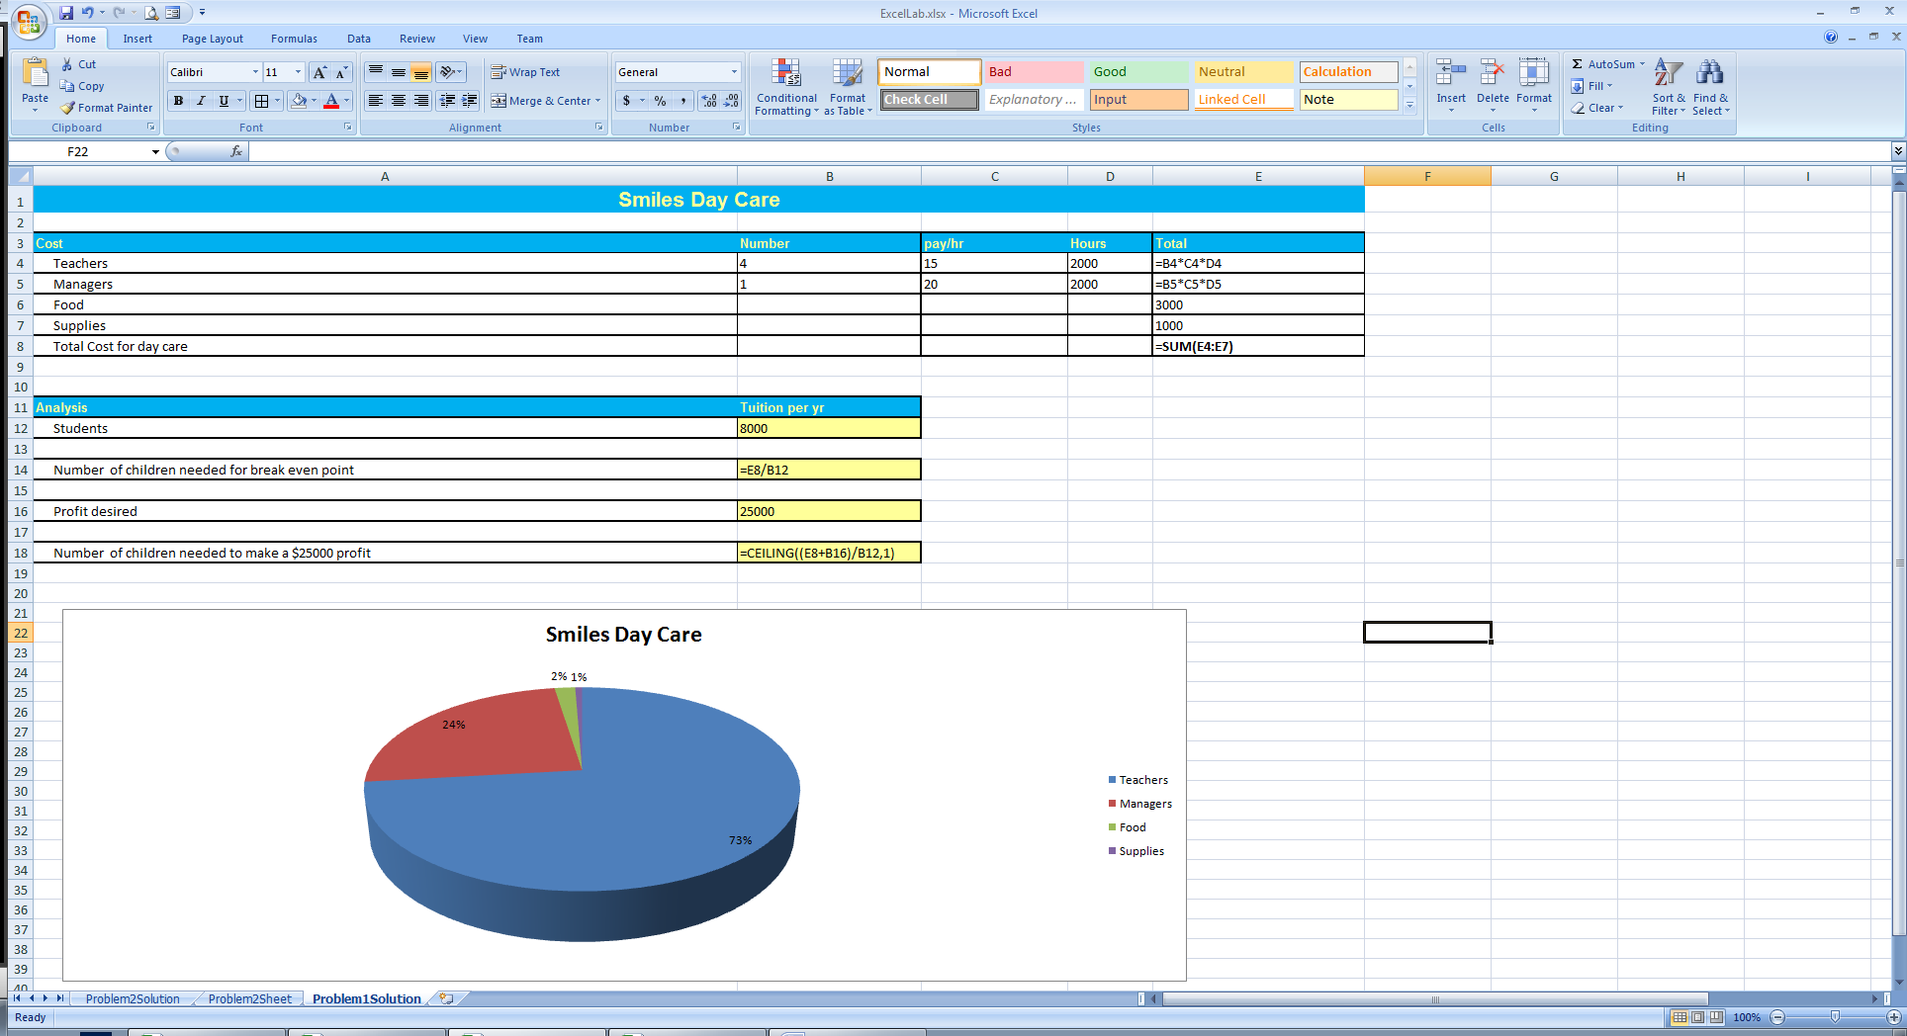

1. A pie chart is needed to illustrate the percentage of expenses for the day care. Select A4:A7 press and hold control and select E4:E7. Then choose Insert -> Pie to create a pie chart based on the expenses. Add a title to the pie chart.

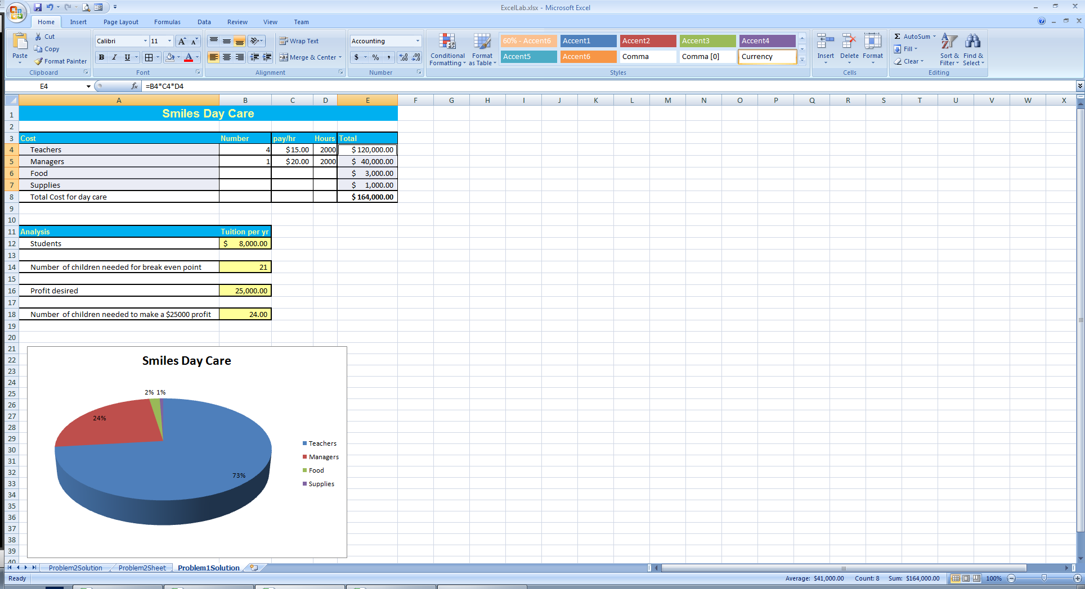

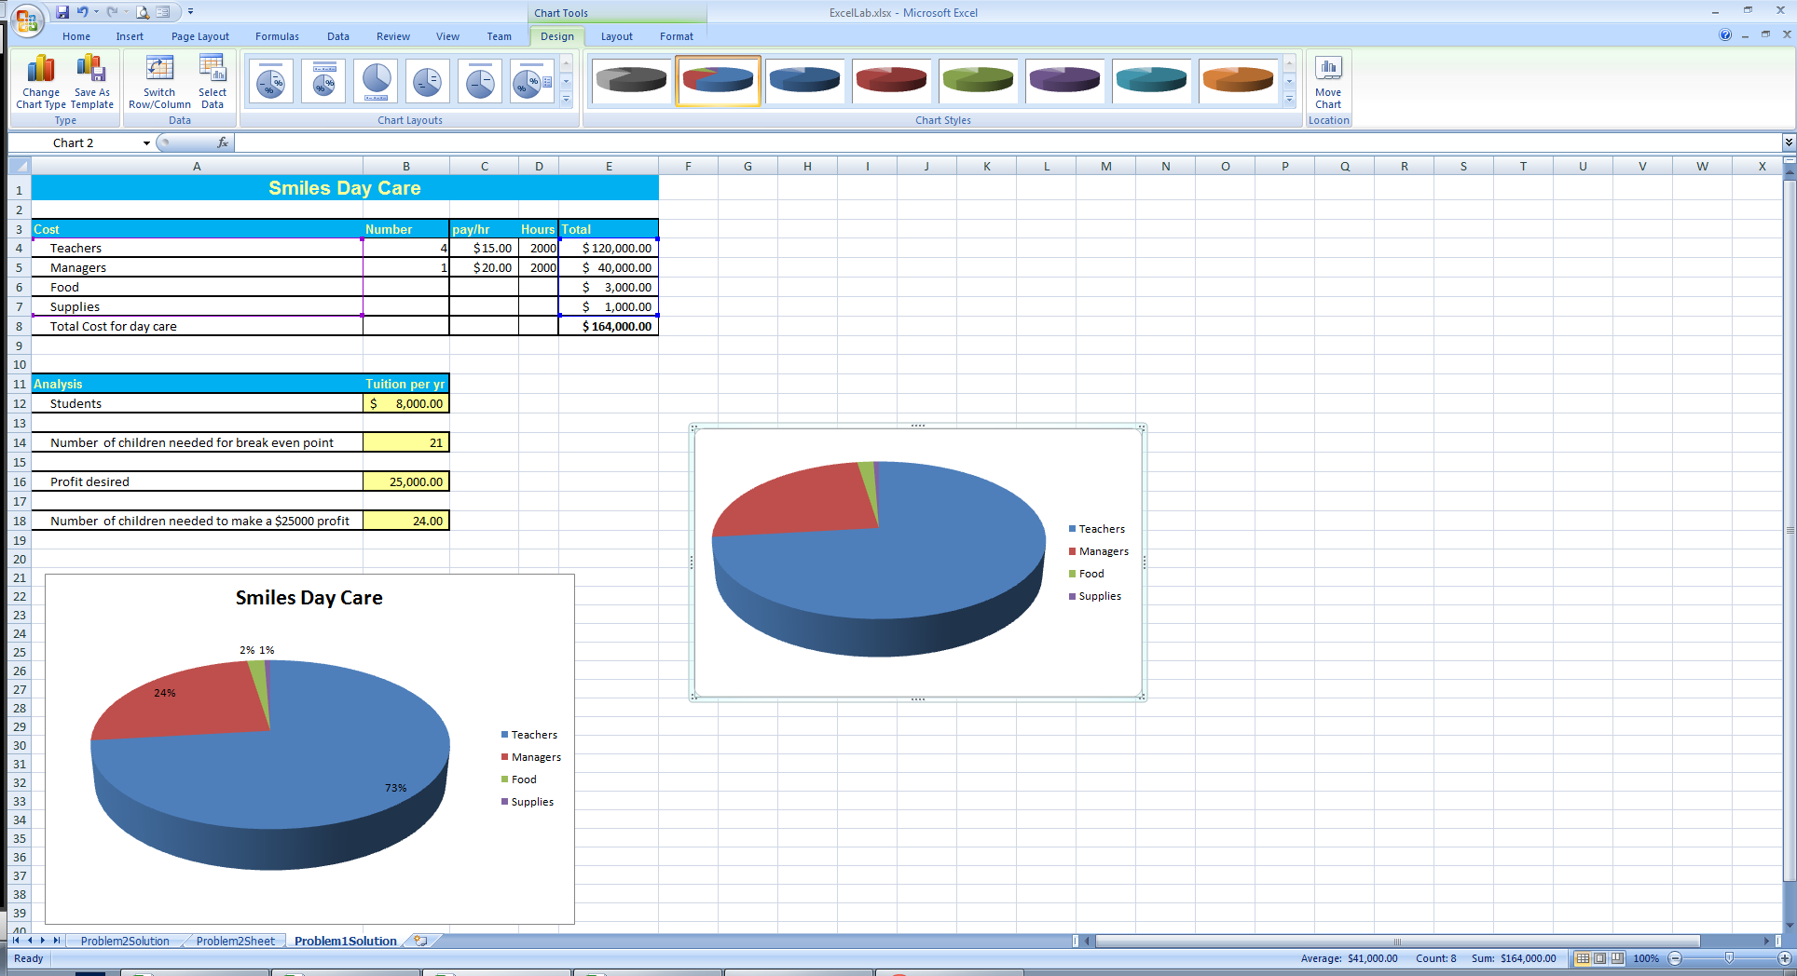

1. Your final spreadsheet should look like the following.

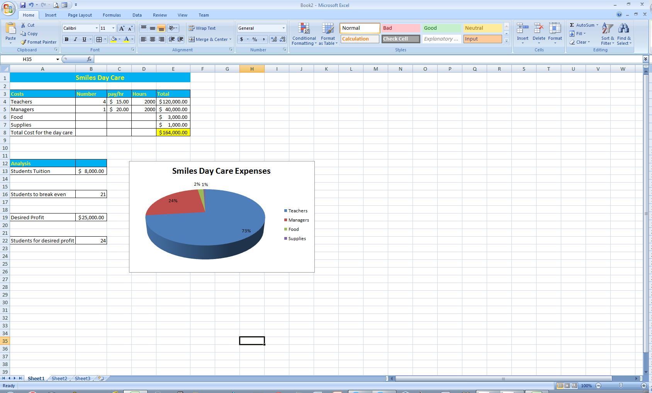

1. Save your worksheet from problem 1 as lastname_problem1_week3.xlsx and submit it to the Dropbox for Week 3.
2. Open a new worksheet for problem 2. Enter all the data into your spreadsheet as shown below. You can format the spreadsheet as you wish. Replace "Your Name" in the title with your first and last name.

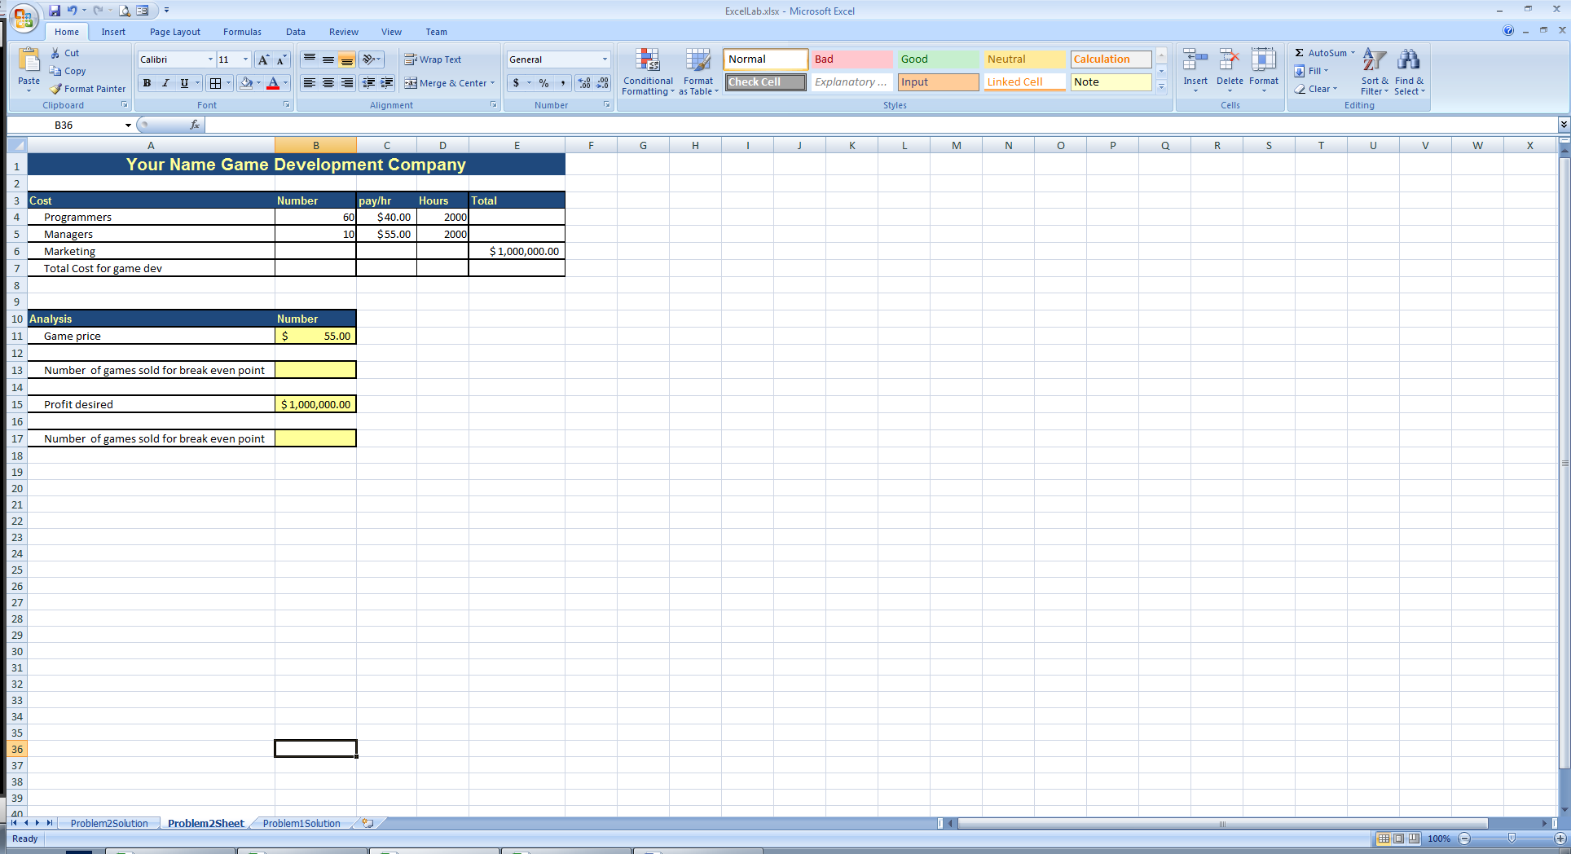

1. Using the knowledge from the previous exercise, solve the problems in this spreadsheet. Save your final spreadsheet as lastname_problem2_week3.xlsx and submit to the Dropbox.

**Laboratory Report Cover Sheet   
DeVry University  
College of Engineering and Information Sciences**

**Course Number: CEIS100**

**Professor:**

**Laboratory Number:** 1

**Laboratory Title:** Using Excel to Solve a Business Problem

**Submittal Date:** Click here to enter a date.

***Objectives:***

***Results:***

***Conclusions:***