**Laboratory Procedures   
DeVry University  
College of Engineering and Information Sciences**

## OBJECTIVES

1. Create a program using python.

## II. ASSUMPTIONS

In this lab you will create a program that will prompt the user to answer a few questions. Check out this demonstration video for understanding of the process. Crtl+Click

<http://www.screencast.com/t/ytpIfarUzp>

## PROCEDURE

## Part 1

1. Open IDLE using your Raspberry PI or Citrix (<http://lab.devry.edu>) or download python on your home computer: <http://www.python.org/download/> .
2. Review the lecture in Week 5 for details on how to program in python. An interactive tutorial is available in the Week 5 Lecture and a video showing how to solve part a step by step is available in the iLab.
3. Ask the user to input his or her name. Then ask the user to enter his or her age. If they are older than 16 then they can drive a car. Display this message along with their name.
4. The code to accomplish this is below:

print("Welcome to the get to know you program")

name = input("What is your name? ")

age = int(input("What is your age? "))

if age>=16:

print("You can drive a car!")

print(name)

print("Nice to meet you!")

1. Print out the results of the input values and a final message saying "Nice to meet you."
2. The program should look like the following.

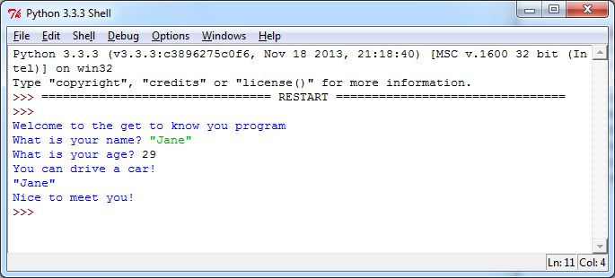

1. Enter your code into the lab report either by copying or pasting or typing it. You may also use a screenshot to show that the program works. You can include a digital picture using your phone or a Windows Screenshot. To include a screenshot in Windows, keep the IDLE window open and press the printscreen button on your keyboard. Open the Word document Lab report. Then click Paste on the Home tab. This will paste the screenshot in Word. You can also use the Windows 7 Snipping tool to paste a screenshot.

## Part 2

1. Open IDLE using your Raspberry PI or Citrix (<http://lab.devry.edu>) or download python on your home computer: <http://www.python.org/download/> .
2. Review the lecture in Week 5 for details on how to program in python. An interactive tutorial is available in the Week 5 Lecture and a video showing how to solve part a step by step is available in the iLab.
3. Ask the user to input his or her name. Next ask the user to input the city they live in. Next ask the user to input the temperature outside. If the temperature is greater than 60 display a message “It is nice where you live”. Please note, when asking the user for a number you need to convert the number to a different data type like integer or float (float means decimal values and integer means whole numbers). For temperature, you will need a float since it is possible to have a decimal value. Your input for temperature should look something like this:

temperature = float(input("What is the temperature? "))

1. Write the code in python to accomplish this task.
2. Print out the results.
3. The program should look like the following.
4. 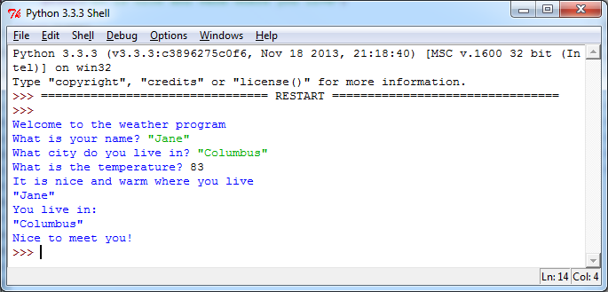
5. Enter your code into the lab report either by copying or pasting or typing it. You may also use a screenshot to show that the program works. You can include a digital picture using your phone or a Windows Screenshot. To include a screenshot in Windows, keep the IDLE window open and press the printscreen button on your keyboard. Open the Word document Lab report. Then click Paste on the Home tab. This will paste the screenshot in Word. You can also use the Windows 7 Snipping tool to paste a screenshot.

**Laboratory Report Cover Sheet   
DeVry University  
College of Engineering and Information Sciences**

**Course Number: CEIS100**

**Professor:**

**Laboratory Number:** 5

**Laboratory Title:** Creating a Program Using Python

**Submittal Date:** Click here to enter a date.

***Objectives:***

***Code—copy and paste (or type) your code below. You can also post a screenshot of the program working if you would like.***

***Conclusions:***