**Laboratory Procedures   
DeVry University  
College of Engineering and Information Sciences**

## OBJECTIVES

1. Get a basic understanding of programming animation.

## II. ASSUMPTIONS

In this lab, you will access Scratch from your Raspberry PI desktop and create an environment where a character will animate on your screen.

## III. SHORT TUTORIAL

1. Turn on your Raspberry PI computers and log in.
2. Use startx to access the desktop.
3. To start Scratch, double click on the Scratch icon  or select it from the programs menu at the bottom left of the screen.
4. The screen is divided into four areas.

* Stage (top right)
* Sprite list (bottom right)
* Scripts Area (tall middle panel)
* Blocks Palette (left)

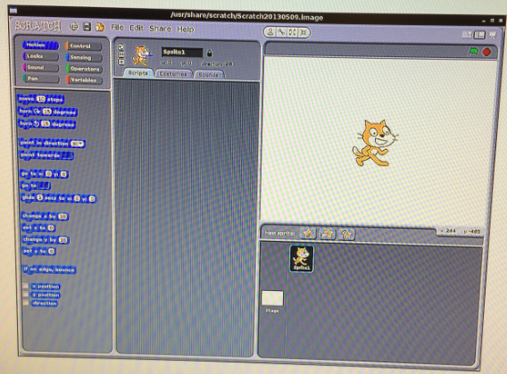

1. Sprite List—These are the characters in the game. You can make these characters do things.
2. Blocks Palette—Essentially, this is the programming language. These are commands you can use to animate your sprite.
3. Scripts Area—This is where you create your program. Essentially it is just a matter of pulling blocks from the Block Palette into this area to create your program.
4. Stage—This is where all the action takes place.
5. Experimenting with Scratch is quite easy and a lot of fun. Try out different blocks. You can do that by simply clicking on them in the Blocks Palette. For example, if you click on the block “move 10 steps,” you will see your sprite move forward. If your sprite ends in a position on the screen that you don’t want you can simply mouse over the sprite and move it to another area.
6. Not all blocks will work. Some have to be combined with other blocks. Also, be patient. There could be a significant lag between clicking on one command and then trying another.
7. Creating a script is easy. Just drag a block from the blocks Palette to the scripts area. You will note that the blocks seem to fit into one another like a puzzle. And you can easily grab one and move it around. Below is a short script I created. If you read the blocks it simply

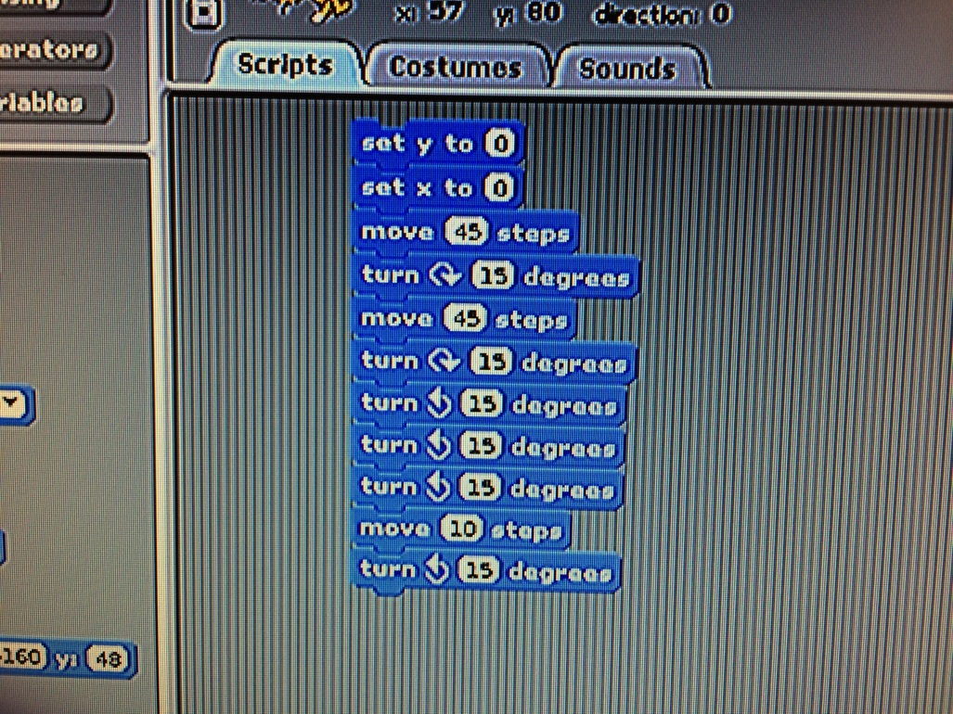

sets the sprite to x position 0 and y position 0 on the screen. The sprite then moves forward 45 steps, turns clockwise 15 degrees and moves another 45 steps. And so on. By clicking on the “set y to 0” block, the script activates and I can see the sprite move according to these directions.

1. You can save your work simply by using File and Save as at the top of your screen.

**IV. PROCEDURE**

1. Research the Internet for more information on Scratch.
2. Create a script that animates two objects on the screen.
3. Describe and report your project on your lab report.

**Laboratory Report Cover Sheet   
DeVry University  
College of Engineering and Information Sciences**

**Course Number: CEIS100**

**Professor:**

**Laboratory Number:** 6

**Laboratory Title:** Experimenting with Scratch—Game Programming

**Submittal Date:** Click here to enter a date.

***Objectives:***

***Results:***

***Describe the program you made. Include a link if possible or take a screenshot.***

***Conclusions:***