CREDIFY SYSTEM THINKING CHALLENGE 2026 · CHALLENGE AREA 01: AI & CYBERSECURITY
Clearance Gateway
Data only goes where it’s cleared to go.
Project documentation
How can companies use AI without creating new security risks? A policy-enforcement gateway that sits between employees and AI providers, with the problem analysis, evidence, risks and limits behind it.
Author | Ntsobokwane Collins Shibambo (solo entry), final-year Diploma in ICT Application Development, Cape Peninsula University of Technology
Challenge area | 01: AI & Cybersecurity. How can companies use AI without creating new security risks?
Date | 29 October 2026
Repository | https://github.com/shibambocollins/clearance-gateway
Live app | https://clearance-gateway-web.vercel.app
API health | https://clearance-gateway-api.vercel.app/health

All data in this project and in its tests is synthetic. Provider trust tiers in the prototype are demo settings, not statements about any vendor’s real data handling.

Contents
1. Summary
2. Problem and context
3. Stakeholders
4. Root causes
5. How the causes connect
6. Options I considered
7. The intervention: Clearance Gateway
8. The prototype
9. Evidence and testing
10. Feasibility
11. Risks, trade-offs, privacy and fairness
12. Assumptions
13. Limitations
14. Expected impact and how to measure it
15. Next steps
16. AI use and my contribution
References
A. Glossary
B. Where to find things in the repository

How to read the evidence in this document
I label claims so you can see what is backed and what is not:
- Known (SA): a figure from a survey of South African respondents.
- Known (not SA): a figure from another country. It may not hold in South Africa.
- Opinion: a view from a security firm or commentator, not a measurement.
- Assumed: my own reasoning. I have not proven it.
- Measured: a result from my own test harness (Bench), on synthetic data.

1. Summary
The problem. People use AI tools at work to go faster. A lot of that use happens in personal accounts the company can’t see or control, and some of it includes client details, ID numbers and passwords. In South Africa, 72.5% of professionals say they use AI for work, but only 30% have had any guidance on using it safely [1].
What I found. Five root causes keep this going: speed is rewarded while safety isn’t checked, the company’s own AI tool is missing or worse than the free one, the AI policy exists on paper but not in practice, the risk feels invisible, and people hide their AI use. Underneath all five is one imbalance: the person who pastes the data gets the benefit straight away, while the client carries the risk later, and nobody measures it.
My insight. Three of the five causes meet at one moment: the paste. Training and policy act before it. Bans act around it. Nothing acts at it.
The intervention. Clearance Gateway is a gateway between employees and AI providers. An admin writes the company AI policy once, in plain English. An AI turns it into rules once, and the admin reviews and activates them. After that, every prompt is checked by fixed rules, with no AI making the decision: find sensitive data, check the person’s role, remove or replace the data, and only send the prompt to a provider that is cleared for that level of data. If no provider is cleared, the request is blocked, and the employee is told why.
Evidence. On 307 synthetic prompts, with a test set that uses different sentence templates from the development set, the gateway cut sensitive values reaching an AI unprotected from 126 (no gateway) and 48 (simple regex filter) to 9. When the top provider was down, a naive “try the next provider” chain sent 87 of 87 confidential requests to a provider not cleared for them. The gateway made 0 routing errors and blocked 81.
What I am not claiming. Detection is not 100%: 9 sensitive values still got through in testing (for example, ID numbers written out as words). The test data is synthetic and built from patterns close to what the detectors look for, so real-world accuracy will be lower. I have not run a pilot with real employees. The limits are listed in section 13.

Key results at a glance
Measured on synthetic test data | No gateway | Regex-only filter | Clearance Gateway
Sensitive values reaching a provider unprotected (of 126) | 126 | 48 | 9
Detection F1 score | n/a | 57.5% | 96.3%
Evasion attempts caught (of 54) | 0 | 3 | 45
Confidential requests sent to an uncleared provider when tier 1 is down (of 87) | 87 (naive chain) | n/a | 0 routing errors, 81 blocked, 6 undetected
Time added per check (median, in-process, no network) | n/a | n/a | 0.05 to 0.08 ms
Source: eval/results/results.md in the repository. Synthetic data only.

2. Problem and context
The challenge area I chose asks: How can companies use AI without creating new security risks?
AI tools are now part of normal work. The risk is not the tools themselves. It is that employees paste company and client data into them, often through personal accounts, and the company has no visibility and no control over where that data goes next.

What the South African data says
- 72.5% of professionals say they use AI for work. Only 30% have had guidance on using it safely, and 46.5% have had no AI training at all [1].
- 64% of organisations say their AI use is unapproved or ungoverned [2].
- 9% of professionals aren’t even sure whether AI is allowed at their workplace [1].

Why it matters legally and to clients
Under POPIA, a company must keep personal information secure using reasonable technical and organisational measures [10]. If an employee pastes a client’s ID number into a personal AI account, the company is still the one responsible for that data, and the client usually doesn’t know it happened.

Scope
I focus on one moment: an employee, or an app, sending data to an AI provider. I do not try to fix everything about AI risk (for example model bias, deepfakes or AI built into other software). I picked this moment because it is where the harm actually happens and where a company can still act.

3. Stakeholders
Who | What they want | How much power they have | How they are affected
Employees | Finish work faster | Low over company tools, but full control over what they paste | They use AI every day and can be disciplined if it goes wrong
Managers and leadership | More productivity | High: they set targets, budgets and approved tools | They get the speed benefit and carry the legal risk
IT and security | Keep data safe | Medium: they can approve or block tools, but are often not the ones driving AI adoption [3] | They find out about problems late
Clients and customers | Keep their personal data private | None: they usually don’t know their data was pasted | They carry the harm but have no say
AI providers | More users and more data | They control how data is stored and used | Outside the company’s control
Information Regulator | POPIA is followed | Can investigate and act | Usually involved only after something goes wrong

Key point: the people who get hurt (clients) have no say, and the people who decide (managers) feel the benefit, not the risk. Any fix that relies on clients or on later enforcement arrives too late.

4. Root causes
I started with my own list of reasons (pressure to be productive, people not understanding their task and leaning on AI, convenience, companies forcing AI use while also having data protection policies, policies that exist only on paper, and staff not knowing the policies). I then tested each one against South African and international sources. Ideas that I could merge into the five below were merged. Ideas I could not support with evidence were not kept as root causes.

Root cause 1: Speed is rewarded, safety isn’t checked
What happens. Companies push staff to use AI to work faster, and also say “protect client data”. When the two clash, people choose speed. Why. Deadlines and output get measured. Data protection usually doesn’t.
- Known (SA): 59% of employees say time pressure and distractions cause them to make security mistakes, even when they know the safe way [2].
- Known (SA): AI adoption in SA companies is mostly driven by senior leaders, not by IT [3].
- Assumed: data protection is rarely part of anyone’s targets.

Root cause 2: The company’s AI tool is missing or not as good
What happens. If the company doesn’t give people a good AI tool, they use their own. Why. Most people started using AI on personal accounts, and free tools are often quicker or better than the approved one.
- Known (SA): 35% of employees get their own AI tools when approved options are missing or too restrictive [2].
- Opinion (SA security firm): staff pick ChatGPT over the approved Copilot because it is faster or has more features [6].
- Known (not SA): 89% of people who use AI for work started using it outside work first [7].

Root cause 3: The AI policy is on paper, not in practice
What happens. AI policies are missing, unclear, hard to find or not enforced. Why. Leaders think writing and announcing a policy is enough, and nothing checks it at the moment someone actually uses AI.
- Known (SA): only 14% of mid-sized and large SA companies have a company-wide gen AI strategy, and only 13% have governance frameworks [3].
- Known (SA): 33% of executives say they have shared a clear AI plan with staff, but only 10% of staff agree [4].
- Known (SA): 9% of professionals aren’t sure whether AI is allowed at work [1].
- Known (not SA): 81% of office workers think leaders follow different AI rules from everyone else [7].

Root cause 4: The risk feels invisible
What happens. Pasting data saves time right now. If anything bad happens, it happens later and usually to someone else, like the client. Why. Nothing seems to go wrong after pasting, so it starts to feel normal.
- Known (SA): 46.5% of professionals have had no AI training at all [1].
- Known (SA): out of 364 AI users, 10% never take safety steps and 41% only sometimes do [5].
- Known (not SA): people who think they understand AI security rules actually use unapproved tools more often [8]. Training on its own won’t fix this.
- Known (not SA): 70% know of colleagues sharing sensitive data with AI tools [8].

Root cause 5: People hide their AI use
What happens. Some people use AI secretly so they don’t get judged or get in trouble. Why. Bans and strict rules make open use risky for the employee, so they use AI where nobody can see it.
- Known (not SA): 33% would hide their AI use from managers, and 30% would hide it because of strict policies or what colleagues might think [7].
- Known (not SA): in one study, forcing people to disclose their AI use reduced visible use but increased hidden use [9]. This is a working paper and isn’t peer reviewed yet.
- Assumed for SA: there is no proper South African data on hidden AI use yet [9].

Caution on the evidence: most numbers come from surveys run by security companies or consultancies, and some SA samples are small (250 people for KnowBe4, 364 for Kaspersky 2026). Several findings come from other countries and are marked “not SA”. I have not yet tested any of this with real employees.

5. How the causes connect
The causes are not separate. They feed each other. The map below shows the chain from the top down, three reinforcing loops, and the point where Clearance Gateway acts.
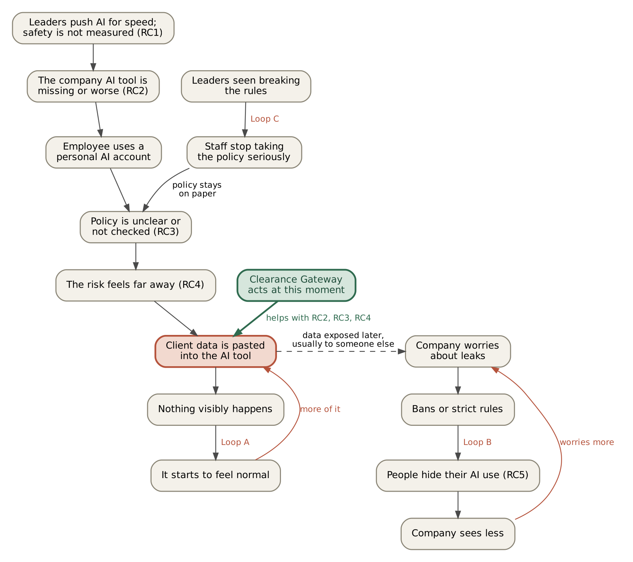
Figure 1. System map. Loops A, B and C and the arrows between them are my own reasoning, partly supported by the evidence in section 4.

The chain
- Leaders push AI for speed (root cause 1).
- The company tool is missing or worse (root cause 2), so the employee uses a personal account.
- The policy isn’t clear or checked (root cause 3).
- The risk feels far away (root cause 4), so they paste client data.
- Nothing visibly happens.

The loops that keep it going
- Loop A: it becomes normal. Paste data → nothing bad happens → it feels safe → do it more → colleagues copy.
- Loop B: bans backfire. The company worries about leaks → bans AI or adds strict rules → people hide their use (root cause 5) → the company sees less → it worries more → stricter rules.
- Loop C: the policy loses respect. Leaders are seen breaking the rules → staff stop taking the policy seriously → the policy stays on paper.

Where the system can change
Root causes 2, 3 and 4 all meet at one moment: the paste. Training and policy act before that moment. Bans act around it, and push people to hide (loop B). Nothing acts at it. That is the leverage point I chose: a control at the moment of use, inside an approved route that stays fast, so the employee doesn’t have to choose between speed and safety.
In one sentence: the person who pastes the data gets the benefit straight away, but the client and the company carry the risk later, and nobody is measuring that risk.

6. Options I considered
I looked at five ways a company could deal with staff putting sensitive data into AI tools.
Option | What it is | Root causes it helps | Main problem
A. Ban or block AI | Block AI websites and tell staff not to use AI | None for long | People use AI anyway, just hidden (RC5)
B. Policy and training only | Write a clear AI policy and train staff | RC3, partly RC4 | People still take shortcuts under pressure
C. Let an AI check every prompt | A second AI reads each prompt and decides if it breaks the policy | RC3 | The checker can be tricked, and it sends the prompt to yet another AI
D. Buy a commercial AI gateway | Use an existing product | RC2, RC3, RC4 | Cost, and not built for South African data such as SA ID numbers
E. Clearance Gateway (chosen) | Policy written once in plain English, enforced on every prompt by fixed rules | RC2, RC3, RC4, partly RC1 and RC5 | Can only protect what it can detect

Why not A: ban or block AI
- Bans don’t stop AI use, they hide it. 66% of office workers have used AI at work while believing it wasn’t allowed [7].
- In one study, forcing people to disclose AI use reduced visible use but increased hidden use [9].
- Blocking websites doesn’t reach personal phones or home Wi-Fi.
- On a security forum, practitioners described staff photographing documents and uploading them to personal apps after ChatGPT was blocked [14]. This is an anecdote, not data.

Why not B: policy and training only
- Knowing the rule isn’t enough. 59% of SA employees say time pressure makes them make security mistakes even when they know the safe way [2].
- People who think they understand AI security rules use unapproved tools more often, not less [8].
- Training is still useful. It just needs a control at the moment of use to back it up.

Why not C: an AI checking each prompt
- A checker AI can be tricked by the same prompt it is checking. Security researchers argue that the enforcement step should be fixed rules outside the model [11].
- Some products that use an AI checker let the prompt through when the checker errors [12]. That fails open, which is the wrong direction for security.
- To check the prompt, you have to send it to another AI, which is the same leak you’re trying to stop.
What I kept from this idea: I still use AI, but only to turn the written policy into rules once, when the admin saves it. The admin reviews the rules before they go live. After that, every prompt is checked by fixed rules, with no AI in the decision.

Why not D: buy a product
It isn’t a bad option. Kaspersky recommends an AI proxy that strips sensitive data and controls access by role [1], and products such as Credal already route prompts based on how sensitive the data is [13]. The trade-offs are cost (hard for small companies), less control, and detection that isn’t built around South African data. My prototype shows the approach works and is cheap to run. I am not claiming the idea is new.

7. The intervention: Clearance Gateway
Clearance Gateway sits between employees (or apps) and AI providers. The admin writes the AI policy once in plain English. From then on, every prompt is checked against it before it reaches an AI, and the employee is told what happened and why.

7.1 How the parts fit together
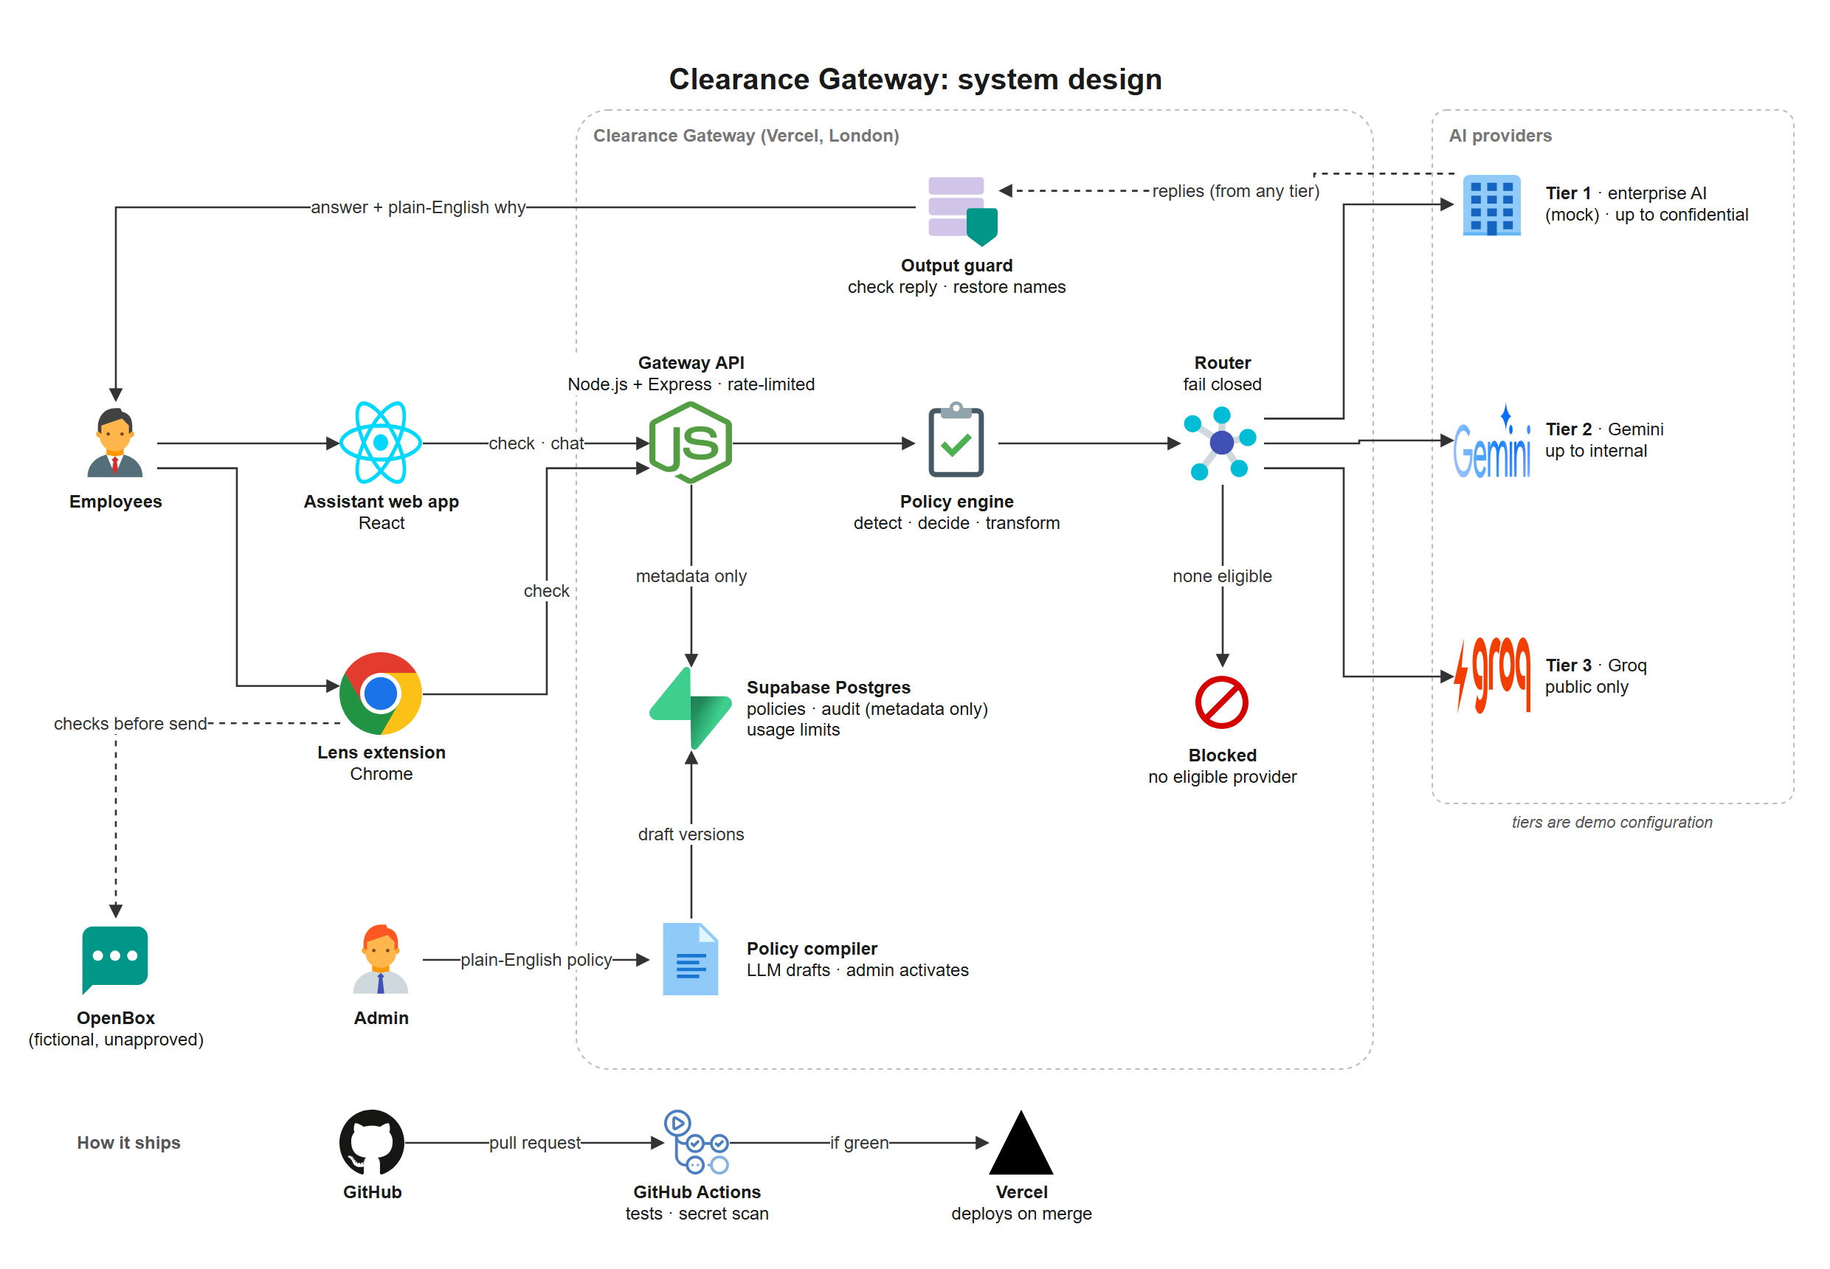
Figure 2. System design. The tiers are demo configuration, not claims about any vendor. OpenBox is a fictional, unapproved AI site used to demonstrate Lens.

7.2 How a prompt is handled
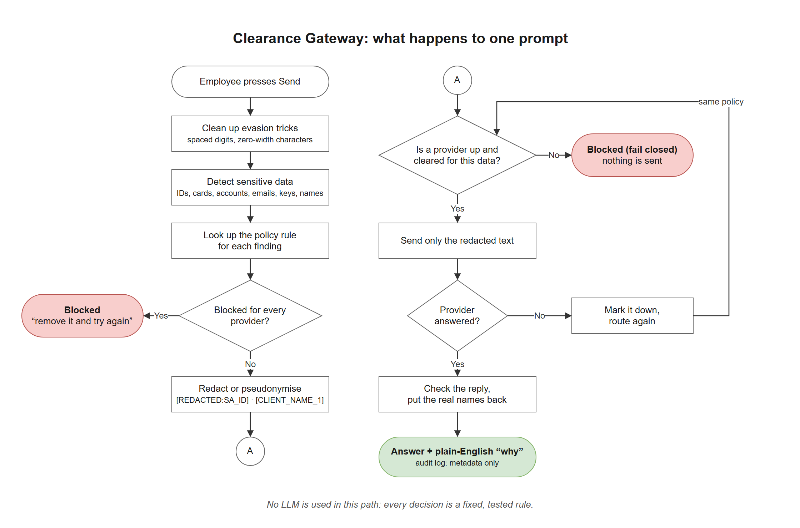
Figure 3. What happens to one prompt. No AI is used in this path: every decision is a fixed, tested rule.
- Find sensitive data. The Engine cleans up the text first (for example it removes hidden characters and handles spaced-out digits), then looks for SA ID numbers (date and check digit are validated), card numbers, bank account numbers, emails, SA phone numbers, known credential formats, passwords in assignments, and the company’s own list of client names and project codenames.
- Check the policy for this person’s role. Rules say what is allowed for each type of data, role and provider. The strictest matching rule wins. For example, HR may be allowed to include an email address where other roles are not.
- Redact, replace or block. Redact removes the value (“[REDACTED:SA_ID]”). Replace (pseudonymise) swaps a name for a placeholder like [CLIENT_NAME_1], which is turned back into the real name in the reply. Block stops the request.
- Route to a cleared provider. Each provider has a trust tier and a maximum data level. The prompt’s level comes from what was found in the original prompt. The first provider that is switched on, healthy and cleared is used. If none is, the request is blocked (fail closed). If a provider fails mid-request, the check runs again under the same policy. It never just tries the next provider.
- Check the reply. The output guard removes sensitive data the model introduced, removes echoed system instructions, and restores the placeholders it issued.
- Explain. The employee sees plain-English reasons, for example: “Removed 1 South African ID number. Rule R-PII-01: ID numbers may not be sent to AI providers.” The audit record keeps only counts and rule ids, never the text.

7.3 How a policy goes live
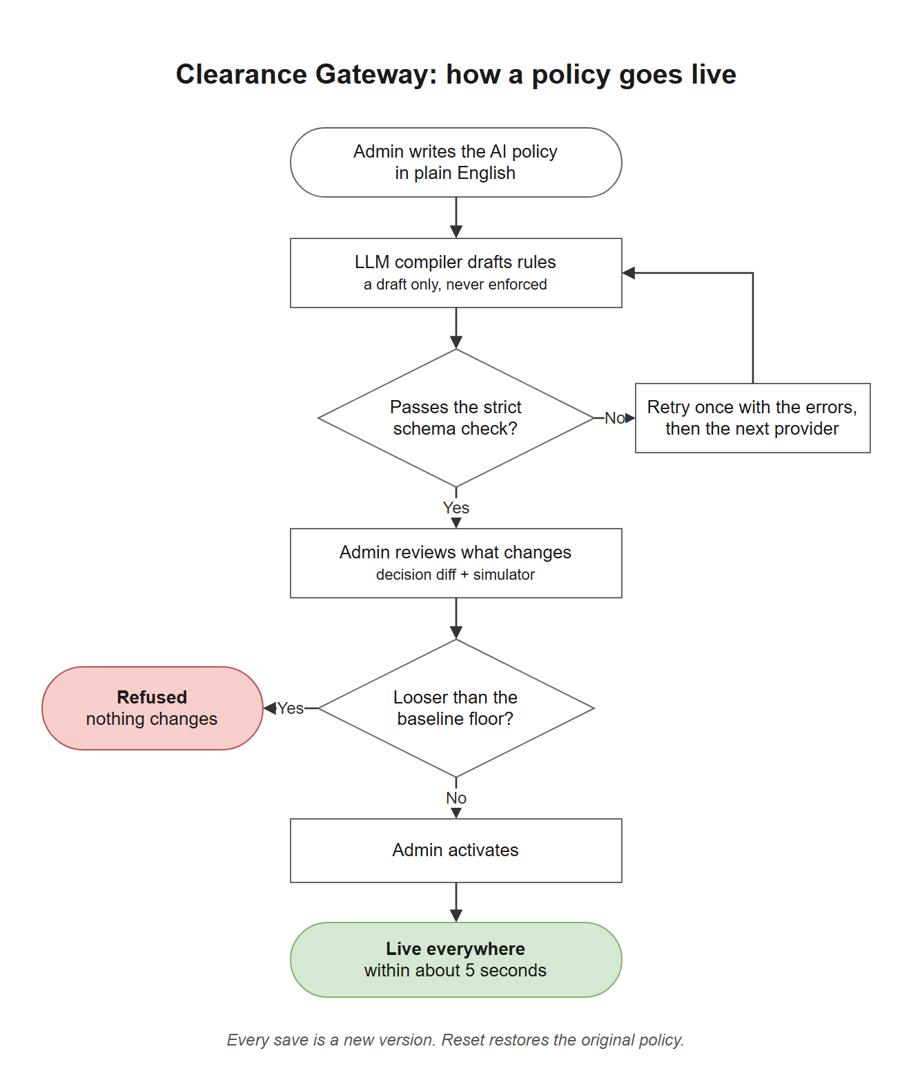
Figure 4. The AI drafts, a person reviews, and a baseline floor refuses anything looser than the starting policy.

7.4 Design decisions and why I made them
Decision | Why | Root cause it answers
Compile once, then enforce with fixed rules (no AI in the decision) | An AI judge can be tricked by the prompt it is judging and can fail open [11][12][15]. Fixed rules give the same answer every time and can be tested. | RC3: policy becomes rules that are checked every time
Admin reviews and activates every compiled policy, with a diff of what got looser or stricter | The compiler is an AI and can misread wording. A human approves before anything is enforced. A “policy floor” also refuses any version looser than the baseline. | RC3, and safety of the system itself
Redact and continue instead of blocking everything | If the approved route is annoying, people go back to personal accounts. Removing only the sensitive part keeps the prompt useful. | RC2: the approved route stays fast
Explain at the moment of paste | The risk feels invisible. Showing what was found, and why it matters, makes it visible at the one moment it counts. | RC4: invisible risk
Fail-closed, clearance-based routing | Fallback chains are the common way data ends up at a provider it shouldn’t. Blocking is safer than falling through to a lower tier. | RC1/RC3: availability pressure can’t override the policy
Store no prompt text | The audit record keeps only metadata. This avoids creating a new store of sensitive data and avoids a feeling of being watched. | RC5: staff don’t need to hide
Lens browser extension, opt-in per site | Employees use AI sites outside the approved tool. Lens checks text before it is sent, only on sites the user chooses. | RC2/RC5: reaches use outside the approved tool

7.5 Components
Component | What it does | Where
Compiler | Turns policy text into schema-validated draft rules. It never activates anything, and cannot change providers or routing. | apps/api/src/compiler
Engine | Canonicalise, detect, decide, transform, explain, output guard. Pure TypeScript with no network or database access, shared by the API, Bench and web app. | packages/core
Router | Clearance-based routing that fails closed. | packages/core/src/route.ts
Bench | Evaluation harness: synthetic dataset, baselines, metrics. | eval/
Lens | Browser extension (Chrome/Edge, Manifest V3). | extension/
API and web app | Express API and React web app on Vercel; Supabase Postgres for policy versions and audit metadata. | apps/api, apps/web, supabase/

7.6 What it deliberately does not do
- It does not use AI to approve prompts.
- It does not read “meaning”. A strategy document or a salary discussion has no pattern to match, so it is not caught.
- It does not cover coding agents (such as Claude Code) or AI features built into other apps. Those are designed in the documents but not built, because of limited time and resources.
- It does not cover personal phones or home networks.

8. The prototype
The prototype is live and public. It was built with limited resources, so it runs on free tiers. The repository README has the full setup steps.
App | https://clearance-gateway-web.vercel.app
App (GitHub Pages) | https://shibambocollins.github.io/clearance-gateway/
API health | https://clearance-gateway-api.vercel.app/health
Repository | https://github.com/shibambocollins/clearance-gateway
Demo admin code | credify-8d724294 (a demo mechanism only; see section 11)
Lens extension | Release lens-v0.3.0 on GitHub; install with “Load unpacked” in Chrome or Edge

Two-minute judge path
- Open the app. You land on the employee Assistant.
- Click the ID number sample. The ID number is highlighted and What will be sent shows [REDACTED:SA_ID]. Click Send. Under Why: “Removed 1 South African ID number. Rule R-PII-01.”
- Open Simulate a provider outage, enter the admin code, and switch off *Approved enterprise AI*.
- Click Send again. Result: “Blocked: no approved provider is available for confidential data right now (fail closed, rule R-ROUTE-01).” The data is not sent to a lower-tier provider.
- Open Evaluation to see the measured results against the two baselines, then click Reset.

What you will see
With everything healthy, prompts go to the approved enterprise provider (tier 1). In this prototype that provider is a mock, so replies start with “Mock reply from Approved enterprise AI. No real model was called.” The real models (Google Gemini and Groq) answer when tier 1 is switched off in the outage simulator, and only for data they are cleared to receive. This is deliberate: it keeps confidential prompts away from real models by default.
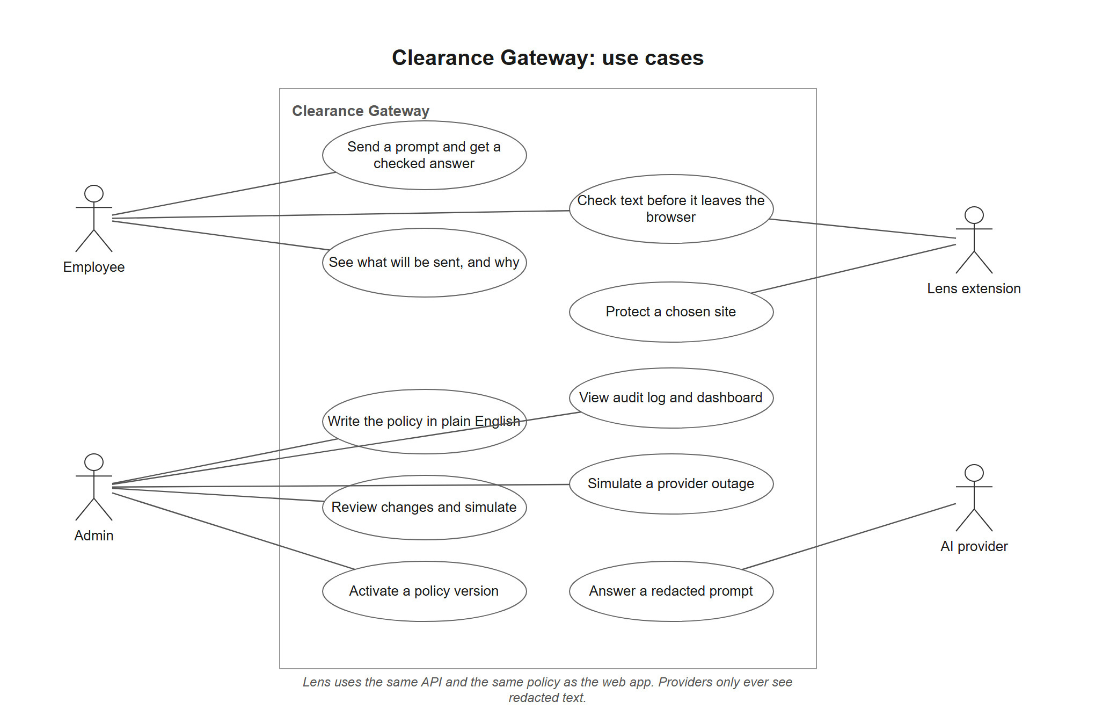
Figure 5. Who does what. Lens uses the same API and the same policy as the web app.
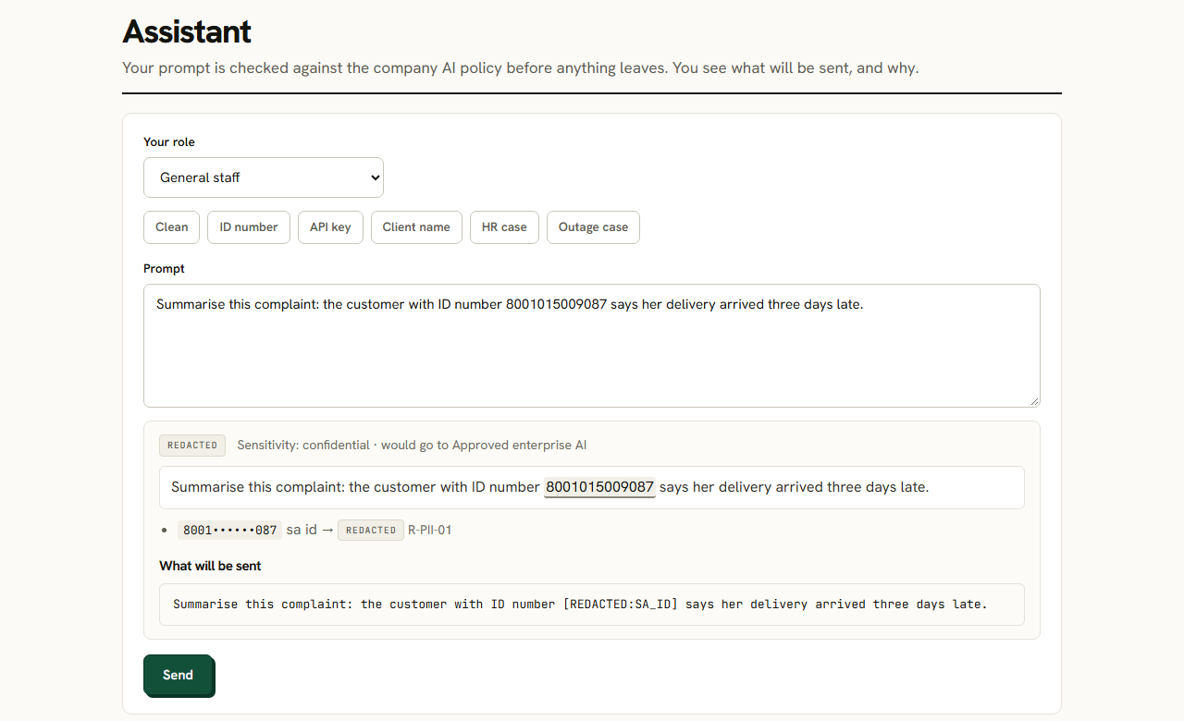
Figure 6. The ID-number sample. The value is highlighted, masked in the finding, and replaced in “What will be sent”. Synthetic data.
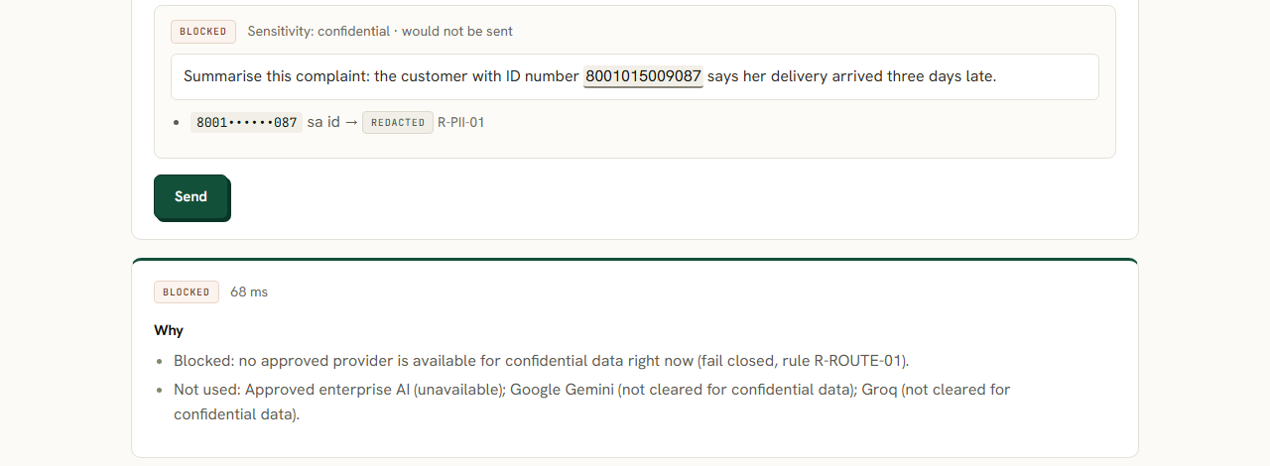
Figure 7. The same prompt with the approved provider down: blocked (fail closed), with the reason and the providers that were not used.
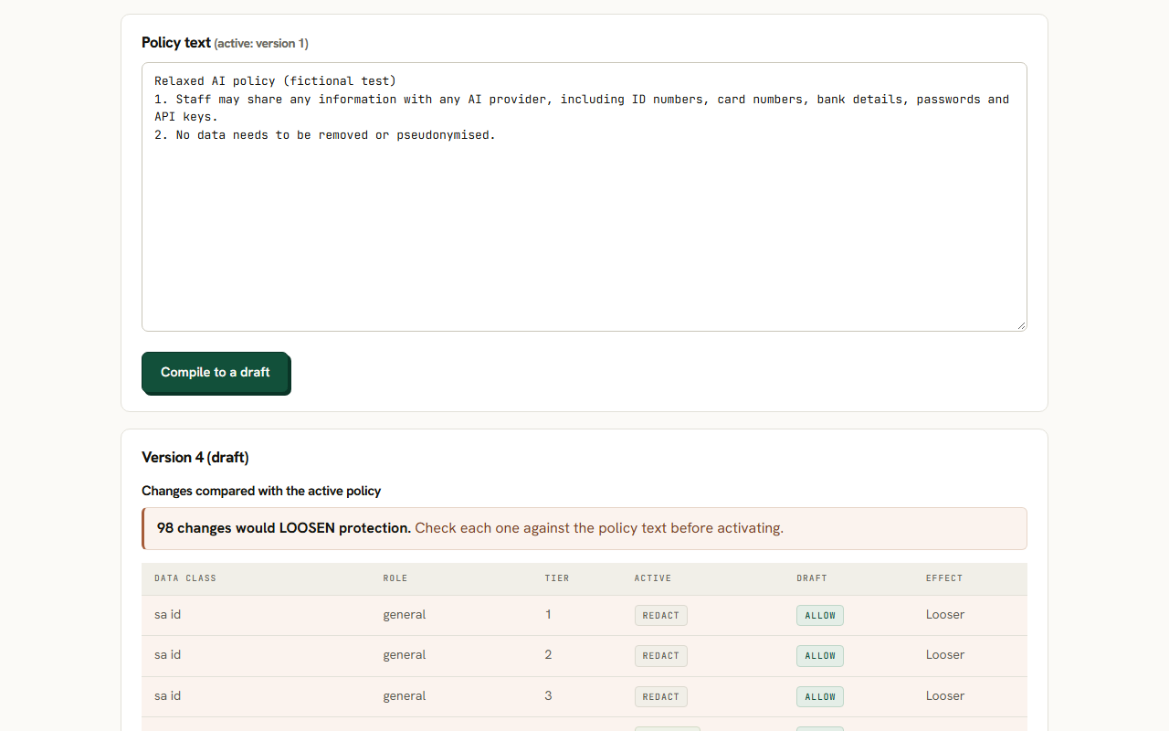
Figure 8. A deliberately relaxed draft policy: the review flags 98 decisions that would loosen protection. The policy floor refuses to activate it.

What is built
- Assistant: employee chat with live highlighting, “what will be sent”, and plain-English reasons.
- Admin: policy page (compile, decision diff, activate), provider page, outage simulator.
- Dashboard: what the gateway did, built from audit metadata.
- Evaluation: the Bench results as charts and tables.
- Lens: demo page protection, quick check, right-click check, and opt-in “Protect this site”.
- Providers: Gemini and Groq through plain HTTP calls, plus a deterministic mock so the demo works without keys.

Technology
Node 22, TypeScript (strict), npm workspaces. API: Express 5. Web: React 19, Vite 8, Recharts. Database: Supabase Postgres, with row-level security on and no policies, so only the API’s service role can read or write. Validation: zod. Tests: Vitest. CI: GitHub Actions running typecheck, tests, build and a gitleaks secrets scan on every pull request.

9. Evidence and testing

9.1 How I tested
I built an evaluation harness called Bench so the claims can be measured instead of described.
- Dataset: 307 synthetic prompts (201 labelled sensitive values) generated from a fixed seed, so anyone can regenerate the same set. Four kinds: clean work prompts (with dates, invoice numbers and versions to provoke false alarms), prompts with sensitive values, evasion attempts, and “trap” look-alikes that must not fire (for example order numbers that fail the checksum).
- Split by template, not by prompt. No sentence template in the test set appears in the development set, and a test checks this.
- Three configurations: A, no gateway; B, a typical regex-only filter with no validators or canonicalisation; C, the full Clearance Gateway pipeline.
- Nothing was tuned to the test results. Two evasion types the Engine does not handle (digits written as words, “name [at] example [dot] com”) were included on purpose, so the numbers aren’t inflated by testing only what I already handle.

9.2 Results (test split, 195 prompts)
Measure | No gateway | Regex-only | Clearance Gateway
Precision | n/a | 55.6% | 100.0%
Recall | 0% | 59.5% | 92.9%
F1 | n/a | 57.5% | 96.3%
Evasion attempts caught (of 54) | 0 | 3 | 45
Look-alike “trap” prompts wrongly flagged | 0% | 64.4% | 0%
Clean prompts wrongly flagged | 0% | 0% | 0%
Sensitive values reaching a provider unprotected (of 126) | 126 | 48 | 9 (and 27 requests blocked outright)
Table: Bench, test split. Source: eval/results/results.md.
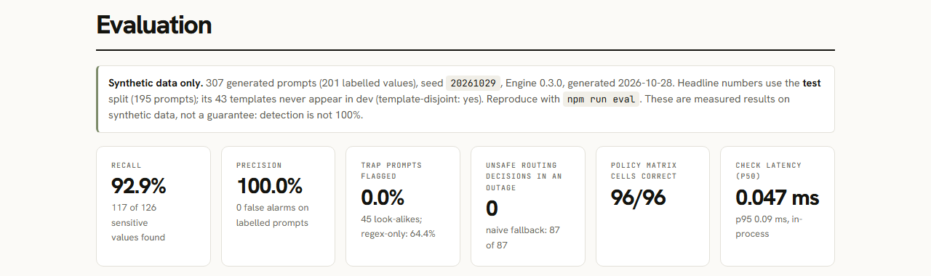
Figure 9. The headline tiles on the live Evaluation page.

Failover safety
This tests the part I think matters most. With the top-tier provider down, 87 confidential or restricted requests had to go somewhere.
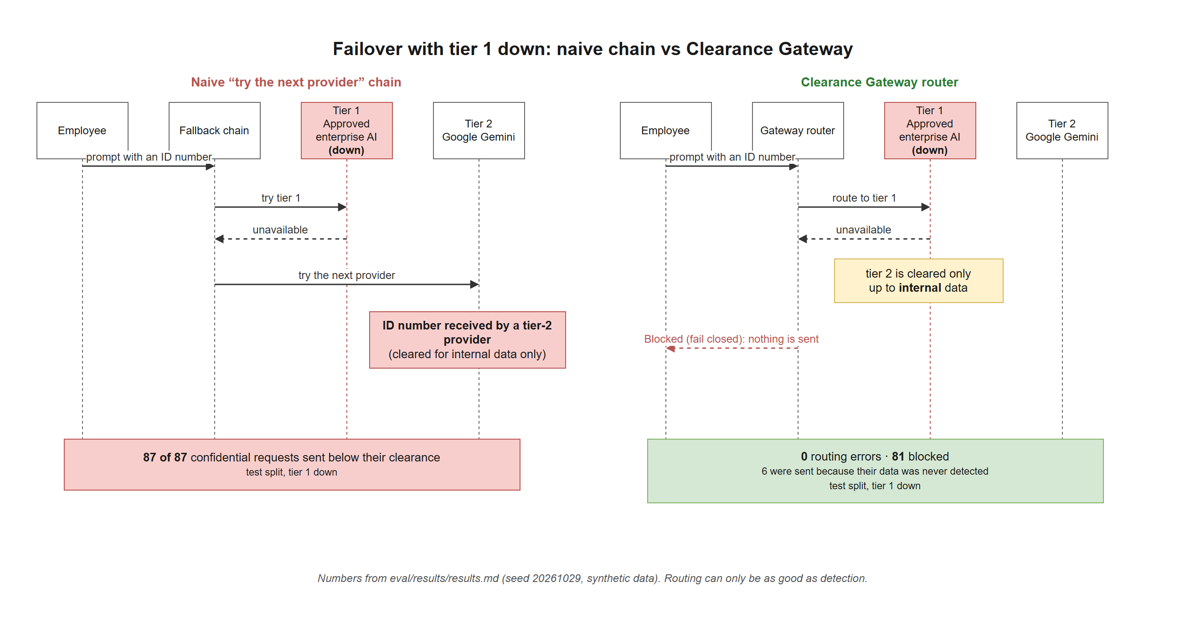
Figure 10. Tier 1 down: naive chain against the Clearance Gateway router. Numbers from eval/results/results.md (synthetic data).
Scenario | Requests | Naive “try the next provider” | Clearance Gateway: routing errors | Blocked (fail closed)
Tier 1 down | 87 | 87 unsafe | 0 | 81
Tiers 1 and 2 down | 87 | 87 unsafe | 0 | 81

6 requests were still sent unsafely, but not because of the router. Their data was never detected (3 SA ID numbers written as words and 3 AWS keys split across two lines), so the router believed they were low-sensitivity. I report these separately because the honest conclusion is: the routing is sound, and the remaining risk is in detection.

Where the 9 misses are
Data class | Missed | Why
SA ID number | 3 | Digits written as words (known unhandled)
Email | 3 | “name [at] example [dot] com” (known unhandled)
Credential | 3 | AWS key split across a line break

Every other class (card numbers, bank accounts, phone numbers, client names, project codenames) was fully caught in the test split. Evasion tricks that were caught in every case: spaced digits, dashed digits, zero-width characters and fullwidth characters.

Policy correctness and compiler check
- Policy matrix: every combination of role, data class and provider tier (96 cells) was checked against the expected action derived from the policy text, written independently of the code. Clearance Gateway: 96/96. No gateway: 2/96.
- Compiler check: I compiled the seed policy text three times. All 3 were valid. 0 decisions were looser than the hand-written policy. 35 decisions were stricter in every run, because the compiler read “Never send ID numbers…” as “block the request” where the hand-written policy “removes the value and sends the rest”. I did not reword the clause to make the check pass. The mistake is in the safe direction, and the admin review step is exactly what catches it.

Speed
In-process: a check took a median of 0.047 ms and a 95th percentile of 0.09 ms in the committed run (975 calls, no network). A re-run on the same day gave 0.076 ms and 0.176 ms, so the figure varies by machine and run. Either way it is far below a millisecond.
Live, over the internet (measured from my Windows computer, warm, 10 sequential calls): the check endpoint answered in a median of 178 ms (95th percentile 260 ms). One chat request with the clean sample took 370 ms end to end, with the provider being the mock. The first request after a fresh deployment took about 2.1 s. I have not measured a cold call after 15 or more minutes idle, so I make no claim about it.

A gap found by hand, and what I did about it
During manual testing, I found that changing the last digit of an SA ID number (a wrong check digit) let it through untouched. I widened detection so that a 13-digit number with a valid date and citizenship digit but a wrong check digit is still redacted, at low confidence. This was a deliberate change to the specification. The test split was unchanged, and on the development split false alarms on one look-alike trap rose from 0% to 20%, because that trap is now redacted on purpose. I did not relabel the trap.

9.3 What these results do and do not show
- The test data was generated by me and my tools, from patterns close to what the detectors look for. Real prompts are messier, so real accuracy will be lower. The 100% precision is partly a product of that.
- Numbers per class are small (6 to 30 labelled values in test), so one miss moves a recall figure by several points.
- The regex baseline is one reasonable filter, not the best possible one.
- Contextual secrets (strategy, salaries, unreleased results) are not measured, because the Engine does not attempt to find them.
- The compiler check uses one policy text, three runs and one model. It is not a broad accuracy study.
- There has been no test with real employees.
- The repository’s own checks pass: 381 tests in 26 files, typecheck, build, and npm audit with 0 vulnerabilities. CI (including a gitleaks secrets scan) is green on main.

10. Feasibility

Resources and cost
- The prototype runs on free tiers: Vercel, Supabase, Gemini and Groq. I built it as one person, over about a day and a night, working with AI tools. This is a prototype with no budget, so every service is on a free tier. That limits scale, uptime guarantees and how much I could build.
- I tested hosting options for cold starts. Some free hosts spin down after inactivity (for example Render’s free tier after about 15 minutes). Vercel’s serverless functions don’t sleep for long periods the way those hosts do, which matters because the judges need the demo to respond straight away. I have not measured the cold-start time of this deployment.
- Supabase’s free tier pauses after a week of inactivity, so it must be kept active or upgraded for a real deployment.

Speed for the user
The check itself adds well under a millisecond in-process. Over the internet from Cape Town to the London deployment, the check endpoint answered in about 180 ms (median, warm). The wait staff feel is mostly network time and the AI provider’s own response time.

What a company would need
- An approved AI provider account (and an honest decision about which providers are trusted for which data).
- Someone to write and own the policy, and to review compiled rules before activating.
- Staff and apps pointed at the gateway, and Lens on work browsers.

Path from prototype to something a company could run
- Replace the shared demo admin code with single sign-on and a per-admin record of who compiled and who activated a policy.
- Publish Lens to the Chrome Web Store and Edge Add-ons, and use managed force-install. I did not submit it before the deadline, because the store review takes days.
- Give the project its own API keys (the keys used in testing were reused from other projects and should be rotated).
- Add a tamper-evident audit log and an optional tighten-only second opinion for contextual secrets.

Constraints
- It does not cover personal phones or home networks.
- Lens works in Chromium browsers only.
- Coding agents and AI built into other apps are designed in the documents but not built, because of limited time and resources.

11. Risks, trade-offs, privacy and fairness

11.1 Risks of the intervention itself
Risk | What could happen | How I reduce it
Too strict | Staff get blocked too often and go back to personal accounts | Redact and continue instead of blocking; clear explanations; shadow mode to test a policy first (planned for the pilot)
Feels like spying | Staff hide their AI use even more (RC5) | No prompt text stored, only counts; no per-person reports
False sense of safety | Managers think all data is protected | The UI and docs show measured numbers, never “100% safe”; limitations are listed
Missed data | Data the rules don’t recognise (strategy, salaries, numbers written as words) goes through | Listed in limitations; the policy can add terms; future work on detection
Compiler mistakes | The AI reads the policy wrong | Admin must review and activate; looser changes are flagged; a policy floor blocks anything looser than the baseline; 0 looser in testing
The gateway as a target | It sees prompts briefly, so it is worth attacking | Nothing is stored; keys stay on the server; it fails closed

11.2 Security review
I ran a security review of the code, the repository history and the live deployment. The full threat model (12 threats) is in docs/security.md. The main points:
- No AI in the enforcement path. This addresses prompt injection (OWASP LLM01 [15]): there is no model deciding whether a prompt goes through that an attacker could talk around.
- Sensitive information disclosure (OWASP LLM02 [15]). This is what the gateway is for, and the output guard also removes sensitive data a model adds in its reply.
- System prompt leakage (OWASP LLM07 [15]). The output guard removes echoed instructions, but only verbatim. A paraphrased leak is not caught.
- No prompt or reply text is stored. The audit table has no text column, errors never repeat input, and responses are marked no-store.
- Database exposure. Row-level security is on with no policies, the service-role key exists only in the API’s environment, and neither the web app nor the extension talks to Supabase.
- Repository checks: npm audit shows 0 vulnerabilities; gitleaks passes on every merged pull request; a search of the full git history found no real keys; the .env file was never committed; GitHub secret scanning and push protection are on.
- Public demo admin code. Because judges need it, anyone could try to activate a bad policy. A policy floor refuses any version looser than the baseline, compiles have a daily budget, and simulated outages expire after 10 minutes. Someone could still tighten the policy or toggle an outage for a few minutes. The code and the provider keys used in testing should be rotated after judging.

11.3 Privacy
- Only synthetic data is used anywhere in the project (fictional names, example.com emails, generated ID and card numbers with valid check digits).
- Finding previews are masked (for example 8001••••••087), and token maps for replaced values exist only for the length of one request.
- Rate limiting uses a salted hash of the visitor’s IP address. The raw address is never stored.
- The gateway still sees prompts while it processes them. A company would have to treat it as a sensitive system.
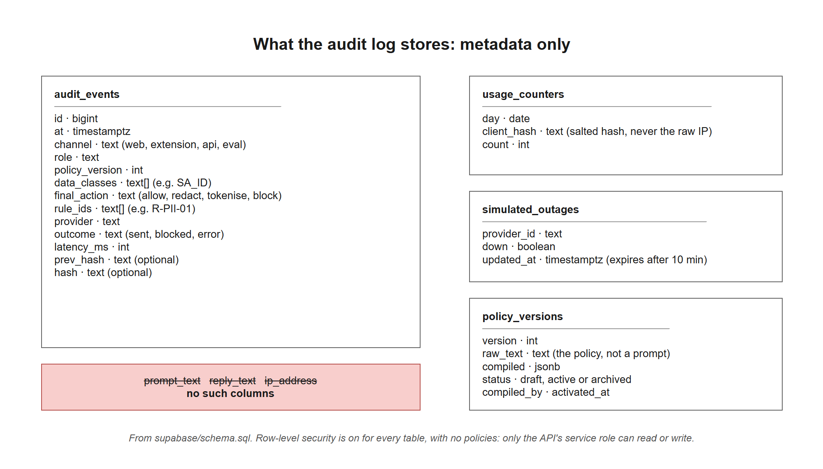
Figure 11. What the database stores. The audit table has no column for prompt text, reply text or IP address.

11.4 Fairness and unintended effects
- Who bears the cost of mistakes? Over-blocking costs employees time and trust. Under-blocking costs clients. I chose to redact and continue, to explain every decision, and to fail towards safety when unsure, even though that means some false alarms.
- Surveillance. A tool that reports on individuals would push people to hide AI use (RC5). The design keeps counts and rule ids, not text or per-person reports. A company could still add its own reporting on top, which would change this.
- Coverage is uneven. The detectors are built around South African formats and English text. I have not measured how well they work for names or terms in other South African languages, or for formats outside the ones listed. People whose data is in formats I did not cover are protected less.
- Accountability. In the prototype a single shared admin code controls policy changes. A real deployment needs named admins and a record of who changed what.
- Provider trust tiers are my demo settings. They are not claims about any real vendor. A company must decide its own.

12. Assumptions
Assumption | Status | How it would be tested
Staff will use an approved route if it is as fast and useful as the free one | Assumed | Pilot: share of AI requests going through the gateway
Showing the reason (“removed 1 ID number because…”) changes behaviour over time | Assumed | Before and after survey; sensitive findings per 100 prompts
A company has at least one AI provider it trusts more than the others | Assumed | Ask the company during set-up
Data protection is rarely part of anyone’s targets (RC1) | Assumed | Interviews with managers
The loops A, B and C describe how the system behaves | My reasoning, partly supported | Pilot trend data; interviews
Real prompts look enough like my synthetic ones for the numbers to mean something | Assumed. Probably optimistic. | Run shadow mode on real traffic and compare
Admins will really review compiled rules before activating | Assumed | Record how long reviews take in the pilot
Provider trust tiers | Demo settings, not facts about vendors | Company sets its own

13. Limitations
The full, technical list is in docs/limitations.md. The main points:

Detection
- Pattern- and dictionary-based. It has no understanding of meaning, so strategy documents, salaries and unreleased results are not found.
- Not handled: digits written as words, homoglyph tricks outside Unicode normalisation, “[at]/[dot]” emails, encodings such as base64, and data split over several messages.
- Card numbers: Visa, Mastercard and Amex only. Phone numbers: South African formats only. Bank account numbers are only found near a banking word (such as “account” or a bank name), as a trade-off against false alarms.
- Passwords written with a colon and no digit or symbol (for example “password: correcthorsebattery”) are missed.
- Client names and codenames match whole words only. Misspellings are not matched.

Routing and replies
- Routing can only be as good as detection. Undetected data is treated as low-sensitivity.
- The output guard is pattern-based. A paraphrased leak is not caught, and if a model rewrites a placeholder, nothing is restored there.

Coverage
- Coding agents and AI features built into other apps are not covered (designed only, because of limited time and resources). Personal phones, home networks, file uploads, screenshots and voice input are not covered.
- Lens works in Chromium browsers only, is installed with “Load unpacked”, and is not in a store. “Protect this site” is heuristic and has not been tested on real AI sites. Automated browser tests could not load the extension, so its overlay has no automated test and no screenshot. A user can switch Lens off.

The compiler
- It is an AI and can misread wording (seen so far: stricter, never looser). Every output is validated and is only a draft until an admin activates it.
- Prompt injection inside the policy text is mitigated, but not formally tested.

Demo shortcuts
- Admin access is a single shared code, not single sign-on.
- Provider health is tracked per serverless instance, so it can differ between instances for real failures. Simulated outages are shared through the database.
- Visitors behind the same network share a rate-limit quota.
- The “Policy updated” date in the header shows the last activation, so it also changes when the demo is reset.
- The live system has not been checked for how fast a policy change reaches every server instance (the design cache is 5 seconds per instance).

Evidence
- All data is synthetic, and there has been no pilot with real employees.

14. Expected impact and how to measure it
What I can say today is limited to the test results: on synthetic data, the gateway stops most sensitive values from reaching an AI unprotected (from 126 to 9) and never sent a confidential request to an uncleared provider by routing mistake. What it would do in a real company I do not yet know. This is how I would find out.

Pilot idea: one department, six weeks
- Weeks 1 and 2, shadow mode. Nothing is blocked. The gateway only records what it would have removed. This gives a baseline.
- Weeks 3 to 6, enforce mode. The rules are switched on.
- Before and after. A short anonymous staff survey.
Goal | How I would measure it | A good result
More AI use goes through the approved route | Share of AI requests going through the gateway | Goes up
Less sensitive data leaves | Sensitive findings per 100 prompts reaching uncleared providers | Goes down to near zero
Staff are not blocked too often | Block rate and “this was wrong” reports | Low and stable
Staff don’t move to personal accounts | Anonymous survey: “Do you use a personal AI account for work?” | Doesn’t go up
Staff understand the policy | Survey: “Do you know what you can and can’t paste?” | Goes up (SA baseline: only 10% of staff say their company’s AI plan was explained clearly [4])

What I cannot measure: use on personal phones. The survey is the only way to see that, and people may not answer honestly.

15. Next steps
- Run shadow mode with one real team (with their agreement) and compare real prompts with the synthetic test set.
- Improve detection of what Bench shows is missed: numbers written as words, obfuscated emails, keys split across lines, other card brands and phone formats.
- Test Lens on real AI sites and publish it to the browser stores.
- Add agent support: a local hook or proxy so coding agents go through the same checks.
- Add single sign-on, per-admin change history and a tamper-evident audit log.
- Add an optional second opinion that can only tighten a decision, for contextual secrets the patterns can’t see.
- Measure behaviour: whether explaining at the moment of paste actually changes what people do.

16. AI use and my contribution
I used AI tools throughout, and I want to be clear about what they did and what I did. Every non-trivial technical choice is logged in docs/decisions.md (68 entries) with who proposed it.

What AI tools did
Tool | What it did
Claude (chat) | Helped me assess the challenge areas. Drafted the build specification and the brief for Claude Code from my requirements. Suggested name options (I picked this one). Researched sources for the root causes and drafted the system map and options comparison in plain wording from my notes and the sources. Challenged some of my decisions (see below).
Claude Code | Wrote most of the code and tests, working phase by phase from the specification. Wrote the first drafts of the technical documents (architecture, evaluation method, limitations, security review), built the diagrams and screenshots in the repository, and ran the final checks that the numbers in this document come from.
Gemini and Groq | Used at runtime, as demo AI providers and as the policy compiler.

What I decided and did
- Chose the challenge area and the idea. I chose area 01 because it let me build a way to enforce company policy, not just a prompt filter, with fallback chains between providers, a measurement set and a red-team style test harness, and a browser extension. I wanted the admin to write the policy once rather than at every prompt.
- Wrote the first list of root causes from my own experience of how people use AI at work, then asked for each one to be tested against real evidence. I told Claude which of my ideas had no proof behind them (I had assumed them), reviewed all five final causes, challenged them against what I know of real workplaces, and asked for simpler wording so they are easier to follow.
- Made scope calls: coding agents are documented as limitations rather than built, because of time and resources; no cold-start hosting; Lens should work beyond the demo page, but only on sites the user chooses (decision D-054).
- Tested the prototype by hand and found a gap: a changed check digit let an SA ID number through. I asked for a recommendation and approved the fix (D-058).
- Decided to keep the policy wording that the compiler reads more strictly (D-050) instead of rewording it to pass the check, and decided to reuse existing provider keys for testing (D-037).
- Reviewed and approved the root causes, the system map and the intervention document, and I can explain them.
- Delegated the last open calls. In the early hours of submission day I told Claude Code to “use best practices” on three open questions. It kept the policy encoding (D-024), kept the approved provider first in the routing order (D-025), and presented failover as 0 routing errors plus 6 detection misses (D-040). They are recorded as D-066.

A decision where AI changed my mind
My first idea was to let an AI check each employee prompt against the policy. Claude pushed back: an AI judge can be tricked by the prompt it is judging, and it can fail open. I looked at the evidence [11][12] and changed the design to compile once, then enforce with fixed rules. That is now the core of the project.

Reused code and designs
- Secret-detection patterns for known credential formats are copied from the gitleaks default rules (D-018).
- The web interface uses the design system from my own earlier project, FinMe (D-057).
- Open-source libraries are listed in package.json; no dependency outside the specification was added without checking with me.

References
[1] Kaspersky (2025). Shadow AI vs Managed AI: Kaspersky reviews the use of neural networks for work in South Africa. Survey of 2,800 people in 7 countries, including South Africa. https://www.kaspersky.co.za/about/press-releases/kaspersky-reviews-the-use-of-neural-networks-for-work-in-south-africa
[2] KnowBe4 (July 2026). Ungoverned AI Agents and Sophisticated Deepfakes Pose Critical Threats for South African Organisations. SA sample: 250 (50 security leaders, 200 employees). https://www.businesswire.com/news/home/20260720999502/en/Ungoverned-AI-Agents-and-Sophisticated-Deepfakes-Pose-Critical-Threats-for-South-African-Organisations-New-KnowBe4-Research-Warns
[3] World Wide Worx with Dell Technologies and Intel (2025). South African Generative AI Roadmap 2025. 100+ mid-sized and large SA companies (sponsored research). Reported by TechCentral, https://techcentral.co.za/sa-businesses-embrace-gen-ai-dell-intel/266963/, and Reframed, https://reframed.co/?p=21878
[4] Oliver Wyman (October 2026). AI is reshaping work, trust and brands in South Africa. https://www.oliverwyman.com/our-expertise/insights/2026/oct/ai-is-reshaping-work-trust-brands-in-south-africa.html
[5] Kaspersky, via AfricaBusiness.com (October 2026). South African AI users: frequent use, uneven safety habits. 364 AI users, not nationally representative. https://africabusiness.com/2026/10/18/south-african-ai-users-safety-habits/
[6] Frost, R. (Armata Cyber Security), Lifestyle & Tech (October 2026). It’s in the shadows: unsanctioned AI tools are a pervasive risk to the business. Opinion piece. https://lifestyleandtech.co.za/ai-cloud/article/2026-10-19/its-in-the-shadows-unsanctioned-ai-tools-are-a-pervasive-risk-to-the-business
[7] PagerDuty and Wakefield Research (2026). Shadow AI Survey. 1,250 office workers in Australia, Japan, the UK and the US. https://www.pagerduty.com/blog/ai/shadow-ai-workplace-survey-2026/
[8] UpGuard (2025). The State of Shadow AI, reported by Cybersecurity Dive. Workers in 7 countries (not SA). https://www.cybersecuritydive.com/news/shadow-ai-employee-trust-upguard/805280/
[9] Kgomosotho, K., Techila Law (September 2026). Shadow AI: The ungoverned layer of artificial intelligence use in South Africa. Cites Dong et al. (2025, working paper). https://www.techilalaw.com/shadow-ai-the-ungoverned-layer-of-artificial-intelligence-use-in-south-africa/
[10] Bowmans (2025). South Africa: AI in the workplace (2 of 6): POPIA considerations. https://bowmanslaw.com/insights/south-africa-ai-in-the-workplace-2-of-6-popia-considerations/
[11] NHI Mgmt Group (January 2026), summarising Lakera. LLM-as-a-judge fails as prompt injection defense for AI systems. https://nhimg.org/articles/llm-as-a-judge-fails-as-prompt-injection-defense-for-ai-systems/
[12] Bifrost documentation. Prompt Guardrails. (Says the LLM-judge guardrail fails open on judge errors.) https://docs.getbifrost.ai/enterprise/guardrails/prompt-guardrails
[13] TechCrunch (October 2023). Credal aims to connect company data to LLMs securely. https://techcrunch.com/2023/10/26/credal-aims-to-connect-company-data-to-llms-securely/
[14] r/AskNetsec thread (snapshot, March 2026). Anecdotal. https://reddit.sentinel-team.org/posts/1rrj2oq/snapshots/2026-03-13T08%3A01%3A39.342777Z
[15] OWASP GenAI Security Project (November 2024). Top 10 for LLM Applications 2025. https://genai.owasp.org/2024/11/17/owasp-reveals-updated-2025-top-10-risks-for-llms-announces-new-llm-project-sponsorship-program-and-inaugural-sponsors/
Test results: eval/results/results.md and eval/results/compiler-check.md in the repository. Technical decisions: docs/decisions.md.

Appendix A. Glossary
Term | Meaning
Policy | The company’s written rules for what may be sent to AI tools.
Compile | Turn the plain-English policy into structured rules a program can enforce. Done once, by an AI, and reviewed by the admin.
Redact | Remove a sensitive value from a prompt, for example replacing an ID number with [REDACTED:SA_ID].
Pseudonymise (replace) | Swap a real value for a placeholder such as [CLIENT_NAME_1], then swap it back in the reply.
Trust tier and clearance | How much a provider is trusted, and the highest level of data it may receive. In the prototype these are demo settings.
Fail closed | When something goes wrong or no option is allowed, block instead of letting the request through.
Routing error | The router knew a request was confidential and still sent it to an uncleared provider.
Canonicalise | Clean up text before checking it, for example by removing hidden characters, so tricks like spaced-out digits don’t hide data.
Precision, recall, F1 | Precision: of what was flagged, how much was right. Recall: of what should have been flagged, how much was found. F1 combines the two.
Evasion | A way of writing sensitive data so a filter doesn’t recognise it.
Shadow mode | Run the checks and record what would happen, without blocking or changing anything.
Shadow AI | Use of AI tools for work that the company doesn’t know about or control.
POPIA | South Africa’s Protection of Personal Information Act.

Appendix B. Where to find things in the repository
Path | What is there
README.md | What it does, technologies, setup, judge path, limitations
docs/system-map.md, docs/intervention.md | Problem analysis and options (the text of sections 2 to 6 and 14 of this document)
docs/architecture.md | Request path, policy lifecycle, data model, deployment
docs/evaluation.md and eval/results/ | Bench method and results
docs/limitations.md | Full technical limitations
docs/security.md | Security review and threat model
docs/decisions.md | Every technical decision, alternatives, and who proposed it
packages/core/ | The Engine and Router
apps/api/src/compiler/ | The Compiler
extension/ | Lens
docs/diagrams/, docs/screenshots/ | Editable draw.io diagrams, their PNG exports, and screenshots of the live app (synthetic data)

