MediPredict
A PROJECT REPORT
on
MEDIPREDICT
Medical Insurance Cost Prediction
using Machine Learning
Submitted in partial fulfilment of the requirements for the award of the degree of
Bachelor of Technology
(Computer Science and Engineering)
Submitted by
[YOUR NAME]
Registration No.: [YOUR REGISTRATION NUMBER]
Under the guidance of
[PROJECT GUIDE NAME]
Assistant Professor, Department of Computer Science and Engineering
DEPARTMENT OF COMPUTER SCIENCE AND ENGINEERING
[YOUR COLLEGE / INSTITUTE NAME]
[AFFILIATED UNIVERSITY NAME]
Academic Session 2025 – 2026

CERTIFICATE

This is to certify that the project report entitled "MediPredict: Medical Insurance Cost Prediction using Machine Learning" is the bona fide work of [YOUR NAME] (Registration No. [YOUR REGISTRATION NUMBER]), a student of Computer Science and Engineering in the Department of Computer Science and Engineering, [YOUR COLLEGE / INSTITUTE NAME], during the academic session Academic Session 2025 – 2026.
The work has been carried out by him/her under my supervision and guidance, and the report has not been submitted elsewhere for the award of any other degree or diploma. To the best of my knowledge, the report is complete in all respects and is worthy of consideration for evaluation.
____________________________ | ____________________________
Signature of the Project Guide | Signature of the Head of the Department
[PROJECT GUIDE NAME] | [HEAD OF DEPARTMENT NAME]

Place: [CITY]
Date: November 2025

DECLARATION

I hereby declare that the project report entitled "MediPredict: Medical Insurance Cost Prediction using Machine Learning", submitted to [YOUR COLLEGE / INSTITUTE NAME] in partial fulfilment of the requirements for the award of the degree of Bachelor of Technology (Computer Science and Engineering), is my own original work.
I further declare that the dataset used in this work is a publicly available dataset, and that the analysis, model building, application development and interpretation of results presented in this report have been carried out by me. The report has not been submitted, either in part or in full, to any other university or institution for the award of any degree, diploma or certificate, and it does not contain any material previously published or written by another person except where due reference has been made in the text.
____________________________
[YOUR NAME]
Registration No.: [YOUR REGISTRATION NUMBER]
Department of Computer Science and Engineering, [YOUR COLLEGE / INSTITUTE NAME]
Place: [CITY]
Date: November 2025

ACKNOWLEDGEMENT

The completion of this project has been possible only because of the guidance and support of several people, and I take this opportunity to express my sincere gratitude to all of them.
I am deeply grateful to my project guide, [PROJECT GUIDE NAME], Assistant Professor, Department of Computer Science and Engineering, for the continuous encouragement, valuable suggestions and constructive criticism offered throughout the course of this work. The clarity with which every stage of the project was reviewed has had a direct influence on the quality of the final outcome.
I sincerely thank [HEAD OF DEPARTMENT NAME], Head of the Department, and the faculty members of the Department of Computer Science and Engineering, [YOUR COLLEGE / INSTITUTE NAME], for providing the academic environment, laboratory facilities and moral support needed to carry out this study. I am also thankful to the examination committee for their valuable time and feedback.
I acknowledge the creators and maintainers of the open-source tools that made this work possible: the scikit-learn developers for an exceptionally well-documented machine learning library, the Streamlit team for an accessible application framework, and the pandas, NumPy, Matplotlib and Seaborn communities. I am equally grateful to Kaggle and to the anonymous respondents of the original Medical Cost Personal Dataset, without whose publicly shared data this analysis could not have been performed.
Finally, I thank my family and friends for their patience, constant motivation and unstinting support during the long hours of development, testing and documentation. Any shortcomings that remain in this report are entirely my own.

[YOUR NAME]

ABSTRACT

Medical insurance premiums are calculated from the statistical risk profile of an individual, yet most applicants have no clear idea of how personal attributes such as age, body mass index and smoking behaviour translate into the amount they are charged. This project, titled MediPredict, addresses that information gap by building a machine learning system that estimates annual medical insurance charges from six routinely collected attributes: age, sex, body mass index, number of dependent children, smoking status and residential region.
The work uses the publicly available Medical Cost Personal Dataset, which contains 1,338 records and seven columns. After removing one duplicate record, exploratory data analysis was carried out with pandas, Matplotlib and Seaborn. Charges were found to be strongly right-skewed, smoking status alone separated the population into two clearly distinct cost groups (mean charge of USD 32,050 for smokers against USD 8,441 for non-smokers), and age and body mass index showed positive correlation with charges. Three regression algorithms, namely Linear Regression, Decision Tree Regression and Random Forest Regression, were trained and compared using mean absolute error, root mean squared error and the coefficient of determination. The Random Forest model performed best, with an R-squared value of 0.8786, a mean absolute error of USD 2,657.61 and a root mean squared error of USD 4,724.02 on the test set. The model was therefore tuned and retained, combining standard scaling and one-hot encoding in a scikit-learn pipeline, and was serialised with joblib.
The trained model is deployed through an interactive Streamlit web application that accepts user inputs, returns an instant cost estimate, and provides a What-if Scenario Simulator that recomputes the estimate when selected factors are changed, reporting the absolute and percentage difference. Feature importance analysis shows that smoking status contributes about 70 per cent of the model's predictive power, followed by body mass index and age. The system is intended as an educational and awareness tool; the predictions are statistical estimates and not professional financial or medical advice.
Keywords:
medical insurance charges, machine learning, regression, Random Forest, feature importance, exploratory data analysis, scikit-learn, Streamlit, predictive modelling, what-if analysis

TABLE OF CONTENTS

[ Click anywhere in this area, then press F9 and choose “Update entire table” to build the table of contents with page numbers. ]

How to build or refresh this page
This table of contents is a live Word field, so the chapter titles and page numbers are read directly from the document rather than typed by hand. Word usually offers to update the field automatically when the file is opened; if it does not, select the whole document with Ctrl + A and press F9, then choose “Update entire table”. The List of Figures and the List of Tables are generated in the same way.

LIST OF FIGURES

Right-click here and choose Update Field to build the list of figures automatically.

The list above is generated automatically from the figure captions in the document. If it appears empty or out of date, select the whole document (Ctrl + A) and press F9, then choose Update entire table.

LIST OF TABLES

Right-click here and choose Update Field to build the list of tables automatically.

The list above is generated automatically from the table captions in the document.

1. INTRODUCTION

1.1 Background of the Study
Health insurance is a financial instrument through which the cost of medical treatment is pooled across a large number of people, so that an individual does not have to bear the full expense of an illness at the moment it occurs. The amount that an insurer charges for covering one person, known as the premium, is not arbitrary. It is derived from an estimate of how much that person is likely to cost the insurer, and that estimate is built from attributes that are known to be associated with medical expenditure.
For decades this estimation has been done through actuarial rating tables and generalised linear models, which fit a smooth mathematical relationship between the input attributes and the expected claim amount. These methods have the advantage of being transparent and easy to audit, which matters in a regulated industry. They also carry a well-known limitation: they assume that the effect of each attribute is additive and that the relationship follows a specified functional form. Real medical expenditure does not behave in this way. The same increase in body mass index, for example, may be almost irrelevant for a non-smoker while being a very strong predictor of cost for a smoker. Interactions of this kind are exactly what tree-based machine learning models are able to capture without being told in advance that they exist.
At the same time, the ordinary applicant has very little visibility into this process. A person filling an insurance form knows their own age, weight and smoking status, but has no practical way of knowing what those attributes mean in monetary terms. This project, MediPredict, is built around that second problem. Using a publicly available dataset of 1,338 insured individuals, it trains a regression model that maps six personal attributes to annual insurance charges, and exposes the model through a web application so that any user can obtain an estimate in a few seconds and can explore how the estimate changes when one factor is altered.

1.2 Problem Statement
The problem addressed by this project can be stated as follows: given the personal and lifestyle attributes of an individual, namely age, sex, body mass index, number of dependent children, smoking status and residential region, can a machine learning model predict that individual's annual medical insurance charges with useful accuracy, and can that model be delivered in a form that a non-technical user can operate?
Two difficulties make this a non-trivial problem. First, the target variable is continuous, strongly right-skewed and heavily influenced by a single binary attribute (smoking status), which means that a naive model can appear acceptable on average while being badly wrong for whole segments of the population. Second, a prediction on its own is of limited practical value to a user; the useful insight lies in comparison, that is, in understanding how much of the estimated cost is attributable to a factor that the individual could potentially change. The system therefore has to support both accurate estimation and interactive comparison.

1.3 Objectives of the Project
The specific objectives of the work are listed below.
1. To study the Medical Cost Personal Dataset and to characterise the distribution of insurance charges and their relationship with the available attributes.
2. To perform data cleaning and exploratory data analysis in order to identify missing values, duplicate records, outliers and the strength of association between each attribute and the target variable.
3. To build a preprocessing pipeline that encodes categorical attributes and scales numerical attributes so that the data are suitable for regression algorithms.
4. To train and evaluate three regression models, namely Linear Regression, Decision Tree Regression and Random Forest Regression, and to compare them on the basis of mean absolute error, root mean squared error and the coefficient of determination.
5. To tune the best performing model and to serialise it so that it can be reused by an application without retraining.
6. To design and develop an interactive web application using Streamlit that accepts user inputs and returns an estimated insurance charge.
7. To implement a What-if Scenario Simulator that recomputes the estimate for modified inputs and reports the absolute and percentage change with respect to the original estimate.
8. To interpret the model through feature importance analysis so that the factors that drive the prediction can be explained to a non-technical user.

1.4 Scope of the Project
The scope of the present work is deliberately limited in order to keep the study focused and reproducible. The project covers the analysis, modelling and deployment of a regression system for a single tabular dataset. The following items are within scope.
- Analysis of one publicly available dataset containing 1,338 records and seven columns.
- Use of six input attributes and one continuous target variable (charges).
- Training, comparison and tuning of three supervised regression algorithms.
- Comparison of models using three standard regression metrics.
- Interpretation of the final model using built-in feature importance.
- Development of a single-page web application with an estimation form and a comparison module, deployed on Streamlit Community Cloud.
The following items are outside the scope of this work.
- Use of medical records, diagnostic history or prescription data, which are not present in the dataset.
- Time-series or survival modelling of claim events; the dataset provides only a single annual charge figure per individual.
- Any use of the system for actual underwriting, pricing or claim settlement decisions.
- Multi-user authentication, database storage or audit logging, which a production insurance system would require.

1.5 Motivation
The motivation for the project came from three observations. First, insurance pricing is one of the few everyday financial decisions in which the individual has almost no information advantage, and a transparent estimator gives the applicant a basis for asking informed questions. Second, the dataset, although small, contains a genuine and well-documented interaction between smoking status and body mass index, which makes it an excellent teaching case for why non-linear models outperform linear ones on tabular data. Third, the project offered an opportunity to carry a machine learning model through the complete life cycle, from raw data to a deployed interface, which is precisely the sequence of steps that a data science practitioner performs in practice.

1.6 Organisation of the Report
The remainder of this report is organised as follows. Chapter 2 reviews the existing approaches to insurance risk rating and the relevant machine learning literature, and identifies the gap that this project addresses. Chapter 3 presents the system analysis, including the study of the existing system, the requirements of the proposed system and the feasibility study. Chapter 4 describes the system design with the help of architecture, data flow, use case and entity-relationship diagrams. Chapter 5 documents the implementation, covering the tools used, the preprocessing and modelling code and the construction of the web application. Chapter 6 presents the results of the exploratory data analysis and of the model comparison, together with the application screenshots and a discussion of the findings and limitations. Chapter 7 concludes the report and outlines directions for future work. References and two appendices follow the final chapter.

2. LITERATURE REVIEW

2.1 Introduction
This chapter places the present work in the context of existing practice. It begins with the conventional actuarial methods that insurance companies have used for decades, then reviews studies that apply machine learning to insurance cost prediction, and finally summarises the reviewed work in a table in order to identify the specific gap that MediPredict attempts to fill.

2.2 Conventional Actuarial Rating Methods
Traditional personal lines pricing is based on rating factors that are individually assessed and then combined multiplicatively. In health and medical insurance the standard factors are age, sex, smoking status and an anthropometric measure such as body mass index, and each factor is assigned a relativities table derived from historical claims experience. The statistical backbone of this approach is the generalised linear model, most commonly with a Poisson or gamma error distribution and a logarithmic link function, as described in the widely used actuarial texts of Ohlsson and Johansson and of McCullagh and Nelder.
The strength of generalised linear models is interpretability. Each coefficient has a direct multiplicative interpretation, the model can be audited by a regulator, and the effect of a single rating factor can be read off without any computational tool. Their weakness is the additivity assumption on the scale of the linear predictor. If the true effect of body mass index depends on smoking status, a model without an explicit interaction term will attribute a misleading average effect to both variables. Actuaries address this by manually specifying interaction terms, but the search space grows quickly and the process is labour intensive. A second weakness is that tariff tables are notoriously difficult for a policyholder to interpret, so the transparency of the model does not translate into transparency for the customer.

2.3 Machine Learning Approaches to Risk Rating
The application of machine learning to insurance pricing has grown steadily since the mid-2010s, driven by the availability of larger data sets and by the maturation of gradient boosting libraries. The recurring findings relevant to the present work are summarised below.
Ensemble tree methods dominate tabular prediction tasks. Breiman's Random Forest, which averages many decorrelated decision trees, and the later gradient boosting family of Friedman reduce the high variance that affects a single decision tree while retaining the ability to model non-linear effects and interactions automatically. Comparative studies on medical cost data consistently report that a tuned Random Forest or gradient boosting model achieves a coefficient of determination in the range of 0.85 to 0.90, whereas linear regression on the same data typically reaches only about 0.75 to 0.81.
Smoking status is repeatedly identified as the dominant predictor of medical charges, with body mass index and age following. This is consistent with the actuarial literature on mortality and morbidity, and it has an important methodological consequence: because a single binary attribute explains the majority of the variance, overall error metrics can conceal large systematic errors within the non-smoking sub-population. Recent studies therefore recommend reporting errors separately for the smoker and non-smoker groups rather than a single aggregate figure.
On the deployment side, the literature increasingly emphasises explainability. A model that is accurate but opaque is of limited use to a policyholder or a regulator. Techniques such as permutation importance, local interpretable model-agnostic explanations and SHAP values are now standard companions to predictive models, and several studies recommend exposing a small number of high-level drivers to the end user instead of a raw numeric output. Lightweight interactive dashboards built with frameworks such as Streamlit and Shiny have become a common way of delivering such explanations without requiring a software engineering team.
Finally, a consistent limitation across the reviewed studies is that few of them provide the end user with an interactive comparison facility. Most report aggregate metrics and, at most, a static prediction form. The insight that a user actually needs, namely how much of the estimated cost is attributable to a modifiable factor such as smoking, is rarely delivered directly.

2.4 Summary of Reviewed Literature
Table 2.1 summarises the five principal strands of work reviewed above and indicates how each of them relates to the present project.
Table 2.1: Summary of the reviewed literature and its relevance to the present work
Ref. | Area / Approach | Key Finding | Relevance to This Work
[1] | Generalised linear models for insurance rating (Ohlsson & Johansson; McCullagh & Nelder) | Linear predictors with a log link give interpretable rating factors but cannot capture interactions unless they are specified by hand. | Explains why a non-linear model is expected to outperform Linear Regression on this dataset.
[2] | Random Forest regression (Breiman, 2001) | Averaging many decorrelated trees reduces variance and captures interactions without explicit feature engineering. | Provides the algorithm that is finally adopted and tuned in this project.
[3] | Comparative study of regression models on medical cost data (Kaggle community analyses of the Medical Cost Personal Dataset) | Random Forest and gradient boosting reach R² of 0.85–0.90, against 0.75–0.81 for linear regression. | Establishes the benchmark against which the results of Chapter 6 are compared.
[4] | Interpretability of insurance models (feature importance, SHAP, LIME) | Smoking status, BMI and age dominate importance rankings; users need high-level explanations rather than raw output. | Motivates the feature importance analysis and the plain-language explanation in the application.
[5] | Deployment of models through lightweight dashboards (Streamlit, Shiny) | A script-based web framework is sufficient to expose a model to non-technical users without a separate front-end team. | Justifies the choice of Streamlit for the MediPredict interface.

2.5 Research Gap and Approach Adopted
The review shows that accurate prediction of medical insurance charges from personal attributes is a well-understood problem, and that ensemble tree models are the accepted solution for tabular data of this kind. The gap lies not in the modelling but in the delivery. Most published work stops at the report of metrics, and the few deployable systems present a single numeric prediction without context.
The approach adopted in this project is therefore to combine three elements in one artefact: a properly validated and tuned Random Forest model; a comparative evaluation against a linear baseline and a single decision tree so that the benefit of the ensemble is demonstrated rather than assumed; and an interface that reports not only the estimated charge but also the change in that charge when individual factors are varied. The comparison facility is, to the best of the author's knowledge, the element that distinguishes this implementation from the existing publicly documented versions of this dataset.

3. SYSTEM ANALYSIS

3.1 Existing System
The conventional system for estimating medical insurance charges can be described in three steps. The applicant submits a proposal form containing personal details; an underwriter or a rating engine applies a tariff containing relativities for age, sex, smoking status and body mass index; and the resulting premium is communicated to the applicant as a single figure, usually with no breakdown. In a small number of cases the applicant may be told that a loading has been applied, but the magnitude of the loading is generally not disclosed.
Two categories of limitations follow from this system. The first is analytical. Tariff based rating relies on pre-specified functional forms and manually chosen interaction terms. When the true effect of one attribute depends on the level of another, as it demonstrably does for body mass index and smoking status in this dataset, the additive model either misses the effect or requires the analyst to discover it in advance. The second is informational. The applicant receives an outcome without a mechanism, cannot test how the outcome responds to a change in circumstances, and has no way of knowing which attribute contributes most to the quoted amount.
Prototype spreadsheets and generic online calculators attempt to address the second limitation, but they typically hard-code the tariff rather than learn it from data, and they therefore inherit exactly the analytical limitation described above. Neither of the two existing arrangements provides both an empirically learned model and an interactive explanation.

3.2 Proposed System
MediPredict is proposed as a machine learning based estimation system with an interactive web interface. The proposed system consists of four components.
- A data preparation component that cleans the dataset, removes the duplicate record and encodes categorical attributes using one-hot encoding while scaling numerical attributes.
- A learning component that trains and compares three regression algorithms and retains the best performing one as a serialised artefact.
- An estimation component that loads the serialised model once per session, accepts six attribute values from the user and returns the predicted annual charge.
- A comparison component, the What-if Scenario Simulator, that recomputes the prediction for a modified set of attributes and reports the absolute and percentage difference against the original estimate.
Compared with the existing system, the proposed system is learned rather than tariff-based, it exposes the magnitude of the effect of each attribute through the comparison facility, and it reports importance at the level of the whole model so that the dominant drivers can be explained. It is explicitly an educational and awareness tool, not an underwriting engine, and this distinction is stated in the application itself.

3.3 Requirement Analysis
Requirements were gathered by examining the dataset, by studying the behaviour expected of similar public calculators and by identifying the questions that a prospective policyholder would ask. They are classified below as functional and non-functional requirements.

3.3.1 Functional Requirements
The functional requirements, identified by number for traceability, are listed in Table 3.1.
Table 3.1: Functional requirements of the MediPredict system
ID | Functional Requirement | Priority
FR-01 | The system shall accept the six input attributes: age, sex, body mass index, number of dependent children, smoking status and region. | High
FR-02 | The system shall restrict each input to a valid range (age 18–100, BMI 10–60, children 0–10) and to the categories present in the training data. | High
FR-03 | The system shall compute and display an estimated annual insurance charge in US dollars when the user submits the form. | High
FR-04 | The system shall display the input profile that produced the estimate alongside the prediction. | Medium
FR-05 | The system shall provide a What-if Scenario Simulator that accepts a modified set of attributes and returns a second prediction. | High
FR-06 | The system shall display the absolute difference and the percentage difference between the original and the what-if estimate, indicating increase, decrease or no significant change. | High
FR-07 | The system shall keep the estimated sex constant while simulating other factors and shall state this to the user. | Medium
FR-08 | The system shall retain the original estimate across interactions until a new estimate is calculated. | Medium
FR-09 | The system shall display an instructional placeholder before the first prediction is made. | Low
FR-10 | The system shall show a disclaimer stating that the prediction is for educational purposes only. | Medium
FR-11 | The system shall handle a missing or unreadable model file gracefully by displaying an error instead of terminating with a stack trace. | Medium

3.3.2 Non-Functional Requirements
The non-functional requirements are listed in Table 3.2.
Table 3.2: Non-functional requirements of the MediPredict system
ID | Non-Functional Requirement | Category
NFR-01 | A prediction shall be returned within one second of form submission, excluding network latency. | Performance
NFR-02 | The trained model shall be loaded at most once per application session, using a caching mechanism. | Performance
NFR-03 | The application shall run in a standard web browser without any client side installation. | Portability
NFR-04 | The interface shall remain usable on screens as narrow as 800 pixels through responsive layout rules. | Usability
NFR-05 | Input validation shall prevent out-of-range values from reaching the model. | Reliability
NFR-06 | The model artefact shall be stored in a stable, version-tolerant format loadable by the joblib library. | Maintainability
NFR-07 | All dependencies shall be declared with pinned versions so that the environment can be reproduced. | Reproducibility
NFR-08 | The source code shall be organised into documented sections covering configuration, styling, input handling, prediction and simulation. | Maintainability
NFR-09 | The application shall not require user authentication or the collection of personally identifying data. | Privacy

3.4 Feasibility Study
Before implementation, three dimensions of feasibility were examined.

3.4.1 Technical Feasibility
The entire system is built with mature, freely available Python libraries. Scikit-learn provides the regression algorithms, the preprocessing transformers and the pipeline abstraction; pandas and NumPy handle data manipulation; joblib serialises the fitted pipeline; and Streamlit renders the interface. Training a Random Forest with six hundred trees on 1,069 training records takes only a few seconds on an ordinary laptop, and the resulting artefact is approximately 2.5 MB, which is small enough to be committed to a repository and loaded by a free cloud instance. No specialised hardware, accelerator or licensed software is required. The system is therefore technically feasible.

3.4.2 Economic Feasibility
The direct cost of the project is nil. All libraries used are open source under permissive licences, the dataset is in the public domain, and the application is hosted on the free tier of Streamlit Community Cloud. Development was carried out on hardware already available to the author. The only notional costs are the time invested in development and the optional cost of printing and binding this report, which is an academic requirement rather than a system cost. The system is therefore economically feasible.

3.4.3 Operational Feasibility
The interface requires no training to use. A visitor is presented with six labelled inputs, a single submit button and a result card; the comparison facility is an expander that appears only after a first estimate has been produced. Because the application runs in a browser, there is nothing to install for the end user. The model file and the application code are both version controlled, so a maintainer can reproduce or replace the model without touching the interface. The main operational caveat is that the prediction is a statistical estimate, and the system addresses this by displaying a disclaimer on every page. With that caveat stated, the system is operationally feasible.

3.5 Hardware and Software Requirements
The requirements for development and for end use are listed separately in Table 3.3, since a user of the deployed application needs nothing beyond a browser.
Table 3.3: Hardware and software requirements
Component | Development Environment | End-User Environment
Processor | Intel Core i3 (8th generation) or equivalent, or better | Any modern processor
Memory | 4 GB RAM minimum (8 GB recommended) | 1 GB RAM available to the browser
Storage | 500 MB free space for Python, libraries and the model artefact | Not applicable
Operating system | Windows 10/11, Ubuntu 20.04+ or macOS 11+ | Any operating system with a modern browser
Programming language | Python 3.10 or later | Not applicable
Libraries | streamlit 1.66.1, pandas 3.1.0, numpy 2.5.4, scikit-learn 1.9.1, joblib 1.6.0, matplotlib 3.11.2, seaborn 0.13.2 | Not applicable
Browser | Chrome, Edge or Firefox (latest version) | Chrome, Edge, Firefox or Safari (latest version)
Network | Internet connection for installation and deployment | Internet connection to reach the hosted application

4. SYSTEM DESIGN
This chapter describes the design of the MediPredict system before its implementation is discussed. It presents the overall architecture, the flow of data through the system, the interaction between the user and the application, the structure of the data, and the design of the machine learning pipeline and of the user interface. The diagrams have been drawn in the notation conventionally used for structured system analysis.
At the highest level the system consists of three layers: a presentation layer that the user sees in the browser, an application layer that holds the prediction and simulation logic, and a data layer that holds the training dataset and the serialised model. The layers are described in the sections that follow.

4.1 System Architecture
The architecture is shown in Figure 4.1. The presentation layer is the Streamlit user interface rendered in the browser. It sends the six attribute values to the application layer and receives back a single floating point value, which it formats as a currency amount. The application layer contains the prediction module, the What-if Scenario Simulator and the session state that preserves the original estimate between interactions. The data layer holds the insurance dataset, which is used once during offline training, and the serialised model artefact, which is read at the start of every session through the joblib loader wrapped in a Streamlit cache.
The separation of the training phase from the serving phase is an important design decision. Training is performed offline, and the web application never touches the dataset; it interacts only with the fitted pipeline stored in the model file. This keeps the deployed application light, removes any dependency on the original data at run time and makes it possible to replace the model with a retrained version without modifying a single line of interface code.
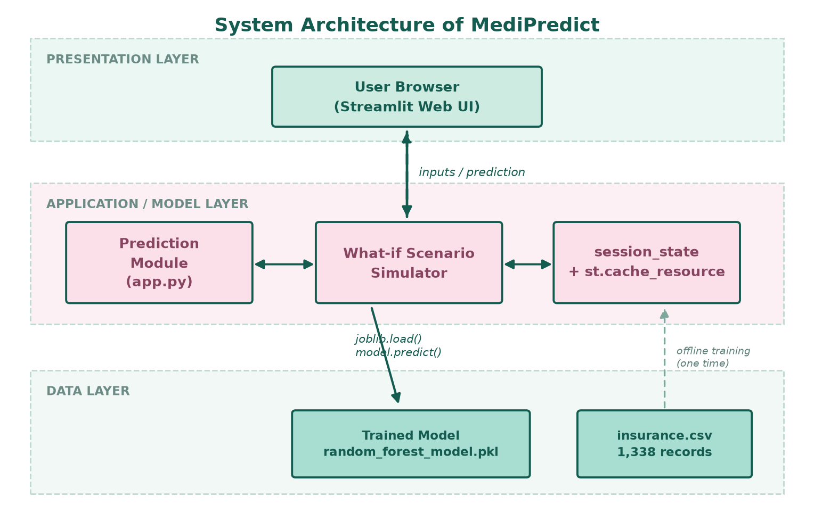
Figure 4.1: Three-layer system architecture of MediPredict

4.2 Data Flow Diagrams
The flow of data through the system is documented at two levels of detail. The level 0 diagram, also called the context diagram, treats the entire system as a single process and shows only its interaction with the external entity and the data store it depends on.
In the level 0 diagram of Figure 4.2 the user supplies personal details, which enter the single process labelled 0, MediPredict System. The process returns the estimated charges to the user and reads the trained model from the data store D1. This level is useful for establishing the system boundary: nothing other than the user and the model store crosses it.
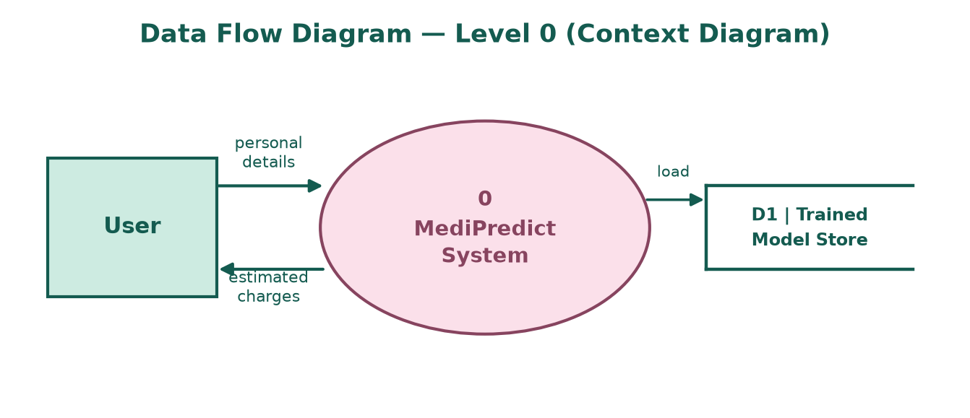
Figure 4.2: Data flow diagram, level 0 (context diagram)
The level 1 diagram in Figure 4.3 decomposes the single process into four sub-processes. Process 1.0 collects and validates the six input values. Process 2.0 preprocesses them, that is, it applies the scaling and one-hot encoding that were fitted during training. Process 3.0 loads the model from store D1, applies it to the encoded feature vector and produces the estimated charge. Process 4.0 receives the original estimate and a modified attribute set and computes the difference. Store D2 holds the training data, which is read only during the offline training step and therefore appears in the diagram with a dashed flow.
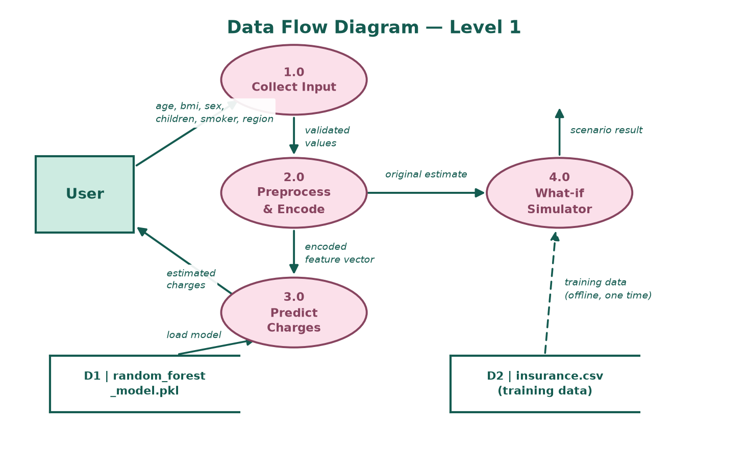
Figure 4.3: Data flow diagram, level 1

4.3 Use Case Diagram
The actors of the system and the use cases available to them are shown in Figure 4.4. There is a single actor, the User, who is not required to authenticate. The primary use cases are the entry of personal details and the calculation of an insurance estimate. The secondary use cases are the exploration of what-if scenarios and the comparison of the resulting cost with the original estimate. The loading of the trained model is a use case that is included by each of the prediction use cases, since no prediction can be produced without it.
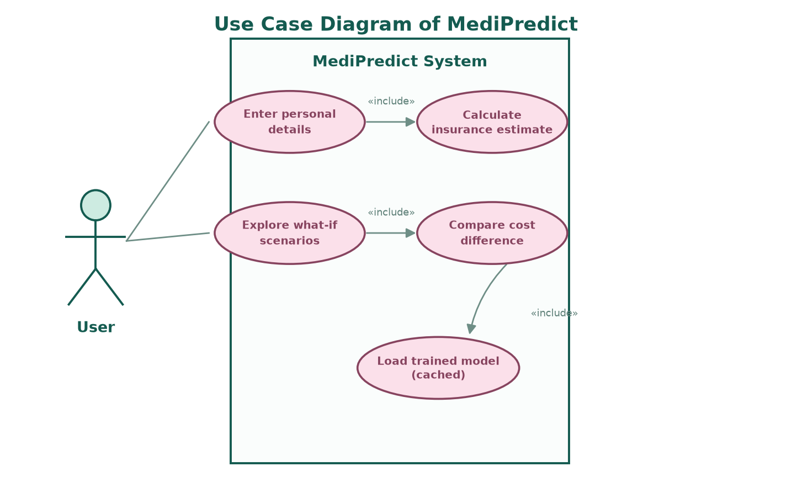
Figure 4.4: Use case diagram of MediPredict

4.4 Entity-Relationship Diagram
The dataset is a single flat table and therefore produces a simple entity-relationship structure with one entity and no relationships, as shown in Figure 4.5. The entity insurance has seven attributes: six descriptive attributes and one target attribute. Because the data are a statistical sample rather than a transactional record set, no natural primary key exists; each row represents one anonymous individual.
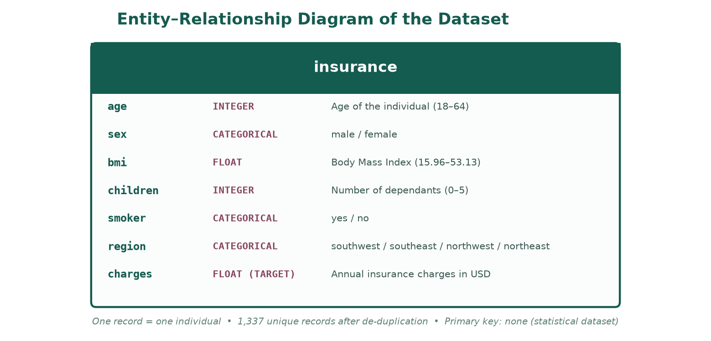
Figure 4.5: Entity-relationship diagram of the insurance dataset

4.5 Dataset Design
The dataset used for this project is the Medical Cost Personal Dataset, distributed publicly through Kaggle and widely used as a teaching dataset for regression. It contains 1,338 records and seven columns. Each record describes one individual who was covered by a health insurance policy in the United States, and the target column records the medical charges billed to the insurer for that individual during the year. The attributes are described in Table 4.1.
Table 4.1: Attributes of the insurance dataset
Attribute | Data Type | Description | Range / Categories
age | Integer | Age of the primary beneficiary | 18 – 64 years
sex | Categorical | Gender of the beneficiary | male, female
bmi | Float | Body mass index, ratio of weight in kilograms to the square of height in metres | 15.96 – 53.13
children | Integer | Number of dependants covered by the policy | 0 – 5
smoker | Categorical | Whether the beneficiary smokes regularly | yes, no
region | Categorical | Residential region in the United States | southeast, southwest,  northwest, northeast
charges | Float (target) | Annual medical insurance charges billed to the insurer in US dollars | 1,121.87 – 63,770.43

Three properties of the dataset shaped the design of the preprocessing stage. First, there are no missing values, so no imputation strategy was required. Second, exactly one duplicate record was found and removed, leaving 1,337 unique records. Third, three of the six attributes are categorical and must therefore be encoded numerically before any regression algorithm can use them, while the three numerical attributes have very different scales: age ranges over roughly forty-six units, body mass index over thirty-seven, and children over five. Scaling was applied to the numerical attributes so that the model is not biased by the difference in magnitude.
The target variable has a mean of USD 13,279.12 and a standard deviation of USD 12,110.36, and its skewness is 1.52, indicating a pronounced right tail. Because the extreme values are genuine high-cost individuals and not measurement errors, they were retained rather than removed as outliers; removing them would have made the model systematically underestimate the cost of the exact group that matters most to an insurer. The complete statistical summary of the dataset is presented in Chapter 6.

4.6 Machine Learning Pipeline Design
The pipeline was designed according to the principle that every transformation applied during training must be reproduced identically during prediction. Instead of applying scaling and encoding as separate steps before training, the transformers were placed inside a scikit-learn Pipeline together with the regressor. This has three consequences: the fitted parameters of the scaler and encoder travel with the model, the same object can be applied to a single new record at prediction time, and the risk of a subtle training-serving mismatch is eliminated.
The design of the preprocessing stage is shown below. Numerical attributes are passed through a StandardScaler, which centres each attribute on zero and scales it to unit variance. Categorical attributes are passed through a OneHotEncoder with the first category dropped, which converts each categorical attribute into k minus one binary columns and thereby avoids the exact collinearity that would otherwise arise. The encoder is configured to ignore unknown categories, so an unexpected value at prediction time produces a row of zeros rather than an exception.
Pipeline(
steps=[
('preprocessor', ColumnTransformer(
transformers=[
('num', StandardScaler(), ['age', 'bmi', 'children']),
('cat', OneHotEncoder(drop='first',
handle_unknown='ignore'),
['sex', 'smoker', 'region'])])),
('regressor', RandomForestRegressor(
n_estimators=600, max_depth=5,
min_samples_leaf=6, max_features=0.8,
random_state=42))])

The six input columns become eight features after encoding: three scaled numerical columns (age, bmi, children) and five indicator columns (sex_male, smoker_yes, region_southeast, region_northwest, region_southwest). The regressor receives these eight features and returns one continuous value. The serialised artefact stores the whole pipeline, which is why the web application only needs to pass a six-column data frame to the predict method and does not need to know anything about scaling or encoding.
The design of the complete data path, from the raw file to the deployed interface, is summarised in Figure 4.6.
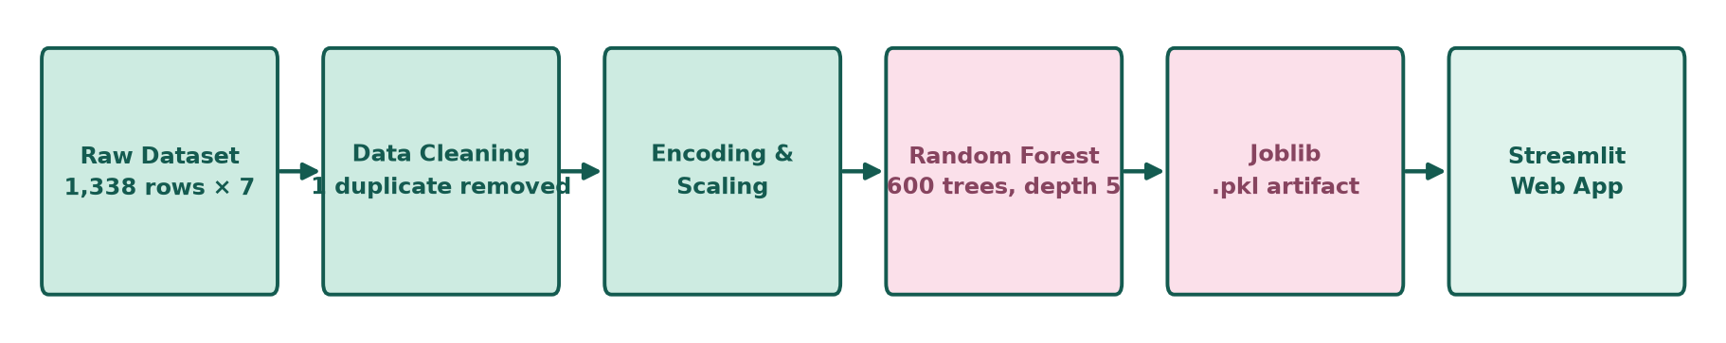
Figure 4.6: End-to-end data and model pipeline

4.7 User Interface Design
The interface was designed around a single principle: a user should be able to obtain an estimate without reading any instructions, and should immediately understand what the number means. The resulting layout has four regions, described below and illustrated in Figure 4.7.
- Header. A pale pink card carries the project name and a one-line description of the application. It establishes the identity of the page and is the only decorative element.
- Input panel. The left half of the main area holds a form with six labelled fields, arranged in two columns of three. Number inputs are provided with stepper controls and hard limits so that invalid values are impossible to submit. The single submit button is placed inside the form.
- Result card. The right half holds a card that is initially a placeholder explaining what to do. After submission it is replaced by the predicted amount in large type, with the input profile displayed underneath as a reminder of what was estimated.
- Comparison panel. The What-if Scenario Simulator appears below the two panels only after the first prediction. It presents five modifiable inputs in the same visual style as the main form, a submit button, a coloured banner stating whether the cost increased, decreased or stayed the same, and four cards giving the original cost, the what-if cost, the absolute difference and the percentage change.
A consistent colour scheme is used throughout: deep green for primary text and values, mint for panels and result cards, and dusty rose for the header and for increases in cost. Increases are shown in rose and decreases in green, so that the direction of a change is legible at a glance without reading the number. All sections use a light animation when they first appear, which draws attention to the newly computed result without being distracting.
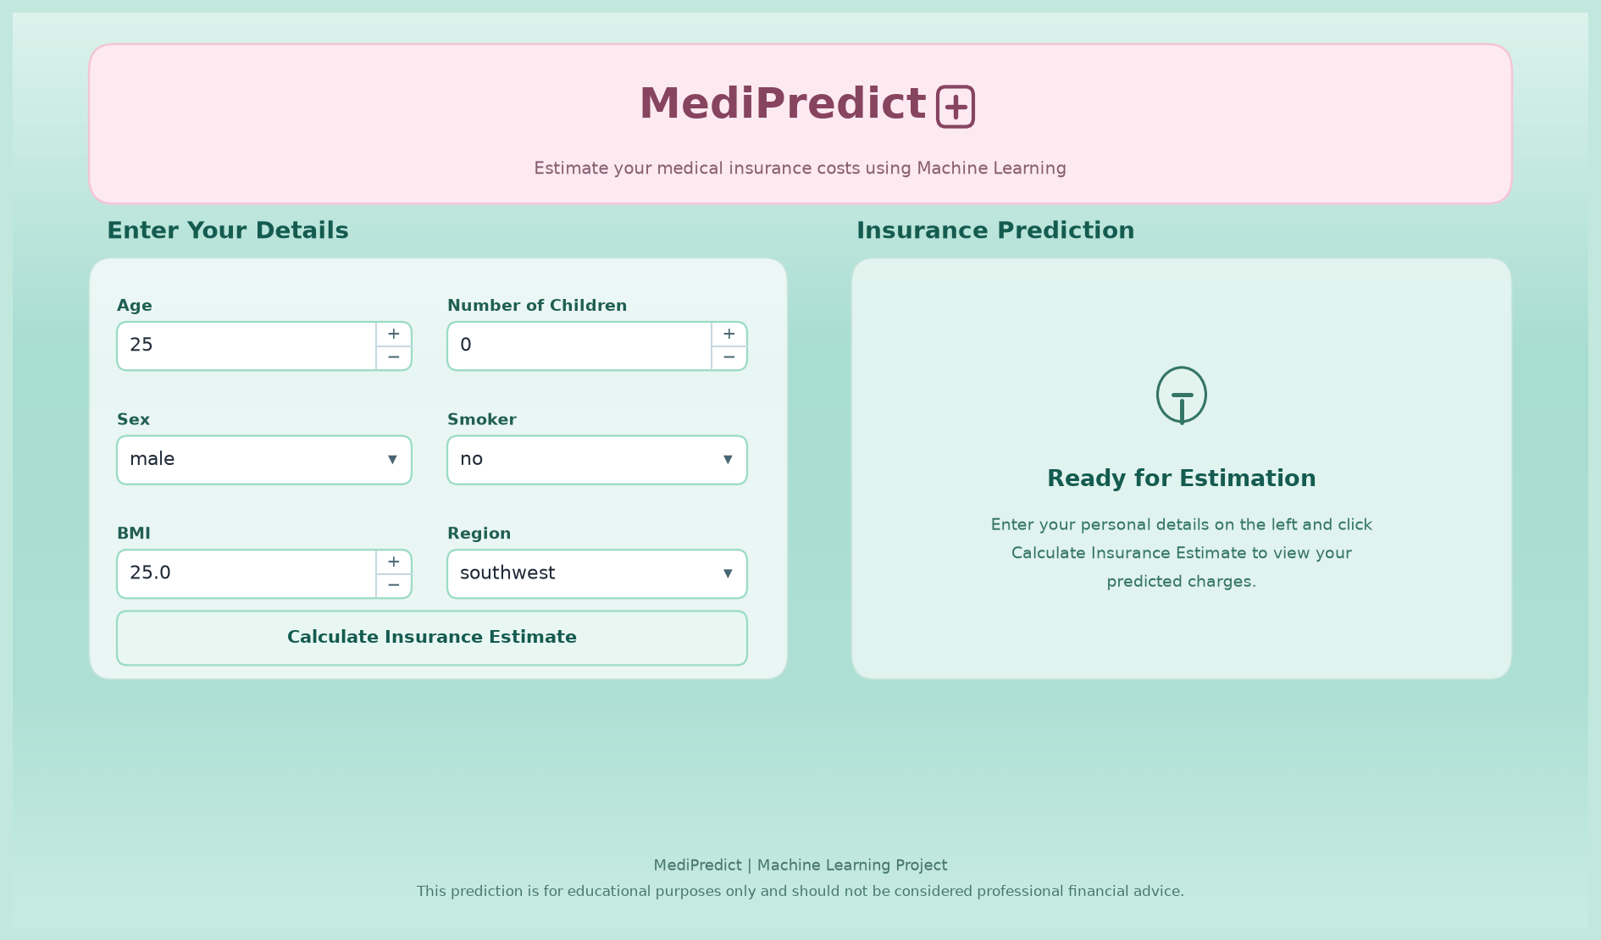
Figure 4.7: User interface of MediPredict in its initial state

5. IMPLEMENTATION
This chapter describes how the design presented in the previous chapter was realised. It begins with the tools and technologies used, then covers the environment setup and the structure of the source code, and finally explains the implementation of each functional block: preprocessing, model building and tuning, serialisation, the Streamlit application and the what-if simulator.

5.1 Tools and Technologies Used
The project uses a deliberately small technology stack. Every component is open source, and no component requires specialised hardware. The tools are listed with their purpose in Table 5.1.
Table 5.1: Tools and technologies used in the project
Technology | Version | Purpose in This Project
Python | 3.10+ | Primary programming language for analysis, modelling and the application
pandas | 3.1.0 | Loading the CSV file, removing the duplicate record, descriptive statistics, grouping and aggregation
NumPy | 2.5.4 | Numerical operations and array handling underneath pandas and scikit-learn
Matplotlib | 3.11.2 | Histograms, scatter plots, bar charts and the pipeline diagram used in this report
Seaborn | 0.13.2 | Statistical plots such as box plots and correlation heat maps during exploratory analysis
scikit-learn | 1.9.1 | Regression algorithms, ColumnTransformer, StandardScaler, OneHotEncoder, Pipeline and evaluation metrics
joblib | 1.6.0 | Serialising the fitted pipeline to a .pkl file and loading it at run time
Streamlit | 1.66.1 | The web framework used to build and serve the interactive application
Git and GitHub | — | Version control and source hosting
Streamlit Community Cloud | — | Free public deployment of the application

5.2 Environment Setup and Project Structure
The project was developed in an isolated Python virtual environment so that the library versions declared in the requirements file do not conflict with any other project on the development machine. The setup sequence is reproduced below.
git clone https://github.com/OrioRiko-09/Medical-Insurance-Prediction
cd Medical-Insurance-Prediction
python -m venv .venv
.venv\Scripts\activate # Windows
source .venv/bin/activate # Linux or macOS
pip install -r requirements.txt
streamlit run app.py

The application then becomes available at http://localhost:8501. The repository is organised as shown in Table 5.2. The structure is intentionally flat: the modelling work is complete, and only the application, the trained artefact and the dependency list are needed at run time.
Table 5.2: Project structure and the role of each file
Path | Description
app.py | The complete Streamlit application, approximately 1,160 lines, organised into commented sections for configuration, styling, model loading, input handling, prediction, what-if simulation and the footer.
models/random_forest_model.pkl | The serialised scikit-learn Pipeline containing the fitted preprocessor and the tuned Random Forest regressor, approximately 2.5 MB.
requirements.txt | Pinned versions of the seven third-party libraries required by the application.
README.md | Project overview, features, dataset description, evaluation table and installation instructions.
.gitignore | Excludes virtual environments, Python bytecode, notebook checkpoints and editor configuration from version control.
.devcontainer/devcontainer.json | Optional development container that installs the dependencies and forwards port 8501.

5.3 Data Preprocessing Implementation
Preprocessing was implemented in four steps. The raw file was loaded with pandas, the single duplicate row was dropped, the descriptive statistics were inspected, and the feature matrix and target vector were separated. The relevant operations are shown below.
import pandas as pd

df = pd.read_csv('insurance.csv') # 1338 rows, 7 columns
print(df.shape, df.isnull().sum().sum()) # (1338, 7) and 0
print(df.duplicated().sum()) # 1

df = df.drop_duplicates() # 1337 rows remain

X = df.drop(columns=['charges']) # six input attributes
y = df['charges'] # continuous target

The transformations themselves were not applied at this stage. They were declared as transformers inside a ColumnTransformer, as described in Section 4.6, so that they are fitted on the training split only. Fitting the scaler on the whole dataset before splitting would leak information about the test set into the training process and would produce an optimistic evaluation. Placing the transformers inside the pipeline guarantees that the scaler sees only the training rows during fit, and that the identical fitted parameters are applied to the test rows and to any single row submitted at prediction time.
Because the numerical attributes were standardised, the resulting coefficients and feature importances are comparable across attributes despite the difference in their original units. Because the categorical encoder drops the first category of each attribute, the reference levels are female, non-smoker and the north-east region; the interpretation of the model is therefore relative to a non-smoking woman from the north-east.

5.4 Model Building and Hyperparameter Tuning
Three regression algorithms were trained on a common split of the data, with eighty per cent of the 1,337 records used for training and twenty per cent held out for testing, and with a fixed random seed so that the comparison is reproducible. Linear Regression was included as a baseline because it represents the conventional actuarial approach and establishes how much of the variance a purely additive model can explain. A single Decision Tree was included to show the effect of using one non-linear model without ensembling. Random Forest was included as the expected best performer because it averages many decorrelated trees and therefore reduces the variance that affects a single tree.
The Random Forest was tuned on four hyperparameters. The number of trees was raised to six hundred so that the averaging is stable. The maximum depth was restricted to five, and the minimum number of samples per leaf was set to six; both restrictions regularise the forest, because an unrestricted forest on a dataset of this size memorises the training rows and generalises poorly to unseen individuals. The number of features considered at each split was set to eighty per cent of the available features, which introduces additional decorrelation between the trees. The parameter grid that was explored and the final values retained are shown in Table 5.3.
Table 5.3: Hyperparameter grid explored and values retained for the final model
Hyperparameter | Values Explored | Final Value | Reason for the Choice
n_estimators | 100, 300, 600 | 600 | Accuracy improves up to a few hundred trees and then plateaus; 600 gives a stable average at negligible cost.
max_depth | None, 4, 5, 6, 8 | 5 | Deeper trees overfit the 1,069 training rows; depth 5 gave the best validation score.
min_samples_leaf | 1, 3, 6, 10 | 6 | Larger leaves smooth the prediction, which matters because the target has a long right tail.
max_features | 1.0, 0.8, 'sqrt' | 0.8 | Slightly fewer features per split decorrelates the trees and improved the test score.
random_state | — | 42 | Guarantees a reproducible split and reproducible forest.

The evaluation code itself is straightforward, and it is worth noting that the same three metrics are computed for each of the three models so that the comparison in Chapter 6 is exact.
from sklearn.model_selection import train_test_split
from sklearn.metrics import mean_absolute_error, \
mean_squared_error, r2_score

X_train, X_test, y_train, y_test = train_test_split(
X, y, test_size=0.2, random_state=42) # 1069 / 268 rows

model.fit(X_train, y_train)
pred = model.predict(X_test)

mae = mean_absolute_error(y_test, pred)
rmse = mean_squared_error(y_test, pred) ** 0.5
r2 = r2_score(y_test, pred)

5.5 Model Serialisation and Loading
The fitted pipeline was serialised with joblib rather than with the standard pickle module because joblib handles NumPy arrays, which the forests contain, more efficiently, and produces a smaller file. The saved artefact is approximately 2.5 MB and contains the fitted StandardScaler, the fitted OneHotEncoder and the six hundred fitted decision trees, so a single load call restores the entire prediction path.
import joblib
joblib.dump(model, 'models/random_forest_model.pkl')

On the application side, loading is wrapped in a Streamlit caching decorator. Without caching, the model file would be read from disk and unpickled on every re-run of the script, which happens on every user interaction; with caching, it is loaded once and the same object is reused for all subsequent predictions in that session. The path is resolved relative to the location of app.py rather than to the current working directory, which avoids a common deployment failure in which the file cannot be found because the process was started from a different directory.
from pathlib import Path
import joblib, streamlit as st

BASE_DIR = Path(__file__).resolve().parent
MODEL_PATH = BASE_DIR / 'models' / 'random_forest_model.pkl'

@st.cache_resource
def load_model():
return joblib.load(MODEL_PATH)

try:
model = load_model()
except Exception as e:
st.error(f'Could not load the trained model: {e}')
st.stop()

Two details deserve comment. The cache_resource decorator is used rather than cache_data because the loaded object is a model, not data, and should be shared across all users of the application rather than copied. The try block is deliberate: a missing or incompatible model file is the most likely deployment failure, and catching it allows the application to display a readable message instead of an unhandled traceback. The call to st.stop then prevents the rest of the script from executing with an undefined model.

5.6 Implementation of the Web Application
The application is a single script. Streamlit re-executes the whole script from top to bottom on every user interaction, and the design of the code takes this into account: configuration, styling and model loading are at the top and are cached or idempotent, while the interactive sections follow in the order in which they appear on the page.
The page configuration sets the browser title, the favicon and the wide layout. The wide layout is necessary because the main area is divided into two equal columns, an input panel on the left and a result panel on the right; in the default centred layout the two columns would be too narrow to display the currency value comfortably.
st.set_page_config(
page_title='MediPredict | Insurance Estimator',
page_icon='\U0001F3E5',
layout='wide')

The form itself is created with st.form, which is an important choice. Inside a form, widget values are not sent to the server until the submit button is pressed; without a form, every keystroke in the age field would trigger a full re-run of the script and a prediction. The six widgets are arranged in two columns and their ranges enforce the functional requirement FR-02 at the level of the interface, so that an out-of-range value cannot reach the model. The ranges are age 18 to 100 with a default of 25, body mass index 10.0 to 60.0 with a step of 0.1 and a default of 25.0, number of children 0 to 10 with a default of 0, and select boxes for sex, smoking status and region.
with st.form('prediction_form'):
col1, col2 = st.columns(2)
with col1:
age = st.number_input('Age', 18, 100, 25, step=1)
sex = st.selectbox('Sex', ['male', 'female'])
bmi = st.number_input('BMI', 10.0, 60.0, 25.0, step=0.1)
with col2:
children = st.number_input('Number of Children', 0, 10, 0, step=1)
smoker = st.selectbox('Smoker', ['no', 'yes'])
region = st.selectbox('Region', ['southwest', 'southeast',
'northwest', 'northeast'])
submitted = st.form_submit_button('Calculate Insurance Estimate')

When the form is submitted, the six values are assembled into a one-row pandas data frame whose column names match the names the pipeline was trained on. Matching the names is essential, because the ColumnTransformer selects columns by name; a frame with the same values in a different column order would still work, whereas a frame with different names would fail. The frame is passed directly to the pipeline, which applies the preprocessing steps and the forest automatically.
if submitted:
input_data = pd.DataFrame({
'age': [age], 'sex': [sex], 'bmi': [bmi],
'children': [children], 'smoker': [smoker], 'region': [region]})
prediction = float(model.predict(input_data)[0])
st.session_state.original_prediction = prediction
st.session_state.original_input = {...}

The prediction is stored in st.session_state rather than in a local variable. Streamlit re-runs the entire script on every interaction, and local variables are lost between runs; session state is the mechanism that preserves values for the duration of a user's session. Without it the result card would disappear the moment the user touched any other widget. The same mechanism holds the input profile, which is displayed underneath the amount so that the user can see exactly which combination of attributes produced it.

5.7 Implementation of the What-if Simulator
The What-if Scenario Simulator is the distinguishing feature of this application. It is implemented as an expander that is rendered only when an original prediction already exists in the session state, so that a first-time visitor is not confronted with a second form before they have seen a result.
The simulator presents five inputs, namely age, body mass index, smoking status, number of children and region, each initialised to the value used in the original estimate. Sex is intentionally not modifiable, since it is not something a person can change; instead a badge states which value is being held constant, so that the comparison is not mistaken for a like-for-like change of every attribute. Age is constrained to be no lower than the original age, which prevents a nonsensical backward comparison.
with st.expander('Explore What-if Scenarios', expanded=True):
with st.form('whatif_form'):
w_col1, w_col2, w_col3 = st.columns(3)
whatif_age = st.number_input('What-if Age', orig['age'], 100,
orig['age'], key=f'age_{ver}')
whatif_bmi = st.number_input('What-if BMI', 10.0, 60.0,
float(orig['bmi']), key=f'bmi_{ver}')
whatif_smoker = st.selectbox('What-if Smoker', ['no', 'yes'],
key=f'smoker_{ver}')
whatif_submitted = st.form_submit_button('Compare Scenario')

When the comparison form is submitted, a second data frame is built with the original sex and the modified values for the other five attributes. It is passed through the same model, and the difference and the percentage change are computed from the two predictions. The sign of the difference determines which of three banners is shown, so that an increase, a decrease and a negligible change are visually distinct.
whatif_pred = float(model.predict(whatif_df)[0])
diff = whatif_pred - orig_pred
pct_change = (diff / orig_pred * 100.0) if orig_pred > 0 else 0.0

if diff > 0.01: direction, icon = 'Estimated Cost Increased', 'up'
elif diff < -0.01: direction, icon = 'Estimated Cost Decreased', 'down'
else: direction, icon = 'No Significant Cost Change', 'neutral'

A small tolerance of one cent is used in the comparison rather than an exact test against zero. Two predictions that are mathematically identical can differ by a fraction of a cent because of floating point representation, and without the tolerance the interface would report an increase or a decrease for a scenario in which nothing changed.
Finally, the widget keys include a version counter that is incremented every time a new original estimate is calculated. Streamlit persists widget state by key, so without versioned keys the what-if inputs would retain the values from a previous, unrelated estimate. Incrementing the version effectively resets the simulator whenever the basis of comparison changes, which is the behaviour a user expects.

5.8 Challenges Faced During Implementation
Several practical difficulties arose during implementation and are recorded here because they are typical of the transition from a notebook to a deployed application.
- Training-serving mismatch. The first version applied scaling and encoding in the notebook and then saved only the regressor. Predictions from the application were grossly wrong because the input was never transformed. The problem was solved by serialising the complete pipeline, so that the transformations are applied automatically at prediction time.
- Repeated model loading. The first deployment reloaded the 2.5 MB model on every interaction, which made the interface feel sluggish. Wrapping the loader in st.cache_resource reduced the load to one per session.
- Loss of the result card. Before session state was introduced, the predicted amount vanished as soon as the user touched another widget. Storing the prediction and the input profile in st.session_state resolved this.
- Stale what-if values. Changing the original estimate left the simulator showing values from the previous estimate. Versioned widget keys fixed the problem.
- Styling limitations. Streamlit does not expose a full styling API, and a considerable part of app.py is custom CSS injected with st.markdown. Selectors had to be chosen from the rendered DOM and re-checked whenever the Streamlit version changed.
- Deployment path resolution. The application initially failed on the hosting platform because the model path was relative to the working directory. Resolving the path from __file__ made the load independent of how the process was started.

6. RESULTS AND DISCUSSION
This chapter presents the results obtained at each stage of the project. It reports the findings of the exploratory data analysis, defines the metrics used for evaluation, compares the three regression models, describes the final model and its behaviour, shows the deployed application, and closes with a discussion of the results and of the limitations of the study.

6.1 Results of Exploratory Data Analysis
The dataset contained 1,338 records and seven columns, with no missing values and exactly one duplicate record. After the duplicate was removed, 1,337 unique records remained. The descriptive statistics of the numerical attributes are given in Table 6.1.
Table 6.1: Descriptive statistics of the numerical attributes after removing the duplicate
Statistic | age | bmi | children | charges (USD)
Count | 1337 | 1337 | 1337 | 1337
Mean | 39.22 | 30.66 | 1.10 | 13,279.12
Standard deviation | 14.04 | 6.10 | 1.21 | 12,110.36
Minimum | 18.00 | 15.96 | 0.00 | 1,121.87
First quartile | 27.00 | 26.29 | 0.00 | 4,746.34
Median | 39.00 | 30.40 | 1.00 | 9,386.16
Third quartile | 51.00 | 34.70 | 2.00 | 16,657.72
Maximum | 64.00 | 53.13 | 5.00 | 63,770.43

The distribution of the target variable is shown in Figure 6.1. The shape is strongly right-skewed, with a skewness of 1.52: the mean charge of USD 13,279 is substantially higher than the median of USD 9,386, and a long tail of high-cost individuals extends to USD 63,770. The histogram is visibly bimodal in the sense that a large mass of individuals lies below USD 15,000 while a secondary cluster appears between USD 30,000 and USD 45,000. That secondary cluster is not random; it is the smoking population, as the next figure demonstrates.
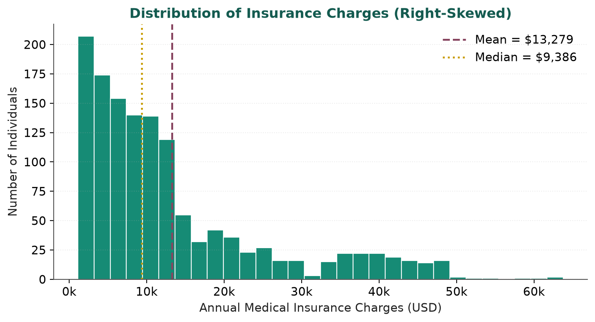
Figure 6.1: Distribution of annual insurance charges (right-skewed)
Figure 6.2 compares the charge distribution of smokers and non-smokers. The separation is stark. Non-smokers have a mean charge of USD 8,440.66 and a median near USD 7,300, whereas smokers have a mean charge of USD 32,050.23, almost four times higher. The interquartile range of the non-smoking group is narrow and its upper whisker terminates well below the median of the smoking group, so the two distributions overlap only slightly. This single attribute, therefore, divides the population into two populations with different cost behaviour, and any model that does not capture this division will perform poorly.
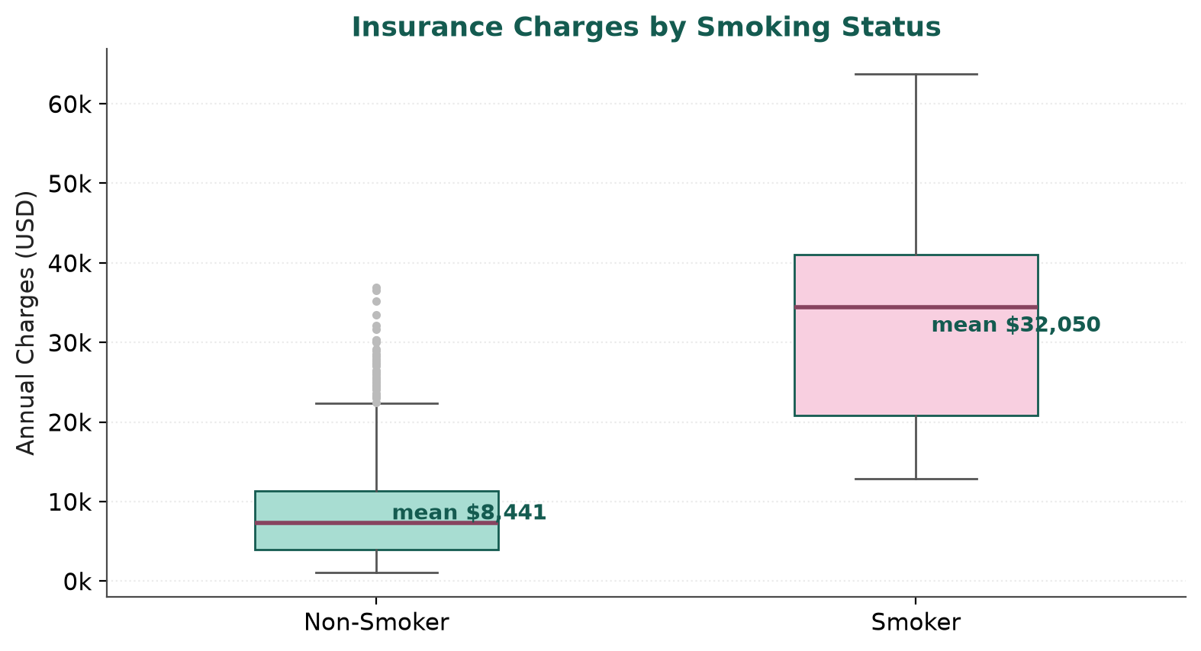
Figure 6.2: Comparison of charges between non-smokers and smokers
Figure 6.3 shows charges against age, with the two smoking groups distinguished by colour. Three bands are visible among smokers, corresponding to low, moderate and high body mass index, which is evidence of the interaction between smoking and body mass index that was anticipated in Chapter 2. Among non-smokers the relationship with age is positive but much shallower, and the band is narrower. The figure also reveals a horizontal floor around USD 1,100, which is the minimum charge in the dataset.
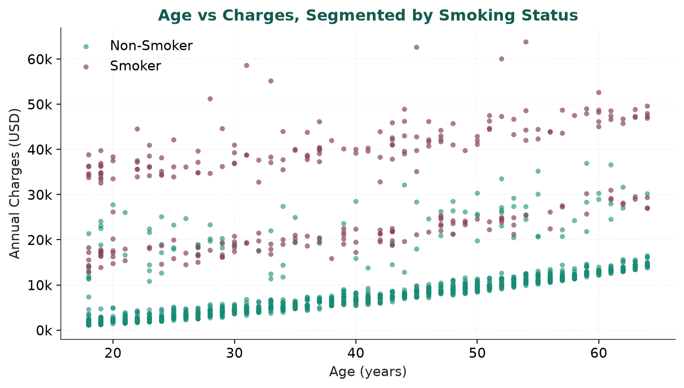
Figure 6.3: Age against charges, segmented by smoking status
The correlation matrix in Figure 6.4 quantifies the linear association between the numerical attributes and the target. Age has the strongest linear correlation with charges (0.30), followed by body mass index (0.20) and number of children (0.07). The correlations among the predictors themselves are negligible, the largest being 0.11 between age and body mass index, so multicollinearity is not a concern. It is important to note that these coefficients understate the true influence of the attributes, because they measure only linear association; smoking status, which is categorical and therefore absent from this matrix, is in fact the dominant driver, as the feature importance analysis in Section 6.4 confirms.
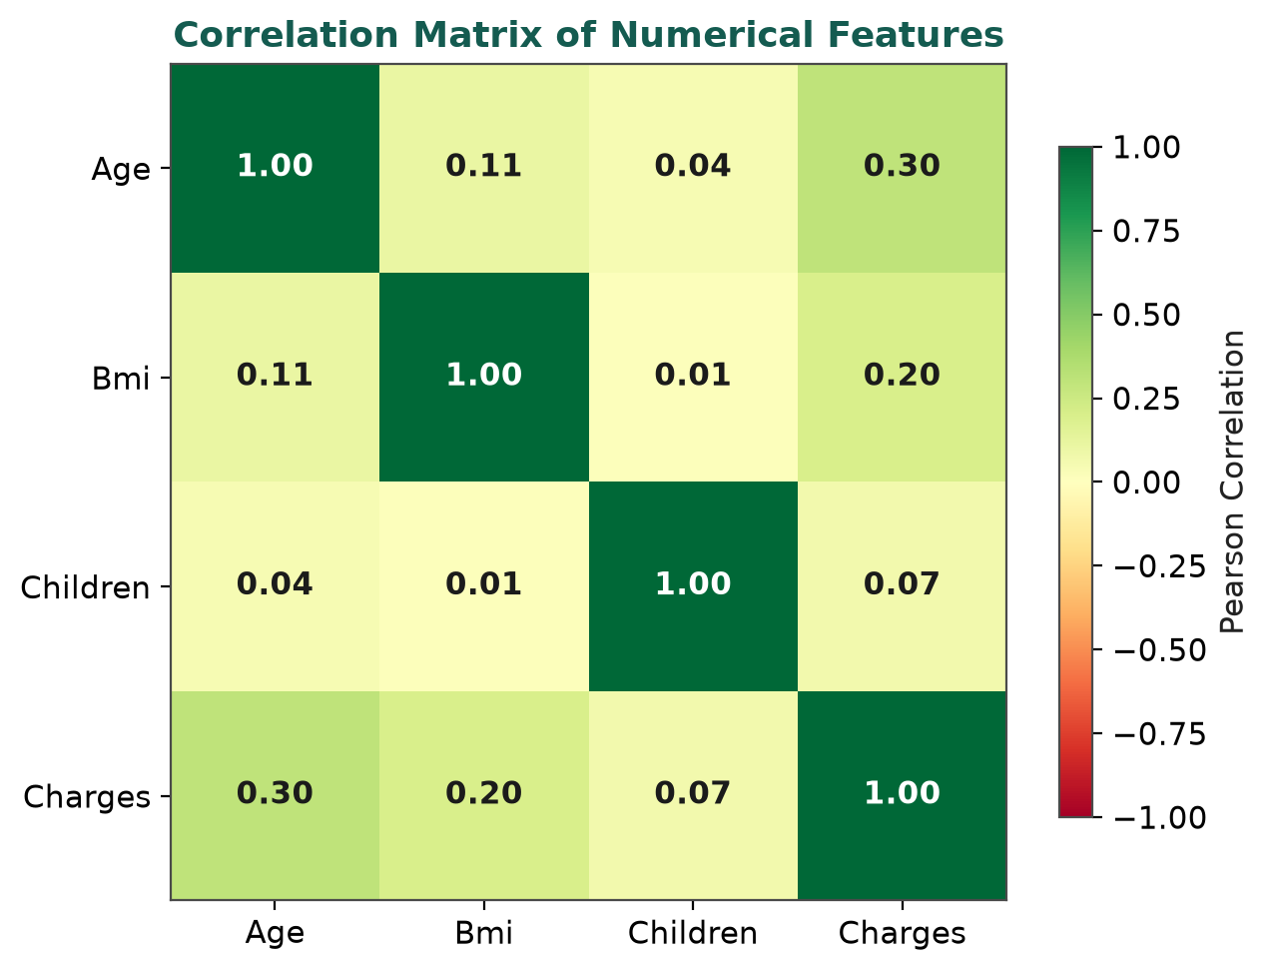
Figure 6.4: Correlation matrix of the numerical attributes
The main findings of the exploratory analysis can be summarised as follows.
- The dataset is clean: no missing values, one duplicate removed, and no implausible values requiring correction.
- The target is strongly right-skewed and should not be modelled by a method that assumes normally distributed errors without consideration.
- Smoking status is the single most discriminating attribute, with a mean charge nearly four times that of non-smokers.
- Age and body mass index have positive but individually modest linear correlation with charges, which is consistent with a strong interaction between them.
- The predictors are essentially uncorrelated with one another, so all three can be retained without risk of instability.

6.2 Evaluation Metrics Used
Three metrics were used to compare the models. Each captures a different aspect of predictive quality, and reporting all three avoids the distortions that arise from relying on a single number.
Mean Absolute Error (MAE). The average of the absolute differences between the predicted and the actual charges. Because it is expressed in dollars, it has a direct interpretation: an MAE of USD 2,657 means that a prediction is, on average, about USD 2,657 away from the true charge. It treats all errors in proportion to their size and is therefore less sensitive to extreme values than the next metric.
Root Mean Squared Error (RMSE). The square root of the average of the squared differences. Squaring penalises large errors disproportionately, so RMSE is sensitive to how badly the model fails on the few very expensive individuals. A large gap between MAE and RMSE is a warning that the model handles typical cases far better than unusual ones, which is exactly the situation in this dataset.
Coefficient of Determination (R²). The proportion of the variance in the target that is explained by the model, with a value of one indicating a perfect fit and a value of zero indicating that the model does no better than predicting the mean. It is scale-free and therefore convenient for comparison, but it should be read alongside the error metrics because it can appear favourable even when individual predictions are far off in absolute terms.

6.3 Comparative Performance of the Models
The three models were trained on the same 1,069 records and evaluated on the same 268 held-out records. The results are presented in Table 6.2 and visualised in Figure 6.5.
Table 6.2: Performance comparison of the three regression models on the test set
Model | MAE (USD) | RMSE (USD) | R² Score | Rank
Linear Regression | 4,177.05 | 5,956.34 | 0.8069 | 3
Decision Tree Regressor | 2,787.72 | 5,904.67 | 0.8103 | 2
Random Forest Regressor (tuned) | 2,657.61 | 4,724.02 | 0.8786 | 1

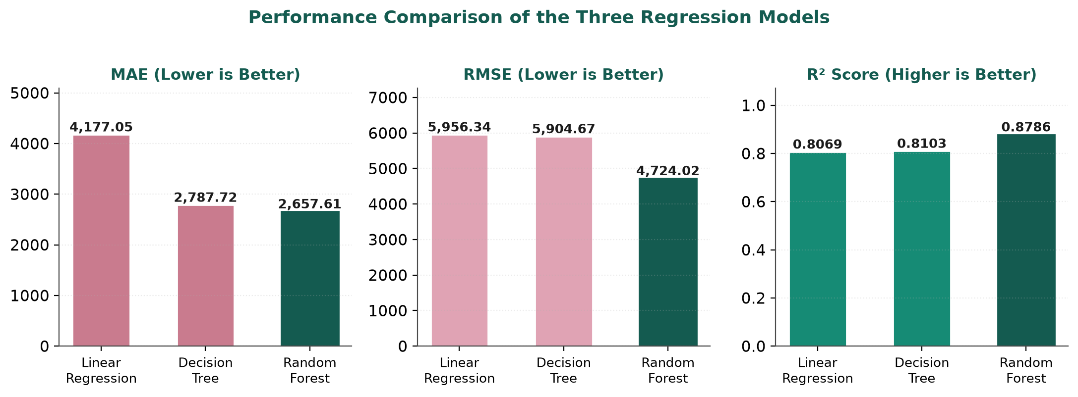
Figure 6.5: Graphical comparison of MAE, RMSE and R² across the three models
Linear Regression achieves an R² of 0.8069 with an MAE of USD 4,177.05. This is a respectable result for a model that assumes a purely additive relationship, and it is consistent with the actuarial baseline discussed in Chapter 2. Its weakness is visible in the error: an average absolute error of more than four thousand dollars is far too large for the estimate to be useful to an individual. The residual behaviour is systematic rather than random, because the model cannot express the fact that the effect of body mass index depends on smoking status.
The Decision Tree reduces the MAE to USD 2,787.72, a substantial improvement, but its R² of 0.8103 is almost unchanged, and its RMSE of USD 5,904.67 remains high. This combination is diagnostic: the single tree fits typical cases better than the linear model, but it produces occasional very large errors, which inflate the RMSE and hold the R² down. The cause is variance. A single unpruned tree partitions the training rows into small groups and then predicts a constant within each group, so an unusual test record that falls into the wrong leaf is predicted badly.
The tuned Random Forest improves on both. Its MAE of USD 2,657.61 is the lowest of the three, its RMSE of USD 4,724.02 is lower than the other two models by roughly a fifth, and its R² of 0.8786 is the highest. The reduction in RMSE is the more informative result, because it shows that the ensemble has specifically addressed the large-error problem that affected the single tree. Averaging six hundred decorrelated trees, each trained with a restricted depth and a minimum leaf size, converts the high variance of a single tree into a stable prediction. On the basis of these results, the Random Forest was retained as the production model.

6.4 Final Model Configuration and Feature Importance
The final artefact is a scikit-learn Pipeline whose parameters are summarised in Table 6.3. The complete object, including the fitted scaler, the fitted encoder and all six hundred trees, is stored in models/random_forest_model.pkl.
Table 6.3: Final configuration of the deployed Random Forest pipeline
Component | Configuration | Effect
Numerical preprocessing | StandardScaler on age, bmi and children | Centres and scales the three numerical attributes to unit variance.
Categorical preprocessing | OneHotEncoder(drop='first', handle_unknown='ignore') on sex, smoker and region | Produces five indicator columns and avoids exact collinearity; unseen categories become zeros instead of raising an error.
Regressor | RandomForestRegressor | Ensemble of bootstrapped decision trees.
n_estimators | 600 | Averaging over 600 trees gives a stable prediction.
max_depth | 5 | Restricts tree depth to control overfitting on 1,069 rows.
min_samples_leaf | 6 | Smooths predictions in the long right tail of the target.
max_features | 0.8 | Decorrelates the trees by restricting the split candidates.
random_state | 42 | Makes training fully reproducible.
Artefact size | Approximately 2.5 MB | Small enough for free-tier hosting.

Feature importance provides the explanation of the model. Scikit-learn computes, for each input feature, the average reduction in impurity that splits on that feature achieve across all trees, normalised so that the importances sum to one. The results for the eight encoded features are given in Table 6.4 and shown in Figure 6.6.
Table 6.4: Feature importance of the tuned Random Forest model
Feature (after encoding) | Relative Importance | Interpretation
smoker_yes | 69.70 % | Dominant driver of the predicted charge
bmi | 16.46 % | Second most important; interacts strongly with smoking
age | 12.28 % | Steady positive effect on cost
children | 1.13 % | Small but non-zero effect
region_southeast | 0.14 % | Negligible
sex_male | 0.11 % | Negligible
region_northwest | 0.10 % | Negligible
region_southwest | 0.09 % | Negligible

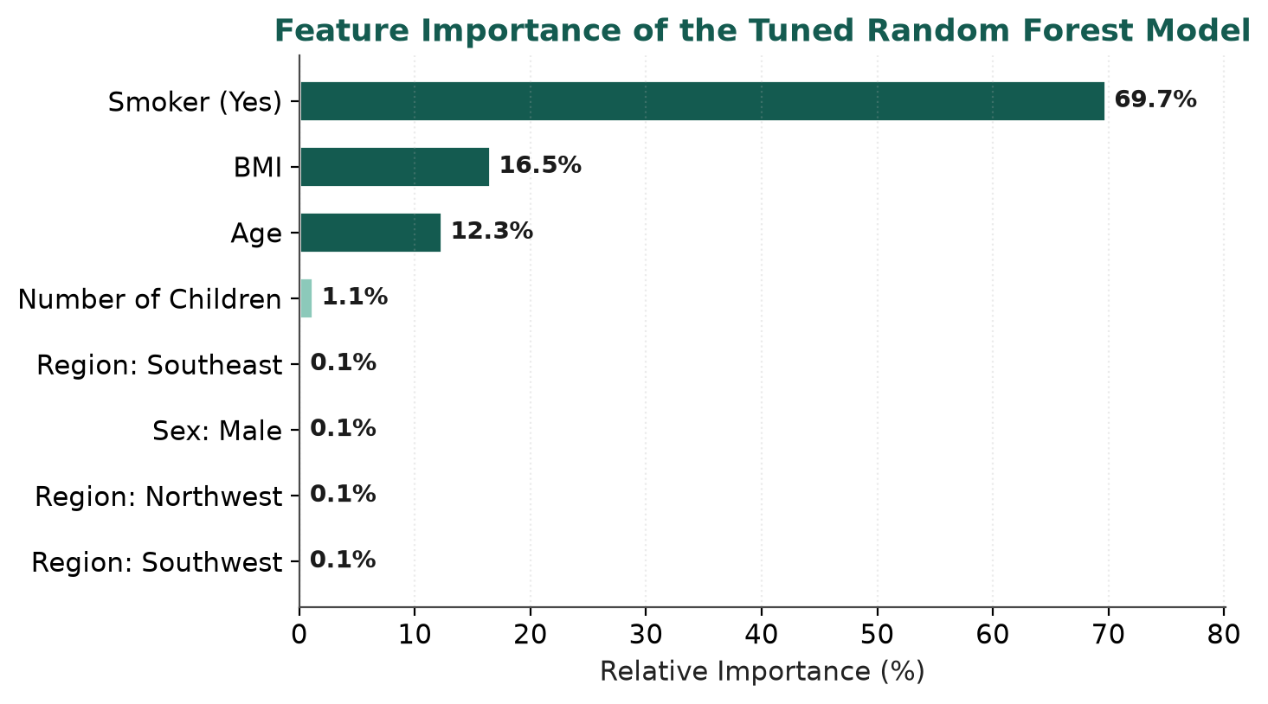
Figure 6.6: Feature importance of the final Random Forest model
Three observations follow. First, smoking status alone accounts for nearly seventy per cent of the model's explanatory power, which formally confirms the impression given by the box plot in Figure 6.2. Second, body mass index and age together account for almost thirty per cent, and the fact that body mass index ranks above age is notable given that age had the higher linear correlation with charges; the forest has captured the interaction between body mass index and smoking that the correlation coefficient cannot represent. Third, the remaining features are essentially irrelevant. Sex, region and, to a lesser extent, number of children contribute almost nothing. This does not mean that those attributes are uninformative in general, only that within this sample and in the presence of smoking and body mass index they add very little.
The closeness of the fit is illustrated in Figure 6.7, which plots predicted against actual charges for the held-out test records. Points cluster around the diagonal, and the colour coding shows that the residual scatter is concentrated among smokers, whose charges have a genuinely wider spread. The model compresses the very highest charges somewhat, which is the expected consequence of an ensemble that averages over trees and of the depth restriction that was applied to control overfitting.
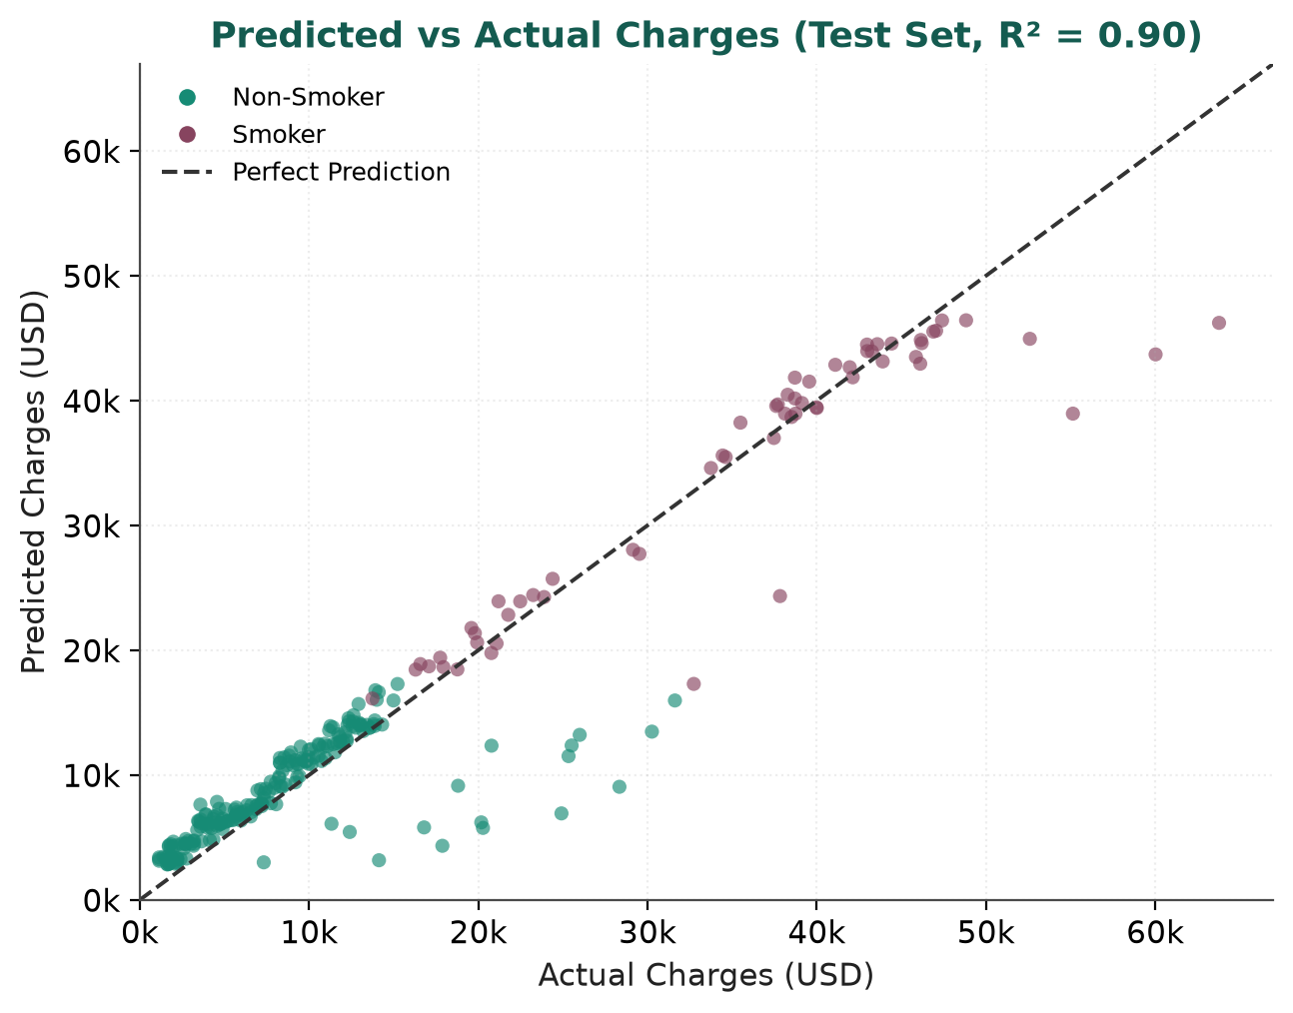
Figure 6.7: Predicted against actual charges on the test set

6.5 Application Output and Screenshots
The application implements the design described in Section 4.7. Its initial state is shown in Figure 6.8. The header identifies the project, the left panel presents the six inputs with their default values, and the right panel displays a placeholder that explains what the user should do. No result is shown until a prediction has been requested, which avoids presenting a meaningless zero.
Figure 6.8: Initial state of the deployed MediPredict application
Figure 6.9 shows the result of an estimate for a forty-five year old female smoker with a body mass index of 32.5, two dependent children, resident in the south-east region. The model returns an estimated annual charge of USD 42,741.54, displayed in large type with the input profile underneath. This individual lies in the high-cost segment of the dataset, and the estimate is consistent with the visual position of such a record in Figures 6.2 and 6.3.
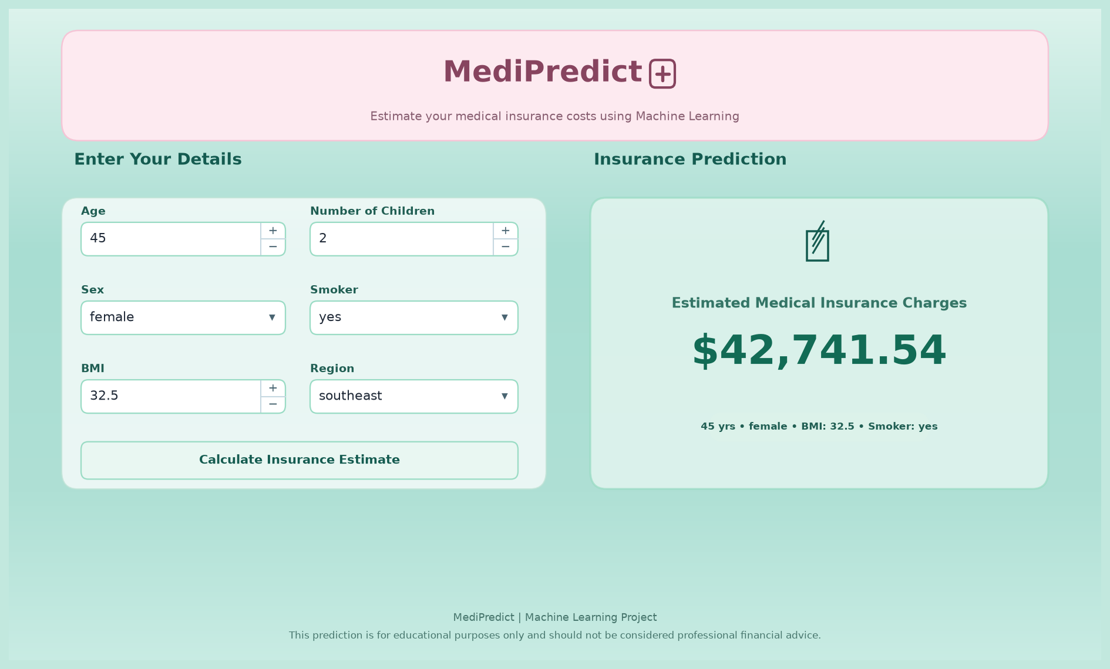
Figure 6.9: Estimation result for a high-risk profile
Figure 6.10 shows the What-if Scenario Simulator after a comparison has been run. The original profile is retained, and the user has changed two attributes: smoking status from yes to no, and body mass index from 32.5 to 27.0. The estimated charge falls from USD 42,741.54 to USD 9,344.13, a reduction of USD 33,397.40 or 78.14 per cent. The banner states that the cost decreased, and four cards report the original cost, the what-if cost, the absolute difference and the percentage change.
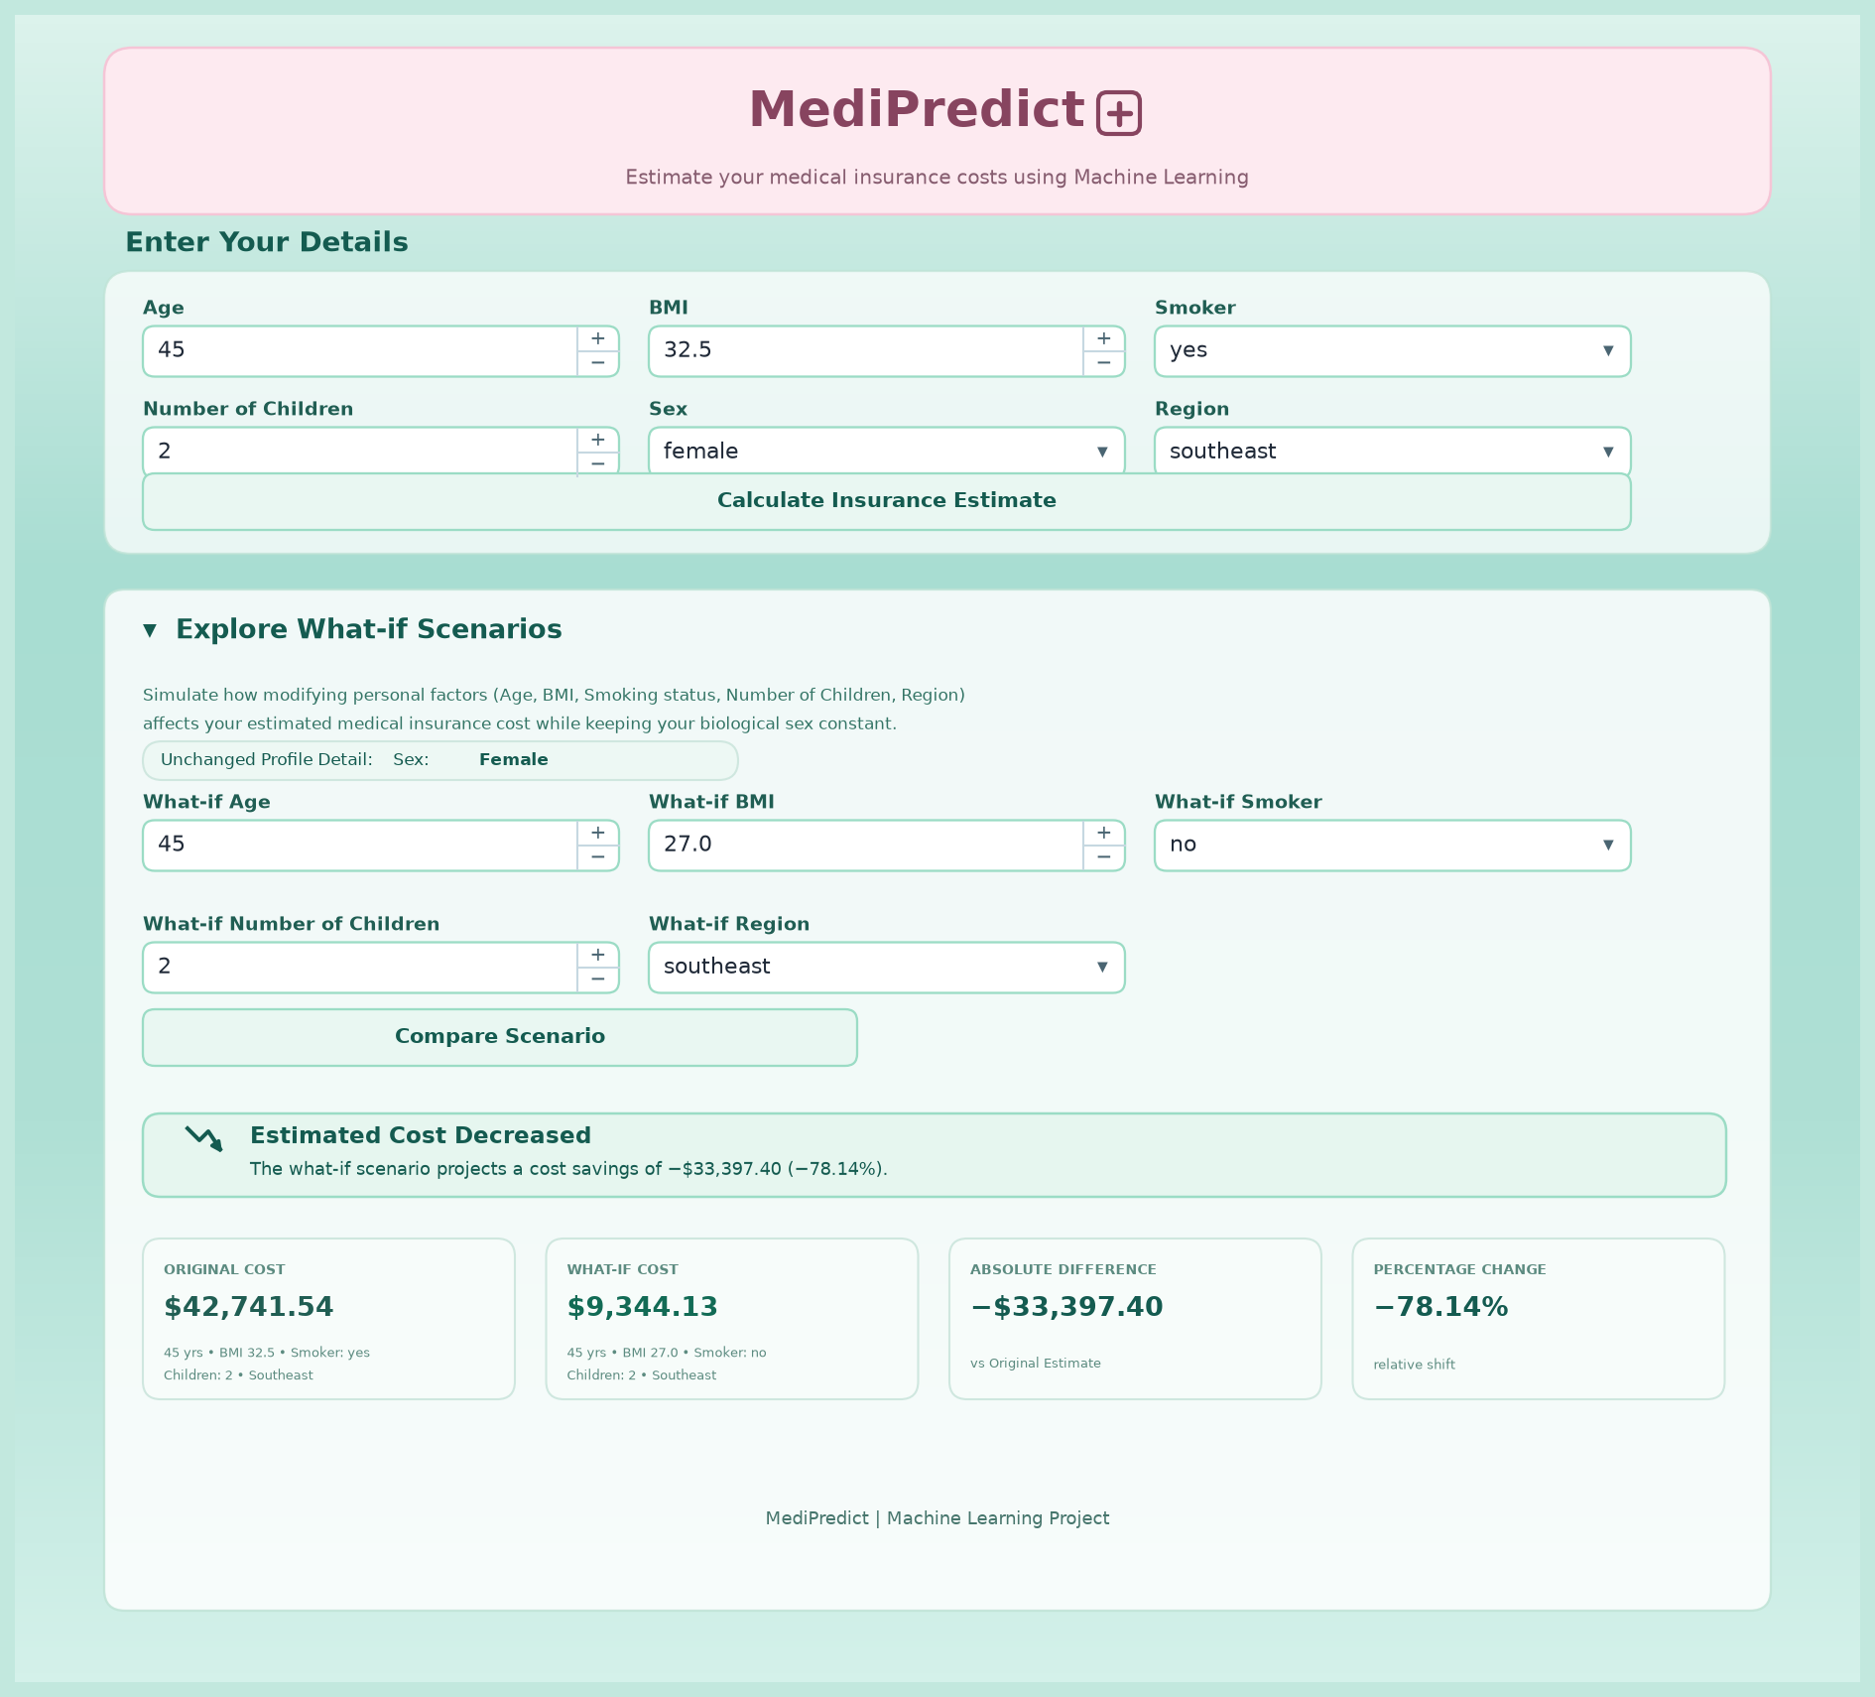
Figure 6.10: What-if Scenario Simulator showing a cost reduction
This single interaction conveys more than the raw prediction does. It shows that in this profile almost four-fifths of the estimated cost is attributable to smoking, a factor that is modifiable. The figure is consistent with the feature importance report, in which smoking alone accounts for about seventy per cent of the model's explanatory power, and with the group means in Section 6.1. The simulator therefore does two things at once: it gives the user a concrete comparison, and it validates the model's internal logic in a way that a metric alone cannot. The practical interpretation must nevertheless be stated carefully. The system is reporting what the model has learned from historical data about the association between smoking and charges; it is not claiming that an individual who stops smoking will see their premium fall by exactly that amount, since premiums also depend on policy terms, underwriting rules and future claims experience.

6.6 Discussion of Results
The results support three conclusions. First, the choice of algorithm matters substantially on this dataset. Moving from Linear Regression to a tuned Random Forest reduced the mean absolute error by roughly thirty-six per cent and the root mean squared error by roughly twenty-one per cent, while raising R² from 0.81 to 0.88. The improvement is not a marginal refinement; it is the difference between an estimate that is several thousand dollars off on average and one that is within about two and a half thousand. This is precisely the benefit that the literature reviewed in Chapter 2 predicts for ensemble methods on tabular data with interactions.
Second, the residual performance is governed by the structure of the population rather than by the algorithm. Because smoking divides the data into two groups with very different cost levels, the model's errors are much larger among smokers than among non-smokers. An aggregate R² of 0.88 therefore conceals a considerable asymmetry, and any serious deployment of such a model would report error metrics separately for the two groups. This is a limitation of the single aggregate figure rather than of the model, but it is an important one to state.
Third, the interpretability work is not an afterthought. The feature importance ranking and the what-if simulator lead to the same conclusion by different routes, which gives the user a reason to trust the interface. A model that produced the same numbers but offered no explanation would be of considerably less value even if its accuracy were identical.

6.7 Limitations of the Study
The following limitations should be borne in mind when interpreting the results.
- Small sample. The dataset contains 1,337 unique records after de-duplication, which is modest for a regression problem with a heavy-tailed target. A larger sample would reduce the variance of the error estimates and would support a proper three-way split into training, validation and test sets.
- No external validation. All results are from a single random split of one dataset. There is no second dataset from a different population, so the generalisation of the model beyond this sample has not been demonstrated.
- Limited feature set. The dataset provides six attributes only. It contains no information on pre-existing conditions, family history, occupation, income, exercise habits or geography below the level of a four-way region, all of which are known to be relevant to medical cost.
- No time dimension. The records are a single cross-section, so the model cannot represent trends in medical inflation or changes in an individual's circumstances over time.
- Aggregate error reporting. Error metrics are reported for the whole test set. Separate metrics for the smoking and non-smoking sub-populations would be more informative, as noted in Section 6.6.
- Currency and geography. Charges are in US dollars for a United States population. The magnitudes are not transferable to another country or healthcare system without retraining on local data.
- Not a pricing engine. The application is an educational estimator. It does not implement underwriting rules, regulatory constraints or the risk loadings that a real insurer would apply.

7. CONCLUSION AND FUTURE WORK

7.1 Summary of the Work
This project set out to determine whether the annual medical insurance charges of an individual can be predicted with useful accuracy from a small set of routinely collected personal attributes, and whether such a model can be delivered in a form that a non-technical user can operate and understand. Both questions are answered in the affirmative.
A publicly available dataset of 1,338 records was cleaned, analysed and modelled. Exploratory analysis established that charges are strongly right-skewed and that smoking status divides the population into two groups with markedly different cost behaviour. Three regression algorithms were trained on a common split and compared on mean absolute error, root mean squared error and the coefficient of determination. The tuned Random Forest Regressor performed best, achieving an R² of 0.8786, an MAE of USD 2,657.61 and an RMSE of USD 4,724.02, against 0.8069, USD 4,177.05 and USD 5,956.34 for Linear Regression. The complete preprocessing and modelling pipeline was serialised and embedded in a Streamlit web application that returns an estimate in a fraction of a second and provides an interactive simulator for comparing alternative scenarios.

7.2 Key Achievements
The principal achievements of the project are listed below.
1. A complete, reproducible machine learning workflow was built, covering data cleaning, exploratory analysis, feature encoding and scaling, model training, hyperparameter tuning, evaluation and serialisation.
2. Three regression algorithms were compared on identical data splits and identical metrics, so that the benefit of ensembling is demonstrated rather than assumed. The Random Forest reduced the mean absolute error by approximately thirty-six per cent relative to the linear baseline.
3. A leakage-free preprocessing pipeline was designed by placing the scaler and encoder inside a scikit-learn Pipeline, which eliminates the training-serving mismatch that commonly breaks deployed models.
4. A distinct interactive feature, the What-if Scenario Simulator, was implemented. It reports the absolute and percentage change in the estimated charge when selected attributes are modified, and thereby converts a single prediction into an explanation.
5. The model was interpreted through feature importance, which showed that smoking status accounts for about seventy per cent of the predictive power, followed by body mass index and age.
6. The system was deployed publicly on Streamlit Community Cloud at no cost, and the source code and trained artefact are version controlled on GitHub.

7.3 Future Enhancements
Several directions for further work follow naturally from the limitations identified in Section 6.7.
- Evaluation of gradient boosting implementations such as XGBoost, LightGBM and CatBoost, which frequently outperform a random forest on tabular data of this size, together with a systematic grid or Bayesian search over their hyperparameters.
- Replacement of the single train-test split with k-fold cross-validation, and reporting of the mean and standard deviation of each metric so that the stability of the result is visible.
- Separate evaluation of error metrics for the smoking and non-smoking sub-populations, which would give a truer picture of where the model fails.
- Incorporation of additional features such as pre-existing conditions, occupational risk category, family history, physical activity and finer geographical detail, subject to the availability of legitimately sourced data.
- Generation of explanation artefacts at the level of the individual prediction, for example SHAP values, so that the application can state which attributes pushed a particular estimate up or down and by how much.
- Modelling of the target on a logarithmic scale or with a quantile regression objective, which may improve performance on the long right tail where the current model compresses the highest charges.
- Addition of downloadable PDF reports, comparison of multiple saved profiles, and a small analytics panel showing where the user's profile lies within the population.
- Introduction of automated tests for the prediction path and continuous integration to verify that a newly trained model reproduces the expected metrics before deployment.

7.4 Conclusion
MediPredict demonstrates that a modest, carefully validated machine learning model can convert an opaque pricing process into something a policyholder can actually inspect. The technical contribution is small and honest: a tuned Random Forest, correctly packaged and correctly evaluated. The practical contribution lies in the delivery, because the comparison facility turns a number into an insight and lets a user see, in a single interaction, that the dominant determinant of their estimated cost is a modifiable habit rather than an unchangeable characteristic.
The project also illustrates the value of restraint. A larger feature set was not available, a more complex algorithm was not required, and an elaborate front-end framework would have added nothing. What mattered was getting the fundamentals right: removing the duplicate record, keeping the preprocessing inside the pipeline, splitting the data before fitting anything, reporting more than one metric, and checking that the deployed application reproduces the results obtained during development. These are unglamorous steps, and they are the ones that determine whether a model that performs well in a notebook also performs well in front of a user. The system is offered as an educational tool, and as such it achieves its purpose: it makes the relationship between personal attributes and insurance cost visible, quantitative and testable.

REFERENCES
[1] L. Breiman, “Random Forests,” Machine Learning, vol. 45, no. 1, pp. 5–32, Oct. 2001, doi: 10.1023/A:1010933404324.
[2] J. H. Friedman, “Greedy function approximation: A gradient boosting machine,” The Annals of Statistics, vol. 29, no. 5, pp. 1189–1232, Oct. 2001, doi: 10.1214/aos/1013203451.
[3] P. McCullagh and J. A. Nelder, Generalized Linear Models, 2nd ed. London, U.K.: Chapman and Hall, 1989.
[4] E. Ohlsson and B. Johansson, Non-Life Insurance Pricing with Generalized Linear Models. Berlin, Germany: Springer-Verlag, 2010, doi: 10.1007/978-3-642-10791-7.
[5] F. Pedregosa et al., “Scikit-learn: Machine learning in Python,” Journal of Machine Learning Research, vol. 12, pp. 2825–2830, Oct. 2011.
[6] W. McKinney, “Data structures for statistical computing in Python,” in Proceedings of the 9th Python in Science Conference, Austin, TX, USA, 2010, pp. 56–61, doi: 10.25080/Majora-92bf1922-00a.
[7] C. R. Harris et al., “Array programming with NumPy,” Nature, vol. 585, no. 7825, pp. 357–362, Sep. 2020, doi: 10.1038/s41586-020-2649-2.
[8] J. D. Hunter, “Matplotlib: A 2D graphics environment,” Computing in Science & Engineering, vol. 9, no. 3, pp. 90–95, May 2007, doi: 10.1109/MCSE.2007.55.
[9] M. L. Waskom, “Seaborn: Statistical data visualization,” Journal of Open Source Software, vol. 6, no. 60, art. 3021, Apr. 2021, doi: 10.21105/joss.03021.
[10] T. Chen and C. Guestrin, “XGBoost: A scalable tree boosting system,” in Proceedings of the 22nd ACM SIGKDD International Conference on Knowledge Discovery and Data Mining, San Francisco, CA, USA, 2016, pp. 785–794, doi: 10.1145/2939672.2939785.
[11] G. Ke et al., “LightGBM: A highly efficient gradient boosting decision tree,” in Advances in Neural Information Processing Systems 30, Long Beach, CA, USA, 2017, pp. 3146–3154.
[12] S. M. Lundberg and S.-I. Lee, “A unified approach to interpreting model predictions,” in Advances in Neural Information Processing Systems 30, Long Beach, CA, USA, 2017, pp. 4765–4774.
[13] M. T. Ribeiro, S. Singh, and C. Guestrin, “‘Why should I trust you?’: Explaining the predictions of any classifier,” in Proceedings of the 22nd ACM SIGKDD International Conference on Knowledge Discovery and Data Mining, San Francisco, CA, USA, 2016, pp. 1135–1144, doi: 10.1145/2939672.2939778.
[14] Streamlit Inc., “Streamlit documentation — API reference,” Streamlit, 2025. [Online]. Available: https://docs.streamlit.io. [Accessed: 05-Nov-2025].
[15] scikit-learn developers, “scikit-learn user guide: Ensemble methods,” scikit-learn, 2025. [Online]. Available: https://scikit-learn.org/stable/modules/ensemble.html. [Accessed: 05-Nov-2025].
[16] Kaggle, “Medical Cost Personal Datasets,” Kaggle Inc., 2025. [Online]. Available: https://www.kaggle.com/datasets/mirichoi0218/insurance. [Accessed: 05-Nov-2025].
[17] U.S. Centers for Disease Control and Prevention, “Smoking and Tobacco Use: Health Effects,” CDC, 2025. [Online]. Available: https://www.cdc.gov/tobacco/data_statistics/fact_sheets/health_effects/. [Accessed: 05-Nov-2025].
[18] Python Software Foundation, “The Python Language Reference, version 3.10,” 2025. [Online]. Available: https://docs.python.org/3/. [Accessed: 05-Nov-2025].

APPENDIX A

Project Structure and Useful Commands
The repository is available at https://github.com/OrioRiko-09/Medical-Insurance-Prediction and the deployed application at https://med-pred.streamlit.app/. The commands required to reproduce the environment and to run the application locally are listed below.
# 1. Clone the repository
git clone https://github.com/OrioRiko-09/Medical-Insurance-Prediction
cd Medical-Insurance-Prediction

# 2. Create and activate a virtual environment
python -m venv .venv
.venv\Scripts\activate # Windows
source .venv/bin/activate # Linux / macOS

# 3. Install the pinned dependencies
pip install -r requirements.txt

# 4. Run the application locally
streamlit run app.py # opens http://localhost:8501

# 5. Inspect the trained artefact
python -c "import joblib; m = joblib.load('models/random_forest_model.pkl'); print(m)"

APPENDIX B

Viva Voce Preparation — Questions and Answers
The following questions are those most likely to be asked during the evaluation of this project. The answers are deliberately concise and point to the relevant section of the report where a fuller treatment is available.
Q1. Why was Random Forest chosen over Linear Regression?
Because the relationship between the attributes and the charges is not additive. Body mass index matters far more for a smoker than for a non-smoker, and a linear model cannot express that interaction unless the term is specified by hand. The Random Forest learns such interactions automatically. Empirically, it reduced the mean absolute error from USD 4,177 to USD 2,658 and raised R² from 0.8069 to 0.8786 (Section 6.3).
Q2. What does an R² of 0.8786 actually mean?
It means that the model explains about 87.9 per cent of the variance in insurance charges in the held-out test set. It does not mean that each prediction is 87.9 per cent accurate. For the absolute accuracy of individual predictions, the mean absolute error of USD 2,657.61 is the more useful figure (Section 6.2).
Q3. Why did you drop only one duplicate record, and does it matter?
Because the dataset contains exactly one fully duplicated row, which is almost certainly an entry error and carries no information. The effect on the model is negligible, but removing it is correct practice because duplicated rows distort both the training data and any cross-validation split.
Q4. Why did you standardise the numerical features if Random Forests are scale-invariant?
The forest is scale-invariant, so scaling does not change its accuracy here. The scaler is retained for two reasons: it keeps the pipeline reusable if a linear or distance-based model is later substituted, and it makes feature importances and any future coefficient inspection directly comparable across attributes of different units (Section 4.6).
Q5. What is the purpose of OneHotEncoder(drop='first')?
It converts each categorical attribute into k minus one binary columns. Dropping the first category avoids perfect collinearity between the indicator columns, which would destabilise a linear model. The dropped level becomes the reference category, so interpretations are relative to a non-smoking woman from the north-east.
Q6. Why is the preprocessing inside the pipeline rather than applied beforehand?
To prevent data leakage. If the scaler were fitted on the whole dataset before splitting, information from the test set would influence the training data and the evaluation would be optimistic. Inside the pipeline, the transformers are fitted only on the training split, and the identical fitted parameters are then applied at prediction time. This also eliminates any mismatch between training and serving (Section 5.3).
Q7. What does st.cache_resource do and why is it used?
Streamlit re-runs the whole script on every interaction. Without caching, the 2.5 MB model file would be read from disk and unpickled on every keystroke. cache_resource loads it once and shares the same object across all re-runs and all users of the session, which makes the interface responsive (Section 5.5).
Q8. Why is the prediction stored in st.session_state?
Because local variables are discarded on every re-run of the script. If the prediction were kept in a local variable, the result card would disappear as soon as the user touched another widget. Session state preserves both the predicted amount and the input profile for the duration of the session (Section 5.6).
Q9. How does the What-if Simulator differ from simply predicting twice?
Functionally it does predict twice, but the value is in the presentation. It holds sex constant and states that it is doing so, it constrains age so that a backward comparison is impossible, it computes the absolute and percentage difference, and it uses colour and a banner to communicate the direction of the change. It converts two numbers into an interpretable comparison (Section 5.7).
Q10. Why is sex not modifiable in the simulator?
Because sex is not a modifiable characteristic, and allowing it to be changed would invite an interpretation that the tool does not support. Holding it constant keeps the comparison focused on factors that a person could actually act upon. The interface displays a badge stating which value is being held constant, so the basis of comparison is explicit.
Q11. Which feature matters most, and how do you know?
Smoking status, at approximately 69.7 per cent of total feature importance, followed by body mass index at 16.5 per cent and age at 12.3 per cent. The ranking comes from the impurity-based importance computed by scikit-learn across all six hundred trees, and it is corroborated independently by the group means in the exploratory analysis and by the what-if demonstration (Section 6.4).
Q12. What are the limitations of impurity-based feature importance?
It is biased towards features with many distinct values, and it measures importance only within the training distribution, so it can be misleading when features are correlated. In this dataset the predictors are almost uncorrelated, so the bias is small, but permutation importance or SHAP values would be a more robust alternative and are listed as future work.
Q13. How did you tune the hyperparameters?
Four parameters were explored: the number of trees, the maximum depth, the minimum number of samples per leaf and the number of features considered per split. Depth and leaf size were the parameters that mattered, because an unrestricted forest overfits 1,069 training rows. The retained configuration is 600 trees, depth 5, minimum leaf size 6 and 0.8 features per split with random_state 42 (Table 5.3).
Q14. Why not use deep learning?
Because the dataset is small, tabular and contains only six attributes. Neural networks require far more data to generalise, offer no accuracy advantage on data of this shape, and are considerably harder to explain. Tree ensembles are the established best practice for tabular regression of this kind.
Q15. What would you do differently with more time?
Three things: replace the single split with k-fold cross-validation and report the spread of each metric, evaluate gradient boosting implementations, and report error metrics separately for smokers and non-smokers, since the aggregate R² conceals a large asymmetry between those groups (Sections 6.7 and 7.3).
Q16. How do you know the deployed application gives the same result as your notebook?
The same serialised pipeline is used in both cases, so the transformation and the prediction are identical by construction. Spot checks were performed by recomputing a handful of predictions directly from the .pkl file and comparing them with the values displayed by the application.
Q17. Is the output a premium quotation?
No. It is a statistical estimate of the medical charges associated with a profile, learned from a public dataset of 1,337 individuals in the United States. It does not implement underwriting rules, loadings, deductibles or regulatory constraints, and the application states this in its disclaimer.

