There are two different projects for the complete solution –

* **API_Proxy**:
  + **Descriotion:** A NodeJs proxy server which connects to the public API. This was setup to avoid the CORS issue in the public API. This appliction is currently configured to run on port 8100.
  + **How To Use:** Go to the directory path and type ***node Server***
  + **To Change the port:** Currently there is no configuration file for this. To change the port , directly edit the ‘Server.js’ file and change the variable ‘const _PORT’
* **SearchComp:**
  + **Description:** This is the main React Application which implements the search functionality.
  + **How to Use:** Go to the directory path type ***npm run start.*** Alternatively, this project can be built and deployed on a webserver. This application connects to the API proxy url to fetch search results. The API proxy URL is configurable and mentioned in the **.env** file. Currently the **.env** file has only one entry – “REACT_APP_PROXY_URL='http://localhost:8100/”
* **How to use the Overall Application:**
  + After launching the Nodejs api proxy and the react app, user can search by name or by ABN.
  + Search By Name (maximum 10 records) –

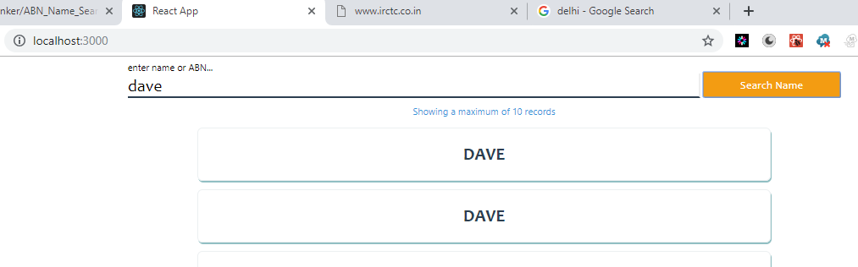

* + Search By ABN - 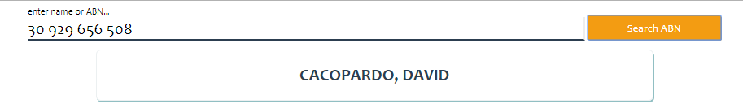
  + **Note** the same button shows **‘Search Name’** or **‘Search ABN’** text based on the input on the textbox
  + User can click on any of the search result which will expand the result - 