<https://udacity.com/>

* Logout

**PROJECT**

Finding Donors for CharityML

A part of the Machine Learning Engineer Nanodegree Program

|  |  |
| --- | --- |
| * **PROJECT REVIEW** | * **NOTES** |

**SHARE YOUR ACCOMPLISHMENT**

Requires Changes

**1 SPECIFICATION REQUIRES CHANGES**

Overall really great job! There's just one point that needs to be revised further, but you've got a really solid foundation here to build from.

Keep at it - we look forward to your revision.

**Exploring the Data**

**Student's implementation correctly calculates the following:**

* **Number of records**
* **Number of individuals with income >$50,000**
* **Number of individuals with income <=$50,000**
* **Percentage of individuals with income > $50,000**

Great work here!

You can also use the value_counts method to get your label counts.

n_at_most_50k, n_greater_50k = data.income.value_counts()

**Preparing the Data**

**Student correctly implements one-hot encoding for the feature and income data.**

Great job implementing get_dummies!

**TIP**

It doesn't provide a ton of benefit in this situation, but it's definitely worth checking out the [LabelEncoder](http://scikit-learn.org/stable/modules/generated/sklearn.preprocessing.LabelEncoder.html) class provided by sklearn. This class will do all the legwork in ordinally encoding your variables, so it's massively helpful when you have a ton of output classes.

You can apply it like so

encoder = LabelEncoder()

income = encoder.fit_transform(income_raw)

**Evaluating Model Performance**

**Student correctly calculates the benchmark score of the naive predictor for both accuracy and F1 scores.**

**The pros and cons or application for each model is provided with reasonable justification why each model was chosen to be explored.**

**Please list all the references you use while listing out your pros and cons.**

Overall really fantastic work here! The only major issue is that you chose "Ensemble Methods" as your last model. This isn't one model though, this is an entire suite of models. Each ensemble method has very different strengths and weaknesses - for example, some are very sensitive to noise and outliers, some can be parallelized for speed, etc. You should pick one ensemble method in particular and discuss it in more detail.

It looks like you chose AdaBoost to implement below, so you should discuss that model to keep your project aligned.

**Student successfully implements a pipeline in code that will train and predict on the supervised learning algorithm given.**

**Student correctly implements three supervised learning models and produces a performance visualization.**

**Improving Results**

**Justification is provided for which model appears to be the best to use given computational cost, model performance, and the characteristics of the data.**

**Student is able to clearly and concisely describe how the optimal model works in layman's terms to someone who is not familiar with machine learning nor has a technical background.**

Really great work here, this is probably the hardest part of the project 

Being able to explain a model in simple terms is a really important asset in business, as many of the people you'll be working with won't have the technical background you do. For this reason you should try to get a similar handle on other popular ML models.

You can use the resources provided below to get a head start in this.

<https://rayli.net/blog/data/top-10-data-mining-algorithms-in-plain-english/>

<http://blog.echen.me/2011/03/14/laymans-introduction-to-random-forests/>

<https://prateekvjoshi.com/2014/05/05/what-is-adaboost/>

<http://xgboost.readthedocs.io/en/latest/model.html>

**The final model chosen is correctly tuned using grid search with at least one parameter using at least three settings. If the model does not need any parameter tuning it is explicitly stated with reasonable justification.**

Great work!

Another search technique worth looking at is the [RandomizedSearchCV](http://scikit-learn.org/stable/modules/generated/sklearn.model_selection.RandomizedSearchCV.html). The difference between this method and the typical grid search method is that the Randomized Search actually doesn't search every value. Instead, it samples random subsets.

At first glance, you might wonder why we'd ever use this over a grid search, but it turns out that in practice this method often gets very close to an optimal value in a fraction of the time. So it's great when we have a ton of hyperparameters. Another benefit is that it can sample from value distributions rather than lists of pre-determined values.

If you're interested, I highly recommend reading the blog post below. It does a phenomenal job of illustrating why you'd want to use a Random Search over a Grid Search.

<https://medium.com/rants-on-machine-learning/smarter-parameter-sweeps-or-why-grid-search-is-plain-stupid-c17d97a0e881>

**Student reports the accuracy and F1 score of the optimized, unoptimized, models correctly in the table provided. Student compares the final model results to previous results obtained.**

**Feature Importance**

**Student ranks five features which they believe to be the most relevant for predicting an individual's’ income. Discussion is provided for why these features were chosen.**

Nice job! Your feature choices are logical and intuitive 

**Student correctly implements a supervised learning model that makes use of the feature_importances_ attribute. Additionally, student discusses the differences or similarities between the features they considered relevant and the reported relevant features.**

Great work here! It's always great to try an intuitively analyze our data in addition to our raw quantitative analysis. Getting a good feel for the data is almost always a benefit in practice.

TIPS

There are a ton of other methods we can use to extract the feature importances in our data. You might remember some of the simpler univariate methods like [SelectKBest](http://scikit-learn.org/stable/modules/generated/sklearn.feature_selection.SelectKBest.html) and [SelectPercentile](http://scikit-learn.org/stable/modules/generated/sklearn.feature_selection.SelectPercentile.html).

We can also try more complex methods like [Recursive Feature Elimination](http://scikit-learn.org/stable/modules/generated/sklearn.feature_selection.RFE.html). This technique recursively cuts out the feature that contributes least to the model, and then re-evaluates the model after the elimination. This process repeats until we have the desired number of features.

If you're interested in checking this technique or others, take a look at the posts below

<http://blog.datadive.net/selecting-good-features-part-iv-stability-selection-rfe-and-everything-side-by-side/>

<https://topepo.github.io/caret/recursive-feature-elimination.html>

**Student analyzes the final model's performance when only the top 5 features are used and compares this performance to the optimized model from Question 5.**

Great work! It's worth mentioning that in instances where we really value training time, we can also elect to try a simpler model. Sometimes reducing the feature space on complex models can result in worse performance and worse training time.

RESUBMIT PROJECT

[**DOWNLOAD PROJECT**](https://review-api.udacity.com/api/v1/submissions/1017275/archive)

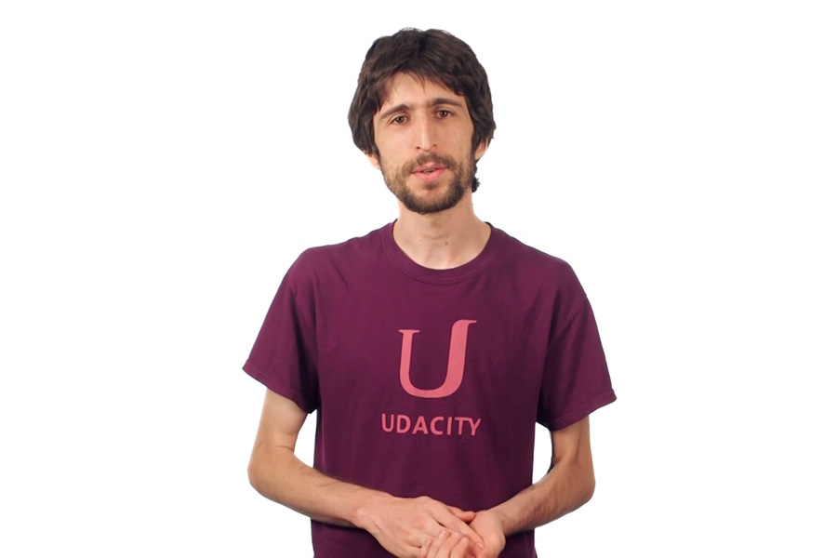

**Best practices for your project resubmission**

Ben shares 5 helpful tips to get you through revising and resubmitting your project.

 Watch Video (3:01)

RETURN TO PATH

**Student FAQ**