Udacity Machine Learning Nanodegree Program – Final Capstone Project Report

Stock Price Prediction Using Machine Learning

Shib Shankar Golder August 9, 2018

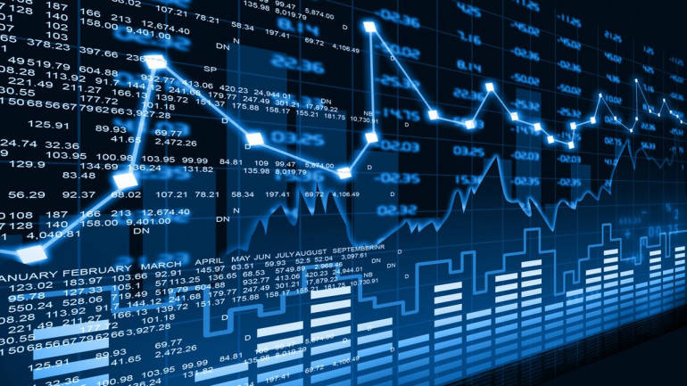

Quotes

***Warren Buffett - “****Risk comes from not knowing what you are doing.”****Peter Sondergaard –*** *“Information is the oil of the 21st century, and analytics is the combustion engine.”*

***Peter Lynch -*** *"Know what you own and know why you own it."*

Table of Contents

1. Definition 3

1.1. Project Overview 3

1.2. Problem Statement 3

1.3. Metrics 3

2. Analysis 3

2.1. Data Exploration 3

2.2. Exploratory Visualization 3

2.3. Algorithms and Techniques 3

2.4. Benchmark 3

3. Methodology 3

3.1. Data Preprocessing 3

3.2. Implementation 3

3.3. Refinement 3

4. Results 3

4.1. Model Evaluation and Validation 3

4.2. Justification 3

5. Conclusion 3

5.1. Free-Form Visualization 3

5.2. Reflection 4

5.3. Improvement 4

# Definition

### Project Overview

### Problem Statement

### Metrics

# Analysis

### Data Exploration

### Exploratory Visualization

### Algorithms and Techniques

### Benchmark

# Methodology

### Data Preprocessing

### Implementation

### Refinement

# Results

### Model Evaluation and Validation

### Justification

# Conclusion

### Free-Form Visualization

### Reflection

### Improvement