LUWA - Learning Using What you Already know

# Overview

LUWA is an innovative AI-based Learning Management System (LMS) that revolutionizes how users learn new programming languages. Unlike conventional platforms that follow a one-size-fits-all approach, LUWA dynamically adapts the learning journey by recognizing a learner's prior knowledge—whether it be in other programming languages or even related domains.  
  
By leveraging a pre-trained AI model, LUWA crafts customized learning paths and applies the most effective teaching methods tailored to a user's skill level: basic, intermediate, or advanced. Whether the user is a complete novice or an experienced developer exploring new languages, LUWA provides a seamless, personalized learning experience that evolves with the learner.

# Problem Statement

Conventional digital learning systems offer various methodologies like gamification, performance tracking, and personalized content. However, they often fail to harness a learner's existing knowledge base from different domains. This results in:  
  
- Slower comprehension  
- Repetitive content  
- Limited engagement  
  
LUWA addresses this by recognizing and utilizing the learner’s pre-existing expertise to:  
- Optimize content relevance  
- Enhance engagement  
- Shorten the learning curve

# Objectives

- Design a web-based platform suitable for students, professionals, educators, and self-learners.  
- Collect and assess user interests and pre-existing domain knowledge.  
- Classify learners by skill level: Basic, Intermediate, Advanced.  
- Generate AI-curated learning paths tailored to the user's input.  
- Continuously adapt teaching methods based on real-time progress.  
- Provide clean, intuitive, and error-free UX across the platform.

# Key Features

## User Registration & Profile Management

* - Secure signup/login with OAuth support
* - Profile configuration to include known programming languages, areas of interest, and learning goals

## Personalized Learning Path

* - Dynamic syllabus generation based on known language(s)
* - Progressive difficulty tiers customized for the user

## AI-Driven Methodology

* - Pre-trained AI selects ideal teaching format: analogies, interactive challenges, or text/video-based instructions
* - Content analogy: Teaching Java through Python if the user knows Python

## Progress Tracking & Analytics

* - Real-time dashboards displaying topic-wise mastery
* - Daily/weekly learning reports with improvement suggestions

## Error-Free Experience

* - User-centric UI/UX design
* - Mobile-friendly and responsive interface
* - Bug-free navigation ensured through extensive testing

# Project Structure (React-based Frontend)

src/  
├── App.js # Entry component rendering main routes  
├── App.css # Global styling  
├── index.js # App entry point to DOM  
├── index.css # Base styles  
├── Components/ # Reusable UI components  
│ ├── Analysis.js # Progress analysis & feedback  
│ ├── Chart.js # Visual progress analytics (charts/graphs)  
│ └── ... # Additional modular UI components  
├── utils/ # Utility functions (future AI logic)  
├── services/ # API integration (auth, course fetch)  
├── assets/ # Static resources like logos/images  
└── tests/ # Unit and integration tests

# Tech Stack

- Frontend: ReactJS  
- Backend: Node.js + Express  
- Database: MongoDB

# Output

**User Login**

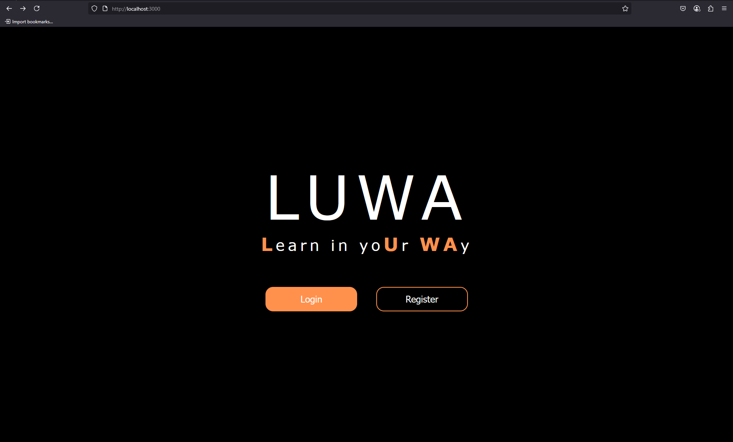

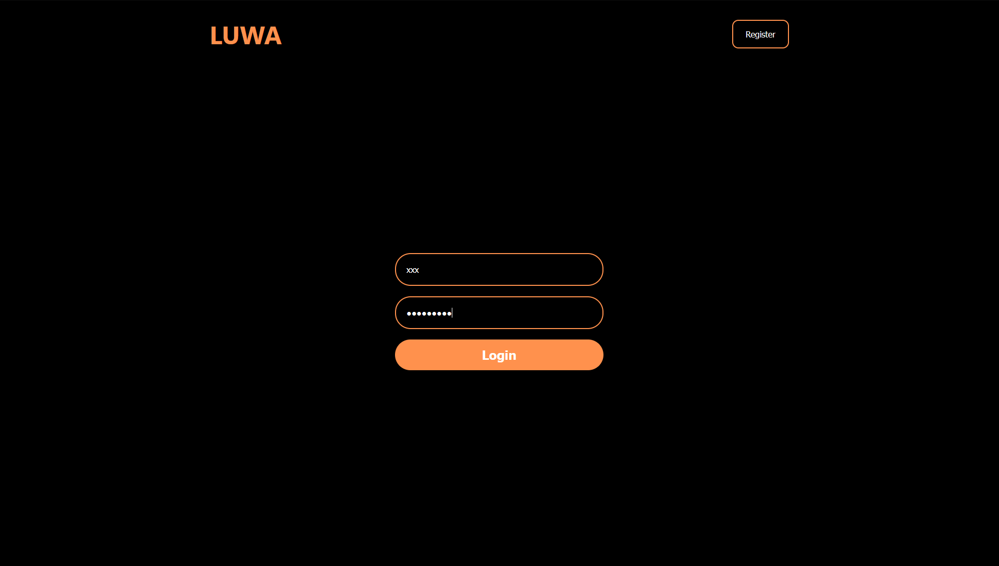

**User Registration**

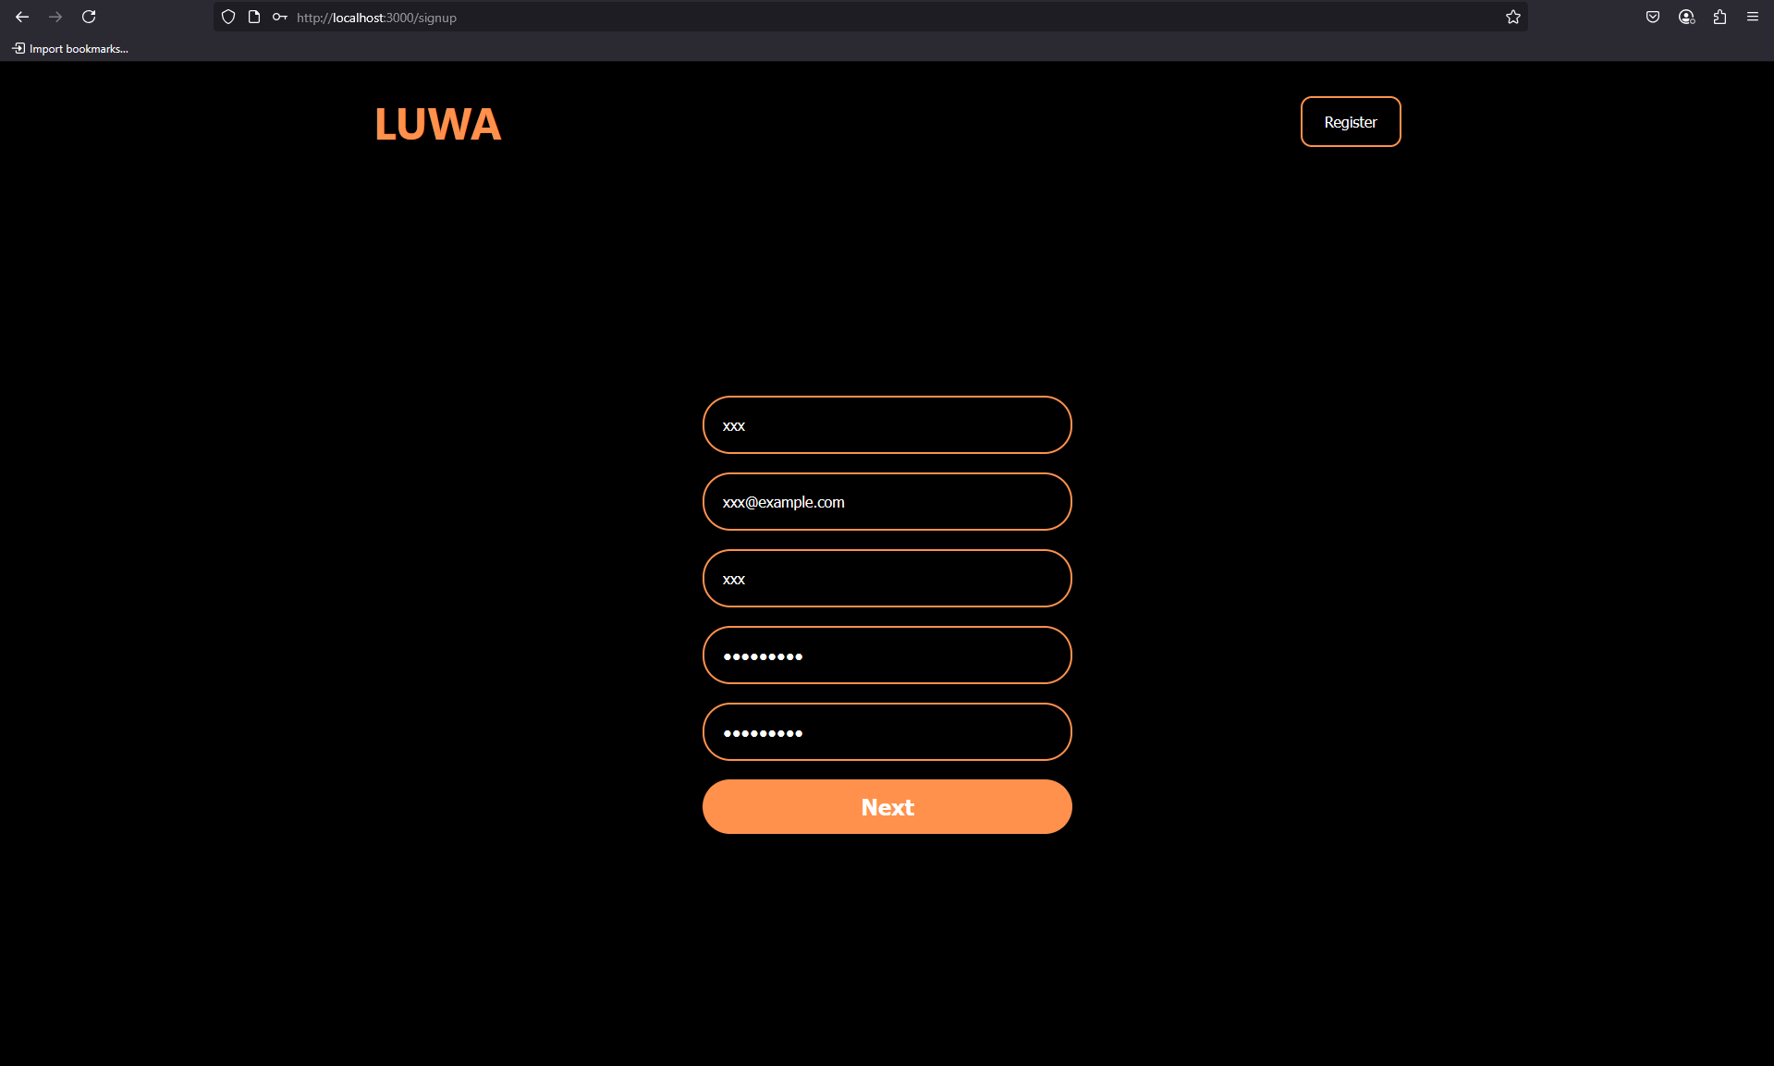

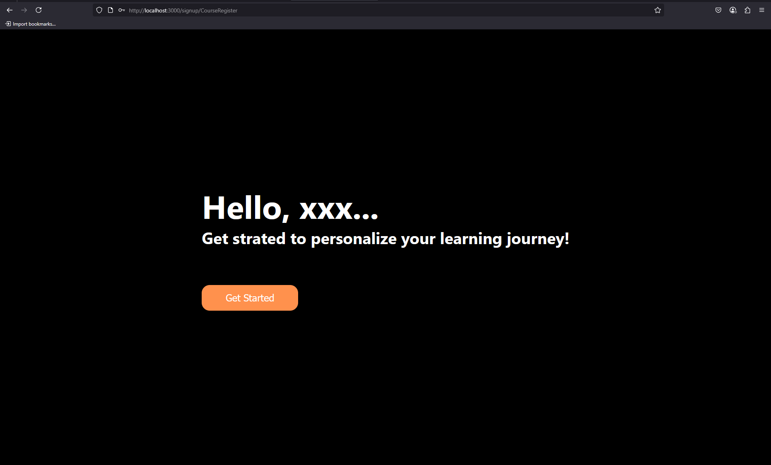

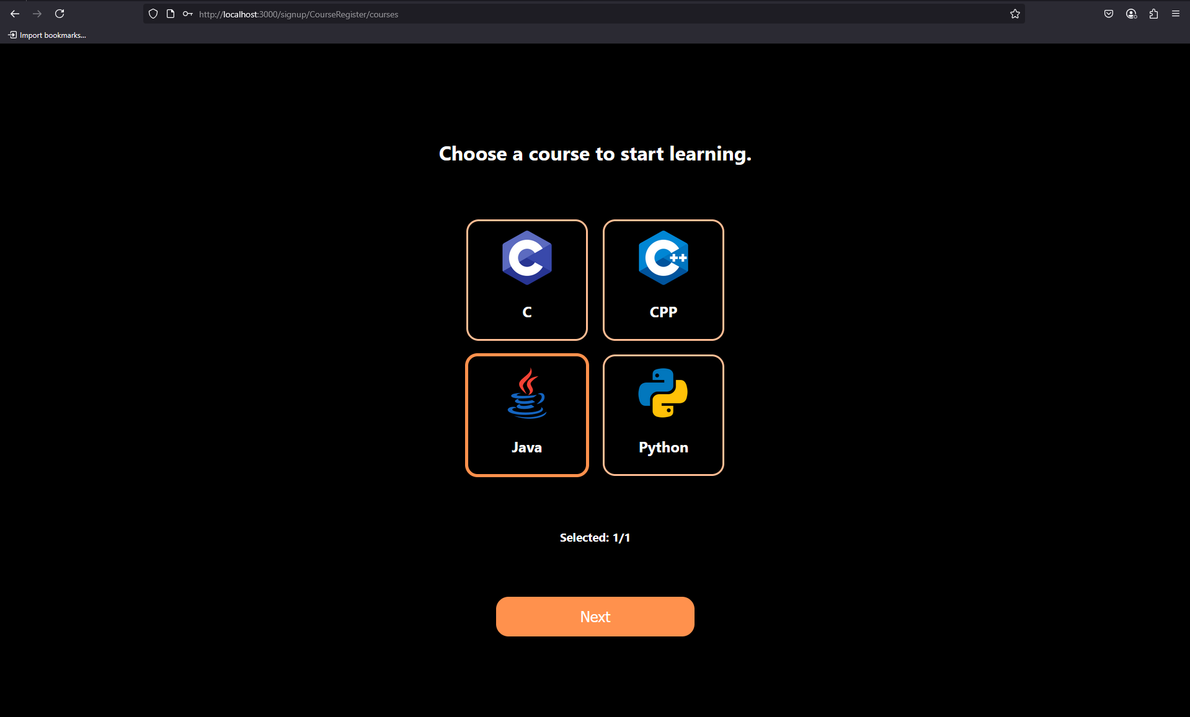

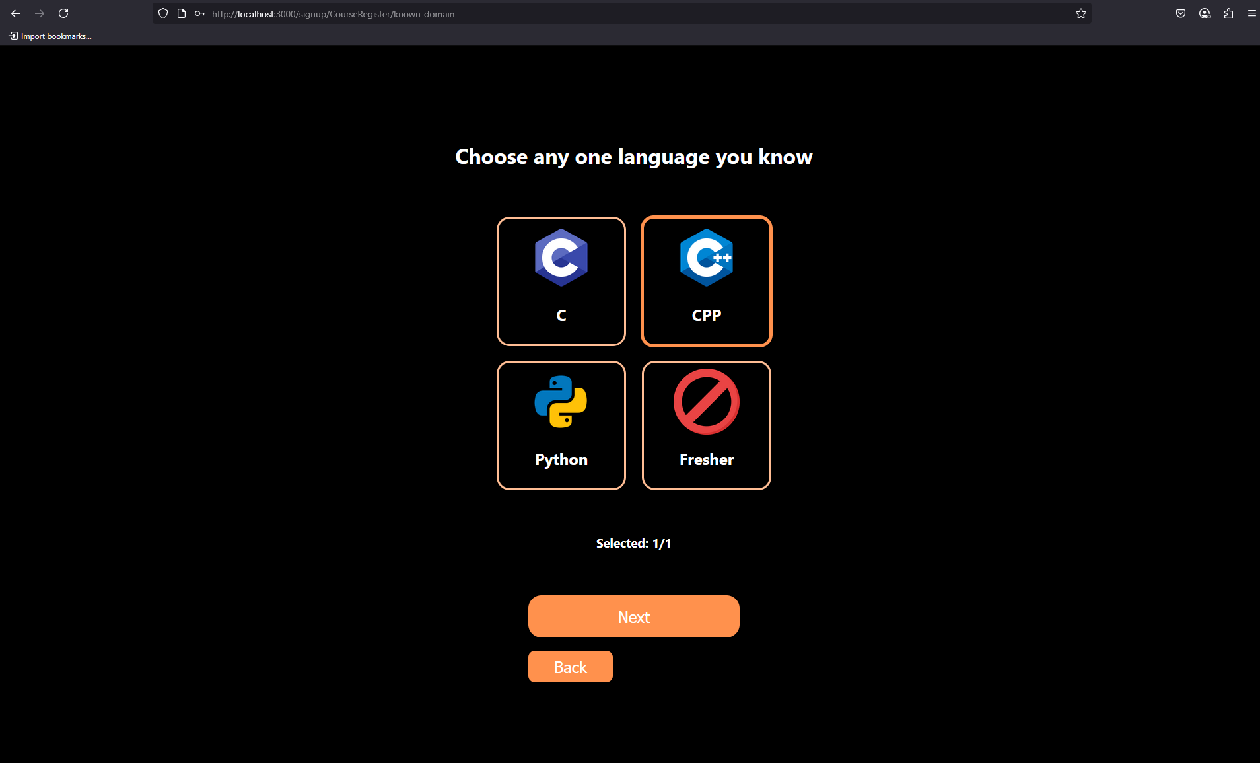

# 

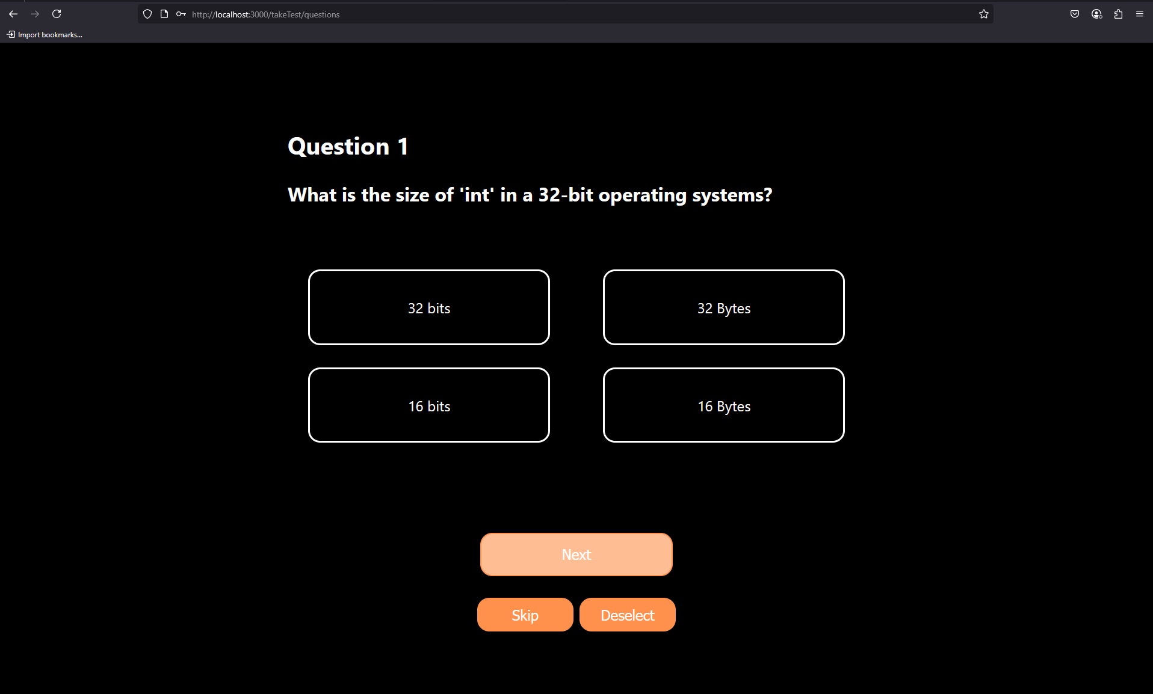

# Conclusion

LUWA doesn’t just teach — it adapts. It transforms programming education into a dynamic dialogue between what you know and what you’re about to master. Designed for clarity, powered by AI, and focused on learner success, LUWA is more than a platform — it’s a learning revolution in motion.