

PERINTHALMANNA

MAIN PROJECT REPORT
TOPIC

Product Management Dashboard

SUBMITTED TO | SUBMITTED BY
NAME OF TRAINER: | NAME: Muhammad Anshid T

REG. NO: 1784455
COURSE: GCEFWDASPNET24
EMAIL: muhammadanshid2005@gmail.com DATE OF SUBMISSION: 5-12-2025

ABSTRACT

This project presents a complete user authentication system built using the MERN stack, combining React for the frontend interface and Express with MongoDB for backend operations. Axios is used to enable smooth and efficient communication between the client and server, allowing secure transmission of user information during registration and login. The backend is designed with Mongoose to structure and manage user data, while Multer and Cloudinary are integrated for handling and storing user profile images in a scalable and optimized manner. CORS is implemented to ensure safe interaction between the frontend and backend, and Nodemon enhances the development process by enabling automatic server restarts. Overall, the system provides a secure, reliable, and user-friendly environment for managing user accounts, demonstrating the practical use of modern web technologies to build a fully functional authentication platform.

INDRODUCTION
The MERN-based user authentication system is developed to provide a secure and efficient platform for managing user login and registration processes. Modern web applications require reliable identity verification, and this project demonstrates how React, Express, MongoDB, and Node.js work together to achieve that goal. The frontend, built with React, offers an intuitive and responsive user interface, while Axios enables smooth communication with the backend server. The backend, powered by Express and connected to MongoDB through Mongoose, handles data storage, user validation, and authentication logic. To support image uploads, Multer processes incoming files, and Cloudinary stores them safely in the cloud. By integrating these technologies, the system ensures a seamless, fast, and secure workflow, making it suitable for real-world applications where user account management is essential.

SYSTEM ANALYSIS
System Analysis is the process of studying and understanding an existing system to identify its components, operations, and limitations in order to develop an improved or new system. It involves examining how inputs are transformed into outputs, understanding workflows, and assessing the interaction between people, processes, and technology. The main goal of system analysis is to find problems or inefficiencies in the current system and define the requirements for a solution that meets organizational objectives and user needs.
Key steps in system analysis include:

- Requirement Gathering: Collecting information about the current system from users, stakeholders, and documentation.

- Feasibility Study: Evaluating whether the proposed system is technically, economically, and operationally viable.

- Data Analysis: Studying the flow of information, processes, and data structures within the system.

- Problem Identification: Detecting inefficiencies, redundancies, or errors in the current system.

- System Modeling: Representing the system using diagrams or charts to visualize processes and workflows.

SYSTEM DESIGN
The system is designed using a layered architecture that separates the application into three main components: the front-end, back-end, and database. Each layer performs a specific role and communicates with the others through well-defined interfaces, ensuring modularity, scalability, and ease of maintenance.
- Front-End (React)

The front-end is built using React, which provides a component-based structure for creating a dynamic and responsive user interface. Users interact with forms, buttons, and views that update in real-time through React’s state management. Each component sends and receives data through API requests handled by the back-end. The UI is designed to be intuitive, ensuring smooth data entry, display, and validation.
- Back-End (Express Server)

The server layer is implemented using Express, which acts as the bridge between the front-end and the database. It contains routes and controllers that process client requests and manage the application logic. The server:
  - Receives API calls from the front-end

  - Validates user data

  - Interacts with the database

  - Sends back formatted responses

Express enables the application to maintain clean RESTful endpoints such as
/api/create, /api/read, /api/update, and /api/delete.

- Database (MongoDB)

The database layer uses MongoDB, a flexible NoSQL database that stores data in collections and documents. MongoDB is chosen for its scalability, simplicity, and schema-less structure, allowing the application to adapt to changing data needs. The server communicates with the database through Mongoose, which provides schemas, models, and query methods to ensure consistent data handling.
- Data Flow

- The user performs an action on the React interface (e.g., adding or viewing data).

- React sends a request to the Express server via REST API.

- The Express server processes the request and interacts with MongoDB.

- MongoDB returns the required data or confirmation.

- The server sends a response back to the front-end.

- React updates the UI based on the server’s response.

- System Architecture

The overall system follows a client–server model, where:

  - The client (React) handles presentation.

  - The server (Express) handles logic and routing.

  - The database (MongoDB) handles storage.

This structure keeps the system organized, scalable, and easy to extend with new features.

SCREEN SHOT

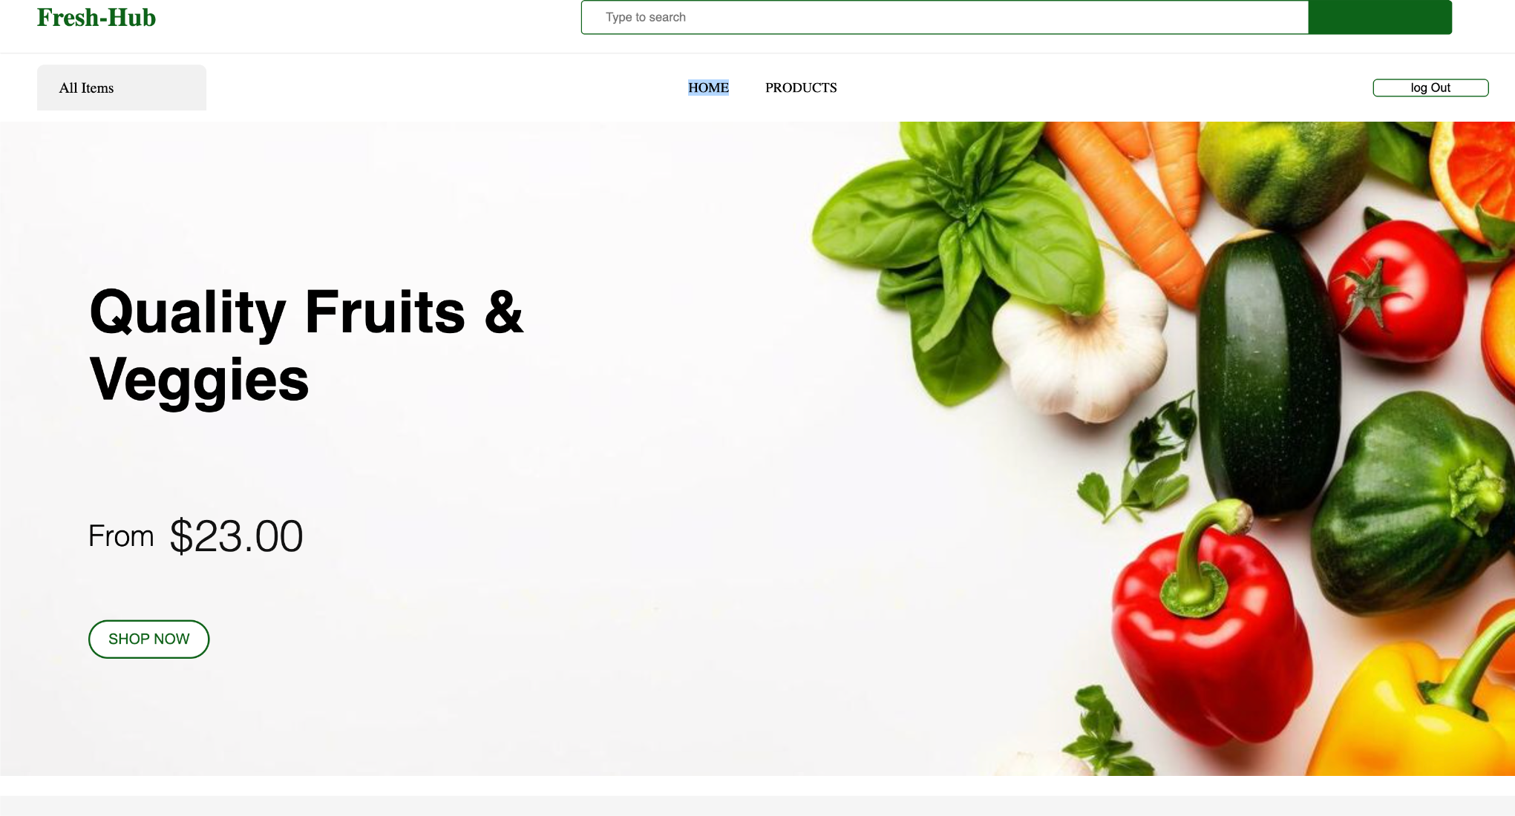

Header Section (My Design)
At the top, I added a clean navigation bar that includes:

My project logo – “Fresh-Hub”
  - A search bar where users can type and search items Navigation links: HOME and PRODUCTS
  - A Log Out button at the right for user session handling

This header helps the user move around the application easily.

Category/Menu Bar

Right below the header, I placed a small category selector:

All Items

I plan to expand this later to include more categories like Fruits, Vegetables, Snacks, etc.

Hero Section (Main Banner I Created)

This is the main highlight of my home page.

Left Side:

  - A large text: "Quality Fruits & Veggies"

  - A price label showing From $23.00

  - A SHOP NOW button for user interaction

Right Side:

  - A colorful image of fresh vegetables that I used to make the page more visually appealing.

This section is designed to display the main theme of my store and attract users.

Purpose of This Page in My Project
This homepage is part of the user side of my MERN project. I built it to:
  - give users a clean welcome page

  - show main items visually

  - allow them to search for products

  - guide them into browsing the full product list

It is fully connected with my backend and is part of my Product Management Dashboard system.

  - highlight main product categories,

  - guide users to start shopping.

Overall Purpose of This Page
This is the User Homepage of your MERN project. It serves to:
  - welcome the user,

  - introduce the store,

  - show main product categories,

  - encourage shopping,

  - give easy access to search and product browsing.

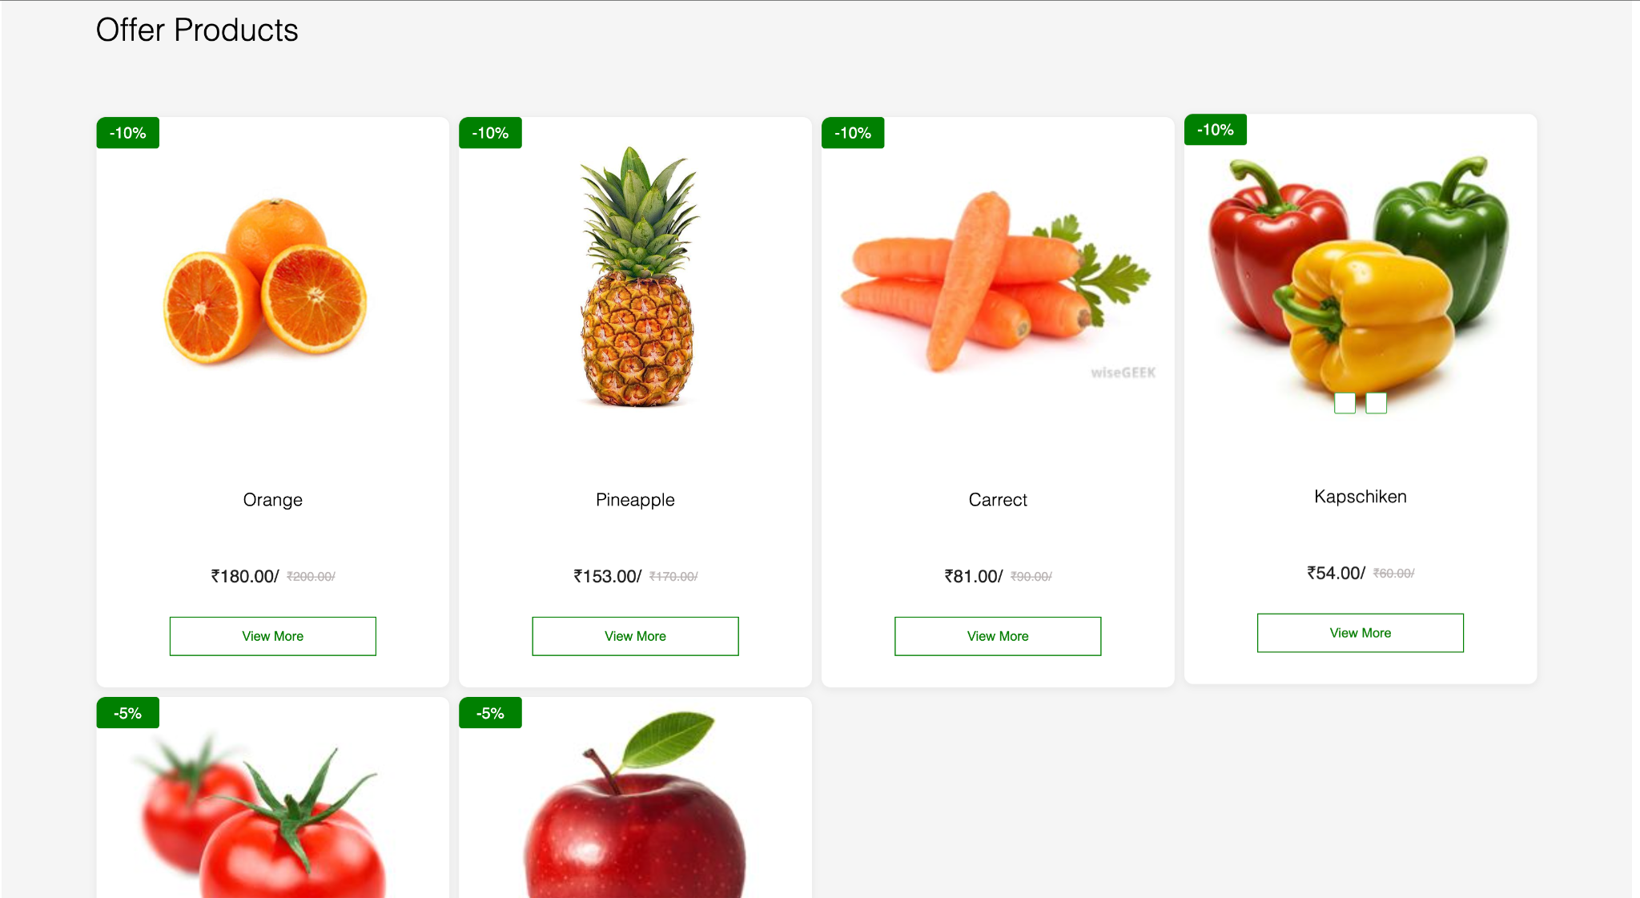

Section Title

At the top, I added:

Offer Products

This lets users know that the products in this area are being sold at special prices.

Product Cards (My Design)

Each product is displayed inside a card layout, and every card includes:

Green Discount Badge

Example:

-10%

  - -5%

This makes the discount more noticeable.

Product Image

A clean, high-quality image for each product such as:

  - Orange

  - Pineapple

  - Carrot

  - Capsicum

  - Tomato

  - Apple

The images help make the design attractive and easy to understand.

Product Name

Displayed clearly below the image.

Price Section

Each card shows:

  - Offer Price (bold)

  - Old Price (strikethrough)

Example:
₹180.00 / ₹200.00

This gives users a clear idea of the discount.

View More Button

Each product has a View More button that takes the user to the detailed product page.
I added this for better navigation and to give users more product information.

Layout
The cards are arranged in a clean grid layout, making everything easy to browse.
The spacing and white background make the section look modern and professional.

Purpose in My Project
I built this Offer Products section to:
  - Attract users with discounts

  - Promote selected products

  - Improve UI/UX with a clean and modern layout

  - Help users quickly browse best deals

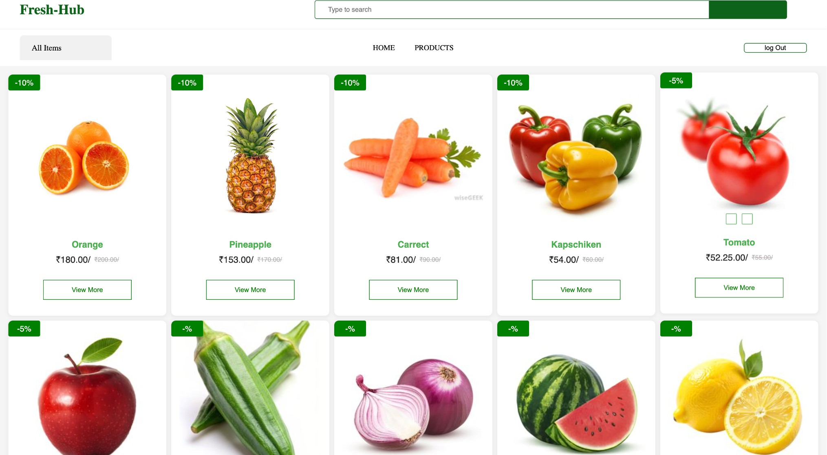

Header Section

At the top, I included:

Fresh-Hub Logo

My project name is displayed in green to match the theme of fresh products.

Search Bar

A wide search input field helps users quickly find any product.

Navigation Menu

- HOME

- PRODUCTS
Both are clickable and help users navigate through different sections of my website.

Log Out Button

Visible only when a user is logged in.

Category Filter – “All Items”

Just below the header, I added a simple filter:

All Items

This shows all available products together.

Later, I can expand this to filters like “Fruits”, “Vegetables”, “Offers”, etc.

Product Grid (Main Section)

All products are displayed in clean, card-style boxes. Each product card includes:

Discount Badge

A small green badge at the top-left shows the offer percentage:

  - -10%

  - -5%

  - sometimes shows -% for items without a defined discount

This quickly highlights which items have offers.

Product Image

Each card contains a large, high-quality image of the fruit/vegetable such as:

  - Orange

  - Pineapple

  - Carrot

  - Capsicum

It makes browsing visually attractive.

Product Name

Displayed in green text for a fresh and clean look. Example:
  - Orange

  - Pineapple

  - Carrot

  - Kapschiken

Price Display

Each product shows two prices:

- Offer Price (bold and dark)

- Old Price (strikethrough to show discount)

Example:
₹180.00 / ₹200.00

This clearly shows the savings.

View More Button

Every card has a View More button in a green outline style.

When clicked, it takes the user to the Product Details page, where full details are displayed.

Layout & Styling

I arranged all product cards in a responsive grid layout, with:

  - Rounded corners

  - Light grey card borders

  - Proper spacing

  - Clean white background

  - Green accent color for branding

The layout is easy to browse and gives a professional e-commerce look.

Purpose of This Page in My Project

I created this product listing page to:

  - Display all products available in my Fresh-Hub app

  - Show offers and discounts clearly

  - Provide a clean UI for browsing

  - Connect to backend API for dynamic data

  - Allow users to open detailed product pages

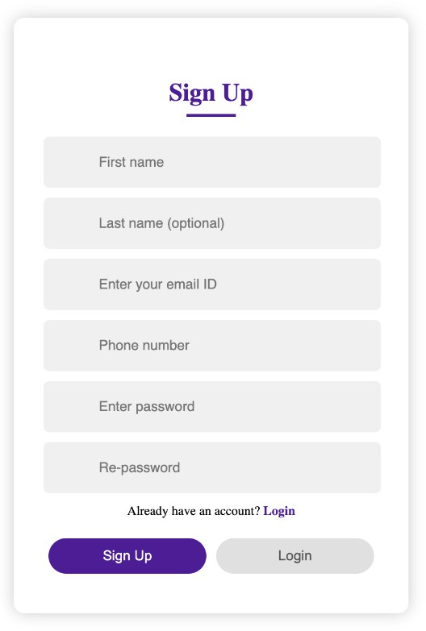

Page Structure

The Sign-Up form is centered on the screen with a white card and soft shadow, giving a modern and minimal look.
The title “Sign Up” is placed at the top with an underline to highlight the heading.

Input Fields Explained

The form includes the required details needed to create a user account:

First Name

Basic identity detail of the user.

Last Name (optional)

This field is optional, giving flexibility for users who prefer not to share it.

Email ID

Used for:

- login authentication

- sending notifications

- account verification

Phone Number

Additional contact information; can also be used for OTP login if needed.

Password

A secure password chosen by the user.

Re-password (Confirm Password)

Ensures that the user enters the correct password without mistakes.

All fields have soft grey background and rounded corners to keep the design clean.

Login Redirect

Below the fields, the page shows:

Already have an account? Login

This helps users who accidentally landed on the registration page to quickly move to the login page.

Action Buttons

At the bottom, two buttons are displayed:

Sign Up

  - Main action button

  - Colored in purple to highlight importance

  - Submits user data to backend (Express + MongoDB)

Login

  - Secondary button

  - Takes user to the Login page

Both buttons are rounded and styled consistently.

Purpose of This Page in My System

The Sign-Up page is where a new user enters their details and creates an account.
It connects to the backend (Node.js + Express) and stores user information in

MongoDB. It ensures:
  - Secure account creation

  - Error-free data input with validations

  - Smooth flow toward logging in and accessing the main website

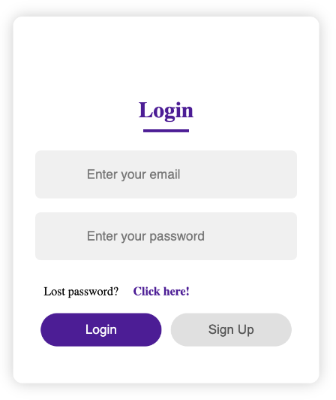

Purpose of This Login Page

The purpose of this page is to allow:

Users

to log in using their email and password.

Admin (Optional)

If your backend supports admin login, the same login form can also be used by admin by checking their role in the database.
So this page works as both:

User Login

  - Admin Login
(depending on credentials saved in MongoDB)

Page Structure Explanation

Page Title – "Login"

Centered at the top with an underline.
It helps the user understand the function of the page immediately.

Input Fields

Enter your email

The user/admin enters the registered email address.

Enter your password

A password field to ensure secure login.

Both fields have a light grey background and smooth rounded edges to match your theme.

Login Button

The purple-colored button is the main action button. When pressed, the system will:
  - Validate email + password

  - Check the database (MongoDB)

  - If matches → redirect to dashboard

  - If admin → redirect to admin panel

  - If wrong → show error message

This is the primary function of the login page.

Sign Up Button

The grey button takes the user back to the registration page. This button helps users who don’t have an account yet.

How It Works in Your System

- User/Admin enters email + password

- Frontend (React) sends data to backend (Express)

- Backend checks MongoDB

- If credentials match:

  - Regular user → goes to home/products page

  - Admin → goes to admin dashboard (if available)

- Else → error message (“Invalid credentials”)

So this page is used for user login, and can also work for admin login if roles exist in the backend.
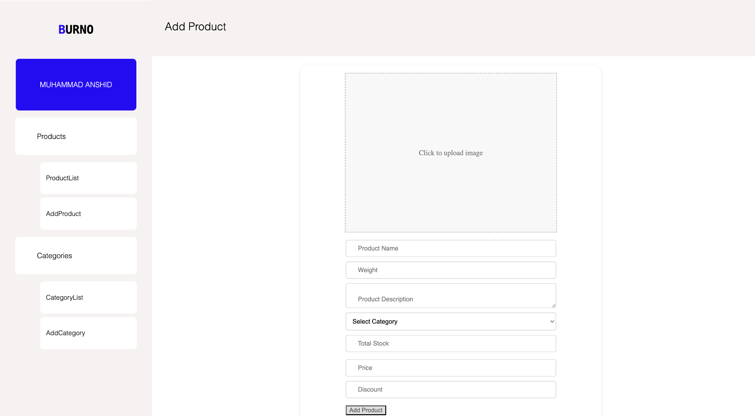

1 Top-Level Elements

- BURNO (Logo/Brand Name): The name of the platform or company. Clicking this usually takes the user to the main dashboard or home screen.
- Add Product (Page Title): Indicates the function of the current screen.

- MUHAMMAD ANSHID (User Display): Shows the name of the user currently logged into the administrative interface.

2 Navigation Sidebar (Top-to-Bottom)

- Products (Header/Group): A main section or group for product management options.
- ProductList (Link): A navigation link to view all existing products in a list or table format.
- AddProduct (Link/Active): The link for the current page, allowing the user to create a new product entry.
- Categories (Header/Group): A main section or group for category management options.
- CategoryList (Link): A navigation link to view all existing product categories.
- AddCategory (Link): A link to a page where a user can create a new category (e.g., "Electronics," "Footwear").

3 Main Form (Top-to-Bottom, Left-to-Right)

- Click to upload image (Placeholder): An interactive area for selecting and uploading the visual assets (photos) of the product.
- Product Name (Input Field): A text box for entering the official title of the product.
- Weight (Input Field): A text box for entering the physical weight of the product, typically used for shipping calculations.
- Product Description (Text Area): A larger input box for entering detailed information, features, and specifications about the product.
- Select Category (Dropdown): A selector that allows the user to assign the product to an organizational category from a pre-defined list.

- Total Stock (Input Field): A number field to specify the quantity of this product currently available in the warehouse/inventory.
- Price (Input Field): A number field for entering the standard selling cost of the product.
- Discount (Input Field): A number field to specify a promotional price reduction (either a fixed amount or percentage).
- Add Product (Submit Button): The button that executes the command to save all the entered data and create the new product record in the system.

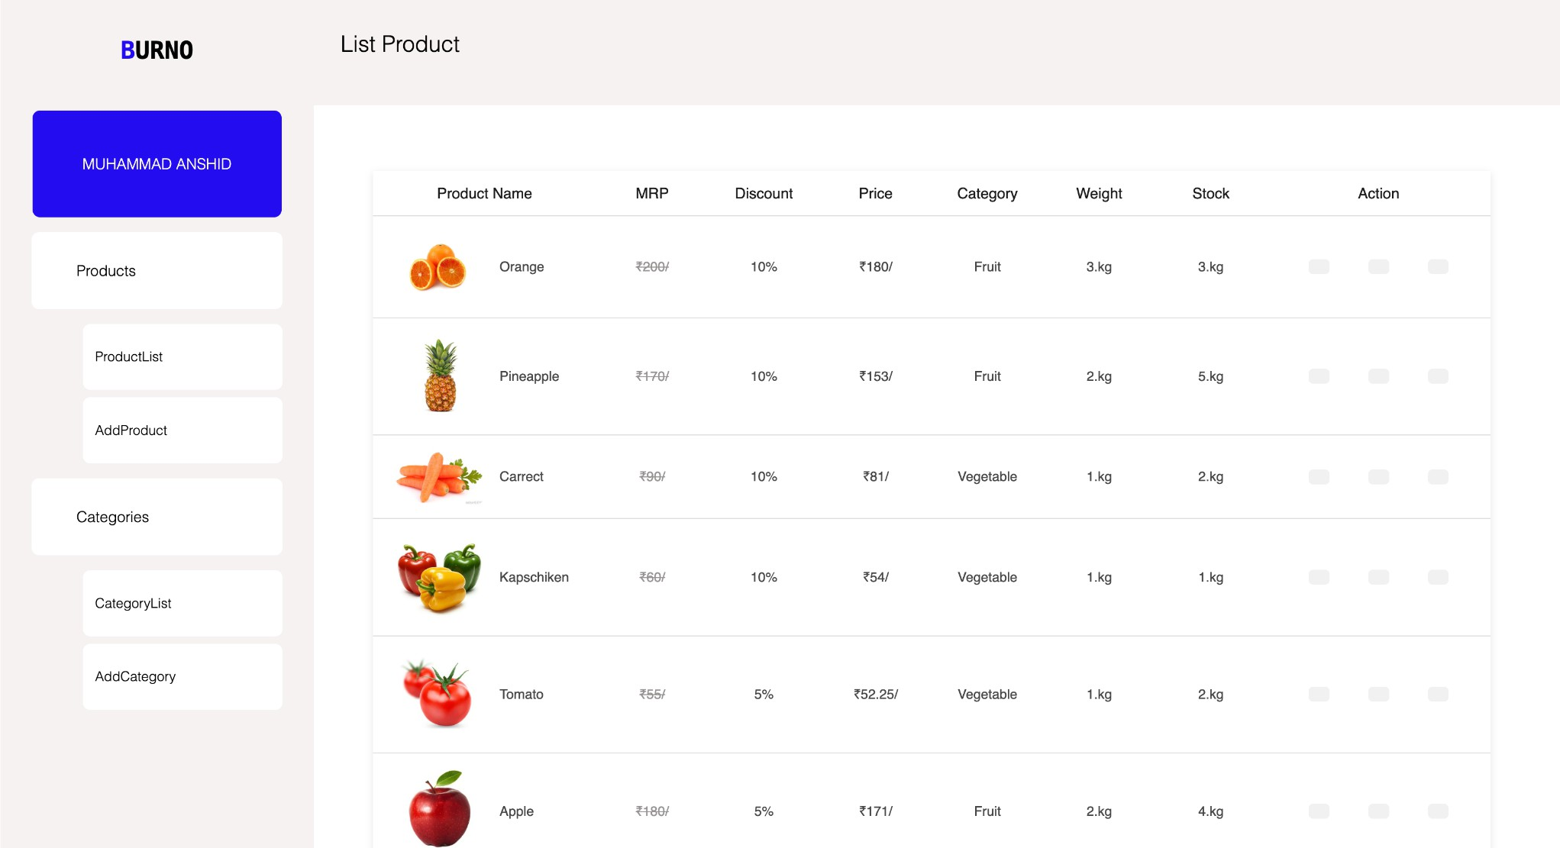

This page serves as the central Product Management Dashboard, where all existing products are displayed in a clean, organized table format.
📋 Table Structure & Data Explanation

The main section is a table listing products, primarily fruits and vegetables, with key data points:

Column Header | Data Example (e.g., Orange Row) | Purpose
Product Name | Orange (with image) | The official name and visual identifier of the item.
MRP | $\text{₹}200$ (crossed out) | The Maximum Retail Price or original suggested price before discounts. The strikethrough indicates a sale.
Discount | $10\%$ | The percentage reduction applied to the MRP to determine the final selling price.
Price | $\text{₹}180$ | The final selling price to the customer after the discount has been applied ($\text{₹}200 - 10\% = \text{₹}180$).
Category | Fruit | The classification/grouping of the product, linking to the Categories section.

Weight | $3 \text{ Kg}$ | The standard unit weight for this product entry, often used for shipping.
Stock | $3 \text{ Kg}$ | The current inventory count or quantity available in the warehouse.
Action | (Icons) | Contains buttons (represented by gray squares) to perform management actions: typically Edit, View Details, and Delete the product record.
🧭 Navigation Sidebar Context
The left sidebar confirms this is an admin panel for MUHAMMAD ANSHID:
  - Products: This group manages the items themselves.
ProductList is the current active screen.
  - Categories: This group manages the organization of the items, leading to the CategoryList and AddCategory pages.
This screen is essential for the administrator to quickly review inventory levels, pricing, and make changes to any item in the product catalog.

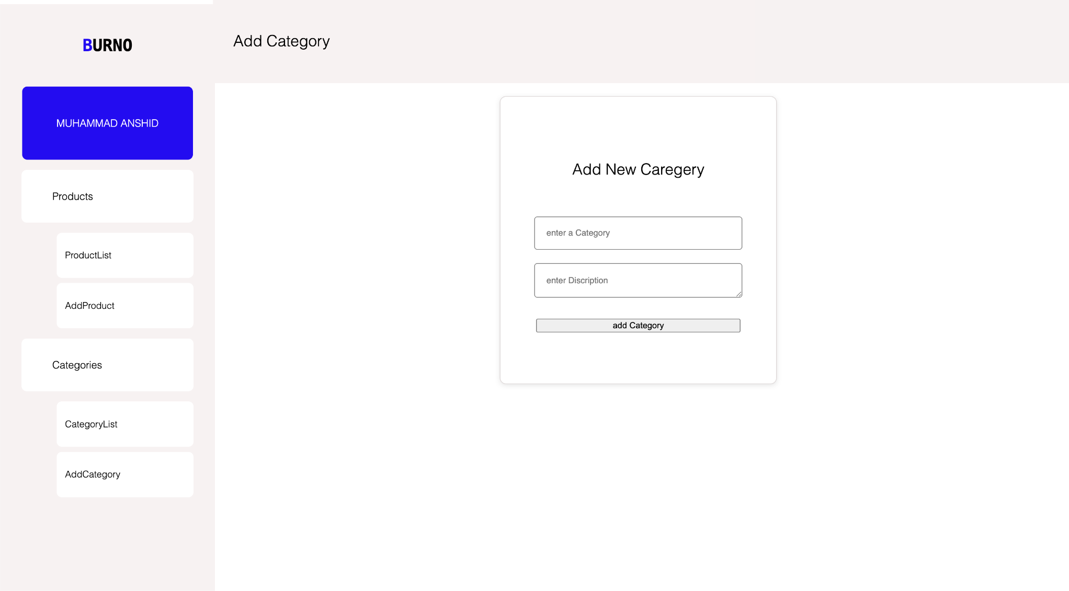

This screen's purpose is to build the organizational structure for all the products in the BURNO system.

Key Components:

  - Page Title: Add Category (Indicates the function of the form).
  - Form Title: Add New Category (A more descriptive header for the user).

Form Fields (Top-to-Bottom):

- enter a Category (Input Field):
  - Purpose: This is the text field where the administrator types the unique name for the new classification group (e.g., "Dairy," "Spices," "Bakery Items").
  - Relation to Products: This name will appear as an option in the
"Select Category" dropdown on the "Add Product" form.

enter Description (Text Area):

  - Purpose: This is a text area for providing a brief explanation or defining notes about what products belong to this new category. It helps maintain clarity across the administration team.

Add Category (Button):
  - Purpose: This is the submission button. Clicking this executes the command to save the new category name and description to the backend database.

Navigation Sidebar Context:

- The left sidebar shows the user MUHAMMAD ANSHID and the main sections.
- The AddCategory link under the Categories group is highlighted, indicating it is the current active page.
This form is a fundamental part of your project, as categories are essential for product filtering, sorting, and overall site usability.
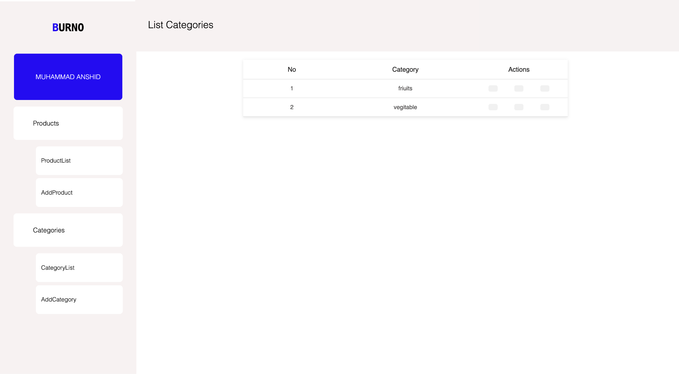

This screen functions as the management hub for all product classifications within the BURNO platform. It allows the administrator to quickly see what categories exist and perform actions on them.

Key Components
- Page Title: List Categories (Indicates the screen's primary purpose).
- Data Source: The categories displayed here are the same ones that appear in the "Select Category" dropdown on the "Add Product" form. They are created using the "Add Category" form.

Table Structure (List Categories)
The data is presented in a simple table format:

Column Header | Data Example | Purpose
No | 1, 2 | The sequential number or ID of the category record.
Category | fruits, vegetable | The name of the product classification group.
Actions | (Icons) | Contains icons (represented by gray squares) that allow the user to manage the category: typically Edit (to rename or modify the description) and Delete (to remove the category).

Data Displayed
Based on the image, the two main categories currently defined in the system are:

- fruits
- vegetable

Navigation Sidebar Context
  - The user is MUHAMMAD ANSHID.
  - The CategoryList link, under the Categories section, is the active page.
This screen is essential for maintaining the organizational structure of the e-commerce store, ensuring products are correctly grouped for both administration and customer browsing

Schema

Product

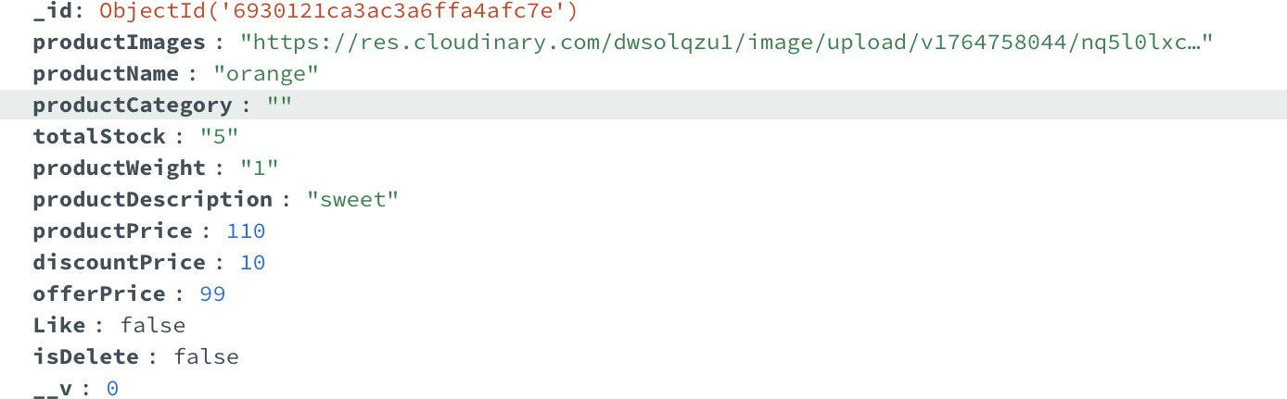

User
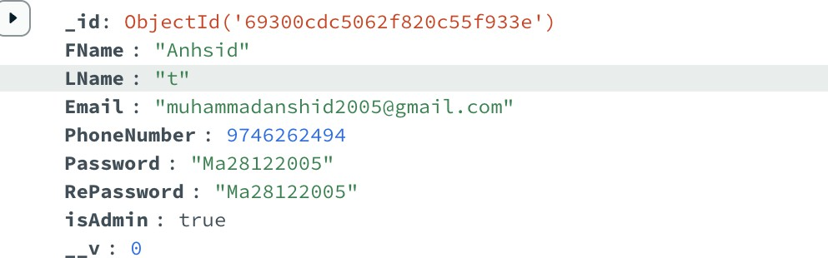

Category
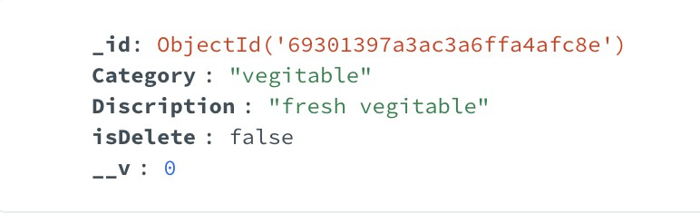

CONCLUSION

In summary, the project integrates modern web technologies such as React, Express, MongoDB, and Cloudinary to build a powerful and scalable MERN application. With properly configured dependencies and backend tools like Multer the system ensures secure data handling, efficient routing, and smooth file uploads. By maintaining a clean structure and correct package setup, the application becomes easier to manage, extend, and deploy, ensuring reliable performance and a seamless user experience.

REFERENCES
- React Official Documentation – https://react.dev

- Express.js Official Documentation – https://expressjs.com

- MongoDB Official Documentation – https://www.mongodb.com/docs

- Mongoose Documentation – https://mongoosejs.com/docs

- Cloudinary Documentation – https://cloudinary.com/documentation

- Axios GitHub Repository – https://github.com/axios/axios

- React Router Documentation – https://reactrouter.com

- Node.js Official Documentation – https://nodejs.org/en/docs

