Proceedings of the International Conference on Industrial Engineering and Operations Management
A Leakage-Aware Baseline for Bone Fracture Classification and CAM-Derived Pseudo-Mask Segmentation
Shibli Sanjid Faheem
Department of Computer Science and Engineering
Independent University, Bangladesh
shiblisanjidfaheem@gmail.com
Yousuf Abdullah
Department of Computer Science and Engineering
Independent University, Bangladesh
Abstract
This study follows a leakage-aware workflow for bone-fracture image classification and weakly supervised pseudo-mask segmentation using the single image-folder dataset available in the project repository. The audit identified 1,927 images and 1,897 unique exact-image hashes; patient identifiers and expert pixel masks were unavailable. An ImageNet-pretrained ResNet-50 was selected using validation AUC and evaluated once on the held-out test split (n=391). Test accuracy was 0.506 (95% exact-hash-group bootstrap interval 0.460-0.555), and fracture-class AUC was 0.508 (0.451-0.565). Grad-CAM maps were generated only from training images and thresholded to produce pseudo-labels. A compact U-Net was trained on 734 training pairs and selected using 184 validation pairs; its best validation Dice and IoU against held-out pseudo-masks were 0.378 and 0.267. These are pseudo-label agreement measures, not expert-mask segmentation results. The near-chance classification AUC and lack of expert annotations limit interpretation; no clinical or localization-performance claim is made.
Keywords
Bone fracture, radiographs, ResNet-50, Grad-CAM, pseudo-mask, U-Net, weak supervision
1. Introduction
Automated fracture analysis from radiographs is often studied first as image-level classification, while localization requires more detailed annotation. Image-folder labels are comparatively simple to collect, but they indicate whether an image is labeled fractured rather than where a fracture is located. A classifier can therefore produce a class prediction without providing an anatomically validated mask. Public resources such as FracAtlas and GRAZPEDWRI-DX illustrate the value of datasets with localization or expert annotations, while also showing why source and population differences must be considered (Abedeen et al. 2023; Nagy et al. 2022).
Class activation maps can provide spatial evidence associated with a classifier decision (Selvaraju et al. 2017). However, a discriminative response map is not equivalent to a complete fracture annotation: its resolution, threshold, and classifier errors can all affect the apparent region. Training a segmentation network on such thresholded maps measures its ability to reproduce the generated targets, not its agreement with expert anatomy.
This paper reports the completed repository workflow as a preliminary empirical baseline. It separates the held-out classification evaluation from the train-only CAM and U-Net experiment, reports uncertainty for classification at the exact-image-hash group level, and treats pseudo-mask metrics as internal agreement only.
1.1 Objectives
The study has four objectives:
to audit the available image folders, exact duplicates, and presence of candidate expert masks;
to train an ImageNet-initialized ResNet-50 and report held-out classification performance with group-bootstrap intervals;
to generate Grad-CAM pseudo-masks exclusively from training images and train a compact U-Net without accessing the test split; and
to distinguish pseudo-label agreement from expert-mask segmentation performance and identify the evidence still needed.
2. Literature Review
Residual networks provide a widely used transfer-learning backbone for image classification (He et al. 2016). Gradient-weighted class activation mapping uses gradients at a convolutional layer to form a class-specific localization map (Selvaraju et al. 2017). Such maps can be useful for visualization and weak supervision, but they should not be treated as expert labels without independent validation.
U-Net is an encoder-decoder architecture developed for biomedical image segmentation (Ronneberger et al. 2015). Its performance depends on the target masks used for training and evaluation. When CAM-derived targets are used, the resulting validation score describes agreement with those targets, and inherits their omissions and false activations.
Shortcut learning is a general risk when predictive image cues do not represent the intended clinical feature (Geirhos et al. 2020). Exact-hash grouping can prevent literal duplicate leakage but does not identify related studies or patients. The present experiment therefore uses hash grouping as a limited safeguard rather than a substitute for patient-level splitting.
Table 1: Positioning of the present workflow against relevant model roles
Approach | Supervision or output | Evaluation scope in this study
ResNet-50 (He et al. 2016) | Image-level class labels | Held-out test classification
Grad-CAM (Selvaraju et al. 2017) | Class-conditioned activation map | Training-only pseudo-mask generation
U-Net (Ronneberger et al. 2015) | Dense segmentation prediction | Validation agreement with pseudo-masks
This workflow | Image labels to CAM pseudo-labels to U-Net | No expert-mask localization benchmark

3. Methods
The workflow comprises data inventory and exact-hash checks, image-level classifier training, training-only Grad-CAM generation, threshold-based pseudo-mask creation, and U-Net training. The classification test split was used only for the classifier evaluation. It was excluded from CAM target generation and segmentation training.
3.1 Data inventory and leakage-aware preparation
The dataset is organized into train, validation, and test directories with fractured and not-fractured labels. The manifest contains 1,927 image files and 1,897 unique SHA-256 image hashes. The original folder split contains 936 train, 600 validation, and 391 test files. The audit found no exact-hash groups crossing the original splits and no conflicting labels within duplicate groups. No candidate expert pixel masks, patient identifiers, or study identifiers were available. Exact hashes cannot rule out transformed near-duplicates or repeated patients.
3.2 Classifier training
An ImageNet-pretrained ResNet-50 with a new two-class head was trained using the image-level labels. Grayscale radiographs were converted to three channels, resized to 224 by 224 pixels, and normalized with ImageNet statistics. Training used class-balanced sampling, AdamW, a batch size of 16, head learning rate 1e-3, backbone learning rate 1e-5, and weight decay 1e-4. The classifier used seed 0, two head-warmup epochs, and ten total epochs. The checkpoint was selected by validation fracture-class AUC; epoch 5 was selected. The test split was not used for checkpoint selection or threshold tuning.
3.3 CAM generation and pseudo-mask construction
Grad-CAM maps were generated for the 918 unique training images only. A global threshold of 0.35 converted each map into a binary pseudo-mask. No validation or test image was used to create a training target. These maps are classifier-derived noisy labels and are not expert delineations.
3.4 U-Net training
The compact U-Net was trained on 734 training image-pseudo-mask pairs and validated on 184 separate pairs. The split was formed by exact-image-hash groups from the original training partition. Inputs were grayscale images resized to 128 by 128 pixels; training used batch size 8 and seed 42 for three epochs. The selected checkpoint was the epoch with highest validation Dice against the held-out pseudo-masks (epoch 2). The repository test split was not used in this segmentation experiment.
3.5 Metrics and uncertainty
Fractured was treated as the positive class at a fixed classification probability threshold of 0.5. Accuracy, fracture precision, recall, F1, and ROC AUC are reported. Percentile 95% confidence intervals use 2,000 bootstrap resamples of exact-image-hash groups with seed 42 (Efron 1979). These intervals quantify image-group sampling uncertainty, not patient-level uncertainty. U-Net Dice and IoU use a 0.5 output threshold and compare predictions with pseudo-masks only; they are not estimates of expert-mask accuracy.
4. Data Collection and Experimental Setup
The experiment used the single image-folder dataset present in the repository checkout. Its provenance, collection protocol, license, and patient grouping were not documented in the available project files. The dataset inventory is summarized in Figure 1. The classifier test set contains 391 images (193 fractured and 198 not fractured). The classifier ran on CPU using Python 3.14.8, PyTorch 2.14.1, and torchvision 0.29.1. The U-Net experiment used the same CPU environment. No external dataset or expert-mask subset was added.
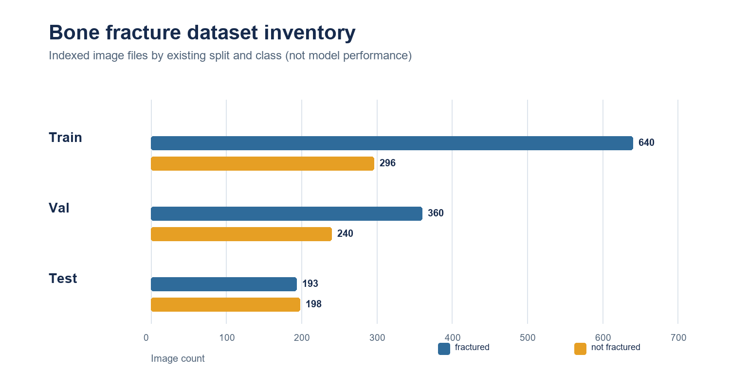
Figure 1: Image counts by existing split and class; inventory counts are not model results.
5. Results and Discussion
5.1 Held-out classification results
The best checkpoint was selected at epoch 5 with validation fracture-class AUC 0.713. On the held-out test split (n=391), accuracy was close to 0.5 and the ROC AUC was 0.508. The AUC 95% group-bootstrap interval includes 0.5, so this single experiment does not show reliable discrimination above chance. The fixed-threshold recall was higher than precision; these results are preliminary and do not establish clinical performance.
Table 2: Held-out classifier performance with 95% exact-hash-group bootstrap intervals
Metric | Estimate | 95% bootstrap interval
Accuracy | 0.506 | [0.460, 0.555]
Fracture precision | 0.500 | [0.438, 0.566]
Fracture recall | 0.637 | [0.571, 0.702]
Fracture F1 | 0.560 | [0.506, 0.615]
Fracture ROC AUC | 0.508 | [0.451, 0.565]

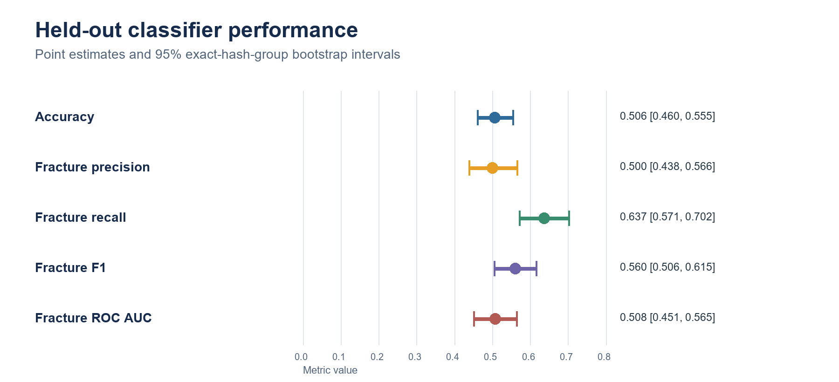
Figure 2: Test classification estimates and 95% exact-hash-group bootstrap intervals; the AUC interval includes 0.5.
5.2 CAM pseudo-mask and U-Net results
The U-Net's best validation Dice was 0.378 and IoU was 0.267, both measured against generated pseudo-masks. These values describe agreement with the training target-generation process, not the correctness of the predicted fracture boundaries.
Table 3: Best U-Net validation results against held-out pseudo-masks
Validation measure | Value | Interpretation
Dice | 0.378 | Pseudo-label agreement only
IoU | 0.267 | Pseudo-label agreement only

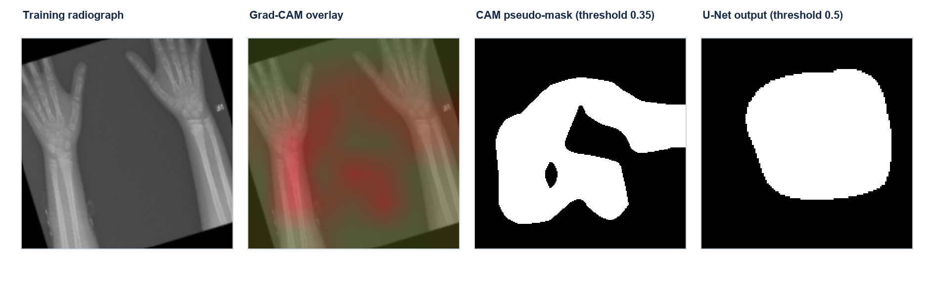
Figure 3: Illustrative training-split radiograph, Grad-CAM, thresholded pseudo-mask, and U-Net output. This example is not expert-annotated and is not a test image.
Figure 3 is included to show the generated artifacts and their relationship, not to demonstrate successful localization. Its example is selected deterministically from the training index; no claim is made that this case is representative of the full dataset.
5.3 Interpretation and limitations
The classification AUC of 0.508 is near chance and its confidence interval spans 0.5. The experiment therefore does not establish a useful classifier, despite recall of 0.637 at the fixed threshold. The uncertainty intervals are based on exact-image groups rather than patients because patient metadata are unavailable. Additionally, the image-statistics diagnostic reported in the project audit is not proof that the model is free of shortcut learning (Geirhos et al. 2020).
The U-Net inherits the quality and omissions of its CAM targets. Its validation set is separated by exact hash from the training pseudo-mask pairs, but both sets come from the same weak-label generation procedure. Without expert masks, the Dice and IoU values cannot be interpreted as anatomical segmentation performance. No segmentation test-set result is reported.
6. Conclusion
This paper documents a single-source, leakage-aware classification and pseudo-mask segmentation workflow using the repository dataset. The ResNet-50 achieved test accuracy 0.506 and AUC 0.508, with the AUC interval including chance-level performance. The U-Net achieved validation Dice 0.378 and IoU 0.267 against held-out CAM pseudo-masks, not expert annotations. These results are insufficient to support clinical or fracture localization claims. A verified dataset citation and license, patient- or study-level splits, repeated experiments, external validation, and expert pixel masks are needed for stronger conclusions.
Acknowledgements
No external funding or additional acknowledgements were provided for this draft.
Declaration of generative AI use: AI-assisted tools were used to help organize and edit this manuscript. The reported results were taken from the project artifacts, and the authors remain responsible for checking the data, citations, interpretation, and final submission.
References
Abedeen, I., Rahman, M. A., Prottyasha, F. Z., Ahmed, T., Chowdhury, T. M., and Shatabda, S., FracAtlas: A Dataset for Fracture Classification, Localization and Segmentation of Musculoskeletal Radiographs, Scientific Data, vol. 10, 521, 2023. https://doi.org/10.1038/s41597-023-02432-4.
Efron, B., Bootstrap Methods: Another Look at the Jackknife, The Annals of Statistics, vol. 7, no. 1, pp. 1-26, 1979. https://doi.org/10.1214/aos/1176344552.
Geirhos, R., Jacobsen, J.-H., Michaelis, C., Zemel, R., Brendel, W., Bethge, M., and Wichmann, F. A., Shortcut Learning in Deep Neural Networks, Nature Machine Intelligence, vol. 2, pp. 665-673, 2020. https://doi.org/10.1038/s42256-020-00257-z.
He, K., Zhang, X., Ren, S., and Sun, J., Deep Residual Learning for Image Recognition, Proceedings of the IEEE Conference on Computer Vision and Pattern Recognition, pp. 770-778, 2016. https://doi.org/10.1109/CVPR.2016.90.
Nagy, E., Janisch, M., Hržić, F., Sorantin, E., and Tschauner, S., A Pediatric Wrist Trauma X-Ray Dataset (GRAZPEDWRI-DX) for Machine Learning, Scientific Data, vol. 9, 222, 2022. https://doi.org/10.1038/s41597-022-01328-z.
Ronneberger, O., Fischer, P., and Brox, T., U-Net: Convolutional Networks for Biomedical Image Segmentation, Medical Image Computing and Computer-Assisted Intervention, Lecture Notes in Computer Science, vol. 9351, pp. 234-241, 2015. https://doi.org/10.1007/978-3-319-24574-4_28.
Selvaraju, R. R., Cogswell, M., Das, A., Vedantam, R., Parikh, D., and Batra, D., Grad-CAM: Visual Explanations From Deep Networks via Gradient-Based Localization, Proceedings of the IEEE International Conference on Computer Vision, pp. 618-626, 2017. https://doi.org/10.1109/ICCV.2017.74.
Biographies
Shibli Sanjid Faheem is an undergraduate student in Computer Science and Engineering with a minor in Management Information Systems at Independent University, Bangladesh.
Yousuf Abdullah is a co-author of this study and is affiliated with the Department of Computer Science and Engineering, Independent University, Bangladesh.

