# System Evaluation

## Login UI

The user has to fill up the login page to access the system.

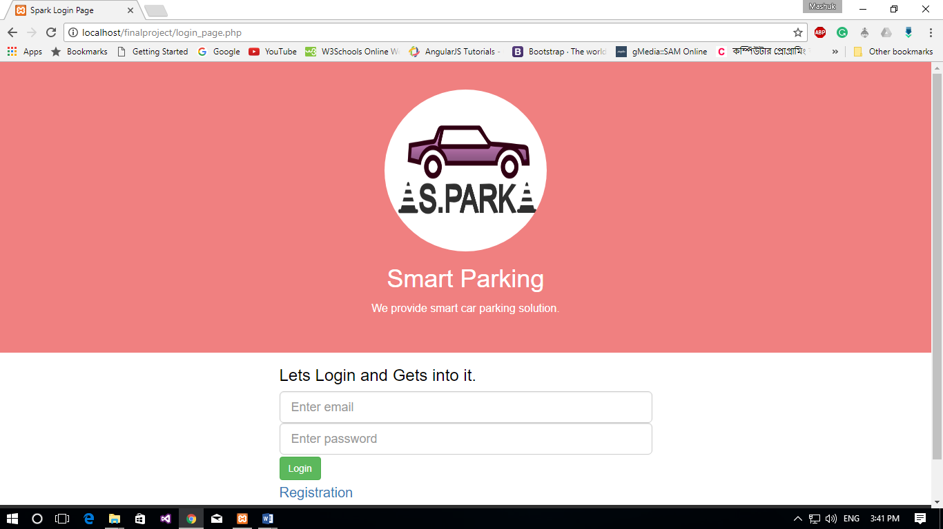

Figure: Login Page

## User Registration UI

The user needs to be registered through user registration page.

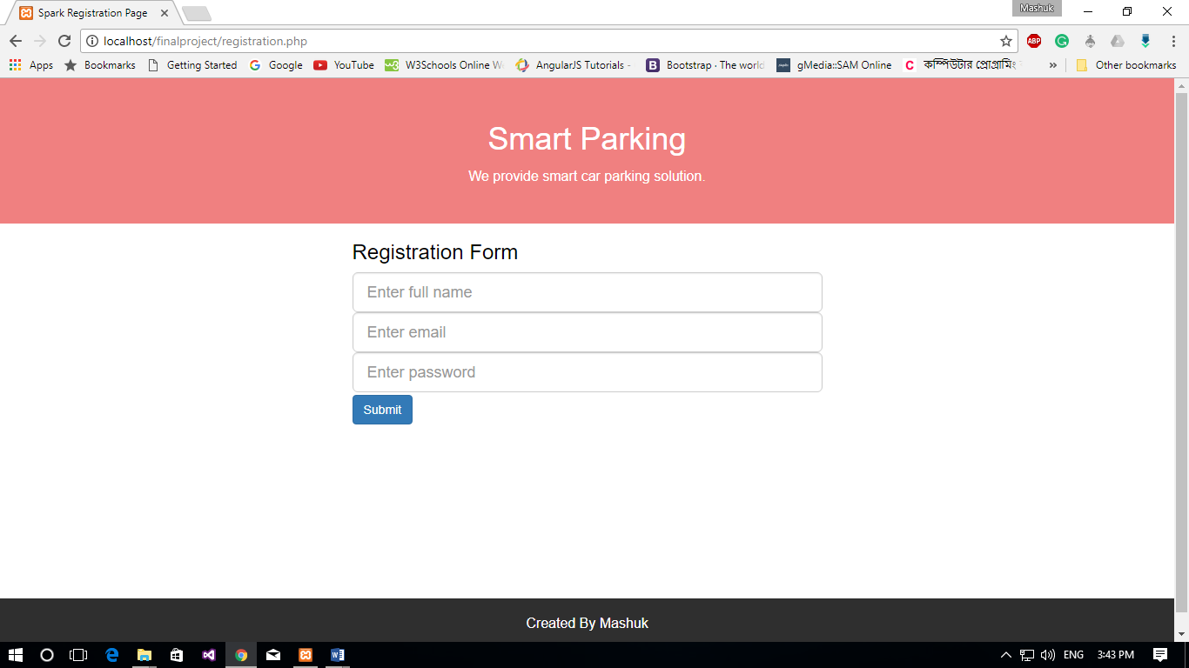

Figure: Registration Page

## Information Page

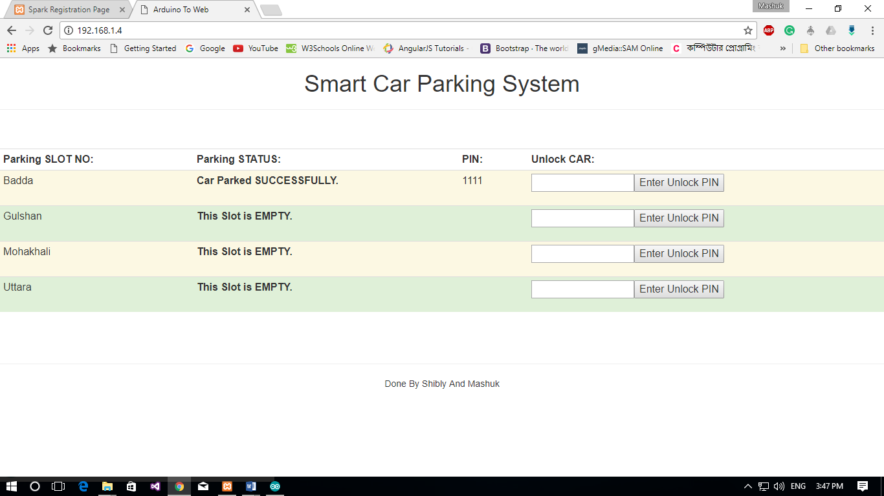

Figure: Information Page showing “car parked successfully”

After logging in, a user will be redirected to the main page, where a user can see all spaces for parking provided by this system. When any vehicle is parked there, Parking Status will be shown as “Car Parked Successfully” and a Secret PIN number will be generated. This scenario is demonstrated inprevious figure.

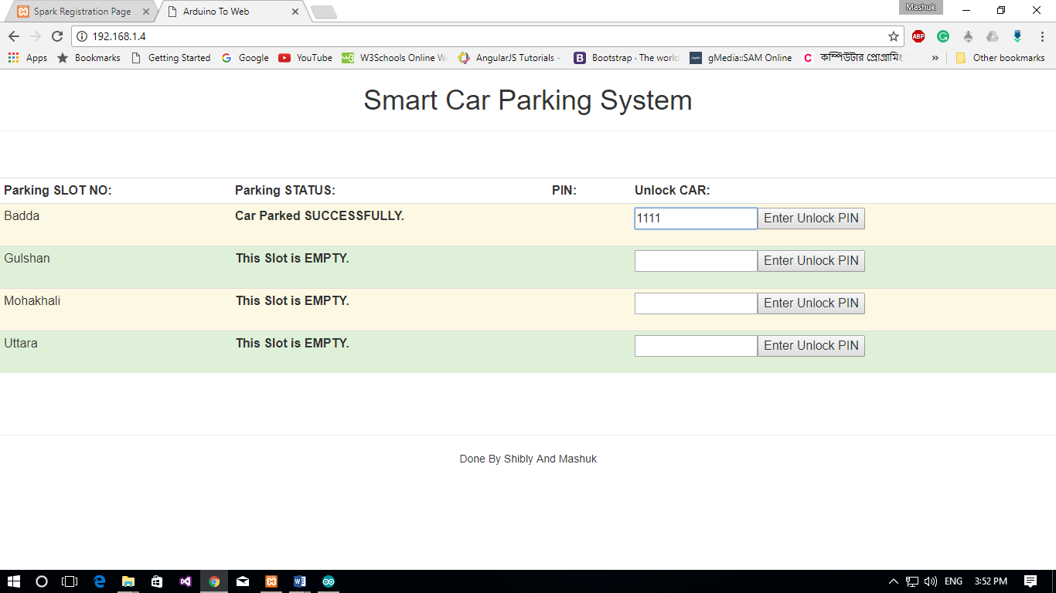

Figure: Entering PIN number on the Information Page

For Unlocking the vehicle, the user has to enter the PIN in the text field which was generated previous figure.

If the PIN does not match, the gate will not open, and a “WRONG PIN” message will be shown. Which is given below .

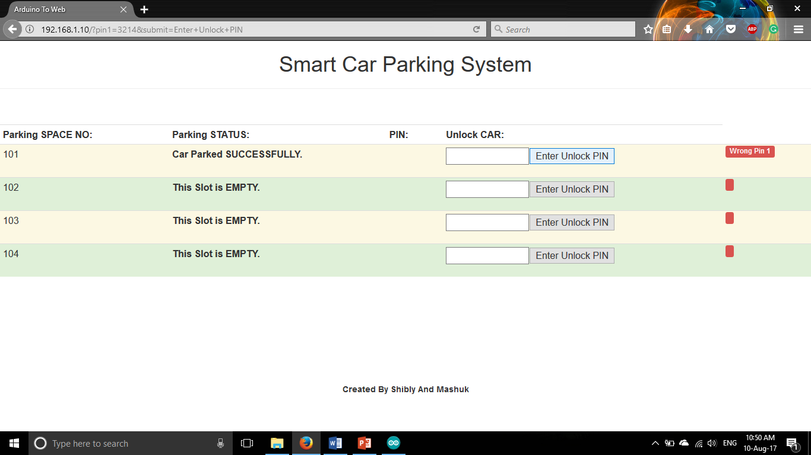

Figure: Entering wrong PIN number on the Information Page

If the PIN matched, the gate will open and he can get his/her vehicle back. The gate lock and unlock is demonstrated in next figure.

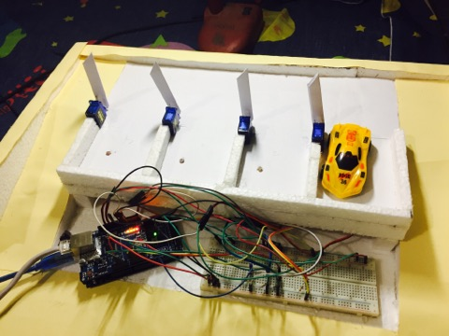

Figure: Entering PIN number and gate is unlocked