**HW772 Credit Risk Homework 3**

**Shi Bo**

**Due Date: 2021/9/30**

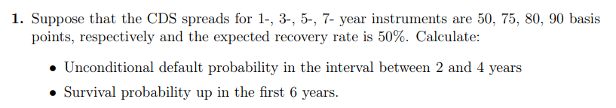

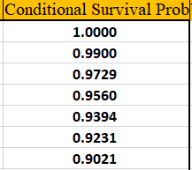



See more details in Excel.

The Unconditional Default Probability between 2 and 4 years is around **0.033**.

The survival probability up in the first 6 years is **0.9021**.

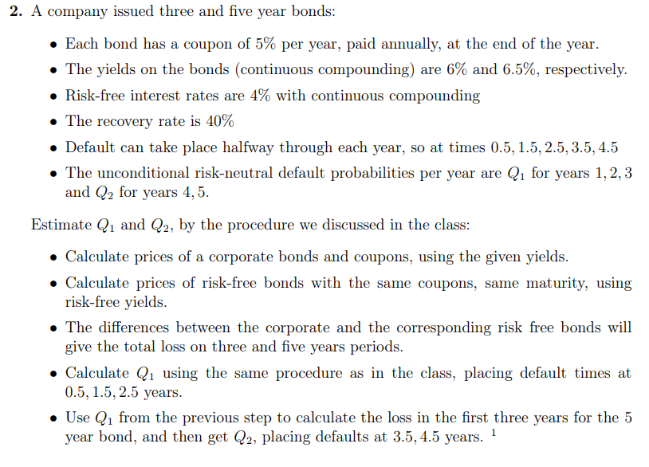

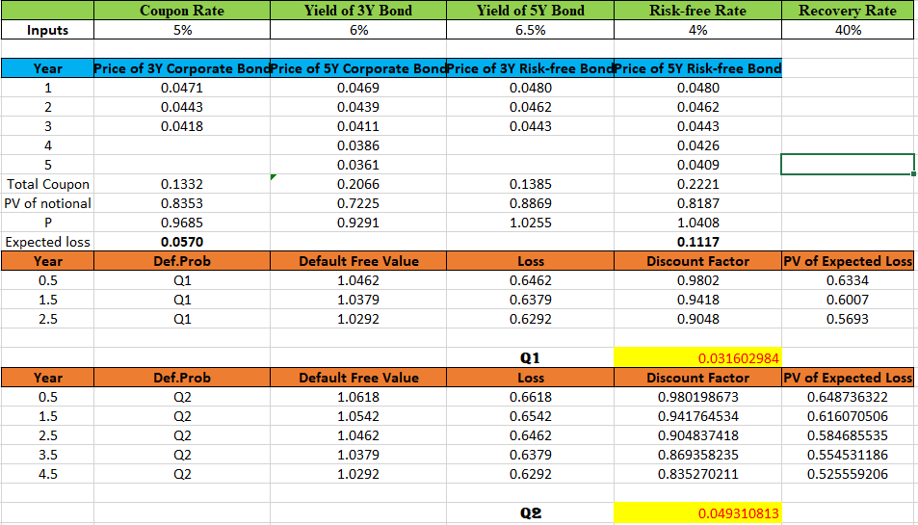

See more details in excel.

Q1 is **0.0316** and Q2 is **0.0493**.