MF 772 Assignment 9 Yuhe Xiao

Problem 1

(a)

$$C\left(u,0\right)=C\left(0,v\right)=0, C\left(u,1\right)=u, C\left(1,v\right)=v$$

$$C\left(u_{2},v_{2}\right)-C\left(u_{2},v_{1}\right)-C\left(u_{1},v_{2}\right)+C\left(u_{1},v_{1}\right)≥0$$

Let $u_{2}=v_{2}=1, u_{1}≤1,v_{1}≤1$

We have $C\left(u_{1},v_{1}\right)≥u_{1}+v_{1}-1$, and by definition, C>=0, so

$$C\left(u,v\right)≥max⁡\{u+v-1,0\}$$

Let $u_{2}=1, v_{1}=0, u_{1}≤1, v_{2}≥0$

We have $C\left(u_{1},v_{2}\right)≤v_{2}$, by the same argument we can have $C\left(u_{1},v_{2}\right)≤u_{1}$, so

$$C\left(u,v\right)≤min⁡\{u,v\}$$

$$⇒\max\left\{u+v-1,0\right\}≤C\left(u,v\right)≤min⁡\{u,v\}$$

(b)

$$C\left(u,0\right)=C\left(0,v\right)=0+0=0$$

$$C\left(u,1\right)=λu+\left(1-λ\right)u=u$$

$$C\left(1,v\right)=λv+\left(1-λ\right)v=v$$

$$C\left(u_{2},v_{2}\right)-C\left(u_{2},v_{1}\right)-C\left(u_{1},v_{2}\right)+C\left(u_{1},v_{1}\right)$$

$$=λ\left[C_{1}\left(u_{2},v_{2}\right)-C_{1}\left(u_{2},v_{1}\right)-C_{1}\left(u_{1},v_{2}\right)+C_{1}\left(u_{1},v_{1}\right)\right]+\left(1-λ\right)\left[C_{2}\left(u_{2},v_{2}\right)-C_{2}\left(u_{2},v_{1}\right)-C_{2}\left(u_{1},v_{2}\right)+C_{2}\left(u_{1},v_{1}\right)\right]≥0$$

So C is copula

(c)

Let $u_{2}=1,u_{1}≤1,1≥v_{2}≥v_{1}≥0$

$$v_{2}-v_{1}≥C\left(u_{1},v_{2}\right)-C\left(u_{1},v_{1}\right)⇒\left|C\left(u,v_{2}\right)-C\left(u,v_{1}\right)\right|≤|v_{2}-v_{1}|$$

Let $v_{2}=1,v_{1}≤1,1≥u_{2}≥u_{1}≥0$

$$u_{2}-u_{1}≥C\left(u_{2},v_{1}\right)-C\left(u_{1},v_{1}\right)⇒\left|C\left(u_{2},v\right)-C\left(u_{1},v\right)\right|≤|u_{2}-u_{1}|$$

$$\left|C\left(u_{2},v_{2}\right)-C\left(u_{1},v_{1}\right)\right|≤\left|C\left(u_{2},v_{2}\right)-C\left(u_{2},v_{1}\right)\right|+\left|C\left(u_{2},v_{1}\right)-C\left(u_{1},v_{1}\right)\right|≤\left|u_{2}-u_{1}\right|+|v_{2}-v_{1}|$$

Problem 2

(a)

$$H\left(x,+∞\right)=\frac{1}{1+e^{-x}}, H\left(+∞,y\right)=\frac{1}{1+e^{-y}}$$

(b)

$$u=H\left(x,+∞\right), e^{-x}=\frac{1}{u}-1, v=H\left(+∞,y\right), e^{-y}=\frac{1}{v}-1$$

$$C\left(u,v\right)=\frac{1}{1+e^{-x}+e^{-y}}=\frac{1}{\frac{1}{u}-1+\frac{1}{v}}=\frac{uv}{u+v-uv}$$

(c)

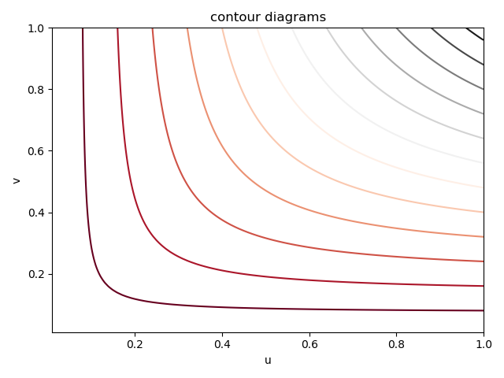

Problem 3

Steps from Copula to default times:

1. Correlated variables $x_{i}, i=1,…,10$ by Gaussian copula

$u_{i}=Φ(x_{i})$

$τ_{i}=-\frac{\log{(1-u_{i})}}{λ}$

rho_list: [0.1, 0.2, 0.3, 0.4, 0.5, 0.6, 0.7, 0.8, 0.9]

probability that first default in 5 years:

[0.80335, 0.74591, 0.69194, 0.63917, 0.58026, 0.52703, 0.46871, 0.4075, 0.32993]

