Real-Time Fraud Detection System with Explainable AI
Strategic Overview and Business Impact Analysis
Domain: AI & Data Analytics | Level: Advanced
Dataset: IEEE-CIS Fraud Detection (Kaggle)

1. Project Overview & Operational Strategy
This report outlines an end-to-end fraud detection pipeline designed to intercept highly sophisticated, automated attacks in real-time environments. The architecture includes comprehensive data merging, class imbalance handling via SMOTE, and model comparisons between LightGBM, XGBoost, and Isolation Forest.
Engine Selection: LightGBM for High-Frequency Threat Detection
Following a rigorous evaluation, LightGBM was selected as the foundational engine for this production environment. It achieved the highest robustness scores (ROC-AUC ~0.91, PR-AUC ~0.61), aligning perfectly with the operational demands of modern e-commerce. Its highly optimized memory utilization enables sub-second scoring latency, ensuring legitimate transactions are processed without introducing conversion-killing friction at checkout.

2. The Strategic Evaluation Framework & Class Imbalance
In an operational environment characterized by extreme class imbalance (a baseline fraud rate of just 3.5%), traditional metrics like "Accuracy" are deeply misleading. A baseline model configured to blindly approve every transaction would boast a 96.5% accuracy rate while facilitating 100% of attempted fraud.
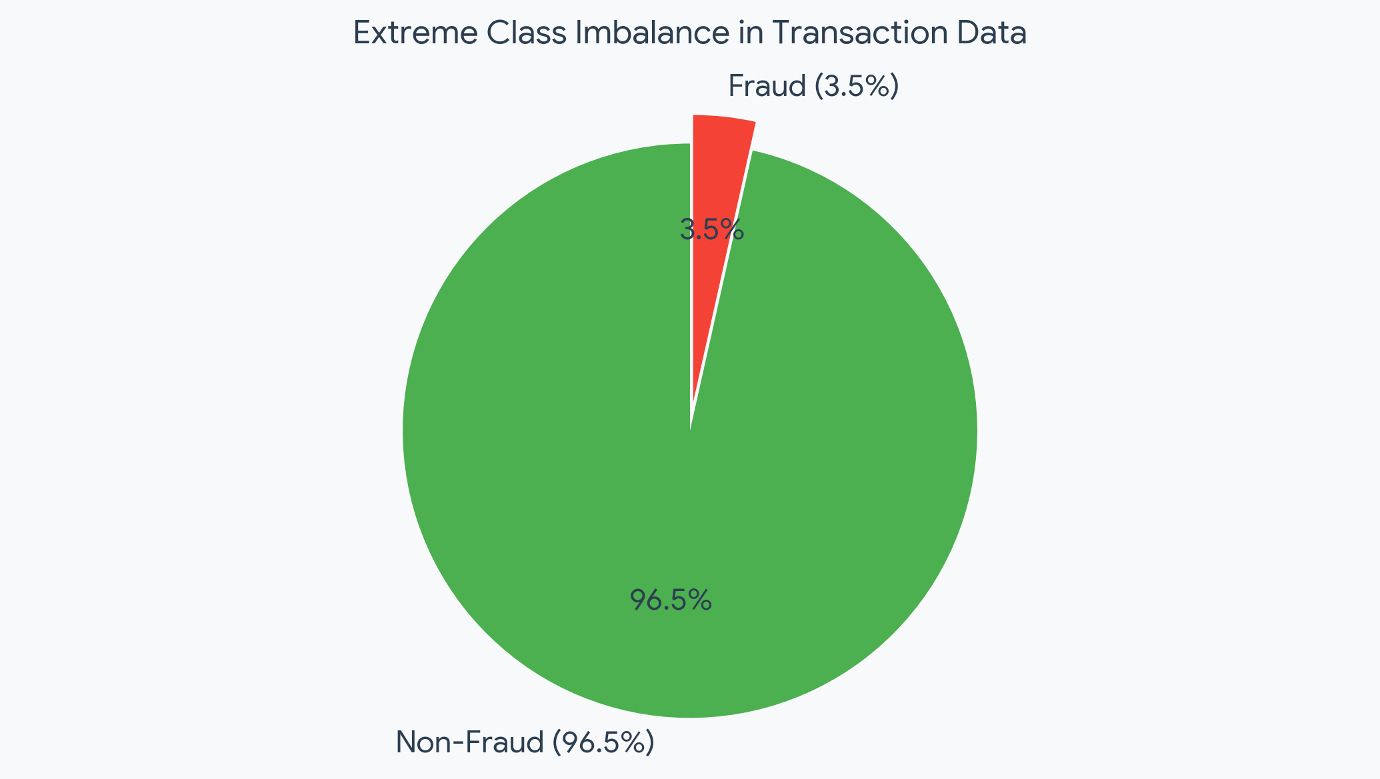
To ensure the algorithmic output translates directly into business value, the model was optimized against the Precision-Recall Area Under Curve (PR-AUC). This metric directly balances the dual mandate of the risk operations team:
- Precision (Preserving Customer Experience & Reducing Operational Overhead): Maximizing precision ensures that when a transaction is flagged, the likelihood of actual fraud is exceptionally high.
- Recall (Financial Loss Prevention): Maximizing recall measures the total volume of fraudulent activity successfully intercepted by the system.

3. Behavioral Threat Intelligence (Explainable AI via SHAP)
By interrogating the model’s internal decision-making architecture using SHAP (SHapley Additive exPlanations) values, we extracted three critical behavioral signatures that define our most pervasive threats:
• The Midnight Anomaly (HourOfDay): Transactions occurring during the 22:00–03:00 UTC window contribute the heaviest predictive weight.
• Account Velocity Spikes (AmtToMeanRatio): Transaction amounts that violently deviate from a user’s historical baseline trigger an immediate increase in risk scoring.
• Compromised Infrastructure Over-representation (card4 / card6): Specific intersections of card networks and funding types are drastically over-represented within the fraud class.
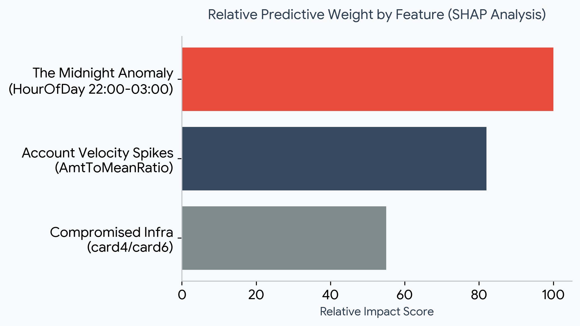

4. Financial Impact and Estimated Annual ROI
The deployment of this model represents a massive defensive asset for the organization's balance sheet:
• Test Environment Baseline: Within a constrained test sample, 4,133 authentic fraud attempts were recorded.
• Capital Preservation: The algorithm prevented approximately $971,500 in direct financial loss within the test window alone.
• Annualized Enterprise Value: When extrapolated across a standard 52-week operational cycle, this detection pipeline is projected to prevent an estimated $50.5 Million in fraudulent losses annually.
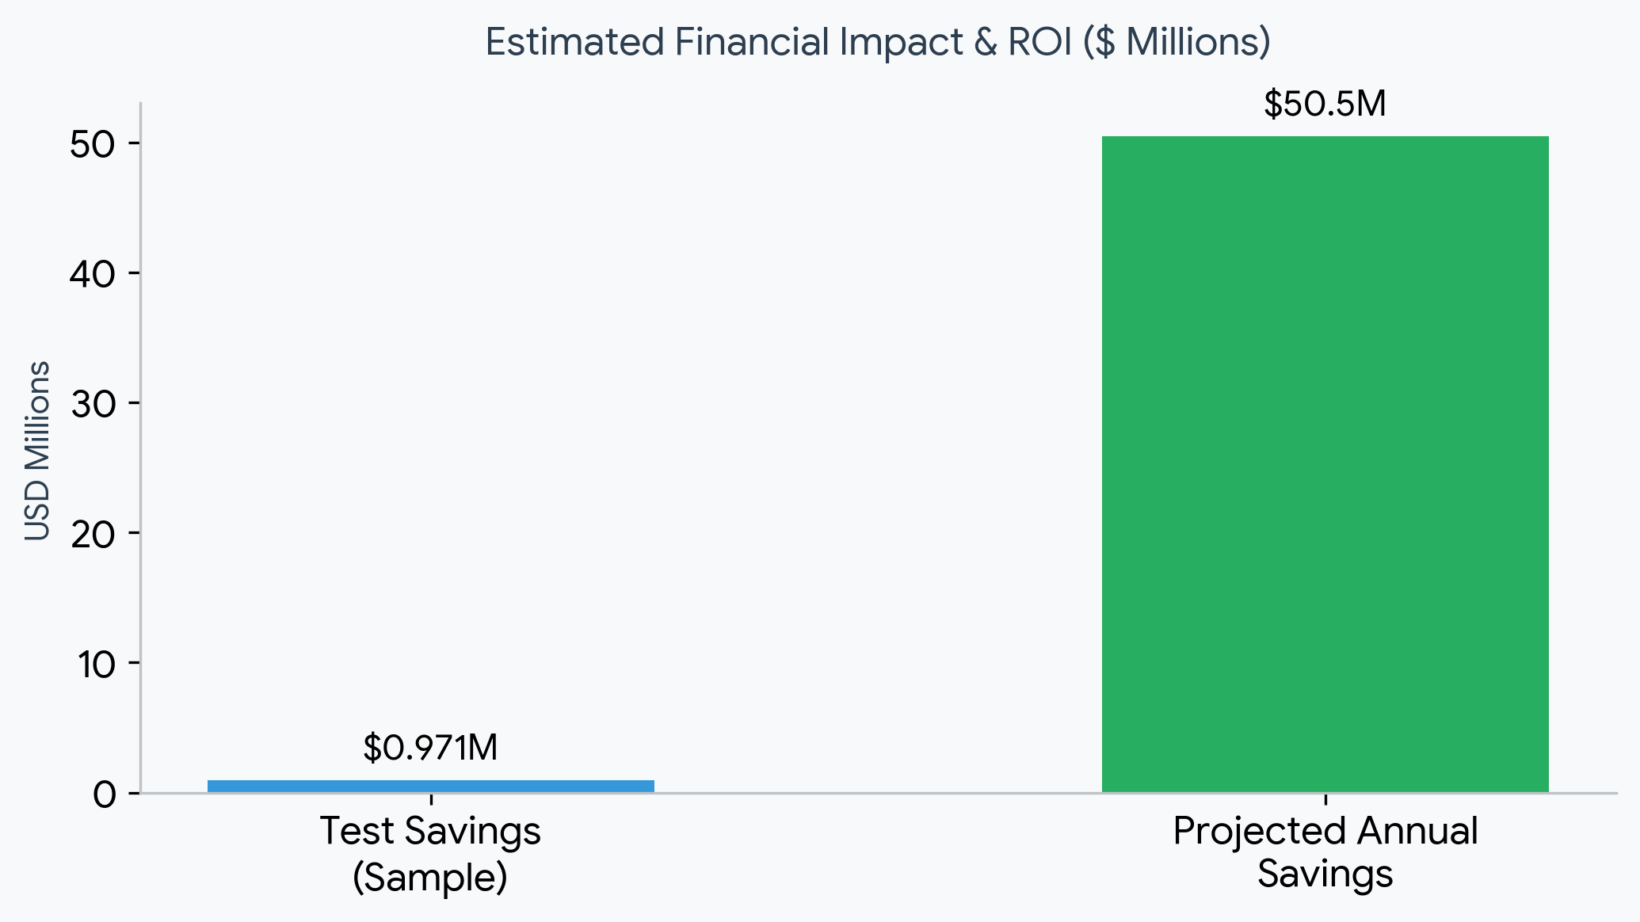

5. Strategic Roadmap: Limitations & V2.0 Data Needs
To push the detection capabilities even further in the next iteration, we must address the following:
• Combating Feature Drift: Fraud rings adapt quickly. The model must be placed on an automated CI/CD pipeline for monthly retraining to learn new attack vectors.
• Identity Resolution: Over 76% of identity-based features were missing. Partnering with a third-party vendor to enrich IP geolocation, device fingerprinting, and shared-email graphs will drastically improve precision.
• Graph & Velocity Features (V2.0): Future models should ingest real-time rolling metrics (e.g., "logins per IP in the last 15 minutes") and merchant category risk scores, moving us from static transaction scoring to dynamic behavioral tracking.

