QUESTION 1
CONSIDER THE FOLLOWING RELATIONAL SCHEMA-

1. SAILORS(sid,sname,rating,date_of_birth)

2.BOATS(bid,bname,color)
3.RESERVES(sid,bid,date,time slot)
(A)FIND SAILORS WHO HAVE RESERVED ATLEAST ONE BOAT
- SQL QUERY-
SELECT SNAME from sailors natural join reserves;
(B)FIND NAMES OF SAILORS WHO HAVE RESERVED A RED OR A GREEN BOAT IN THE
MONTH OF MARCH.
(B)SQL QUERY-
select distinct sname from sailors NATURAL JOIN reseves
N ATURAL JOIN boats
WHERE reservedate like "%-03-%" AND (color='red' or
color='green');
(C)FIND NAMES OF SAILORS WHO HAVE RESERVED A RED
AND A GREEN BOAT.
(C)SQL QUERY-
select distinct sname from sailors NATURAL JOIN reserves
NATURAL JOIN boats
WHERE color='red' and
sname in
( select distinct sname from sailors NATURAL JOIN reserves
NATURAL JOIN boats
WHERE color=‘green');
(D)FIND SID OF SAILORS WHO HAVE NOT RESERVED A BOAT AFTER JAN 2018.
(D) SQL QUERY-
select distinct sailors.sid from sailors natural join reserves
where sailors.sid not in(select sailors.sid from sailors natural
join reserves
where date>’2018-01-01');

(E) FIND SAILORS WHOSE RATING IS GREATER THAN THAT OF ALL THE SAILORS NAMED
“JOHN”
(E)SQL QUERY-
select * from sailors
Where rating>(select rating from sailors where sname=‘john');

(F)FIND SAILORS WHO HAVE RESERVED ALL BOATS.
(F) SQL QUERY-
select sname from sailors where not exists
((select bid from boats) except(select bid from reserves natural join sailors));

{Empty set}

(G) FIND NAME AND AGE OF THE OLDEST SAILOR.
(G) SQL QUERY-
select sname,FLOOR(DATED (curdate(),date_of_birth)/365.25) as age from sailors
where FLOOR (DATED IFF (CURDATE(),date_of_birth/365.25)>= all
(select FLOOR(dated iff(curdate(),date_of_birth/365.25) as age from sailors);

(H)FIND THE AGE OF THE YOUNGEST SAILOR FOR EACH RATING WITH ATLEAST 2 SUCH SAILORS.
(H) SQL QUERY-
select MIN(FLOOR(DATED (curdate(),date_of_birth)/365.25) as
age rating from
sailors group by rating having count(*)>1;

Question 2

Consider the following relational schema:

- CUSTOMER (cust_num, cust_lname ,cust_fname, cust_balance)

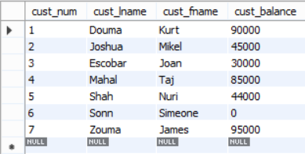

- PRDUCT (prod_num, prod_name, price)
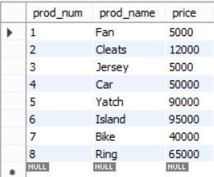

- INVOICE (inv_num,prod_num,cust_num, inv_date ,unit_sold, inv_amount)

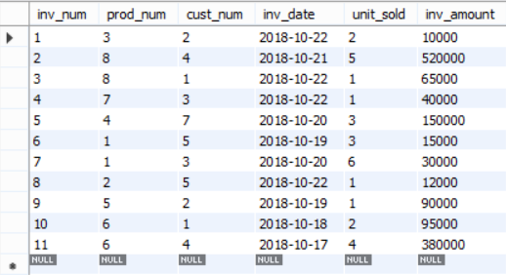

- Find the names of the customer who have purchased no item. Set default value of Cust_balance as 0 for such customers.

SQL Query
UPDATE CUSTOMER,INVOICE SET CUSTOMER.CUST_BALANCE = 0
WHERE CUSTOMER.CUST_NUM IN
(SELECT CUSTOMER.CUST_NUM FROM CUSTOMER WHERE CUSTOMER.CUST_NUM NOT IN (SELECT DISTINCT(INVOICE.CUST_NUM) FROM INVOICE));

Output
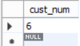

- Write the trigger to update the CUST_BALANCE in the CUSTOMER table when a new invoice record is entered for the customer.
CREATE TRIGGER UPDATE_BALANCE AFTER UPDATE
ON CUSTOMER,INVOICE
FOR EACH NEW ROW
BEGIN
SET CUST_BALANCE = CUST_BALANCE + INV_AMOUNT
GROUP BY CUST_ID
END;

- Find the customers who have purchased more than three units of a product on a day.
SQL Query
SELECT CUSTOMER.* FROM CUSTOMER NATURAL JOIN INVOICE WHERE UNIT_SOLD >3;

Output
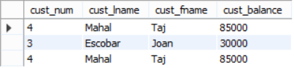

- Write a query to illustrate Left Outer, Right Outer and Full Outer Join.
SQL Query
SELECT * FROM CUSTOMER LEFT OUTER JOIN INVOICE ON
CUSTOMER.CUST_NUM = INVOICE.CUST_NUM ;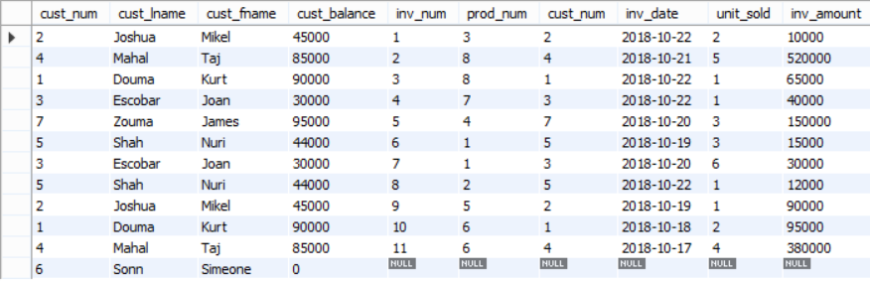
SELECT * FROM CUSTOMER RIGHT OUTER JOIN INVOICE ON
CUSTOMER.CUST_NUM = INVOICE.CUST_NUM ;
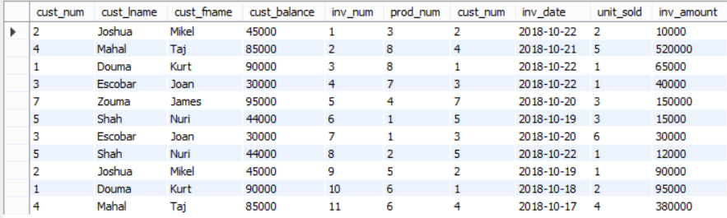

SELECT * FROM CUSTOMER JOIN INVOICE ON
CUSTOMER.CUST_NUM = INVOICE.CUST_NUM;

- Count number of products sold on each date.

SQL Query
SELECT SUM(UNIT_SOLD),INV_DATE FROM INVOICE GROUP BY INV_DATE;

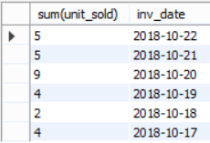

Output

- As soon as customer balance becomes greater than Rs. 100,000, copy the customer_num in new table called ”GOLD_CUSTOMER”.

SQL Query
INSERT INTO GOLD_CUSTOMER
SELECT CUST_BALANCE FROM CUSTOMER WHERE CUST_BALANCE > 100000;

- Add a new attribute CUST_DOB in customer table.

SQL Query
ALTER TABLE CUSTOMER ADD COLUMN CUST_DOB DATE;

Output
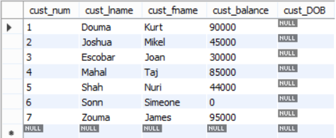

Question 3

Consider the following relational schema

- DEPARTMENT(Department_ID, Name, Location_ID)

- JOB (Job_ID , Function )

- EMPLOYEE (Employee_ID, name, DOB, Job_ID , Manager_ID, Hire_Date, Salary, Department_id)

- Write a query to count number of employees who joined in March 2015.

SQL QUERY-
SELECT count(Employee_ID) from EMPLOYEE WHERE
Hire_Date LIKE “2015-03%”;

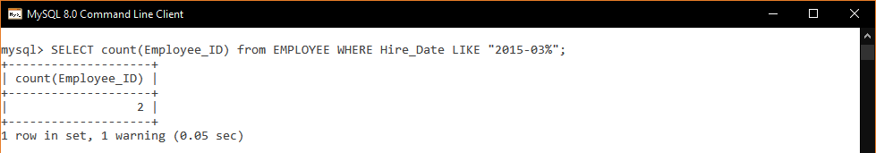

2.Display the Nth highest salary drawing employee details.

SQL QUERY-
SELECT * from EMPLOYEE EMP1 WHERE (N-1) = (SELECT COUNT(DISTINCT(EMP2.SALARY)) FROM EMPLOYEE EMP2 WHERE EMP2.SALARY>EMP1.SALARY);

So say for N=2 and for N=1 we have the following output:-

SELECT * from EMPLOYEE EMP1 WHERE 1 = (SELECT COUNT(DISTINCT(EMP2.SALARY)) FROM EMPLOYEE EMP2 WHERE EMP2.SALARY>EMP1.SALARY);

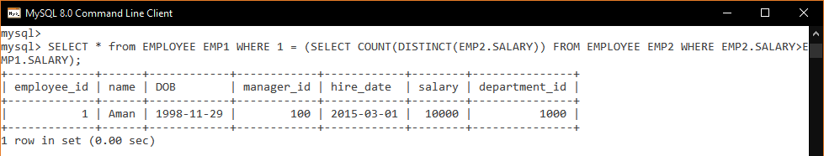
SELECT * from EMPLOYEE EMP1 WHERE 0 = (SELECT COUNT(DISTINCT(EMP2.SALARY)) FROM EMPLOYEE EMP2 WHERE EMP2.SALARY>EMP1.SALARY);

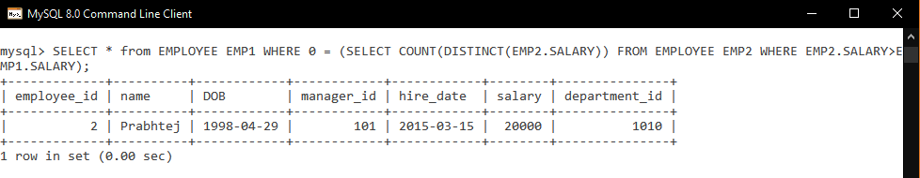

- Find the budget (total salary) of each department.

SQL QUERY-
SELECT Department_ID, sum(SALARY) as Budget from EMPLOYEE GROUP BY Department_ID;

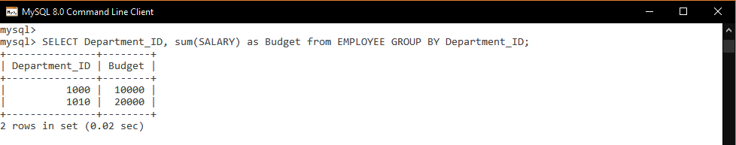

- Find the department with maximum budget.

SQL QUERY-
SELECT Department_ID from EMPLOYEE GROUP BY Department_ID
HAVING sum(SALARY) >= ALL(SELECT sum(SALARY) from EMPLOYEE GROUP BY Department_ID);

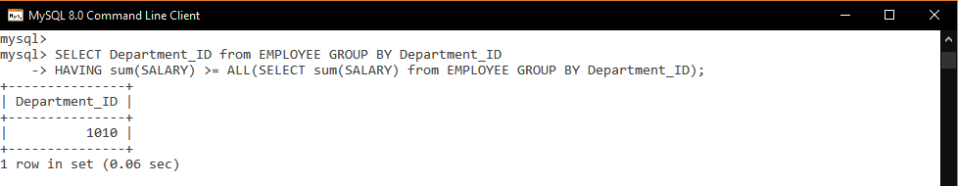

- Create a view to show number of employees working in Delhi and update it automatically when the database is modified.

SQL QUERY-
CREATE VIEW Delhi_Population as SELECT COUNT(Employee_ID) from EMPLOYEE,DEPARTMENT WHERE EMPLOYEE.Department_ID = DEPARTMENT.Department_ID and Location_ID = “Delhi”;

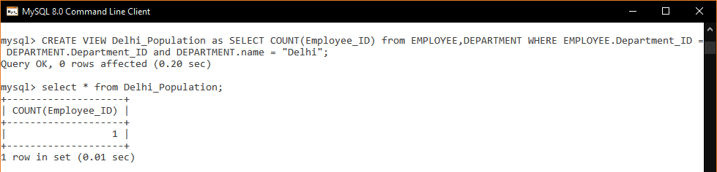

- Write a trigger to ensure that no employee of age less than 25 can be inserted in the database.

SQL QUERY-
DELIMITER $$
CREATE TRIGGER bef_ins BEFORE INSERT ON EMPLOYEE
FOR EACH ROW
BEGIN
IF((YEAR(SYSDATE() – YEAR(NEW.DOB)) < 25)
THEN
SIGNAL SQLSTATE “45000” SET MESSAGE_TEXT = “Age of Employee is less than 25!!!”;
END IF;
END$$
DELIMITER;

