

**A PROJECT REPORT ON**

# HDC VOTING SYSTEM

## Submitted to Department of Management

**Himalaya Darshan College**

***Inpartial fulfillment of the requirements for the Bachelors in Information management***

Submitted by

Kajal Kumari Mehta (7-2-1073-10-2021) Shibu Sharma (7-2-1073-25-2021)

August, 2024

# ABSTRACT

The **HDC Voting System** is designed for facilitating HDC voting. The primary goal of this system is to enable voters to cast their votes online and make the better version website of HDC and view the election results of their own Faculty and semester as well.

### System Overview

The system consists of two main parts: Admin and Voter sides.

#### User Roles:

* **Voter:** Users who participate in voting.
* **Admin:** Users who adds the candidate for election and many others.

#### Workflow:

1. **Candidate:**
   * The admin adds the candidate who is already the student of HDC.
2. **Dashboard:**
   * The candidate list, including their details, is visible on the dashboard for users/vote to vote and admin to delete.

# ACKNOWLEDGEMENT

In this project accomplishment, we would like to express our gratitude to all our teachers and mostly to our project assigner, Mr. Nabin Ghimire. Without the proper guidance and feedback from him, it would not have been possible to work and complete the project.

In addition, we extend our sincere thanks to our friends, seniors for their contribution in this project and helping us to accomplish. We will be always looking forward to hear the comments. And, suggestions for further improvement in our project.

Kajal Kumari Mehta (7-2-1073-10-2021) Shibu Sharma (7-2-1073-25-2021)

# TABLEOF CONTENTS

SUPERVISOR’SRECOMMENDATION i

LETTER OF APPROVAL ii

ABSTRACT iii

ACKNOWLEDGEMENT iv

TABLE OFCONTENTS v

List of Abbreviations vii

List ofFigures viii

List ofTables ix

CHAPTER1: INTRODUCTION 1

* 1. Introduction 1
  2. ProblemStatement 1
  3. Objectives 1
  4. Scopeand Limitation 1
  5. ReportOrganization 2

CHAPTER2:BACKGROUNDSTUDYANDLITERATUREREVIEW 3

* 1. BackgroundStudy 3
  2. Literature Review 3

CHAPTER3:SYSTEMANALYSISANDDESIGN 4

* 1. SystemAnalysis 4
     1. RequirementIdentification 4
     2. Feasibilityanalysis 6
     3. DataModeling 8
     4. ProcessModeling 9
  2. SystemDesign 11
     1. ArchitecturalDesign 11
     2. InterfaceDesign 12

CHAPTER4:IMPLEMENTATIONANDTESTING 14

* 1. Implementation 14
     1. ToolsUsed 14
     2. ImplementationDetailsofModules 15
  2. Testing 15
     1. TestCasesforUnitTesting 15
     2. Test Cases for SystemTesting 18

Chapter5:CONCLUSIONANDFUTURERECOMMENDATIONS 19

* 1. Lesson Learnt/Outcome 19
  2. Conclusion 19
  3. Future Recommendations 19

REFERENCES 20

# List of Abbreviations

HDC: Himalaya Darshan College

VS Code: Visual Studio Code

HTML: Hypertext Markup Language

CSS: Cascading Style Sheets

JS: JavaScript

PHP: Hypertext Pre-processor

DFD: Data Flow Diagram

# List of Figures

Figure1: Incremental Methodology 4

Figure2: Use Case Diagram 5

Figure3: Gantt chart 7

Figure4: ER-Diagram 8

Figure5: Context Diagram 9

Figure6: Architectural Design 11

Figure7: Admin Login Page 12

Figure8: Voter login Page 13

Figure9: Student Registration Page 14

Figure10: Free CMAT Registration page 15

# List of Tables

Table1: Test 1-Login Form 18

Table2:Test2-Registration Form 19

Table3: Test 3-Candidate Application 19

Table4:TestCase4… 20

* 1. **Introduction**

# CHAPTER1: INTRODUCTION

Voting allows individuals to express their preferences in decision-making. HDC voting systems use advanced IT to simplify voting, making it more convenient and accessible. These electronic systems enhance ease of use and implement security measures to protect vote integrity. They aim to speed up the voting process, streamline vote casting, and reduce staffing costs. Key features include accessibility, security, and convenience.

## Problem Statement

An HDC voting system allows individuals to cast their votes over the internet instead of visiting a polling station (or as per the college rule). This approach offers convenience as voters can participate from any location with an internet connection. To ensure the security and privacy of votes, the system employs robust measures such as encryption and authentication. It also includes voter verification processes to prevent fraud. This system simplifies the voting experience, enhances accessibility, and upholds fairness and transparency in elections.

## Objectives

The primary goals of an HDC voting system are to simplify and enhance the convenience of voting, enabling individuals to cast their votes from any location with internet access. Key objectives include:

* **Increasing voter turnout** by eliminating obstacles such as long distances or busy schedules that may prevent people from voting in person.
* **Improving the accuracy and efficiency** of the voting process.

### Scope and Limitations

The system is suitable for use in small-scale organizations where individuals can elect roles such as class monitors, group leaders, and other positions. However, there is a risk of multiple votes from a single user through the creation of multiple login accounts. Additionally, the system does not include a feature for selecting faculty members for voters.

## Report Organization

The project report is organized as follows:

* **Chapter1 (Introduction):** This chapter deals with the introduction of the system with its problem statement, objectives, scope and limitation.
* **Chapter 2 (Background Study and Literature Review):** This chapter describes about the background of the car rental system and information related to the existing system.
* **Chapter3 (System Analysis and Design):** This chapter describes the functional and non-functional requirements of the system, feasibility analysis (operational, technical, economic, schedule-GANTTCHART), ER-diagramandDFDofthesystem,database schema, user interface diagrams, and architectural diagram.
* **Chapter 4 (Implementation and Testing):** Different tools including CASE Tools, documentation tools, etc., test case for unit testing and system testing are discussed in this section.
* **Chapter5 (Conclusion):** This chapter describes the conclusion, outcomes and future recommendations and the improvements or update of the project that can be done on the upcoming days.

# CHAPTER2: BACKGROUND STUDY AND LITERATURE REVIEW

## Background Study

Voting through paper ballots is still common but it is time-consuming, labor-intensive, and expensive. Training voters in rural areas before elections adds to the cost and effort. Although some high-density chip systems exist, they are generally only suitable for large-scale organizations.

## Literature Review

The description and function of an existing HDC voting system are explained, along with the hardware and software specifications used in its development.

### HDC Class Representative Election system:-

Yojana Subedi, our senior sister, has already developed a system where candidates apply for elections via a form. Once an admin approves an application, the candidate's information is displayed on the voters' dashboard, allowing voters to vote for their candidates based on their class. There was an issue in the system where, after voters cast their vote, the voting options remained available, enabling them to vote for multiple candidates.

### Type form:-

Type form is an HDC voting system software that provides various features, including creating voting polls, registration forms, quiz makers, research surveys, and application forms.

# CHAPTER3: SYSTEM ANALYSIS AND DESIGN

## System Analysis

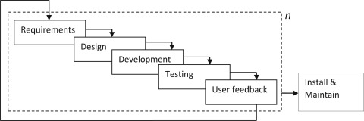System analysis involves examining and understanding a system's requirements, processes, and objectives to design efficient solutions .It's essential for creating effective software and IT solutions.

### Figure1: Incremental Methodology

### Requirement Identification

The requirement that is essential for the development of the proposed system is functional and non-functional requirements .Its various parameters are based on a feasibility study and so on.

### Functional Requirements

* + - * + Add for program.
        + Add for student.
        + Add for candidate.
        + Start or Place a vote and view the results.

**USECASE DIAGRAM**

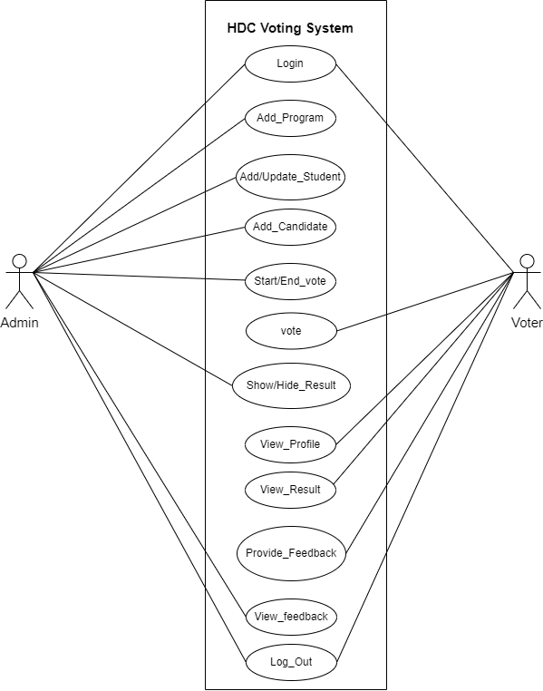

**Figure2: Use Case Diagram**

* + - 1. **Non-functional Requirements**

It defines the criteria according to which the system must work.

* **Usability:** The website should be easy to use and navigate, with a clear and simple interface that is accessible to all users.
* **Performance**: The website should load quickly and respond promptly to user actions.
* **Security**: The website should have basic authentication and access controls to ensure that only authorized users can access the system as the admin performs the many actions i.e. add program, student and candidate.
* **Reliability:** The website should be stable and reliable, with minimal errors or downtime.

### Feasibility analysis

Feasibility study means to analyze and evaluate the proposed project that indicates if a project is viable or not. It estimates the existing business environment, problems and opportunities, and resources which will ultimately lead success of project.

### Technical Feasibility

The HDC voting system is technically feasible as the requirements for the development of system is easily accessible. The required hardware and software (PHP, MySQL, JS, HTML, CSS) for the system is also available

### Operational Feasibility

The HDC voting system will be easy to operate as the working process of the system is similar to other system and is user-friendly. So, the system is operationally feasible.

### Economic Feasibility

The HDC voting system is economically feasible and cost effective. All the tools and technologies required to build this project is available and free.

### Schedule Feasibility

Schedule feasibility shows that if the project can be completed in a given time or not.

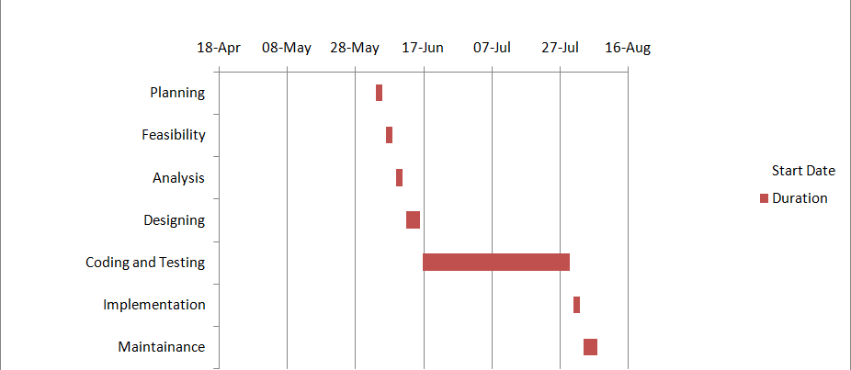

**Figure3: Gantt chart of HDC Voting System**

### Data Modeling

### 

**Figure4: ER-Diagram**

In the above ER-diagram, there are total of 9 entities: Register_cmat,Student,Feedback,program,vote,candidate,Sadmin,Result_update,Votestatus.

### Process Modeling

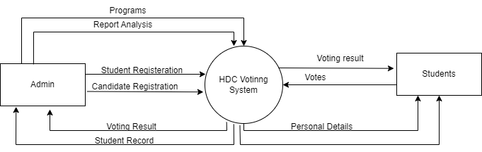

**Figure5: Context Diagram**

A context diagram depicts the system as a single entity and shows its interactions with external entities such as users and other systems. It provides a broad overview of the system's boundaries and interactions with the external environment.

## System Design

## System design is the process of defining the architecture, interfaces, and data for a system to meet specific requirements.

### Architectural Design

### Architectural design is the process of defining the hardware and software components and their interfaces to create the framework for system development.

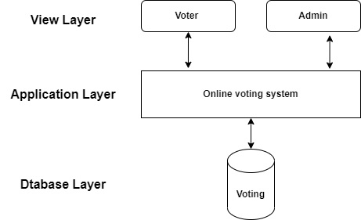

### Figure7: Architectural Design

### Interface Design

User Interface (UI) refers to the visual and interactive elements of software or a website that users interact with. The interface of all major pages of this system is shown below.

* + - * **Admin Login Page:**

This is the page where the admin enters the pre-set information for the username and password i.e. [admin@gmail.com](mailto:admin@gmail.com) and admin123 respectively.

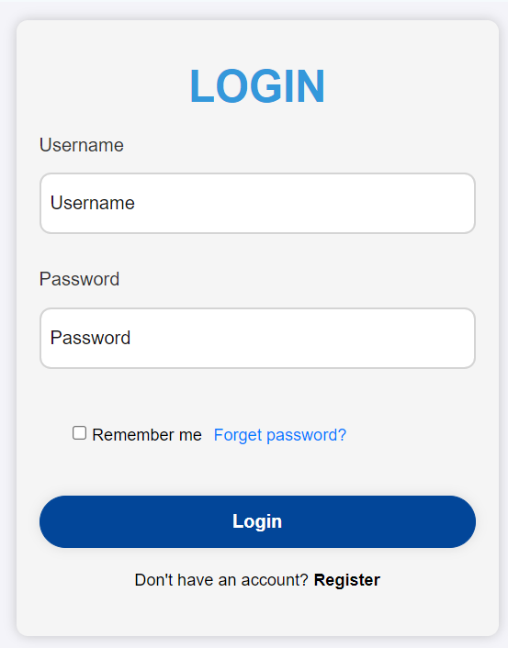

**Figure 8: Admin Login page**

* + - * **Voter Login Page:**

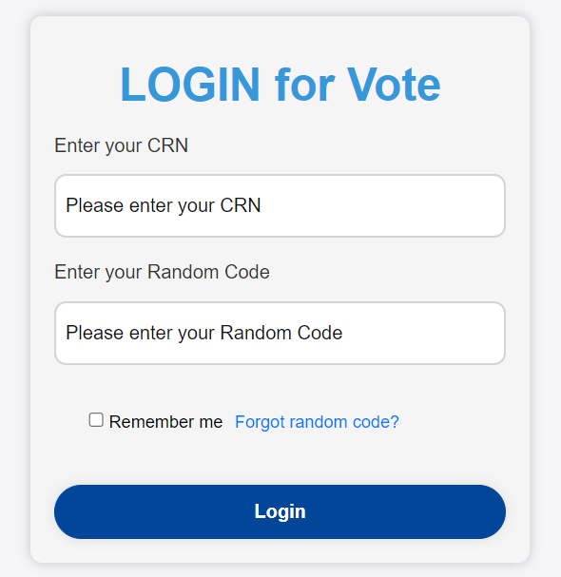This is the page where the voter enters the CRN and Random Code for login to his/her dashboard which is generated automatically and provided by the admin.

**Figure 9: Voter Login page**

* + - * **Student Registration Page**

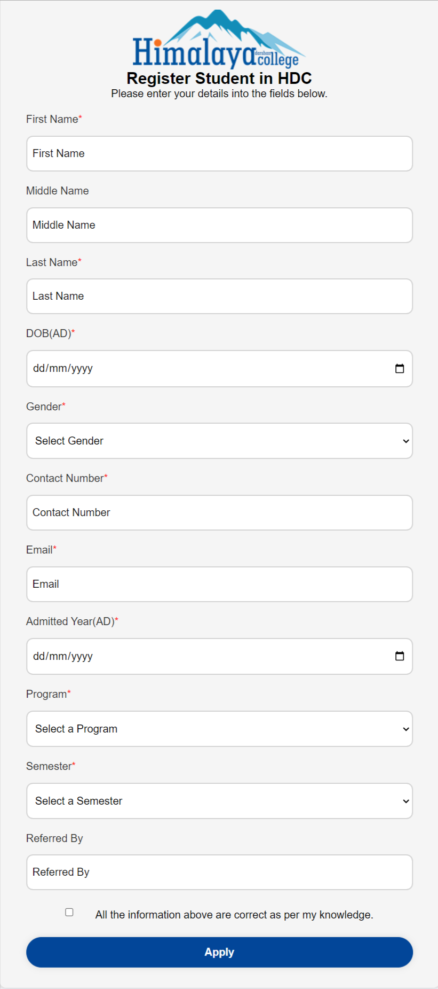

**Figure 10: Student Registration page**

* **Free CMAT Registration Page**

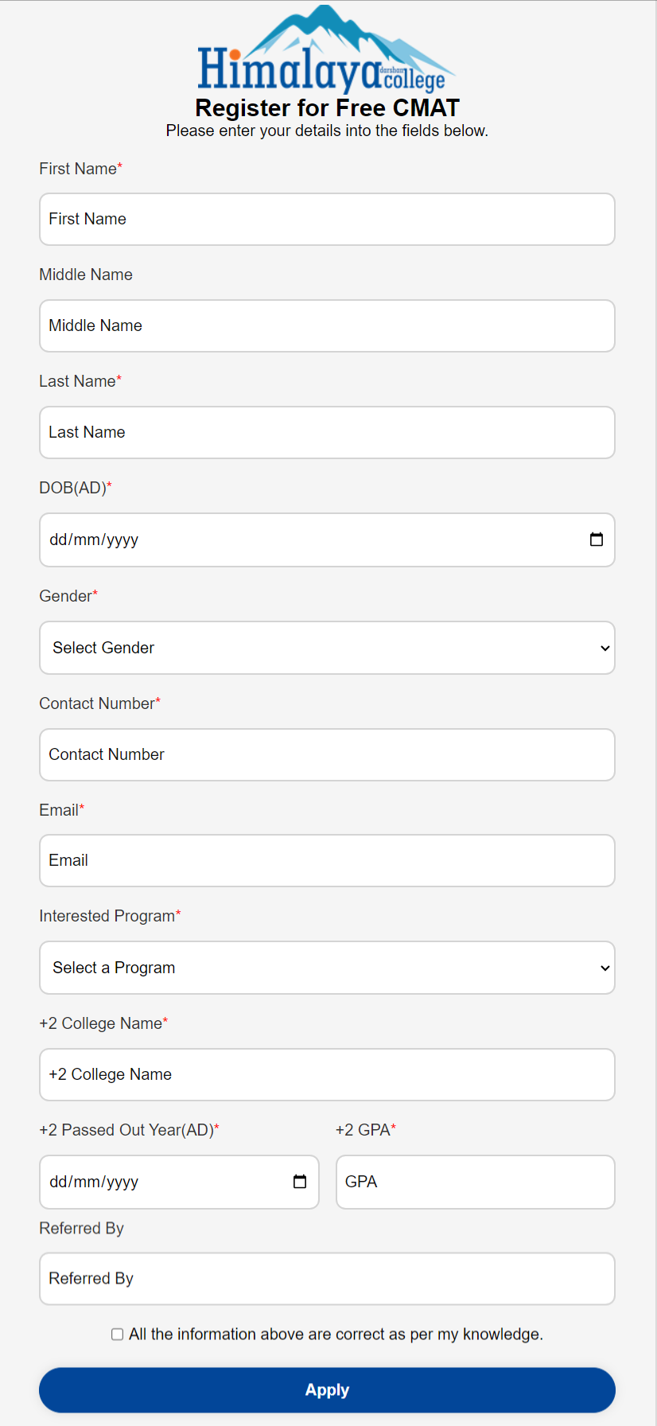

**Figure 11: Free CMAT Registration page**

# CHAPTER 4:IMPLEMENTATION AND TESTING

## Implementation

### Tools Used

The tools that are used in order to make the HDC Voting System are:

### CASE Tools:

* + Draw.io: It is proprietary software for making diagrams and charts. The software let us choose for man automatic layout. They have a large selection of shapes and hundreds of visual elements to help in making our diagrams.
  + VS Code: VS Code is the most popular source code editor. The functioning of the HDC Voting System is only possible through the lines of codes and VS Code is the platform for writing these codes.

### Programming Languages: Front-End Tools

* + HTML: HTML is the markup language that we use to structure and give meaning to our web content, for example defining paragraphs, headings, and data tables, or embedding images and videos in the page.
  + CSS: CSS is a language of style rules that we use to apply styling to our HTML content, for example setting background colors and fonts, and laying out our content in multiple columns.
  + JS: JS is a scripting language that enables you to create dynamically updating content, control multimedia, animate images, and pretty much everything else.

### Back-End Tools

* + Php: Php is server-side scripting language used for the back-end and for making dynamic web pages.
  + MySQL: MySQL is a popular open source database that stores data of the system.

### Microsoft Office Package:

We used MS Word for project documentation and MS PowerPoint to create and present slides, both part of the Microsoft Office Suite.

### Implementation Details of Modules

* + - * **Admin Model:-**

The admin model of this system consists of the following functions:

* + - * 1. Login into the system
        2. Add program, students and candidates
        3. Update/Delete existing program, student or candidate.
        4. Start/End vote
        5. Hide/Show the results
        6. Check Feedback

### User Model:-

The user models of this system consist of the following functions:

* + - * 1. Login into the system
        2. Place vote
        3. View result
        4. Provide Feedbacks

## Testing

Testing is the phase where each module and the entire system are checked for correct output, and any errors found are corrected or updated.

### Test Cases for Unit Testing

Some of the unit testing conducted areas follows:

**Table1: Test 1-Login Form**

|  |  |  |  |
| --- | --- | --- | --- |
| TestCase1 | Description | Expected Results | Test result |
| 1 | Enter a valid username and password | Should redirect to the main page | Successful |
| 2 | Invalid details | Should display error | Successful |

**Table2: Test 2- Registration Form**

|  |  |  |  |
| --- | --- | --- | --- |
| Testcase2 | Description | Expected Result | Test Result |
| 1 | Enter correct and validate details of the Students | Registered into the database successfully | Successful |
| 2 | Enter the invalid details of Student | Display Error | Successful |

**Table3: Test 3-Candidate Form**

|  |  |  |  |
| --- | --- | --- | --- |
| TestCase3 | Description | Expected Result | Test Result |
| 1 | Add Candidate | If the candidate is the Student of HDC, s/he can be candidate else show error | Successful |

**Table4: Test 4-Program Form**

|  |  |  |  |
| --- | --- | --- | --- |
| TestCase4 | Description | Expected Result | Test Result |
| 1 | Add Program | If the program doesn’t already exists then show error else add sucessfully | Successful |

### Test Cases for System Testing

**Table4: Test4**

|  |  |  |  |
| --- | --- | --- | --- |
| S .No | Description | Expected Result | Test Result |
| 1 | Enter Vote to interested candidate | Vote Successful | Pass |
| 2 | Go to a different page after login | Successfully able to change the page | Pass |
| 3 | Update candidate information | Able to display candidate information on user dashboard | Pass |
| 4 | Select a candidate to place a vote | The user should be able to place a vote by choosing their candidates | Pass |
| 5 | Sharing feedback | The user provide the feedback using the feedback form. | Pass |

# Chapter 5: CONCLUSION AND FUTURE RECOMMENDATIONS

## Lesson Learnt/Outcome

While working on this project, we improved our programming skills in HTML, CSS, PHP, and JS. It taught us the importance of cooperation and coordination with team members and the supervisor. Additionally, we learned valuable lessons in time management to meet the project deadline.

## Conclusion

After analyzing the positive aspects, we concluded that this system, with enhanced security features, can be used by schools, colleges, and offices for various voting purposes. It aims to eliminate the need for in-person voting with ballots, allowing users to apply as candidates, vote, and view results easily on personal devices.

## Future Recommendations

To enhance this system, we should first improve security. Users must be approved by the admin and receive a unique login code after registration. We can add features for streams and faculties. To prevent multiple votes from the same user in different elections, the admin can approve or reject submitted votes.

# REFERENCES

* + 1. YojanaSubedi,HDCClassRepresentativevotingsystem,2022
    2. https:/[/www](http://www.typeform.com/).[typeform.com/](http://www.typeform.com/)