CIWEC Development
CI/CD Deployment Guide
A step-by-step guide for safely deploying the project to cPanel using GitHub Actions.

GitHub repository | shibusharma1/ciwec_development
Deployment branch | main
cPanel account / SSH user | ukeshcom
Project directory on server | /home/ukeshcom/demo2

Important: This guide documents the setup details available from the deployment discussion and the failure screenshot. Secret values are deliberately not included.

1. What CI/CD means
CI/CD is a way to move code from GitHub to the hosting server with fewer manual steps.
- CI (Continuous Integration): checks or tests run when code is pushed.
- CD (Continuous Deployment/Delivery): the workflow connects to the server and updates the website.
For this project, GitHub Actions runs a workflow when changes are pushed to the main branch. The workflow connects to cPanel over SSH and updates the project in /home/ukeshcom/demo2.

2. The two SSH connections (do not mix them up)
There are two separate connections, and each needs its own key pair. A key pair has a private key (keep secret) and a public key (safe to install on the destination).
Connection | Private key lives here | Public key is installed here | Purpose
cPanel server → GitHub | cPanel: ~/.ssh/id_ed25519_ciwec | GitHub repository → Settings → Deploy keys (read-only) | Lets the server fetch/pull the private repository.
GitHub Actions → cPanel | GitHub Actions secret: SSH_PRIVATE_KEY (private key from C:\Users\Victus\Downloads\github_cpanel_deploy) | cPanel: ~/.ssh/authorized_keys | Lets the workflow log in to cPanel and run deployment commands.

3. Key and secret inventory
The names below are the names recorded during setup. The actual private-key text is not reproduced in this document.
Name / item | Where / value | Meaning / handling
Server-side GitHub key | ~/.ssh/id_ed25519_ciwec | Private key on cPanel; used for cPanel → GitHub. Its matching public key is registered as the repository Deploy Key named “cPanel Production” with read-only access.
GitHub Actions → cPanel private key | C:\Users\Victus\Downloads\github_cpanel_deploy | Private key used as the value of GitHub Actions secret SSH_PRIVATE_KEY. Do not upload this file to the repository or send it in chat/email.
Matching public key | github_cpanel_deploy.pub (or the corresponding .pub file) | Public half of the Actions-to-cPanel key. Add its full single-line content to cPanel ~/.ssh/authorized_keys.
SSH_HOST | GitHub repository → Settings → Secrets and variables → Actions | Server host/IP. The recorded server IP is 103.233.58.110.
SSH_USERNAME | GitHub Actions secret | Recorded SSH/cPanel username: ukeshcom.
SSH_PORT | GitHub Actions secret | Use the SSH port configured by the hosting provider. Do not assume a value; verify it in cPanel/hosting settings.
SSH_PRIVATE_KEY | GitHub Actions secret | Paste the complete private key, including BEGIN/END lines and line breaks, for the key authorized in cPanel.

4. Where the GitHub Actions secrets go
- Open the GitHub repository: shibusharma1/ciwec_development.
- Go to Settings → Secrets and variables → Actions.
- Create or update the repository secrets using these exact names: SSH_HOST, SSH_USERNAME, SSH_PORT, SSH_PRIVATE_KEY.
- Set SSH_HOST to the server host/IP (recorded: 103.233.58.110); SSH_USERNAME to ukeshcom; SSH_PORT to the hosting provider’s actual SSH port.
- For SSH_PRIVATE_KEY, paste the private key corresponding to the public key placed in cPanel’s ~/.ssh/authorized_keys. Preserve the full key block and line breaks.
Secret names are case-sensitive. Do not put secret values directly in deploy.yml.

5. cPanel and repository setup

A. Confirm the project directory
cd /home/ukeshcom/demo2
git status
git remote -v
git branch --show-current
The directory should be the intended project checkout, the remote should point to the CIWEC GitHub repository, and the deployment branch should be main.

B. Confirm server → GitHub access
The server uses the SSH alias github-ciwec and key ~/.ssh/id_ed25519_ciwec. Its public key is registered in the repository as the read-only Deploy Key “cPanel Production”.
ssh -T github-ciwec
If the alias is not configured, inspect ~/.ssh/config and confirm that the Host alias, HostName github.com, User git, and IdentityFile point to the intended key. Do not paste private-key contents into a terminal command or document.

C. Confirm GitHub Actions → cPanel access
The matching public key must be present in /home/ukeshcom/.ssh/authorized_keys (or the account’s actual SSH home). Ensure ~/.ssh permissions are restricted, commonly 700, and authorized_keys is commonly 600. Follow the hosting provider’s requirements if they differ.

6. Workflow file location and deployment flow
The workflow file is stored in the repository at:
.github/workflows/deploy.yml
The recorded workflow uses appleboy/ssh-action@v1.2.0 and runs on pushes to main. Its deployment sequence is: connect by SSH → move to /home/ukeshcom/demo2 → fetch origin/main → stop if the server working tree has local changes → update the checkout to origin/main.
The workflow discussion also included git reset --hard origin/main. This command permanently discards tracked local edits in the project directory. Keep the safety check that rejects local changes; do not remove it just to make a deployment pass.

Workflow outline (for understanding)
name: Deploy to cPanel
on:
push:
branches:
- main
jobs:
deploy:
runs-on: ubuntu-latest
steps:
- name: Deploy through SSH
uses: appleboy/ssh-action@v1.2.0
with:
host: ${{ secrets.SSH_HOST }}
username: ${{ secrets.SSH_USERNAME }}
port: ${{ secrets.SSH_PORT }}
key: ${{ secrets.SSH_PRIVATE_KEY }}
script: |
cd /home/ukeshcom/demo2
git fetch origin main
# Stop if local changes exist; review/back up before cleanup.
git status --short
git reset --hard origin/main
This is an explanatory outline, not a guaranteed byte-for-byte copy of the repository’s current deploy.yml. Open the actual file in GitHub and compare it before editing. Do not add Composer, migration, cache, or other commands unless they are appropriate for this application and have been tested.

7. Current failure: what the screenshot tells us
The latest GitHub Actions run failed in the “Deploy through SSH” step. The important log line is:
ERROR: Server working tree has local changes.
The log listed these server-side changes:
- .htaccess (modified)
- resources/views/themes/default/frontpage.blade.php (modified)
- shibu (untracked)
- shibu.pub (untracked)
Git is stopping the deployment because files in the server checkout differ from GitHub. The untracked names shibu and shibu.pub look like they may be an SSH private/public key pair, but filenames alone do not prove that. Inspect them before moving or deleting anything.
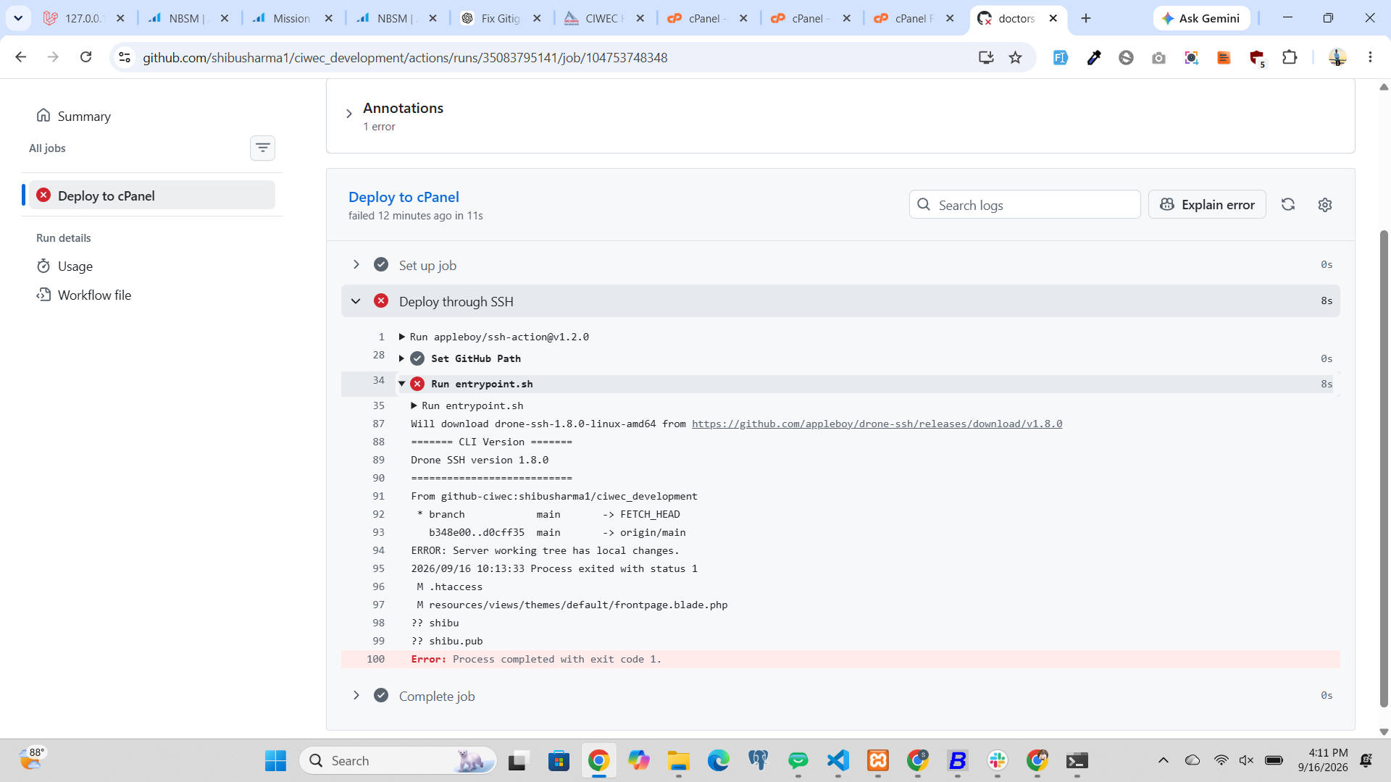
Figure 1. GitHub Actions failure screenshot: deployment stopped because the server working tree has local changes.

8. Safe, step-by-step recovery for this failure
Do this in an SSH terminal connected to cPanel. Replace no paths unless you have verified the project location.
- Go to the project and inspect status:
cd /home/ukeshcom/demo2
git status --short
git diff -- .htaccess resources/views/themes/default/frontpage.blade.php
- Back up the two modified tracked files before changing them:
mkdir -p ~/ciwec-deploy-backup
cp .htaccess ~/ciwec-deploy-backup/htaccess.backup
cp resources/views/themes/default/frontpage.blade.php ~/ciwec-deploy-backup/frontpage.blade.php.backup
- Inspect the untracked files. Do not print private-key contents into shared logs or chat:
ls -la shibu shibu.pub
file shibu shibu.pub
- If these are SSH keys, move them outside the Git checkout to a secure location only after confirming which connection uses them. Never delete a key that is still needed for SSH access.
- Decide what to do with the two modified files. If the server edits are needed, save/commit them appropriately or reapply them after deployment. If they are not needed and the backups are verified, restore them:
git restore -- .htaccess resources/views/themes/default/frontpage.blade.php
- After safely moving/removing the untracked files from the project directory, confirm the checkout is clean:
git status --short
- Return to GitHub Actions and rerun the failed workflow. Review the new logs from the top if it fails again.

9. Mistakes to avoid
- Never paste, commit, email, or screenshot a private SSH key. Public keys end in .pub; private keys do not.
- Do not confuse the two key pairs: cPanel → GitHub uses id_ed25519_ciwec; GitHub Actions → cPanel uses github_cpanel_deploy and the SSH_PRIVATE_KEY secret.
- Do not place SSH key files inside the Laravel project or commit them. Keep keys under the SSH account’s secure .ssh directory or another protected location.
- Do not run git reset --hard, git clean -fd, or git restore before inspecting and backing up server changes. These commands can discard work.
- Do not delete shibu or shibu.pub based only on their names. First confirm whether they are keys and whether anything depends on them.
- Do not change the production project path casually. The configured path is /home/ukeshcom/demo2.
- Do not rename GitHub secrets unless you also update deploy.yml. Names must match exactly.
- Do not put secret values in YAML, source code, screenshots, or logs.
- Do not deploy uncommitted changes from your local computer. Commit and push the intended changes to main first.
- Do not assume SSH_PORT. Verify the configured port with the hosting provider.
- Do not disable the workflow’s local-change safety check simply to force deployment.
- Do not run database migrations automatically unless the migration has been reviewed, backups exist, and production deployment behavior is understood.

10. Normal deployment routine
- Make and test changes locally.
- Review the changes, then commit and push to the main branch.
- Open GitHub → Actions → Deploy to cPanel.
- Wait for the run to finish. A green check means the workflow completed; still open the website and verify the changed page.
- If it fails, read the first meaningful error in the log. Do not repeatedly rerun without fixing the cause.
- If the server reports local changes, inspect and back them up using Section 8.

11. Quick troubleshooting
Error / symptom | What to check
Server working tree has local changes | Run git status --short in /home/ukeshcom/demo2. Back up and review changes; then reconcile them.
Permission denied (publickey) | Check that SSH_PRIVATE_KEY matches a public key in cPanel authorized_keys; verify SSH username, host, port, and key formatting.
Could not read from remote repository | Check cPanel → GitHub Deploy Key and the server’s ~/.ssh/config alias github-ciwec. Ensure the deploy key is read-only and attached to the correct repo.
Repository not found | Check the Git remote URL and that the deploy key is attached to shibusharma1/ciwec_development.
Workflow does not run | Confirm .github/workflows/deploy.yml is committed to main and the push event/branch matches.
Website errors after deployment | Inspect application/server logs and verify environment settings, dependencies, permissions, and document root. Avoid making unreviewed production changes.

12. Final checklist
- ☐ Repository is shibusharma1/ciwec_development and deployment branch is main.
- ☐ Project checkout is /home/ukeshcom/demo2.
- ☐ Server → GitHub key is ~/.ssh/id_ed25519_ciwec; public key is the read-only “cPanel Production” Deploy Key.
- ☐ GitHub Actions → cPanel public key is in cPanel authorized_keys.
- ☐ GitHub Actions secrets exist with exact names: SSH_HOST, SSH_USERNAME, SSH_PORT, SSH_PRIVATE_KEY.
- ☐ Private keys are not inside the repository and are not shared.
- ☐ Server working tree is clean, or all local edits are intentionally preserved.
- ☐ Workflow succeeds and the deployed website is checked manually.

13. Information to verify against the live setup
Before treating this as the final production runbook, verify the actual current deploy.yml in GitHub, the exact SSH port, the full key filenames and their locations, the Git remote on cPanel, and whether shibu/shibu.pub are key files. This document intentionally does not contain private-key material or guess any secret value.

