**DATA FLOW DIAGRAM**

**Level 0 (Context Level):**

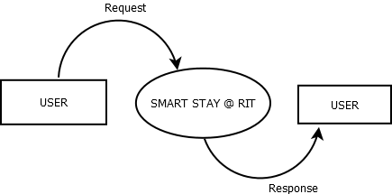

**Level 1 for Admin:**

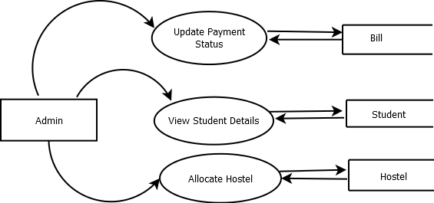

**Level 1 for Warden:**

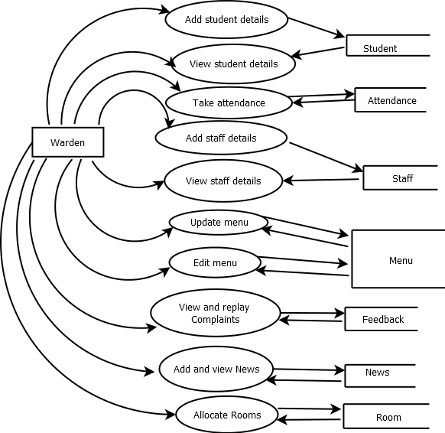

**Level 1 for Student:**

