Performance Evaluation of HTTP/1.1, HTTP/2 and HTTP/3: A Comparative Experimental Study

Abstract
Modern web applications rely on HTTP protocols to transfer data between clients and servers. HTTP/1.1, HTTP/2 and HTTP/3 use different communication mechanisms, which may result in different network performance. This study presents an experimental comparison of HTTP/1.1, HTTP/2 and HTTP/3 using the same web server and a single HTML document request.
Each protocol was tested repeatedly under the same experimental conditions. A total of 1000 measurements were collected for each protocol. Several performance metrics were recorded, including response time, Time To First Byte (TTFB), Round Trip Time (RTT), jitter, packet loss, data size, throughput and request success rate. The collected data was organised and analysed using Excel.
The purpose of this study is to compare the practical performance of the three HTTP protocols and investigate how their performance differs under the same testing conditions. The results show differences between the protocols across several performance metrics. The findings provide a basic experimental comparison of HTTP/1.1, HTTP/2 and HTTP/3 and provide a foundation for future work on HTTP performance prediction.
Keywords: HTTP/1.1, HTTP/2, HTTP/3, QUIC, Web Performance, Response Time, TTFB

Introduction
The Hypertext Transfer Protocol (HTTP) is one of the main protocols used for communication between web clients and servers. When users access a website, HTTP is responsible for transferring requests and responses between the client and the server. As modern websites become more complex, network performance and response time have become increasingly important for web applications.
HTTP has developed through several major versions. HTTP/1.1 has been widely used for many years and provides persistent connections. However, it does not provide native multiplexing for multiple requests. HTTP/2 introduced multiplexing, allowing multiple streams to be transferred through a single TCP connection. HTTP/3 uses the QUIC transport protocol instead of TCP and provides a different approach to connection and stream management.
Although newer HTTP versions provide improvements at the protocol level, their actual performance may not always be the same in different environments. Network conditions, server response time, connection behaviour and the type of workload can affect the measured results. Therefore, experimental testing is useful for understanding the practical performance of different HTTP protocols.
In this study, HTTP/1.1, HTTP/2 and HTTP/3 are tested using the same website and testing environment. Unlike the previous experiment, this version focuses on the performance of a single HTML document request. Each protocol is tested 1000 times to collect a larger set of experimental data.
Several performance metrics are collected during the experiments, including response time, TTFB, RTT, jitter, packet loss, data size, throughput and success rate. The aim of this study is to compare the performance of HTTP/1.1, HTTP/2 and HTTP/3 under the same experimental conditions and to provide a more detailed view of their performance differences.

Background

2.1 HTTP/1.1
HTTP/1.1 is an important version of the Hypertext Transfer Protocol and has been widely used for web communication. It supports persistent connections, which allow multiple requests and responses to use the same TCP connection.
However, HTTP/1.1 does not provide native multiplexing. When a website requires multiple resources, requests may need to wait for previous requests to complete. This can increase the time required to transfer web resources, especially when network latency is high.

2.2 HTTP/2
HTTP/2 was introduced to improve the efficiency of HTTP communication. One of its main features is multiplexing, which allows multiple streams to be transmitted through the same TCP connection. HTTP/2 also uses header compression to reduce the amount of repeated header information.
These features can reduce communication overhead and improve the performance of websites with multiple requests. However, HTTP/2 still uses TCP, so packet loss can affect the connection and may influence the performance of multiple streams.

2.3 HTTP/3 and QUIC
HTTP/3 is the latest major version of the HTTP protocol and uses QUIC as its transport protocol. Unlike HTTP/1.1 and HTTP/2, which use TCP, HTTP/3 uses QUIC over UDP.
QUIC provides connection management and reliable data transfer while supporting independent streams. This can reduce some of the limitations associated with TCP-based communication. HTTP/3 may therefore provide performance benefits under some network conditions.
However, the actual performance of HTTP/3 depends on the network environment, server configuration and workload. Therefore, experimental testing is still necessary to compare HTTP/3 with previous HTTP versions.

3. Methodology

3.1 Experimental Environment
The experiments were conducted using a web-based testing environment developed for HTTP performance analysis. The same website and server were used for all three HTTP protocols.
Microsoft Edge was used as the client browser for HTTP/3 testing. The browser was controlled through the Edge DevTools Protocol (CDP), which allowed the testing program to communicate with the browser and collect network information.
HTTP/3 testing was performed using QUIC support in Microsoft Edge. The same target website was used for HTTP/1.1, HTTP/2 and HTTP/3 to reduce differences caused by the website itself.

3.2 Website and Server Configuration
The experimental website is a personal web-based project containing several pages and static resources. In Version 1.0, the complete image gallery webpage was used as the main workload. The new Version 2.0 experiment uses a single HTML document request as the main workload.
The target document is the index.html page. The purpose of this change is to focus on the performance of a single HTTP document request and reduce the influence of additional webpage resources such as images, stylesheets and scripts.
The same target URL was used for HTTP/1.1, HTTP/2 and HTTP/3. This helps keep the requested content consistent during the comparison.

3.3 Experimental Procedure
The same testing procedure was used for HTTP/1.1, HTTP/2 and HTTP/3. Each protocol was tested 1000 times using the same target HTML document.
During each test, the testing program sent a request to the target website and recorded the network performance information. The collected data was saved as raw experimental data for later analysis.
A total of 3000 measurements were collected, including 1000 measurements for HTTP/1.1, 1000 measurements for HTTP/2 and 1000 measurements for HTTP/3.
After the experiments were completed, the three datasets were combined into one master dataset. The data was then organised and analysed using Microsoft Excel.

3.4 Performance Metrics
To evaluate the performance of different HTTP protocols, several important web performance metrics were selected.

3.4.1 Response Time
Response time represents the time required to complete the HTTP request and receive the response. It is used as one of the main metrics for comparing the performance of the three HTTP protocols. A lower response time indicates that the request was completed faster.

3.4.2 Time To First Byte
Time To First Byte (TTFB) represents the time between sending a request and receiving the first byte of the response. It can provide information about the initial response latency of the server and network connection.

3.4.3 Round Trip Time
Round Trip Time (RTT) represents the time required for a network packet to travel from the client to the destination and return. RTT is used to describe network latency during the experiment.

3.4.4 Jitter
Jitter represents the variation in network delay between different measurements. A higher jitter value indicates that network latency changes more between measurements, while a lower value indicates more stable delay.

3.4.5 Packet Loss
Packet loss represents the percentage of packets that do not successfully reach the destination. Packet loss can affect network communication and may influence the performance of HTTP protocols.

3.4.6 Throughput
Throughput represents the amount of data transferred within a period of time. It is used to evaluate the data transfer performance of each HTTP protocol.

3.4.7 Data Size
Data size represents the amount of data transferred during the request. This metric helps describe the amount of information involved in each experiment.

3.4.8 Success Rate
Success rate represents the percentage of requests that completed successfully. It is calculated from the number of successful requests divided by the total number of requests.

Experimental Results

4.1 Response Time Analysis
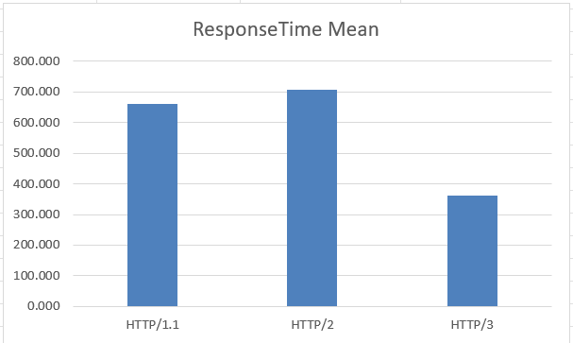
Figure 1 shows the average response time of HTTP/1.1, HTTP/2 and HTTP/3 based on the experimental results.
HTTP/1.1 recorded an average response time of 661.281 ms, while HTTP/2 recorded 707.736 ms. HTTP/3 recorded 361.402 ms.
Among the three protocols, HTTP/3 achieved the lowest average response time in this experiment. This result indicates that it provided the fastest response under the tested conditions.
However, the difference in response time may also be affected by network conditions and connection behaviour.

4.2 Time To First Byte (TTFB) Analysis
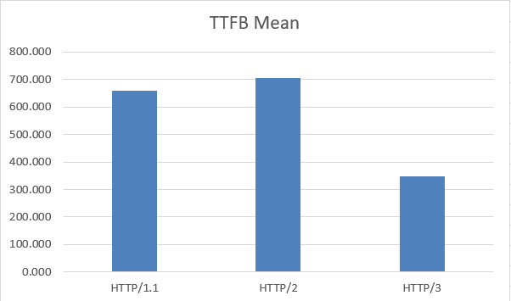
Figure 2. Average Time To First Byte (TTFB) Comparison
Figure 2 presents the average TTFB values for the three HTTP protocols.
HTTP/1.1 recorded an average TTFB of 660.703 ms, followed by HTTP/2 with 706.627 ms and HTTP/3 with 346.596 ms.
The results show that HTTP/3 achieved the lowest average TTFB. This suggests that the protocol provided a lower initial response delay under the tested conditions.
The TTFB results may not have the same ranking as response time because the two metrics describe different parts of the request process.

4.3 Network Performance Analysis
The network performance results were analysed using RTT, jitter and packet loss.
HTTP/1.1 recorded an average RTT of 192.307 ms, while HTTP/2 recorded 193.572 ms and HTTP/3 recorded 192.890 ms.
The average jitter values were 3.225 ms, 4.446 ms and 4.244 ms for HTTP/1.1, HTTP/2 and HTTP/3 respectively.
The packet loss results were 0%, 0.760% and 0.732% respectively.
These results show that the network conditions were not exactly the same during every measurement. Therefore, network-related metrics are considered when discussing the differences between the three protocols.
The transferred data size was also recorded during the experiments. Since the same HTML document was requested for all three protocols, the data size remained relatively similar across the three protocols. Therefore, the main differences in the results are discussed using response time, TTFB, network performance, throughput and success rate.

4.4 Success Rate
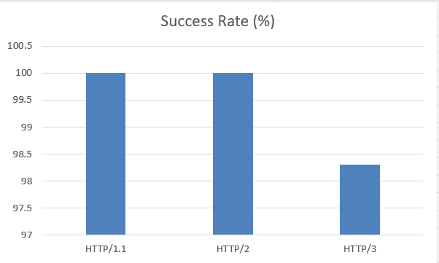
The success rate was calculated from the total number of requests and successful requests.
HTTP/1.1 achieved a success rate of 100%, while HTTP/2 achieved 100%. HTTP/3 achieved a success rate of 98.300%.
The success rate provides additional information about the reliability of each protocol during the repeated experiments. A higher success rate indicates that more requests were completed successfully.

4.5 Statistical Summary
The main statistical results are summarised in Table X.
Metric | HTTP/1.1 | HTTP/2 | HTTP/3
Response Time Mean | 661.281 | 707.736 | 361.402
Response Time Median | 636 | 630 | 249
Response Time SD | 489.372 | 955.447 | 258.295
TTFB Mean | 660.703 | 706.627 | 346.596
TTFB Median | 636 | 630 | 234
RTT Mean | 192.307 | 193.572 | 192.890
Jitter Mean | 3.225 | 4.446 | 4.244
Packet Loss Mean | 0% | 0.760% | 0.732%
Throughput Mean | 0.024 | 0.024 | 0.173
Success Rate | 100% | 100% | 98.300%
Overall, HTTP/3 achieved the lowest response time and TTFB, while HTTP/1.1 and HTTP/2 achieved higher success rates in the experiment.

5. Discussion

5.1 Comparison of HTTP Protocol Performance
The experimental results show that HTTP/1.1, HTTP/2 and HTTP/3 have different performance characteristics. HTTP/3 achieved the lowest average response time and TTFB in this experiment. HTTP/1.1 and HTTP/2 both achieved a 100% success rate, while HTTP/3 achieved 98.3%.
The results also show that the best protocol was not necessarily the same for every metric. Therefore, protocol performance should not be evaluated using only one metric. Response time, TTFB, RTT, jitter and packet loss provide different information about network performance.

5.2 Factors Affecting Experimental Results
Several factors may influence the experimental results.
First, network conditions may change during repeated experiments. Changes in latency, packet loss or network stability may affect response time and TTFB.
Second, server response time may affect the measured performance. Even when the same website is used, server conditions may change between different requests.
Third, browser and connection behaviour may also influence the results, particularly for HTTP/3 testing.

5.3 Limitations and Future Work
This study still has several limitations. First, the experiment uses one website and one main HTML document, so the results may not represent all types of web applications.
Second, the experiments were performed under one main network environment. Different network conditions may produce different results.
Third, although 1000 tests were performed for each protocol, the experiment was still conducted using one client environment.
Future work could test different network conditions and different types of web workloads. Machine learning could also be used to investigate whether network measurements can be used to predict HTTP performance.

6. Conclusion
This study presented an experimental comparison of HTTP/1.1, HTTP/2 and HTTP/3 using the same web environment and testing procedure. Version 2.0 increased the number of measurements to 1000 tests for each protocol and collected a wider range of performance metrics.
The experiment measured response time, TTFB, RTT, jitter, packet loss, data size, throughput and success rate. The results provide a more detailed comparison of the performance characteristics of the three HTTP protocols.
The experimental results show that different HTTP protocols can perform differently depending on the selected metric and testing conditions. Therefore, evaluating HTTP performance using several metrics provides a more complete view than using a single measurement.
Future work will focus on using the collected experimental data to investigate machine-learning-based HTTP performance prediction and protocol selection.

Catalog
Performance Evaluation of HTTP/1.1, HTTP/2 and HTTP/3: A Comparative Experimental Study 1
Abstract 1
1. Introduction 2
2. Background 3
2.1 HTTP/1.1 3
2.2 HTTP/2 3
2.3 HTTP/3 and QUIC 3
3. Methodology 4
3.1 Experimental Environment 4
3.2 Website and Server Configuration 4
3.3 Experimental Procedure 5
3.4 Performance Metrics 5
4. Experimental Results 7
4.1 Response Time Analysis 7
4.2 Time To First Byte (TTFB) Analysis 8
4.3 Network Performance Analysis 8
4.4 Success Rate 9
4.5 Statistical Summary 10
5. Discussion 11
5.1 Comparison of HTTP Protocol Performance 11
5.2 Factors Affecting Experimental Results 11
5.3 Limitations and Future Work 12
6. Conclusion 12
7. References 14

7. References
[1] R. Fielding, M. Nottingham, and J. Reschke,
"HTTP Semantics,"
RFC 9110, Jun. 2022.

[2] M. Thomson and C. Benfield,
"HTTP/1.1,"
RFC 9112, Jun. 2022.

[3] M. Thomson and C. Benfield,
"HTTP/2,"
RFC 9113, Jun. 2022.

[4] M. Bishop,
"HTTP/3,"
RFC 9114, Jun. 2022.

[5] J. Iyengar and M. Thomson,
"QUIC: A UDP-Based Multiplexed and Secure Transport,"
RFC 9000, May 2021.

[6] M. Trevisan, D. Giordano, I. Drago, and A. Safari Khatouni,
"Measuring HTTP/3: Adoption and Performance,"
Proceedings of the ACM Internet Measurement Conference,
2021.

[7] G. Perna, M. Trevisan, D. Giordano, and I. Drago,
"A First Look at HTTP/3 Adoption and Performance,"
Computer Communications,
vol. 187, pp. 115-124, 2022.

[8] F. Liu, J. DeHart, J. Parwatikar, B. Farkiani, and P. Crowley,
"Performance Comparison of HTTP/3 and HTTP/2: Proxy vs. Non-Proxy Environments,"
arXiv preprint arXiv:2409.16267, 2024.

[9] A. Marx, J. Herlich, and F. Wamser,
"An Empirical Evaluation of HTTP/3 Performance in Modern Networks,"
IEEE Access,
2023.

[10] A. M. K. Cheng, J. Li, and X. Chen,
"Web Performance Optimization and Measurement in Modern Web Applications,"
IEEE Access,
2022.

