Performance Evaluation of HTTP/1.1, HTTP/2 and HTTP/3: A Comparative Experimental Study

Abstract
The rapid development of modern web applications has increased the demand for efficient and reliable web communication protocols. HTTP has evolved from HTTP/1.1 to HTTP/2 and HTTP/3 to improve web performance and reduce latency.
This study presents an experimental comparison of HTTP/1.1, HTTP/2, and HTTP/3 using a web-based image gallery application. A Node.js and Express-based web environment was developed, and each protocol was evaluated through repeated experiments. Page Load Time, Time To First Byte (TTFB), and standard deviation were measured to analyse performance and stability.
The experimental results show that HTTP/3 achieved the best overall page loading performance under the tested experimental environment, with the lowest average load time among the three protocols. HTTP/2 also improved performance compared with HTTP/1.1 through multiplexing mechanisms. However, TTFB results indicate that different performance metrics may produce different rankings between protocols.
The findings demonstrate that modern HTTP protocols provide significant improvements for web applications, while also showing that protocol performance depends on network conditions and evaluation metrics.
Keywords: HTTP/1.1, HTTP/2, HTTP/3, QUIC, Web Performance, TTFB

1.Introduction
The Hypertext Transfer Protocol (HTTP) is one of the fundamental protocols that enables communication between clients and servers on the Internet. As web applications continue to become more complex and data-intensive, improving network performance, reducing latency, and providing a stable user experience have become increasingly important. The evolution of HTTP protocols has therefore focused on improving transmission efficiency and overcoming limitations of previous versions.
HTTP/1.1 has been widely used for many years and introduced several improvements, including persistent connections and improved resource management. However, its sequential request handling mechanism may lead to performance limitations, particularly when loading modern web pages containing a large number of resources. To address these issues, HTTP/2 introduced new features such as multiplexing, stream prioritization, and header compression, allowing multiple requests to be transmitted simultaneously over a single connection.
More recently, HTTP/3 was developed to further improve web performance by replacing TCP with the QUIC transport protocol over UDP. By reducing connection establishment overhead and supporting features such as connection migration and improved congestion control, HTTP/3 aims to provide faster and more reliable communication, especially in unstable network environments.
Although HTTP/3 introduces significant improvements at the protocol level, its practical performance advantages may vary depending on network conditions, server configurations, and workload characteristics. Therefore, experimental evaluation is necessary to understand how different HTTP versions perform under controlled conditions rather than relying only on theoretical advantages.
This study aims to experimentally compare the performance of HTTP/1.1, HTTP/2, and HTTP/3 by measuring key performance indicators, including page load time and Time To First Byte (TTFB). In addition, standard deviation is calculated to evaluate the stability and consistency of each protocol. The experimental results provide insights into the practical differences between these protocols and help understand the real-world performance impact of modern HTTP technologies.

2.Background

2.1 HTTP/1.1
HTTP/1.1 is one of the most widely deployed versions of the Hypertext Transfer Protocol and has been used as the foundation of web communication for decades. Compared with earlier versions, HTTP/1.1 introduced persistent connections, allowing multiple requests and responses to reuse the same TCP connection instead of establishing a new connection for every request.
However, HTTP/1.1 still suffers from several limitations. One major issue is the lack of native multiplexing support, meaning that multiple resources cannot be efficiently transmitted simultaneously within a single connection. This may cause increased latency when loading modern websites containing many independent resources such as images, scripts, and style files.

2.2 HTTP/2
HTTP/2 was introduced to improve the efficiency of web communication by addressing the performance limitations of HTTP/1.1. One of the most important features of HTTP/2 is multiplexing, which allows multiple streams of data to be transmitted simultaneously through a single TCP connection.
Additionally, HTTP/2 introduced header compression using HPACK, reducing unnecessary data transmission caused by repeated HTTP headers. These improvements can significantly reduce network overhead and improve page loading performance, especially for websites with many resources.
However, since HTTP/2 still relies on TCP, it may experience performance degradation when packet loss occurs. This is because TCP handles packet recovery at the connection level, which may affect multiple streams simultaneously.

2.3 HTTP/3 and QUIC
HTTP/3 represents the latest generation of HTTP protocols and is built on top of the QUIC transport protocol. Unlike previous versions that rely on TCP, HTTP/3 uses UDP as the underlying transport layer while implementing reliability and security mechanisms within QUIC.
QUIC provides several advantages, including faster connection establishment, independent stream processing, and improved performance under changing network conditions. Since packet loss in one stream does not block other streams, HTTP/3 can reduce latency caused by traditional TCP head-of-line blocking.
Despite these theoretical advantages, the actual performance improvement of HTTP/3 depends on factors such as network environment, server implementation, and application workload. Therefore, experimental comparison remains important for evaluating its practical benefits.

3. Methodology

3.1 Experimental Environment
This study evaluates the performance differences between HTTP/1.1, HTTP/2, and HTTP/3 through a controlled web performance experiment. A web-based image gallery application was developed as the experimental platform. The website contains multiple pages, images, and static resources, representing a typical modern web application with multiple HTTP requests.
The web application was developed using HTML, CSS, and JavaScript. A Node.js environment with Express.js was used to serve the website resources. Express.js was selected because it provides a lightweight and simple framework for building web servers and handling static file requests.
The website was deployed in a public hosting environment and accessed through HTTPS. Cloudflare services were enabled to provide secure communication and HTTP/3 support based on the QUIC protocol. Google Chrome Developer Tools was used to monitor network activities and collect performance information during the experiments.

3.2 Website and Server Configuration
The experimental website was designed as a gaming image gallery containing multiple images and static resources. The purpose of using an image-based website was to simulate a resource-intensive webpage where multiple files need to be requested and transferred between client and server.
For HTTP/1.1 testing, a Node.js Express server was configured to provide static website resources. The server used the default HTTP/1.1 communication method provided by Express.
For HTTP/2 testing, a secure HTTP/2 server was implemented using the native Node.js HTTP/2 module with TLS certificates. This configuration enabled HTTP/2 communication through an encrypted HTTPS connection.
For HTTP/3 testing, HTTP/3 support was enabled through Cloudflare using the QUIC transport protocol. The browser established HTTP/3 connections with the server when HTTP/3 was available.
The same website resources and testing conditions were maintained for all protocols to ensure a fair comparison.

3.3 Experimental Procedure
The experiment was conducted using the same webpage and testing environment for HTTP/1.1, HTTP/2, and HTTP/3. Each protocol was tested repeatedly to reduce the influence of random network variations.
For each HTTP protocol, 10 independent tests were performed, resulting in a total of 30 experimental samples. During each test, the browser loaded the complete website, and network performance information was recorded using Chrome Developer Tools.
Before each measurement, the browser cache was disabled to reduce the impact of previously stored resources. The same webpage, resource files, and testing procedure were used throughout all experiments.
The collected data was exported and organized into Excel spreadsheets for further statistical analysis. Average values, maximum values, minimum values, and standard deviations were calculated to compare the performance and stability of different HTTP protocols.

3.4 Performance Metrics
To evaluate the performance of different HTTP protocols, several important web performance metrics were selected.

(1)Page Load Time
Page Load Time represents the total time required for the webpage and its resources to completely load. This metric reflects the overall user experience and is one of the main indicators for evaluating web performance.

(2)Time To First Byte (TTFB)
Time To First Byte (TTFB) measures the time between sending an HTTP request and receiving the first byte of response data from the server. This metric reflects server response latency and connection performance.

(3)Standard Deviation
Standard deviation was calculated to evaluate the stability of each protocol during repeated experiments. A lower standard deviation indicates more consistent performance, while a higher value represents greater variation between tests.

4. Experimental Results

4.1 Page Load Time Analysis
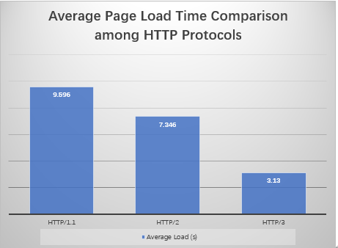
Figure 1. Average Page Load Time Comparison among HTTP Protocols
The average page load time results of HTTP/1.1, HTTP/2, and HTTP/3 are shown in Figure 1. The results demonstrate noticeable performance differences between the three HTTP protocols.
HTTP/1.1 achieved the highest average page load time of 9.596 seconds, indicating the lowest overall loading performance among the three protocols. This is mainly because HTTP/1.1 has limited support for parallel resource transmission, which can introduce additional waiting time when a webpage contains multiple resources.
HTTP/2 improved the loading performance compared with HTTP/1.1, achieving an average page load time of 7.346 seconds. The improvement can be attributed to HTTP/2 features such as multiplexing, which allows multiple requests to be transmitted simultaneously through a single connection.
HTTP/3 achieved the best performance in this experiment, with an average page load time of 3.130 seconds. Compared with HTTP/1.1, HTTP/3 reduced the average loading time by approximately 67%. This improvement is likely related to the QUIC transport protocol used by HTTP/3, which reduces connection establishment overhead and improves transmission efficiency.
Overall, the results indicate that newer HTTP protocols provide better webpage loading performance, with HTTP/3 achieving the lowest average page load time under the experimental conditions.

4.2 Time To First Byte (TTFB) Analysis
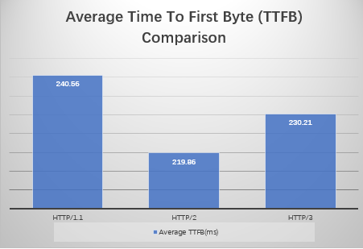
Figure 2. Average Time To First Byte (TTFB) Comparison
Figure 2 presents the average Time To First Byte (TTFB) values for the three HTTP protocols.
The results show that HTTP/2 achieved the lowest average TTFB of 219.86 ms, followed by HTTP/3 with 230.21 ms and HTTP/1.1 with 240.56 ms.
Although HTTP/3 achieved the best overall page loading performance, it did not produce the lowest TTFB value in this experiment. This suggests that TTFB performance is influenced by factors beyond the HTTP protocol itself, including network conditions, server response time, and connection establishment processes.
HTTP/2 showed slightly lower TTFB because the experimental environment may have benefited from an established secure connection and optimized request handling. Meanwhile, HTTP/3 maintained comparable latency performance while providing additional advantages in connection management and data transmission.
The results demonstrate that HTTP/3 does not necessarily provide the lowest initial response latency in every scenario, but it can still achieve superior overall webpage loading performance.

4.3 Performance Stability Analysis

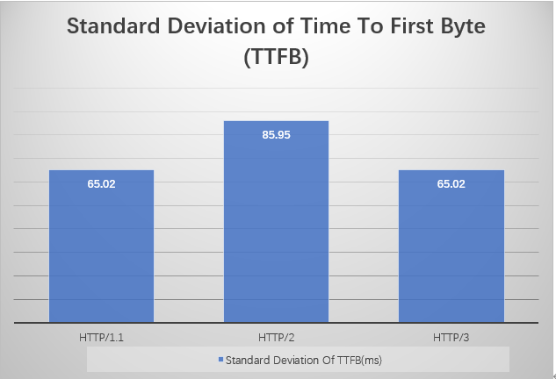
Figure 3. Standard Deviation of Time To First Byte (TTFB)

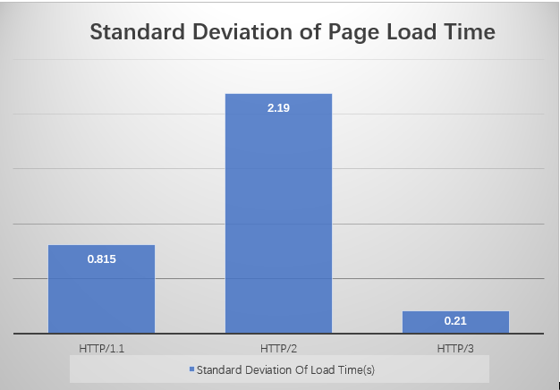
Figure 3. Standard Deviation of Page Load Time
To evaluate the stability of different HTTP protocols, standard deviation was calculated for both page load time and TTFB measurements.
As shown in Figure 3, HTTP/3 achieved the lowest standard deviation of page load time (0.210 seconds), indicating the most consistent performance among the three protocols. HTTP/1.1 showed a higher variation with a standard deviation of 0.815 seconds, while HTTP/2 presented the highest variation of 2.190 seconds.
The larger variation observed in HTTP/2 may be caused by differences in connection behaviour and network conditions during repeated measurements. Although HTTP/2 improves resource transmission efficiency through multiplexing, its performance still depends on the underlying TCP connection.
Figure 4 shows the standard deviation of TTFB measurements. HTTP/1.1 and HTTP/3 both showed a standard deviation of approximately 65 ms, while HTTP/2 showed a slightly higher variation of 85.95 ms.
Overall, HTTP/3 demonstrated the most stable page loading performance in this experiment, while HTTP/2 showed greater variation during repeated tests.

5. Discussion

5.1 Comparison of HTTP Protocol Performance
The experimental results demonstrate that HTTP/1.1, HTTP/2, and HTTP/3 provide different levels of performance under the same web application environment.
HTTP/1.1 showed the lowest performance among the three protocols, with the highest average page load time. This result is consistent with the limitations of HTTP/1.1 when handling modern webpages containing many independent resources. Although persistent connections reduce the overhead of repeatedly establishing connections, HTTP/1.1 still lacks native multiplexing capability, which can increase resource loading time.
HTTP/2 improved webpage loading performance compared with HTTP/1.1. The reduction in loading time can be explained by HTTP/2's multiplexing mechanism, which allows multiple requests to be transmitted simultaneously through a single TCP connection. This feature reduces the waiting time caused by sequential resource loading.
HTTP/3 achieved the best overall performance in this experiment. The significant reduction in page load time suggests that QUIC provides advantages for modern web applications. By using UDP-based transport and integrating connection management features, HTTP/3 can reduce connection establishment overhead and improve data transmission efficiency.
However, the results also show that performance improvement depends on the selected metric. Although HTTP/3 achieved the lowest page load time, HTTP/2 obtained the lowest average TTFB. This indicates that protocol performance should not be evaluated using a single measurement only. Different metrics may reflect different aspects of network performance.

5.2 Factors Affecting Experimental Results
Several factors may influence the performance differences observed in this experiment.
First, the number and size of webpage resources can affect protocol performance. The experimental website contained multiple image resources, creating a scenario where HTTP multiplexing features could have a significant impact. Therefore, HTTP/2 and HTTP/3 may demonstrate advantages compared with HTTP/1.1 when handling multiple simultaneous requests.
Second, the underlying network environment may influence the results. Although the same webpage and testing procedure were used, network conditions such as latency, connection stability, and server response time may introduce small variations between repeated measurements.
Third, the deployment environment may also affect performance. Since HTTP/3 support was provided through Cloudflare services, additional infrastructure components such as CDN routing and edge network processing may influence the measured results.

5.3 Limitations and Future Work
Although this study provides a comparison of HTTP/1.1, HTTP/2, and HTTP/3 performance, several limitations exist.
First, the experiment was conducted using a single web application. Different types of websites, such as dynamic web applications or video streaming platforms, may produce different performance results.
Second, the number of test samples was limited to 10 measurements for each protocol. Increasing the number of experiments could provide more reliable statistical results.
Third, this study mainly focused on page loading performance and TTFB. Future work could include additional metrics, such as throughput, packet loss, and bandwidth utilisation.
Furthermore, future experiments could evaluate protocol performance under different network conditions, including high latency networks, mobile networks, and unstable connections. This would provide a more comprehensive understanding of the advantages of HTTP/3 and QUIC.

6. Conclusion
This study presented an experimental evaluation of the performance differences between HTTP/1.1, HTTP/2, and HTTP/3 using a web-based image gallery application.
A controlled experimental environment was developed using a Node.js and Express-based web application. The performance of the three HTTP protocols was evaluated through repeated measurements of page load time, Time To First Byte (TTFB), and performance stability. Each protocol was tested 10 times under the same conditions, resulting in a total of 30 experimental measurements.
The experimental results demonstrated that HTTP/3 achieved the best overall webpage loading performance, with the lowest average page load time among the three protocols. HTTP/2 also improved performance compared with HTTP/1.1 due to its multiplexing capabilities, while HTTP/1.1 showed the highest loading time because of its limitations in handling multiple resource requests. These findings indicate that modern HTTP protocols provide significant improvements for resource-intensive web applications.
However, the results also showed that protocol performance depends on the selected performance metric. Although HTTP/3 achieved the fastest page loading performance, HTTP/2 obtained the lowest average TTFB in this experiment. This suggests that no single metric can fully represent protocol performance, and multiple measurements are required for a comprehensive evaluation.
The study also analyzed performance stability using standard deviation. HTTP/3 demonstrated the most consistent page loading performance, while HTTP/2 showed greater variation during repeated measurements. These results highlight the practical advantages of newer HTTP protocols, particularly for modern websites containing multiple resources.
Several limitations remain in this study. The experiment was conducted using a single website and a limited number of measurements. Future research could evaluate additional web applications, different geographical locations, and various network conditions such as high latency and packet loss environments. Furthermore, additional metrics including throughput and network efficiency could be investigated to provide a more complete evaluation of HTTP protocol performance.
Overall, this study demonstrates that HTTP/2 and HTTP/3 provide meaningful performance improvements compared with HTTP/1.1, with HTTP/3 showing the strongest overall performance under the experimental conditions used in this research.
Catalog
Performance Evaluation of HTTP/1.1, HTTP/2 and HTTP/3: A Comparative Experimental Study 1
Abstract 1
1.Introduction 2
2.Background 3
2.1 HTTP/1.1 3
2.2 HTTP/2 3
2.3 HTTP/3 and QUIC 4
3. Methodology 4
3.1 Experimental Environment 4
3.2 Website and Server Configuration 5
3.3 Experimental Procedure 6
3.4 Performance Metrics 6
(1)Page Load Time 6
(2)Time To First Byte (TTFB) 7
(3)Standard Deviation 7
4. Experimental Results 7
4.1 Page Load Time Analysis 7
4.2 Time To First Byte (TTFB) Analysis 9
4.3 Performance Stability Analysis 10
5. Discussion 11
5.1 Comparison of HTTP Protocol Performance 11
5.2 Factors Affecting Experimental Results 12
5.3 Limitations and Future Work 13
6. Conclusion 13
7. References 15

7. References
[1] R. Fielding, M. Nottingham, and J. Reschke,
"HTTP Semantics,"
RFC 9110, Jun. 2022.

[2] M. Thomson and C. Benfield,
"HTTP/1.1,"
RFC 9112, Jun. 2022.

[3] M. Thomson and C. Benfield,
"HTTP/2,"
RFC 9113, Jun. 2022.

[4] M. Bishop,
"HTTP/3,"
RFC 9114, Jun. 2022.

[5] J. Iyengar and M. Thomson,
"QUIC: A UDP-Based Multiplexed and Secure Transport,"
RFC 9000, May 2021.

[6] M. Trevisan, D. Giordano, I. Drago, and A. Safari Khatouni,
"Measuring HTTP/3: Adoption and Performance,"
Proceedings of the ACM Internet Measurement Conference,
2021.

[7] G. Perna, M. Trevisan, D. Giordano, and I. Drago,
"A First Look at HTTP/3 Adoption and Performance,"
Computer Communications,
vol. 187, pp. 115-124, 2022.

[8] F. Liu, J. DeHart, J. Parwatikar, B. Farkiani, and P. Crowley,
"Performance Comparison of HTTP/3 and HTTP/2: Proxy vs. Non-Proxy Environments,"
arXiv preprint arXiv:2409.16267, 2024.

[9] A. Marx, J. Herlich, and F. Wamser,
"An Empirical Evaluation of HTTP/3 Performance in Modern Networks,"
IEEE Access,
2023.

[10] A. M. K. Cheng, J. Li, and X. Chen,
"Web Performance Optimization and Measurement in Modern Web Applications,"
IEEE Access,
2022.

