|  |
| --- |
| Brylee Curran |
| Frank Li |
| Stella Xu |
| Saiful Sufri |

Assignment 2 – Task 3

158.383 Information Technology Project

2018

# Task 3

## Concept description – Database backup

The databases in any organization are crucial for the continuation of its operation when a serious disruption occurs. When Christchurch suffered the major earthquake in 2011, a lot of businesses completely lost their operation as they lost their ability to operate, due to most organisations having only one set of database in use primarily. This is what is known as a single-point of failure. In order to avoid this, there must be a duplicate of the database, or an exact copy in which can be used to restore data. Whether the duplicate is used concurrently during normal operations or a scheduled backup is run, a backup file is created and stored remotely.

In our approach, we have chosen to have a backup system where the backup file is stored remotely in a cloud system for disaster recovery or backup when needed. We believe that a backup should be performed once a day when traffic is low after midnight due to low user traffic, but since the system may be run and accessed by users globally, there is a high chance that there would be no window for an ideal low traffic volume for the ideal backup procedure. Therefore, we have opted for the criteria where the backup is a load-based instead of a time-based backup. But to demonstrate our how our script functions, the backup will be performed every 1 minute.

In the context of DevOps, the backup is a safeguard for us to use before implementing a newer version of our system. If the upgrade fails, there is always the old system to be restored to fall back on. So the system failure would not completely paralyse our operation. When user data is involved it is always important to have a backup of their information, to ensure that should something go wrong, their data is not lost.

## Database Backup

**1. Launch Instance:**

* Select t2.micro Ubuntu server 16.04.
* Use all default settings.
* Create a key pair and name it anything you want (I have called it “a2”).
* Create a folder on your computer (e.g. I have created a folder on my desktop and called it “383a2”).
* Download the key pair and then place the key pair into your newly created folder.
* Launch the instance.

**2. Connect to your Instance:**

* Open the terminal and cd into the folder you created earlier e.g.

../Desktop/屏幕快照%202018-10-05%20上午10.36.42.png

* Open SSH client and ensure key is not publicly viewable by changing the permissions of your key pair e.g. enter the command into the terminal chmod 400 a2.pem.
* Download our zip file called “final.zip” and place this file into the folder you created earlier (i.e. the 383a2 folder). Ensure that this file is still zipped once downloaded.

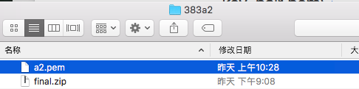

* Connect to your instance via the terminal e.g.



* Copy and paste the following red lines:

sudo su

mkdir /home/ubuntu/upload

chmod 777 upload

exit

logout

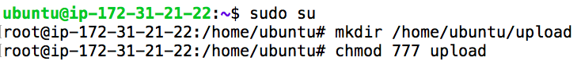The output should look like the following:

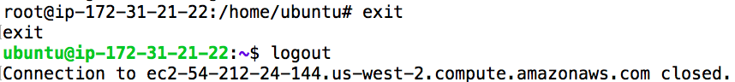

* Enter your own details into the following command and then copy and paste it into the terminal:

sudo scp –i path_to_keypair path_to_zipfile hostname@public_ip:/home/hostname/upload

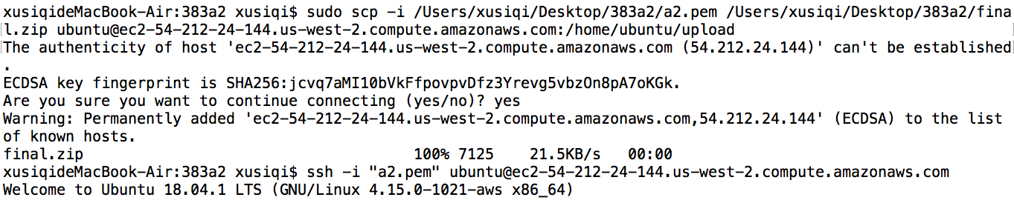e.g.

The output should look like the following:



* Now the zip file has been put into the ec2 server and under the upload
* Connect to the instance again (e.g. ssh -i "key_pair.pem" ubuntu@ec2-54-200-246-70.us-west-2.compute.amazonaws.com)
* By using the ls command in the terminal, you can see the zip file. Firstly cd into “upload” by using the cd upload command, and then ls command.

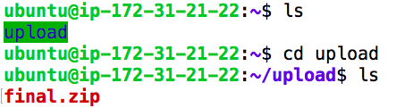

* 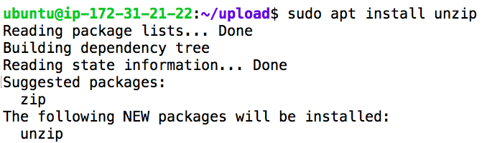Download “unzip” command by using: sudo apt install unzip
* Then unzip zip file by using: unzip final.zip and then cd to “final”

The output should be:

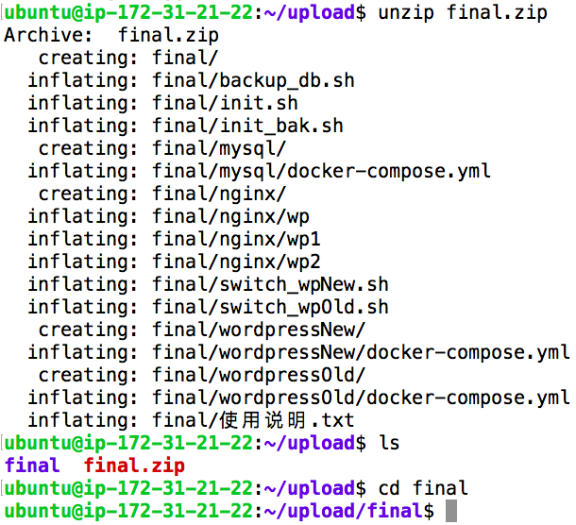

* Then copy and paste the following into the terminal:

sudo bash init.sh

bash init_bak.sh (sometimes you need to input this line twice)

cd ~

ls

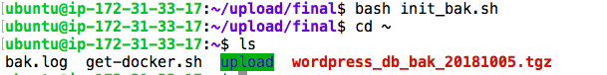

**-----Just wait for one minute and then you can see that there is a new file which back up the data.**