使用说明

我们要做的事就是一个校正过程，和下面数码摄影的校正很像

<http://www.seka168.com/xrite/1128114579.html>

论文里面的数据 L a b 标准

|  |  |  |  |  |  |  |  |  |  |  |  |  |
| --- | --- | --- | --- | --- | --- | --- | --- | --- | --- | --- | --- | --- |
| Zone | R-meas | G-meas | B-meas | R-ideal | G-ideal | B-ideal | L-meas | a*-meas | b*-meas | L-ideal | a*-ideal | b*-ideal |
| 1 | 0.415 | 0.283 | 0.221 | 0.455 | 0.318 | 0.263 | 34.01 | 12.23 | 15.21 | 38.08 | 12.09 | 14.39 |
| 2 | 0.789 | 0.553 | 0.534 | 0.773 | 0.596 | 0.518 | 64.41 | 22.23 | 11.79 | 66.38 | 13.22 | 17.14 |
| 3 | 0.302 | 0.358 | 0.602 | 0.376 | 0.486 | 0.624 | 40.26 | 12.52 | -35.8 | 51.06 | 0.38 | -22.06 |
| 4 | 0.304 | 0.421 | 0.195 | 0.341 | 0.427 | 0.255 | 41.84 | -21.72 | 28.58 | 43.3 | -16.52 | 21.46 |
| 5 | 0.495 | 0.379 | 0.714 | 0.522 | 0.51 | 0.702 | 47.42 | 30.56 | -41.09 | 56.36 | 12.84 | -25.29 |
| 6 | 0.265 | 0.692 | 0.704 | 0.396 | 0.749 | 0.675 | 66.27 | -29.48 | -10.84 | 71.6 | -30.71 | 1.17 |
| 7 | 0.843 | 0.507 | 0.195 | 0.855 | 0.49 | 0.161 | 62.05 | 26.88 | 54.61 | 61.7 | 27.54 | 58.23 |
| 8 | 0.24 | 0.2 | 0.692 | 0.294 | 0.357 | 0.659 | 30.71 | 42.4 | -65.09 | 41.22 | 17.95 | -43.16 |
| 9 | 0.799 | 0.308 | 0.352 | 0.773 | 0.345 | 0.392 | 50.76 | 50.41 | 19.92 | 51.57 | 43 | 14.75 |
| 10 | 0.332 | 0.167 | 0.314 | 0.369 | 0.227 | 0.427 | 24.29 | 25.59 | -14.67 | 30.77 | 25.74 | -23.38 |
| 11 | 0.575 | 0.824 | 0.253 | 0.627 | 0.745 | 0.235 | 77.72 | -42.19 | 62.6 | 72.58 | -28.17 | 58.61 |
| 12 | 0.852 | 0.702 | 0.21 | 0.894 | 0.643 | 0.169 | 74.39 | 1.43 | 65.08 | 71.6 | 12.45 | 66.58 |
| 13 | 0.105 | 0.103 | 0.596 | 0.188 | 0.231 | 0.592 | 21 | 44.83 | -66.31 | 29.73 | 28.47 | -51.99 |
| 14 | 0.178 | 0.615 | 0.26 | 0.267 | 0.588 | 0.282 | 57.06 | -50.24 | 37.97 | 55.65 | -41.52 | 33.73 |
| 15 | 0.794 | 0.252 | 0.214 | 0.702 | 0.184 | 0.227 | 47.74 | 53.91 | 36.71 | 41.22 | 50.85 | 25.86 |
| 16 | 0.963 | 0.944 | 0.138 | 0.922 | 0.788 | 0.11 | 92.78 | -18.23 | 86.96 | 81.35 | -4.13 | 79.25 |
| 17 | 0.795 | 0.235 | 0.573 | 0.745 | 0.329 | 0.592 | 49.44 | 63.42 | -15.88 | 51.57 | 48.98 | -15.96 |
| 18 | 0.105 | 0.333 | 0.713 | 0 | 0.557 | 0.686 | 38 | 18.89 | -56.43 | 51.57 | -19.85 | -24.01 |
| 19 | 0.987 | 0.994 | 0.994 | 0.953 | 0.957 | 0.953 | 99.34 | -0.59 | -0.24 | 96 | -0.06 | 0.06 |
| 20 | 0.799 | 0.806 | 0.857 | 0.792 | 0.792 | 0.792 | 82.78 | 1.85 | -6.69 | 81.35 | -0.05 | 0.06 |
| 21 | 0.595 | 0.622 | 0.662 | 0.635 | 0.635 | 0.635 | 65.11 | -0.4 | -6.13 | 66.67 | -0.04 | 0.05 |
| 22 | 0.398 | 0.41 | 0.445 | 0.482 | 0.482 | 0.482 | 44.26 | 0.77 | -5.45 | 51.57 | -0.03 | 0.04 |
| 23 | 0.27 | 0.248 | 0.296 | 0.333 | 0.333 | 0.333 | 27.73 | 5.16 | -6.61 | 35.99 | -0.03 | 0.03 |
| 24 | 0.072 | 0.098 | 0.127 | 0.192 | 0.196 | 0.192 | 8.48 | -0.73 | -6.09 | 20.54 | -0.02 | 0.02 |

网上的L a b

|  |  |  |  |  |  |  |  |  |  |  |
| --- | --- | --- | --- | --- | --- | --- | --- | --- | --- | --- |
| NO. | Number | | sRGB | | | CIE L*a*b* | | | Munsell Notation Hue Value / Chroma | |
| R | G | B | L* | a* | b* |
| 1. | dark skin |  | 115 | 82 | 68 | 37.986 | 13.555 | 14.059 | 3YR | 3.7 / 3.2 |
| 2. | light skin |  | 194 | 150 | 130 | 65.711 | 18.13 | 17.81 | 2.2YR | 6.47 / 4.1 |
| 3. | blue sky |  | 98 | 122 | 157 | 49.927 | -4.88 | -21.925 | 4.3PB | 4.95 / 5.5 |
| 4. | foliage |  | 87 | 108 | 67 | 43.139 | -13.095 | 21.905 | 6.7GY | 4.2 / 4.1 |
| 5. | blue flower |  | 133 | 128 | 177 | 55.112 | 8.844 | -25.399 | 9.7PB | 5.47 / 6.7 |
| 6. | bluish green |  | 103 | 189 | 170 | 70.719 | -33.397 | -0.199 | 2.5BG | 7 / 6 |
| 7. | Orange |  | 214 | 126 | 44 | 62.661 | 36.067 | 57.096 | 5YR | 6 / 11 |
| 8. | Purplish blue |  | 80 | 91 | 166 | 40.02 | 10.41 | -45.964 | 7.5PB | 4 / 10.7 |
| 9. | Moderate red |  | 193 | 90 | 99 | 51.124 | 48.239 | 16.248 | 2.5R | 5 / 10 |
| 10. | Purple |  | 94 | 60 | 108 | 30.325 | 22.976 | -22.587 | 5P | 3 / 7 |
| 11. | Yellow green |  | 157 | 188 | 64 | 72.532 | -23.709 | 57.255 | 5GY | 7.1 / 9.1 |
| 12. | Orange yellow |  | 224 | 163 | 46 | 71.941 | 19.363 | 67.857 | 10YR | 7 / 10.5 |
| 13. | Blue |  | 56 | 61 | 150 | 28.778 | 14.179 | -50.297 | 7.5PB | 2.9 / 12.7 |
| 14. | Green |  | 70 | 148 | 73 | 55.261 | -38.342 | 31.37 | 0.25G | 5.4 / 8.65 |
| 15. | Red |  | 175 | 54 | 60 | 42.101 | 53.378 | 28.19 | 5R | 4 / 12 |
| 16. | Yellow |  | 231 | 199 | 31 | 81.733 | 4.039 | 79.819 | 5Y | 8 / 11.1 |
| 17. | Magenta |  | 187 | 86 | 149 | 51.935 | 49.986 | -14.574 | 2.5RP | 5 / 12 |
| 18. | Cyan |  | 8 | 133 | 161 | 51.038 | -28.631 | -28.638 | 5B | 5/8 |
| 19. | White(.05*) |  | 243 | 243 | 242 | 96.539 | -0.425 | 1.186 | N | 9.5 / |
| 20. | Neutral 8(.23*) |  | 200 | 200 | 200 | 81.257 | -0.638 | -0.335 | N | 8 / |
| 21. | Neutral 6.5(.44*) |  | 160 | 160 | 160 | 66.766 | -0.734 | -0.504 | N | 6.5/ |
| 22. | Neutral 5(.70*) |  | 122 | 122 | 121 | 50.867 | -0.153 | -0.27 | N | 5/ |
| 23. | Neutral 3.5(1.05*) |  | 85 | 85 | 85 | 35.656 | -0.421 | -1.231 | N | 3.5/ |
| 24. | Black |  | 52 | 52 | 52 | 20.461 | -0.079 | 0.973 | N | 2/ |

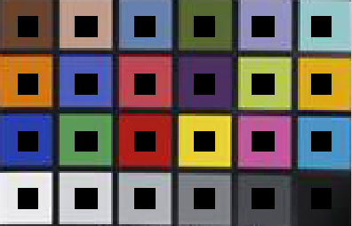

采样范围为每张色卡中间那个黑块，然后算RGB的平均值。

使用方法。首先，待校正的图片中包含24色卡，在文件夹里面均命名为befor(i)，sampl(i)是用photoshop将待校正图片befor(i)中色卡裁剪下来，用来算校正矩阵X用的。算出了对应的X，就可以逐个校正像素了。after(i)命名的图片是网上校正的，他的校正效果很好，我的这个程序校正效果是在matlab中用figure2 表示，figure1为原图。效果不是太理想，可能跟图片质量有关，网上下载的图片质量不行。

程序在mainfun里面。

用我程序校正的图片：

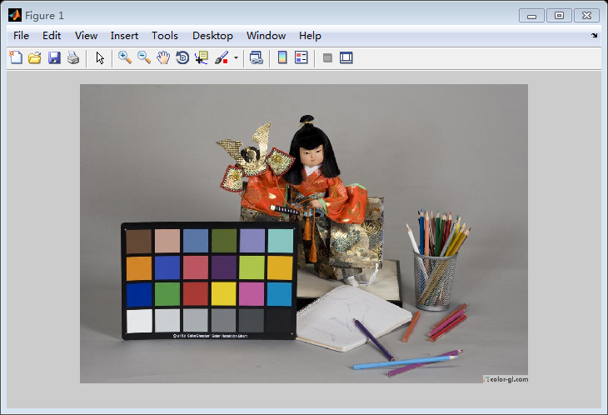

校正前

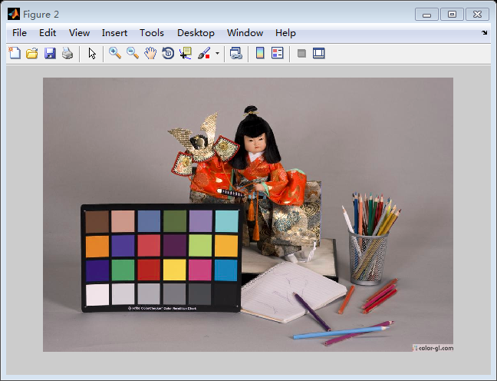

校正后

网上的校正结果（after2）效果比较好。可能是我们用的片源质量不行。

