Neil Gurram, Donglai Wei, Shidan Xu

6.170 Project 3 Part 1

10/14/14

Team Design for MyWay

We each made our own individual submissions as a contribution for the team design. Then, we went to office hours and took their advice and we collaborated as a team to get a new team design that was quite different from what the three of us had initially proposed.

So, here are the main points needed for Phase 1, all of which come from the **Design Component**.

**Overview:**

We want to realize the following goal for our app: given a list of artworks that one wants to see, how can we create a visual representation for the user to check out the works in the Museum of Fine Arts (MFA) of Boston. This ties in strongly with our purposes:

* help a **traveler** find the best **way** to check out **artworks** in **MFA**
* serve as an advertisement platform for **MFA**
* help a **traveler** organize their interaction with **MFA**.

So far, there isn’t an app that can do exactly what we want. All bold faced terms will be talked about later. If anything, our app hopes to be an extension of the three apps of MOMA, Yelp, and TripAdvisor.

Below you will see the context diagram to show the various roles that will interact with our app.

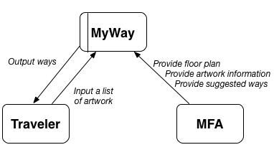

**Design Model**:

Then, we focus on our design model, and we start by touching base with the concepts.

* The first concept deals with the **way**. A way is just a graphical representation of how to view artworks; more specifically, given that a traveler provides a list of art, the website processes the list and returns a visualization of the routes that the traveler should take, so that we can minimize some characteristic (either trip time or distance, for now). This concept is motivated by the purpose of needing a traveler to organize their interaction with MFA.
* The second concept concerns with the **traveler**. A traveler is just a user who can search for artwork to see in MFA. This concept is motivated by the purpose of wanting a traveler to find the best ways to check out artworks. Another concept motivated by this same purpose is **artwork**, which is an abstract representation of the paintings, sculptures, and other works of art, that are in the MFA. The artwork is the basis of the ways that people can create and search for.
* A final concept under consideration is **MFA** itself. The MFA acts as a service provider who gives floor plans, provides recommended ways, and will update artworks as needed. This concept is motivated by the purpose of wanting to provide an advertisement platform for MFA.

Below you will see the data model to show all our concepts as well as essential data elements and relationships for our app.

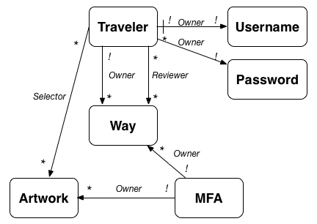

**Challenges**:

This project did not come without its challenges.

* First, we wondered whether we should have our concepts focus on a social aspect in our app (such as becoming friends with people who share a common way). We initially wanted to put this in our app, but then we decided better of it, as we wanted to have our focus be narrowed, and having a social aspect only deviates from our purpose.
* Secondly, we wondered whether we should have a parent class for MFA and a user. This is a good point as both MFA and user can provide ways. However, we decided that they perform different functions and their difference is too large to necessitate a same parent class to occur, and thus we avoided this so that our app did not become overcomplicated.
* Lastly, we had to choose between using a normalized data model vs and embedded data model. We chose a normalized data model as we have a lot of many-to-many relationships (e.g. multiple travelers can review multiple ways). We want to query from both sides; for example, we want to know how many ways does user A favor, and who favors way W. Through the replicating of the data, normalized data models provide faster query time, which led us to our choice.