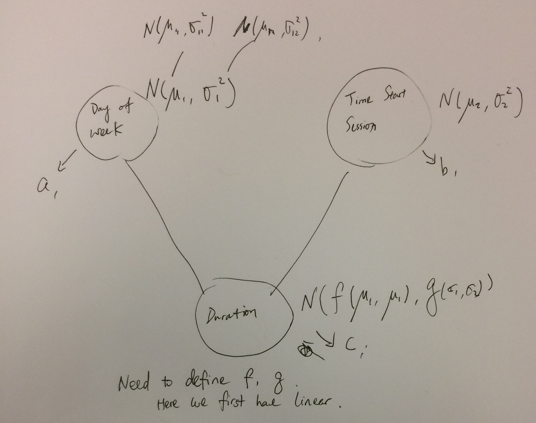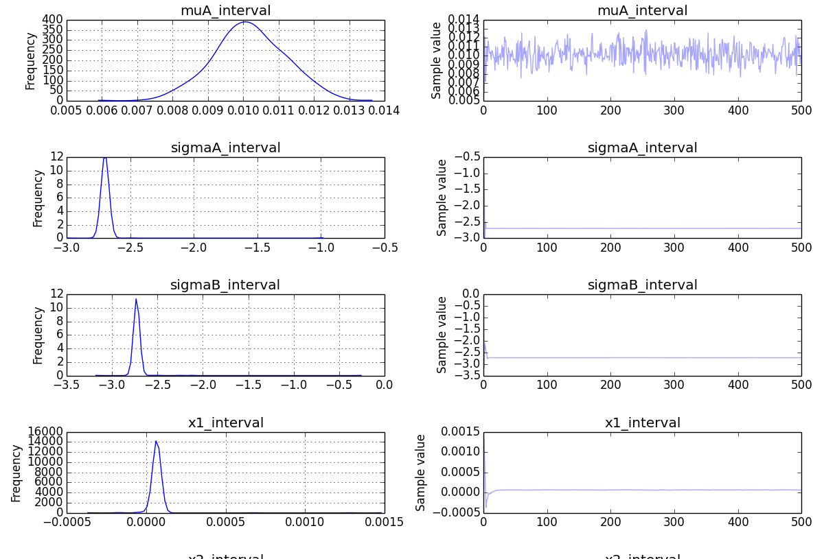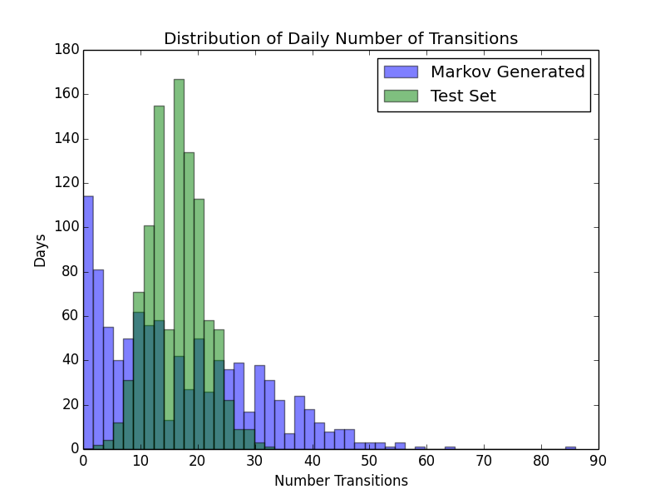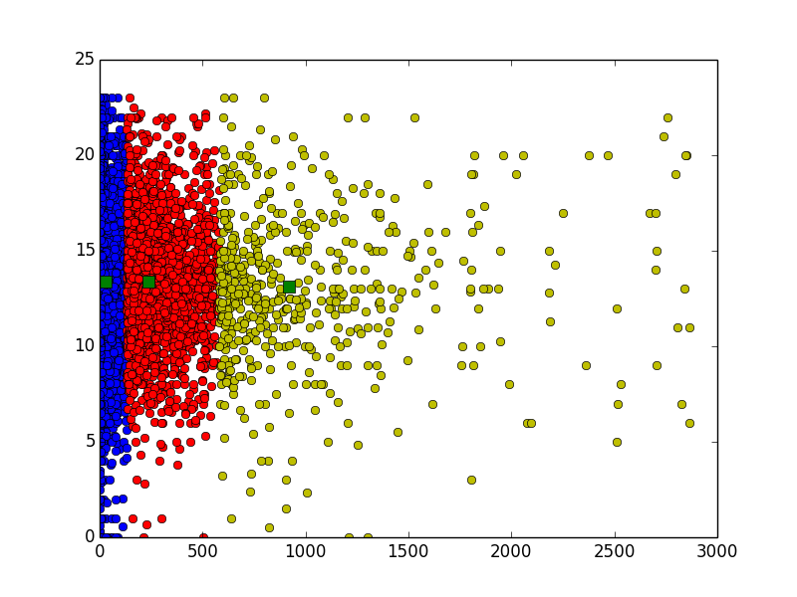

## Predict Users Mobility in Networks

## ANA Group

## AN

Why?

Fast inference, more models

How?

PYMC3, Python API

Results & Comparison

How PP works that picture of graph models

Goal: Predict user topological mobility based on email IMAP logs

Incentive: NSF FIND (Future Internet Design)

- Availability

MIT SECURE

Cambridge Station

New England Networks

Networks

AT&T 4G LTE

Boston AT&T Station

US Eastern



### Topological ≠ Physical Mobility

## Predictions

## How many types of users?

## How long is each session

## How often transition happens

A Technique for Fast inference: PYMC3

Probabilistic Programming

Picture of topological != physical

Two kinds of modeling:

1. Generative
   1. Markov
2. Discriminative
   1. Regression
   2. Classifier

Here give one graph output of each model, also the original transition graph is good

Lorem Ipsum Dolor

Comments:

1. Better images in columns 3 to illustrate how PP works / helps us, and more understandable results.
2. Second column, need 1 decisively interesting result to glue together the story
   1. Label the graphs markov, kmeans, etc
3. First column, the goal and incentive could be done better.