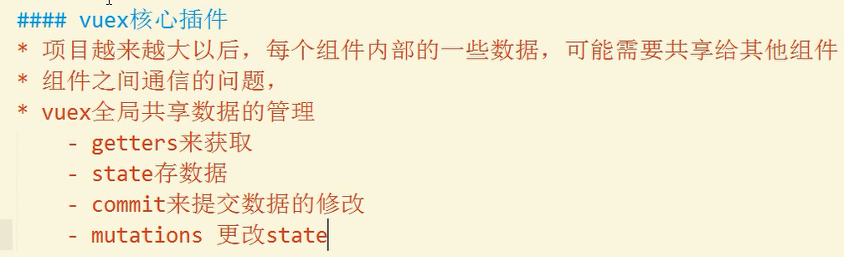

入口文件main.js

import Vue from 'vue';  
import App from './App.vue';  
  
import Vuex from 'vuex';  
Vue.use(Vuex);  
  
let store = new Vuex.Store({  
 state: { *//数据* num: 1  
 },  
 mutations: { *//改变靠近的数据* add (state) {  
 state.num++;  
 },  
 add2 (state,obj) {  
 state.num = obj.num + 10;  
 }  
 },  
 actions: { *//执行动作* addAction (store) {  
 store.commit('add');  
 },  
 add2Action ({commit},obj){  
 commit('add2',obj);  
 }  
 },  
 getters: {  
 getNum(state){  
 return state.num;  
 }  
 }  
});  
  
new Vue({  
 el: '#App',  
 render:create=>create(App),  
 store  
});

App.vue

<script>  
 export default {  
 name: "App",  
 created(){  
 *//注意：不建议下列方式修改状态  
 // this.$store.commit('add');  
 // this.$store.commit('add',{num:5}); //进化版  
 //推荐做法：使用actions分发任务  
 // this.$store.dispatch('addAction');* this.$store.dispatch('add2Action',{  
 num:10  
 });  
 *// console.log(this.$store.state); //不推荐该获取方式* },  
 computed:{  
 getNum(){  
 return this.$store.getters.getNum;  
 }  
 }  
 }  
</script>

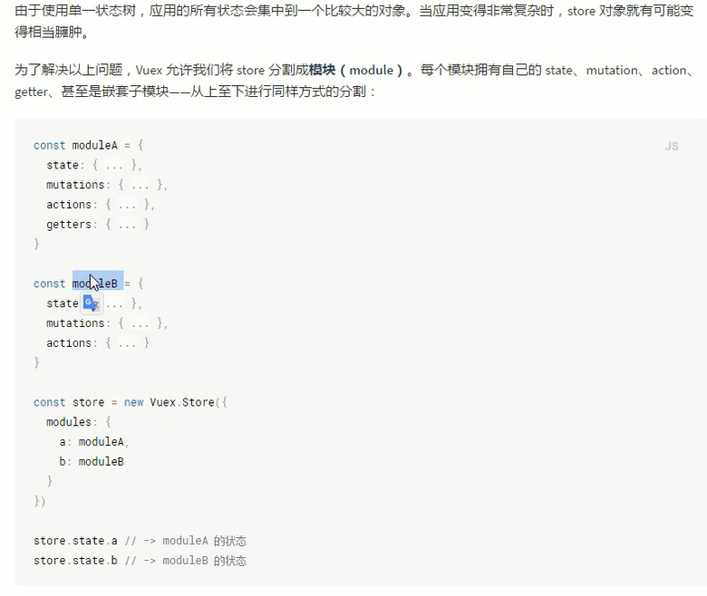

<https://segmentfault.com/a/1190000007020623>