RentWheels: A Car Rental Application
A PROJECT REPORT
Submitted to

ASSAM DON BOSCO UNIVERSITY

by
SHIDHARTH LAISHRAM
DC2022BTE0131
NISHANT KASHYAP
DC2022BTE0105
KEVIN KASHUNG
DC2022BTE0084
in partial fulfilment for the award degree
of
BACHELOR OF TECHNOLOGY
IN
COMPUTER SCIENCE AND ENGINEERING

DEPARTMENT OF COMPUTER SCIENCE & ENGINEERING
SCHOOL OF TECHNOLOGY ASSAM DON BOSCO UNIVERSITY
AZARA, GUWAHATI 781017, ASSAM, INDIA.
BATCH (2022- 2026)
DECLARATION

We hereby declare that the project work entitled “RentWheels: A Car Rental Application” submitted to the Assam Don Bosco University, Guwahati, Assam, in partial fulfilment of the requirement for Mini Project of 5th semester of Bachelor of Technology. It is an original work done by me under the guidance of name of Dr. Alexy Bhowmick (Associate Professor, Computer Science and Engineering , School of Technology, Assam Don Bosco University) and has not been submitted for the award of any degree.

(Signature of the student)
Shidharth Laishram
DC2022BTE0131
Department of Computer Science and Engineering

(Signature of the student)
Nishant Kashyap
DC2022BTE0105
Department of Computer Science and Engineering

(Signature of the student)
Kevin Kashung
DC2022BTE0084
Department of Computer Science and Engineering

CERTIFICATE

This is to certify that the Project Report entitled “RentWheels: A Car Rental Application” submitted by Shidharth Laishram (DC2022BTE0131), Kevin Kashung (DC2022BTE0084) and Nishant Kashyap (DC2022BTE0105) to Assam Don Bosco University, Guwahati, Assam, in partial fulfilment of the requirement for Mini project of 5th semester of Bachelor of Technology. It is a bonafide record of the project work carried out by them under my supervision during the year 2024.

(Signature of the Internal Guide)

Dr. Alexy Bhowmick,
Associate Professor,
Computer Science and Engineering,
School of Technology
Assam Don Bosco University

Date: .......................................................
EXAMINATION CERTIFICATE

This is to certify that Shidharth Laishram (DC2022BTE0131), Kevin Kashung (DC2022BTE0084) and Nishant Kashyap (DC2022BTE0105) of the Department of Computer Science and Engineering has carried out the Project Work in a manner satisfactory to warrant its acceptance and also defended it successfully.
We wish them all the success in their future endeavors.

Examiners:

- Internal Examiner:

- Internal Examiner:

ACKNOWLEDGEMENT

We extend our heartfelt gratitude and appreciation to all those who have successfully contributed to our project, "RentWheels: A Car Rental Application".

First and foremost, we would like to express our sincere thanks to our project guide, Dr. Alexy Bhowmick, Associate Professor, Department of Computer Science and Engineering, for unwavering support, expert guidance, and invaluable mentorship throughout this project. Sir’s profound knowledge, patience, and dedication have been instrumental in shaping our ideas into a reality.

We are also immensely thankful to our project coordinators, Mr. Rupesh Mandal and Mr. Kausthav Pratim Kalita for helping us in our project.

We would also like to thank Dr. Bobby Sharma, Head of Department, Computer Science and Engineering, School of technology, Assam Don Bosco University for providing us this opportunity and their support and encouragement throughout this project.

Thank you

Shidharth Laishram
DC2022BTE0131

Nishant Kashyap
DC2022BTE0105

Kevin Kashung
DC2022BTE0084

ABSTRACT

Our Aim is to design and create a data management System for a car rental company. This enables admin can rent a vehicle that can be used by a customer This system increases customer retention and simplify vehicle and staff Management in an efficient way. This software car Rental System has a very user-friendly interface.
Thus, the users will feel very easy to work on it. By using this system admin can manage customer confirm and cancel booking request, customer Testimonials, customer issues. The car information can be added to the system. Or existed car information can be edited or deleted too by Administrator. There is no delay in the availability of any car information, whenever needed, car information can be Captured very quickly and easily. The customers can also use the system to get car rent. The customer should create a new account before logging in or he/she can log into the System with his/her created account. Then he/she can book the available cars and can book this car This system will helpful to the admin as well as to the customer also.

CONTENTS

- Introduction Pg. No. 9 - 10
- Objective Pg. No. 11
- Problem Definition Pg. No. 12
- Study of existing system/Literature survey Pg. No. 13 - 21
- Proposed Plan Pg. No. 22 - 24
- Feasibility Study (COCOMO, estimation,
Tools and Platforms, WBS etc.) Pg. No. 25 - 38
- Requirement Gathering Pg. No. 39 -41
- Design Diagrams Pg. No. 42 – 44
- Implementation till date and Conclusion Pg. No. 45 - 59

LIST OF TABLES

- Survey of Existing system pg: 19-20

LIST OF FIGURES

  - Gantt Chart

  - WBS

  - Activity Diagram

  - Use Case Diagram

  - Class Diagram

  - API Level Testing

  - Implementation Figures
1.INTRODUCTION
The car rental industry is experiencing transformative shifts as customers place greater emphasis on convenience, flexibility, and efficiency in their rental experience. As consumer expectations evolve, the demand for more sophisticated and user-friendly Car Rental Applications has surged. These applications are becoming indispensable tools for streamlining the rental process, providing seamless access to vehicles, and offering flexible options to cater to diverse needs.
Furthermore, the ongoing expansion of highways and road networks is intensifying the need for reliable transportation services to link cities, towns, and key landmarks. A well-designed Car Rental Application plays a crucial role in addressing these transportation needs by connecting users with accessible and efficient travel options, ensuring smooth and hassle-free mobility across different regions. This shift toward advanced digital solutions is shaping the future of the car rental industry, driving innovation and enhancing the overall customer experience.
This project focuses on creating a robust car rental management system that not only simplifies the rental process but also enhances the overall customer experience and optimizes the operational efficiency for rental companies.
Key features of this system will include: -

- Seamless online booking: Users can effortlessly browse available vehicles, select their preferred options, and complete bookings online through an intuitive, user-friendly interface, reducing the time and effort typically associated with renting a car.

- Instant availability updates: The system will provide real-time updates on vehicle availability, ensuring that customers are always informed of what options are immediately accessible, allowing for quick decisions and minimizing booking conflicts.
- Comprehensive management tools: Managers will have access to a range of advanced tools for managing inventory, bookings, maintenance schedules, and customer data, enabling efficient oversight and smooth operation of the entire rental process.
By integrating these features, the application will provide - a streamlined, user-friendly solution that addresses the needs of both customers and rental companies, ensuring a smoother and more efficient rental experience.
2.OBJECTIVE
2.1 OBJECTIVE: The objective of the RentWheels App mini project is:
- To create an intuitive, user-friendly platform that significantly streamlines the car rental process, enhancing the overall customer experience.
- To simplify the process of browsing, booking, and managing rentals, the app aims to make car rentals more accessible and convenient for users.
- Create a comprehensive dashboard for rental companies to efficiently manage vehicle inventory, oversee bookings, and access detailed financial reports.
- To incorporate features such as detailed car listings, secure payment options.
- To provide a responsive feedback system that allows users to share their experiences and provide valuable insights.
2.2 SCOPE: The RentWheels App mini project aims:
- To provide a sophisticated, user-friendly platform designed specifically for residents of Guwahati.
- To provide a simple, secure payment method.
- To provide rental companies easy-to-understand and manage their business within the dashboard.
- It will not include features for offering coupons or promo codes, keeping the system focused on core functionalities for efficient local operation.
- A system capacity designed to handle up to multiple users simultaneously, optimized for local demand and smaller-scale operations.
3.PROBLEM DEFINITION
Renting a car can often be frustrating and time-consuming, with common issues like limited car availability, slow and outdated booking systems, poor communication between renters and service providers, and a lack of real-time information on car conditions, prices, and locations. On top of that, traditional car rental processes involve long paperwork and unclear policies, leading to a lot of confusion and dissatisfaction.
The RentWheels App is designed to solve these problems by offering a user-friendly, digital platform where people can rent cars easily and quickly. This app will focus on making the entire process as smooth and transparent as possible, giving users more control and flexibility.
With the RentWheels App, users will be able to:
- Browse cars in real time based on their location and preferences like car type and budget.
- View detailed car info, including condition, availability, and pricing, so they know exactly what they're getting.
- Book cars securely and hassle-free, selecting pickup and drop-off locations that work for them.
- Access digital documents to eliminate time-consuming paperwork.
- Track car status and get route recommendations using GPS.
- Communicate directly with rental service providers to handle changes or resolve issues.
- Receive real-time notifications for booking confirmations, rental extensions, and car availability updates.
- Make quick, easy payments.

4.STUDY OF EXISTING SYSTEMS/LITERATURE SURVEY
The car rental industry in India has grown significantly due to rising urbanization, increased tourism, and the shift towards a sharing economy. However, like in other parts of the world, traditional car rental methods in India are often inefficient, and digital platforms have emerged to solve these challenges. Below is a study of existing systems and a literature review focusing on the car rental ecosystem in India.

1. Traditional Car Rental Services
- Examples: Zoomcar.
- Booking Process: Online and physical branches, but often delayed due to manual verification.
- Challenges:
  - Lack of instant confirmation.
  - Limited fleet availability, especially in smaller cities.
  - Manual documentation requirements.
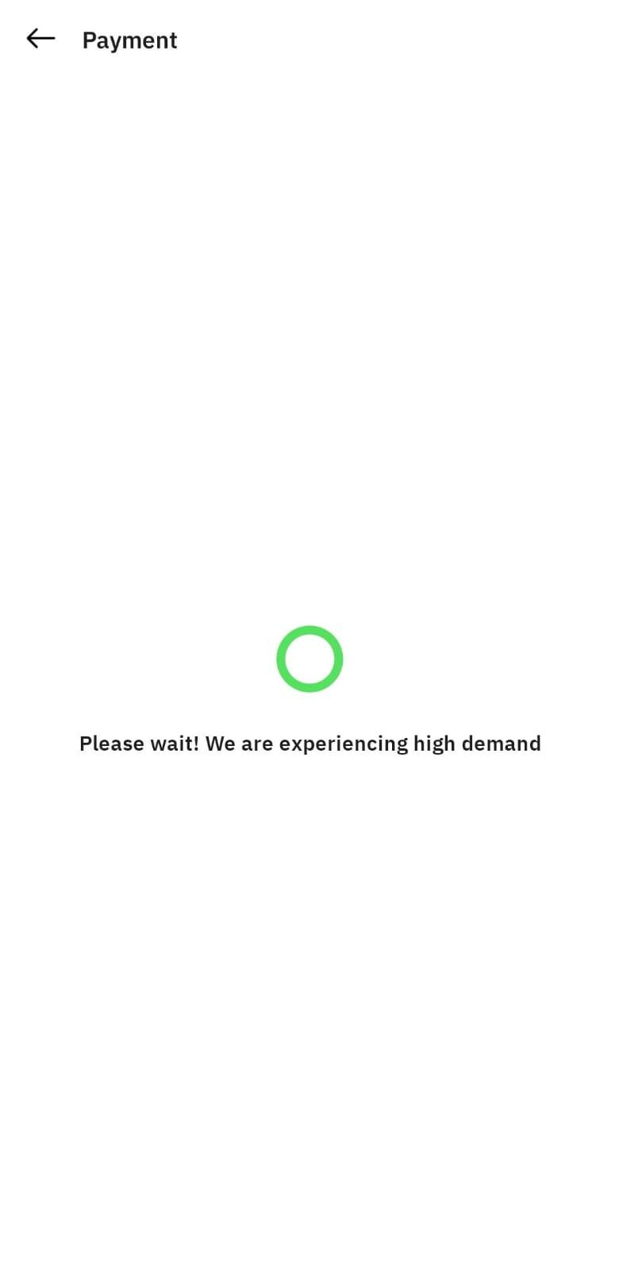
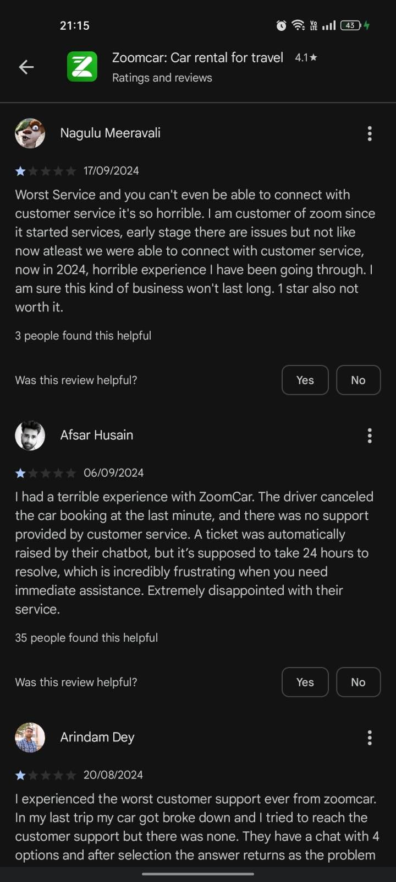
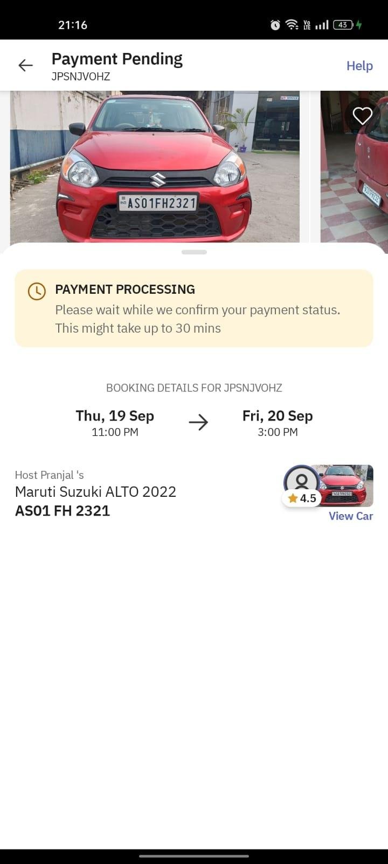
  - Inefficient communication between customers and service providers.

Example: Fufu Gadi
- Challenges:
  - High Initial Setup Costs: Investment in technology, fleet acquisition, and maintenance is significant, making scalability challenging.
  - Insurance and Liability Management: Complicated processes involving claims, accident handling, and liability disputes between the company and renters.
  - Dependency on Technology: High reliance on tech can lead to disruptions during system outages, app crashes, or software bugs.
  - Limited Reach in Rural Areas: Operations primarily focused in urban regions, with limited availability and logistics support in smaller towns and rural settings.
  - Competition with Established Players: Faces tough competition from established brands, making customer acquisition and retention challenging.
  - Regulatory Compliance: Navigating the complex regulatory landscape, including vehicle permits, insurance requirements, and environmental regulations, can be burdensome.

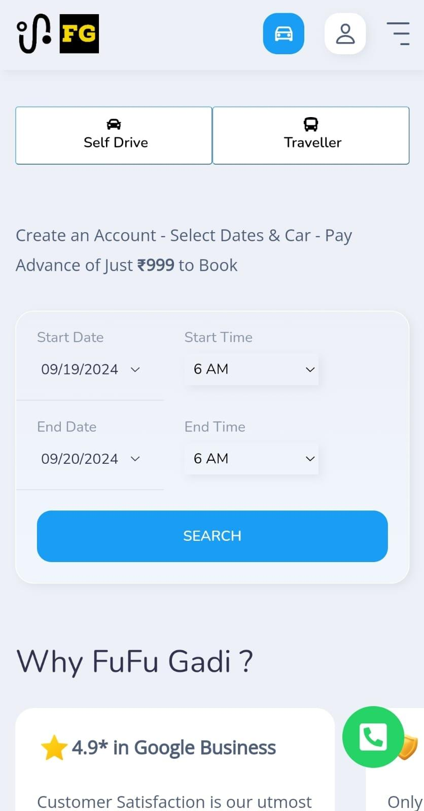
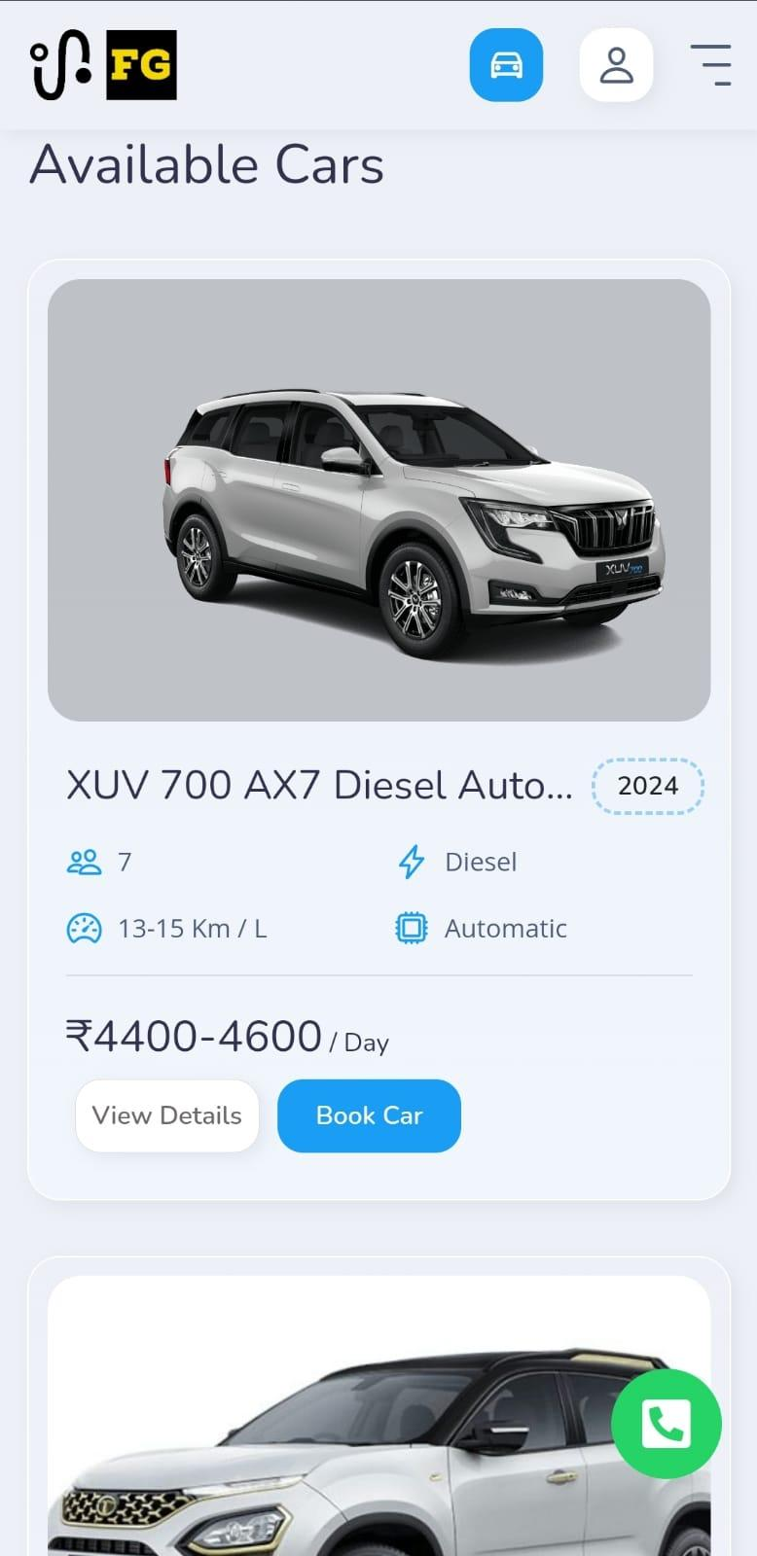

2. App-Based Car Rental Services
- Examples: Drivezy
- Challenges:
  - Limited presence in smaller cities (Tier-2/3) - early access.
  - High demand during peak seasons affects availability.
  - Inconsistent vehicle maintenance.
  - Slow-app.
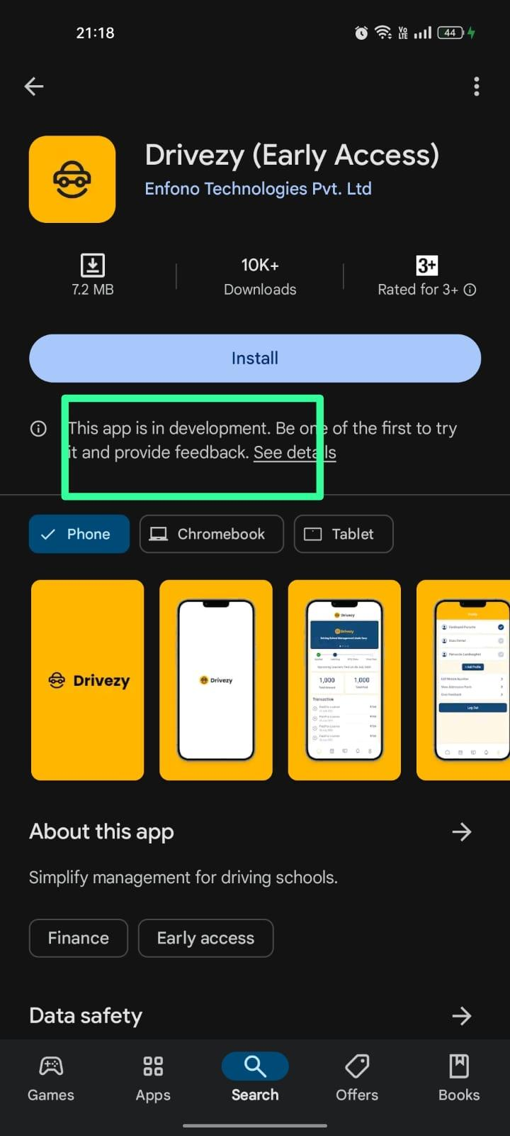
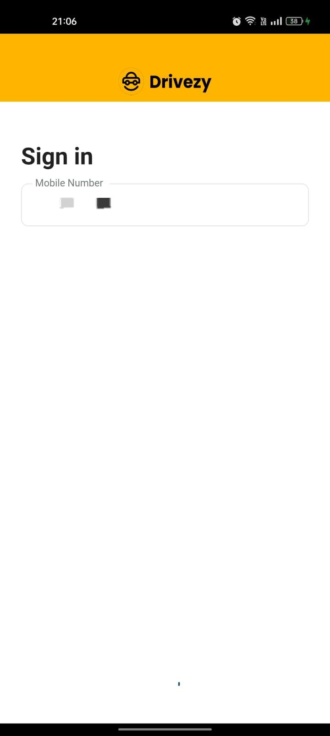

3. Peer-to-Peer (P2P) Car Rental Platforms
- Examples: Revv.
- Key Features:
  - Wide variety of vehicles, including luxury models.
  - Flexible rental durations.
  - Fully digital process (booking, payment, handover).
- Challenges:
  - Trust and quality concerns due to reliance on individual owners.
  - Complexities around insurance and liability.
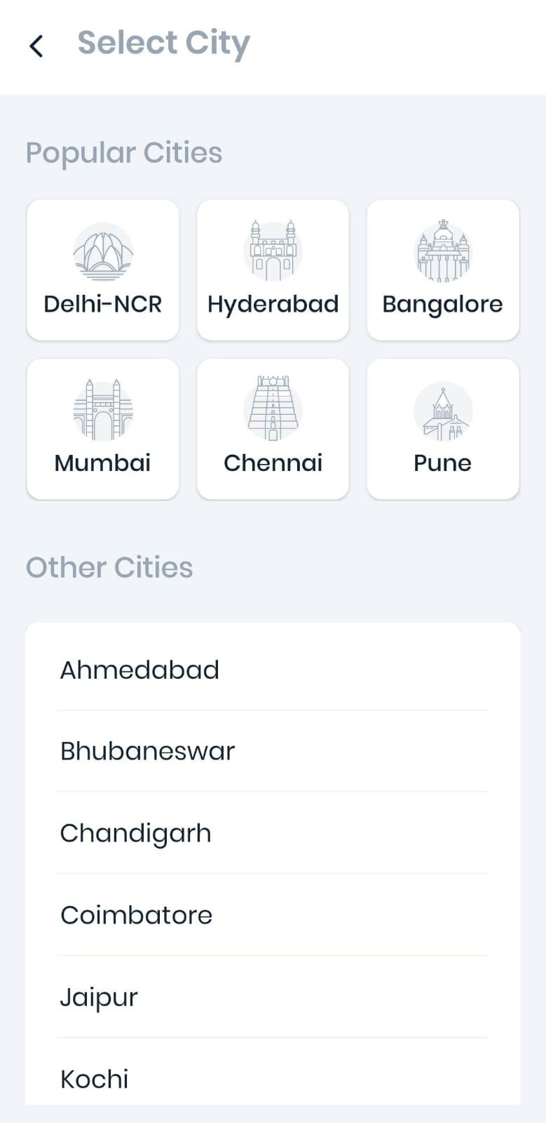
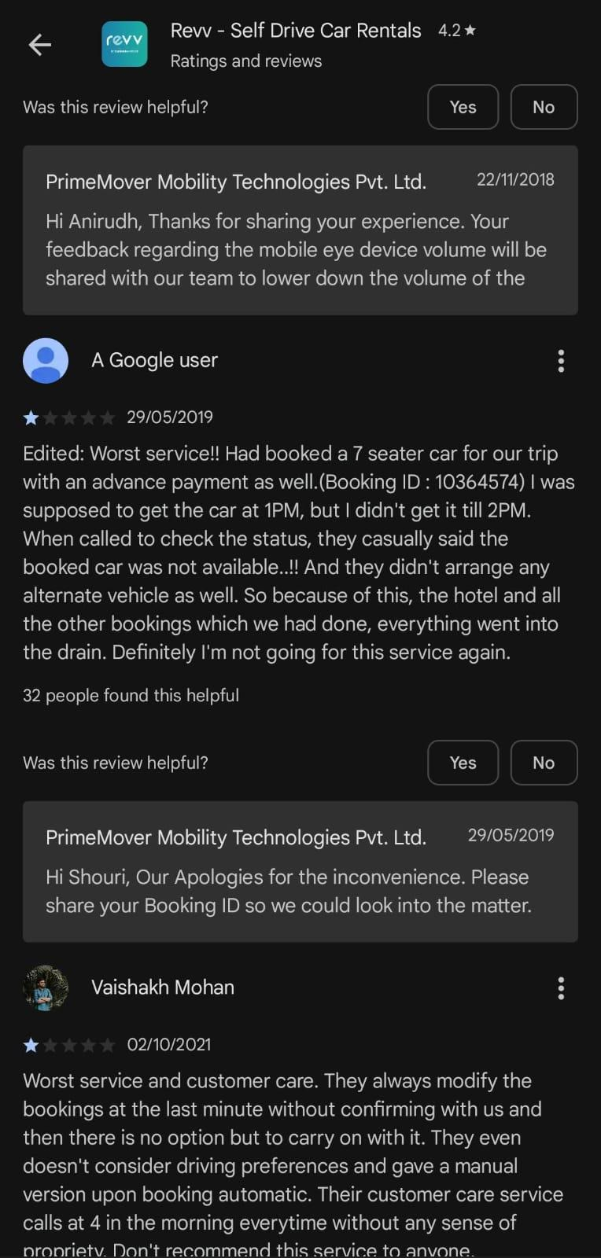
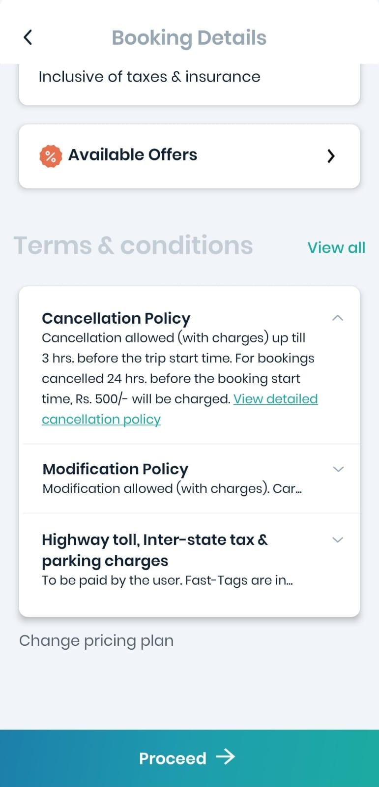
  - Limited access outside major cities.

4. Car Rental for Tourism
- Examples: Savaari, Ola Rentals, Clear Car Rental.
- Key Features:
  - Custom travel packages for popular tourist destinations.
  - Multilingual support for international tourists.
  - Integrated online payments, including foreign currency options.
- Challenges:
  - Focus on chauffeur-driven services, limiting self-drive options.
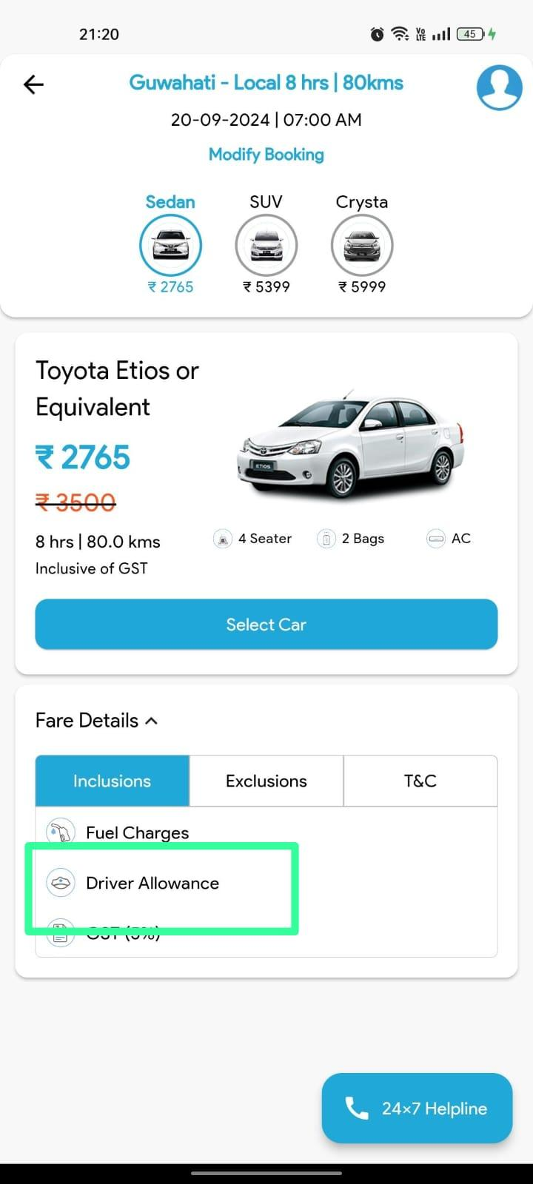
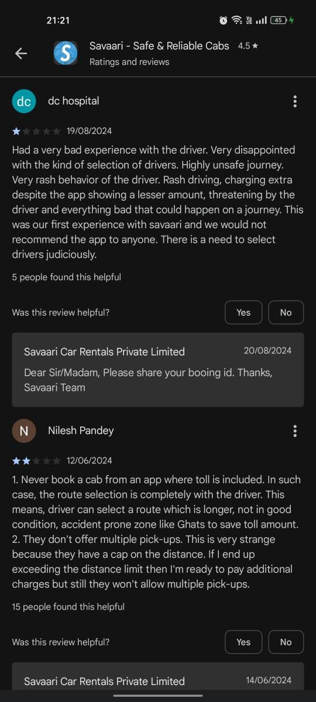
  - Inconsistent service standards across regions.

Below is a table summarizing the differences between traditional car rental services, app-based services, peer-to-peer (P2P) platforms, and car rentals for tourism in India:
Feature | Traditional Car Rental Services | App-Based Car Rental Services | Peer-to-Peer (P2P) Platforms | Car Rental for Tourism
Examples | Zoomcar, Fufu Gadi | Drivezy | Revv | Savaari, Ola Rentals, Clear Car Rental
Booking Process | Online and physical branches, often manual | Fully digital | Fully digital | Online or app-based for chauffeur-driven services
Key Features | Basic fleet, limited tech integration | App-based interface, GPS-enabled | Variety of vehicles, flexible durations | Chauffeur-driven, multilingual support
Challenges | Delayed confirmations, limited fleet, manual docs | Limited presence in smaller cities, inconsistent maintenance, app slowness | Trust concerns, insurance complexities | Limited self-drive options, inconsistent service
Technology Integration | Low | High (mobile apps, GPS) | Moderate (depends on individual owners) | Moderate (for online booking/payment systems)
Target Audience | General public, small cities | Tech-savvy younger population | Urban customers, niche markets (luxury rentals) | Tourists (domestic and international)
Focus | Basic rentals | Convenient, app-based self-drive rentals | Personalized, varied vehicle options | Tourism-focused packages
Payment Options | Cash or limited digital options | Digital payments, UPI, wallets | Fully digital | Integrated payments, foreign currency options
Scalability | Low | High (tech-reliant) | Moderate | Regional scalability dependent on demand
Fleet Management | Manual | GPS, cloud-based | Relies on individual owners | Limited fleet, chauffeur-centric
Customer Experience | Traditional, less seamless | Efficient but app performance may vary | Trust dependent, experience varies | Chauffeur-dependent service quality
Table: Survey of existing system

This table highlights the strengths and weaknesses of each approach, showcasing the evolving dynamics of India's car rental ecosystem.

5. Literature on Car Rental Technology in India
Several studies have focused on the adoption of technology in India’s car rental market. The use of mobile apps, cloud-based platforms, and GPS tracking has been highlighted as major enablers for improving efficiency in this space.
- Mobile App Adoption: Studies show that the rising number of smartphone users and improved internet access in India have led to increased adoption of app-based car rentals, particularly among the younger population
- Cloud Technology: Cloud-based fleet management systems allow rental companies to monitor vehicle usage, track maintenance schedules, and analyze customer data in real-time, optimizing operations
- GPS and Telematics: The integration of GPS and telematics enables both customers and rental companies to track vehicles, ensuring security and optimizing routes
- Digital Payments: The growth of digital payment systems like UPI and mobile wallets has made it easier for users to pay for rentals, while reducing friction in the booking process

5.PROPOSED PLAN

5.1. Project Overview
The goal of this project is to build a car rental app - RentWheels that enables users to rent vehicles on-demand through a seamless mobile experience. The app will offer real-time booking, self-drive options, multiple payment methods, and advanced features like GPS tracking and keyless entry.

5.2. Key Features
- User Registration & Authentication: Simple sign-up and login using email, phone, or social accounts.
- Real-Time Booking: Users can browse and instantly book available cars.
- Self-Drive & Chauffeur Options: Flexibility to choose between driving themselves or hiring a driver.
- Multiple Payment Options: UPI, credit/debit cards, mobile wallets, etc.
- Vehicle Availability Management: Dynamic vehicle availability display based on location and time.
- Rating & Review System: Post-rental feedback on vehicle and service quality.

5.3. Development Phases

Phase 1: Planning & Research
- Market Research: Identify target audience, competitors, and market trends.
- Define App Scope: Determine app features, business model (rental commission, subscription, etc.), and technology stack.
- Partnerships: Secure partnerships with car owners and service providers.

Phase 2: UI/UX Design
- Wireframes & prototypes: Create app wireframes and initial design concepts.
- User Flow Mapping: Design intuitive navigation for booking, vehicle selection, and payments.
- Feedback: Conduct user testing on prototypes and refine based on feedback.

Phase 3: Core Development (8 weeks)
- Backend Development: Set up database, API, and server architecture for managing users, cars, and bookings.
- Frontend Development: Build the user interface for Android and iOS.
- Feature Integration:
  - Real-time booking and availability.
  - GPS and keyless entry integration.
  - Secure payment gateway integration.
- User Profiles & Account Management: Enable users to manage bookings, payments, and preferences.

Phase 4: Testing & Debugging
- Beta Testing: Test core functionalities (booking, payments, vehicle access).
- Bug Fixing: Resolve issues and optimize app performance.

Phase 5: Launch & Marketing
- App Store Deployment: Publish the app on Google Play and Apple App Store.
- Marketing Campaign: Use social media, SEO, and influencer marketing to promote the app.
- Onboarding Partnerships: Expand partnerships with car rental companies and individual vehicle owners.

Phase 6: Post-Launch Support
- Customer Support: Provide 24/7 customer service through chatbots and live agents.
- Feature Updates: Continuously improve app features based on user feedback.
- Market Expansion: Expand availability to Tier-2 and Tier-3 cities.

5.4. Technology Stack
- Frontend: Flutter or React Native for cross-platform mobile app development.
- Backend: Node.js or Python for API development, MongoDB or MySQL for database.
- Cloud Hosting: AWS or Google Cloud for scalable infrastructure.
- Payment Gateway: Integration with Paytm, Razorpay, or Stripe for handling payments.
- GPS & Keyless Integration: Integration of vehicle access technologies and Google Maps API.

5.5. Revenue Model
- Commission-Based: Take a percentage of each car rental transaction.
- Subscription Model: Offer subscription plans for frequent users.
- Partnership Revenue: Earn from partnerships with car owners and manufacturers.

5.6. Timeline
- Total Time: 16 weeks (Planning, Design, Development, Testing, Launch)

5.7. Risks & Mitigation
- Fleet Management Issues: Partner with reliable car rental companies to maintain a healthy fleet.
- Market Competition: Differentiate through superior features like keyless entry and user-friendly design.
- Maintenance & Quality Control: Implement a strong rating and review system to ensure vehicle quality.
6.FEASIBILITY STUDY
Let’s break down the feasibility of your project, considering the specifics:

6.1.1 Technical Feasibility
- Tools and Platforms: The project will be built using mobile app development frameworks like Flutter, React Native, or native development environments for iOS and Android.
- Technological Stack:
  - Frontend: Mobile app frameworks ( Flutter) and UI/UX Design (Figma )
  - Database: Cloud-based databases (e.g. Firebase).
  - Third-Party APIs: For payments (e.g. Phonepay).
- Development Team: The team of 3 developers has the necessary skills in mobile app development, cloud services, and integration of APIs.

6.1.2. Operational Feasibility
- User Needs: The app is designed for users looking to rent cars conveniently. The key features, such as browsing, booking, payments, and notifications, align with user expectations.
- User Experience: A minimal yet functional UI will be created, focusing on ease of use. This should meet operational goals for both the users (renters) and the rental companies.
- Scalability: While the initial version is limited in scope, it can be expanded in the future to handle more users, cars, and rental locations.

6.1.3. Economic Feasibility
- Development Costs: Since the developers are students working on the project without a salary, the primary costs are now reduced to:
- Cloud Hosting: Firebase for app hosting and database management
- Third-Party Services: Integrating payment gateways like Razorpay.
- App Store Fees: Registration costs for deploying the app on platforms such as Google Play or Apple's App Store.
- Miscellaneous Costs: This might include software licenses, development tools, and test devices, although many tools are free or available at student discounts.

6.1.4. Schedule Feasibility
- Project Timeline: Based on the COCOMO estimate, a 3 KLOC project requires 10.98 person-months. With a team of 3 developers, this fits well within the available 12 person-months over 4 months.
- Critical Milestones:
  - Month 1: Requirement gathering, UI/UX design, basic structure.
  - Month 2: Backend integration, API development.
  - Month 3: Feature development (search, booking, payments).
  - Month 4: Testing, bug fixing, and deployment.

6.1.5. Legal and Regulatory Feasibility
- Terms of Service: Proper terms and conditions for users and rental providers must be created, outlining liabilities, insurance, and payment policies.
- Third-Party Integrations: Use of APIs like GPS and payment gateways must comply with the terms of service of the respective platforms.

6.1.6. Risk Analysis
- Technical Risks: Delays in integrating third-party services like payment gateways or GPS could arise. Mitigation: Ensure APIs are well-documented and tested early.
- Operational Risks: User adoption could be slower than expected. Mitigation: Run a pilot in one city or region to gauge user interest and expand gradually.
- Schedule Risks: The team may face unexpected delays due to bugs or integration issues. Mitigation: Build buffer time into the schedule for testing and debugging.

6.2 COCOMO ESTIMATION
Let's estimate the COCOMO effort with a project size of 3,000 lines of code (LOC), or 3 KLOC, and a team size of 3 developers:
For a Semi-Detached project with 3 KLOC:
Effort (E)=3.0×(KLOC)^1.12
Substituting 3 KLOC:
Effort (E)=3.0×(3)^1.12≈3.0×3.422≈10.268 person-months
Using the formula for development time (T):
Development Time (T)=2.5×Effort^0.35
Development Time (T)=2.5×(10.268)^0.35≈2.5×2.25≈5.625 months
The total available effort with a team size of 3 and a timeline of 4 months:
Available Effort=3×4=12 person-months
Now,
- Required Effort (from COCOMO estimate): 10.26 person-months
- Available Effort: 12 person-months

Conclusion
With a project size of 3 KLOC, the COCOMO model estimates 10.26 person-months of effort, which fits well within the 12 person-months available with your current team size and timeline.

Feasibility:
- Timeline: The project can be completed within the 4-month timeframe.
- Team Size: The team of 3 developers is sufficient to handle the estimated workload.

Final Adjustment
With a 3 KLOC project size, the team of 3 developers should be able to complete the RentWheels App within the 4-month deadline. This scope allows for a basic but functional version of the app, with room for future enhancements.
6.3TOOLS AND PLATFORMS
6.3.1 Development Environment:
  - IDE (Integrated Development Environment):
    - Visual Studio Code: A popular code editor with support for various programming languages, extensions, and tools that facilitate debugging, code formatting, and version control, making it ideal for both front-end and back-end development.
6.3.2 Programming Languages:
- Dart (Android) : This language will be used for mobile app development, depending on the target platform.
6.3.3 Version Control:
- Git & GitHub: Git is used for version control, allowing the development team to track changes, manage different versions of the code, and collaborate seamlessly. GitHub acts as a central repository for the project, enabling code sharing, issue tracking, and documentation.
6.3.4. Frameworks & Libraries:
- Flutter: For cross-platform mobile app development, either of these frameworks could be used. They allow developers to create native-like applications for both iOS and Android with a single codebase, saving time and effort.
6.3.5 Database:
- Firebase: For managing user data, reservations, and car listings. Firebase offers a scalable cloud-based solution with real-time database capabilities, while SQLite is suitable for lightweight, local storage..
6.3.6 APIs & Integrations:
- Payment Gateway API (PhonePay): Secure payment gateways will be integrated to handle user payments, ensuring smooth and secure transactions.
- Google APIs: For seamless user authentication.

6.3.7 Cloud Platforms:
- Firebase: Firebase can be an all-in-one solution for back-end services such as database, authentication, and hosting, providing scalability and ease of integration with mobile apps.
6.3.8 UI/UX Design Tools:
- Figma: These tools will be used during the wireframing and design process. They allow the design team to create high-fidelity prototypes, collaborate, and iterate on the app’s UI/UX design.
6.3.9 Analytics:
- Firebase Analytics: To track user behavior, monitor app usage patterns, and provide insights into how users interact with the app. These analytics tools will assist in improving the app's user experience and identifying potential areas for optimization.

6.4 GANTT CHART
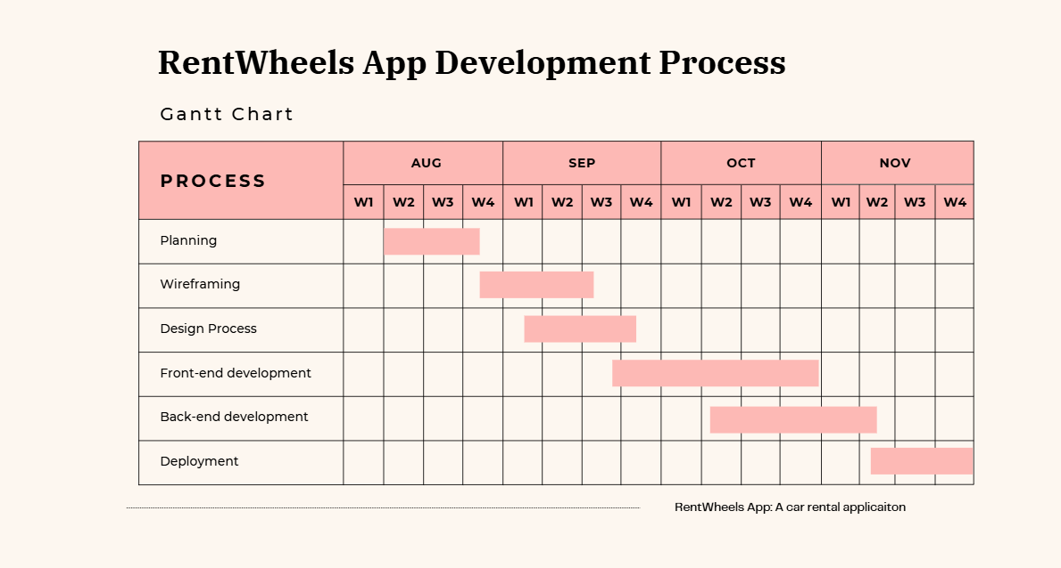
Fig: Gantt Chart RentWheels
The diagram above illustrates the Gantt Chart for the RentWheels App Development Process, which represents the schedule and timeline for completing the various phases of the project. This chart serves as a visual tool for tracking progress, identifying dependencies, and ensuring that each task is completed within the allocated time frame.

6.4.1. Planning (August Week 2 – August Week 4 )
- The planning phase starts at the beginning of the project in August and spans over two weeks. During this phase, the team:
- defines the project's scope
- sets goals
- identifies stakeholders
- outlines the requirements
- initial project discussions and documentation of the app’s objectives and functionalities.

6.4.2. Wireframing (August Week 4 – September Week 3)
- The wireframing phase is scheduled right after the planning phase and takes place during the third and fourth weeks of August. This phase involves:
- creating a rough structure of the app
- focusing on the layout and placement of various components
- wireframes help visualize the app’s interface without detailed designs, providing a blueprint for the UI/UX team.

6.4.3. Design Process (September Week 1 – September Week 4)
- Once the wireframing is complete, the design process starts in the first week of September and runs through the third week. This phase focuses on:
- detailed visual design of the app
- including color schemes
- typography, and the overall look and feel
- UI/UX team finalizes the interactive elements to ensure the app provides an intuitive user experience.

6.4.4. Frontend Development (September Week 3 – October Week 4)
- Frontend development overlaps with the design process, beginning in the second week of September and continuing until the fourth week of October. During this phase:
- the developers code the user interface, making sure it is responsive and functional on multiple devices
- the frontend development involves integrating design elements into an interactive, navigable interface

6.4.5. Backend Development (October Week 2 – November Week 2)
- Backend development begins in the last week of September and runs through the second week of November. This phase involves:
- developing the server-side infrastructure, which includes
- setting up databases
- APIs
- security protocols
- the backend developers work on the logic that powers the app, ensuring smooth communication between the frontend and backend

6.4.6. Deployment (November Week 2 – November Week 4)
- The deployment phase is the final process of the project, taking place during the third and fourth weeks of November. This phase includes:
- preparing the app for release
- testing it for performance and security
- submitting it to app stores
- the deployment phase ensures that the app is functional and ready for user
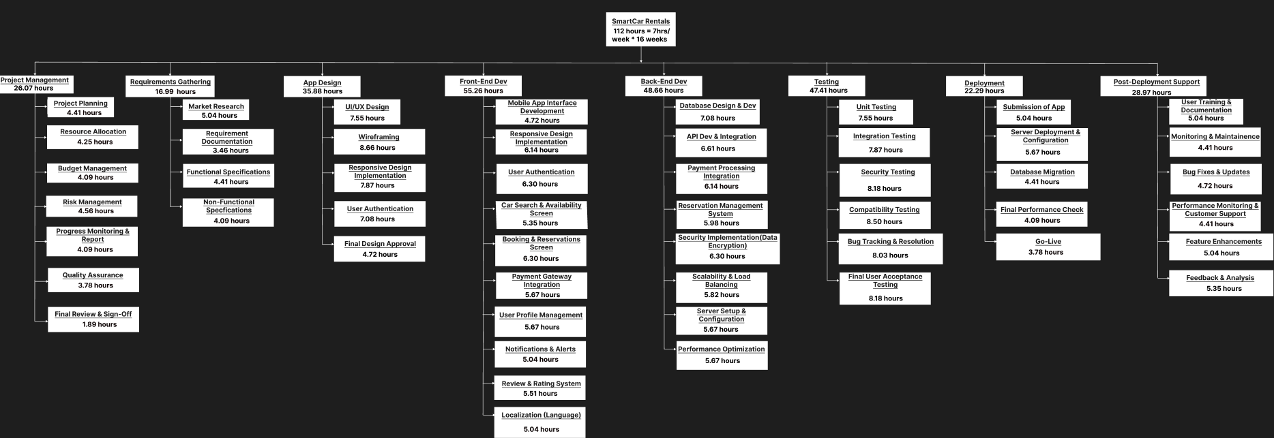
6.5 WBS (WORK BREAKDOWN STRUCTURE)
https://www.figma.com/design/mZ13ZssXwf4LiLKUK1l1N8/Mini-Project%3A-WBS?node-id=0-1&node-type=canvas&t=j1pQPBx6UTpTcERa-0
The Work Breakdown Structure (WBS) for the RentWheels App provides a clear representation of all the essential phases involved in the development of the project, with corresponding working hours allocated to each phase. This structured approach helps to break down the project into manageable tasks and provides a comprehensive roadmap to ensure timely completion.

6.5.1 Calculation of total working hours:

Number of weeks in 4 months (August to November):
  - August has 4 weeks
  - September has 4 weeks
  - October has 4 weeks
  - November has 4 weeks
- Therefore, total number of weeks = 16 weeks.
- Number of working hours per week:
  - On average, working hours are taken to be 7 hours/week.
  - We'll use an average of 7 hours/week for simplicity.
- Total working hours available:
  - Total working hours over 16 weeks = 7 hours/week × 16 weeks = 112 hours.

Below is an expanded explanation of the WBS for inclusion in the report:

1.Project Management & Requirement Analysis – 43.06 Hours (26.07 hours & 16.99 hours)
- This phase involves gathering and analyzing the app requirements from all stakeholders, including the rental companies and potential users. The team will work on defining the features, user workflows, and the overall objectives of the app.
- Activities:
  - Gathering user requirements.
  - Documenting system specifications.
  - Reviewing existing market solutions for inspiration and enhancement ideas.

2. App Design – 35.88 Hours
- Designing the user interface and user experience is a critical phase to ensure the app is intuitive and user-friendly. This phase focuses on the layout, design elements, and navigation structure, with a goal of delivering an aesthetically pleasing and functional interface.
- Activities:
  - Wireframing and prototyping.
  - Designing the main screens, such as the car search, booking, and payment screens.
  - Conducting user testing to refine designs.

3. Frontend Development – 55.26 Hours
- The frontend development phase is responsible for implementing the app’s user interface and interactive features. This involves coding the mobile interface based on the approved designs using mobile development frameworks such as Flutter or React Native.
- Activities:
  - Coding the user interface for mobile devices.
  - Implementing navigation, buttons, forms, and other user-interactive elements.
  - Integrating frontend with the backend for real-time updates.

4. Backend Development – 48.66 Hours
- This phase focuses on developing the server-side logic that powers the app, including databases, user authentication, and car booking management. A secure and scalable backend will ensure that all app features function correctly.
- Activities:
  - Setting up cloud services and database management.
  - Developing APIs for car search, booking, and user management.
  - Integration of third-party services such as payment gateways

7. Testing and QA – 47.41 Hours
- Testing is vital for ensuring the app performs as expected and is free of bugs. Both manual and automated testing will be performed to verify the functionality, security, and reliability of the app.
- Activities:
  - Unit testing for individual components.
  - Integration testing to ensure that different parts of the system work together.
  - User acceptance testing (UAT) to gather feedback and address any usability issues.

8. Deployment – 22.29 Hours
- This phase involves preparing the app for launch and making it available on app stores (Google Play and Apple App Store). The team will handle final configurations, performance checks, and submission processes.
- Activities:
  - Configuring app settings for different platforms ( Android).
  - Submitting the app for review on the relevant app stores.
  - Performing final performance and security checks before launch.

9. Post Deployment Support – 28.97 Hours
- After the app is deployed, a maintenance phase will follow to address any issues that arise and to ensure continued smooth operation. Support will also be provided to assist users and resolve any bugs or performance problems.
- Activities:
  - Bug fixing based on user feedback.
  - Routine app updates to ensure compatibility with new OS versions.
  - Continuous monitoring of app performance.

7.REQUIREMENT GATHERING
7.1 FUNCTIONAL REQUIREMENT: The RentWheels App will feature a comprehensive range of functionalities designed to enhance the user experience and streamline the car rental process.
- User authentication will allow users to easily register and log in using their email, phone number, or social media accounts.
- Password recovery options available for added convenience.
- The app will include a car search and availability feature, enabling users to search for available vehicles based on criteria such as location, date, time, and vehicle type.
- The search results will display detailed information about each car, including the model, features, price, and images, helping users make informed decisions.
- For booking and reservations, users will be able to select their desired car, choose the rental period, and book it directly through the app. They will also have the ability to view and manage their reservations, including making cancellations or modifications if needed.
- Payment integration will be a key feature, with secure payment gateways allowing users to pay for their bookings using credit/debit cards, mobile wallets, or other online payment methods. The app will automatically generate invoices and send them to users via email or within the app for easy record-keeping.
- User profile management will enable users to manage their personal information, payment details, and preferences, with access to their booking and payment history for reference.
- Notifications to keep users informed with push notifications for booking confirmations, payment receipts, reminders for upcoming rentals, and promotional offers.
- GPS integration will be included to help users locate nearby rental car locations and track the car's location during the rental period.
- Customer support through an interface where users can contact the rental service provider via chat, email, or phone for issues and enquiries.
- A review and rating system will allow users to rate their rental experience and provide feedback on the vehicle and service, contributing to the continuous improvement of the app and the services offered.
7.2 NON-FUNCTIONAL REQUIREMENTS: The RentWheels App is designed with several key considerations to ensure optimal performance, security, and user satisfaction.
Security
- Sensitive Information: Yes, the product stores and transmits sensitive data, including user credentials, payment information, and personal details.
- Standards Compliance: It complies with industry-specific security standards for payment security and data protection.
- Best Practices: Implements encryption, user authentication, and real-time monitoring.
Capacity
- Future Scaling: Supports cloud-based storage scaling using ensuring seamless expansion for data growth without downtime.
Reliability and Availability
- Critical Failure Time: Maximum allowable downtime is 1 hour per month under normal usage conditions.
- Access Requirements: 24/7 availability is ensured using high-availability architectures and redundant servers.
Maintainability and Manageability
- Ease of Management: Includes an intuitive admin dashboard for real-time system monitoring, configuration, and user management.
- Recoverability and Serviceability: Supports automated backups and disaster recovery.
Usability
- Ease of Use: Features a clean, intuitive interface designed with user-centered principles, ensuring minimal onboarding time.
User Experience: Prioritizes accessibility, responsive design across all devices, and context-sensitive help and documentation.

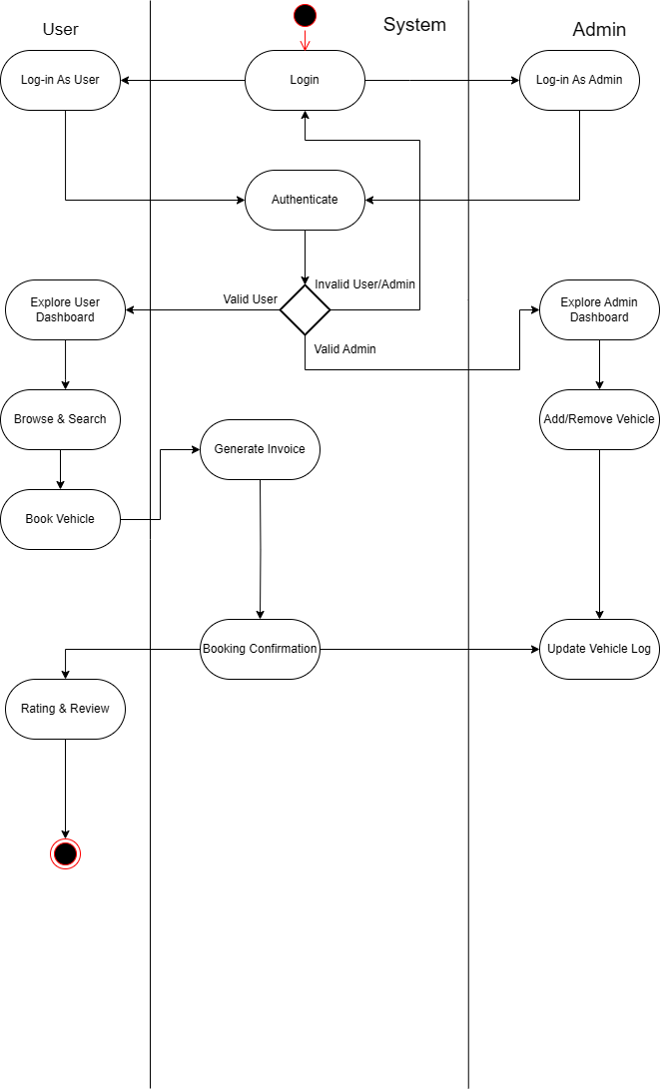
8.DESIGN DIAGRAMS
Fig 8.1: Activity Diagram
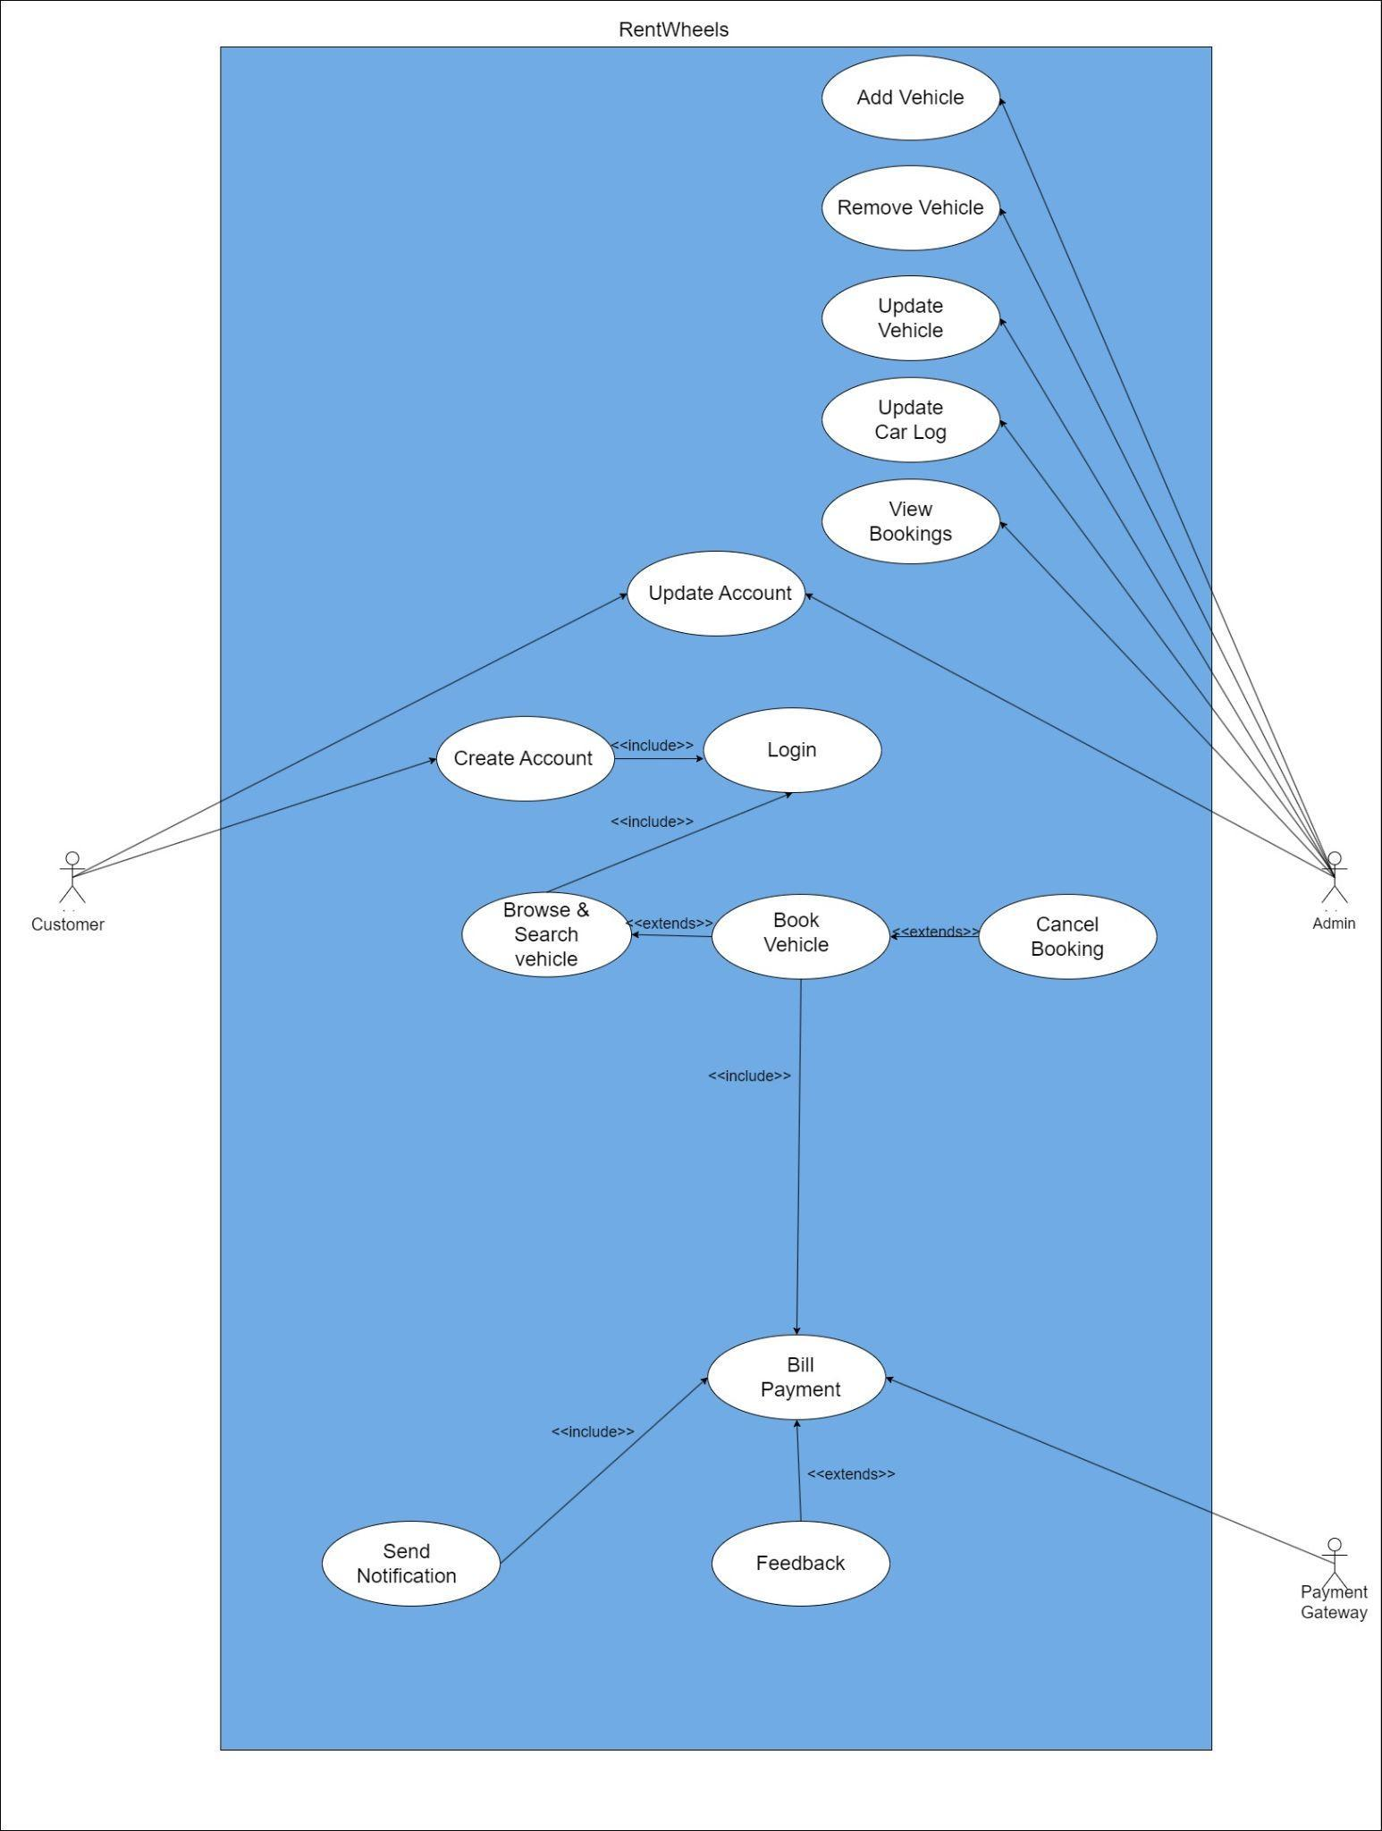 Fig 8.2:Use Case Diagram
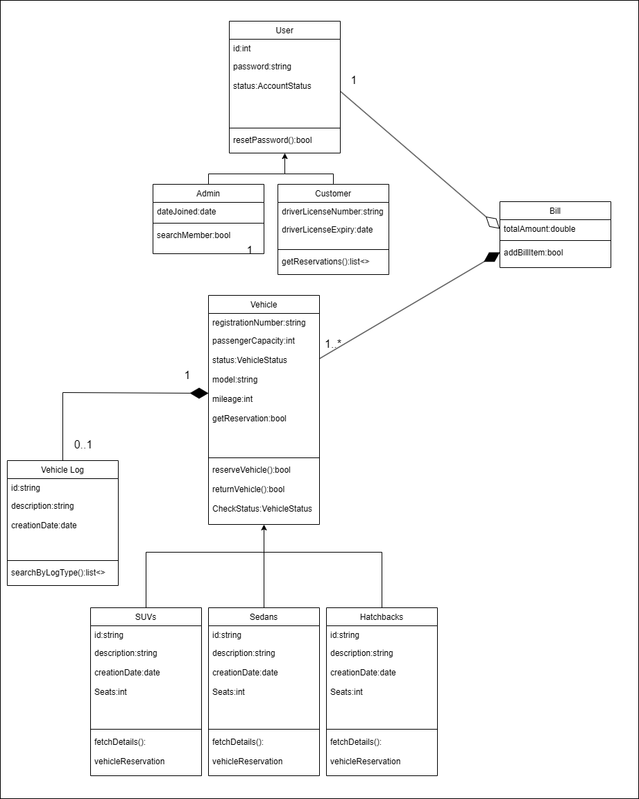Fig 8.3: Class Diagram

9.IMPLEMENTATION TILL DATE AND CONCLUSION
9.1 OVERVIEW OF SYSTEM:
- The RentWheels car rental application is designed using a 3-tier architecture, which separates the application into the Frontend, Backend, and Database layers.
- This enhances maintainability, scalability, and performance.
9.2 FRONTEND
- Built using Flutter for a cross platform experience on both Android
- Key screens include the:
  - Login Screen
  - Registration Page
  - Forgot Password Page
  - Home Screen
  - Explore and Search Page
  - Car-Detail Screen
  - Admin Dashboard
  - Add Vehicle Page
  - User-Profile Page (Customer & Admin)
  - Booking Page
BACKEND
- Cloud databases like Firebase for proper database management like:
  - Car Retrieval: Fetches available cars and their details.
  - Booking Management: Handles booking requests, and recording rental transactions.
  - User Authentication: Manages secure user login, registration.

9.3 IDE-PLATFORM USED:
- VISUAL STUDIO CODE
- ANDROID STUDIO

9.5 SYSTEM WORKFLOW
- Users open the app, the frontend sends an API request to the backend to fetch and verify user credentials and sign-in’s the user
- Users then log-in into the home page where he can either log-out or go into the explore and search vehicle page.
- Users can select a car and initiate a booking, select dates for reservation , and store booking details.
- Upon successful booking, the app confirms the reservation to the user and records the transaction in the database.
9.6 CORE FEATURES:
- An intuitive, user-friendly sophisticated platform that significantly streamlines the car rental process, enhancing the overall customer experience.
- Simplifying the process of browsing, booking, and managing rentals, the app aims to make car rentals more accessible and convenient for users. .

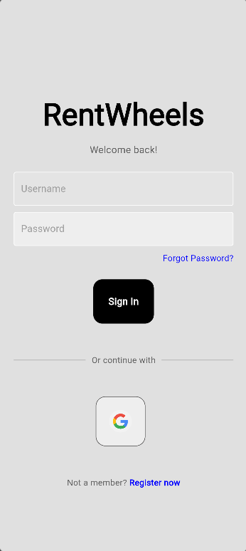
9.7 USER INTERFACE DEVELOPMENT
Fig 9.7.1: User Authentication Page
- Users will enter their credentials or by using Google to login into the system.
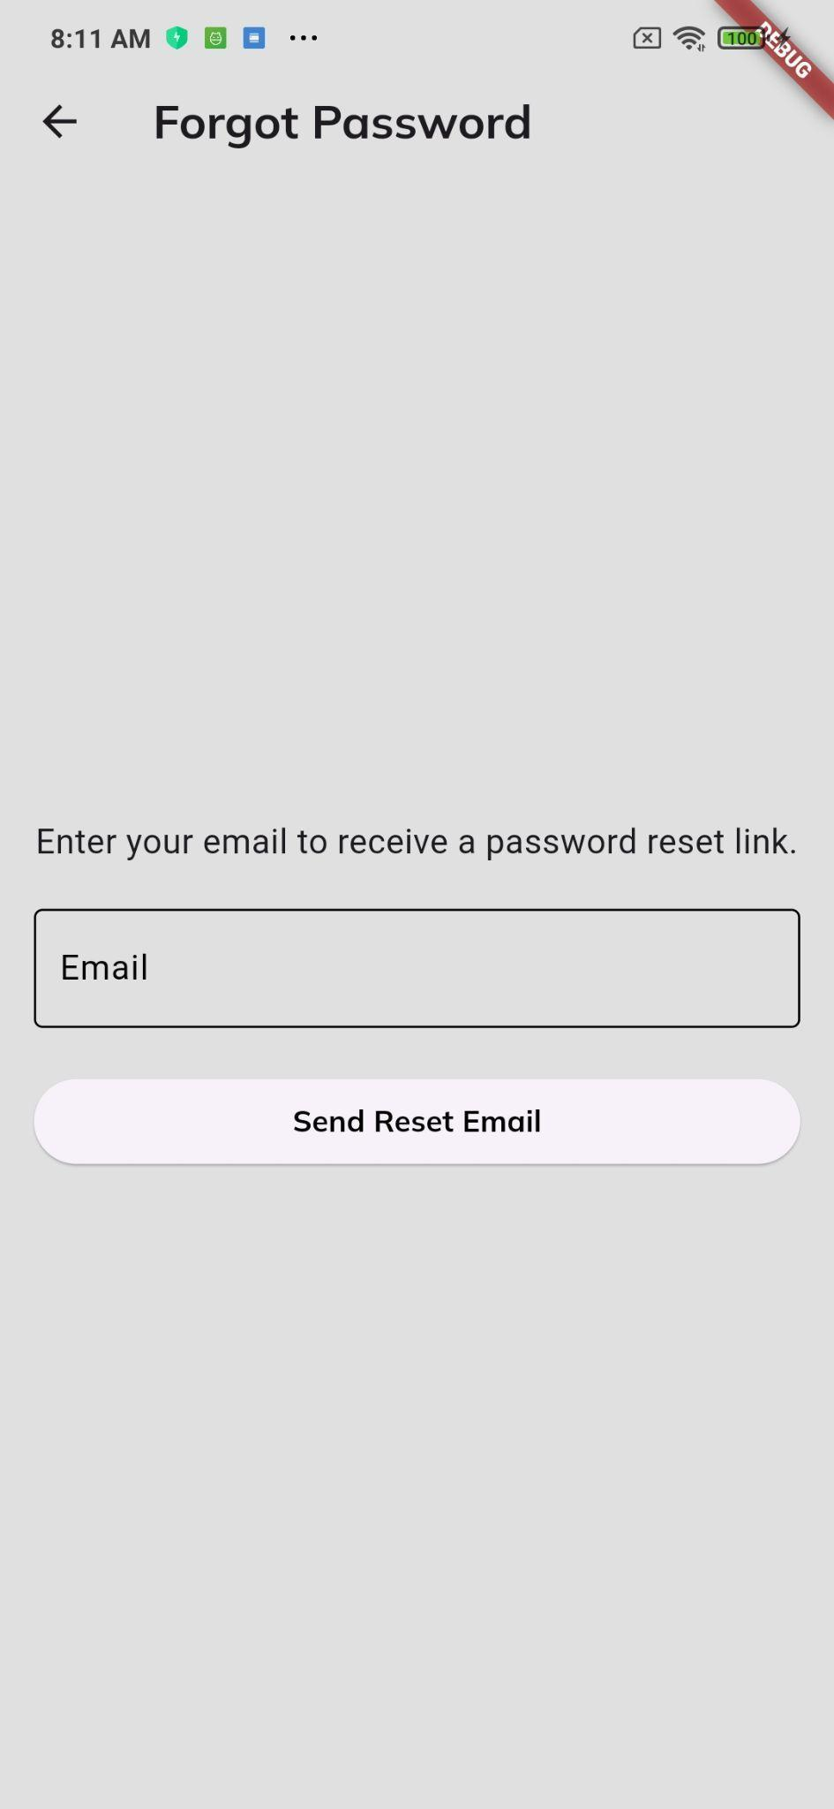
- Account can be registered if there is no account through Google or manually register.
Fig: 9.7.2: Forgot Password Page
- Users can add their Email to get a password reset link in their email account.

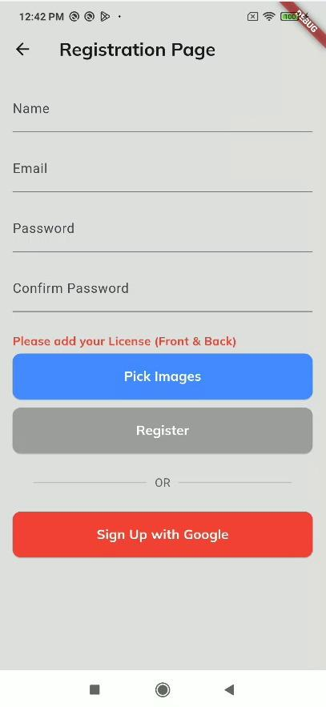

Fig: 9.7.3: Registration Page
- The user can register either by using their google account or by using their own email.
- Passwords must be at least 6 letters long and must be same in both the fields (i.e. Password and Confirm Password).
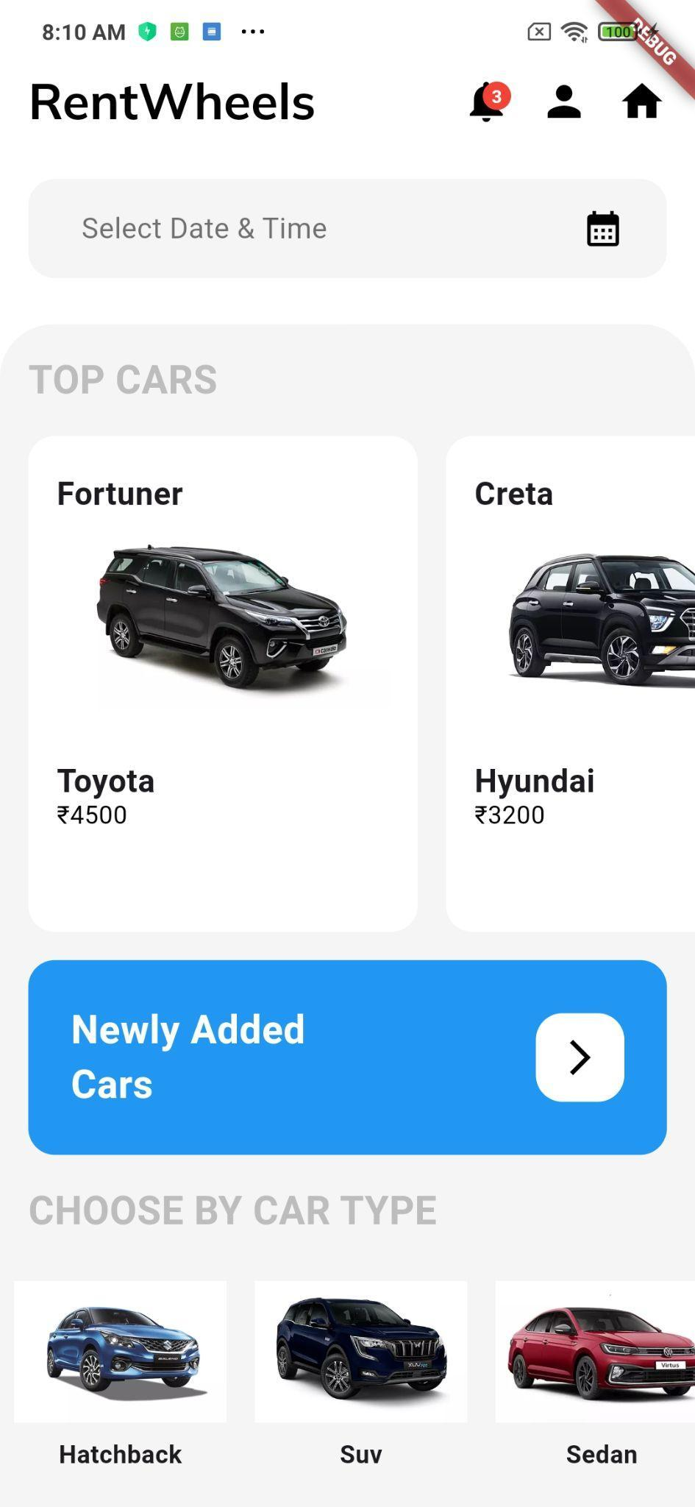
Fig 9.7.5: Explore and Search Vehicle Page
- Users can browse and search for vehicles and book their desired vehicles.
- Users can see newly added vehicles.
- Users can select based on their preference for different types of cars.
- Users can go back to the home page, or go to the profile page, or to the notification page.

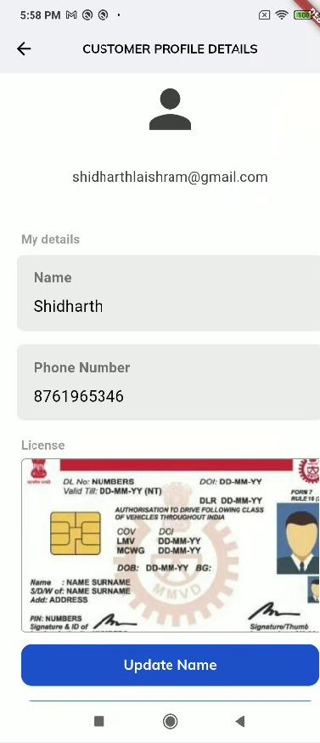
Fig 9.7.6: Customer Profile Page
- The users can access their account for changing and updating their account information.
- Users can delete their account.
- Users can become admin.

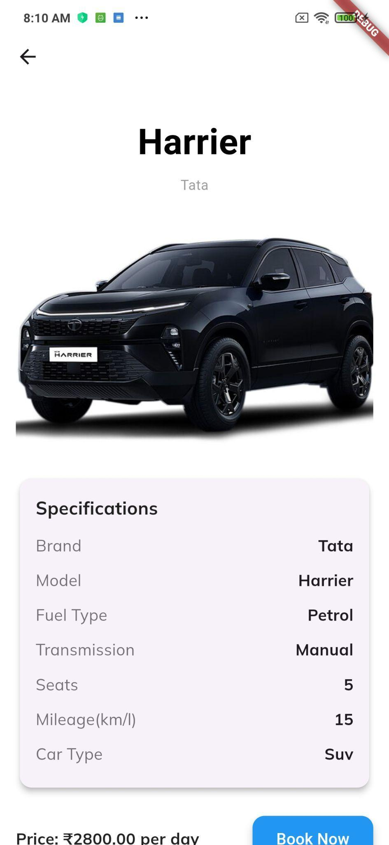

Fig 9.7.7: Car Details Page
- The user can access the car details and book the vehicle.


Fig 9.7.8: Newly Added Cars Page
- Users can see the newly added cars from the “Explore and Search Vehicle Page(Fig 9.7.5)”.
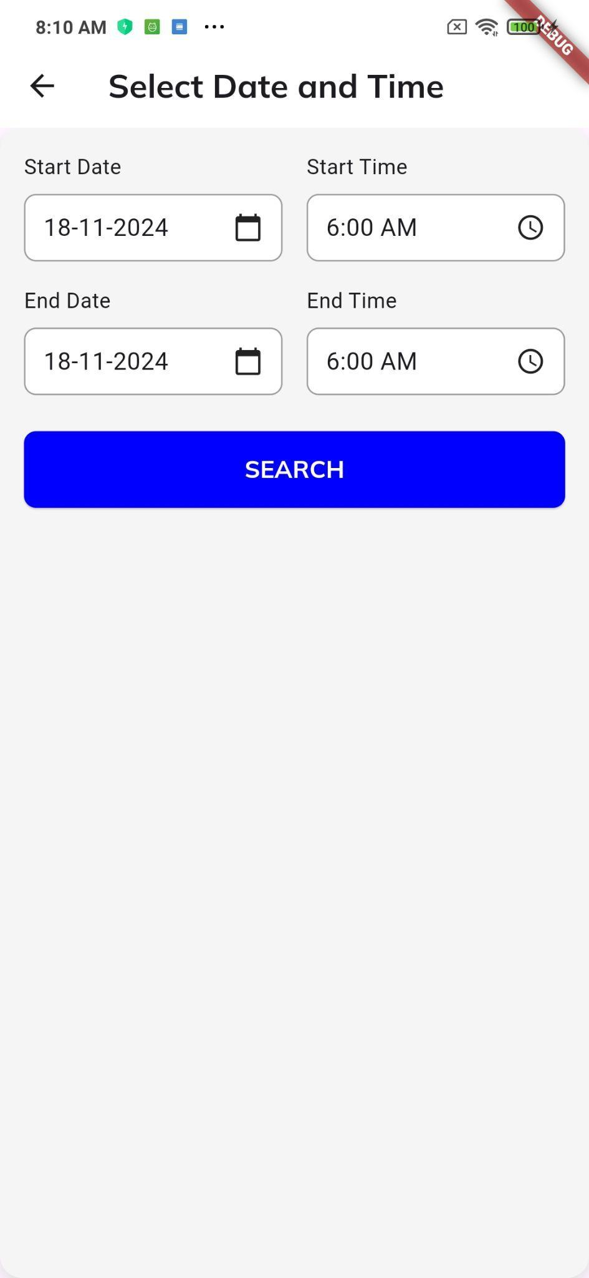
- Users can select the desired vehicles.
Fig 9.7.9: Select Date & Time
- Users can select date & time from the Explore and Search Vehicle Page (Fig 9.7.5) for searching available vehicles based on the date and time chosen.

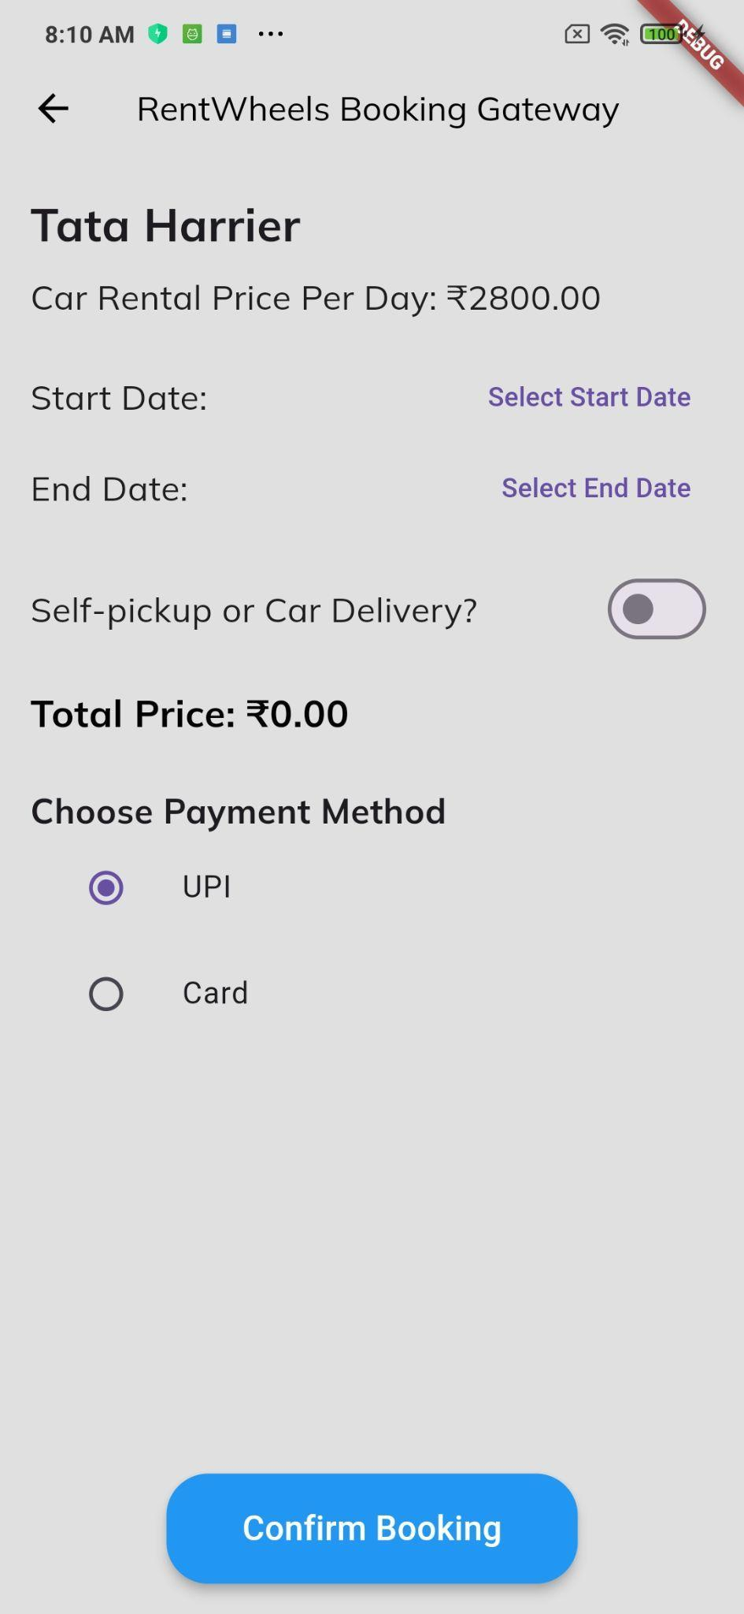
Fig 9.7.10: Booking Page
- Users after pressing on “Book Now” button (see Fig 9.7.7) they will be directed to the Booking Page.
- They can select the date and time (if not chosen earlier in the Fig: 9.7.9).
- They get the feature for self-pickup and Car delivery option.
- Users can pay either by UPI or Card.

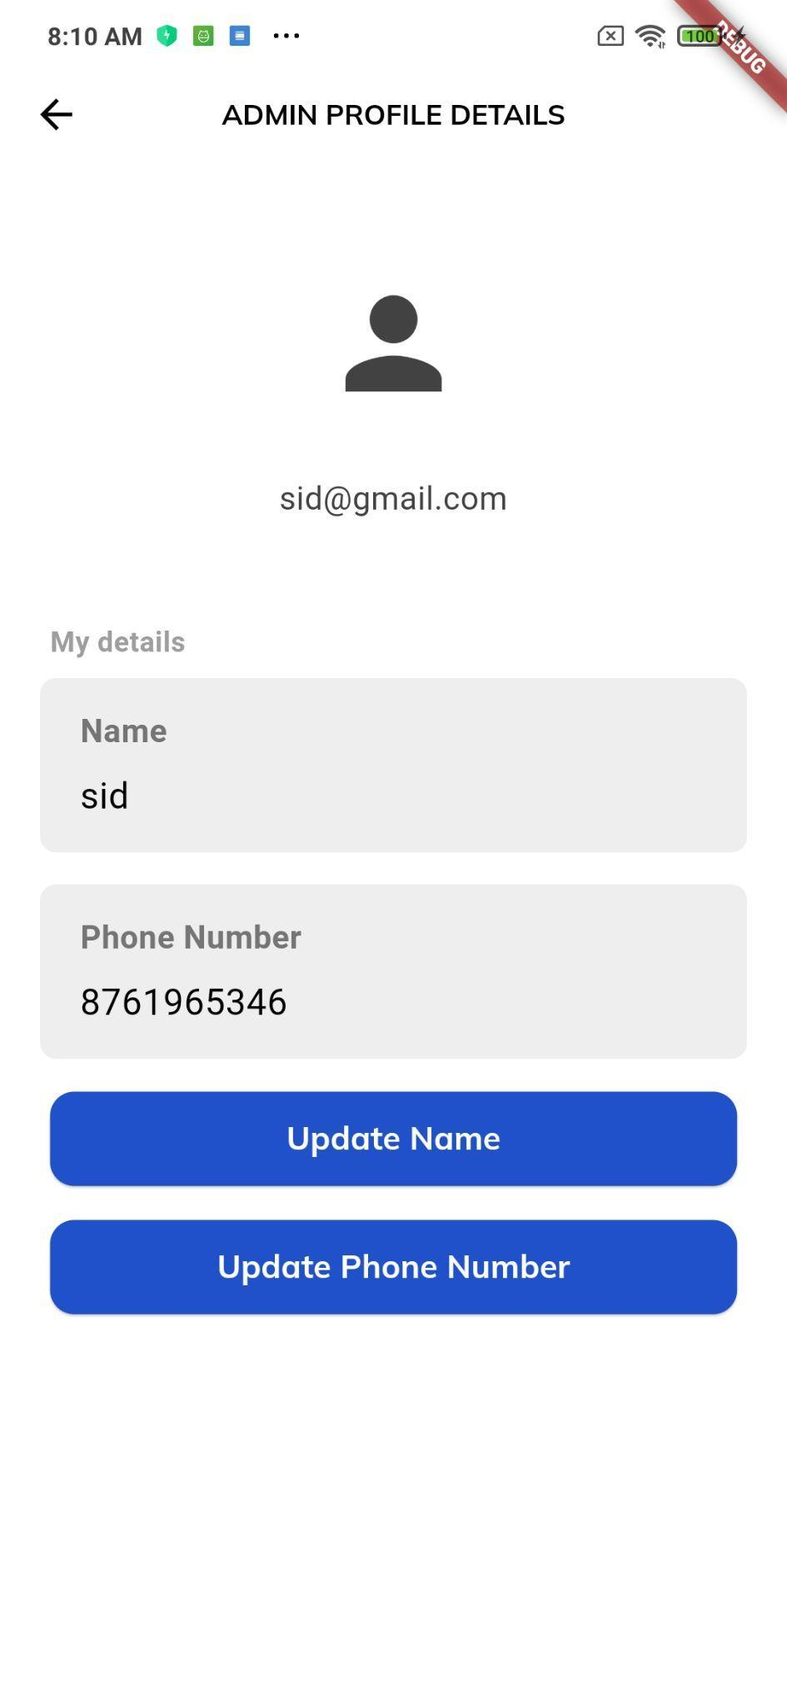

Fig 9.7.12: Admin Profile Page
- Admin Profile Page for admins to update their account information.

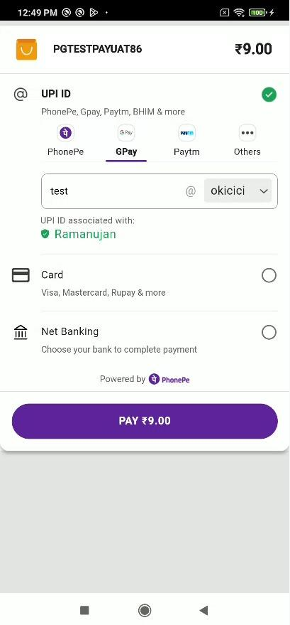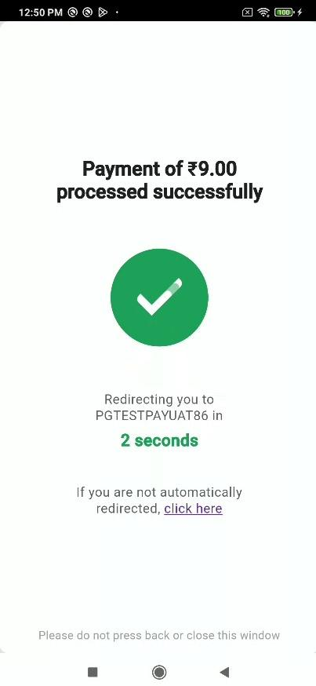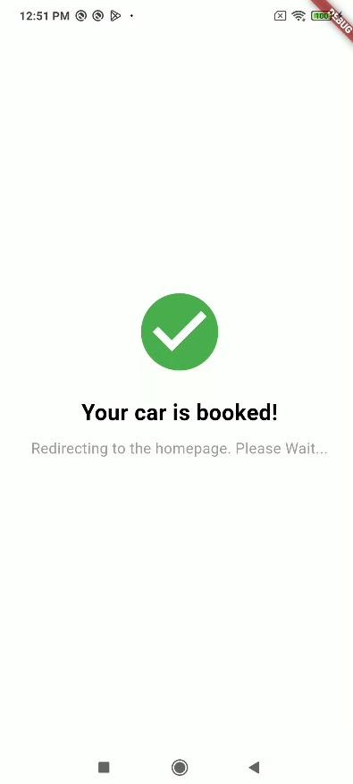

Fig 9.7.13: Payment gateway Page
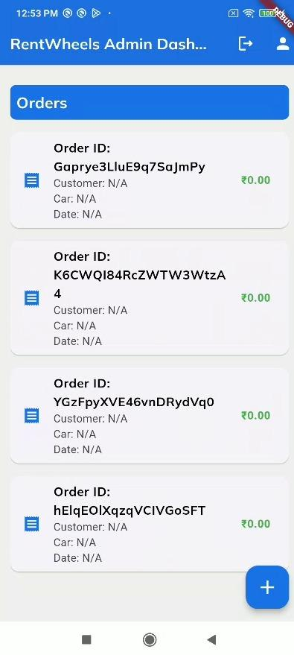
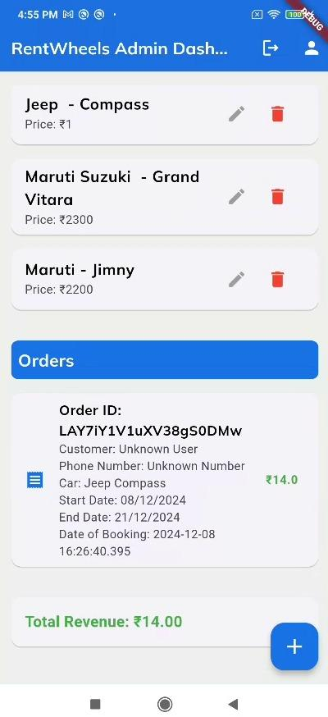
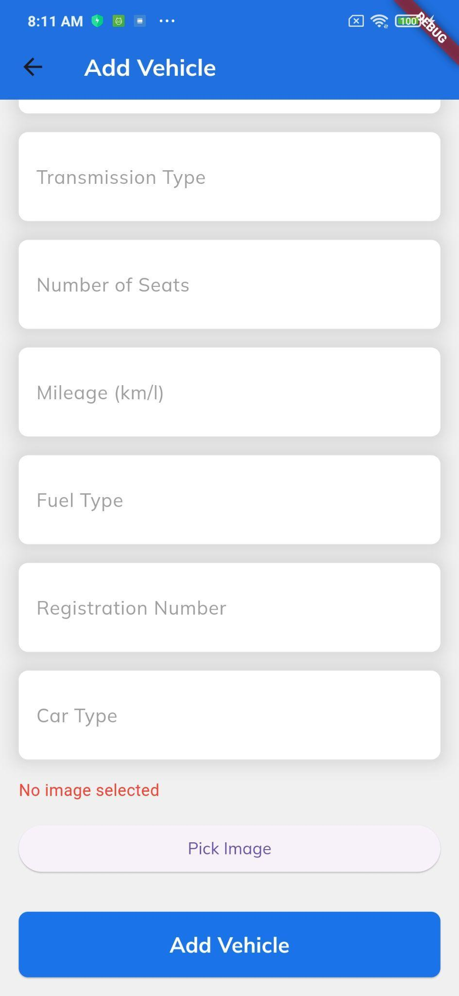
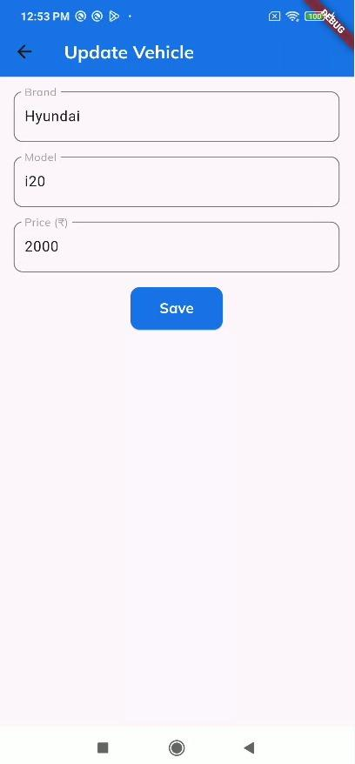

Fig 9.7.13: ADMIN Dashboard Page & Add Vehicle Page

9.4 PROJECT TESTING:
- Compatibility and Performance Testing
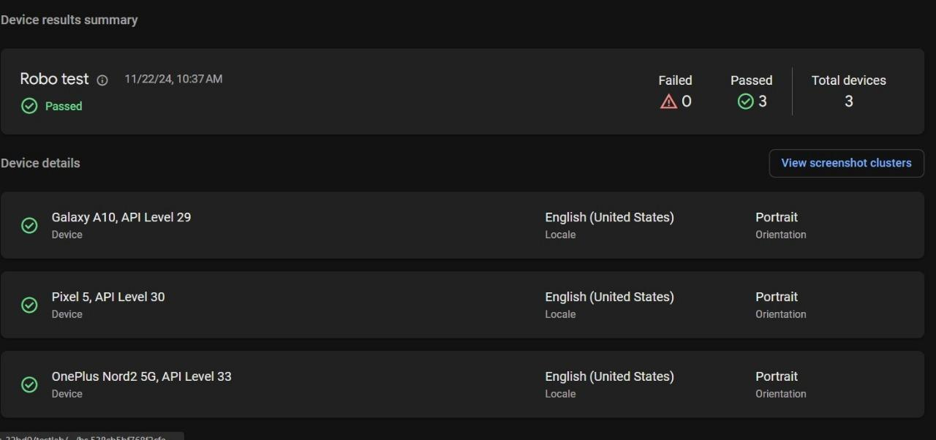
Fig : API level testing

10. CONCLUSION
The development of a smart car rental app presents an opportunity to significantly modernize the traditional car rental industry by introducing greater convenience, flexibility, and a more streamlined user experience. This approach leverages emerging technologies to meet the evolving needs of users across urban and rural areas. The app's potential benefits and future challenges can be outlined as follows:

10.1 Key Advantages:
- Enhanced User Convenience:
  - Real-time booking: Users can instantly reserve vehicles at their convenience without waiting for manual confirmation.
  - On-demand access: The app allows users to access cars anytime.
  - Self-drive options: Gives users the autonomy to drive rented vehicles without the need for chauffeurs.
- Advanced Technology Integration:
  - GPS tracking: Ensures real-time vehicle tracking, offering both safety and navigation benefits for users.
- Robust Vehicle Management System:
  - Fleet management: Efficient allocation and monitoring of vehicles ensure operational efficiency, minimizing downtime and maximizing vehicle availability.

10.2 Challenges and Considerations:
- Fleet and Resource Management:
  - Managing and maintaining a large fleet of vehicles, ensuring each is available, properly maintained, and meets customer expectations, is a critical task that requires ongoing operational diligence.
- Expansion to Tier-2 and Tier-3 Cities:
  - As the app scales, expanding into Tier-2 and Tier-3 cities will require careful market assessment, local partnerships, and customized service offerings to address varying consumer behaviors and demands.
In conclusion, while the development of a smart car rental app comes with its challenges, it offers a transformative solution for the mobility market, catering to both urban and rural users. Through a combination of innovative technology, operational efficiency, and a customer-first approach, the app has the potential to lead the evolution of car rental services in India’s expanding market.
REMARKS

