Project 2: Report

During the process of creating my program, I faced some expected challenges in writing my first code. However, I handled it well and ended up with an executable code that did exactly what I wanted it to do, albeit with many trials and tribulations.

First, I wrote what I wanted to do by commenting on my project using //. I proceeded to write my first draft of code step by step. I started with “Customer Name: “ which presented my first obstacle. When I ran the code, it prompted me with Customer Name:, but required me to press Enter twice, and only the input after the first pressing of Enter would process. By using // to isolate the problem, I discovered that cin.ignore( INT_MAX, '\n' ); was causing this issue. Once I deleted this line of code, the output “Customer Name: “ and the test user input “Stef Shidoosh” worked correctly.

Next, I wrote the code that would prompt the “Miles to be driven: ”, “Minutes to be driven: “, and the “Ride Type: “ outputs, and the corresponding error messages if a negative value (or in case of Ride Type, an input that was not Br-UberX or Br-UberXL), hence an invalid input was inputted. However, because I mixed int and string, I needed to use cin.ignore(INT_MAX, ‘\n’). This was relatively easy, but I preferred to making the program stop if an invalid value was inputted. I did not know how, but after referring back to the first lecture notes, I remembered that return would make the program stop. So, by using {}, I coded the program so that if there was an error message, the following prompted output would never execute by writing return 0 in the {} and after the if statement that coded for the error message.

I continued the code and wrote the equations that would calculate the Br-Uber fare using my assigned variables, milesDriven and minutesDriven. The next step was the most difficult obstacle for me – how to tell the program which equation to use depending on Ride Type, as the parameters differed contingent on whether the Ride Type was Br-UberX or Br-UberXL. I knew I needed to utilize flow of control, assumedly an if statement, so I tried. I determined that the program could essentially calculate both, but could output the value that corresponded to the ride type inputted. Thus, in the cout line for the fare output statement, I put <<BRx; (the variable I assigned the Br-UberX calculation) and <<BRXL; (the variable I assigned the Br-UberXL calculation) for the inputs Br-UberX and Br-UberXL, respectively, using an if statement to determine which to use and when.

When I thought I was finished, I ran some test cases. At first I was using whole numbers, which all worked fine. Then, I tried with numbers with decimal points, and while my program compiled, it was not working correctly as it could not render a floating-point decimal in the input. I realized that this was occurring because I incorrectly type-casted milesDriven and minutesDriven using int rather than double. Once I fixed this, and after a multitude of test cases in both XCode and the Linux server (g++), along with checking the correctness of my output using the fare calculator Howard provided, my project was finished.

*Test cases on the following page*..

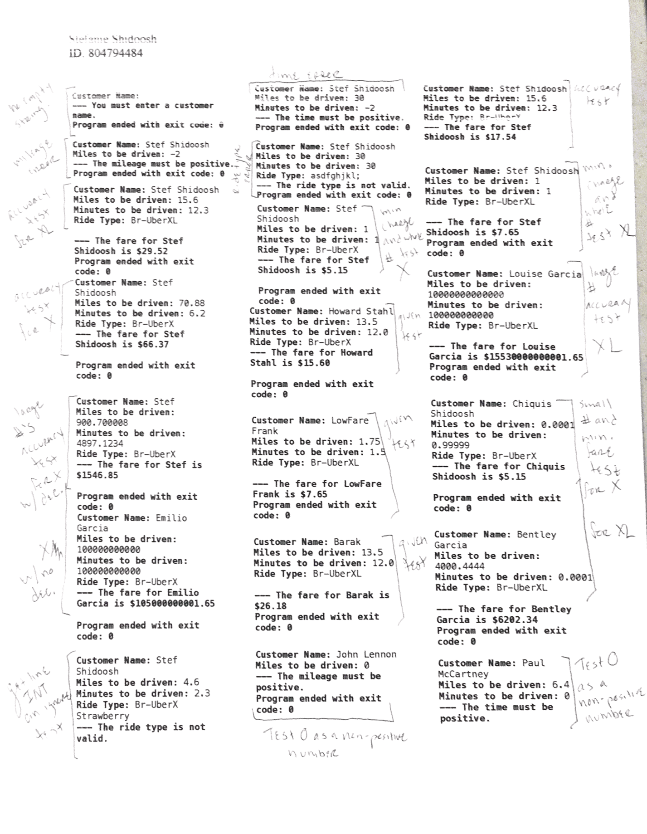

**Customer Name:** Stef Shidoosh

**Miles to be driven:** 1

**Minutes to be driven:** 1

**Ride Type:** Br-UberXL

**--- The fare for Stef Shidoosh is $7.65**

**Program ended with exit code: 0**

**Customer Name:** Louise Garcia

**Miles to be driven:** 10000000000000

**Minutes to be driven:** 100000000000

**Ride Type:** Br-UberXL

**--- The fare for Louise Garcia is $15530000000001.65**

**Program ended with exit code: 0**

**Customer Name:** Chiquis Shidoosh

**Miles to be driven:** 0.0001

**Minutes to be driven:** 0.99999

**Ride Type:** Br-UberX

**--- The fare for Chiquis Shidoosh is $5.15**

**Program ended with exit code: 0**

**Customer Name:** Bentley Garcia

**Miles to be driven:** 4000.4444

**Minutes to be driven:** 0.0001

**Ride Type:** Br-UberXL

**--- The fare for Bentley Garcia is $6202.34**

**Program ended with exit code: 0**

**Customer Name:** Paul McCartney

**Miles to be driven:** 6.4

**Minutes to be driven:** 0

**--- The time must be positive.**

**Program ended with exit code: 0**

**Customer Name:** Stef Shidoosh

**Miles to be driven:** 1

**Minutes to be driven:** 1

**Ride Type:** Br-UberX

**--- The fare for Stef Shidoosh is $5.15**

**Program ended with exit code: 0**

**Customer Name:** Howard Stahl

**Miles to be driven:** 13.5

**Minutes to be driven:** 12.0

**Ride Type:** Br-UberX

**--- The fare for Howard Stahl is $15.60**

**Program ended with exit code: 0**

**Customer Name:** LowFare Frank

**Miles to be driven:** 1.75

**Minutes to be driven:** 1.5

**Ride Type:** Br-UberXL

**--- The fare for LowFare Frank is $7.65**

**Program ended with exit code: 0**

**Customer Name:** Barak

**Miles to be driven:** 13.5

**Minutes to be driven:** 12.0

**Ride Type:** Br-UberXL

**--- The fare for Barak is $26.18**

**Program ended with exit code: 0**

**Customer Name:** John Lennon

**Miles to be driven:** 0

**--- The mileage must be positive.**

**Program ended with exit code: 0**

**Customer Name:** Stef Shidoosh

**Miles to be driven:** 4.6

**Minutes to be driven:** 2.3

**Ride Type:** Br-UberX Strawberry

**--- The ride type is not valid.**

**Customer Name:** Stef Shidoosh

**Miles to be driven:** 70.88

**Minutes to be driven:** 6.2

**Ride Type:** Br-UberX

**--- The fare for Stef Shidoosh is $66.37**

**Program ended with exit code: 0**

**Customer Name:** Stef

**Miles to be driven:** 900.700008

**Minutes to be driven:** 4897.1234

**Ride Type:** Br-UberX

**--- The fare for Stef is $1546.85**

**Program ended with exit code: 0**

**Customer Name:** Emilio Garcia

**Miles to be driven:** 100000000000

**Minutes to be driven:** 100000000000

**Ride Type:** Br-UberX

**--- The fare for Emilio Garcia is $105000000001.65**

**Program ended with exit code: 0**

**Customer Name:** Stef Shidoosh

**Miles to be driven:** 15.6

**Minutes to be driven:** 12.3

**Ride Type:** Br-UberXL

**--- The fare for Stef Shidoosh is $29.52**

**Program ended with exit code: 0**

**Customer Name:** Stef Shidoosh

**Miles to be driven:** 15.6

**Minutes to be driven:** 12.3

**Ride Type:** Br-UberX

**--- The fare for Stef Shidoosh is $17.54**

**Customer Name:**

**--- You must enter a customer name.**

**Program ended with exit code: 0**

**Customer Name:** Stef Shidoosh

**Miles to be driven:** -2

**--- The mileage must be positive.**

**Program ended with exit code: 0**

**Customer Name:** Stef Shidoosh

**Miles to be driven:** 30

**Minutes to be driven:** -2

**--- The time must be positive.**

**Program ended with exit code: 0**

**Customer Name:** Stef Shidoosh

**Miles to be driven:** 30

**Minutes to be driven:** 30

**Ride Type:** asdfghjkl;

**--- The ride type is not valid.**

**Program ended with exit code: 0**