  - ZIVUGMATCH / MASTER DESIGN REFERENCE

ZivugMatch
Consolidated design reference · v10.2 · 7 November 2026
Design reference, not a live application release.

V11 HANDOFF PRIORITY — SINGLE MODE WORKING PROTOTYPE
Build the functional Single Mode application first. Use the exact user-supplied Claude My Profile visuals as the protected source for the Profile screen, and use a coherent Claude minimalist visual language for the first integrated prototype. A second warm ChatGPT/ZivugMatch visual design for every page is a LATER REQUIREMENT ONLY; do not create or implement it in this handoff phase. Do not generate experimental Game or Neon palettes. Retain the supplied original appearance screenshots as future references. Shadchan Mode is excluded.

What is in this document
- Shidduchim: Offers, In Progress, Ended; stages, dates, history and the outstanding Make Match flow.
- Add Person and Add Shadchan: approved intake architecture, detailed categories, contacts, attachments and source preservation.
- Home: approved notes, quick entry, follow-ups and history behavior.
- Desktop Contacts: the Outlook-style three-area layout and supplied original screenshot.
- Mobile Contacts: six user-selectable views, search, Sort, Filters, pinned people, optional folders and independent scrolling.
- My Profile: phone and desktop Profile, Short versions and private Notes reference layouts.
- People and Ideas / Offers: person-reading cards styled like My Profile, populated from Add Person fields.
- Appearance reference: keep the original ZivugMatch settings screenshots, including the existing Game and Neon choices. No assistant-created themes or theme demos are included.

Design status and implementation boundary
- Approved baseline: Home, Shidduchim core, Add Person / Add Shadchan intake and the ability for the user to change Contacts views.
- Current design direction: Outlook-style desktop Contacts, My Profile screen references and profile-like saved-person cards.
- Still under review: default phone Contacts view, precise mobile dimensions and scroll behavior, joined or separate People and Ideas navigation and final visual defaults.
- Future implementation: one shared application data model and persistence across all pages. The companion HTML files are independent local design studies with fictional sample records.

Companion files in the same ZIP
- My Profile.html — Profile, Short versions, private Notes and sharing demonstration.
- Shadchanim Offers.html — saved person cards, interest, sources, history and contact navigation.
- Contacts layouts.html — six selectable phone views with sort, filters, pinned and folder experiments.
- Theme screenshots.html — supplied screenshots only; no new theme implementation or interactive style picker.
- References folder — original Add Person v3.0 source and supplied screenshots.
Keep this document as the design source of truth. Do not replace the live site’s index.html with one of the standalone prototype files.

Shidduchim — Design Review
ZivugMatch | Consolidated decisions for the prototype | Version 1
Version 10 | Preserves earlier reviewed chapters; adds Profile-style person cards and shared appearance requirements, 7 November 2026.
Purpose This opening Shidduchim review is retained as the historical baseline. Later chapters document Add Person, Home, Contacts, My Profile, person cards and shared appearance.
Status Design approved in conversation; not a claim that the app has been coded or tested.

Quick function list
- SH-01 Shidduchim tab — Offers / In Progress / Ended, Compact and Expanded cards, inline answer bubbles, quick update and milestone bars. REVIEWED
- SH-02 Shidduch Overview — person details, answers, progress, shadchan, notes. REVIEWED
- SH-03 Dates — view dates, arrange a date, edit a date, record feedback. REVIEWED
- SH-04 History — automatic activity history, past tries, quick notes. REVIEWED
- SH-05 Make Match — create a new pairing. NOT DESIGNED YET

Key rules — quick glance
- Both sides say Yes → move from Offers to In Progress.
- Either side says No → move to Ended. Thinking during dating stays In Progress.
- The bar has 11 segments: Offer / first milestone (label still to confirm), References, Dates 1–8, Marriage.
- Date segments fill only when that date is marked Happened. Skipped References stays gray.
- The bar stops at Date 8, but Date 9, 10, etc. continue in the date records.
- Ended preserves who ended it, optional reason, and a grayed snapshot of that try’s progress.
- Try Again is offered only after Ended; previous attempts remain, called 1st Try / 2nd Try / 3rd Try.
- No separate Pause button and no automatic meeting-confirmation tasks.

What must not be assumed
- Make Match is a future design task; do not invent its form or workflow.
- The exact definition/name of progress segment 1 still needs confirmation.
- Automatic change of a past arranged date to Happened was not approved; do not implement it by assumption.
- “Three tries total” is provisional; confirm before enforcing a hard limit.
This document intentionally records approved decisions plus explicit open items. It does not replace the older architecture research; the relevant shared-data rules are summarized on the last page.

SH-01 — Shidduchim main tab
Layout Three tabs in this order: Offers → In Progress → Ended. A top-right button says “Make Match” (never just “Add”).
Sorting Offers: recently updated first. In Progress: recently updated first. Ended: most recently ended first.
Cards Rounded cards with names, segmented progress bars, and a Compact / Expanded switch. Compact is the default; Expanded offers quick actions on the list without replacing or duplicating the existing Details page. Preserve the cheerful teal-to-pink tab treatment from the visual reference.
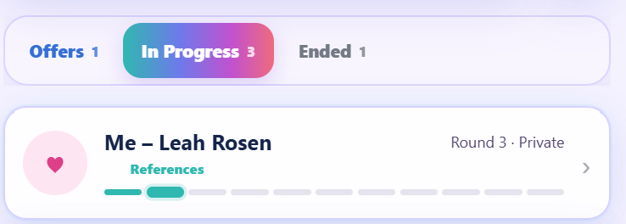
Reference A — Original tab appearance and In Progress card; retain the selected-tab gradient.

Milestone bar — 11 positions
- 1: Offer / initial step (exact label needs confirmation; an offer should visibly begin the bar).
- 2: References, if either side actually checked references. If skipped, leave gray even after dates begin.
- 3–10: Date 1 through Date 8. Fill only each date marked Happened; arranged/cancelled stays gray.
- 11: Marriage. After Date 4, use a stronger color change for later dates.
- More than eight dates: the visible bar stops filling after Date 8, but the actual date number keeps increasing.
Color direction (provisionally approved): teal #28B6AD for early steps; purple #826CEB for Dates 1–4; pink-purple #B85AC4 for Dates 5–8; gold #D0A041 for marriage; light gray #E1E3EC for not completed. These are design colors, not status logic.

Category rules
- Offers: remain here while at least one side has not said Yes, including while checking references.
- In Progress: enter only when BOTH sides have said Yes. Choosing Thinking after dating has already begun does not erase dating progress or automatically return the shidduch to Offers.
- Ended: move here when EITHER side says No, after confirmation. On the list show both answer bubbles followed by one simple “Ended” label; do not repeat “Ended by [name]” because the colored answer already shows who said No. Preserve the ending source and optional reason in Details and History.
- Ended card retains the progress reached. Previous completed steps appear as darker gray; unfinished steps lighter gray.

SH-01 — Compact and Expanded cards (approved design update)
- Compact is the default. Expanded is an optional larger card mode. Both show the same underlying match and current try; changing modes must not create duplicate records.
- Compact before both Yes: show two rounded, softly colored answer bubbles directly below the couple’s names, above the progress bar. Do not repeat the old waiting/status explanation beside them.
- Each Compact answer bubble is one clickable, oval, color-coded button showing the person’s name and current answer. Do not show up/down arrows, chevrons, or dropdown indicators inside the bubble. Tapping anywhere on it opens a small custom floating panel with four rounded choices in this order: Not answered yet / Yes / Thinking / No. Do not use the operating system’s rectangular select dropdown. After selection the panel closes and the bubble updates; the unanswered state reads “Waiting” (never “Undecided”).
- Answer colors: Yes = soft green; No = soft peach; Thinking = soft yellow; Waiting (not answered yet) = neutral pale gray. Name and answer remain readable together.
- Once both have Yes on an active match, hide the two Compact answer bubbles and restore the original simple stage / next-date information and unchanged 11-segment progress bar.
- Compact in Ended: retain the two colored answer bubbles, then show only the label “Ended” after them; omit duplicate Ended badges and “Ended by [person]” prose on the list. Keep provenance and reason in Details and History.
- Expanded shows direct one-tap Stage choices (Checking / Dating / Ended), direct one-tap answer choices (Yes / No / Thinking) for each person, “Add update”, and “Open details”. Do not show a second colored answer summary that duplicates the editable choices.
- “Add update” on the Expanded list card opens a short inline writing area. Saving appends one dated and timed item to the current try’s existing History (also visible in Overview Recent history), not a separate duplicate note.
- Consequential actions: selecting No asks for confirmation before ending a match; recording a reason and reporter is optional. Selecting Ended explicitly also asks for confirmation. Undo is offered for quick list changes.
- Moving from Checking to Dating requires both Yes answers. A later Thinking after dating has started leaves the match In Progress; previously completed dates and history remain intact. “Not answered yet” clears an unreported answer without deleting past events.
- Ended tries preserve historical answers. Their Compact bubbles retain the same appearance (no arrow) and may open a read-only floating panel, but changing an ended try must not silently rewrite its history; use Try Again from Details to begin a new attempt. Any future historical correction workflow requires separate approval.
- Keep the existing Overview, Dates, History, Try Again rules and visuals. The new direct controls are on the main list only; avoid duplicating this control panel inside the details screen.
- On narrow mobile screens the answer bubbles wrap when needed; the floating choice panel remains visible and tappable without covering its own controls or requiring horizontal page scrolling. Tap outside or press Escape to close the panel; keep keyboard focus and accessibility labels for the arrow-free clickable bubbles.

SH-02 — Shidduch details / Overview
Navigation Three tabs only: Overview, Dates, History. Remove People because it duplicates person records.
Top Keep a small Back control and the same 11-segment bar. Remove the large duplicate couple title and the old five-step progress text.
Opening summary Use a short heading such as “Dating”, followed by “Next: Date 2” and a friendly date/time if arranged. Avoid “Getting to know each other” and “Round 2”.

Two person cards
- Show two cards side by side: first name on line 1, surname on line 2, in larger readable type.
- Each card shows age, city and occupation; tapping the name opens the existing person profile.
- Each card has its own Answer dropdown: Yes / Thinking / No. No separate “Update Status” button.
- Keep the display uncluttered. Reporting source (“Who told you?”) can be requested only when an answer changes; exact save interaction remains to be settled.

Under the person cards
- Show one compact “Shadchan: Miriam Cohen” line. Tapping the name opens that shadchan’s profile.
- Remove the duplicate blue Next date box: the next date is already shown above.
- Remove “Confirm tomorrow’s meeting” and related auto-generated confirmation tasks.
- Remove the Pause button; Thinking covers a break without closing or resetting the match.
- Keep Recent history at bottom: 3 recent items, date AND time of change, “Add note” text button, plus a way to see all history.

When answers change
- No: the match moves to Ended, showing who ended it and optional reason. Past activity stays saved.
- Thinking after dating started: remains In Progress; changing back to Yes continues with the next date number.
- In Ended only: offer a “Try Again” action, subject to the tries limit; nothing resets just because someone chose Thinking.

SH-02 continued — Trying again
Terminology Never show technical “Round 1 / Round 2”. Use “1st Try”, “2nd Try”, and “3rd Try”.
- “Try Again” appears only after a match has moved to Ended, and not while it is active or an open offer.
- Same couple, same underlying match record. Do not create a duplicate shidduch.
- Keep the previous try’s progress bar underneath the current one; all its filled steps turn shades of gray to show how far it got.
- Start a fresh colored bar for the new try. Dates are numbered afresh for that try, starting with Date 1.
- Keep previous tries’ dates, ending reason and history. Both old and current bars remain visible on Details.
- Proposed maximum is 3 total tries; this remains provisional, not a final business rule.

SH-03 — Dates tab
Layout Keep the Astra design with a Dates list and “Arrange a date” at top right. List dates in order and show Date number, status, date/time and place.
Display Use friendly dates, e.g. “Oct 7 · 7:00 PM”, instead of raw 2026-10-07 / 19:00 formatting.
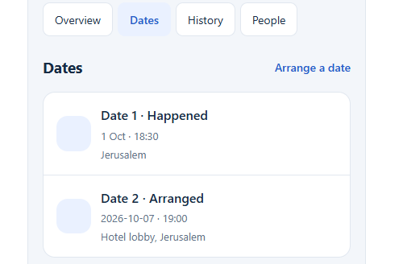
Reference D — Approved Dates list appearance.

Statuses and progress
- Arranged: planned; its progress-bar segment stays gray.
- Happened: this date’s segment fills in the bar and appears in history.
- Cancelled: the date remains in history but does not color a progress segment.
- Dates 9 and later remain in the list with their real date numbers, even though the visible bar only has eight date positions.

SH-03 continued — Arrange or edit a date
Form Keep the simple Astra form for new dates and existing dates, with the same fields and Save date button.
- When — date and time picker.
- Where — meeting location.
- Status — Arranged / Happened / Cancelled.
- Feedback (private) — optional free-text field.
- Save date — persist edits and return to the Dates tab; update the Overview and shared history automatically.
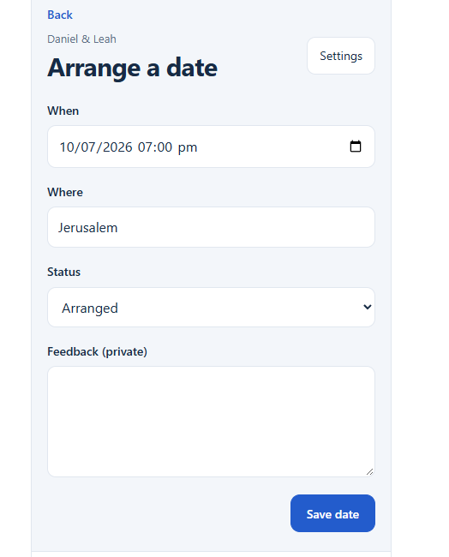 | 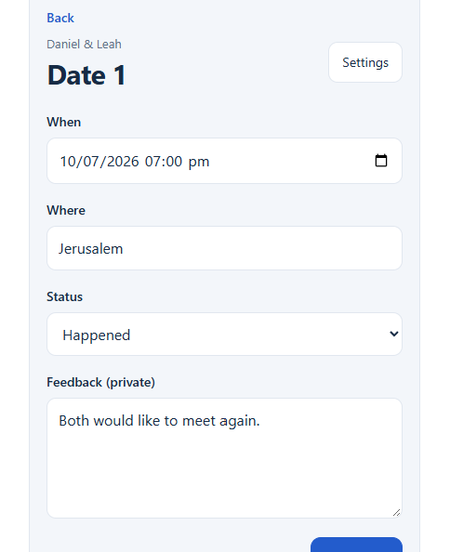
Reference E — Arrange a date (left) and Edit Date 1 (right). Original form layout approved.

Important behavior to confirm later
- After the scheduled time passes, should the app ask you to change Arranged to Happened, or do anything automatically? This was asked but not answered. For now, leave it as a decision, not an automatic feature.
- Feedback remains private; never include it when sending someone’s profile.

SH-04 — History tab and quick notes
Layout Preserve the clean vertical history list from Astra. No “This round” or “Current Try” heading. Keep “Add note” at top right exactly as text, without a plus sign.
- New activities and answer changes are automatically logged once and shown both on this tab and on Recent history in Overview.
- Every item shows what happened and the date/time it was recorded. If the real event date differs, preserve both when known.
- Avoid duplicate noise such as two identical “Stage changed to Dates” entries.
- Add note expands a small text input directly in the History tab; no extra screen or popup.
- Saving a note timestamps it and associates it with the current try; it also shows in the Overview’s recent history.
- Older tries are listed below, expandable, with their original events and ending reason.
- History and notes are private; never automatically send them with a profile.
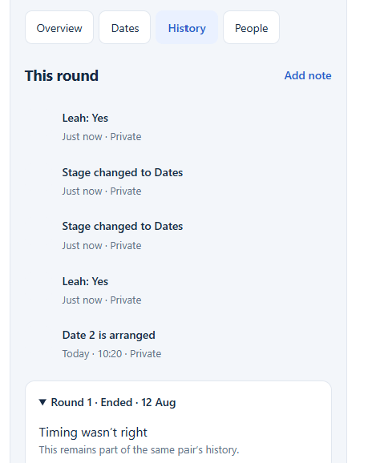
Reference F — Astra History tab. Keep the list and Add note position; remove the “This round” header and rename old rounds as “1st Try,” etc.

Shared behavior behind these screens
- One record for a real person, reused across Guys, Girls, Shadchanim, and Shidduchim; no copied person records.
- One record for each couple; a later try belongs to that same couple. Keep each try’s separate history and progress.
- One shared activity record powers Overview Recent history and the History tab. Do not write the same action twice.
- Keep which side answered, who reported it (when given), date/time, and provenance without inventing missing facts.
- Sharing someone's profile must never include private feedback, shidduch history, notes or reasons for rejection.

SH-05 — Make Match (deferred)
Status NOT DESIGNED. The only approved visible requirement is a top-right button on the main tab labeled “Make Match”.
Do not build a guessed form, match-creation flow, shadchan selection, profile exchange, or automatic offer logic from this document. We will review screenshots and business rules for this function in a separate session.

Open questions / next design pass
- 1. First progress segment: whether its official label is “Offer” (instead of “Profile sent”), and the exact fill rule when a suggestion exists but no profile has gone out.
- 2. After a past scheduled date: whether a reminder or manual status action is needed before it becomes Happened. No automatic change is approved.
- 3. Try Again: three total tries is provisional; approve the actual cap and what happens if a couple reconnects years later.
- 4. Try Again confirmation: the final wording and whether confirmation appears inline have not been approved.
- 5. Who reported an answer: agree on the minimal inline interaction for optional source attribution while keeping cards uncluttered.
- 6. One-versus-multiple shadchanim: Overview presently shows one simple Shadchan line; how multiple involved contacts display is not yet reviewed.

Submission guidance for an AI builder
- Use this document for SH-01 to SH-04 only. Preserve the approved look from the embedded images, but the written updates override older screenshot details.
- Do not change the rest of ZivugMatch, the existing shared person records, or the repository architecture without a separate explicit request.
- Do not build Make Match yet. Mark open decisions as questions instead of silently guessing.
- Check phone-size and desktop-size layouts and actual data rules—especially arrow-free Compact answer pills and their rounded floating choices (Not answered yet / Yes / Thinking / No), Dating only after both Yes, Thinking not resetting dating progress, dates colored only after Happened, and past tries preserved.
- Test duplicate-free history, accurate date timestamps, and keeping private notes out of profile sharing.
Visual references are prototype screenshots supplied for design discussion. They are not implementation proof. Names, dates and feedback shown in them are example data.

ADD PERSON & SHADCHAN / DESIGN ADDENDUM

Add Person & Shadchan — Intake Forms
ZivugMatch | Version 4 | Approved design decisions through 13 October 2026
Scope The original Shidduchim Version 1 specification is retained without changing its decisions. This addendum describes Add Guy/Girl and Add Shadchan forms, based on the reviewed interactive prototype.
Status User-reviewed design reference only. The companion HTML is an interactive visual prototype; it does not persist contacts or implement production extraction, file storage, or a backend.

Quick function list
AP-01 Add Person — Paste, Basic Info, Detailed Info; adaptive layout. REVIEWED
AP-02 Paste — retain original; attach files; Save for later or Next. REVIEWED
AP-03 Basic Info — name, optional age, phone ownership; quick save. REVIEWED
AP-04 Detailed Info — full-width fields, fixed section shortcuts, View Original. REVIEWED
AP-05 Contacts & Source — named contact cards, phones, references, optional email. REVIEWED
AP-06 Personal, religious, Character & Lifestyle, and familiarity information. REVIEWED
AP-07 Custom and built-in categories and bubble choices — add, hide, delete and arrange; preserve saved values. REVIEWED
AP-08 Data/behavior — preserve source, sensible extraction, no mixing contacts. REVIEWED
AP-09 Personal receiving link / online inbox. FUTURE DESIGN (NOT FINALIZED)

Core experience
Paste an existing profile → Next to confirm the essentials → Save and Finish, or Add More Details. Everything else is optional.
Do not build a large intake dashboard or require the user to fill in complete profiles. The original profile remains available and the app should organize extracted information, not make users retype it.
Companion file: ZivugMatch_Add_Person_Prototype_v3_0.html (clickable local design demo, packaged separately). Open it in a browser; Word cannot run its interactions. The document includes additional settings decisions that are not yet implemented in the HTML.

AP-01 — Three tabs and responsive layout
Tab | When no original exists | When pasted/attached original exists
Paste | Full-width input | Full-width input / attached files
Basic Info | Full-width form | Original on left, editable form on right
Detailed Info | Full-width form | Full-width form with View Original button
Tabs at top: Paste → Basic Info → Detailed Info. Switching tabs must not lose changes.
Basic Info keeps the original visible on the left for direct comparison; adapt spacing on narrow phones without requiring dropdowns for phone ownership.
Detailed Info uses full width so category sections and contacts are not cramped. View Original opens a temporary readable, scrollable overlay/drawer and returns to exactly where the user was.
All Detailed Info sections stay open; no collapsing/expanding just to reach a field. Distinct softly outlined, rounded sections separate the content.
A slim, fixed/sticky line of category names beside “Detailed Info” jumps straight to a section. No Jump-to dropdown. On phones this line scrolls horizontally.

AP-02 — Paste and Basic Info
Starting point Paste
A prominent “Paste a profile” button reads text from the clipboard in one click where browser permission allows, to save a manual paste. The full-width profile text box remains editable and supports ordinary Ctrl and V together when clipboard access is blocked. Allow attaching files and preserve the original.
Bottom buttons: Save for later | Next. Save for later preserves the item without forcing a person record; Next goes to Basic Info.
Extract known fields from the source whenever reliable; missing/uncertain values stay empty, never invented.
Exactly three types of fields Basic Info
Name — editable and automatically filled if found.
Phone number rows — one per extracted number, with a minimum of one blank row when none is found; editable individually.
Age (optional) — editable; never invent birthdate or extrapolate a current age from an undated old profile.
Each phone sits within its own clearly outlined card. Put the short prompt “Whose number is this?” immediately ABOVE the one-tap role buttons, so their purpose is obvious. The number and owner/role selector remain visually tied together.
Basic Info and Detailed Info use the same clearly labeled one-tap role choices: Their phone, Shadchan, Unknown, Mother, Father, Reference and Other; no role dropdown.
Unknown is the default when the owner cannot be determined. Never turn a shadchan, parent or reference number into the person’s direct number.
Bottom row: Save and Finish (left) | Add More Details (right). Both save. Save and Finish closes; Add More Details opens Detailed Info for the same person.
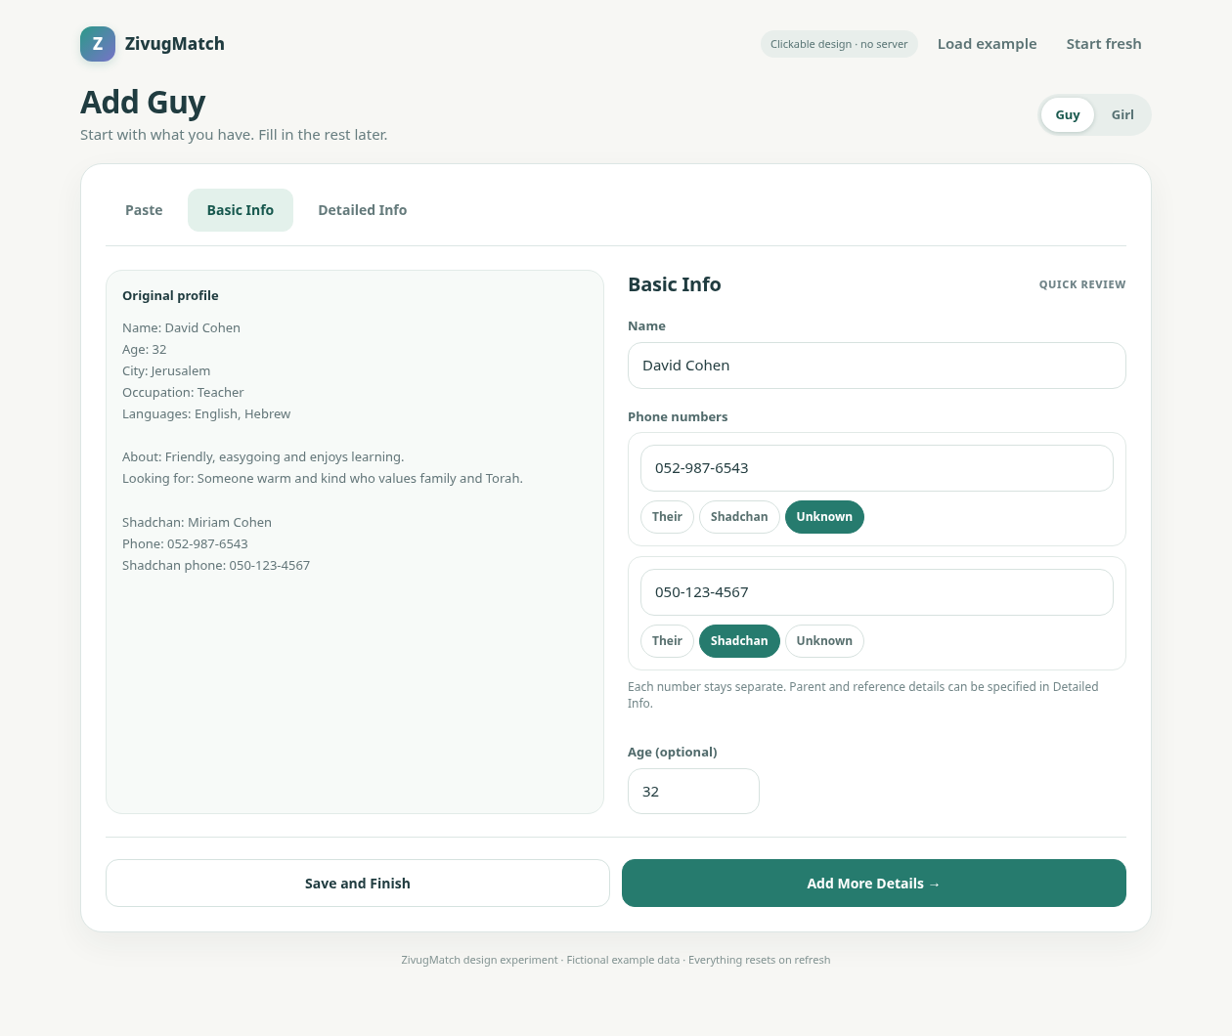
Reference AP-A — Basic Info desktop concept: original on left, editable essentials and separate phone cards on right.

AP-03 — Detailed Info organization
Opening sections: About & Looking For; Personal Info; Contacts & Source; How well do I know them?; Status; Religious; Character & Lifestyle; user-defined categories; and Attached items at the end.
Each section stays expanded (never require a click to open it) and is visually separated with clear spacing/borders. The slim category shortcut row stays accessible while scrolling; tapping a name scrolls directly to that category. Do not insert an extra Jump-to dropdown.
View Original stays near the Detailed Info title. The original is read-only, scrollable and dismissible without clearing the form or changing the scroll position.

AP-04 — Main information fields
Section | Field / UI
About & Looking For | About the Person (free text), What are they looking for? (free text), Up to what age? (small number box inline)
Personal Info | Occupation; City (typed plus recently entered city buttons); Languages spoken (multiple quick-select buttons, three dots to add a new language)
Contacts & Source | Person, shadchan, references, parents and unknown contacts; Who sent the profile? with recently used names
How well do I know them? | Never spoke; Talked by phone; Met in person; Know personally; Would recommend; Years known (small number); How do you know them? (free text)
Family | Divorced; Has children; additional user options
Religious | Religious Level; Tzniut; Religious Background; religious characteristic rows; optional Other religious details
Character & Lifestyle | Trait bubbles: Kind, Quiet, Outgoing, Athletic. Body Type is a separate single-choice subcategory with Regular, Overweight, Highly overweight. Additional bubbles via three dots.
Attached items | At the end of Detailed Info. Attach files, show existing attachments and allow removing attachments.
Optional fields should populate from pasted text when clearly supported, and remain fully editable.
Personal Info is one full-width vertical column, in this order: Occupation, City, Languages spoken. City and “Who sent it?” can offer recently used one-tap suggestions in addition to typing.
Languages spoken supports selecting multiple bubbles; the three dots (…) appear immediately after the language choices to add more. Built-in and custom language bubbles can be hidden OR deleted through the low-visibility manager.
Do not force users to fill out Detailed Info before saving a person.

AP-05 — Contacts & Source (preferred card design)
Keep the approved separate rounded contact cards with the small pencil icon, NOT the later connected accordion/list redesign.
Each card keeps the contact’s relationship, name and phone number together. Tapping the pencil opens inline editable name, phone and relationship controls; close with Done.
Use the same seven role choices as Basic Info. Editing from either screen updates the same contact, without copying or duplicating numbers.
When provided in the original, extract a shadchan’s name into Detailed Info and link it to the correct shadchan number.
Support any number of references, mothers, fathers, other people, or unconfirmed numbers. A shared family number is not proof that two singles are duplicates.
An optional “Add email…” action appears inside an individual contact’s edit area. No stock email field on every card; email belongs to that specific person.
Who sent the profile? is separate below the contact cards. The sender and shadchan may be the same, but the app must not assume so.
Suggest linking to an existing known shadchan/contact instead of silently creating a duplicate. Keep source/received version traceable.
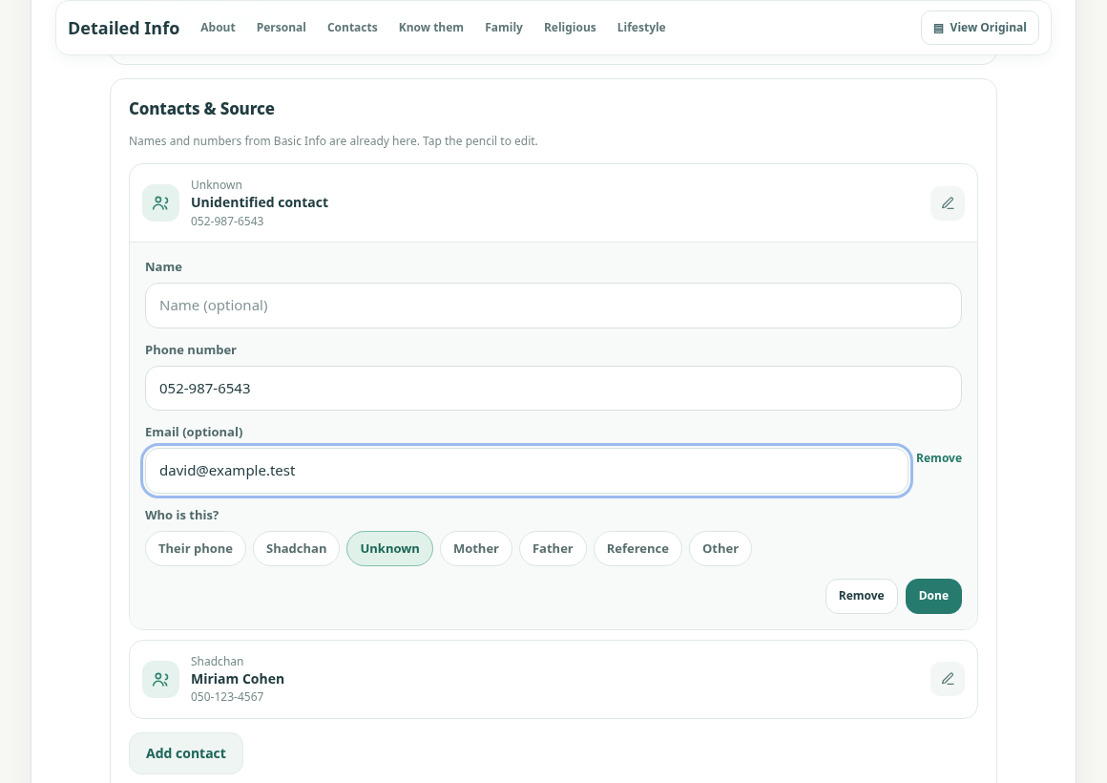
Reference AP-B — Contacts & Source concept, including per-contact pencil editing and optional Add email.

AP-06 — Personal knowledge, family, religious and lifestyle
Personal knowledge How well do I know them?
Single tap oval rows: Never spoke, Talked by phone, Met in person, Know personally, Would recommend.
Talked by phone and Met in person can both apply. Never spoke clears both. Know personally and Would recommend are independent.
Years known is a compact optional number field, and How do you know them? is a flexible free-text field (roommate, coworker, neighbor, etc.).
Do not put the word “Private” beside this section heading. This relationship information remains internal and is not part of an outgoing profile.
Defaults Status / Religious / Character & Lifestyle
Status: Never been married; Divorced; Has children. Never been married and Divorced are mutually exclusive; selecting either deselects the other. Has children is independent.
Religious Level: Light / Moderate / Strong; Tzniut: Light / Moderate / Strong; Religious Background: common choices such as Chabad, Yeshivish, Breslev, Sephardi, Dati Leumi.
Religious characteristic rows: Kohen, Prays 3× daily, Baal Teshuvah, Kosher for Kohen (Girls only). Other religious details free text.
Character & Lifestyle: default trait bubbles are Kind, Quiet, Outgoing, Athletic, with three dots to add more. Body Type remains a SEPARATE subcategory beneath traits, with only these three default single-select bubbles: Regular, Overweight, Highly overweight. Do not include Smokes, Watches movies, Funny, Patient or Easygoing as default bubbles; users may add extra traits themselves.
Use clean one-column soft rounded oval rows for yes-style characteristics; empty circle when not selected and a gentle teal highlight across the whole row when selected.
No red crosses, no separate yes/no button clutter, no forced tri-state tapping cycle. Unselected means not specified, not an asserted No. Do not infer sensitive facts from names, communities or photos.

AP-07 — Add, hide, delete and arrange categories and choices
Put the three dots (…) AFTER the relevant options or list text, to the right. Tapping them opens a small nearby fillable bubble to type and save an additional option; do not open a new screen.
This works for Family, Religious characteristics, Character & Lifestyle traits, Body Type, Religious Level, Tzniut, Religious Background, Languages, and other custom lists.
Saved custom choices become reusable for future people on that user’s device and must be included in backups. Never allow duplicate choices solely because of capitalization.
At the bottom, show a compact inline “New category …” control, not a full-width button. Creating a new category immediately shows its “Add subcategory” control and its own three dots.
“Manage categories & choices” is a SMALL TEXT LINK at the far bottom-left of the form, away from Save/Cancel. It opens management for both custom and built-in categories and all bubble options, without taking prominent screen space.
Management must offer distinct Hide and Delete actions for BOTH built-in and custom categories AND individual bubble choices. Hide removes the item from normal entry screens but keeps it available to restore. Delete removes the item from the user’s active configuration (not just hides it); require confirmation. Never silently erase values previously saved on people. Do not restrict deletion to custom items.
Keep the settings link unobtrusive but findable. The everyday form only shows three dots for adding choices, a small New category … control, and the far bottom-left management link—not permanent edit/reorder/delete controls.
Guys-only/Girls-only custom-field configuration is deliberately deferred. “Kosher for Kohen” is Girls-only in the current design.

AP-08 — Data and save behavior
Save the source text/file unchanged. Extraction is a suggestion, not proof: do not invent names, ownership, religious details, sources or identity matches.
One saved person record should be reused; updated profiles become additional versions, not duplicate people. Review ambiguous matches instead of merging automatically.
Basic Info and Detailed Info edit one shared set of values, including contact roles and sender metadata. Edits persist when switching tabs or viewing the original.
Save for later is not the same as Save Person: it preserves an unfiled original without pretending its owner is known.
User-created categories/choices and customization settings (hide/delete/reorder) apply to future profiles and survive backup/restore. Neither hiding nor deleting form definitions erases historical answers saved on existing people.
The UI should operate comfortably on desktop and phone. The Basic Info half-screen phone layout needs careful fit/tap testing; avoid adding more taps simply to hide options.

AP-09 — Outside scope for now
Receiving links and private online inboxes are promising future features, but their final ownership model, online storage, security and submission workflow are not fully approved in this Add Person specification.
Make Match (SH-05) remains deferred. Do not design or build it based on this addendum.

Implementation notes and open details
The companion HTML v3.0 prototype demonstrates Guy, Girl and Shadchan intake, direct clipboard paste (subject to browser permission), section shortcuts, basic category/choice management, Status, and optional email. It is NOT a working backend, AI/OCR import service, online receiving link, or durable database. The newly required permanent deletion and category-reordering controls are specified for the real application, not yet present in this HTML.
In the current HTML, the manager is reached from the small bottom-left text link; it primarily demonstrates hiding/restoring standard choices and removing/restoring custom items. The approved final design additionally needs real Delete for built-ins and customs plus Move up / Move down for category order, while preserving saved person data.
A potential “Rabbi” field was mentioned but its meaning (contact person versus characteristic) was not finalized; do not invent it.
The exact treatment of a definite “No” for oval characteristics is still open: current empty circles mean “not recorded.”
The original Shidduchim Version 1 pages were retained as the working baseline; their outstanding decisions are unchanged.

AS-01 — Add Shadchan (single screen)
A separate Add Shadchan form uses ONE straightforward screen. It does not use the three Paste / Basic Info / Detailed Info tabs required for Guy/Girl profiles. All fields are visible and optional except the name required to save.
Contact basics: Name, Phone number, Email. Email is a normal visible field on a Shadchan form, unlike the optional per-contact email hidden by default inside Guy/Girl contact cards.
Notes: roomy auto-growing text field for useful reminders, such as “Prefers not to receive calls before 5 PM.” Treat as internal information, not as part of a shareable personal profile.
Who do they work with? Ages: start with only one default selectable bubble, “30 and under.” The user can add other ranges through the three dots. Do not prefill “All” or other age-range bubbles.
Religious groups: multiple selectable bubbles, for example Chabad, Breslov and Haredi, with common additional groups and a three-dot control for user-created options.
How well do I know them? Reuse the Guy/Girl contact familiarity choices: Never spoke, Talked by phone, Met in person, Know personally, Would recommend, an optional Years known number, and “How do you know them?” notes.
Languages spoken: selectable bubbles, with the three-dot control after the choices for adding languages.
Source: record where this shadchan/contact information came from; do not invent a source.
Attached items: attach file(s) such as a document or photo; show the items added.
Bottom actions: Cancel and Save Shadchan. Keep the small “Manage categories & choices” link unobtrusively at far bottom-left, separate from the main action buttons.
Text fields and textareas align to the same left edge; as the user types longer notes, the text area grows instead of forcing an oddly mismatched narrow box.
The Shadchan form is also a design prototype. Save and Cancel demonstrate the interface; there is no persistent people database in this HTML file.

AP-10 — Final Character & Lifestyle arrangement
Detailed Info for BOTH Guy and Girl uses a single category named “Character & Lifestyle.” The trait bubbles appear first; Body Type remains visibly labeled as a separate subcategory, directly below them.
Character & Lifestyle → Traits (multi-select): Kind · Quiet · Outgoing · Athletic. No other trait or habit bubbles are shown by default.
Body Type (single-select): Regular · Overweight · Highly overweight. Retain the existing separate Body Type heading and pill-button appearance.
The three dots after Traits and Body Type allow adding extra personal options. The manager must allow hiding or deleting any built-in or custom bubble, not just removing custom ones.
A hidden bubble is not interpreted as an explicit “No.” Do not infer character, body type or habits from photographs, background, or other unrelated information.
The section name appears in the fixed category-jump shortcuts and in Manage categories & choices. Its position can be changed using category ordering controls.
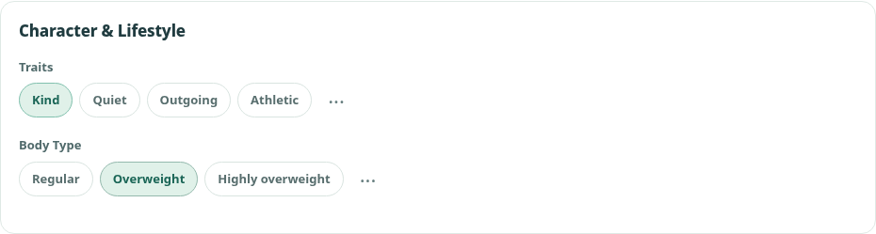
Reference AP-C — Character & Lifestyle after the final default-bubble change. This is a design screenshot, not evidence of backend implementation.

AP-11 — Cross-form usability and configuration
Guy/Girl Detailed Info, Add Shadchan, and their settings use consistent bubbles, spacing, and expanding multi-line inputs. Avoid side-by-side Occupation / City / Languages layout.
On desktop, the category-jump names sit in one compact horizontal row near the Detailed Info heading and remain easy to reach while scrolling. On small phones, the names can scroll horizontally without taking a second bulky bar.
“Manage categories & choices” sits on the far bottom-left, never centered among Save and Cancel. Hide, Delete and Show/restore must cover standard and custom bubbles, including ages, languages and religious choices.
Category management also includes Move up and Move down (or equally clear reorder controls) for all visible categories. The form and sticky category-jump shortcuts must immediately use the same saved order; rearranging definitions must not destroy previously saved profile data.
Field applicability settings (Guys/Girls/Both) for custom fields are deferred to a later version. For now, Kosher for Kohen appears only on Girls; other existing options remain shared.
Do not auto-include private notes, familiarity details, contact source, or internal activity in any outgoing shared person profile.

Companion prototype and limitations
Companion design file in this delivery: ZivugMatch_Add_Person_Prototype_v3_0.html. Open separately in a browser; interactive HTML cannot run inside Word. The prototype is a visual reference only: the new deletion/reordering settings in this Version 4 specification are not yet implemented in it.
This prototype is not connected to GitHub or the live ZivugMatch app. It does not permanently store contacts or files. Clipboard paste works only where the browser permits access; otherwise a normal manual paste still works.
Document history: Version 1 retained the approved Shidduchim baseline; Version 2 added Add Person; Version 3 added Shadchan, category/choice management and Character & Lifestyle; Version 4 adds final Status and phone-label refinements, keeps three tabs, and specifies separate Hide/Delete and category ordering controls.

AP-12 — Approved refinements (13 October 2026)
Keep the three Add Guy/Girl tabs: Paste | Basic Info | Detailed Info. The proposal to combine Paste and Basic Info into one screen was considered and REJECTED as too busy. No extra combined page.
In Basic Info, display “Whose number is this?” immediately above the ownership bubbles for every phone number. Keep the selected owner linked to that number; do not infer the wrong owner.
Replace the “Family” heading with “Status” everywhere in Detailed Info, the sticky jump shortcuts and management UI. Defaults: Never been married, Divorced, Has children. Never been married and Divorced exclude one another; Has children is independent.
Users must be able to HIDE or DELETE a category, regardless of whether it was supplied with the app or created by the user. The same applies to EACH bubble choice, including built-in choices. Hide and Delete are two separate actions, not synonyms.
Hide means temporarily remove from the normal form, with an easy way to restore it. Delete removes the category/choice definition from that user’s configuration (with a confirmation), not merely hiding it. Do not silently erase historical values attached to existing people; deleting those values would be a distinct explicit operation.
Provide simple Move up / Move down controls in Manage categories & choices so users can arrange sections in their preferred order. Use that order in Detailed Info, including the slim fixed category-jump row. Save the order for future forms and backups.
Keep “Manage categories & choices” as a small text link at the far LEFT of the bottom form footer, outside the central Save/Cancel buttons. Do not put the management tools across the top or into normal data-entry fields.
These are requirements for the finished app. The accompanying HTML prototype v3.0 does not yet implement permanent deletion of built-ins or category reordering; do not mistake a visual demo for a finished feature.
Next review: begin another app section together. Do not treat the remainder of ZivugMatch as approved or design missing screens without reviewing them.

HOME-01 — Single Mode Home / Note Intake
Design status: Home layout and note-entry interactions reviewed and refined through October 2026. Companion functional reference: ZivugMatch_Single_Mode_Home_Final_v8.html. This chapter is a prototype/UI specification—not a claim of deployed implementation or validated AI accuracy.

Home — one page for writing and remembering
- Single Mode main navigation: Home, People, Shidduchim. Follow Ups and History are sections on Home, NOT separate main tabs.
- New Note spans the main content width at the top. On desktop, Existing Notes and History form the left column; Follow Ups occupies the right column. On phone, stack sections in one column: New Note → Existing Notes → Follow Ups → History.
- Keep a warm, uncluttered note-app feel. Avoid corporate dashboards, metrics, redundant icon blocks and mandatory intake forms. Search across all information remains easily accessible.

HOME-02 — New Note editor
- Begin writing immediately. Title is optional; ordinary notes save without selecting a category, person, action or date. Store the original wording, creation time and subsequent dated updates.
- Visible editor actions (once writing begins): Actions, Link Contact, Follow Up, Save Note. No dropdown arrow symbols next to Actions or Link Contact. Pin / Unpin is a separate, always-visible, small plain-text toggle in the note header, not a large badge or a footer button.
- Suggestions On/Off is a very small dot in the note header: blue when enabled, grey when disabled; hover tooltip and accessible label explain the control. It must not occupy a long toolbar space.
- While typing, recognized people, possible new contacts, relevant answer phrases and time phrases may receive subtle inline highlighting. Show up to three compact, optional suggestions; never interrupt capture with a mandatory review.
- One tiny blue, rounded Star of David (approximately 12 × 14 px) appears beside the Suggestions heading only; none beside individual suggestion rows. Do not substitute sparkle graphics.

HOME-03 — Notes, pinning and color
- Existing Notes has two groups: Pinned first, Other Notes below. Notes can be unlinked, linked to one person or linked to several people; linking must not create duplicate editable notes.
- Pin and Unpin are the two states of ONE control. The small plain-text control is always visible on an existing note, including when expanded; clicking it must never accidentally enter the writing field.
- Note colors are MANUAL, not auto-assigned from the contents. Default paper/cream plus five subtle optional colors: Blue, Yellow, Peach, Green, Lilac. Choosing a color changes the whole note, not just an update.
- Change Color belongs inside the small Actions dropdown, not a separate prominent control or screen. Provide six circular, individually named color swatches (Default, Blue, Yellow, Peach, Green, Lilac) and show the currently selected swatch. For a NEW note, selecting a color prepares the new note and it is stored on Save; for an EXISTING note, apply the chosen color directly and record that change in History.

HOME-04 — Actions and Link Contact dropdowns
- Actions is a compact dropdown beneath its button (desktop and phone): detailed Follow Up settings (optional due date/description), Add to an Existing Note when starting from New Note, Waiting for Someone, Create Contact, and the integrated Change Color swatches. Do not force these advanced settings during ordinary entry.
- Link Contact is another compact dropdown: quick search, selection of more than one existing person, and Create New Contact. Recognized unique names can be suggested before Save; ambiguous names must not be silently assigned.
- Follow Up is a one-click action that queues the item when the note is saved, with NO date selection required. If the note already says “call back in 2 weeks”, use that date automatically. Actions → Follow Up Details is available for editing time or description. Never ask again for an unambiguous date already typed.

HOME-05 — Add to an Existing Note inline
- A note is a continuously editable, dated record. Appending new material NEVER overwrites the earlier entries. Automatically insert a thin date/time divider and append the new words below the prior updates; the new event appears in History and relevant people histories.
- On desktop, clicking the body of an existing note expands an update writing area on Home and focuses it. On a touch phone, swiping or tapping the card body must NOT open the editor; show a small “Add to note” text link as the deliberate action. The update stays on Home—do not navigate to a separate editing page.
- When the user begins typing an inline update, display the compact note actions and any relevant Smart Suggestions. The existing note’s linked people are already known; do not request those links again unless the new text mentions others.
- From New Note, when a person has an unambiguous related existing note, Smart Suggestions may offer “Add dated update to Rachel’s note” in one click. When multiple notes match, let the user pick the correct note; never silently merge unrelated notes.

HOME-06 — Follow Ups, on the Home page
- Follow Ups is a right-hand desktop column with distinct but restrained styling: muted blue titles and/or a very faint tinted background. On phones it stacks beneath Existing Notes. The group includes the user’s tasks and items waiting on other people.
- Show the first TEN open items. Put “See all” at the BOTTOM; it expands the remaining items right there on Home and becomes “Show less.” No separate Follow Ups navigation destination.
- The completion circle on each Follow Up is an explicit click target. On desktop, hovering over its row makes a checkmark appear inside that circle so the action is obvious. Include keyboard-focus feedback. Completing a Follow Up keeps the underlying note/history intact.

HOME-07 — History, on the Home page
- History automatically records meaningful app activity—new notes, dated updates, linked contact/answer changes, reminders and completed Follow Ups. One dated original event can be displayed in multiple linked contexts without copying its source information.
- History is intentionally text-forward and visually quieter than Follow Ups. Show the latest FIVE entries; place “See all” at the BOTTOM to expand inline, then “Show less.” Do not use a separate History tab.
- Each History row has a small chevron on its right, not repeated “Open” text. Only that specific tap target expands the row on Home, showing the complete entry and any related-note shortcut. Touch swiping/scrolling over the row must not trigger opening.

HOME-08 — Safety, information processing and implementation boundaries
- Save the original text reliably before depending on optional classification or AI. Smart Suggestions may use simple offline rules first; the attached v8 HTML is a rules-based demo, not real AI. Disabled suggestions never prevent saving or manual actions.
- Suggested Yes/No answers, match endings and other consequential status changes require explicit approval. Preserve who reported information, distinguish one person’s answer from another’s, and never invent an unnamed girl/profile or shadchan response.
- Search should cover notes, person names and contacts, time-stamped updates, Follow Ups and meaningful record-change History. Revisions and app-generated actions should remain attributable to their source note or person.
- Prototype stores fictional sample information in browser localStorage only; it has no account synchronization, real notifications, production backend or evaluated language model. People and Shidduchim destinations in the Home prototype are lightweight previews, NOT replacements for the separately approved screens in the earlier chapters.

HOME-09 — Acceptance walkthrough / practical tests
Scenario | Expected Home behavior
Write “Spoke to Rachel” | Suggest linking Rachel; save words even if suggestion ignored
Write “Call Rachel back in two weeks” | Suggest one-tap Follow Up using the recognized date; no date picker
Write “Jim has ideas” | Offer to link a real Jim or create a minimal new contact; do not fabricate a phone
Write “Called Rachel again” | Offer dated Add to Rachel’s existing note, only if the note match is clear
Write “Mrs. Cohen says Leah is not interested” | Preserve original report; require confirmation to change Leah’s answer / end an offer
Open a note and write again | Inline dated update on Home; desktop card click, mobile “Add to note” link
Change an existing note’s color | Actions → choose a swatch; note changes immediately and History records the change
Browse long Follow Ups / History | Ten and five initial rows respectively; See all expands inline; no new page

Design reference screenshot below. The screenshot is an illustration of the browser prototype and not proof of production persistence or deployed functionality.
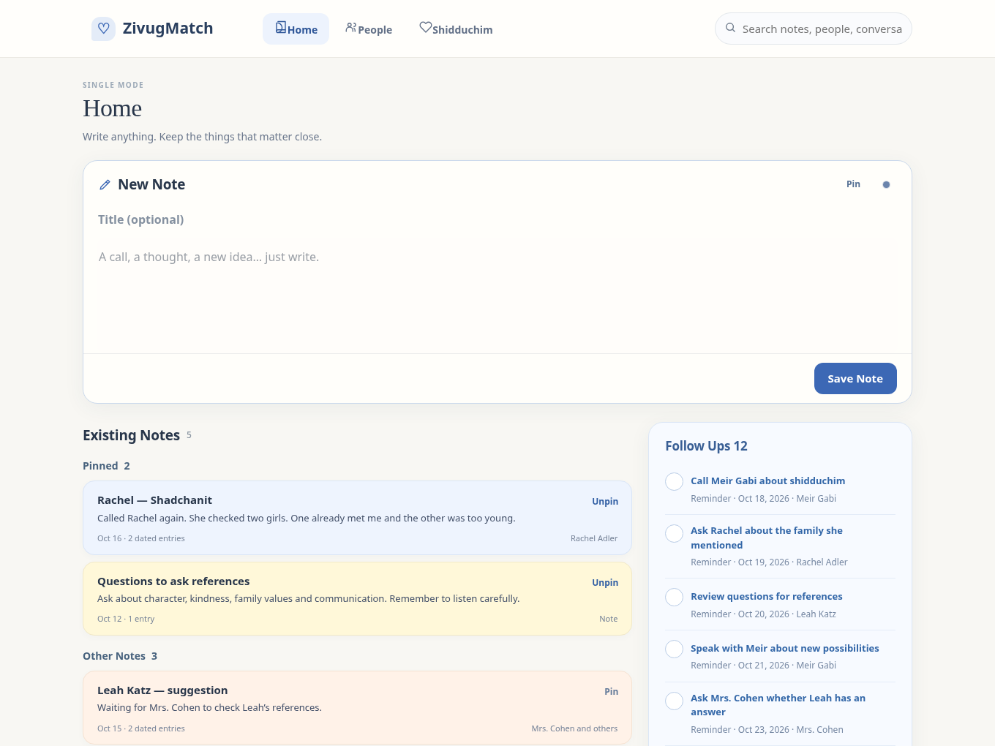
Home v8: New Note above Pinned / Other Notes, Follow Ups on the right, History on Home. The color menu is integrated into Actions.
Version history: v6 captured Shidduchim and Add Person design decisions; v7 adds reviewed Single Mode Home behavior and the integrated note color palette. The live app remains unchanged.

  - CONTACTS / SHADCHANIM

Mobile layouts, organization controls, and navigation choices
Design review addendum · 7 November 2026 · Version 8
This chapter extends the existing v7 master specification. It does not replace the approved Home v8, Shidduchim, Add Person, or Add Shadchan behavior. The companion index.html is an interactive study, not a deployed application.

Decision register
Topic | Decision / status
Desktop Contacts | Maintain the Outlook-style directory on the left and selected person details with conversations on the right. Established direction.
Phone Layout A | Add as a selectable test layout: names top left; quick information top right; full-width activity below. Trial design, not final default.
Other phone layouts | Preserve the previously available list, inbox, side-rail, top-strip options while comparative testing continues.
Pinning | Provide Pin and Unpin; pinned contacts appear in a clearly labeled Pinned section at the top. Requested requirement.
Folders | Optional user-created folders; Move to folder and New folder. Empty accounts have no folders by default. Requested requirement.
Sorting and filtering | Visible Sort and Filters controls above the directory. Filter contact role, city, language, community served, recorded activity and folder. Requested requirement.
Navigation grouping | Compare three destinations with People & ideas inside Shidduchim against four destinations with People & ideas separate. Not finally decided.

CT-01 — Desktop Contacts baseline
- Preserve the familiar Outlook organization: left navigation, central contact directory, right-hand selected record, and visible recent conversations. Do not redesign the desktop merely to accommodate a phone.
- Shadchanim, references, friends and other helpers share one contact record. A person may have several roles simultaneously.
- A suggested person has one stable person record. A passing idea is not a formal offer and must never automatically start a dating process.

CT-02 — Phone Layout A: top-left directory and top-right quick information
- The upper area is divided into two columns of approximately equal width on a phone. Left: independently scrollable shadchan directory. Right: independently scrollable quick information for the selected shadchan.
- The right side includes name, city, contact role, phone, email, spoken languages, communities served, preferred contact method when recorded, last recorded conversation, and brief current status. Missing fields show Not recorded.
- The entire lower portion of the screen belongs to the selected person: follow-ups, latest conversation, linked suggested people, full conversation history, and a quick note/composer action. Avoid duplicating the quick-info fields below.
- Tapping a different name updates both right-hand summary and lower activity, keeping the left directory and its scroll location. Finger movement started in the directory scrolls that list; movement in the quick-info panel scrolls its own contents. Elsewhere, the page scrolls normally.
- A 320 px phone must remain usable without horizontal overflow. At very small heights or large text, the selected summary can have independent scrolling rather than truncate essential contact information.

CT-03 — Alternative phone layouts and settings
- The View control opens the existing layout chooser. Layout A is added as an option; the earlier One list, Names across the top, Inbox, and Names beside messages options stay available for comparison.
- The wider design study may also compare a vertically split layout with a draggable separator and a compact versus regular visual style. These are experiments, not mandatory changes to the live app.
- For the full app, a compact View and Organize area should hold layout and appearance choices. Search, Sort and Filters stay visible on the Contacts page and are not buried in Settings.

CT-04 — Sorting, searching, and filters
- Search by saved name, city, known roles and relevant recorded conversation text; do not treat lack of recorded conversation as proof that the person has never been contacted outside the app.
- Sort choices: recent recorded conversation, oldest recorded conversation, name, city, language and community served. Missing activity sorts after dated records for the recent-first view.
- Filters may be combined: contact role, city, spoken language, community served, activity state (All, Waiting, Follow-up, Pinned), and optional folder. Provide Clear filters and visible selected-state indicators.
- Communities served is distinct from the shadchan’s own religious identity. Supported examples: Chabad, Haredi, Litvish, Bukharian, Sephardi, Breslev, Dati Leumi and user-created categories. A shadchan may work with several groups.
- Community, language and location values must be user supplied or otherwise genuinely recorded; never infer them from a person’s name or background. A filter with no matching contacts gives a clear empty state.

CT-05 — Pinning
- Every contact can be pinned and unpinned. Pinned is a separate directory section at the top; its members retain ordinary sorting within the section.
- Pinning is organization only: it must not imply priority, activity or romantic interest. Changing pin state never duplicates a contact or its conversations.
- Pin/Unpin is accessible in the selected person view without requiring a new screen. The original contact remains searchable when unpinned.

CT-06 — User-created folders
- No folders appear by default. A user may create a folder while moving a contact, choose an existing folder, or return the contact to No folder.
- Display folders only after they exist. Provide Move to folder on the selected contact. A contact moved to a folder remains in All contacts and other applicable filters.
- Folders must not be mistaken for separate person records or shidduch stages. The same conversation and references remain linked regardless of folder.

CT-07 — Conversations, provenance and privacy
- Use the approved universal Home note model: one original note or activity item may appear in linked contexts without duplicate editable copies.
- Record a phone call, WhatsApp conversation, email, or personal note quickly. Communication type can be optional when unknown. A source-specific label means only what was actually recorded.
- Do not silently change Yes/No answers, create an offer, invent a person or infer a shadchan response from note text. Any consequential suggestion requires explicit confirmation.
- Send my profile must never include private conversation history, references, dating feedback or internal reasons. Opening a message composer is not confirmation that a message was sent.

CT-08 — Mobile acceptance scenarios
- Choose Mrs. Cohen, scroll the directory 100 names lower, choose Mrs. Levy, and return without losing the directory location.
- Filter shadchanim by a city and multiple communities served; remove the filter without losing contact records.
- Sort by last recorded conversation and verify a contact without a recorded call is not falsely described as never contacted.
- Pin Mrs. Cohen; verify a labeled Pinned section; unpin and verify the normal sorted position returns.
- Create an optional folder, move a contact to it, filter by the folder and return to All contacts.
- Open the same conversation from a contact or linked saved person without creating two independent notes.
- Check 320, 360, 390 and 430 px widths; verify natural directory scrolling and no horizontal overflow.
- Switch to the previous phone views and desktop; ensure none of the approved flows are silently replaced.

CT-09 — What the supplied HTML implements, and what remains future work
Implemented in the November 7 standalone index.html study: Layout A, prior phone views, role filters, a Sort selector, additional Filters, city/language/community options, Pin and Unpin, optional folder creation and assignment, and quick-info plus full-width activity. These operate on fictional sample data. Layout and some organization preferences can be retained locally in the browser for testing.
Not implemented or not validated for production: a real 200-contact persistent database, account synchronization, live Gmail/WhatsApp integrations, notifications, full folder management and shared backups, real telephone dialing permissions, verified data ingestion, or end-to-end accessibility evaluation. The approved Home and formal Shidduchim prototypes remain authoritative for their own workflows.

CT-10 — Navigation comparison remains open
Arrangement | Where People & ideas lives | Status
Joined: Home, Contacts, Shidduchim | A visible People & ideas view inside Shidduchim, separate from Offers / In Progress / Ended | Research starting preference
Separate: Home, Contacts, People & ideas, Shidduchim | An independently labeled destination with identical linked person records | Alternative to test

No person, offer, trial, history or shidduch may be duplicated or moved merely because the main navigation presentation changes.

Layout A — phone visual reference
Screenshot captured from the standalone HTML at 390 px width with fictional sample contacts. The image is a test reference rather than proof of production readiness.
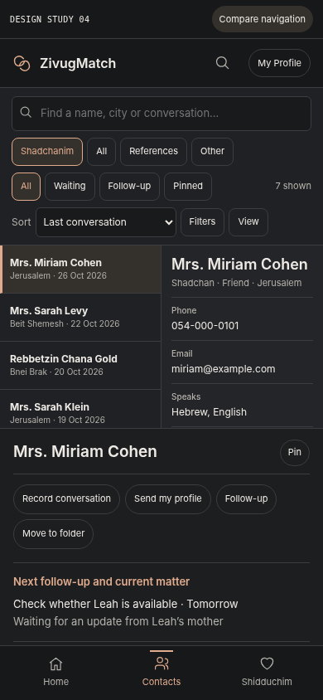
The upper-left directory and upper-right quick information scroll independently. The lower conversation history uses the available page width.

CONTACTS / DESKTOP VISUAL BASELINE
  - CT-11 | Recovered Outlook-inspired appearance | 7 November 2026
This page adds the actual Outlook-inspired desktop reference to the v8 Contacts chapter. The previous document described it but did not contain this screenshot. The reference does not replace the approved desktop experience or the still-experimental phone layouts.

CT-11 — The three visible desktop areas
- Leading navigation: Home, Contacts, Shidduchim and access to People & Ideas, without turning ideas into formal offers.
- Central explorer: searchable and filterable list of named shadchanim, with the selected contact clearly highlighted; Pin and optional folders are organizational actions.
- Large right record: name, details and communications actions, current waiting/follow-up state, linked suggested people and chronological conversation history. Select another contact without leaving this workspace.
- Design principle: preserve the Outlook-style master/detail relationship. On the phone test layouts separately; do not squeeze the desktop columns into an unreadable narrow space.

Outlook-style desktop screenshot (supplied by user)
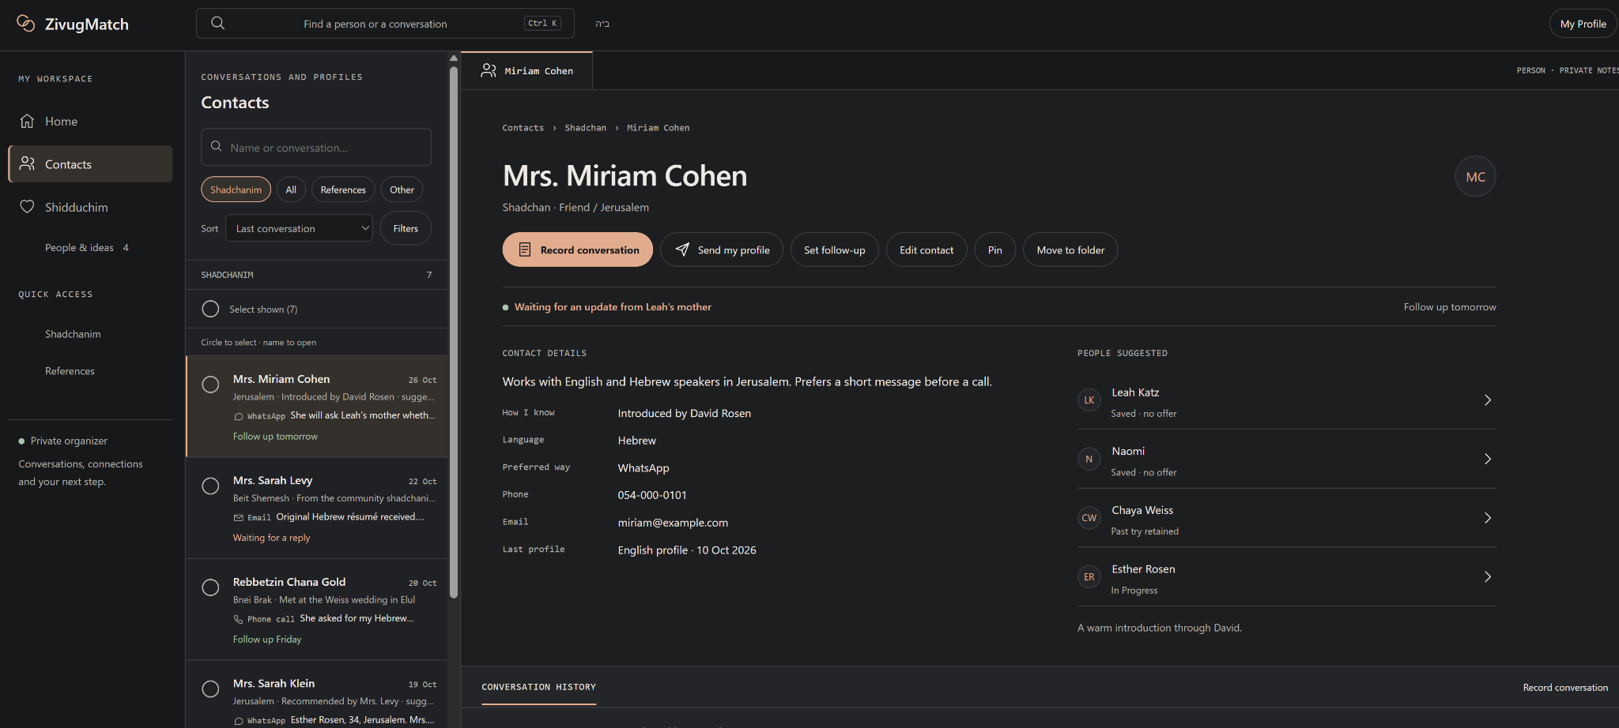
Desktop Contacts screenshot. Design appearance reference, not a claim of production deployment. The actual conversation list continues below the visible record area.
Relationship to the phone experiments: v8 Layout A uses a scrollable directory at the upper left and quick information at the upper right, with conversations below; the alternate split-screen and other phone layouts remain comparative options.

MY PROFILE / DESIGN REFERENCE
  - MP-01 to MP-09 | New master chapter | 7 November 2026
Source status: the supplied desktop and phone screenshots and their HTML exports are visual design references. Their sample identity, facts, phone numbers and messages are demonstration content. The HTML ZIP files explicitly describe the screens as mockups, not production functionality.

MP-01 — My Profile: purpose and navigation
- My Profile is the owner’s shareable personal profile, separate from other people’s records and from private contact notes or shidduch histories.
- The visible three tabs are Profile, Short versions and Notes. They are views of the same owner identity, not different copies of the person.
- The header shows the owner’s name, an EN/language selector, an edit action and a prominent Share action. The desktop uses a left-side subsection navigator; the phone uses stacked, full-width content.
- The screenshots use a restrained, warm light appearance for Profile and Short versions; a dark appearance is also shown for Notes. Treat these as supported visual directions, not proof that theme-switching has been implemented.

MP-02 — Profile tab: the supplied structure
- Top identity summary: name, age, location and occupation, followed by a brief introduction. Each substantial section has a small edit pencil rather than a large editing control panel.
- Facts: religious background, learning, education, height, languages, marital status, family, interests and Kohen are examples in the supplied screenshot, not an exhaustive or mandatory fixed schema. “Add a fact” permits user-defined facts.
- About me and What I’m looking for remain readable free-text sections. “Add section” suggests user-created profile content.
- Contact distinguishes a contact for inquiries from the owner’s own phone and email. The screenshot explicitly distinguishes “shared” from “you choose”; never assume a personal phone or email should be sent by default.
- References and Files appear under an optional “Also yours to include” area; the screenshot indicates that the owner chooses whether to include those items. Do not silently attach files or confidential references.

MP-03 — Desktop and phone reading behavior
- Desktop: a narrow left navigator offers shortcuts into Facts, About me, What I’m looking for, Contact, References and Files, plus the other tabs. Main content is centered and text-led rather than stretched to full monitor width.
- Phone: the same sections appear in one column with generous readable text, light dividers, and accessible editing targets. The phone tab bar offers Profile, Short versions, Notes.
- Preserve the selected language, section and tab when editing; avoid losing drafts or unintentionally sharing the result. Exact save and navigation mechanics still require production decisions.

MP-04 — Outgoing sharing and provenance
- The Share control needs a preview of exactly which text, facts and optional attachments will be sent, and to which recipient. Full and short presentations must reuse the underlying owner profile data.
- A share should not include the private Notes tab, contact histories, references or files unless the user explicitly chooses allowed outgoing material. References shown on a profile can be separate from confidential reference-call notes.
- A Copy action copies text but is not a confirmed send. Opening WhatsApp or email does not prove that the recipient received anything. Save immutable sent snapshots and source/time when a send is explicitly confirmed.

Source-supported status register
Item | What the supplied source shows | Status in this specification
Profile / Short versions / Notes | Three named tabs, consistent person header | Visual design reference
Language selector | EN and language-change affordance | Visual design reference; behavior unverified
Share, Edit, Copy | Visible controls in mockups | Workflow needs implementation/validation
Private notes | “only me” and “nothing on this screen is ever shared” | Strong privacy design intention
Automatic saving | Notes mockup says “saves as you type” | Visual copy; persistence mechanics unverified

MP-05 — Full Profile: desktop visual
The desktop reference uses a left navigation rail and centered reading column. The top row keeps the name, language and Share accessible, while each information section can be edited separately.
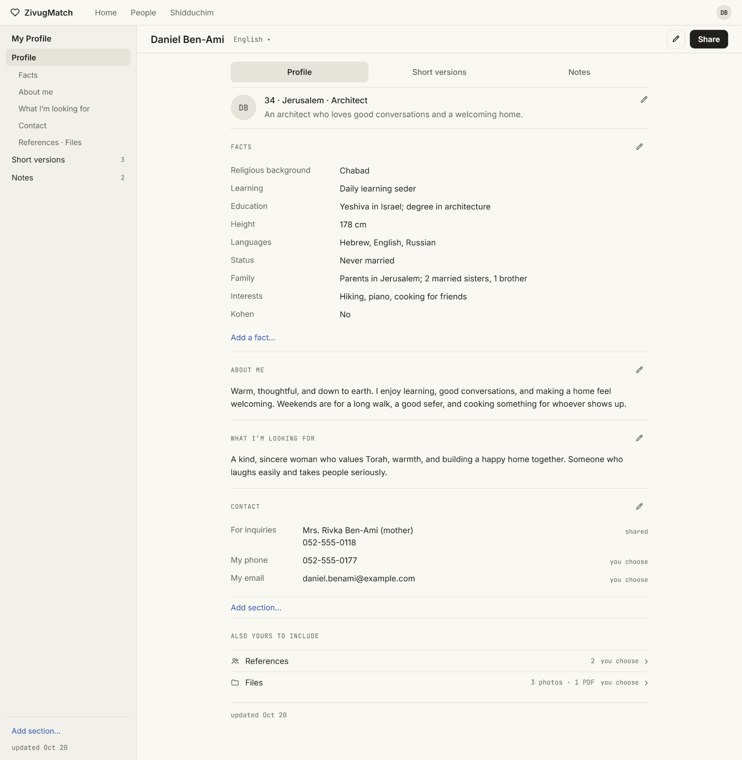
Supplied desktop Profile artboard. The rendered screenshot is a reference; the accompanying HTML export is not production code.

MP-06 — Full Profile: phone visual
The mobile screenshot preserves the same information hierarchy without retaining the desktop left sidebar. It shows the identity summary, Facts, About me, What I’m looking for, Contact, and References/Files.
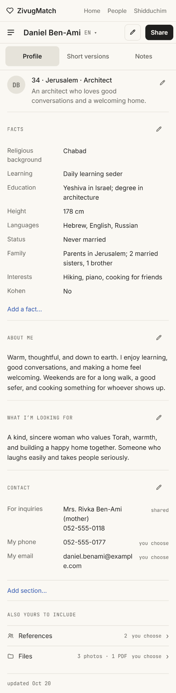
Supplied phone Profile screenshot; full-resolution source is included in the companion reference package.

MP-07 — Short versions: sendable text representations
- The Short versions tab shows at least two kinds of text in the sample: a “Suggested” version described as automatic and always up to date, and a saved recipient-specific version labeled “Mrs. Cohen.”
- Each visible card includes Copy. A menu and edit affordances appear for saved versions. The screenshot also shows “New short version” and an Undo option after a deletion.
- Keep manually saved versions separate from the generated Suggested text. The visual does not establish whether saved versions should update when the owner profile changes; preserve historical sent snapshots either way.
- The exact template settings, which facts are included, language-by-language generation and whether contact-specific versions can be automatically regenerated are open implementation choices.
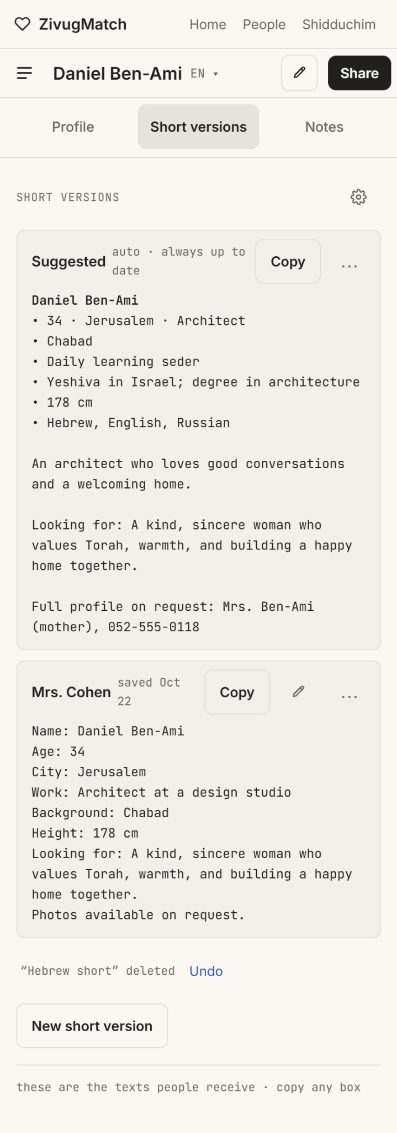
Supplied phone Short versions screenshot. “Suggested” and “Mrs. Cohen” are sample version titles and text, not real outgoing messages.

MP-08 — Private Notes and sharing activity
- The dark phone design shows the Notes tab labeled “only me.” Example notes include a potential reference and a later contact follow-up, with links to other contexts such as References and Home.
- A visible “Write a note...” composer is labeled “saves as you type · linked to you · add people after.” This represents the intended low-friction capture experience; autosave timing and durable storage are not demonstrated by the mockup.
- A separate Sharing Activity area records a previously shared version and the number of shares. Sharing activity is metadata, not a reason to expose notes.
- The explicit privacy boundary shown is “nothing on this screen is ever shared.” Maintain that boundary across Share and Short versions and preserve one underlying note across linked contexts.
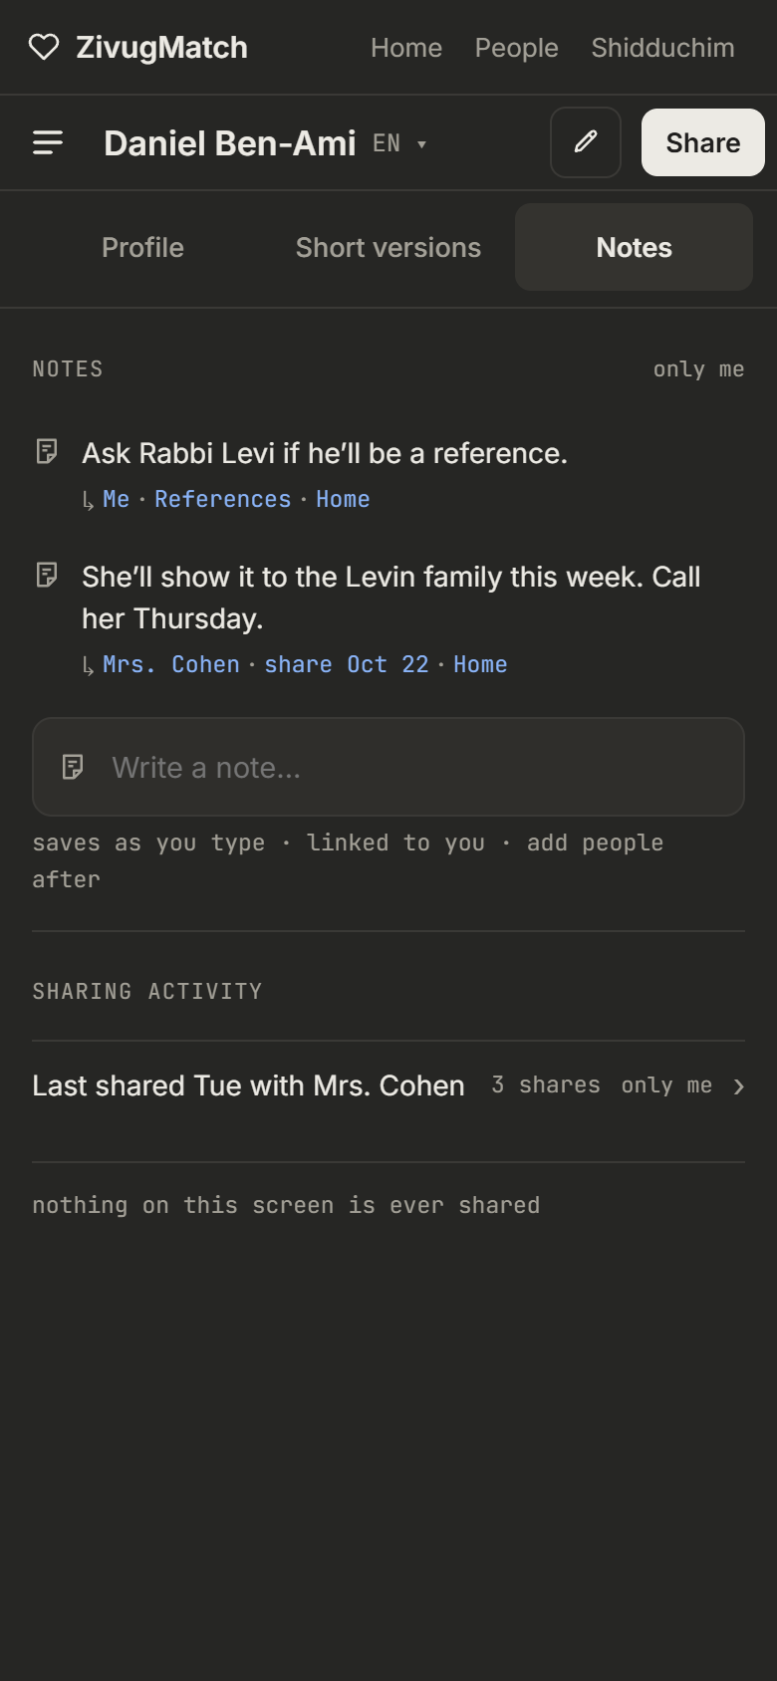
Supplied dark Notes phone screenshot. No corresponding Notes HTML export was supplied in this set.

MP-09 — Source files and outstanding decisions
The original screenshot and HTML ZIP exports are included in the companion archive. They should be retained beside the master specification so a developer can reproduce styling accurately without treating visual mockups as application code.
Source | Role
image(7).png | Outlook-inspired desktop Contacts appearance
Three screens · desktop · Profile@2x.png | Desktop Profile layout and information hierarchy
Three screens · phone · Profile@2x.png | Phone Profile layout and editable sections
Three screens · phone · Short versions@2x.png | Short versions, Copy, New, Undo, Suggested
Three screens · phone · Notes (dark)@2x.png | Private Notes and Sharing Activity visual
Three screens · desktop · Profile-html.zip | Desktop Profile exported visual artboard
Three screens · phone · Profile-html.zip | Phone Profile exported visual artboard
Three screens · phone · Short versions-html.zip | Phone Short versions exported visual artboard

Still to review before treating My Profile as fully approved
- Share dialog: recipient choice, channel choice, attachment/reference inclusion, exact snapshot and confirmation of delivery status.
- Language selection and translation: what is manually translated, generated, or independently saved by language.
- Short version management: whether saved versions are frozen or editable templates, default generation rules, deletion and Undo persistence.
- Notes: true autosave behavior, recovery, related-person linking, and consistency with the approved Home v8 note system.
- Privacy: separate own-contact details, inquiries contact, selected references and optional files; never expose private histories.
- Theme consistency: warm light My Profile, optional dark Notes, and the desktop Contacts dark workspace are separate visual references until a shared theme strategy is chosen.
- Exact UI response of visual-export buttons, whose presence alone does not prove operational behavior.

Version-control note
This v9 specification appends desktop Contacts visual evidence and the My Profile design chapter to v8. It does not deploy the live site, modify the existing application index.html, replace prior approved Shidduchim/Add Person/Home decisions, or approve any untested My Profile functionality automatically.

CT-12 — Narrow-sidebar phone contacts
Additional phone research reference. The left rail stays visible for switching people, while the selected person’s conversation or information uses the remaining width. This is a concept for comparison, not an approved replacement for the top-split Layout A, the vertically split layout or the desktop Outlook design.
- Left contact rail: names or concise previews, a selected-state highlight, independent vertical scrolling, and quick switching without returning to a separate list.
- Right reading area: selected shadchan, relevant actions, recent conversation and note entry; conversation scrolling should not inadvertently scroll the contact list.
- On phones, narrow rails trade readable contact identities for more message width. Test full names, first-name lists and high-density previews at 320, 360, 390 and 430 px.
- Preserve search, Sort, Filters, pinning, optional folders, and the joined/separate People & Ideas navigation choice regardless of the viewing layout.
- Examples below are taken from the ten two-pane mobile layouts comparison. These artboards show appearance and relative geometry, not proven interactive behavior or a production implementation.
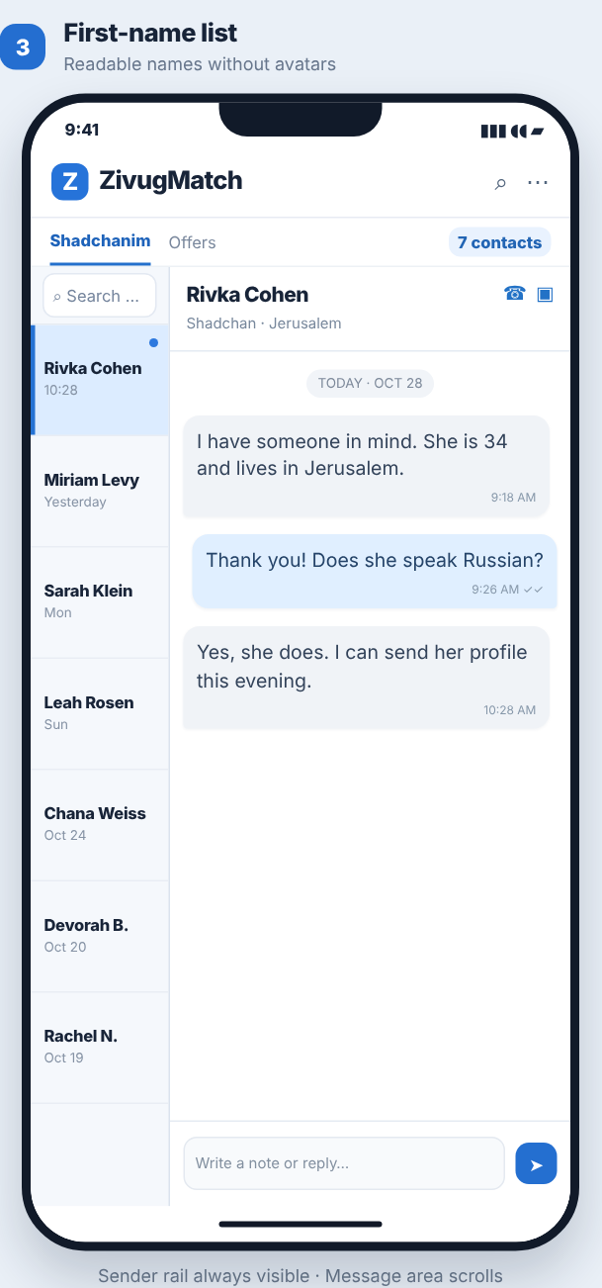  First-name list (concept 3) | 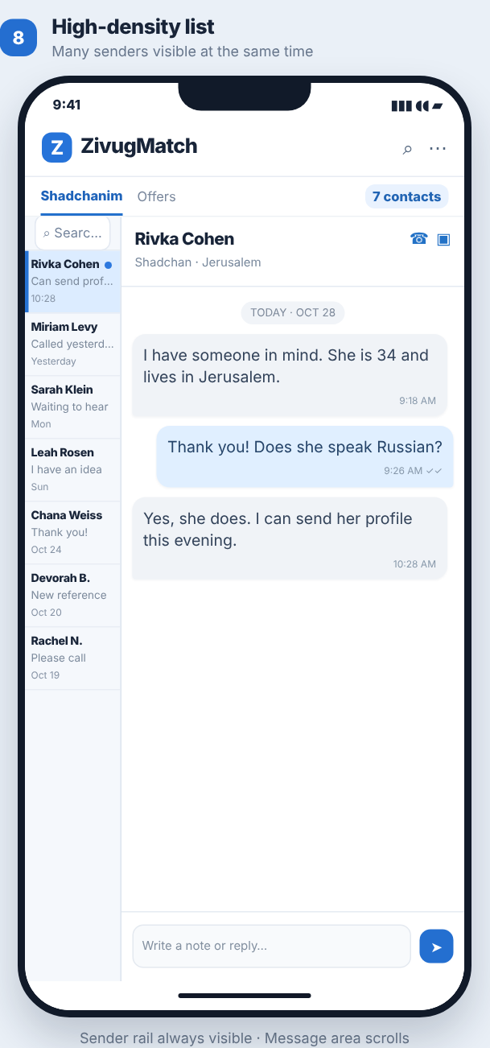  High-density contact rail (concept 8)
Reference files: Mobile_Contacts_Two_Pane_Study/compare.html and Mobile_Contacts_Two_Pane_Study/ZivugMatch_10_Mobile_Two_Pane_Layouts.zip in the companion ZIP. The contact prototype itself remains separate from the full ZivugMatch application.

CT-13 — User-selectable Contacts layouts
APPROVED FEATURE REQUIREMENT · Layout choice belongs to the user. The app should provide an ordinary, findable View control on Contacts, not a hidden study-only option. Choosing another layout must change presentation only; person data, shidduchim, conversation events, privacy boundaries and saved contact organization all remain shared.

Layouts to make selectable on phones
View | How it works
A — Outlook summary at top | Independent contact directory at upper left and selected person quick facts at upper right; full-width conversation and activity below.
B — Top/bottom split | Scrollable contacts across the upper pane, full-width selected-person history below. Both panes scroll independently; user adjusts the split height.
Narrow left sidebar | Compact persistent names on the left and selected conversation on the right. The name rail scrolls independently.
Horizontal name tabs | Names swipe left and right across the top; selected-person content occupies the full reading width.
Expanded list | Contact list remains one column; selecting a person opens their details inline.
Inbox-style drill-down | Contact list, then selected person, then full conversation, with ordinary Back navigation.

View switcher behavior
- A small labeled “View” control belongs near Search, Sort and Filters on mobile Contacts. The selection panel lists each layout with a miniature structural preview, a short explanation, and a visible Current indicator. No large mode-switching toolbar is needed in normal use.
- Switch with one tap and immediately return to Contacts. Do not open a second people database or force a redesign of the other pages.
- Keep the same selected shadchan wherever the destination view supports an open selection; preserve active search, sort, city, language, community, folder, Pin and follow-up filters. Avoid discarding an unfinished note when changing a view.
- Remember the last chosen view on that device and restore it when Contacts reopens. Store this as a presentation preference, not as contact data. Production persistence across devices may be considered separately.
- The user must be free to change the view at any time; none of the six phone views is approved as the permanent default. Mobile selection is independent of the desktop Outlook-style Contacts arrangement.
- Maintain selection highlighting, readable names, keyboard and screen-reader labels, and right-to-left behavior when appropriate. Do not substitute symbols that resemble diagonal crosses or upright plus signs.
- Filtering/sorting, Pinned, optional folders, Record conversation, Send my profile, and the joined/separate People & Ideas navigation setting must be functional regardless of the selected layout. These are data and navigation features, not properties of a particular visual template.
- On 320, 360, 390 and 430 px screens, test selecting people, moving between modes, searching and restoring list position. Test long histories and 200 contacts. When two panes scroll, finger location must determine which region scrolls, with no accidental selection.

Prototype and implementation status
The companion standalone Contacts prototype now offers all six views from its View picker, including the top/bottom split experiment with a saved height control. It uses fictional data and local browser storage for presentation settings. It does not replace the complete live ZivugMatch index or implement a production backend.
Status clarification: ability to switch views is an approved requirement. Individual views, their precise spacing and the default are still under review. The ten-layout comparison board is research; not all ten experimental artboards are promised as production view modes.

  - ZIVUGMATCH / SAVED PERSON CARDS

PC-01 — People & Ideas / Offers reading card
NEW DESIGN REQUIREMENT · The saved-person card should read like My Profile, using the fields and source records already defined by the approved Add Person v3.0 intake. The approved formal Shidduchim experience remains a separate linked process. This is not a request to replace all offer progress bars with the card.
- Identity at top: name, available age, city and occupation, with compact Edit person, Add note and Follow-up actions. Show no fabricated field when information is missing.
- Reading sections: Facts; About the person; What they are looking for; Contacts and Source; original résumé and attachments. Use the same airy text, dividers and section-level organization as My Profile.
- Fields originate in the approved Add Person sections: About and Looking For, Personal Info, Contacts and Source, How well do I know them, Status, Religious, Character and Lifestyle, and Attached items. Hidden or custom fields keep their existing saved values.
- Display contact ownership correctly. A number supplied by a mother, father, reference or shadchan is not a direct number for the proposed person. Preserve original profile text and versions unchanged.
- Interest and Offers is a separate reading tab or section: My interest, the other person’s reported response, who reported it, private reasons and dated revisions. No automatic creation or ending of an offer from a note.
- A formal offer, active try or ended try is linked to the preserved Shidduchim record. The card may show a short status and open that record, but must not duplicate or independently edit formal dates, answers or stage history.
- The person record remains unique even when several shadchanim suggest the same person. Each source retains its relationship. Suggested-person cards must be findable through the source shadchan and People and Ideas search.
- On mobile, show a single readable profile column; on desktop, reuse the original Claude My Profile structure. New skin treatments are not part of the current HTML prototypes.

PC-02 — Prototype behavior and scope
Companion file: Shadchanim Offers.html. This is a standalone saved-person / Offers card derived from the exact original Claude Profile HTML and Add Person v3.0 fields. Its tabs are Profile, Offers and Notes, and it does not replace the live Shidduchim, Contacts or Home application. The Contacts layout experiment is a separate file.

User interface preview — saved person
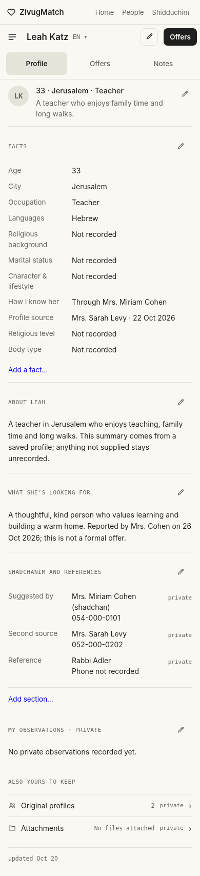
Corrected prototype: Claude Profile page structure with saved Add Person facts, and separate Offers and Notes tabs. Fictional example.

  - ZIVUGMATCH / ORIGINAL APPEARANCE REFERENCES

TH-01 — Visual references only in this package
The existing ZivugMatch site has an appearance menu, including colors/skins and Compact, Standard and Roomy density modes. Those are future app-wide integration requirements, not functionality recreated in these HTML files. Preserve the original Claude Profile without recoloring or stylistic alterations.

TH-02 — Appearance and density remain separate future settings
Setting | Choices | Meaning
Visual style | Minimal / Claude-like; ZivugMatch / soft cards | Flat, compact professional reading vs. warmer rounded, more spacious component styling.
Density | Compact; Standard; Roomy | Adjust row heights, spacing, panel padding and information density; do not remove essential actions.
Skin / theme | Classic, Game, Dark, Frosted Glass, Boys, Girls, Cartoon, High Contrast, Neon, Ocean, Sunset | Use the existing live-site skin names and semantics.
Contacts layout | Six user-switchable phone layouts retained from CT-13 | A separate presentation preference. No influence on themes or record content.

TH-03 — Original Game and Neon designs
Keep the user-provided original screenshots as the authority for Game and Neon. The settings screenshot lists Classic, Game, Dark, Frosted Glass, Boys, Girls, Cartoon, High Contrast, Neon, Ocean and Sunset. No new interpretations, recoloring, themes or CSS are approved here.
- Game and Neon are separate existing styles. Reproduce their actual appearance only after the user reviews the original screenshots and the main page designs are settled.
- Compact, Standard and Roomy are spacing choices, not separate data models. The compact Claude Profile layout is an approved visual reference, not an assistant-built replacement skin.
- The current final package intentionally contains no functioning theme playground. This chapter preserves only a requirement for possible later work and a screenshot of the original settings interface.
- A later unified appearance system, if built, should apply consistently across all pages without changing records, contacts, offers, profile content, notes, or history.
- A future implementation must preserve readable contrast, touch sizing, keyboard navigation, RTL support and reduced motion preferences.
- Any future theme or density preference must be saved independently of data and must not alter a person selection, conversation, filters or form values.
- No additional permanent theme toolbar is part of the present Contacts or Offers prototypes.

TH-04 — No new appearance default selected
The supplied Claude My Profile remains in its original light appearance. Game and Neon are shown only as original screenshot references. A new unified theme implementation and its defaults have not been approved.

TH-05 — Original screenshot reference
The image below is the user-supplied screenshot of the existing ZivugMatch settings menu. It is not an image of the assistant-created themes. Additional Neon and Game screenshots shared in the conversation are design references; this package does not recreate them.
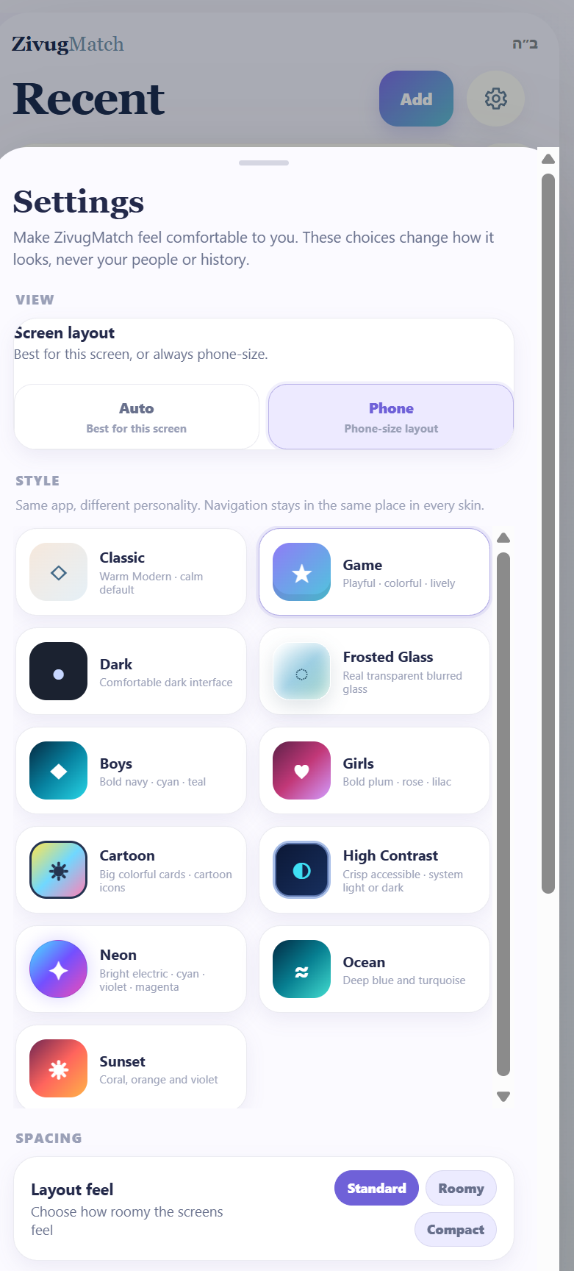
Original settings screenshot: theme choices and Compact / Standard / Roomy density. Reference only; no interactive theme demo in this package.

TH-06 — Later implementation checklist
- Finalize Home, My Profile, Contacts, saved person / Offers and formal Shidduchim page structure first. Any later appearance development must use original user references, not speculative theme recreations.
- When a real unified theme system is implemented, test at 320, 360, 390 and 430 px plus desktop for clipping, overflow and readability.
- Test a future appearance switch with an open person, long conversation, active filters, and unsaved notes; switching must not lose user data or context.
- Do not convey offer status through color alone. Preserve accessible controls and full Hebrew/right-to-left compatibility.
- No live theme settings or theme storage are implemented in this delivered prototype package.

TH-07 — Package reference
File | Role
ZivugMatch_Master_Design_Specification_v10_2026-11-07.docx | Latest consolidated working master; preserves earlier approved chapters and adds PC and TH chapters.
ZivugMatch_My_Profile_Study_v10.html | Standalone Profile / Short versions / private Notes design study with working local interactions and theme controls.
ZivugMatch_Contacts_Offers_Study_v10.html | Standalone desktop Contacts study and six selectable phone layouts; includes new saved-person reading cards.
ZivugMatch_Add_Person_Prototype_v3_0.html | Original Add Person intake reference; use fields and provenance, not a new database.
Original screenshot references and HTML artboards | Visual baseline for My Profile and Outlook Contacts; retained in companion ZIP.
Theme screenshots.html displays original screenshots only. It contains no color-switching controls. My Profile and Offers use Claude’s original warm light visual design.

FINAL-01 — Build and review checklist
- All five companion deliverables open independently on phone and desktop and use fictional example people only.
- The Offers card renders fields defined in the approved Add Person intake. Missing facts are not silently completed. A saved name is not automatically a formal offer.
- The My Profile Share action may prepare or copy an approved profile; private notes, unrelated contacts and recorded feedback must never leak into shared content.
- A contact can be pinned or moved to an optional folder without duplicating the person. Search, Sort, Filters and the selected person survive Contacts layout changes in the production implementation.
- Theme / density choices adjust visuals only and do not mutate people, shidduchim, notes, contact relationships or history.
- Run touch and keyboard checks at 320, 360, 390 and 430 px; test long Hebrew text, right-to-left layout and accessibility.
- Keep Home v8 and the approved Shidduchim / Add Person prototypes intact until a deliberate integration into the actual ZivugMatch application.

FINAL-02 — Companion HTML status
The delivered HTML files are standalone design references, not a synchronized production application. The original Claude My Profile exports are preserved byte-for-byte. The Offers prototype has fictional Add Person data and its own local demo behavior; it is not the live data store. Contacts layouts is a separate comparison prototype. No new theme system is provided.

FINAL-03 — Design source priority
When references disagree: preserve the latest explicitly approved functional behavior, then use the latest named design reference for appearance. Proposed improvements are not automatically approvals. Keep historical originals and change records accessible, and require an explicit review before replacing the approved source screens.

FINAL-04 — Offers profile: visual match to My Profile
Confirmed design direction · 7 November 2026
The saved person / Offers card is a person profile, not a second CRM interface. It must have the same visual arrangement as My Profile.html. The content comes from the existing Add Person prototype and its underlying record; the current prototype uses fictional examples.
- Use the same narrow reading column, compact name bar, three equal profile tabs, avatar and summary row, section dividers, label/value facts grid, and restrained inline edit controls as My Profile.
- Tabs are Profile, Offers, and Notes. The top-level Profile tab reads like My Profile, whereas Offers holds relationship decisions and formal offer links, and Notes holds private observations and conversations.
- Populate facts and sections from ZivugMatch_Add_Person_Prototype_v3_0: name, age, city, occupation, languages, religious level and background, family status, character and lifestyle, body type, familiarity, description, what the person is looking for, contacts, references, sources, originals and attachments.
- Show only recorded facts and preserve missing values as unknown. Never infer a private attribute from the name, city, shadchan or community served.
- Editing should open the existing three-tab Add Person intake (Paste, Basic Info, Detailed Info), preserving originals and source attribution. Use the same underlying person record across Contacts, People and Ideas, and formal Shidduchim.
- Offers distinguishes preliminary interest from a formal offer. A saved person must never enter the formal stages automatically; previous attempts, ending reasons and date history remain intact.
- Keep private impressions, notes, interest reasons and conversation history separate from outgoing My Profile content. Themes and density are presentation preferences only.
- The desktop Outlook-style Contacts interface is preserved independently; it is not the visual template for the Offers person card.

Visual references — same structure, different person data
Left: supplied My Profile reference. Right: updated Offers profile using fields from Add Person. Both use the same restrained reading layout; the Offers page has its own tabs for preliminary interest and private notes.
My Profile · reference | Offers / saved person · updated
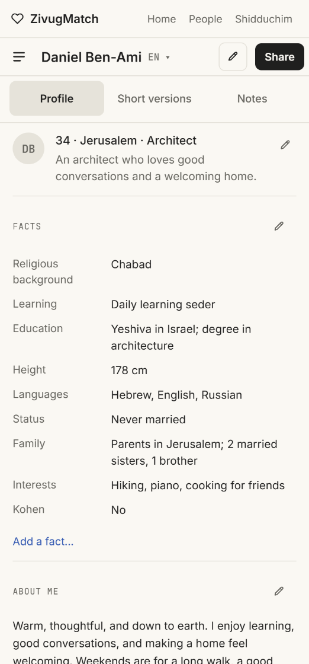 | 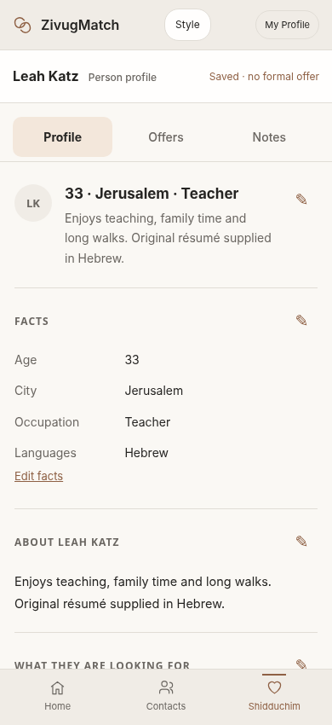

FINAL-05 — Source of truth: original Claude My Profile
Design correction and approved source priority · 7 November 2026
The exact user-provided Claude Profile HTML exports are the visual source of truth. Earlier assistant-built My Profile.html designs were an unintended redesign and must not be treated as the approved reference. Retain the supplied Profile phone, Profile desktop and Short versions artboards together with their support.js and vendor files. The dark Notes screenshot is an additional design reference, not a replacement for the approved light Profile artboard.

Offers person card — copy the Claude profile language
- Use the same white/ivory background, subdued grey section dividers, narrow facts rows, typography, name bar, compact three-tab navigation, inline edit pencils and reading rhythm as the original Claude Profile export.
- The person card has Profile, Offers and Notes tabs. Profile is the same visual template as My Profile, but reads saved Add Person fields; Offers contains my interest, her reported response, formal-offer status and any past tries; Notes contains private recorded contacts, conversation entries and reminders.
- Use the single existing Add Person person record and retain sources, pasted originals, attachments, contacts and references. Unknown fields remain Not recorded, not inferred or filled automatically.
- The prototype supplies a fictional person to demonstrate field mapping. A saved person or suggested idea does not become a formal offer automatically.
- The user’s Claude HTML is preserved byte-for-byte; the companion Shadchanim Offers.html is a derived mockup. Editing in the full app should invoke the approved Add Person form rather than maintain a second data model.

Appearance — screenshots only at this stage
Remove all assistant-created theme demonstrations from this package. Retain only the screenshot of the user’s existing ZivugMatch appearance menu, which shows their available skins and the Compact / Standard / Roomy density modes. This image documents a later integration requirement; do not claim that any reproduced skins or theme controls are implemented in these prototype HTML files. Do not recolor or restyle the original Claude My Profile to demonstrate themes.

Correction visual reference — supplied Claude source
The screenshot below is from the original Claude design. It is the required look and visual hierarchy for Offers person cards, with the content swapped to Add Person data.
Theme appearance is referenced only by the user-supplied screenshot below, not by a new design.

V11 — Claude Code build handoff for Single Mode
  - Status: implementation instructions and acceptance contract. This chapter complements the approved design history above; when old exploratory language conflicts with this section, use the latest explicitly approved behavior and this implementation scope.

A. Non-negotiable source and scope rules
Target: a single locally testable Single Mode app with actual navigation, editing and persistent shared data. Create it in an isolated development folder or branch. Do not overwrite a live Stable deployment. Inspect the real repository before choosing a framework or storage architecture; keep existing technology wherever reasonable.
The user-supplied Claude My Profile.html, its desktop and short-version artboards, and support.js and vendor files are immutable visual source references. Never replace or restyle these source files. Build working components from them; do not claim that the static export itself implements editing.
For the first coherent implementation, all new pages should match Claude’s minimalist style and reading rhythm. User-approved Home v8, Shidduchim v7 and Add Person v3.0 remain behavioral and structure references; their original HTML must remain unchanged.
Only Single Mode is included. The single user may organize shadchanim, suggested people, offers and their own shidduch history. The separate professional Shadchan Mode, including multi-client matching operations, is a future project.
Build no second visual system now. Preserve a clear future note: all pages should eventually support two complete visual designs, Claude minimalist and warmer ChatGPT/ZivugMatch, with Compact, Standard and Roomy spacing. Game and Neon are only screenshot references, not requested implementations in this phase.

B. Page and navigation inventory
Area | Implementation contract
Home | Use Home_v8_APPROVED.html. Real note intake, inline note editing, history, follow-up tasks, note links, and shortcuts into the same contact and person records.
Contacts / Shadchanim | Desktop Outlook-style navigator and mobile selectable views. View selection, search, sort, multiple filters, pinned group, optional folders, conversation log, linked people and profile sharing must work.
People and Ideas / Offers | Use Profile card visual structure from the original Claude My Profile, but populate from Add Person. Profile, Offers, Notes tabs. Preserve private interest and reported response separately. A saved idea is not a formal shidduch offer.
Shidduchim | Use Shidduchim_v7_APPROVED.html. Offers, In Progress and Ended lanes; 11 milestone positions; Overview, Dates, History and People. Date status and repeated tries remain separate.
My Profile | Retain original Claude appearance: Profile, Short versions, Notes. Editable facts and sections, safe sharing, language selection and protected private notes.
Add Person | Use Add_Person_v3_APPROVED.html. Paste, Basic Info and Detailed Info, preserving source text, contacts, references, custom attributes and attachments.
Add Shadchan | Use the approved Add Shadchan one-screen flow, linked to the Contacts entity rather than a duplicate contact.
Settings | Expose Contacts layout picker, sorting defaults and navigation comparison where appropriate; defer second appearance system to future notes.
Navigation is still being compared: either Home / Contacts / Shidduchim with People and Ideas inside Shidduchim, or Home / Contacts / People and Ideas / Shidduchim. Prototype may offer a user-selectable navigation arrangement, without changing data.

C. Single source of truth: records and relationships
A shared person record must be the canonical source for person profiles; a shared contact record must be the canonical source for shadchanim and references. A contact may hold more than one role. Do not copy contacts or person profiles into page-specific lists.
Recommended conceptual entities: UserProfile, Person, Contact, ContactRole, ContactGroup, Folder, ContactFolderMembership, Pin, Note, ConversationEvent, FollowUp, SuggestionSource, PreliminaryInterest, FormalOffer, ShidduchTry, StageEvent, DateEvent, ProfileVersion, ShareSnapshot and Attachment. Exact storage schema may follow the existing app conventions.
One recorded conversation or note may link to several people and may appear from Home, the relevant shadchan contact and a suggested person profile. It remains one record with one identifier, not separately copied rows. Edits propagate to every linked view; links and provenance remain visible.
Record exact stated facts with source, timestamp, and owner where known. Separate a shadchan’s personal background from the communities the shadchan works with. Unknown is unknown. Do not infer identities, status, dates, contact history or religious background from a name or city.
A person can be a saved idea with no offer. Only the explicit offer process creates a formal offer. It advances to In Progress only after both parties have affirmatively responded Yes. A recorded date becomes completed only if it actually happened. An ended try remains preserved; a new attempt creates a separate try with its own 11-stage bar.

D. End-to-end workflow acceptance requirements
- Create a shadchan from the Add Shadchan screen; find the same contact in Contacts; set city, spoken languages, groups served and last contact; pin it and place it in an optional folder. The contact appears once everywhere.
- Browse at least 200 realistic fictional shadchan contacts. Sort by name, city, last recorded interaction, language and community. Filter by city, languages, groups served, Waiting, Follow-up, active status, and folders. Filters may combine and are resettable.
- Switch among Contacts mobile layouts without losing the selected contact, current search or filters, and when practical the contact directory scroll position. The top-left directory and top-right quick-info layout, narrow-sidebar view, top/bottom independent-scroll view, horizontal tabs and inbox variants remain selectable.
- Record a call or message once, link it to a shadchan and a suggested person, and see that same record in both histories and Home. Editing it anywhere updates all linked views.
- Enter a suggested person through Add Person Paste / Basic / Detailed. Keep original pasted profile, claimed source, language, phone ownership, custom fields, attachments, and the earliest version. Show that person in Offers using the Claude Profile look, not an Outlook CRM card.
- Record my private interest and the other person’s reported response separately, including the reason, who reported it and when. Changing an interest does not automatically start, end or reopen a formal shidduch.
- Convert a genuine offer into In Progress only after explicit Yes from both sides; record stage transitions, date outcomes and private feedback. End it with reason and attribution. Try again opens a new numbered try and preserves all older history.
- Edit My Profile facts, About Me, What I am looking for, inquiries and references. Switch its Profile, Short versions and Notes tabs. A short version can be copied, edited or saved with a timestamp. Private notes never enter outgoing content.
- Prepare a shareable My Profile snapshot, preview exactly what is shared, copy or open an external channel with explicit user action, then record sent status only after user confirmation. A share log must not imply delivery or read confirmation.
- Reload and reopen the prototype: edits, notes, contacts, folders, pinned state, layout choice and histories remain. Export and import local demo data or give a well-documented reset path.

E. Architecture, persistence, validation and privacy
Inspect the app’s actual source, package manager, routing and deployment before choosing implementation details. Maintain a consistent component tree with a shared record store, centralized actions and validation. Do not create isolated mini-apps that only look connected.
For a standalone local prototype, implement durable browser persistence using an appropriate existing store or IndexedDB; store small presentation preferences separately if useful. Version the data shape and provide a safe migration strategy. Use seeded fictional people only. Do not substitute real user records without an explicit import decision.
Use stable opaque identifiers and explicit relationship tables. Keep display strings, status and language separate from keys. Offer duplicate detection before creating a new person, and provide undo for merges or ending an offer when possible.
Sharing must be allowlisted: include only expressly approved profile fields and selected attachments. Never leak conversation notes, private impressions, reference notes, another person’s data or shadchan history into outgoing content. Do not claim that a WhatsApp or email was delivered unless a supported source confirms it.
All buttons in the prototype must either perform their named action or clearly state that the feature is deferred; no silent placeholders. Handle empty data, source conflicts, long text, Hebrew and right-to-left content. Touch targets, focus, keyboard controls and color contrast require basic accessibility checks.

F. Practical build stages for Claude Code
Area | Implementation contract
Stage 0 — inspect | Read the references and real repository, inventory existing features, establish a safe branch and local build. Report conflicts and preserve approved source files.
Stage 1 — data foundation | Define canonical records, relationships, events and persistence. Add fictional seed data and working save, edit, reload, export and import.
Stage 2 — core page wiring | Integrate Home, My Profile, Contacts, People and Ideas, Shidduchim and Add Person into one navigation system. Connect actions to the same records.
Stage 3 — full workflows | Make add, edit, filter, pin, folder, follow-up, note, share, interest, offer, date and ending/retry actions work end to end.
Stage 4 — verify | Run automated checks and practical phone / desktop walkthroughs. Fix regressions and deliver a build with instructions and a known-gaps list.
Later — not in this handoff | Develop second warm ChatGPT/ZivugMatch app-wide design alongside Claude minimalist, then user-selectable density modes. Keep Game and Neon as screenshot-only references for later exploration.

G. Verification and completion gates
Test 320, 360, 390 and 430 pixel phone widths plus desktop. Check no horizontal page overflow; independent scrolling in Contacts; sticky and safe-height behaviors; visible actions and readable facts; keyboard tab navigation; Hebrew/right-to-left text; long names and conversations; a 200-contact directory; persistent state after refresh; and share-content privacy.
A page is not finished because a screenshot looks good. The prototype is complete only when the navigation works, data is shared, records persist, and acceptance workflows pass without fake confirmations. Maintain a PASS / FAIL matrix and a short list of defects and deferred work.
Do not deploy to the live site without explicit instruction. Deliver a buildable local project with README, clear run commands, test commands, screenshots of validated pages, and concise change notes. Preserve the original Claude Profile HTML artifacts unchanged in the references directory.

H. Future visual system — notes only, not current implementation
Future requirement as requested: ALL pages must eventually offer at least TWO coherent design systems: (1) the original Claude minimalist visual style, grounded in the exact user-supplied My Profile files, and (2) the warmer ChatGPT/ZivugMatch visual style grounded in the approved Home v8, Shidduchim v7 and Add Person v3.0 prototypes. This is a product-design note, NOT an instruction to build the second design in this phase.
At that later stage, ensure My Profile also has a warmer variant while the original Claude version remains untouched as its visual baseline. Keep theme choice separate from spacing choices Compact, Standard and Roomy; presentational changes must never mutate records, navigation history or drafts. The Game and Neon examples and original appearance-menu screenshot are illustrative references only. Do not create speculative theme recreations now.
Status: recorded for future phase. No second app-wide skin, no Game/Neon recreated screens, and no theme picker are requested for the current Single Mode working prototype.

