不同饱和度下生长的KDP晶体结构应力的研究

Study on the Structural Stress of KDP Crystals Grown at Different Saturations

王帅1，王圣来1*，刘慧1，李祥琳1，李滟鸿1，吴天赐1，王开宇1，代晓阳1，张太新1，张力元2

1.山东大学晶体材料国家重点实验室，济南250100，2.浙江大学材料学院，杭州310000

Shuai Wang1, Shenglai Wang1*, Hui Liu1, Xianglin Li1, Yanhong Li1, Tianci Wu1, Kaiyu Wang1, Xiaoyang Dai1, Taixin Zhang1, Liyuan Zhang2

1. State Key Laboratory of Crystal Materials, Shandong University, Jinan 250100, 2. School of Materials, Zhejiang University, Hangzhou 310000

Abstract

This paper studies the relationship between the fringe spacing and the structural stress of the KDP crystal in wide-angle conoscopic interference based on the elasto-optical effect, and uses its conclusion to study the relationship between the shear stress and the supersaturation of the KDP crystal growth. Experiments have found that the overall structural stress of the KDP crystal is positively correlated with the supersaturation of its growth, and the shear stress distribution on crystals shows a concentrated phenomenon at the boundaries of the growth zone.

1.Introduction

and its isomer are the only nonlinear crystals that can be used as electro-optical switches and frequency converters in inertial confinement fusion (ICF) systems due to their special properties [1-3]. Since traditional growth methods require 1-2 years to grow KDP-type crystals of the size required for ICF systems, a rapid growth method was developed [4, 5]. However, during the rapid growth of KDP crystals, structural stress will inevitably be generated [6-8]. This kind of stress will not disappear with the end of crystal growth [9, 10] and restricts practical applications of KDP crystals. Such as reducing the extinction ratio of electro-optical switch and the frequency doubling efficiency when used as a frequency converters device. Therefore, precise measurement of the structural stress and its distribution in KDP crystals is crucial for directing the practical growth of KDP and evaluating its optical quality for suitability in ICF systems.

In previous studies on crystal structure stress. Generally, the displacement of the diffraction peak in X-ray diffraction and neutron diffraction is used to determine the stress of the crystal structure [11-13]. However, the penetration depth of X-ray diffraction into crystals is limited [14], and the surface flatness of the bulk crystal to be tested has a great influence on the test results, so it is difficult to obtain quantitative results about the local structural stress and structural stress distribution of the crystal.

In experiments, the elasto-optical effect can be used to obtain information on the local structural stress and stress distribution inside the crystal [15-17]. For optically isotropic materials, such as transparent amorphous materials and isometric system crystals, the optical phase delay phenomenon caused by the stress birefringence effect can be used in experiments, and a combination of polarizers can be used to directly observe the magnitude of structural stress. and the distribution of structural stress [18-20]. However, for crystals low-level symmetry crystal systems such as trigonal, tetragonal, and hexagonal crystal systems, the birefringence caused by the optical anisotropy of the crystal itself prevents the polarizer from directly observing the crystal stress information [21].

Therefore, this paper starts from the perspective of the elasto-optical effect of KDP crystal and obtains a method for measuring the structural stress of uniaxial KDP crystal by analyzing the relationship between crystal shear stress and fringes spacing in wide-angle conoscopic interference. And uses its conclusion to investigate the magnitude and distribution of structural stress in KDP crystals grown at different degrees of supersaturation.

2. Experiment

2.1 Sample preparation

Six KDP crystals were grown from aqueous solution using a rapid growth method. The crystals grow in a "forward-stop-reverse" mode at the same saturation point (60 degrees Celsius) and different degrees of supersaturation. The supersaturation of growth are A1:0.04, A2:0.06, A3:0.08, A4:0.10, A5:0.12, A6:0.14. The crystals were all in a good crystalline state, with no macroscopic defects detected. Figure 1 shows the cutting diagram of the Z-direction slice of the KDP crystals, in which the orange part is the part used for actual testing. Appendix Figure 6 is a picture of the unprocessed KDP crystal sample A1-A6. The dimensions of the KDP crystal after cutting are A1: 4.0cm×3.5cm×1.0cm, A2: 3.8cm×4.2cm×1.0cm, A3: 4.0cm×4.0cm×1.0cm, A4: 4.5cm×4.4cm×1.0cm , A5: 4.4cm×3.8cm×1.0cm, A6: 4.6cm×4.3cm×1.0cm crystal slices. The (001) crystal surface of samples A1-A6 has been precision polished, with a polishing accuracy of 0-0.3.

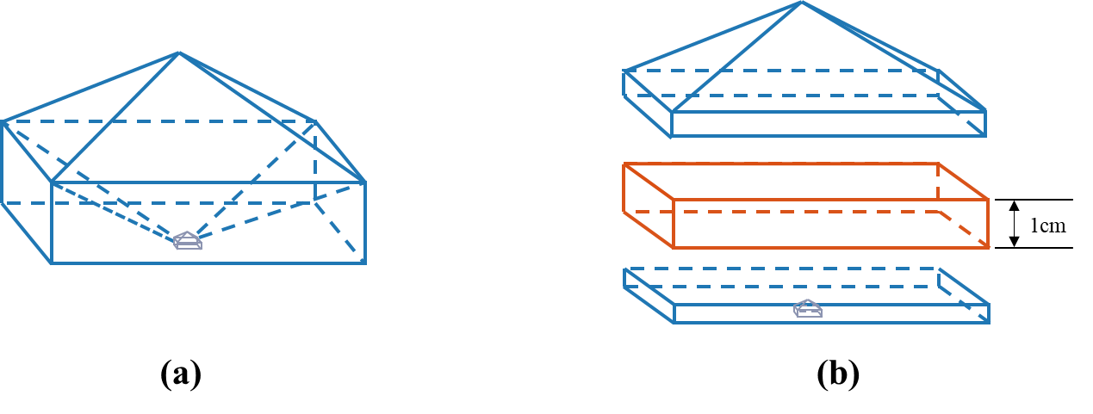

图1(a)晶体样品切割前(b)晶体样品切割后

Figure 1 (a) the crystal sample before cutting (b) the crystal sample after cutting

2.2 切应力和干涉条纹间距之间的关系

以往的研究表明，在广角锥光干涉图中单轴晶体在光轴方向上的正交偏振干涉图样与晶体所处应力状态有关[22]，在施加载荷的情况下，光学单轴晶会畸变为光学双轴晶，相应的锥光干涉的十字条纹会畸变为双曲线。如图2(a)所示，由于在双光轴晶体的干涉图中双曲线的两个顶点分别代表着光轴的露头点[23]。因此，利用双曲线顶点之间的距离的一半除以光屏到透镜焦平面的距离L就可以得到离开晶体后的光束与晶体Z轴之间夹角的正切值：

2.2 Relationship between shear stress and interference fringe spacing

Previous studies have shown that when wide-angle conoscopic light goes in the optical axis direction, the orthogonal polarization interference pattern of the uniaxial crystal is related to the stress state of the crystal [22]. When a load is applied, the conoscopic interference pattern of optical uniaxial crystal will be distorted.

For optical biaxial crystals, the corresponding orthogonal polarization interference pattern of conoscopic light is naturally hyperbolas, As shown in Figure 2(a). Since the two vertices of the hyperbola in the interference pattern of the optical biaxial crystals respectively represent the melatopes of the optical axis [23]. Therefore, by dividing half of the distance between the hyperbola vertices by the distance L from the light screen to the focal plane of the lens, we can get the tangent of the which is the angle between the light beam after leaving the crystal and the Z-axis of the crystal:

由图2中可以看出：角和晶体光轴倾角存在这样的关系：

It can be seen from Figure 2(b) that there is such a relationship between the angle and the acute angle of two crystal optical axes:

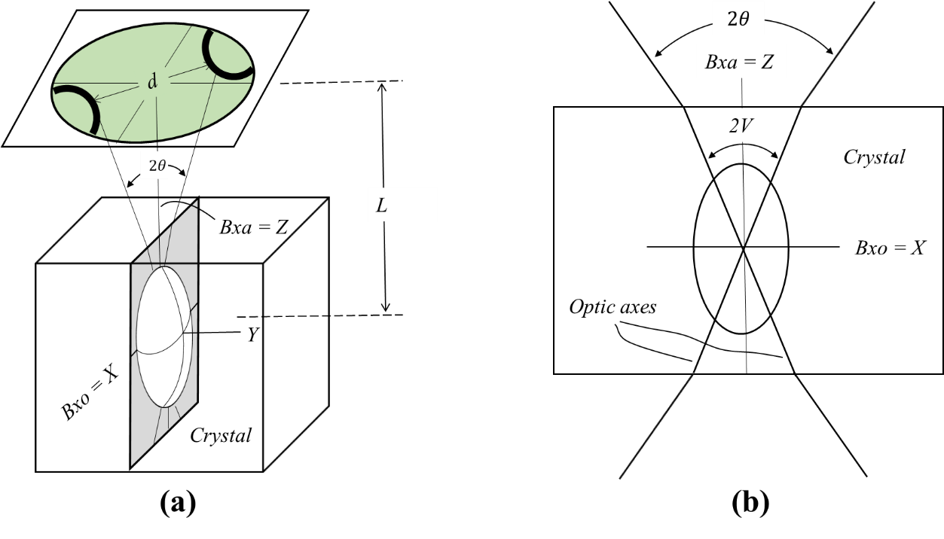

图2双轴晶体的锥光光路图

(a)整体光路图 (b)光轴面内光路图

Figure 2 Conoscopic optical path diagram of biaxial crystal

(a) Overall optical path diagram (b) Optical axis in-plane optical path diagram

Bxa is Acute Bisectricx of optical axes Bxo is obtuse Bisectricx of optical axes

其中和分别为光沿着晶体光轴方向传播的折射率和在空气中传播的折射率，考虑到，

而且由单光轴晶体畸变为双光轴晶体的光轴倾角很小，可以利用等价无穷小得到：

where and are the refractive index of light propagating along the optical axis of the crystal and the refractive index of light propagating in the air respectively. Considering , and the distortion of the crystal from single optical axis to double, when is very small, by using the infinitesimal equivalent :

(2)与(1)联立得到：

combing (2) and (1) we get:

在晶体光学中，双光轴晶体的光轴倾角由晶体的折射率椭球决定，光轴倾角和介电隔离率的关系可以由解析几何得到[24]：

In crystal optics, the optical axis angle V of optical biaxial crystals is determined by the refractive index ellipsoid of the crystals. The relationship between the optical axis inclination and the dielectric isolation rate can be obtained from analytical geometry [24]:

其中，是双轴晶体的主轴介电隔离率。

where, is the main axis dielectric isolation rate of the biaxial crystal.

理想的KDP晶体是光学单轴晶体（），但是在应力作用下会畸变为光学双轴晶体，介电隔离率的大小会发生变化，可以运用弹光效应来分析这一现象。

无应力或应变状态下主轴化的晶体折射率椭球方程为：

The ideal KDP crystal is an optical uniaxial crystal (), but it will be distorted into an optical biaxial crystal under the action of stress, and the dielectric isolation rate will change. The elastic-optical effect can be used to analyze this phenomenon.

The principal axis crystal refractive index ellipsoid equation under no stress or strain state is:

存在应力后：

when stress exists:

或者简写为：

Or abbreviated as:

其中下标关系为 ：

The subscript relationship is:

介电隔离率的变化量与应力的关系：

The relationship between the change in and stress :

考虑KDP晶体点群对称性后：

After considering the point group symmetry of KDP crystal:

可得：

so that Eq. 6 becomes:

其中

where :

考虑到：和[25]，在介电隔离率椭球中，在切应力中可以主要考虑的贡献，(在附录中给出了关于这个近似合理性的证明)。

于是，式(10)简化为：

consider that: and [25]，In the dielectric isolation ellipsoid, the contribution of can be mainly considered in the shear stress (a proof of the plausibility of this approximation is given in the appendix).

Therefore, equation (10) is simplified to:

将式(12)的介电隔离率张量主轴化，求解介电隔离率张量矩阵的特征方程：

Spindle-shaping the dielectric isolation tensor in Equation (12) is equivalent to solving the characteristic equation of the dielectric isolation tensor matrix:

求解这个久期方程，得到主轴化后的介电隔离率：

Solving this secular equation yields the dielectric isolation ratio after spindleization:

将三个特征值带入光轴倾角的表达式式(4)得到:

Putting the three eigenvalues into the expression (4) of the optical axis inclination angle, we get:

考虑到和(因为)[25],所以上式近似为：

consider that and ()[25],所以上式近似为：

Therefore, the above formula is approximately

Combining it with (3) we get:

或者将它写成：

Or write it as:

对于应变重复上述过程同样可以得到：

Repeating the above process for strain can also get:

这里的是实验中唯一的变量，透镜焦平面到光屏之间的距离可以由实验测得，而，和在之前的研究中已经得到(见附录表1)[25]，到此得到了KDP晶体切应变和广角锥光干涉双曲线顶点间距之间的关系。

here，d is the only variable in the experiment. The distance L between the focal plane of the lens and the light screen can be measured experimentally, but ， and have been obtained in previous studies ( See Appendix Table 1) [25]，At this point, the relationship between the KDP crystal shear strain and the wide-angle conoscopic interference hyperbola vertex distance d is obtained.

2.3结构应力测量实验设计

2.3 Structural stress measurement experimental design

实验中采用广角锥光干涉的设备[26, 27]为基础加以改进进行实验。实验中的具体设备如图3所示。

In the experiment, the wide-angle conoscopic interference equipment [26, 27] was used as the basis to improve the experiment. The specific equipment used in the experiment is shown in Figure 3.

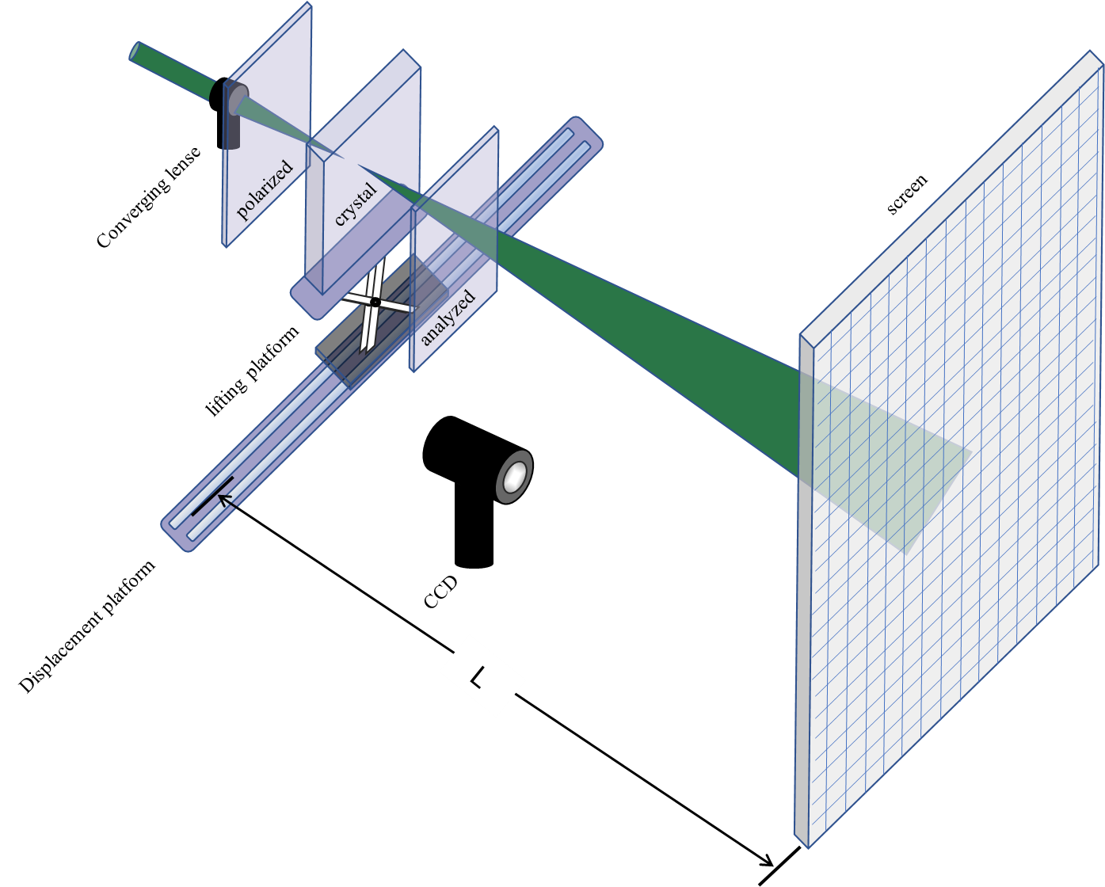

图3实验设备示意图

Figure 3 Schematic diagram of experimental equipment

在KDP晶体的样品台上水平位移台和升降台来移动测试时的样品，使得激光光束能够照射到KDP晶体xy平面上的每一个点上，其中水平位移台和光屏之间的间距为L，在光屏上的刻度线用作测量双曲线顶点间距值，并用CCD摄像头采集Z切KDP晶体(A1到A6)垂直于光轴平面上每一个点的广角锥光干涉图，以各个干涉图测量得到的双曲线顶点间距值，利用式(19)计算晶体各个点处的切应力的值，最后以切应变为指标，作出KDP晶体xy平面上的切应变的分布。

The horizontal displacement stage and lifting stage are used to move the test sample on the KDP crystal sample stage so that the laser beam can illuminate every point on the xy plane of the KDP crystal. The distance between the horizontal displacement stage and the light screen is L, The scale mark on the light screen is used to measure the hyperbola vertex spacing value d, and a CCD camera is used to collect the wide-angle conoscopic interference pattern of each point on the Z-cut KDP crystal (A1 to A6) perpendicular to the optical axis plane, and each interference pattern is Using the measured hyperbola vertex spacing value d, use equation (19) to calculate the value of the shear stress at each point of the crystal. Finally, use the shear strain as an indicator to calculate the shear strain on the xy plane of the KDP crystal. The distribution of .

3. 结果与讨论

3. Results and discussion

KDP样品A1-A6的切应变的分布如图3所示(考虑到切应变的单位无量纲，这里使用应变值作为指标)：

The distribution of shear strain of KDP samples A1-A6 is shown in Figure 3 (considering that the unit of shear strain is dimensionless, the strain value is used as an index here):

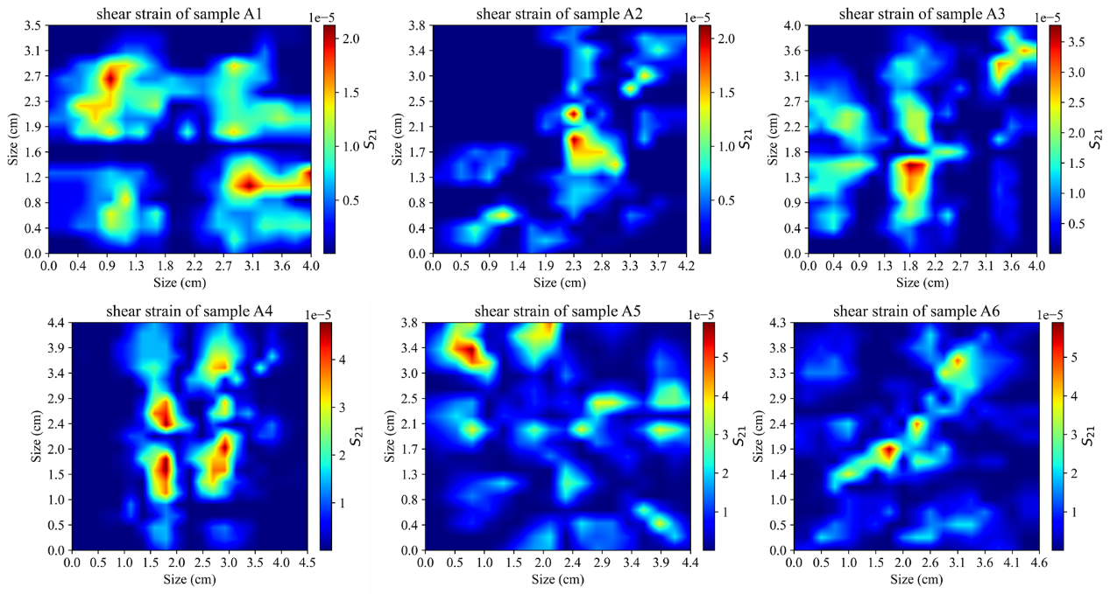

图4 切应变分布图

Figure 4 Shear strain distribution diagram

为了衡量不同过饱和度下生长的KDP晶体的总体切应变的大小，计算了A1-A6每一块样品各个点切应变值的均方根(RMS)和平均值(AVG)：

In order to measure the overall shear strain of KDP crystals grown at different degrees of supersaturation, the root mean square (RMS) and average value (AVG) of the shear strain values at each point of each sample of A1-A6 were calculated:

如图4(b)所示：

As shown in Figure 4(b):

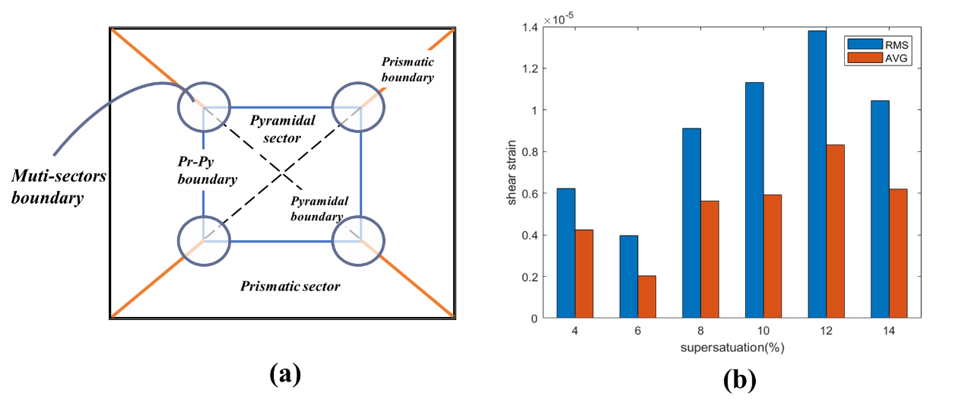

图5.(a)多个生长区交界示意图(b)切应变与过饱和度之间的关系

Figure 5. (a) Schematic diagram of the junction of multiple growth zones (b) Relationship between shear strain and supersaturation

可以看出，在不同过饱和度下生长的KDP晶体的总体切应变的大小和随着晶体生长的过饱和度的增加而增加，这在切应变均方根作为指标的时候更明显，由于均方根放大了高应变值的权重。

It can be seen that the overall shear strain of KDP crystals grown at different degrees of supersaturation increases with the increase in supersaturation of crystal growth. This is more obvious when the root mean square of shear strain is used as an indicator. Since the average The square root amplifies the weight of high strain values.

在晶体生长的过程中杂质的有效分凝系数可以表示为[28]：

The effective segregation coefficient of impurities during the crystal growth process can be expressed as [28]:

其中，为临界过饱和度。随着过饱和度的增加，晶体生长过程中的的排杂效应减弱，杂质离子的分凝系数升高，更多的杂质进入晶格，使得晶体整体的缺陷浓度增高。

where, is the critical supersaturation. As the degree of supersaturation increases, the exclusion effect during the crystal growth process weakens, the segregation coefficient of impurity ions increases, and more impurities enter the crystal lattice, causing the overall defect concentration of the crystal to increase.

另一方面，在KDP晶体生长过程中，过饱和度影响着晶体生长速度，在本实验中，所生长的样品过饱和度(0.04-0.14)处于线性生长区域[29]，在这区域内部，较小，KDP晶体的生长速度在某个恒定的过饱和度左右波动不大，晶体生长速度在整个生长过程中可以认为保持恒定，那么在不同过饱和度等间距增大的同时，KDP晶体的生长速度也随之等间距增大，晶体在快速生长的过程中，由于生长速度的增加，晶体形成内部缺陷的可能性增大。这些因素都有可能直接或间接地导致过饱和度增加引起晶体整体结构应力的增加的现象[28, 30]。

On the other hand, during the growth process of KDP crystals, supersaturation affects the crystal growth rate. In this experiment, the supersaturation of the grown sample (0.04-0.14) is in the linear growth region [29]. Within this region, is small, and the growth rate of KDP crystal does not fluctuate much around a certain constant supersaturation. The crystal growth rate can be considered as Keeping constant, then when the different supersaturations increase at equal intervals, the growth rate of the KDP crystal also increases at equal intervals. During the rapid growth of the crystal, due to the increase in growth rate, the possibility of the crystal forming internal defects increase. These factors may directly or indirectly lead to an increase in the overall structural stress of the crystal due to an increase in supersaturation[28, 30].

由图4中每个晶体样品的切应变分布图可以看出，KDP晶体的切应变在在晶体生长区的内部相对较小，而晶体的生长区交界处较大，尤其在多个生长区的交界处形变量最为大，以过饱和度为0.10的A4样品为例，四个应变值较大的红色区域分别是KDP晶体生长两个锥生长区连同两个柱生长区这四个生长区域的交界处（如图5(a)所示）。这些生长区域交界处的应变量较大可能是由于在KDP晶体中生长区交界处的杂质离子或者缺陷浓度的富集程度较其他区域高，关于结构应力分布和生长区的关系，有待于进一步的研究。

It can be seen from the shear strain distribution diagram of each crystal sample in Figure 4 that the shear strain of the KDP crystal is relatively small inside the crystal growth zone, while it is larger at the junction of the crystal growth zones, especially in multiple growth zones. The deformation variable is the largest at the junction. Taking the A4 sample with a supersaturation degree of 0.10 as an example, the four red areas with large strain values are the two cone growth areas and the two columnar growth areas of the KDP crystal. junction (shown in Figure 5(a)). The larger strain at the junction of these growth regions may be due to the higher concentration of impurity ions or defect concentrations at the junction of the growth regions in KDP crystals than in other regions. Further research is needed on the relationship between structural stress distribution and growth regions. Research.

4. 总结

为了研究不同过饱和度下生长的KDP晶体的结构应力的大小和应力的分布，从弹光效应的理论分析了KDP晶体广角干涉图中双曲线的顶点间距和晶体样品切应变大小之间的关系并得到了和切应力和切应变关于干涉条纹间距的表达式。之后使用广角锥光干涉装置加上步进电机和升降台的组合来实现对晶体整个xy平面的干涉条纹间距值的测量,并且将它换算成，并以切应变的值为指标绘制了晶体的平面上的切应变分布。从不同过饱和度的晶体样品的切应力分布图发现，KDP晶体的总体的切应变和晶体的过饱和度之间呈现正相关，而在单块晶体的内部的晶体的结构应力分布图表现出在晶体生长区的交界处较大，在多个生长区的交界处往往最大，而在生长区的内部切应变相对较小。

4. Summary

In order to study the structural stress and stress distribution of KDP crystals grown under different supersaturations, the vertex spacing d of the hyperbola in the wide-angle interference pattern of the KDP crystal and the shear strain of the crystal sample were analyzed from the theory of elasto-optical effect. The relationship between the magnitudes and the expressions of shear stress and shear strain with respect to the interference fringe spacing d are obtained. Then, a combination of a wide-angle conoscopic interference device, a stepper motor, and a lifting table is used to measure the interference fringe spacing d value of the entire xy plane of the crystal, and convert it into , and use the shear strain from different points plots the shear strain distribution on the plane of the crystal as an indicator. From the shear stress distribution diagrams of crystal samples with different degrees of supersaturation, it is found that there is a positive correlation between the overall shear strain of the KDP crystal and the supersaturation degree of the crystal, while the structural stress distribution diagram of the crystal inside a single crystal shows It is larger at the junction of the crystal growth zone and tends to be largest at the junction of multiple growth zones, while the shear strain is relatively small inside the growth zone.

**附录**

**Appendix**

表1 KDP晶体介电隔离率和弹光系数[31]

Table 1 Dielectric isolation rate and elastic optical coefficient of KDP crystal [31]

|  |  |  |
| --- | --- | --- |
|  |  |  |
|  |  |  |
|  | 00 |  |
|  |  |  |
|  | 00 |  |
|  |  |  |
|  | 00 |  |
|  |  |  |

这里考虑所有切应力的对介电隔离率的影响，并且说明正文中式(12)近似的合理性：

双轴晶体光轴倾角的表达式为：

Here, we consider the influence of all shear stresses on dielectric isolation and illustrate the rationality of the approximation of equation (12) in the text:

The expression of the tilt angle of the optical axis of a biaxial crystal is:

其中(*<<*)为主轴化的介电隔离率。

单轴晶体()在微小的结构应力下主轴化的介电隔离率可以表示为：

Among them (*<<*) is the axis-oriented dielectric isolation rate.

The dielectric isolation rate of spindleization of uniaxial crystal () under slight structural stress can be expressed as:

其中，，，是无应力状态下的主轴介电隔离率，

将光轴倾角展开为：

Among them, ，， are the spindle dielectric isolation ratio under stress-free state,

Expand the optical axis inclination angle as:

因为，上式近似为：

Because , the above formula is approximately:

这里的待求值是主轴化的介电隔离率和之差，也就是下式的前两个根之差

The value to be evaluated here is the difference between the spindle dielectric isolation ratio and , which is the difference between the first two roots of the following formula

它的的值如下：

equals(this result is solved by matlab program):

容易发现，非对角元*，，*，对特征值保持相同的单调性，并且在和，两个系数相近的时候(实际，)，，对于的贡献可以认为是占主导并且彼此等价，因此，考虑到在晶体生长过程中结构应力在各个方向上是随机分布的，可以认为弹光系数较大的所对应的，在三个非对角元中占主导。

It is easy to find that the off-diagonal elements *，，* maintain the same monotonicity for the eigenvalues , and when and , the two coefficients are close (actual ,),， contributions to can be considered dominant and equivalent to each other. Therefore, considering that the structural stress is randomly distributed in all directions during the crystal growth process , it can be considered that corresponding to with a larger elastomeric coefficient dominates the three off-diagonal elements.

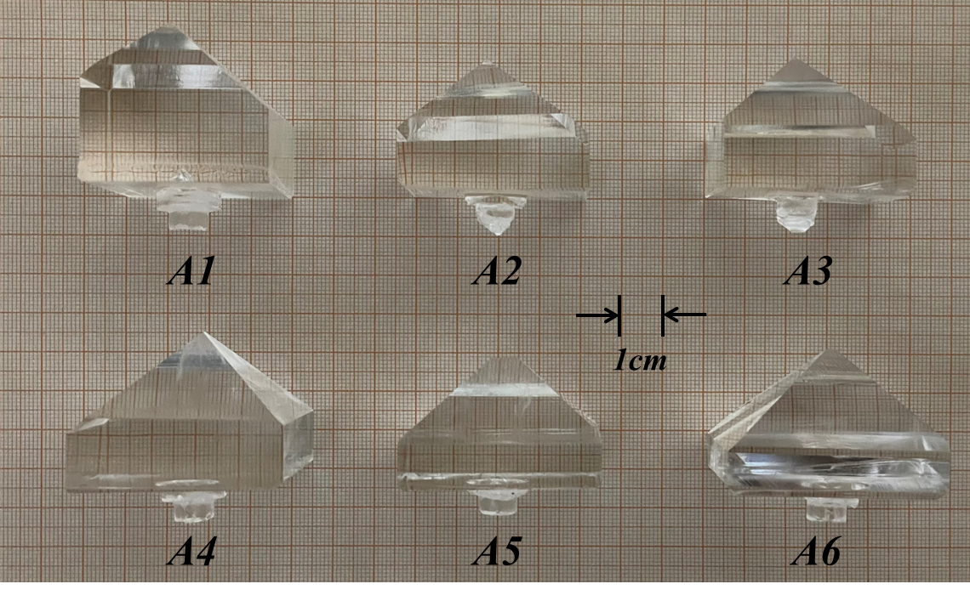

图6晶体样品图片

Figure 6 Crystal sample picture

参考文献

Reference

[1] J. De Yoreo, A. Burnham, P.J.M.R. Whitman, Developing KDP and DKDP crystals for the world’s most powerful laser, 47 (2002) 113-152.

[2] J. Lindl, Development of the indirect‐drive approach to inertial confinement fusion and the target physics basis for ignition and gain, Physics of Plasmas, 2 (1995) 3933-4024.

[3] E.I. Moses, R.E. Bonanno, C.A. Haynam, R.L. Kauffman, B.J. MacGowan, R.W. Patterson, R.H. Sawicki, B.M. Van Wonterghem, The national ignition facility: path to ignition in the laboratory, The European Physical Journal D, 44 (2006) 215-218.

[4] L.C. N.Zaitseva, Rapid growth of KDP-type crystals, Progress in Crystal Growth Characterization of Materials, 43 (2001) 1-118.

[5] Z.Y. Hu, P.F. Li, Y.L. Sun, J.W. Li, G.Z. Zheng, Rapid growth technology and optical properties of a large aperture high-deuterium DKDP crystal, Crystengcomm, 24 (2022) 8440-8448.

[6] J.J. De Yoreo, B.W. Woods, Investigation of strain birefringence and wavefront distortion in 001 plates of KD2PO4, Inorganic Crystals for Optics, Electro-Optics, and Frequency Conversion, SPIE, 1991, pp. 50-58.

[7] J.W. De Yoreo, BW Journal of applied physics, A study of residual stress and the stress‐optic effect in mixed crystals of K (D x H1− x) 2PO4, 73 (1993) 7780-7789.

[8] V.M. Krymov, Y.G. Nosov, S.I. Bakholdin, V.N. Maslov, I.L. Shul′pina, V.I. Nikolaev, Blocks and residual stresses in shaped sapphire single crystals, Journal of Crystal Growth, 457 (2017) 314-319.

[9] M.S. Yankova, A. Garner, F. Baxter, S. Armson, C.P. Race, M. Preuss, P. Frankel, Untangling competition between epitaxial strain and growth stress through examination of variations in local oxidation, Nat Commun, 14 (2023) 250.

[10] N. Tsakiris, P. Argyrakis, I. Avramov, C. Bocker, C. Rüssel, Crystal growth model with stress development and relaxation, EPL (Europhysics Letters), 89 (2010).

[11] K. Tanaka, Y. Akiniwa, Diffraction measurements-of residual macrostress and microstress using X-rays, synchrotron and neutrons, Jsme International Journal Series a-Solid Mechanics and Material Engineering, 47 (2004) 252-263.

[12] J. Podder, S. Ramalingom, S.N.J.C.R. Kalkura, Technology, An Investigation on the Lattice Distortion in Urea and KCl Doped KDP Single Crystals by X-ray Diffraction Studies, 36 (2001) 549-556.

[13] J. West, A quantitative x-ray analysis of the structure of potassium dihydrogen phosphate (KH2PO4), Ferroelectrics, 71 (1987) 1-9.

[14] A. Morawiec, Geometry of X-ray based measurement of residual strain at desired penetration depth, physica status solidi (a), 214 (2017).

[15] L. Chen, M. Zhang, D. Li, Y. Li, Visualization and quantification of the stress distribution on epoxy resin through photoelasticity and infrared radiation techniques, AIP Advances, 12 (2022).

[16] F. Brommel, D. Kramer, B.P. Brown, H. Finkelmann, A. Hoffmann, Orientability of the minor director of homeotropically aligned smectic-a elastomers in external mechanical fields, Macromol Rapid Commun, 34 (2013) 135-141.

[17] P. Kehayias, M.J. Turner, R. Trubko, J.M. Schloss, C.A. Hart, M. Wesson, D.R. Glenn, R.L. Walsworth, Imaging crystal stress in diamond using ensembles of nitrogen-vacancy centers, Physical Review B, 100 (2019).

[18] P.L. Diggle, U.F.S. D’Haenens-Johansson, B.L. Green, C.M. Welbourn, T.N. Tran Thi, A. Katrusha, W. Wang, M.E. Newton, Decoration of growth sector boundaries with nitrogen vacancy centers in as-grown single crystal high-pressure high-temperature synthetic diamond, Physical Review Materials, 4 (2020).

[19] A. Kaur, Hirdesh, A. Khanna, M. Fábián, P.S.R. Krishna, A.B. Shinde, Structure of lead tellurite glasses and its relationship with stress-optic properties, Materials Research Bulletin, 110 (2019) 239-246.

[20] D. Sun, T. Lu, T. Wang, Nonlinear photoelasticity of rubber-like soft materials: comparison between theory and experiment, Soft Matter, 17 (2021) 4998-5005.

[21] F. Daví, Some approximate relations in the photoelasticity of strongly anisotropic crystals, Mathematical Methods in the Applied Sciences, 43 (2020) 9692-9705.

[22] L. Montalto, N. Paone, L. Scalise, D. Rinaldi, A photoelastic measurement system for residual stress analysis in scintillating crystals by conoscopic imaging, Rev Sci Instrum, 86 (2015) 063102.

[23] W. D.Nesse, Introduction to Optical Mineralogy, Third Edition ed., Oxford University Press2004.

[24] E.W. Max Born Principles of Optics, 60th anniversary edition ed., Cambridge University Press 2019.

[25] K. Veerabhadrarao, T.S. Narasimhamurty, Photoelasticity Behavior of KDP, Journal of Materials Science, 10 (1975) 1019-1021.

[26] F.E. Veiras, M.T. Garea, L.I. Perez, Wide angle conoscopic interference patterns in uniaxial crystals, Appl Opt, 51 (2012) 3081-3090.

[27] F.E. Veiras, G. Perez, M.T. Garea, L.I. Perez, Characterization of uniaxial crystals through the study of fringe patterns, Journal of Physics: Conference Series, 274 (2011).

[28] K. Sangwal, E.J.J.o.C.G. Mielniczek-Brzoska, Study of segregation coefficient of Mn(II) impurity in ammonium oxalate monohydrate crystals and the relationship between segregation coefficient and growth kinetics, 257 (2003) 185-198.

[29] N.P. Zaitseva, L. Carman, I. Smolsky, R. Torres, M.J.J.o.C.G. Yan, The effect of impurities and supersaturation on the rapid growth of KDP crystals, 204 (1999) 512-524.

[30] K. Sangwal, T.J.J.o.C.G. Palczynska, On the supersaturation and impurity concentration dependence of segregation coefficient in crystals grown from solutions, 212 (2000) 522-531.

[31] K. Veerabhadra Rao, T.S. Narasimhamurty, Photoelastic behaviour of KDP, Journal of Materials Science, 10 (1975) 1019-1021.