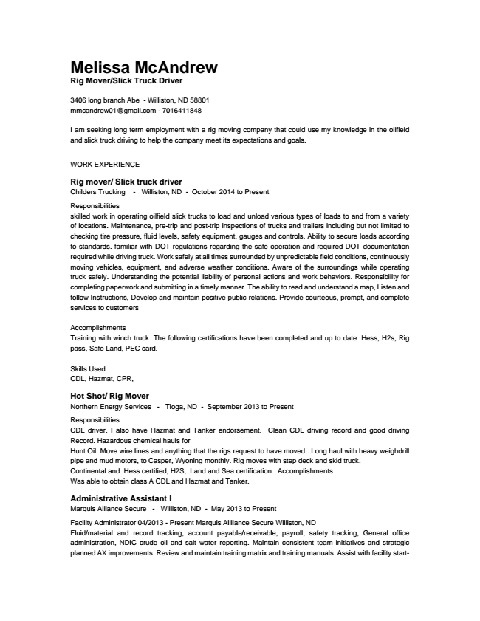

Melissa McAndrew Rig Mover/Slick Truck Driver
3406 long branch Abe - Williston, ND 58801 mmcandrew01@gmail.com - 7016411848
I am seeking long term employment with a rig moving company that could use my knowledge in the oilfield and slick truck driving to help the company meet its expectations and goals.
WORK EXPERIENCE
Rig mover/ Slick truck driver Childers Trucking - Williston, ND - October 2014 to Present
Responsibilities skilled work in operating oilfield slick trucks to load and unload various types of loads to and from a variety of locations. Maintenance, pre-trip and post-trip inspections of trucks and trailers including but not limited to checking tire pressure, fluid levels, safety equipment, gauges and controls. Ability to secure loads according to standards. familiar with DOT regulations regarding the safe operation and required DOT documentation required while driving truck. Work safely at all times surrounded by unpredictable field conditions, continuously moving vehicles, equipment, and adverse weather conditions. Aware of the surroundings while operating truck safely. Understanding the potential liability of personal actions and work behaviors. Responsibility for completing paperwork and submitting in a timely manner. The ability to read and understand a map, Listen and follow Instructions, Develop and maintain positive public relations. Provide courteous, prompt, and complete services to customers
Accomplishments Training with winch truck. The following certifications have been completed and up to date: Hess, H2s, Rig pass, Safe Land, PEC card.
Skills Used CDL, Hazmat, CPR,
Hot Shot/ Rig Mover Northern Energy Services - Tioga, ND - September 2013 to Present
Responsibilities CDL driver. I also have Hazmat and Tanker endorsement. Clean CDL driving record and good driving Record. Hazardous chemical hauls for Hunt Oil. Move wire lines and anything that the rigs request to have moved. Long haul with heavy weighdrill pipe and mud motors, to Casper, Wyoning monthly. Rig moves with step deck and skid truck. Continental and Hess certified, H2S, Land and Sea certification. Accomplishments Was able to obtain class A CDL and Hazmat and Tanker.
Administrative Assistant I Marquis Alliance Secure - Williston, ND - May 2013 to Present
Facility Administrator 04/2013 - Present Marquis Allliance Secure Williston, ND Fluid/material and record tracking, account payable/receivable, payroll, safety tracking, General office administration, NDIC crude oil and salt water reporting. Maintain consistent team initiatives and strategic planned AX improvements. Review and maintain training matrix and training manuals. Assist with facility start-

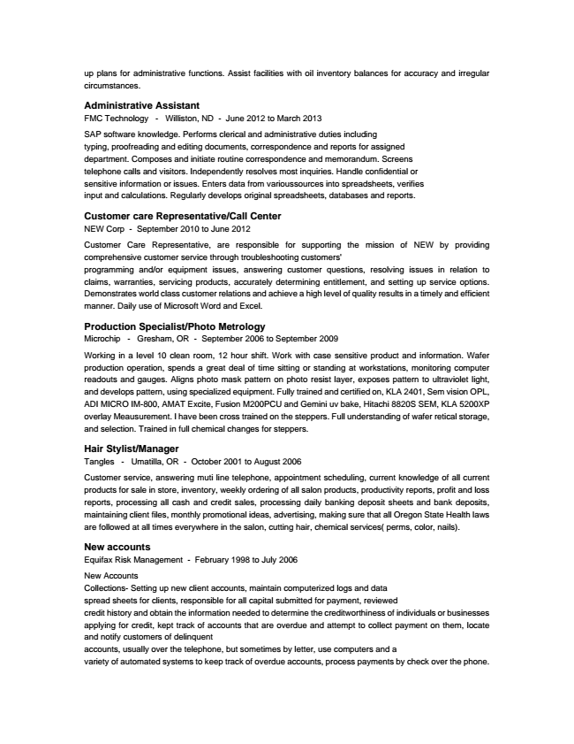

up plans for administrative functions. Assist facilities with oil inventory balances for accuracy and irregular circumstances.
Administrative Assistant FMC Technology - Williston, ND - June 2012 to March 2013
SAP software knowledge. Performs clerical and administrative duties including typing, proofreading and editing documents, correspondence and reports for assigned department. Composes and initiate routine correspondence and memorandum. Screens telephone calls and visitors. Independently resolves most inquiries. Handle confidential or sensitive information or issues. Enters data from varioussources into spreadsheets, verifies input and calculations. Regularly develops original spreadsheets, databases and reports.
Customer care Representative/Call Center NEW Corp - September 2010 to June 2012
Customer Care Representative, are responsible for supporting the mission of NEW by providing comprehensive customer service through troubleshooting customers' programming and/or equipment issues, answering customer questions, resolving issues in relation to claims, warranties, servicing products, accurately determining entitlement, and setting up service options. Demonstrates world class customer relations and achieve a high level of quality results in a timely and efficient manner. Daily use of Microsoft Word and Excel.
Production Specialist/Photo Metrology Microchip - Gresham, OR - September 2006 to September 2009
Working in a level 10 clean room, 12 hour shift. Work with case sensitive product and information. Wafer production operation, spends a great deal of time sitting or standing at workstations, monitoring computer readouts and gauges. Aligns photo mask pattern on photo resist layer, exposes pattern to ultraviolet light, and develops pattern, using specialized equipment. Fully trained and certified on, KLA 2401, Sem vision OPL, ADI MICRO IM-800, AMAT Excite, Fusion M200PCU and Gemini uv bake, Hitachi 8820S SEM, KLA 5200XP overlay Meausurement. I have been cross trained on the steppers. Full understanding of wafer retical storage, and selection. Trained in full chemical changes for steppers.
Hair Stylist/Manager Tangles - Umatilla, OR - October 2001 to August 2006
Customer service, answering muti line telephone, appointment scheduling, current knowledge of all current products for sale in store, inventory, weekly ordering of all salon products, productivity reports, profit and loss reports, processing all cash and credit sales, processing daily banking deposit sheets and bank deposits, maintaining client files, monthly promotional ideas, advertising, making sure that all Oregon State Health laws are followed at all times everywhere in the salon, cutting hair, chemical services( perms, color, nails).
New accounts Equifax Risk Management - February 1998 to July 2006
New Accounts Collections- Setting up new client accounts, maintain computerized logs and data spread sheets for clients, responsible for all capital submitted for payment, reviewed credit history and obtain the information needed to determine the creditworthiness of individuals or businesses applying for credit, kept track of accounts that are overdue and attempt to collect payment on them, locate and notify customers of delinquent accounts, usually over the telephone, but sometimes by letter, use computers and a variety of automated systems to keep track of overdue accounts, process payments by check over the phone.

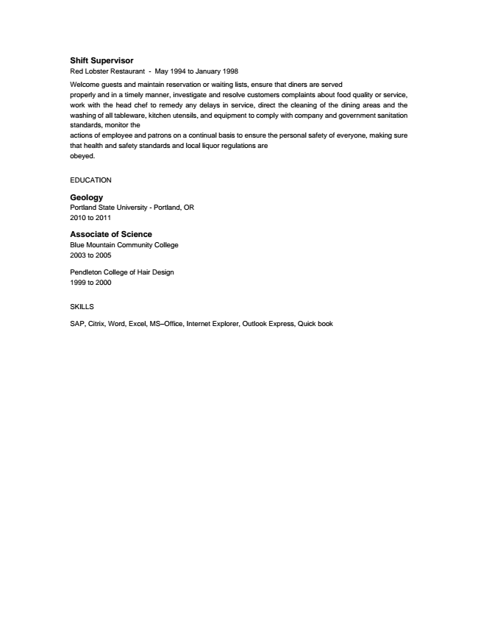

Shift Supervisor Red Lobster Restaurant - May 1994 to January 1998
Welcome guests and maintain reservation or waiting lists, ensure that diners are served properly and in a timely manner, investigate and resolve customers complaints about food quality or service, work with the head chef to remedy any delays in service, direct the cleaning of the dining areas and the washing of all tableware, kitchen utensils, and equipment to comply with company and government sanitation standards, monitor the actions of employee and patrons on a continual basis to ensure the personal safety of everyone, making sure that health and safety standards and local liquor regulations are obeyed.
EDUCATION
Geology Portland State University - Portland, OR 2010 to 2011
Associate of Science Blue Mountain Community College 2003 to 2005
Pendleton College of Hair Design 1999 to 2000
SKILLS
SAP, Citrix, Word, Excel, MS–Office, Internet Explorer, Outlook Express, Quick book

