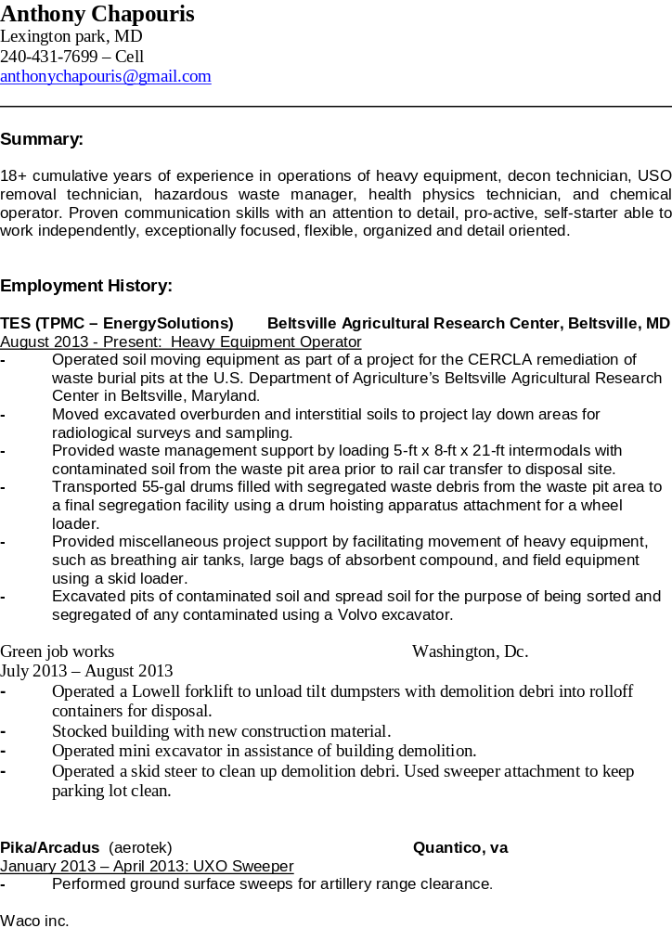
May 2004 – August 2012 (Asbestos Supervisor)
- Supervised and removed asbestos, lead and mold from various schools, businesses and
Private dwellings.
- Bagging, labeling and transported waste material following all state and federal guidlines.
- Ordered material and maintained warehouse.
- Load and unload trucks when not in the field and maintain logbooks as well as employee licenses.

Kelly Scientific Services Manasses, Va
January 2004 - May 2004: Clean Room Technician
- Decontamination acids from process tools used in manufacturing wafers and chips for a variety of electronic components.
- Decontamination of various corrosive chemicals and solvents in pipe used in the manufacturing process.
- Provided assistance in the proper packaging and labeling of hazardous waste for transport and disposal.

Andrews Air Force Base Joint Base Andrews, MD
August 2003 - January 2004: Onsite Engineering & Environmental Hazardous Materials Handler
- Performed all work related activity regarding acceptance, accumulation, and disposal of all hazardous waste generated on the Base.
- Provided technical assistance to Operations to ensure compliance with federal, state, and local laws.
- Conducted facility inspections, labeling, container management, scheduling of appointments, and pickups of waste containers.
- Responsible for processing and transfers of containers to off-site facilities.
- Provided hazardous waste receiving documents to the Defense Re-Utilization Fund.

Shaw E & I U. S. Postal Service, Brentwood, MD
March 2003 - August 2003: Anthrax Decontamination Technician
- Responsible for performance of internal HAVC duct cleaning.
- Decontamination of equipment used for gassing during sampling and demobilization.
- Operation of shredder machines for metals, computer components, monitors, and classified inspector documents.
- Performed removal of adhesive from brick building.
- Collected samples for analysis of anthrax contamination.

Shaw E & I BOMARC Missile Site, Plumstead, NJ
August 2002 - February 2003: Junior Health Physics Technician
- Responsible for daily performance test of the Eberline E600 Smart Meter and the Ludlum Model 2929 dual phosphor alpha/beta scalar, which included smear counting times and required smear counting protocols such as minimum detectable activity calculations.
- Performed smear and radiation surveys of intermodal waste shipping containers after loading radioactive soil prior to shipping.
- Prepared solid samples for onsite analytical laboratory and provided Health Physics support at the contamination exclusion zone by performing material release surveys.
- Worked under the direction of a Senior Health Physics Technician to perform gamma walkover surveys in support of site excavation surveys.

Shaw E & I NNMC Mercury Removal, Bethesda, MD
May 2002 - August 2002: Decontamination Technician
- Decontamination of three buildings used by the Naval National Medical Research Institute since the 1930’s as an extensive chemical and infectious disease clinical research facility.
- With the main contaminant of mercury, over 10,000 linear feet of piping was removed (sewer piping, sink traps, laboratory floor drains, janitor closets, sub basements and crawl spaces).
- Project worked over 100 days with an OSHA recordable incident.

Shaw E & I Picatinny Arsenal, Rockaway Township, NJ
March 2002 - April 2002: Heavy Equipment Operator
- Performed clearing and grubbing around pits containing tetryl to create space for equipment needed to begin removal of the tetryl and other potentially detected UXO material.
- Blast shields were positioned near the pits and a 100-ft perimeter was established during excavation activities.

Shaw E & I Fort Detrick, Frederick, MD
August 2001 - September 2001: Heavy Equipment Operator
- Performed work involving the installation of a freeze wall using drill rigs.
- Operated Terex Fork Lifts and Skid Loaders.

Shaw E & I York St. Metal Plating, Philadelphia, PA
June 2001 - August 2001: Heavy Equipment Operator
- Operated Skid Loaders and Scissor Lifts to remove metal and debris during the removal of acids and cyanides from an old metal plating facility.
- After debris and machinery were cut for size reduction, all material was placed into 30-yd roll-off containers for disposal.

Shaw E & I Customer? Portsmouth, VA
April 2001 - May 2001: Heavy Equipment Operator
- Performed excavation of lead contaminated soil.
- Cleaned and maintained the public roads using a skid loaded with a sweeper attachment.
- Performed dust suppression using a water truck.

Shaw E & I Customer? Nitro, WV
February 2001- March 2001: Chemical Operator
- Responsible for the removal of phosphorous compound from the chemical plant.
- Used heated water to soften the phosphorous material to facilitate pumping out of the pit.
- Performed work in Level B protective suits and fire retardant suits.

Shaw E & I Diamond State Salvage, Wilmington, DE
September 2000- January 2001: Chemical Operator
- Duties included recycling of salvageable material and segregation of hazardous materials.
- Installed a run off pond and erected a silt fence around the site.

Shaw E & I Customer? Philadelphia, PA
August 2000- September 2000: Environmental Technician
- Containerizing and over-packing leaky drums of unknown hazardous material in a residential neighborhood.
- Erected a silt fence around the site.

Shaw E & I Hollywood Wood Treatment Plant Superfund Site. Hollywood, MD
April 1999 - August 2000: Environmental Technician
- Operated and maintained a continuous thermal desorption unit to heat soil to burn off contaminants.
- Mobilized and maintained thermal equipment and onsite analytical laboratory.
- Performed as a team member for excavation and backfill of more than 250,000 tons of soil. The team worked a 24 hour per day operation and work over 1,000 days with a lost work day incident.

Sunrise Erectors, Inc. Chambersburg, PA
April 1998 – April 1999: Erector/Pre-cast
- Operated torches and welders to tack weld bearings to structural beams for placement of pre-cast panels.
- Monitored and maintained visual environment by giving hand signals to Crane Operator while moving concrete panels.
- Hooked concrete panels to crane for structural movement and placement.

Howling Concrete, Inc. Mechanicsville, MD
September 1996 – April 1998: Pre-cast Manager
- Managed and contributed to production of concrete septic tanks, distribution boxes, and risers.
- Broke down forms and poured concrete utilizing boom trucks and heavy equipment for the removal and placement of finished product.
- Log and maintain inventory of all product onsite and stored at other locations.

Education:
Graduated Great Mill High School May 1991 Great Mills, MD

Skills/Computer Proficiencies:
Proficient in operation of Case 721F Wheel Loader, Volvo L110G Wheel Loader, Volvo MCT 125C Skid Loader, and Volvo EC250 DL Excavator.
Proficient in Microsoft Word, Excel, Power Point
Proficient in daily use of hand held radiological survey meters, i.e., Eberline E600,
Ludlum Model 2929, and Ludlum Model 3.

Training and Certifications:
- August 2013 Certificate, Radiological Worker II and Respiratory Protection (Regulatory Guide 8.15 and 10 CFR 19)
- August 2013 Certificate, Radiological Work I (Regulatory Guide 8.15 and 10 CFR 19)
- December 2011 Certificate, Mold Remediation Supervisor
- December 2010 Certificate, Fall Protection Safety Awareness Training
- November 2010 License, ANSI A92.5, A92.6 AWP Operator- Boom, Scissor Lifts
- September 2004 Certificate, 2-Day Lead Abatement Worker(VA, MD, DC)
- June 2004 Certificate, 5-day AHERA Asbestos Supervisor(VA, MD)
- April 2004 Certificate, Blood Bourne Pathogens
- December 2003 Certificate, DOT Training for Drivers of HAZMAT Shipments
- November 2003 Certificate, RCRA, Hazardous Waste Management for Generators
- November 2003 Certificate, DOT Training for Offerers of Non-Bulk hazmat Packages
- November 2003 Certificate, DOT Training for Offerers of Bulk and Non-Bulk HAZMAT Packages
- March 2000 Certificate, Confined Space Rescue Training
- January 2000 Certificate, Permit Required Confined Space Rescue Training
- December 1999 Certificate, Confined Space Training for Attendant and Authorized Entrant
- April 1999 Certificate, OSHA 1910.120 40-Hour Hazardous Waste Operations Health and
Safety Training

