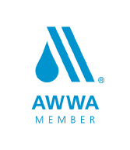
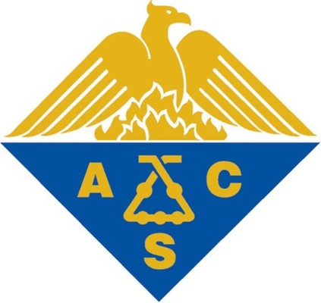
George Reva

2254 North Baldwin, Unit 8B
Palatine, IL 60074
(312)-623-7713
George.Y.Reva@gmail.com

Water Treatment Chemist
20+ years of progressive experience in Water Treatment

Objective: To take on a challenging role in water treatment that will allow me to utilize over 20 years of experience.

Professional Experience:
Skilled Chemistry professional with 20+ years of water treatment experience working with both drinking (surface and underground) and industrial water. Knowledge of HPLC, GC GC/​MS, TLC, IR, UV/​vis and AA.​ Experienced with all stages and variations of water treatment, including:
Waterworks:
- Numerous Waterworks projects ranging from single stage to complex treatment with output from 10 m³/h (270 cu ft/h) to 10,000 m³/h (270,000 cu ft/h).
- Reagents preparation/introduction, coagulation, flocculation and sedimentation.
- Experience with rapid and pressure filtration.
- Disinfection and organics elimination using chlorine gas (with awareness of by-products), sodium hypochlorite from electrolysis, ozonation and UV-treatment.
- Adsorption techniques (powdered/granulated activated carbon).
- Ion exchange and deionization. Reverse Osmosis.
- Extensive hands-on lab experience in water quality testing and assurance.
- Knowledge of regulations and standards, including: CWA, ESWTR, SDW/NPDES, and FDPCA.
- Wastewater treatment (complex and by-stages) : domestic and industrial waste water
Process (multiyear project), activated sludge recirculation optimization, tertiary treatment (ultra-filtration,
Adsorption), sludge management, adsorption material testing for waste water/oil spill application.
Regulatory Skills:
- Hands on Knowledge of OSHA and EPA regulations.
Technology Skills:
- Knowledge of Microsoft Windows XP/Vista/7 and the Microsoft Excel/Outlook/PowerPoint/Word.
Personal Interests:
- Chemical technology and engineering, automotive engineering, energy utilization and green technology.

Employment History:
Business Owner Grand Rapids, MI 2003-2014

Analytical Chemist Kalamazoo, MI 2000-2003
Pharmacia Co.

Wastewater Consultant New York, NY 1999-2000
American EnviroCare Consulting Co.

Analytical Chemist Amityville, NY 1995-1997
Hi-tech Pharmacal

R&D Chemist Brooklyn, NY 1997-1999
Helsey Drugs

Waterworks Specialist Moscow, Russia 1974-1992
SouzChem Consulting

Education and Professional Organizations:
M.S. Chemistry
Belarus State University Belarus, USSR 1969-1974
- Focused on physical, inorganic and adsorption chemistry.
- Masters’ thesis on adsorption chemistry and granulated activated carbon filtration.
Professional Organizations:
- ACS (American Chemical Society)
- AWWA (American Water Works Association)

Training:

Hands on training in "Modern Instrumentation and Methodologies in Analytical Service”
AHP Co. & LPGM United White Plains, NY 2001

Hands on training in “HPLC Quality Control and Analytical Service in Pharmaceuticals"

Ramapo College Mahwah, NJ 1994

Hands on software and lab training in analytical equipment AA (Perkin-Elmer-5100), TLC (Quick Scan R&D), UV-Vis Specrotometer (DMS90), Beckman DU64, HPLC (Shimadazu 6-series).

Rockefeller University New York, NY 1994

