**MODULE DESCRIPTION:**

**About library management:**

A library management system is an example of an information system. An information system, whether it is computerised or not, is a system that represents objects in a physical system, for example, information resources in a library collection.

**Benefits:**

**1. Up-to-date:** This keeps details of the books, magazines or other materials available in the library as per their categories. The addition or removal of the books is simple as the software updates the records in one fraction.

**2. Student Involvement:** The students can login & browse through the different books present in the library, it is one simple searching option and leads to more student engagement in the library.

**3. Record Maintenance:** The borrower details will be stored & maintained, and due return date is set based on the categories and fine calculation begins when due date gets skipped.

**4. Web Interface:** School library is accessible to the students since they have access to the web interface by which they can easily check out the borrowing history, apply for the renewal, due dates, and view fine. It develops the better weather in the school because students feel highly connected with the information being accessible to them.

**5. Progressive:** Library & book management of the school goes online that proves as the step towards the academic growth that leads to the school development.

**6. Get Easy Access:** It is easy to do library audit any time as records are maintained with highly efficiency.

**FEATURES:**

* Customize login for the students, internal staff, and non member reader
* Enumeration competency of the regular newspaper, journals and magazines
* Flawless issuance & returning of books
* Digital records for the check in & checkout candidates of the library
* Simple to manage accounts in the Library management software for the academic compliances
* Fetching record of the issued or unissued materials in a library
* Manage & classify books as per the category of academics
* Feature to add any new books and other material in to central database
* Complete information for book will be recorded such as Book name, Publisher's name, Author name, Date and Year of publication, Book purchasing date or Bill no and Cost of the book
* Gives remote access for managing centralized database of the library to authorized person

It is important to note how library management systems work to ensure you may experience optimal benefits. It will boost your school's performance just by allowing you to adequately manage and disseminate some important information through the simple to use & highly available platform.

**PROBLEM STATEMENT:**

**Write a program based on a library management system for our college for easy access on books and to get the list of issued book list for easy maintenance of records for future reference.**

**ABOUT THE PROGRAM:**

The below program is a basic library management system program using concepts of structures, functions, files etc.. where books can be added , issued to students and a list is displayed.

**PICTORIAL REPRESENTATION**

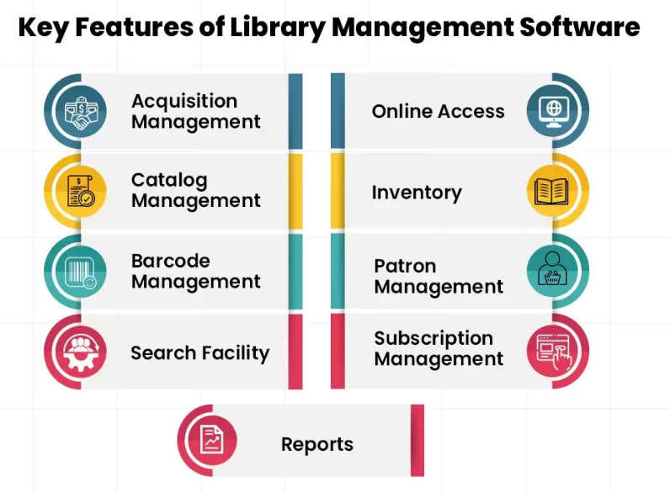



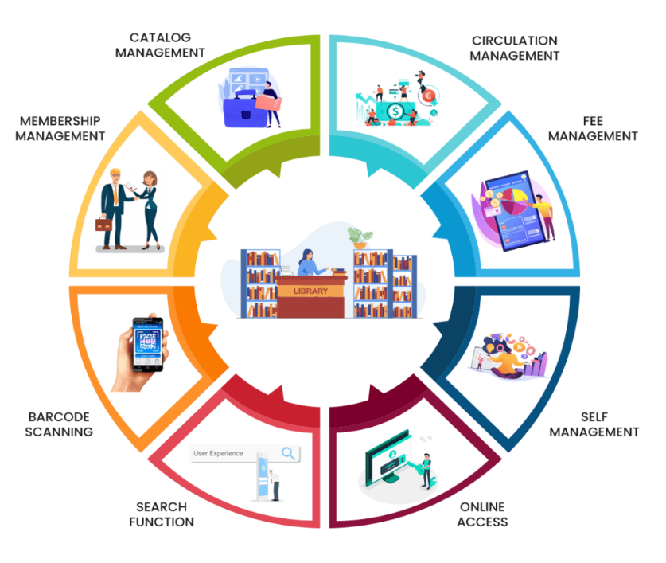

**SOURCE CODE:**

/*NAME OF THE PROGRAMMERS: Shifa,Divya ,Kritiga ,Indhu.

To develop a c program on LIBRARY MANAGEMENT SYSTEM.*/

#include<stdio.h>

#include<conio.h>

#include<stdlib.h>

#include<time.h>

struct books{

int id;

char bookName[50];

char authorName[50];

char date[12];

}b;

struct student{

int id;

char sName[50];

char sClass[50];

int sRoll;

char bookName[50];

char date[12];

}s;

FILE *fp;

int main(){

int ch;

while(1){

system("cls");

printf("\n\n\n\n\n");

printf("\n\t\t\t *--------------------------------------------------------------*\n");

printf("\n\t\t\t =-=-=-=-=-=-=-=-=-=-=-=-=-=-=-=-=-=-=-=-=-=-=");

printf("\n\t\t\t = WELCOME =");

printf("\n\t\t\t = TO =");

printf("\n\t\t\t = LIBRARY =");

printf("\n\t\t\t = MANAGEMENT =");

printf("\n\t\t\t = SYSTEM =");

printf("\n\t\t\t =-=-=-=-=-=-=-=-=-=-=-=-=-=-=-=-=-=-=-=-=-=-=");

printf("\n\t\t\t *---------------------------------------------------------------*\n");

printf("\n\n\n\t\t\t Enter any key to continue.....");

getch();

printf("\n1.Add Book\n");

printf("2.Books List\n");

printf("3.Remove Book\n");

printf("4.Issue Book\n");

printf("5.Issued Book List\n");

printf("0.Exit\n\n");

printf("Enter your choice: ");

scanf("%d", &ch);

switch(ch){

case 0:

exit(0);

case 1:

addBook();

break;

case 2:

booksList();

break;

case 3:

del();

break;

case 4:

issueBook();

break;

case 5:

issueList();

break;

default:

printf("Invalid Choice...\n\n");

}

printf("Press Any Key To Continue...");

getch();

}

return 0;

}

void addBook(){

char myDate[12];

time_t t = time(NULL);

struct tm tm = *localtime(&t);

sprintf(myDate, "%02d/%02d/%d", tm.tm_mday, tm.tm_mon+1, tm.tm_year + 1900);

strcpy(b.date, myDate);

fp = fopen("books.txt", "ab");

printf("Enter book id: ");

scanf("%d", &b.id);

printf("Enter book name: ");

fflush(stdin);

gets(b.bookName);

printf("Enter author name: ");

fflush(stdin);

gets(b.authorName);

printf("Book Added Successfully");

fwrite(&b, sizeof(b), 1, fp);

fclose(fp);

}

void booksList(){

system("cls");

printf("<== Available Books ==>\n\n");

printf("%-10s %-30s %-20s %s\n\n", "Book id", "Book Name", "Author", "Date");

fp = fopen("books.txt", "rb");

while(fread(&b, sizeof(b), 1, fp) == 1){

printf("%-10d %-30s %-20s %s\n", b.id, b.bookName, b.authorName, b.date);

}

fclose(fp);

}

void del(){

int id, f=0;

system("cls");

printf("<== Remove Books ==>\n\n");

printf("Enter Book id to remove: ");

scanf("%d", &id);

FILE *ft;

fp = fopen("books.txt", "rb");

ft = fopen("temp.txt", "wb");

while(fread(&b, sizeof(b), 1, fp) == 1){

if(id == b.id){

f=1;

}else{

fwrite(&b, sizeof(b), 1, ft);

}

}

if(f==1){

printf("\n\nDeleted Successfully.");

}else{

printf("\n\nRecord Not Found !");

}

fclose(fp);

fclose(ft);

remove("books.txt");

rename("temp.txt", "books.txt");

}

void issueBook(){

char myDate[12];

time_t t = time(NULL);

struct tm tm = *localtime(&t);

sprintf(myDate, "%02d/%02d/%d", tm.tm_mday, tm.tm_mon+1, tm.tm_year + 1900);

strcpy(s.date, myDate);

int f=0;

system("cls");

printf("<== Issue Books ==>\n\n");

printf("Enter Book id to issue: ");

scanf("%d", &s.id);

//Check if we have book of given id

fp = fopen("books.txt", "rb");

while(fread(&b, sizeof(b), 1, fp) == 1){

if(b.id == s.id){

strcpy(s.bookName, b.bookName);

f=1;

break;

}

}

if(f==0){

printf("No book found with this id\n");

printf("Please try again...\n\n");

return;

}

fp = fopen("issue.txt", "ab");

printf("Enter Student Name: ");

fflush(stdin);

gets(s.sName);

printf("Enter Student Class: ");

fflush(stdin);

gets(s.sClass);

printf("Enter Student Roll: ");

scanf("%d", &s.sRoll);

printf("Book Issued Successfully\n\n");

fwrite(&s, sizeof(s), 1, fp);

fclose(fp);

}

void issueList(){

system("cls");

printf("<== Book Issue List ==>\n\n");

printf("%-10s %-30s %-20s %-10s %-30s %s\n\n", "S.id", "Name", "Class", "Roll", "Book Name", "Date");

fp = fopen("issue.txt", "rb");

while(fread(&s, sizeof(s), 1, fp) == 1){

printf("%-10d %-30s %-20s %-10d %-30s %s\n", s.id, s.sName, s.sClass, s.sRoll, s.bookName, s.date);

}

fclose(fp);

}

**PROGRAM:**

Environment: CODE BLOCKS.

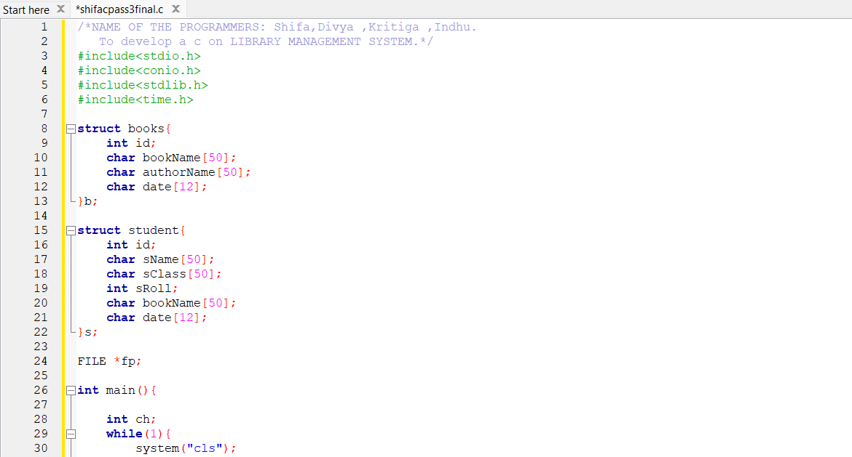

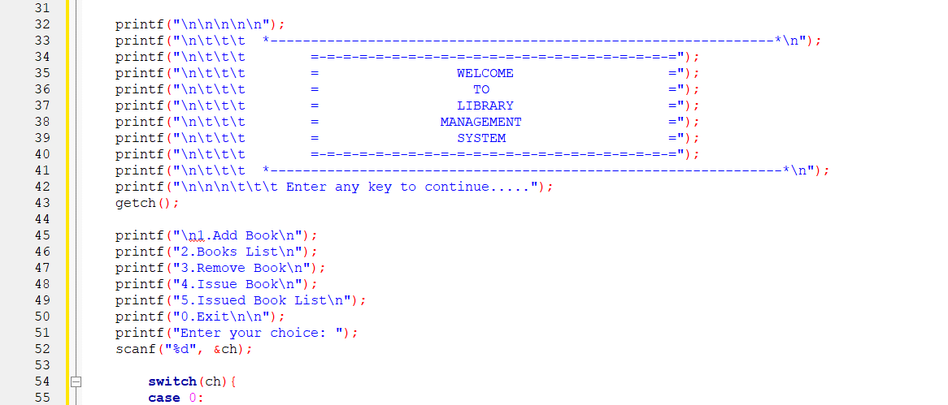



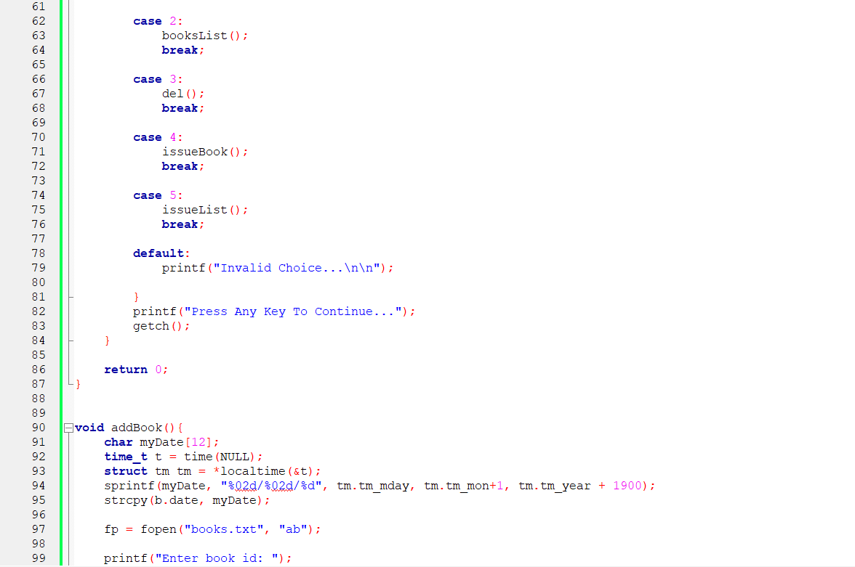

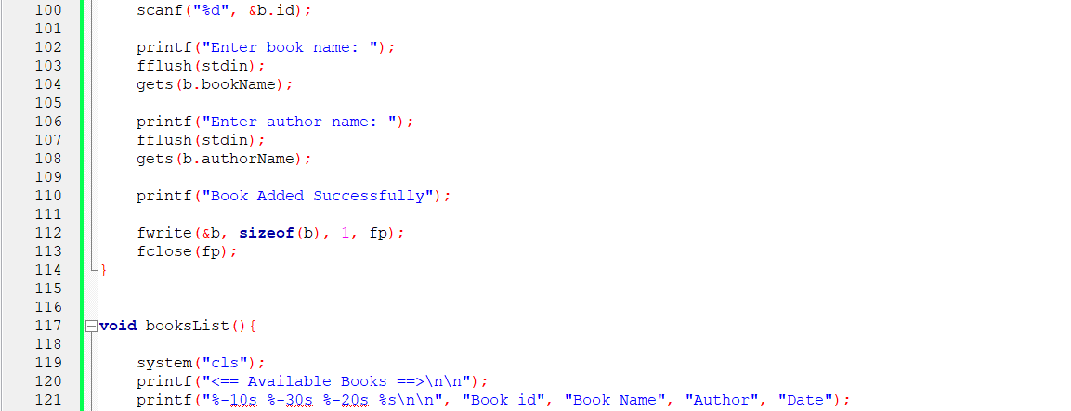

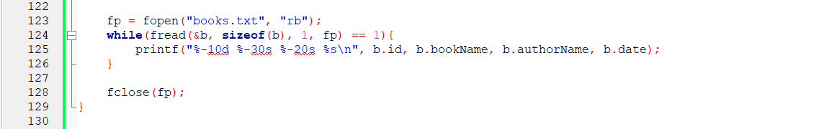

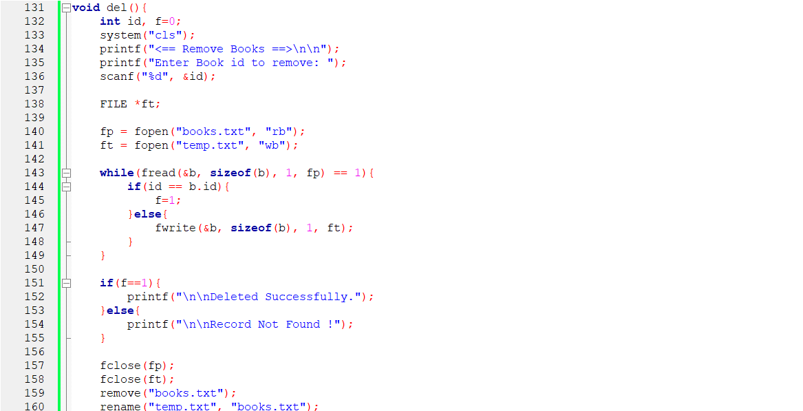

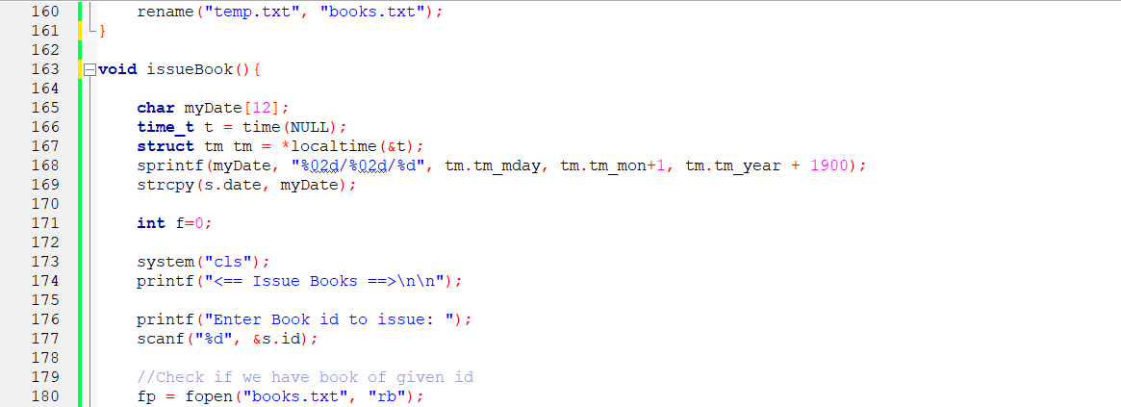

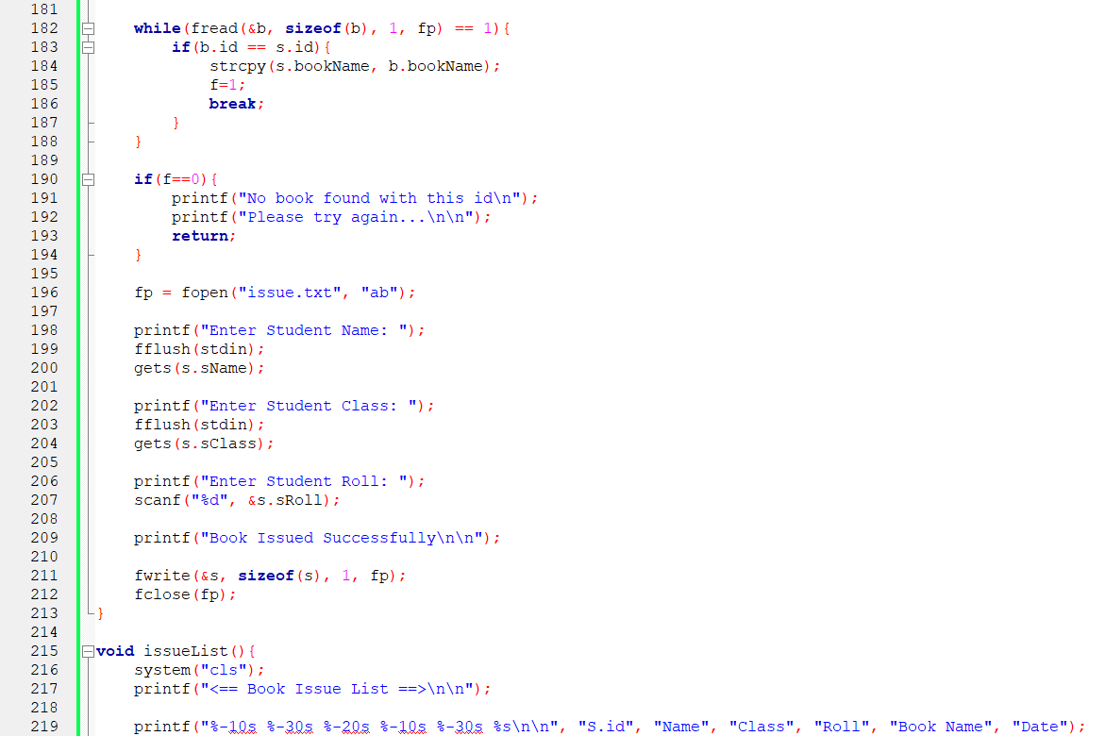

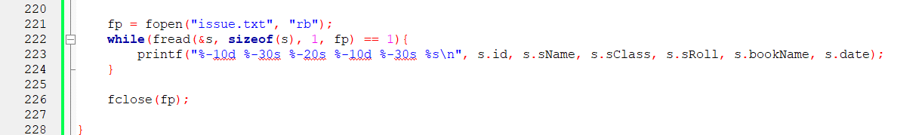

**OUTPUT:**

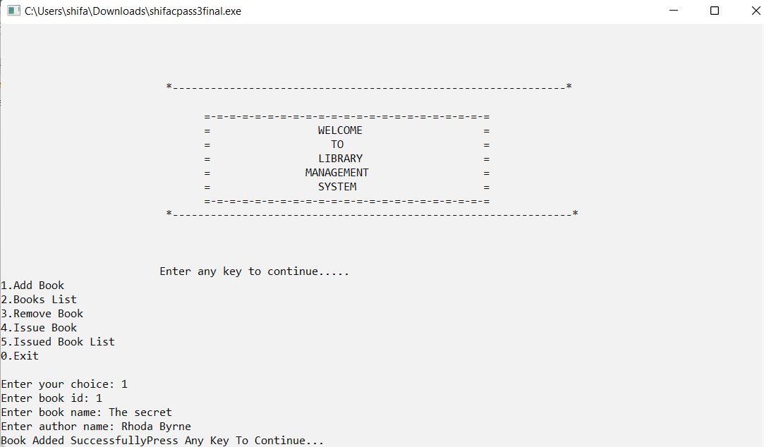







**Displaying book list:**

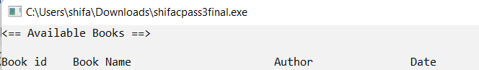

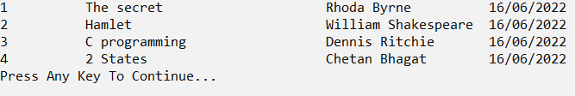

**Removing book:**

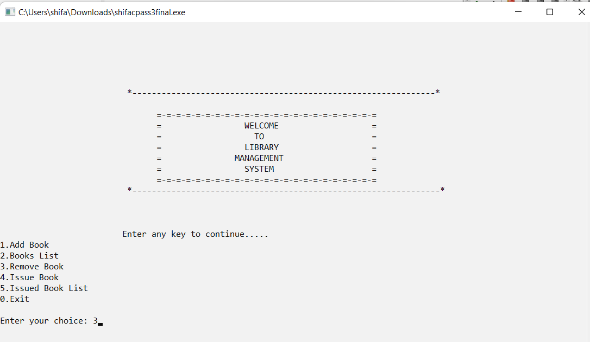

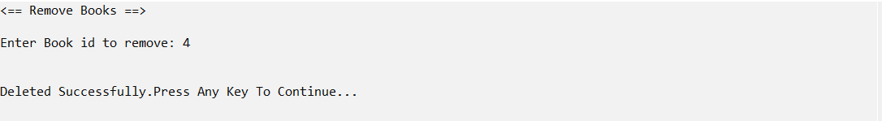



**Displaying : (with removed books )**





**Issue books to students:**

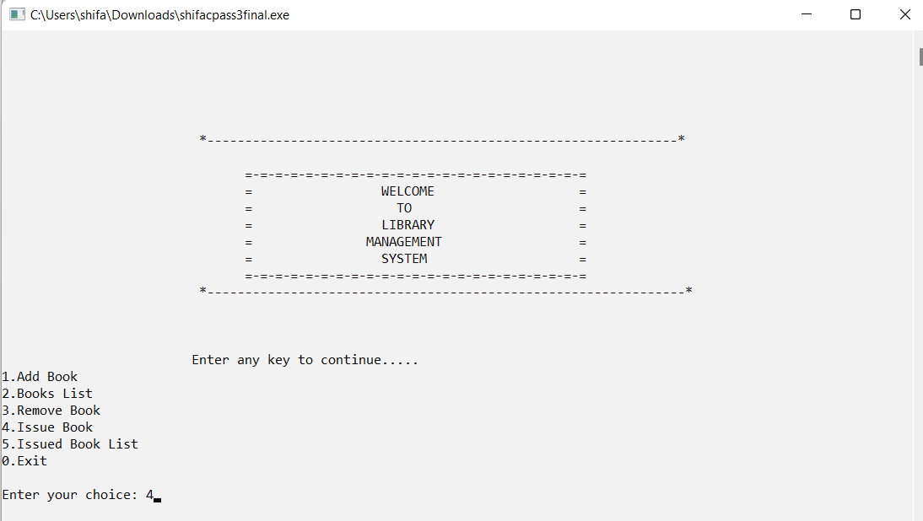

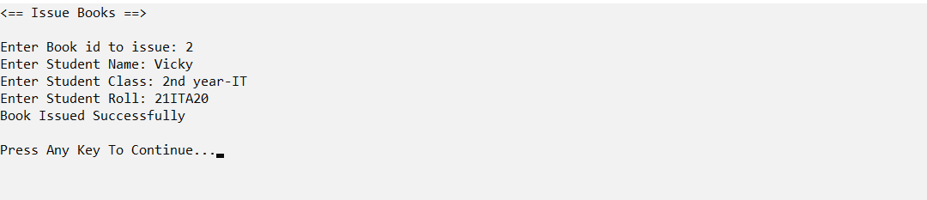

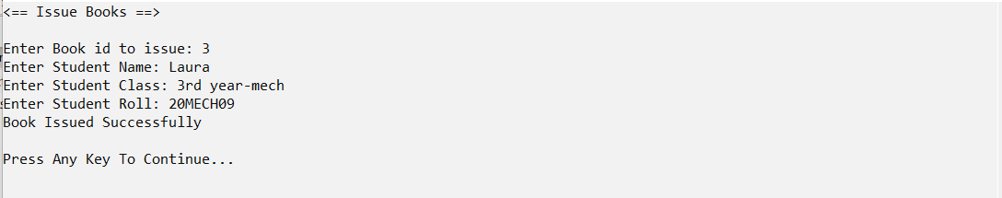

**Issued book list :**



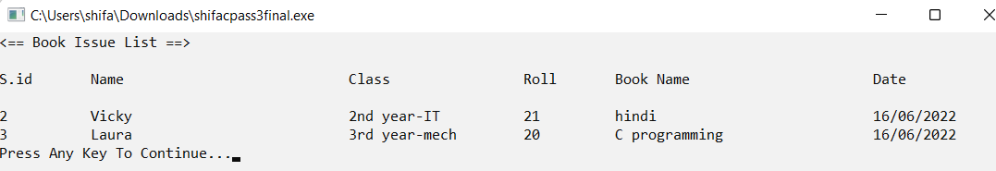

**STEP WISE EXECUTION:**

**The above program allows the user to choose if he wants to add books, or display the book list or issue books or display issue books list or exit.**

1. Start the program with the documentation section containing comments like name of the programmer and other specifications.

2. Followed by the preprocessor section . In the preprocessor section #include<stdio.h>,#include<conio.h>,#include<stdlib.h>,#include<time.h> are used .

3. Then structures are declared with the keyword struct,of different data type and are group together .Here in this program struct students and struct books are declared.

4. Files concept is used because it is usually integrated into computers operating system and is responsible for storing and retrieving information .ie.list of issued books , book list etc.

5. Different functions are used performing different tasks in the program like

void addbook(),void booklist(),void issuebook(),void issuelist() and void del()

6.Switch case with keyword break ; along with loops are used inside the main function.

7. Use printf() and scanf() statements to get the input as well as the output.

(both these functions are inbuilt library functions defined by stdio.h header file.) and insert semicolon where ever necessary to the the required output.

**RESULT:**

In this exercise, I have implemented the Library management system using structures and functions in “C” and the output was verified successfully.