**TASK 3**

**1-2:**

**Open the hello_world.py file you just created. Make a typo somewhere in the line and run the program again.**

**Can you make a typo that generates an error? Can you make sense of the error message?**

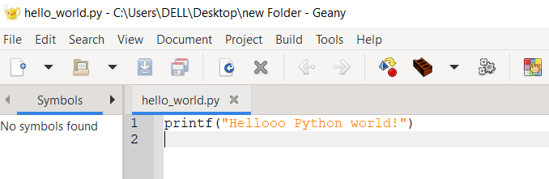

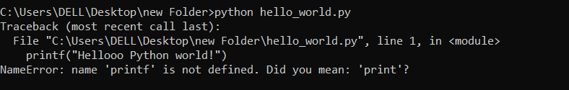

The error is generated as printf is not defined in it, there is no function as printf in python.

**Can you make a typo that doesn’t generate an error? Why do you think it didn’t make an error?**

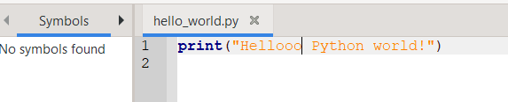

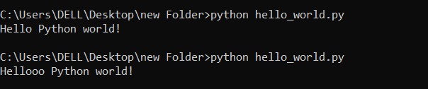

This typo doesn’t generated error because I simply added more Os in Hello that doesn’t cause any error.

Can also add semi colon that doesn’t generate any error like below, because it is a part of syntax of python that it can terminate with semi colon and doesn’t generate error.

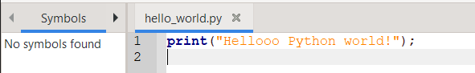

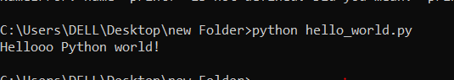

**1-3:**

**Infinite Skills: If you had infinite programming skills, what would you build? You’re about to learn how to program. If you have an end goal in mind, you’ll have an immediate use for your new skills; now is a great time to draft descriptions of what you’d like to create. It’s a good habit to keep an “ideas” notebook that you can refer to whenever you want to start a new project. Take a few minutes now to describe three programs you’d like to create.**

1. Bluetooth enabled attendance system: I would like to create a Bluetooth-enabled attendance system that uses Bluetooth technology to record and track attendance. This system involves a Bluetooth-enabled device, such as a smartphone or a tablet, which is used to mark the attendance of individuals who carry Bluetooth-enabled devices.
2. A virtual reality platform for education: I would create a virtual reality platform that could be used for educational purposes. The platform would allow users to explore different environments, interact with objects and people, and experience a wide range of sensations. It could be used to teach subjects like history, science, and geography in a more immersive and engaging way.
3. Recommendation system: I would like to build an intelligent system that suggests items or content to users based on their preferences, behavior, and historical data. That can be used in e-commerce, media, social media, and other industries to provide personalized recommendations to users and increase engagement.

**2-1:**

**Simple Message: Store a message in a variable, and then print that message.**

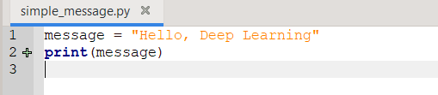

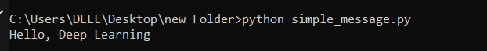

**2-2**

**Simple Messages: Store a message in a variable, and print that message. Then change the value of your variable to a new message, and print the new message.**

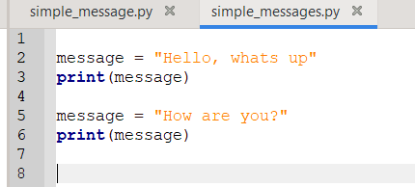

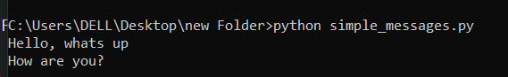

**2-3:**

**Personal Message: Store a person’s name in a variable, and print a message to that person. Your message should be simple, such as, “Hello Eric, would you like to learn some Python today?”**

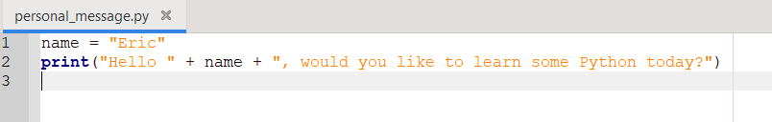

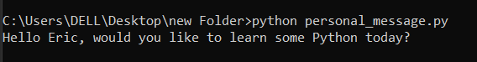

**2-4:**

**Name Cases: Store a person’s name in a variable, and then print that person’s name in lowercase, uppercase, and titlecase.**

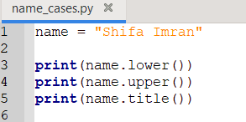

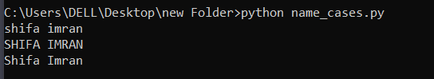

**2-5:**

**Famous Quote: Find a quote from a famous person you admire. Print the quote and the name of its author. Your output should look something like the following, including the quotation marks: Albert Einstein once said, “A person who never made a mistake never tried anything new.”**

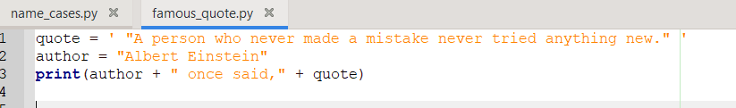



**2-6:**

**Famous Quote 2: Repeat Exercise 2-5, but this time store the famous person’s name in a variable called famous_person. Then compose your message and store it in a new variable called message. Print your message.**

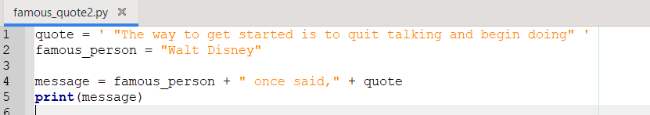



**2-7:**

**Stripping Names: Store a person’s name, and include some whitespace characters at the beginning and end of the name. Make sure you use each character combination, "\t" and "\n", at least once. Print the name once, so the whitespace around the name is displayed. Then print the name using each of the three stripping functions, lstrip(), rstrip(), and strip().**

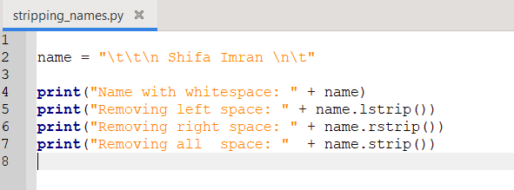

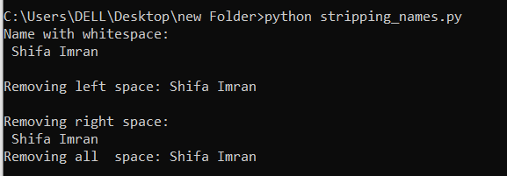

**2-8:**

**Number Eight: Write addition, subtraction, multiplication, and division operations that each result in the number 8. Be sure to enclose your operations in print statements to see the results. You should create four lines that look like this: print(5 + 3)**

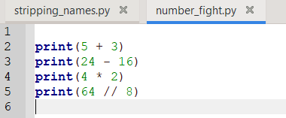

Note: for division “//” is used to force result to in int, otherwise with “/” it comes in float i.e 8.0

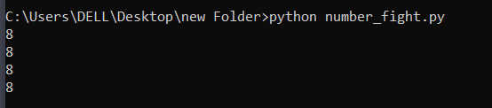

**2-9:**

**Favorite Number: Store your favorite number in a variable. Then, using that variable, create a message that reveals your favorite number. Print that message.**

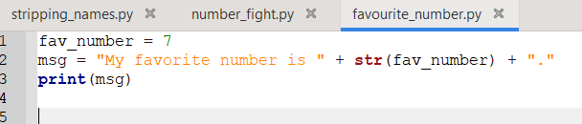



**2-10:**

**Adding Comments: Choose two of the programs you’ve written, and add at least one comment to each. If you don’t have anything specific to write because your programs are too simple at this point, just add your name and the current date at the top of each program file. Then write one sentence describing what the program does.**

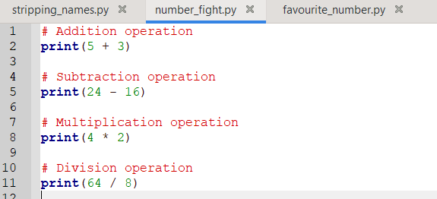

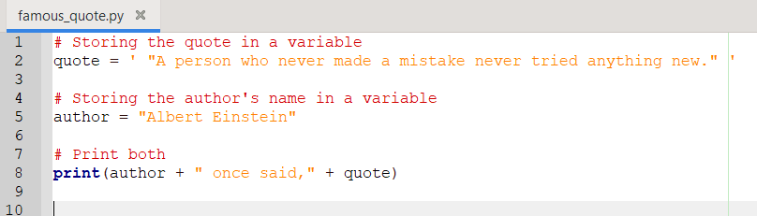

**2-11:**

**Zen of Python: Enter import this into a Python terminal session and skim through the additional principles.**

