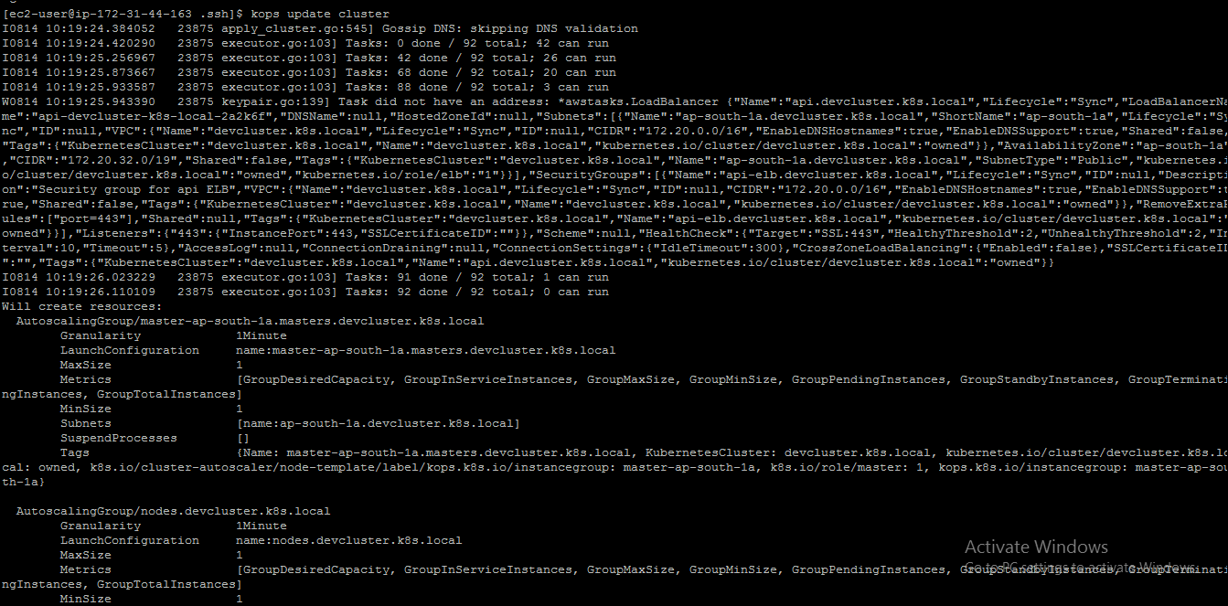

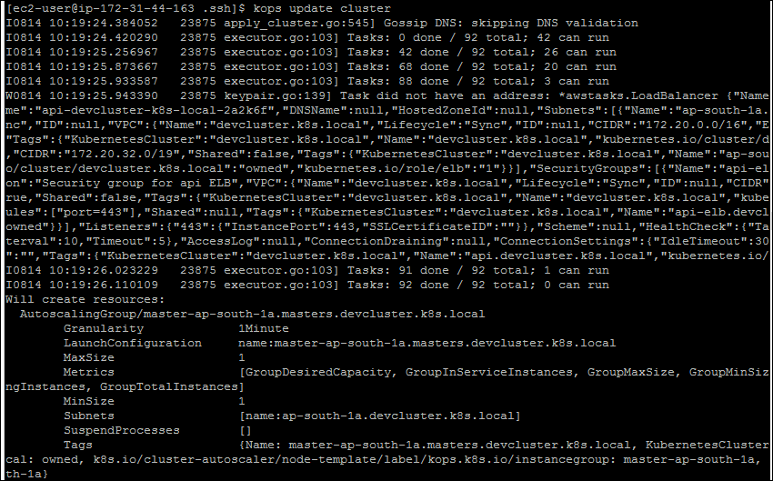

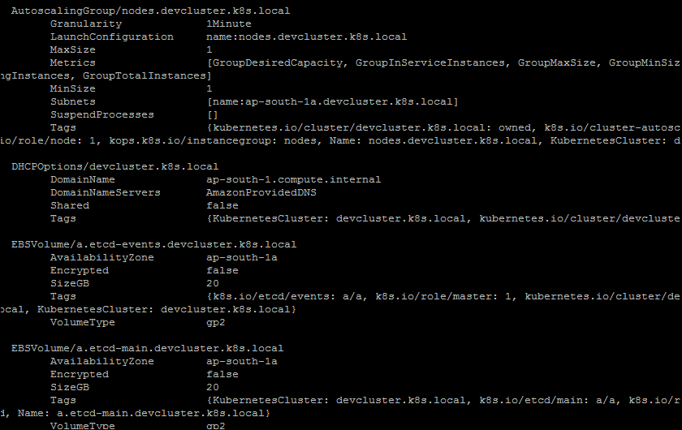

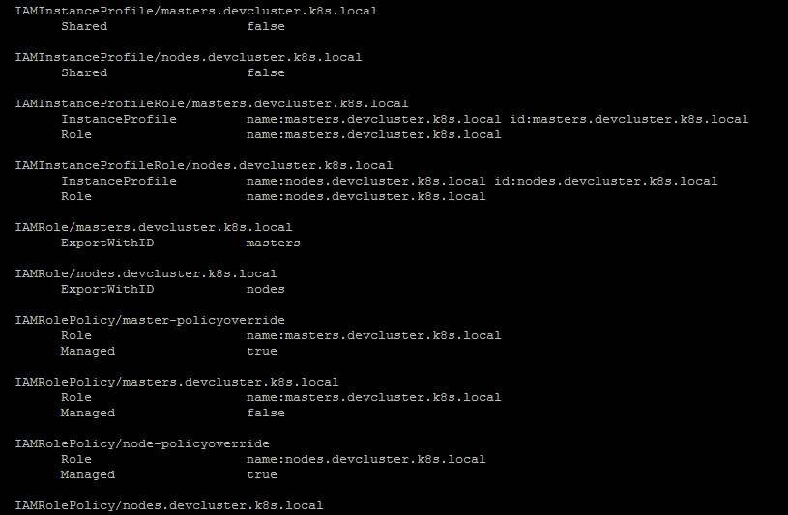

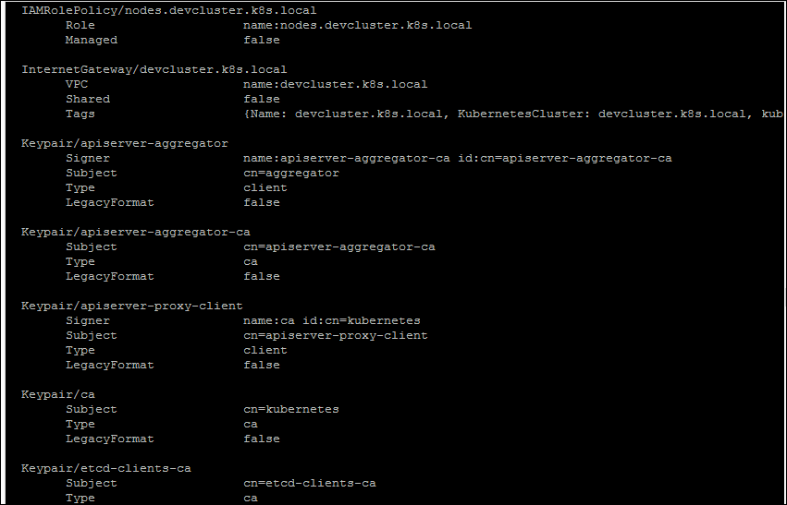

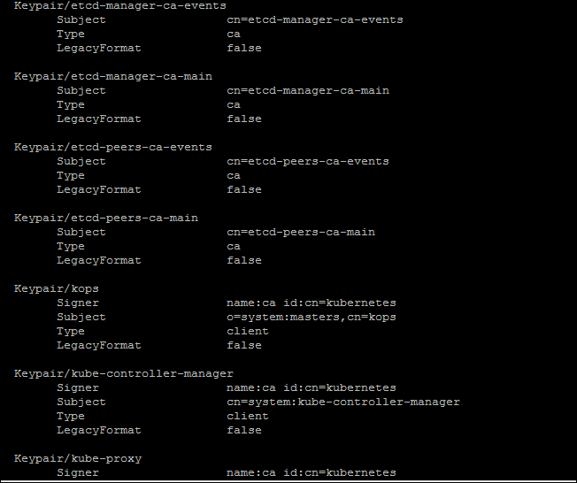

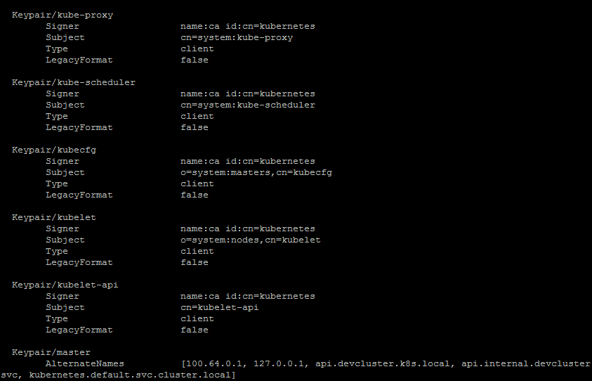

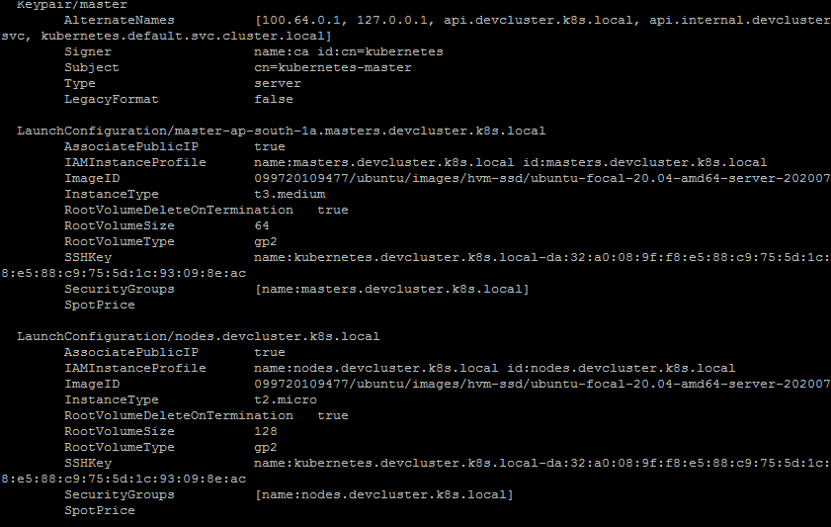

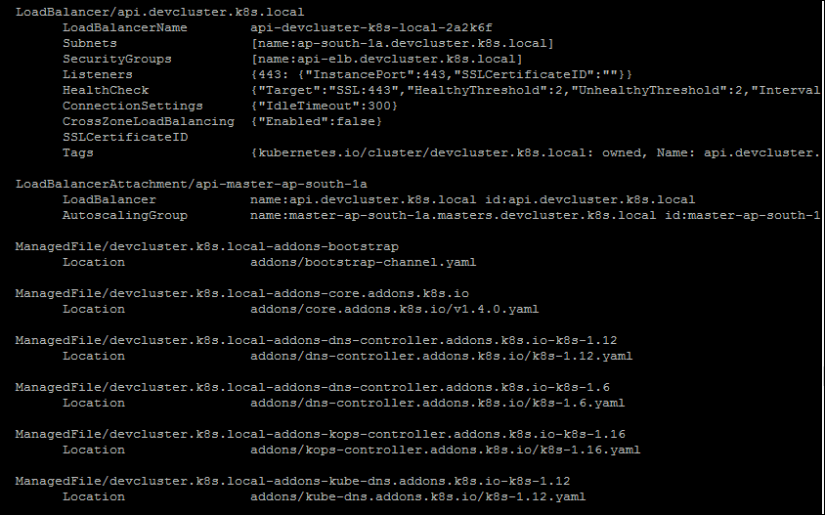

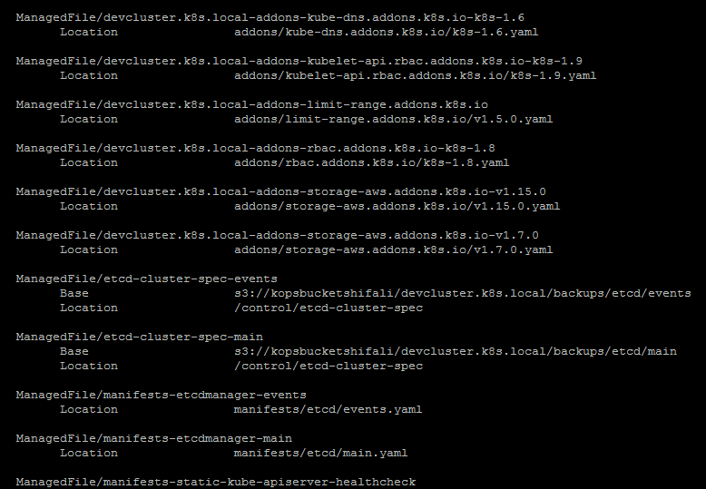

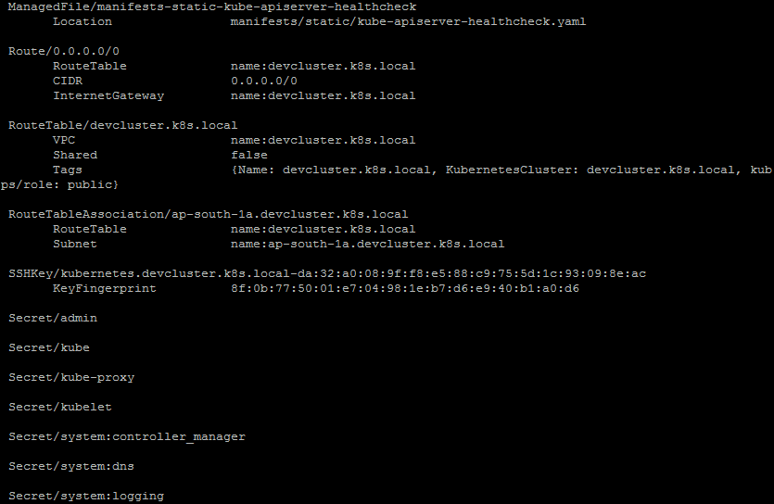

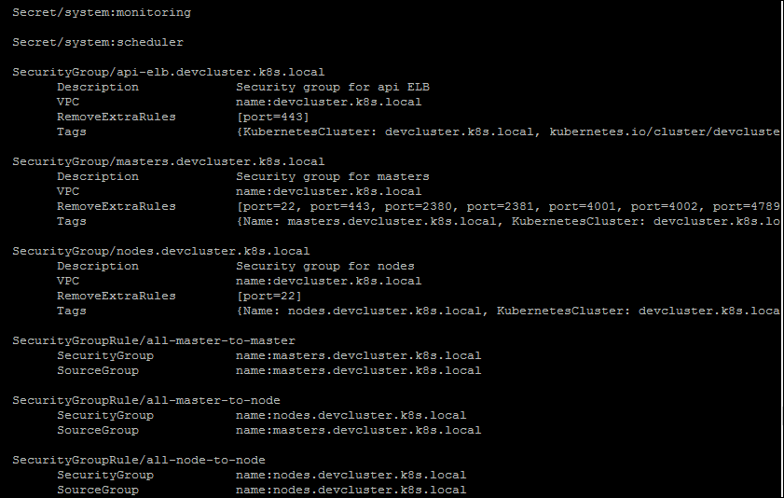

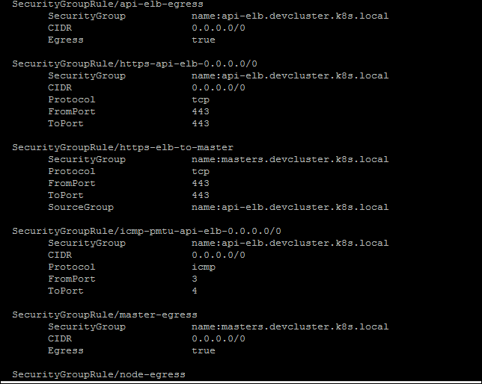

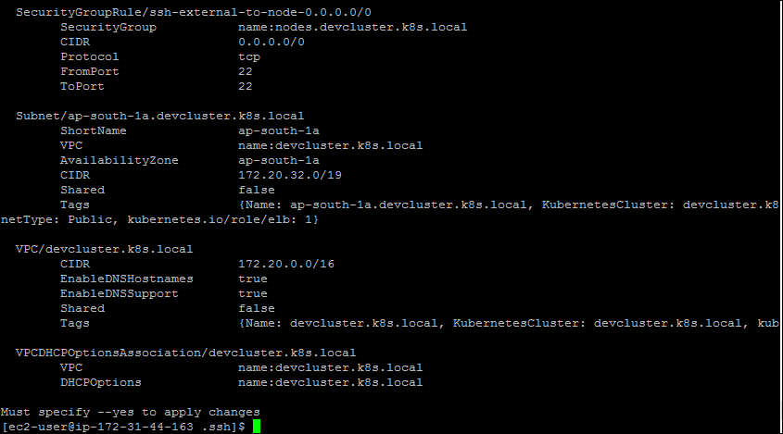

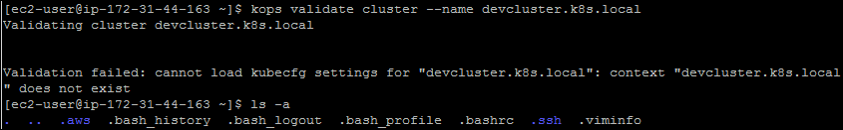

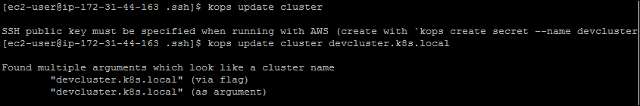

Ssh-keygen

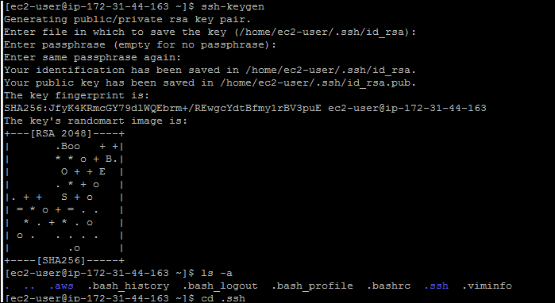

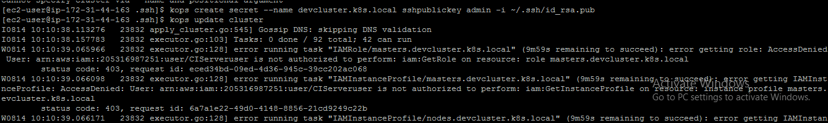

kops create secret --name devcluster.k8s.local sshpublickey admin -i ~/.ssh/id_rsa.pub

post this also some access related errors

therefore gave my user all the admin rights

now we are good

kops update cluster --name ${KOPS_CLUSTER_NAME} –yes

after running this command .kube folder was created

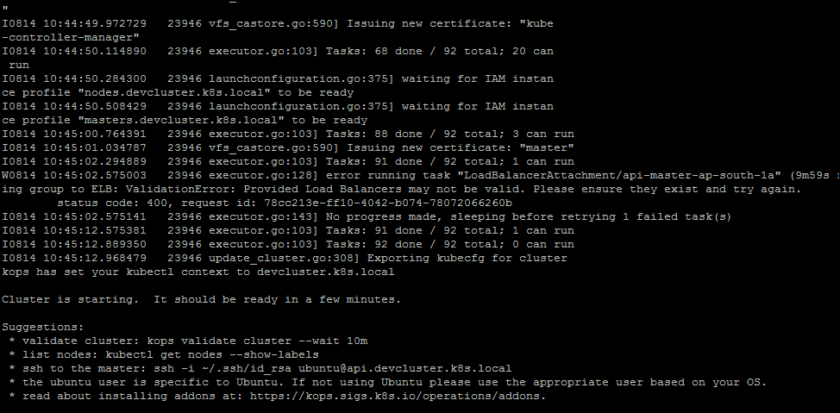

<https://medium.com/containermind/how-to-create-a-kubernetes-cluster-on-aws-in-few-minutes-89dda10354f4>

deleted the cluster for now .

Install Jenkins

1. Install java .

sudo yum install java-1.8.0-openjdk-devel

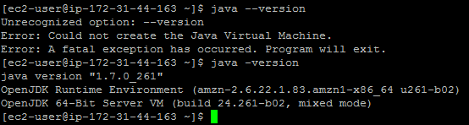

Install the keys correctly look for new ones if required

<https://medium.com/@mohan08p/install-and-configure-jenkins-on-amazon-ami-8617f0816444>

<http://mirrors.jenkins-ci.org/redhat/>

try accessing on public IP , if unable to acess means trouble with inbound rules

<https://devops.stackexchange.com/questions/2102/jenkins-installed-on-aws-unable-to-launch-on-browser>

nomal enter the password from /var/lib/Jenkins/secrets/initialAdminPassword file nter on console and mode ahead user admin passwprd admin

<http://ec2-13-127-62-233.ap-south-1.compute.amazonaws.com:8080/>

now u have a fresh Jenkins dashboard available for use

now create a git project with a minimal jenkinsfile try using it here in Jenkins

1. Install git on ur machine to perform checkout

<https://cloudaffaire.com/how-to-install-git-in-aws-ec2-instance/>

#Create an EC2 instance with Amazon Linux 2 with internet access

#Connect to your instance using putty

#Perform a quick update on your instance:

sudo yum update -y

#Install git in your EC2 instance

sudo yum install git -y

#Check git version

git version

once your jobs run they are stored at : /var/lib/jenkins/workspace/job1

install maven to run maven phases

<https://smartechie.com/srplilu0gmail-com/trending/installing-maven-using-yum-on-ec2-instance-amazon-linux/>

* sudo wget http://repos.fedorapeople.org/repos/dchen/apache-maven/epel-apache-maven.repo -O /etc/yum.repos.d/epel-apache-maven.repo
* sudo sed -i s/\$releasever/6/g /etc/yum.repos.d/epel-apache-maven.repo
* sudo yum install -y apache-maven
* mvn –version

**no need to mention mvn installation unless using multi agent (I think)**

Install docker on the same instance

<https://www.lewuathe.com/how-to-install-docker-in-amazon-linux.html>

ERROR : Got permission denied while trying to connect to the Docker daemon socket at unix:///var/run/docker.sock: Post

SOLUTION : sudo chmod 666 /var/run/docker.sock

ERROR: java.lang.NoSuchMethodError: No such DSL method 'withDockerRegistry' found among steps

SOLUTION: docker various docker related plugins

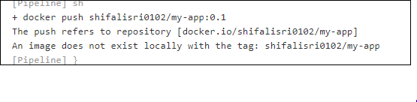

This shows how your image needs to be tagged to be pushed to ur docker hub account