**INTERNSHIP REPORT**

**On**

Front End Development Using HTML, CSS and JS

**Duration**: 15 June 2022 – 15 August 2022

**By**

Shifa Mahveen

1604-19-733-068

MUFFAKHAM JAH COLLEGE OF ENGINEERING AND TECHNOLOGY

Affiliated to Osmania University & Recognized by AICTE

Banjara Hills, Hyderabad 500034



**INDEX**

|  |  |  |
| --- | --- | --- |
| **S.NO** | **TITLE OF CONTENTS** | **PAGE NO** |
| 1. | Certificate | 3 |
| 2. | Declaration | 4 |
| 3. | Abstract | 5 |
| 4. | Introduction | 6 |
| 5. | HTML | 8 |
| 6. | CSS | 10 |
| 7. | JavaScript | 12 |
| 8. | Bootstrap | 13 |
| 9. | Figma | 15 |
| 10. | Project Description | 18 |
| 11. | References | 22 |

**CERTIFICATE**

**DECLARATION**

This is to certify that the work reported in the present project titled “**Front End Development using HTML, CSS and JS**” is a record of Bonafide work done by **Shifa Mahveen** as part of an online internship for a duration of 2 months starting from 15 June 2022 to ending at 15 August 2022 at **Prabhavathi Digital Services** Private Limited which is an IT Services and IT Consulting startup company. The report is based on the project work done entirely by me and not copied from any other source.

Shifa Mahveen

1604-19-733-068

**ABSTRACT**

A front-end developer is responsible for linking the world of design as well as technology together. This includes client-side development using HTML, CSS, and JavaScript for developing web applications and effective interaction between the product or service. In general, everything you see, use, or click on a website to retrieve specific information is a front-end developer’s work. Content, design layout, images, navigation, and internal linking are all closely connected with the front-end developer responsibilities.

A front-end developer’s role is to make sure a user can access the website without any hassle or further guidance at its convenience. There are chances that a user may access your website from various platforms like desktop, tablets or mobile phones of varying dimensions and browsers in today’s digital world, so all the possibilities should be comprehensively covered without any bugs or errors from the front-end side.

It is essential to determine the website structure and design according to the end user requirements. When developing a website, many HTML pages should be linked and designed to characterize the site architecture by the front-end developers.

Front end development and UX design are once used internally and externally as usability provides UX’s essential contribution. Figma is one such popular UI/UX design framework which is used to map the basic idea of the website design and structure. The front-end developer primary responsibility is that the UI design and project’s main design are the same and develop the feature that matches the UI design. They improve the front-end user experience with real time features and make it attractive to increase customer satisfaction.

A variety of markup languages using the suitable front-end framework are required to write web pages. HTML is the standard markup language widely used for designing web applications and it can be assisted by CSS and JavaScript. Framework like Bootstrap also provide a better experience of designing websites.

**INTRODUCTION**

As a full-time student at MJCET, I was provided an opportunity to undertake an internship at Prabhavathi Digital Services. The degree towards I am currently studying is a Bachelor of Engineering in Computer Science and Technology. My role in Internship was a FRONT-END DEVELOPER. This report is a description of my 2 months internship carried out at Prabhavathi Digital Services.

In the following chapter details of tools and technology used and an overview is given. Afterwards, description of my role and tasks as a trainee and some specific technical details about my main tasks.

**Introduction about frontend development**

Front-end web development, or client-side development, refers to working with HTML, CSS and JavaScript for a website or web application that allows users to see and interact with them directly. It is the act of changing over information to a graphical interface for the client to see and connect with information through computerized cooperation utilizing HTML, CSS.

The main challenge in front end development is that the tools and techniques used to build a website’s front end are subject to constant change. This means that a front-end developer needs to keep tabs on how the field is evolving, what are the latest tools and so on. Such a developer working on the site’s front-end has to come up with a format that makes it easy for the user to open and read relevant information on the said site. Moreover, with users accessing websites through different devices with varying screen sizes and resolutions, front-end developers have to deal with greater levels of complexity. Now they need to ensure that their site comes up correctly in different browsers, on different devices and on different operating systems (cross-platform)

**Objectives**

The objective of the web design is to handle the entire design of a website. The Software keeps track of all the information about the entire website. The system contains database where all the information will be stored safely.

**To gain skills and knowledge**

This internship provided us essential skills and knowledge one requires in the field of web designing. The crucial tools used during the tenure helped us in gaining knowledge about programming languages.

**To get field work experience**

By taking this training we enhanced our knowledge in web designing and got insight in how the websites are designed using HTML, CSS.

**To enhance our communication skills**

By interacting with my trainee and colleagues I got to learn a lot. It helped me to enhance my communicative skills and represent my work with confidence. It boosted my confidence to design more webpages and creative some great designs just for fun.

**To link theory with practice**

First, we learned the theory aspect and then we put that into practice. By doing the practical work, our concept got clearer and it was easy to code into HTML once we got familiar with it. By putting our theoretical knowledge into practical, coding became more fun.

**To build a network**

By learning how to code in HTML and CSS it is easy to build and design our own websites with all the changes we want. We also got to know about how websites are designed initially and the logic behind that.

* **Tools and Technologies Used**

1. HTML5

2. CSS3

3. JavaScript

**HTML**

HTML stands for Hyper Text Mark-up Language. It is used to design web pages using mark-up language. HTML is the combination of Hypertext and Mark-up language. Hypertext defines the link between the web pages. Mark-up language is used to define the text document within tag which defines the structure of web pages. HTML5 is the fifth and current version of HTML. It has improved the mark-up available for documents and has introduced application programming interfaces (API) and Document Object Model (DOM). It can be assisted by technologies such as Cascading Style Sheets (CSS) and scripting languages such as JavaScript. HTML describes the structure of a web page semantically and originally included cues for the appearance of the document. HTML elements are the building blocks of HTML pages. With HTML constructs, images and other objects such as interactive forms may be embedded into the rendered page.

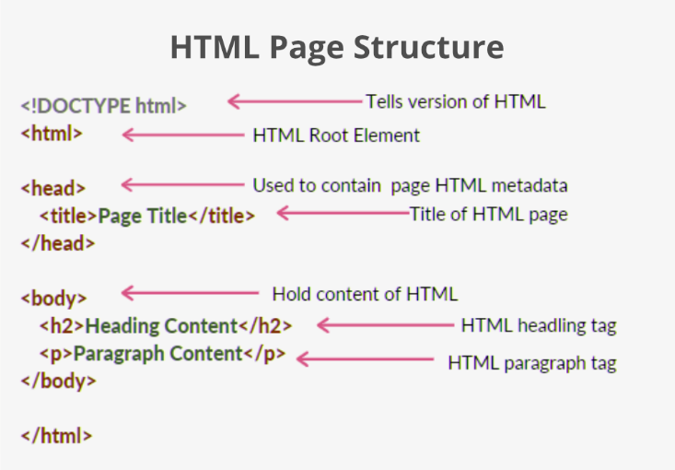

There are different HTML elements for different purpose like <h>,<img>,<form>,<a>, <section>,<div> with their own attributes which defines the tags in a correct and semantic manner.

The objective of the web design is to handle the entire

design of a website. The software keeps track of all the

information about the entire website. The system contains

database where all the information will be stored safely.

Basic Concept (WWW & HTTP, client server

communication)

Basic Concept (WWW & HTTP, client server

communication)

* **Basic Concept** (WWW & HTTP, client server communication)
* **Basic HTML** (tags, element, attributes, paragraphs, headings, line breaks, lists, table, color codes, font, text linking, email, images, background, comments, media, charset)
* **HTML Forms** (input, text fields, password, checkbox, combo-box, radio box, text areas, files, buttons)
* **HTML features:**

1. It is easy to learn, User Friendly and Simple.
2. Semantic Structured.
3. It is platform-independent.
4. Images, videos, and audio can be added to a web page.
5. Hypertext can be added to the text.
6. Local storage and indexed DB- Client-Side data storage.
7. Canvas for Game Development.

**CSS3**

Cascading Style Sheets, fondly referred to as CSS, is a simply designed language intended to simplify the process of making web pages presentable. CSS allows you to apply styles to web pages. More importantly, CSS enables you to do this independent of the HTML that makes up each web page. CSS3 is the latest version of an earlier CSS version, CSS2.

There are three types of CSS which are given below:

* Inline CSS
* Internal or Embedded CSS
* External CSS

**Key Models of CSS3:**

1. Box model
2. Image values and replaced content
3. Text effects
4. Selectors
5. Backgrounds and Borders
6. Animations
7. User Interface (UI)
8. Multiple column layouts
9. 2D/3D transformations

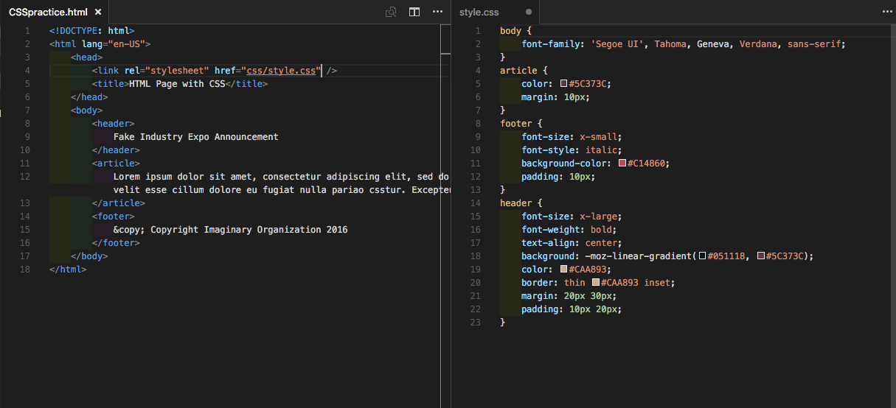

* **Basic CSS** (selector, internal, external, inline, class, id, background, font, text, padding, margin, border, list CSS, hovering and elements)
* **Box Model**

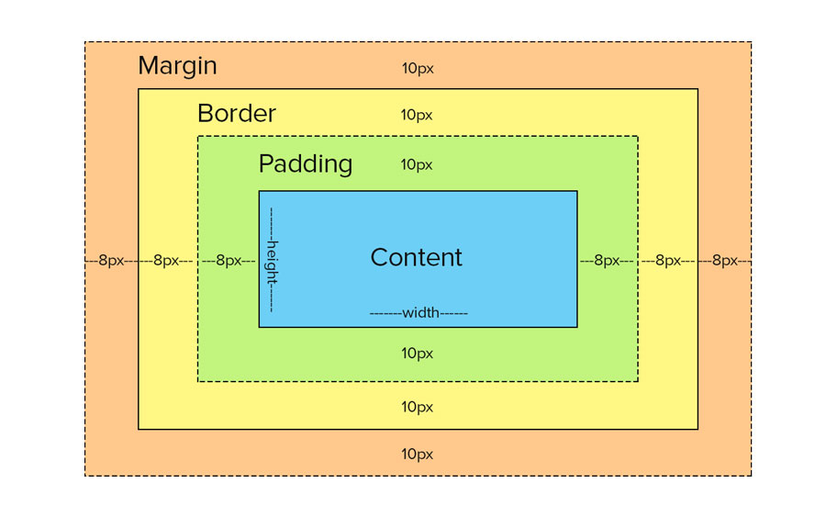

* **Advance CSS** (border-radius, opacity, cursor, layers, position, display, float, gradient and multiple-column)
* **Concept of Menu** (single menu, drop-down menu)
* Template design using CSS div.

**JavaScript**

**JavaScript** is a lightweight, cross-platform, and interpreted compiled programming language which is also known as the scripting language for webpages.  JavaScript can be used for **Client-side** developments as well as **Server-side** developments. JavaScript is both imperative and declarative type of language.

JavaScript can be added to your HTML file in two ways:

* **Internal JS:** We can add JavaScript directly to our HTML file by writing the code inside the <script> tag. The <script> tag can either be placed inside the <head> or the <body> tag according to the requirement.
* [**External JS**](https://www.geeksforgeeks.org/what-is-external-javascript/)**:** We can write JavaScript code in other file having an extension.js and then link this file inside the <head> tag of the HTML file in which we want to add this code.

**Features of JavaScript:**

1. Object-Centered Scripting Language
2. Client edge Technology
3. Validation of User’s Input
4. Interpreter Centered
5. Ability to perform Inbuilt Functions
6. Handling Events

**Applications of JavaScript:**

* Web Development
* Web Applications
* Server Applications
* Games
* Smart Watches
* Machine Learning
* Mobile Applications

**BOOTSTRAP**

**What is Bootstrap?**

Bootstrap is a [free, open source](https://www.techtarget.com/whatis/definition/Free-and-open-source-software-FOSS-or-free-libre-open-source-software-FLOSS) [front-end](https://www.techtarget.com/whatis/definition/front-end) development framework for the creation of websites and web apps. Designed to enable [responsive](https://www.techtarget.com/whatis/definition/responsive-design) development of [mobile-first](https://www.techtarget.com/searchmobilecomputing/definition/mobile-first) websites, Bootstrap provides a collection of syntax for template designs.

As a framework, Bootstrap includes the basics for responsive web development, so developers only need to insert the code into a pre-defined grid system. The [Bootstrap framework](https://www.theserverside.com/quiz/12-tough-Bootstrap-5-quiz-questions-for-web-developers) is built on Hypertext Markup Language ([HTML](https://www.theserverside.com/definition/HTML-Hypertext-Markup-Language)), cascading style sheets ([CSS](https://www.theserverside.com/definition/cascading-style-sheet-CSS)) and [JavaScript](https://www.theserverside.com/definition/JavaScript). Web developers using Bootstrap can build websites much faster without spending time worrying about basic commands and functions.

### What is Bootstrap used for?

Bootstrap makes responsive web design a reality. It makes it possible for a web page or app to detect the visitor's screen size and orientation and automatically adapt the display accordingly. The mobile-first approach assumes [smartphones](https://www.techtarget.com/searchmobilecomputing/definition/smartphone), [tablets](https://www.techtarget.com/searchmobilecomputing/definition/tablet-PC) and task-specific mobile apps are employees' primary tools for getting work done. Bootstrap addresses the requirements of those technologies in design and includes [UI](https://www.techtarget.com/searchapparchitecture/definition/user-interface-UI) components, layouts, JavaScript tools and the implementation framework. The software is available precompiled or as [source code](https://www.techtarget.com/searchapparchitecture/definition/source-code).

**Mark Otto** and **Jacob Thornton** developed Bootstrap at Twitter to improve the consistency of tools used on the site and to reduce maintenance. The software was formerly known as Twitter Blueprint and is sometimes referred to as Twitter Bootstrap.

## **Why Use Bootstrap?**

Advantages of Bootstrap:

* **Easy to use:** Anybody with just basic knowledge of HTML and CSS can start using Bootstrap
* **Responsive features:** Bootstrap's responsive CSS adjusts to phones, tablets, and desktops
* **Mobile-first approach:** In Bootstrap 3, mobile-first styles are part of the core framework
* **Browser compatibility:** Bootstrap is compatible with all modern browsers (Chrome, Firefox, Internet Explorer, Edge, Safari, and Opera)

## **Bootstrap Versions**

This tutorial follows **Bootstrap 3**, which was released in 2013. However, we also cover newer versions; [**Bootstrap 4 (released 2018)**](https://www.w3schools.com/bootstrap4/default.asp) and [**Bootstrap 5 (released 2021)**](https://www.w3schools.com/bootstrap5/index.php)**.**

[**Bootstrap 5**](https://www.w3schools.com/bootstrap5/index.php) is the newest version of [**Bootstrap**](https://www.w3schools.com/bootstrap/default.asp); with new components, faster stylesheets, more responsiveness etc. It supports the latest, stable releases of all major browsers and platforms. However, Internet Explorer 11 and down is not supported.

The main differences between Bootstrap 5 and Bootstrap 3 & 4, is that Bootstrap 5 has switched to [**JavaScript**](https://www.w3schools.com/js/default.asp)instead of [**jQuery**](https://www.w3schools.com/jquery/default.asp).

## **Where to Get Bootstrap?**

There are two ways to start using Bootstrap on your own web site.

You can:

* Download Bootstrap from getbootstrap.com
* Include Bootstrap from a CDN

## **Downloading Bootstrap**

If you want to download and host Bootstrap yourself, go to [getbootstrap.com](http://getbootstrap.com/getting-started/), and follow the instructions there.

## **Bootstrap CDN**

If you don't want to download and host Bootstrap yourself, you can include it from a CDN (Content Delivery Network).

MaxCDN provides CDN support for Bootstrap's CSS and JavaScript. You must also include jQuery:

MaxCDN:

<!-- Latest compiled and minified CSS -->  
<link rel="stylesheet" href="https://maxcdn.bootstrapcdn.com/bootstrap/3.4.1/css/bootstrap.min.css">  
  
<!-- jQuery library -->  
<script src="https://ajax.googleapis.com/ajax/libs/jquery/3.6.1/jquery.min.js"></script>  
  
<!-- Latest compiled JavaScript -->  
<script src="https://maxcdn.bootstrapcdn.com/bootstrap/3.4.1/js/bootstrap.min.js"></script>

**FIGMA**

[Figma](https://www.toptal.com/designers/figma) is a cloud-based design tool that is similar to [Sketch](https://www.toptal.com/designers/sketch) in functionality and features, but with big differences that make Figma better for [team collaboration](https://www.toptal.com/designers/product-design/collaboration-in-figma-app).

**Figma Works on Any Platform**

Figma works on any operating system that runs a web browser. Macs, Windows PCs, Linux machines, and even Chromebooks can be used with Figma. It is the only design tool of its type that does this, and in shops that use hardware running different operating systems, **everyone** can still share, open, and edit Figma files.

In many organizations, [designers](https://www.toptal.com/designers/figma) use Macs and developers use Windows PCs. Figma helps bring these groups together. Figma’s universal nature also prevents the annoyance of PNG-pong (where updated images are bounced back and forth between design team disciplines). In Figma, there is no need for a mediating mechanism to make design work available to everyone.

**Collaboration in Figma Is Simple and Familiar**

Because Figma is browser-based, teams can collaborate as they would in [Google Docs](https://www.google.com/docs/about/). People viewing and editing a file are shown in the top of the app as circular avatars. Each person also has a named cursor, so tracking who is doing what is easy. Clicking on someone else’s avatar zooms to what they are viewing at that time.

## **Figma Uses Slack for Team Communication**

Figma uses [Slack](http://www.slack.com/) as its communication channel. When a [Figma channel is created in Slack](https://help.figma.com/hc/en-us/articles/360039829154-Receive-Comment-Notifications-in-Slack), any comments or design edits made in Figma are “slacked” to the team. This functionality is crucial when designing live because changes to a Figma file will update every other instance where the file is embedded (a potential headache for developers). Changes to a mockup, warranted or not, are immediately vetted, and the feedback channel is live.

## **Figma Sharing Is Uncomplicated and Flexible**

Figma also allows [permissions-based sharing](https://help.figma.com/hc/en-us/articles/360040530793-Adjust-permissions-on-a-file) of any file, page, or frame (called an artboard in other design tools). When a share link is created to a frame on a page, the person clicking on that link will open a browser version of Figma, and a zoomed-in view of the frame is loaded.

This form of selective sharing, from file down to frame, lets [designers](https://www.toptal.com/designers/ui), product owners, and developers share exactly what is needed in bug tracking tools and community software like [Confluence](https://www.atlassian.com/software/confluence) or [SharePoint](https://www.toptal.com/sharepoint/why-use-sharepoint-business-benefits).

## **Developer Handoff Is Facilitated Using Figma**

Figma displays code snippets on any selected frame or object in CSS, iOS, or Android formats for developers to use when reviewing a design file. The design components can be [inspected by any developer](https://help.figma.com/hc/en-us/articles/360040521453-Optimize-design-files-for-developer-handoff) in any file they can view. There is no need to use a third-party tool to get the information. Even so, Figma has full integration with [Zeplin](https://zeplin.io/) if teams want to do more than simple measurement and CSS display.

## **Figma APIs Provide Third-party Tool Integration**

Figma now has [developer APIs](https://www.figma.com/developers) to allow true integration with any browser-based app. Companies are using this to integrate real-time displays of design files in their apps. For example, Uber has large screens displaying design files “live on air” around their company. Designs are shared, and feedback is welcome from anyone in the company.

Atlassian’s JIRA software has implemented a [Figma add-on](https://marketplace.atlassian.com/vendors/1214930/figma) so product owners, developers, and quality engineers are always viewing the latest version of any mockup from the designers.

Additionally, Figma’s API promises to fulfill customer requests for third-party plugins and feature enhancements that Sketch already provides.

## **Figma Is Built to Enhance Design Teamwork**

Using Figma for any length of time will demonstrate the benefits of this live collaboration tool. It keeps teams on task and encourages full disclosure, essential when building a design system for a variety of disciplines. Figma is easy for anyone to use on any platform, and lets teams share their work and libraries quickly.

[Design experts](https://www.toptal.com/designers/figma) that use Figma after [making the switch from Sketch](https://medium.com/caboodle/why-our-remote-design-team-is-moving-from-sketch-to-figma-2cce088a8b9f) (Sketch files can be imported with parity into Figma) are not disappointed:

**PROJECT DESCRIPTION**

As part of the front-end development team, various front-end based projects were developed which includes websites, web applications or mobile applications. The different languages used include HTML (Hyper Text Markup Language), CSS (Cascading Style Sheets), JavaScript, Bootstrap and Figma. The Code editor used is Visual Studio Code.

1. **Meeting App**

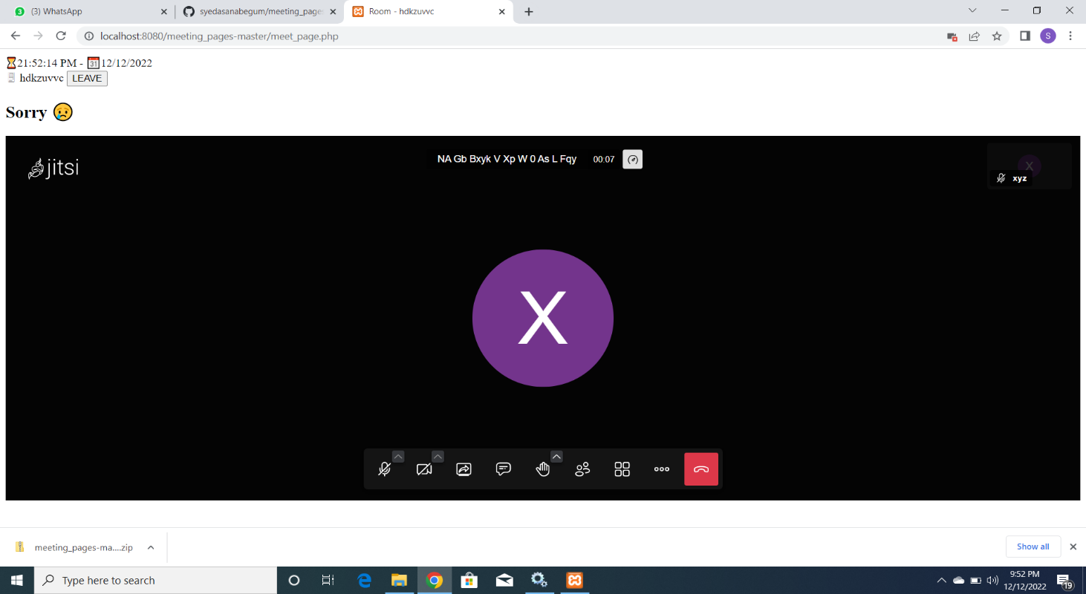

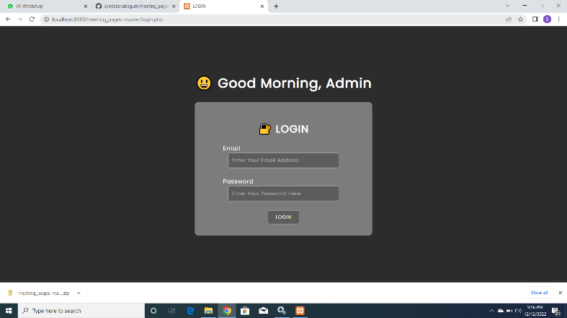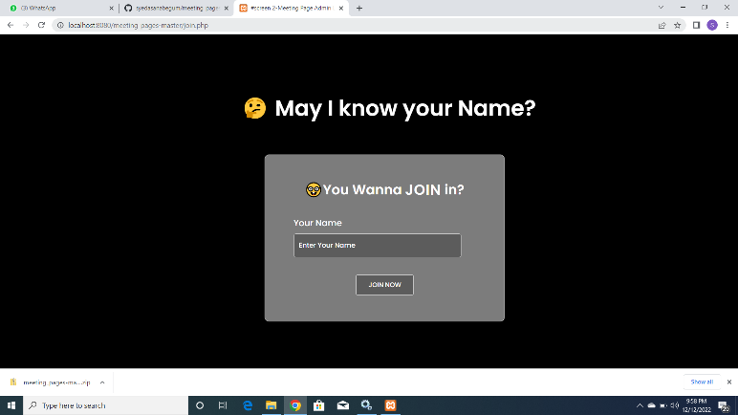

**Fig I. Meeting Web Application Design and Implementation**

A clone meeting web application. It is similar to Microsoft Teams App, which can be used to schedule meetings, chat box and screen share options. It helps connect to various devices which has the application installed on it.

1. **vCard or Visiting Cards**

A vCard enables you to send contact information in a format that can be easily read in other e-mail programs. These cards were designed for professionals whose contact information can be easily accessed and appointment dates can be scheduled appropriately.

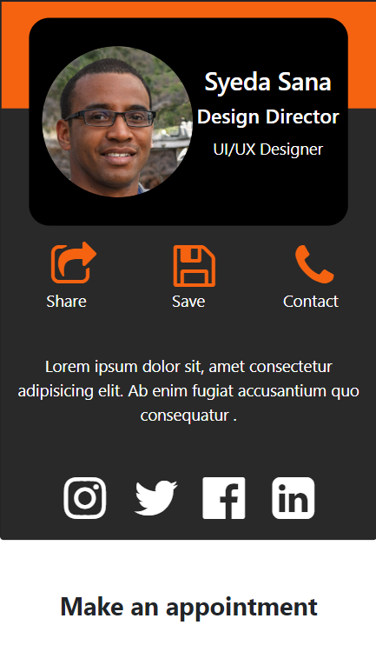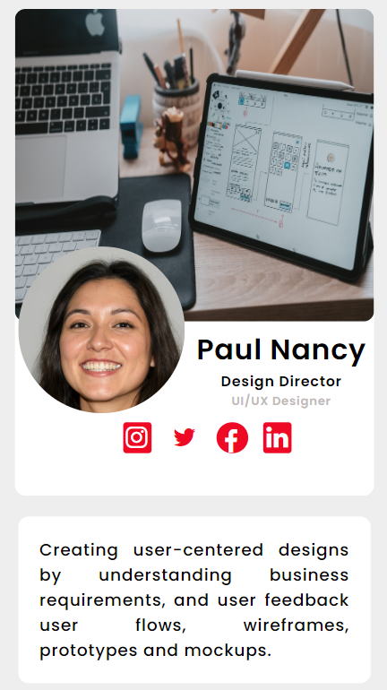

**Fig II. Visiting Cards**

1. **Matrimonial Web Application**

An application built to offer matchmaking services. The Application is developed where separate modules are created for admin and registered users. Its frontend is created using HTML, CSS, JS and Bootstrap.

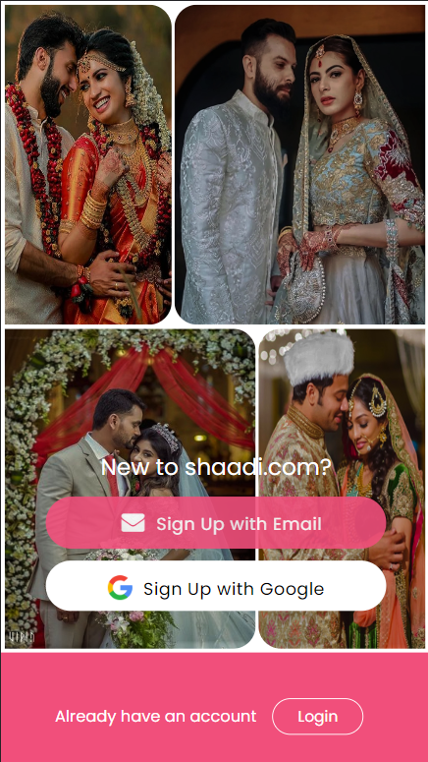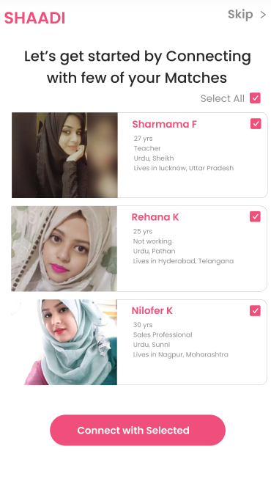

**Fig III. Matrimonial App**

1. **Landing Page**
2. 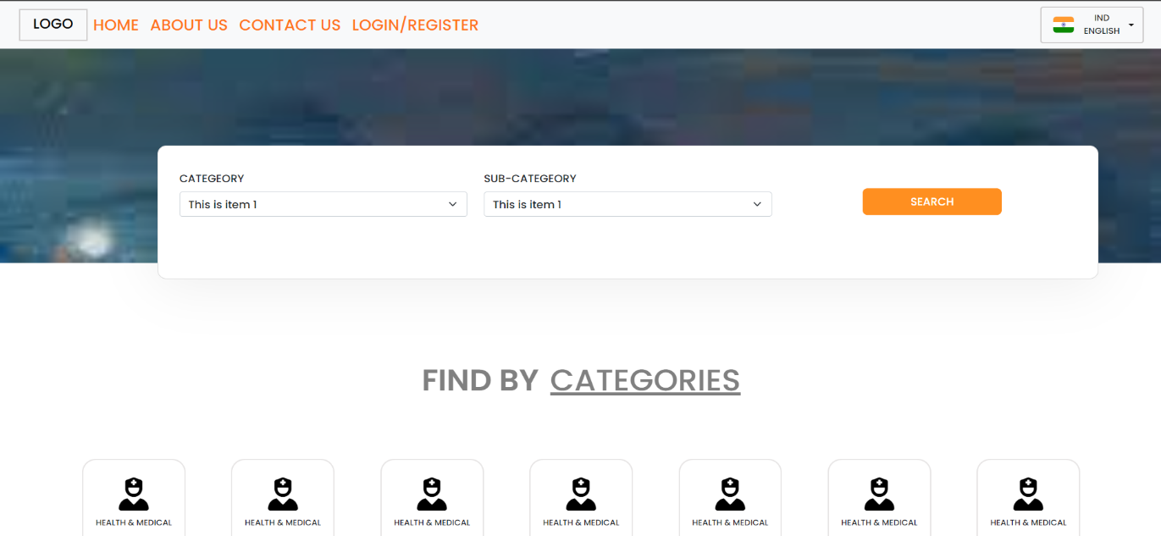

This job portal landing page contains various categories which any applicant can use to apply or search for required posts.

1. **Ecommerce Website**

**Fig V. Attire Shopping Site**

A platform to easily sell and purchase items. This is designed using HTML, CSS and JS which includes features like payment, add to cart.

A website that allows people to buy and sell physical goods, services, and digital products over the internet rather than at a brick-and-mortar location.

**REFERENCES**

1. https://www.w3schools.com/

2. <https://www.freecodecamp.org/>

3. <https://developer.mozilla.org/en-US/>

4. <https://www.geeksforgeeks.org/>

5. https://getbootstrap.com/