MYSQL PROJECT
TOPIC :WALMART SALES DATA ANALYSIS USING MYSQL

INTRODUCTION:
This project undertakes a comprehensive analysis of Walmart sales data using Structured Query Language (MySQL), drawing insights from transaction records and sales-related information sourced from Kaggle. The entire analysis, involving data manipulation, aggregation, filtering, grouping, subqueries, and ranking functions, was executed and verified within the MySQL Workbench environment. The primary objective is to extract key business insights regarding branch performance, revenue generation, customer ratings, product category trends, payment methods, and profit margins. The analysis helps in understanding sales patterns and evaluating the overall performance of Walmart branches through SQL-based data analysis.
TOOL : MySQL WORKBENCH
SUBMITTED BY:
SHIFANA SHERIN
- Find the total number of transactions made in each branch.
SELECT branch,COUNT(*) AS total_transactions
FROM walmart_data GROUP BY branch;
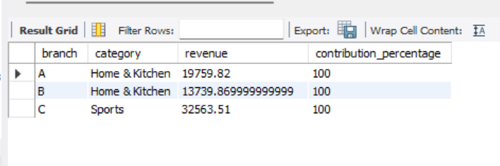
- Calculate the total revenue for each city.
SELECT city, SUM(unit_price * quantity) AS total_revenue FROM walmart_data GROUP BY city;
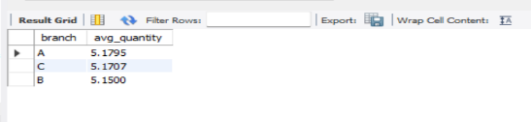
- Find the earliest and latest transaction date in the dataset
SELECT MIN(date) AS earliest_date, MAX(date) AS latest_date
FROM walmart_data;
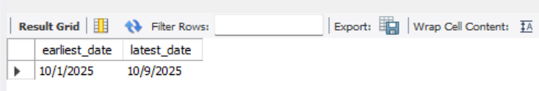
- Calculate the total profit margin for all transactions combined.
SELECT SUM(profit_margin) AS total_profit_margin FROM walmart_data;
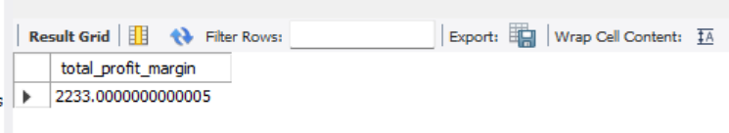
- Display all transactions where the payment method is not “Credit card.”
SELECT * FROM walmart_data WHERE payment_method <> 'Credit card';
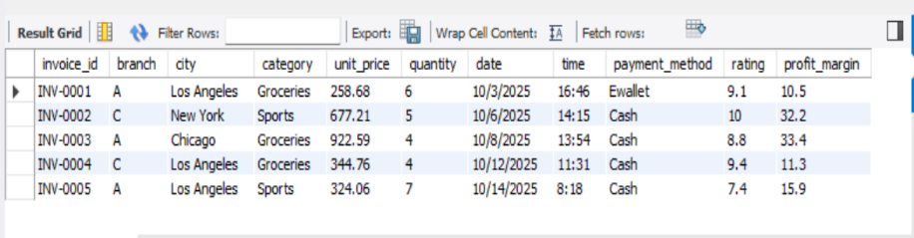
- Calculate the total revenue generated by each payment method.
SELECT payment_method, SUM(unit_price * quantity) AS total_revenue FROM walmart_data GROUP BY payment_method;
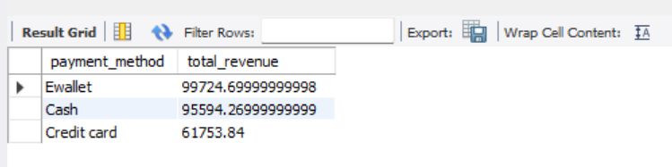
- . Find the average rating given by customers in each city.
SELECT city, AVG(rating) AS avg_rating
FROM walmart_data GROUP BY city;

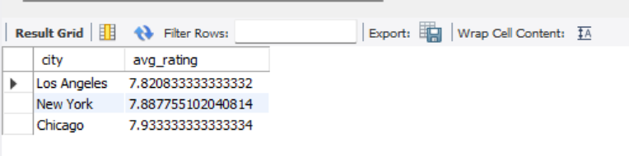

- Identify the top 3 branches with the highest total revenue.
SELECT branch, SUM(unit_price * quantity) AS total_revenue FROM walmart_data GROUP BY branch ORDER BY total_revenue DESC LIMIT 3;
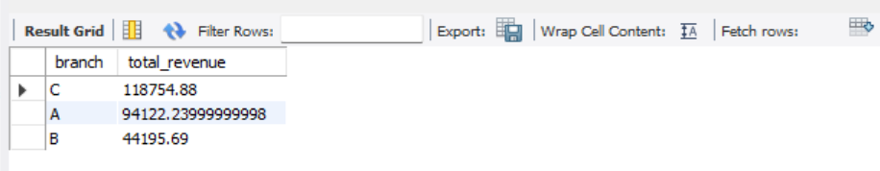

- List all branches where the average profit margin is greater than 15%.
SELECT branch, AVG(profit_margin) AS avg_profit_margin FROM walmart_data GROUP BY branch HAVING AVG(profit_margin) > 15;
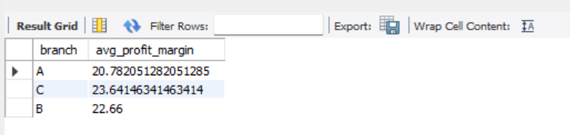
- Find the category that generated the maximum revenue in each city.
SELECT city, category, revenue FROM ( SELECT city, category,
SUM(unit_price * quantity) AS revenue, RANK() OVER(PARTITION BY city ORDER BY SUM(unit_price * quantity) DESC) AS rnk
FROM walmart_data GROUP BY city, category) t
WHERE rnk = 1;
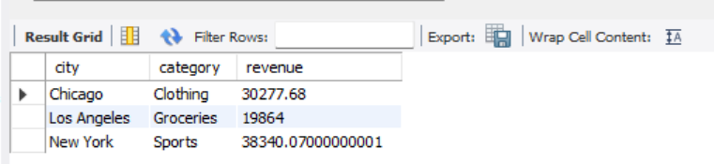

- Display all transactions that occurred on weekends (Saturday or Sunday).
SELECT * FROM walmart_data
WHERE DAYNAME(STR_TO_DATE(date, '%m/%d/%Y'))
IN ('Saturday', 'Sunday') LIMIT 5;
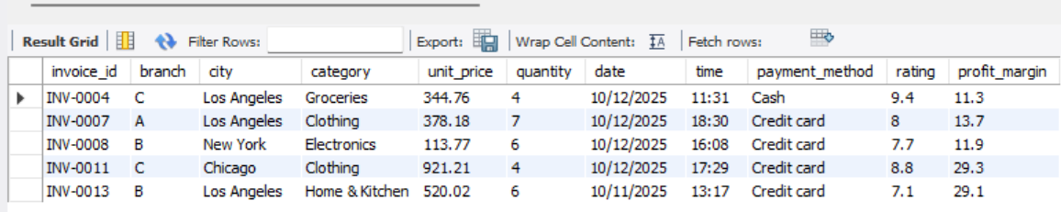

- Find the number of transactions for each payment method per branch..
SELECT branch, payment_method, COUNT(*) AS total_transactions
FROM walmart_data GROUP BY branch, payment_method
LIMIT 5;
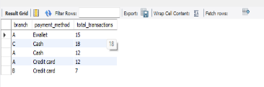
- Find the city with the lowest total revenue.
SELECT city, SUM(unit_price * quantity) AS total_revenue
FROM walmart_data GROUP BY city ORDER BY total_revenue ASC
LIMIT 3;
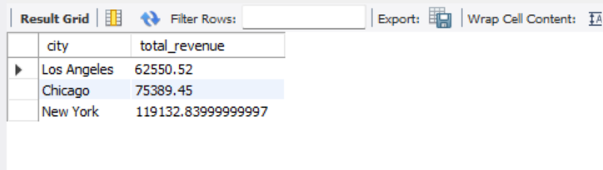
- Rank all cities by total revenue in descending order.
SELECT city, SUM(unit_price * quantity) AS total_revenue,
RANK() OVER(ORDER BY SUM(unit_price * quantity) DESC) AS city_rank
FROM walmart_data GROUP BY city;
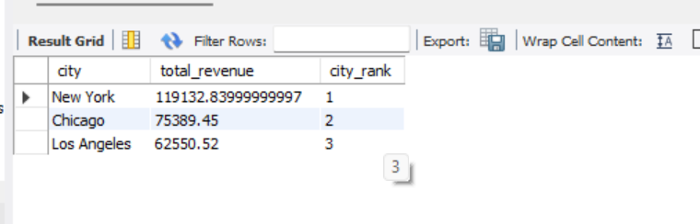
- Find the top 5 branches with the highest number of transactions.
SELECT branch, COUNT(*) AS total_transactions FROM walmart_data
GROUP BY branch ORDER BY total_transactions DESC
LIMIT 5;
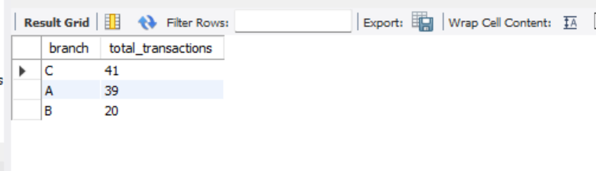
- Calculate the total revenue for each city, including only those with revenue less than or equal to 500.
SELECT city, SUM(unit_price * quantity) AS total_revenue FROM walmart_data
GROUP BY city
HAVING SUM(unit_price * quantity) <= 500;
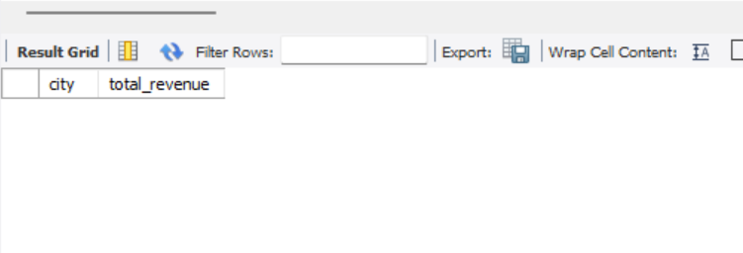
- Find the month and year with the highest number of transactions.
SELECT
YEAR(STR_TO_DATE(date, '%m/%d/%Y')) AS year,
MONTH(STR_TO_DATE(date, '%m/%d/%Y')) AS month,
COUNT(*) AS total_transactions FROM walmart_data
GROUP BY
YEAR(STR_TO_DATE(date, '%m/%d/%Y')),
MONTH(STR_TO_DATE(date, '%m/%d/%Y'))
ORDER BY total_transactions DESC LIMIT 1;
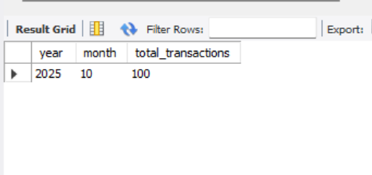

- List all transactions where the total amount exceeds the average revenue of that branch.
SELECT * FROM walmart_data w
WHERE (unit_price * quantity) >
( SELECT AVG(unit_price * quantity) FROM walmart_data
WHERE branch = w.branch)
LIMIT 5;
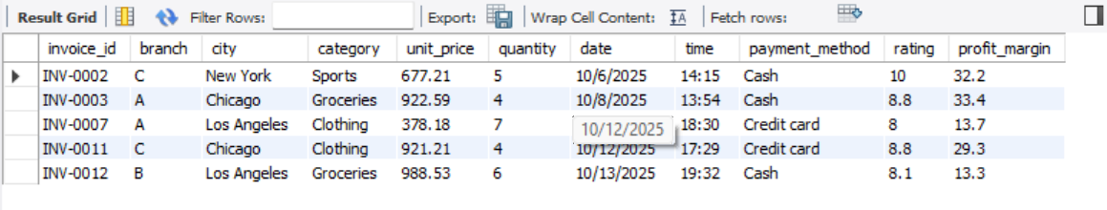

- Find the average quantity of products sold per transaction for each branch.
SELECT branch, AVG(quantity) AS avg_quantity FROM walmart_data
GROUP BY branch;
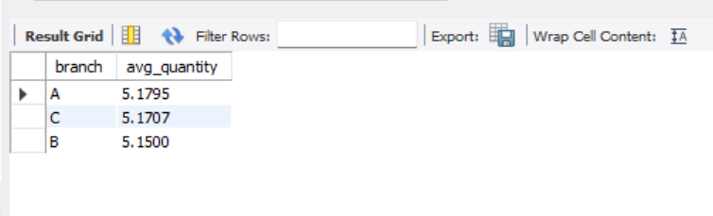
- For each branch, find the top-selling category and show its revenue contribution percentage.
WITH category_sales AS ( SELECT branch, category,
SUM(unit_price * quantity) AS revenue
FROM walmart_data GROUP BY branch, category),
branch_total AS ( SELECT branch, SUM(revenue) AS total_branch_revenue
FROM category_sales GROUP BY branch),
ranked_sales AS ( SELECT
cs.branch, cs.category, cs.revenue, bt.total_branch_revenue,
RANK() OVER(PARTITION BY cs.branch ORDER BY cs.revenue DESC) AS rnk
FROM category_sales cs JOIN branch_total bt ON cs.branch = bt.branch)
SELECT branch, category, revenue,
ROUND((revenue * 100.0) / total_branch_revenue, 2) AS contribution_percentage
FROM ranked_sales WHERE rnk = 1;
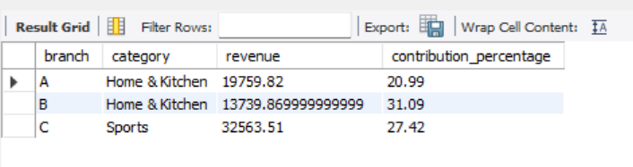

CONCLUSION
The analysis of the Walmart Sales Dataset using MySQL provided valuable insights into sales performance, customer behavior, revenue generation, and branch-wise operations. By applying various SQL concepts such as filtering, aggregation, grouping, subqueries, and ranking functions, meaningful business information was extracted from the dataset.
The queries helped identify top-performing branches, revenue trends across cities, popular product categories, payment method contributions, customer ratings, and profit margins. This project demonstrates how MySQL can be effectively used to analyze large volumes of sales data and transform raw data into useful business insights for decision-making. Overall, this project demonstrates the effectiveness of SQL as a tool for structured data analysis. It highlights how raw data can be transformed into meaningful insights through systematic querying.

