# Features of project

1. Stm communicates with other stm using uart (UART)
2. Sends Phot-registers reading (ADC + UART)
3. Send update to the computer or log file (UART)
4. Receive data from other stm and response by setting light state (UART)
5. Reveive data from computer and turns on led or off (UART)
6. Timer: a particular data will be sent in a fixed delay.

# Features of stm32 used in project

1. UART
2. ADC
3. Systick timer
4. Time gpio trigger
5. All in interrupt

# Project functions

1. Function for clock
2. Function for pin config
3. Function for systick setup
4. Function for time delay
5. Function for UART enable (both uart 1 and 2)
6. Function for ADC
7. Timer config function
8. All interrupt vector function
9. Main function.

# Circuit diagram:

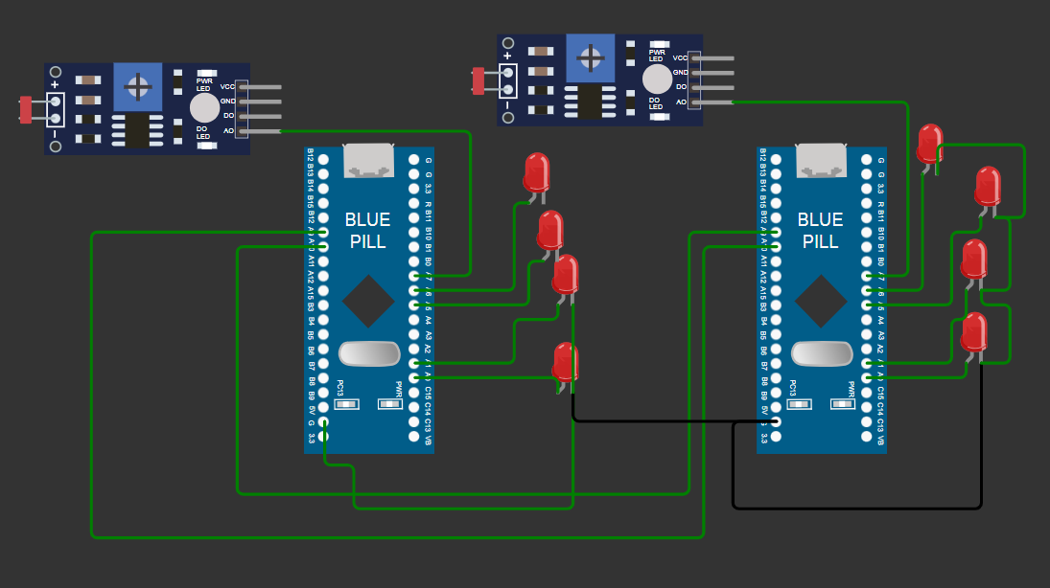

# Clock enable

* APB1ENR UART2, Timer2
* APB2ENR UART1, Systick, PA,ADC, AFIO

# Pin config:

## For UART:

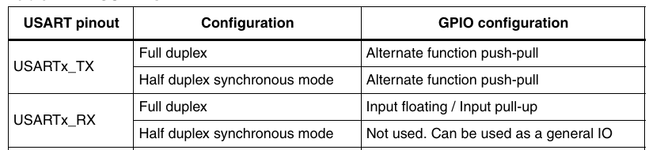

* PA9: UART1 Tx : Output AF push-pull
* PA10: UART1 Rx : Input Floating
* PA2: UART2: Tx output AF push-pull
* PA3: UART2 Rx: input Floating
* PA0: TX/RX signal for uart1 : GPIO output pushpull
* PA1: Output in response of photo reg : GPIO output pushpull
* PA5: Tx/Rx signal for UART2: GPIO output push pull
* pA6: Output is response of computer: GPIO output pushpull
* PA7: Input for photo register: analog input

# SysTick Config:

1. SysTick Load: 72000-1;
2. Clock source cpu

# Timer setup:

1. Set counter value 0 in TIM2->CNT
2. Set the TIM2-> PSC value. CK_CNT = fCK_PSC / (PSC[15:0] + 1). (for 1ms, 7200-1)
3. Load autoreload register TIM2->ARR
4. Enable Update Interrupt in TIM2->DIER bit 0;
5. Set count Direction in TIM->2CR1 bit 4. Set is downcounter
6. Enable Timer in TIM2->CR1 bit 0;
7. Write interrupt vector runtime.

# UART setup