**Verilog Based UART System**

User Manual

Syed Shifat

**Table of Contents**

Introduction 2

* System Overview 2
* Features 2
* File Structure and Descriptions 2
* Input output of top module 3
* Block Diagram 3
* Working Procedure 3
* How to Use 4
  + Setting Up the Simulation 4
  + Running the UART System 4
  + Interpreting GTKWave 4
* Waveform Examples 5
* Limitations 5
* Troubleshooting 5

# Introduction

This project implements a fully synthesizable UART (Universal Asynchronous Receiver/Transmitter) in Verilog RTL. The system is designed to support 8-bit asynchronous communication with configurable baud rates and uses 16x oversampling for accurate reception.

# System Overview

The RTL UART system includes the following core modules:

* **Baud Rate Generator:** Produces 1x and 16x baud ticks.
* **Counter & Comparator:** Drives the timing logic for baud control.
* **UART Transmitter (TX):** Sends 8-bit data serially.
* **UART Receiver (RX):** Receives serial data and reconstructs 8-bit parallel output.
* **Top Module:** Integrates all components.

# Features

* 8-bit UART Transmitter and Receiver
* Configurable baud rate via 16-bit divisor input
* 16x oversampling for reliable UART reception
* Modular and testbench-covered design
* Easy simulation with provided Makefile targets

# File Structure and Descriptions

RTL_UART/

├── baud_gen/

│   ├── baud_gen.v           # Baud rate generator module

│   └── tb_baud.v            # Testbench for baud generator

├── count_comp/

│   ├── comparator.v         # Comparator module for baud timing pulses

│   └── counter.v            # 16-bit counter module

├── Rx_/

│   ├── uart_rx.v            # UART Receiver module

│   └── tb_rx.v              # Testbench for UART Receiver

├── Tx_/

│   ├── uart_tx.v            # UART Transmitter module

│   └── tb_tx.v              # Testbench for UART Transmitter

├── Top_/

│   ├── top.v                # Top-level UART integration module

│   └── tb_top.v             # Full UART system testbench

├── Makefile                 # Simulation and waveform helper commands

└── README.md                # Project documentation

# Input output of top module

|  |  |  |
| --- | --- | --- |
| **Signal** | **Direction** | **Description** |
| clk | Input | System clock |
| rst_n | Input | Active-low reset |
| data_in | Input | 8-bit input data for TX |
| start_tx | Input | Trigger signal to start TX |
| tx_line | Output | UART transmit output |
| rx_line | Input | UART receive input |
| data_received | Output | Received 8-bit parallel data |
| tx_busy | Output | TX active indicator |
| rx_done | Output | RX complete flag |
| baud_div | Input | 16-bit divisor for baud rate |

# Block Diagram

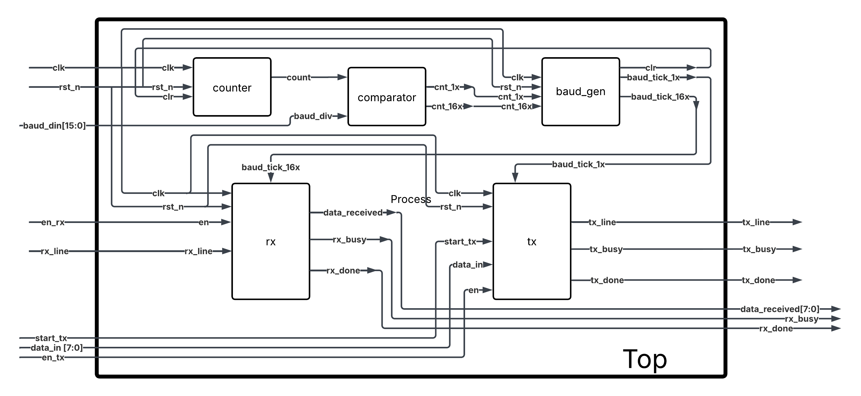

# Working Procedure

**1. Clock and Reset Initialization:** The system is driven by a clock input (clk) and an active-low reset (rst_n). Reset initializes all modules to their default states.

**2. Baud Rate Generation:** The 16-bit counter increments each clock cycle until cleared. The comparator compares this count to baud_div to generate timing pulses cnt_1x and cnt_16x. These pulses feed into baud_gen, which creates precise baud ticks:

* baud_tick_1x for transmitter timing
* baud_tick_16x for receiver oversampling timing

**3. Transmission Flow:** When enabled (en_tx) and triggered (start_tx), the UART transmitter (uart_tx) takes 8-bit parallel data (data_in), adds start and stop bits, and serializes the bits onto tx_line. The process is paced by baud_tick_1x. Transmitter status flags tx_busy and tx_done indicate transmission progress.

**4. Reception Flow:** When enabled (en_rx), the UART receiver (uart_rx) monitors the rx_line for start bits. Using the baud_tick_16x oversampled clock, it samples incoming bits, reconstructs the 8-bit data, and sets rx_done upon completion. The received byte is available on data_received. Receiver status is shown by rx_busy.

**5. Top-Level Integration:** The top module ties all these pieces together, allowing simultaneous transmission and reception with configurable baud rate.

# How to Use

## Setting Up the Simulation

Requirments:

* Icarus Verilog (iverilog, vvp)
* GTKWave

Clone and navigate to the project directory:

|  |
| --- |
| **>git clone https://github.com/yourusername/RTL_UART.git**  **>cd RTL_UART** |

## Running the UART System

Use the Makefile to run simulations:

|  |
| --- |
| **>make tx # Simulate transmitter**  **>make g_tx # View transmitter waveform**  **>make rx # Simulate receiver**  **>make g_rx # View receiver waveform**  **>make top # Simulate full UART system**  **>make g_top # View full UART waveform** |

## Interpreting GTKWave

Observe the following signals:

* **tx_line:** Serialized data bits (start, data[7:0], stop)
* **tx_busy, tx_done:** Transmission state
* **rx_line:** Serial input
* **rx_done, data_received:** Reception result

# Waveform Examples

Include screenshots from GTKWave showing:

* A full TX transmission (with start bit, 8 data bits, stop bit)
* RX reconstruction with sampled ticks
* Data match confirmation

Label:

* Start bit, data bits, stop bit
* rx_done, data_received

Sample output:

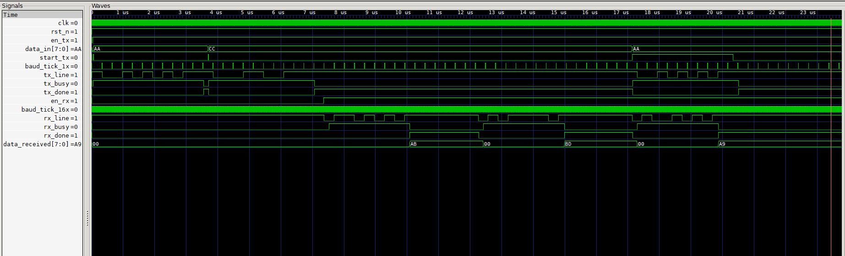

# Limitations

* Only transmits and receives one byte at a time.
* No FIFO buffering.
* No parity or framing error detection.
* Receiver assumes clean and noise-free line.

# Troubleshooting

|  |  |
| --- | --- |
| **Issue** | **Solution** |
| rx_done never asserted | Check baud_tick_16x timing and RX line logic |
| data_received incorrect | Confirm start bit detection is stable |
| GTKWave not updating | Ensure vcd dump is triggered in testbench |