Project Documentation
Title: EDU Genie Google Gemini Powered Learning Assistant
- Team Details
Team Leader: M. Kokila
E-Mail ID: kokilamaruthai404@gmail.com
Team Member 1: A. Nijasri
E-Mail ID: nijasriarumugam@gmail.com
Team Member 2: B. Sathyashree
E-Mail ID: sathyaboopathi307@gmail.com
Team Member 3: T. Sivakami
E-Mail ID: sivakamithiru007@gmail.com
Team Member 4: S. Ramya
E-Mail ID: Shanmugam.tamil.001@gmail.com
2. Introduction
EDU Genie is an AI-powered learning assistant designed to support students with personalized, interactive and easy-to-understand learning. It uses Google Gemini and Google Cloud Generative AI capabilities to provide explanations, summaries, examples, study guidance and question answering.
3. Objectives
- Provide quick and simple answers to students’ learning questions.
- Explain difficult topics in a clear and student-friendly manner.
- Generate summaries, examples and revision notes.
- Support personalized learning based on the student’s needs.
- Reduce the time required to search for learning resources.
4.Key Features
- AI Question Answering – Answers academic questions using natural language.
- Personalized Learning – Adjusts explanations according to the learner’s requirement.
- Topic Explanation – Converts complex concepts into simple explanations.
- Summarization – Creates short notes from longer learning content.
- Practice Support – Generates questions and examples for revision.
- Interactive Learning – Allows students to continue a topic through follow-up questions.
5. Google Gemini and Google Cloud
Google Gemini provides the generative AI capability of EDU Genie. Google Cloud provides the cloud environment and services required to build, deploy and manage the application. Together, they enable EDU Genie to process user prompts and generate useful educational responses.
6.Working Process
- Student enters a question or learning request.
- EDU Genie receives and processes the prompt.
- The request is sent to the Gemini generative AI model through the application’s cloud-based AI service.
- Gemini generates a relevant response.
- EDU Genie presents the response in a simple and readable format.
- The student can ask follow-up questions for further learning.
7. Benefits
- Available as a convenient learning support tool.
- Provides fast and interactive assistance.
- Helps students understand concepts more easily.
- Supports self-learning and revision.
- Can reduce repetitive work for basic educational support
8. Technology Stack
- Google Gemini – Generative AI model.
- Google Cloud – Cloud platform for application and AI services.
- Generative AI – Natural-language understanding and content generation.
- Web or Mobile Interface – User interaction with the learning assistant.
- Cloud APIs – Communication between the application and AI services.
9.Proof of Completion for all Milestones
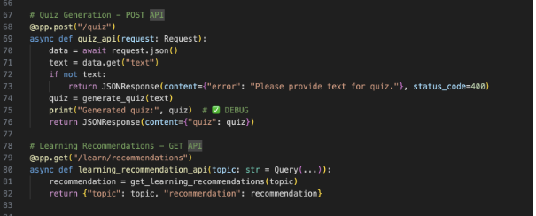

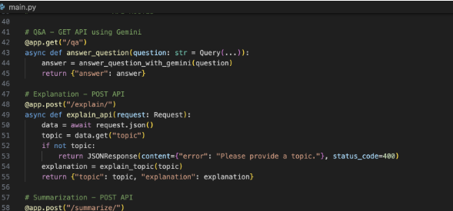
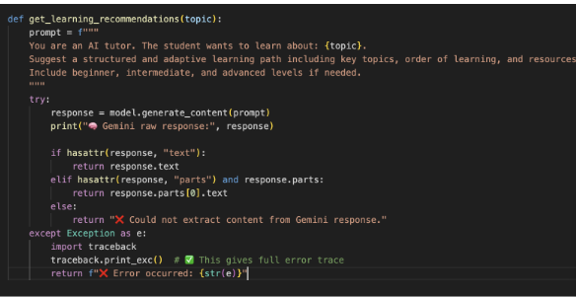

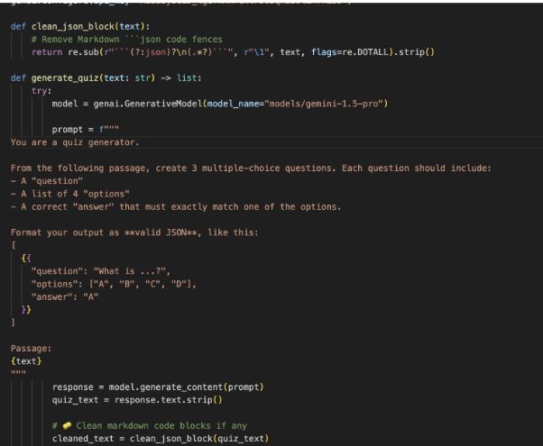

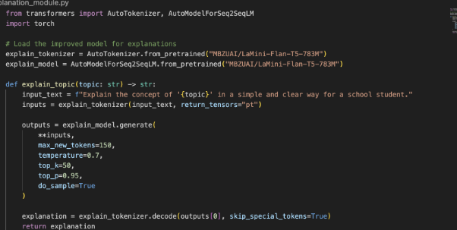
10. Git Hub
Git Hub Link:
https://github.com/kokilamaruthai/EduGenie-Google-Gemini-Powered-Learning-Assistant
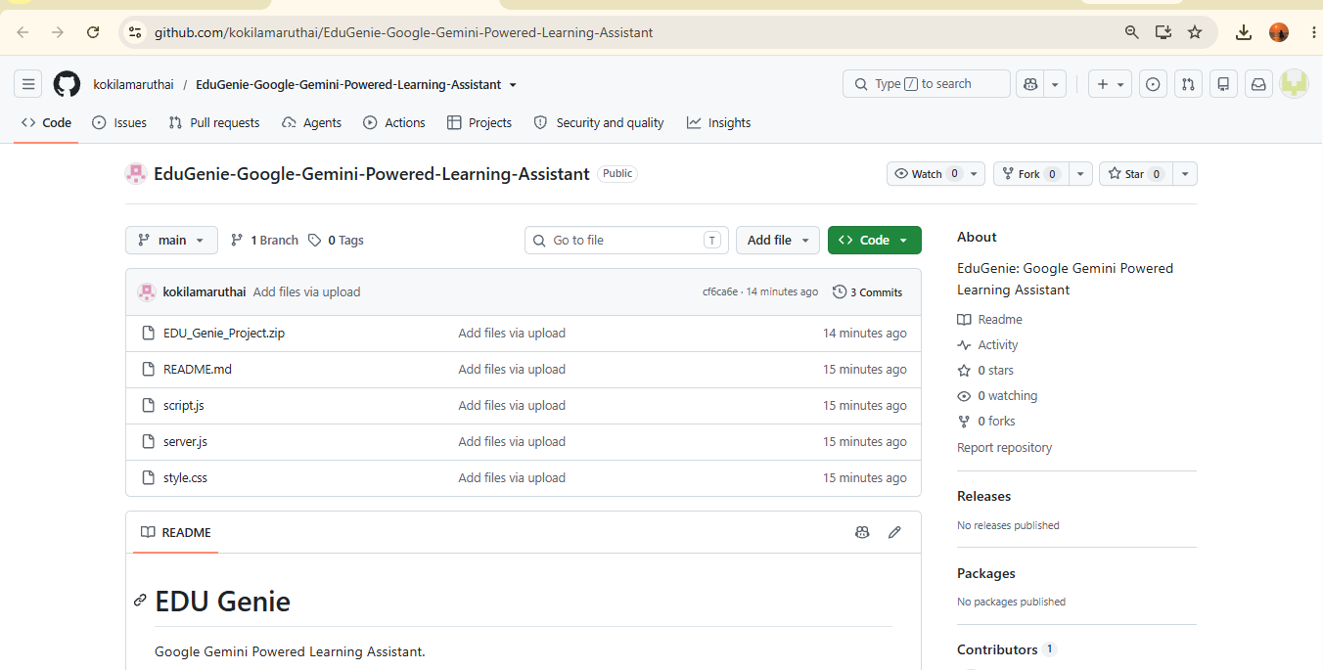
11. Conclusion
EDU Genie combines Google Gemini with Google Cloud Generative AI to create an intelligent learning assistant. It can help students learn, revise and understand academic topics through simple, interactive and personalized AI support.

