DPM Solver-3 Predefined Explanation

# Context

Paper: DPM-Solver: A Fast ODE Solver for Diffusion Probabilistic Model Sampling in Around 10 Steps. NIPS 2022.

Code: schedule/main_schedule_batch.py, function: calc_loss_order3()

Original algorithm in original paper:

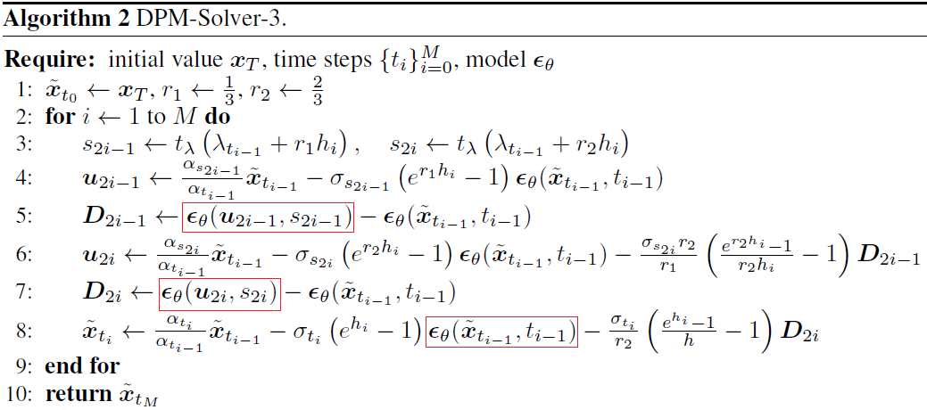

# My deduction

DPM-Solver-3, in DDIM format

$$D_{2i}=ϵ_{θ}\left(u_{2i},s_{2i}\right)-ϵ_{θ}\left(x_{t},t\right) \\ s_{2i}=t_{λ}\left(λ_{t}+r_{2}h_{i}\right)=t_{λ}\left(λ_{t}+\frac{2}{3}h_{i}\right)=t-\frac{2}{3}$$

$$x_{t-1}=\frac{\sqrt{{\overline{α}}_{t-1}}}{\sqrt{{\overline{α}}_{t}}}∙x_{t}-\sqrt{1-{\overline{α}}_{t-1}}∙\left(e^{λ_{t-1}-λ_{t}}-1\right)∙ϵ_{θ}\left(x_{t},t\right)-\frac{\sqrt{1-{\overline{α}}_{t-1}}}{r_{2}}\left(\frac{e_{}^{λ_{t-1}-λ_{t}}-1}{λ_{t-1}-λ_{t}}-1\right)D_{2i}$$

$$let: σ_{t-1}=\sqrt{1-{\overline{α}}_{t-1}}, h=λ_{t-1}-λ_{t}, \\ then:$$

$$x_{t-1}=\frac{\sqrt{{\overline{α}}_{t-1}}}{\sqrt{{\overline{α}}_{t}}}∙x_{t}-σ_{t-1}∙\left(e^{h}-1\right)∙ϵ_{θ}\left(x_{t},t\right)-\frac{σ_{t-1}}{r_{2}}\left(\frac{e_{}^{h}-1}{h}-1\right)D_{2i}$$

$$=\frac{\sqrt{{\overline{α}}_{t-1}}}{\sqrt{{\overline{α}}_{t}}}∙x_{t}-σ_{t-1}∙\left(e^{h}-1\right)∙ϵ_{θ}\left(x_{t},t\right)-\frac{σ_{t-1}}{r_{2}}\left(\frac{e_{}^{h}-1}{h}-1\right)\left(ϵ_{θ}\left(u_{2i},s_{2i}\right)-ϵ_{θ}\left(x_{t},t\right)\right)$$

$$=\frac{\sqrt{{\overline{α}}_{t-1}}}{\sqrt{{\overline{α}}_{t}}}∙x_{t}-σ_{t-1}∙\left[\left(e^{h}-1-\frac{1}{r_{2}}\left(\frac{e_{}^{h}-1}{h}-1\right)\right)∙ϵ_{θ}\left(x_{t},t\right)+\frac{1}{r_{2}}\left(\frac{e_{}^{h}-1}{h}-1\right)ϵ_{θ}\left(u_{2i},s_{2i}\right)\right]$$

$$=\frac{\sqrt{{\overline{α}}_{t-1}}}{\sqrt{{\overline{α}}_{t}}}∙x_{t}-\frac{σ_{t-1}}{r_{2}h}∙\left[\left(r_{2}h\left(e^{h}-1\right)-\left(e_{}^{h}-1-h\right)\right)∙ϵ_{θ}\left(x_{t},t\right)+\left(e_{}^{h}-1-h\right)ϵ_{θ}\left(u_{2i},s_{2i}\right)\right] \\ =\frac{\sqrt{{\overline{α}}_{t-1}}}{\sqrt{{\overline{α}}_{t}}}∙x_{t}-\frac{σ_{t-1}}{r_{2}h}∙\left[\left(\left(r_{2}h-1\right)\left(e^{h}-1\right)+h\right)∙ϵ_{θ}\left(x_{t},t\right)+\left(e_{}^{h}-1-h\right)ϵ_{θ}\left(u_{2i},s_{2i}\right)\right]$$

This is order-3 sampling. So, one sampling step involves 3 timestep. Assume the sampling step is from $x_{t}$ to $x_{t-1}$, then the involved timesteps will be: $t, t-\frac{1}{3},t-\frac{2}{3}, t-1$.

# Conclusion

In the above formula, the variance of $x_{t-1}$ only depends on $ϵ_{θ}\left(x_{t},t\right)$ and $ϵ_{θ}\left(x_{t-\frac{2}{3}},t-\frac{2}{3}\right)$.

# Calculate loss

Inner steps. From: models/dpm_solver2_pytorch.py, function: get_orders_and_timesteps_for_singlestep_solver()

|  |
| --- |
| K = steps // 3 + 1 if steps % 3 == 0:  orders = [3,] * (K - 2) + [2, 1] elif steps % 3 == 1:  orders = [3,] * (K - 1) + [1] else:  orders = [3,] * (K - 1) + [2] |

## If step count % 3 == 0

Assume step count is 9. Then the inner steps are: [3, 3, 2, 1]. The sampling process will be:

|  |  |
| --- | --- |
| **x** | **Formula** |
| x9 |  |
| x8 |  |
| x7 |  |
| x6 |  |
| x5 |  |
| x4 |  |
| x3 |  |
| x2 |  |
| x1 |  |
| x0 (Generated sample) | $$\frac{\sqrt{{\overline{α}}_{0}}}{\sqrt{{\overline{α}}_{1}}}∙x_{1}-\sqrt{1-{\overline{α}}_{0}}∙\left(e^{λ_{0}-λ_{1}}-1\right)∙ϵ_{θ}\left(x_{1},1\right)$$ |

## If step count % 3 == 1

## If step count % 3 == 2