
Another first for the most innovative, most usable office software package in the world
The Open Answer

OpenOffice.org Version 1 was the first product to deliver the benefits of open-source software to mass-market users, delivering essential everyday software tools completely free of charge. Translated into over 30 languages, available on all major computing platforms (Microsoft Windows, Mac OS X X11, GNU/Linux, Solaris), OpenOffice.org Version 1 is now in use by tens of millions of delighted users worldwide.
With Version 2, it gets even better
- the first office suite to use the new OASIS OpenDocument format, the future-proof international standard for office software
- easier to install, with a whole new look and feel, matched to the type of computer in use
- more intuitive, more easy to use than ever, with a host of new usability features
- introducing a major new component, Base: an easy-to-use database manager with a fully integrated database
- more compatible with other software packages; minor glitches, formatting, and font problems occasionally found with Microsoft Office files have been eliminated

But the licence is still the same: you may download OpenOffice.org Version 2 completely free of any licence fees, use it for any purpose – private, educational, government and public administration, commercial – and pass on copies free of charge to family, friends, students, employees, etc.
OpenOffice.org Version 2 is available now
- download today from http://download.openoffice.org
- order a CD-ROM from a distributor http://distribution.openoffice.org/cdrom
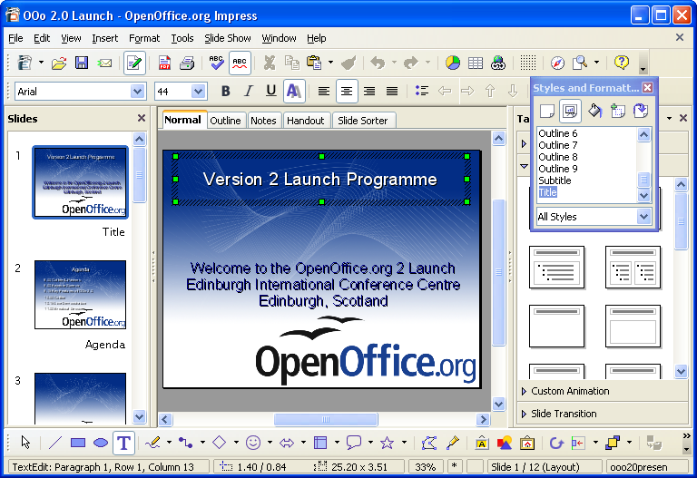Impress - OpenOffice.org's tool for creating dynamic presentations

