Writer – for all your Documents
Quality Office Suite
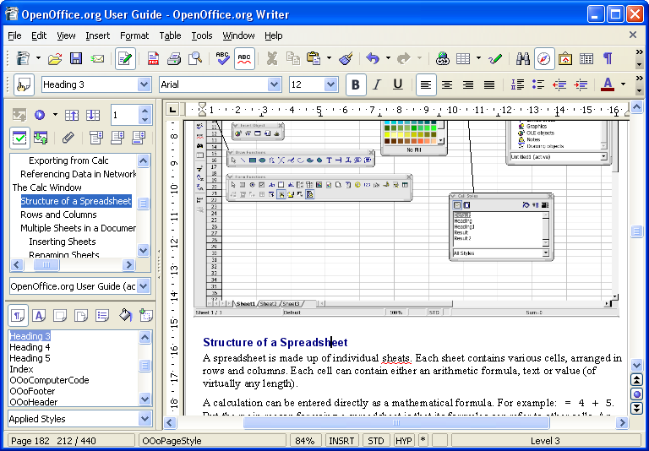
Writer is OpenOffice.org’s word processor: use it for anything from writing a quick letter to producing an entire book with embedded illustrations, cross-references, tables of contents, indexes, bibliographies... Auto-complete, auto-format, and real-time spelling check make light work of the hardest task. Writer is powerful enough to tackle desktop publishing tasks such as creating multi-column newsletters, brochures – the only limit is your imagination.
Calc – the all-purpose Spreadsheet
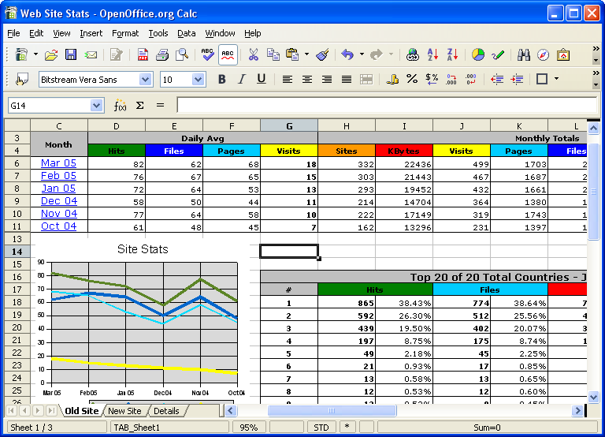
Use Calc to bring your numbers under control. This powerful spreadsheet has all the tools you need to calculate, analyse, summarise, and present your data in numerical reports or sizzling graphics. A fully-integrated help system makes entering complex formulas a breeze. Sophisticated decision-making tools are just a few mouse clicks away. Pull in external data using the Data Pilot, and sort it, filter it, and produce subtotals and statistical analyses. Use previews to select from thirteen categories of 2-D and 3-D charts including line, area, column, pie, XY, stock and net with dozens of variants.

