cohen sutherland line clipping

Download this file : cohen.c

program:

#include"stdio.h"
#include"conio.h"
#include"graphics.h"
void main()
{
int gd=DETECT, gm;
float i,xmax,ymax,xmin,ymin,x1,y1,x2,y2,m;
float start[4],end[4],code[4];
clrscr();
initgraph(&gd,&gm,"");
printf("\n\tEnter the bottom-left coordinate of viewport: ");
scanf("%f %f",&xmin,&ymin);
printf("\n\tEnter the top-right coordinate of viewport: ");
scanf("%f %f",&xmax,&ymax);
printf("\nEnter the coordinates for starting point of line: ");
scanf("%f %f",&x1,&y1);
printf("\nEnter the coordinates for ending point of line: ");
scanf("%f %f",&x2,&y2);
for(i=0;i <4;i++)

{
start[i]=0;
end[i]=0;
}
m=(y2-y1)/(x2-x1);
if(x1 <xmin) start[0]=1;
if(x1 >xmax) start[1]=1;
if(y1 >ymax) start[2]=1;
if(y1 <ymin) start[3]=1;
if(x2 <xmin) end[0]=1;
if(x2 >xmax) end[1]=1;
if(y2 >ymax) end[2]=1;
if(y2 <ymin) end[3]=1;
for(i=0;i <4;i++)

code[i]=start[i]&&end[i];

if((code[0]==0)&&(code[1]==0)&&(code[2]==0)&&(code[3]==0))
{
if((start[0]==0)&&(start[1]==0)&&(start[2]==0)&&(start[3]==0)&&(end[0]==0)&&(end[1]==0)&&(end[2]==0)&&(end[3]==0))
{
cleardevice();
printf("\n\t\tThe line is totally visible\n\t\tand not a clipping candidate");
rectangle(xmin,ymin,xmax,ymax);
line(x1,y1,x2,y2);
getch();
}
else
{
cleardevice();
printf("\n\t\tLine is partially visible");
rectangle(xmin,ymin,xmax,ymax);
line(x1,y1,x2,y2);
getch();
if((start[2]==0)&&(start[3]==1))
{
x1=x1+(ymin-y1)/m;
y1=ymin;
}
if((end[2]==0)&&(end[3]==1))
{
x2=x2+(ymin-y2)/m;
y2=ymin;
}
if((start[2]==1)&&(start[3]==0))
{
x1=x1+(ymax-y1)/m;
y1=ymax;
}
if((end[2]==1)&&(end[3]==0))
{
x2=x2+(ymax-y2)/m;
y2=ymax;
}
if((start[1]==0)&&(start[0]==1))
{
y1=y1+m*(xmin-x1);
x1=xmin;
}
if((end[1]==0)&&(end[0]==1))
{
y2=y2+m*(xmin-x2);
x2=xmin;
}
if((start[1]==1)&&(start[0]==0))
{
y1=y1+m*(xmax-x1);
x1=xmax;
}
if((end[1]==1)&&(end[0]==0))
{
y2=y2+m*(xmax-x2);
x2=xmax;
}
clrscr();
cleardevice();
printf("\n\t\tAfter clippling:");
rectangle(xmin,ymin,xmax,ymax);
line(x1,y1,x2,y2);
getch();
}
}
else
{
clrscr();
cleardevice();
printf("\nLine is invisible");
rectangle(xmin,ymin,xmax,ymax);
}
getch();
closegraph();
}

Download this file : cohen.c

ouput:

Enter the bottom-left coordinate of viewport: 100 100
Enter the top-right coordinate of viewport: 400 400
Enter the coordinates for starting point of line: 120 60
Enter the coordinates for ending point of line: 350 450

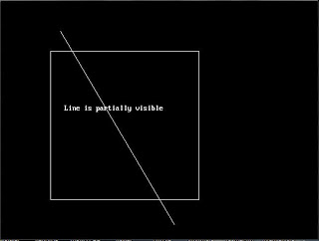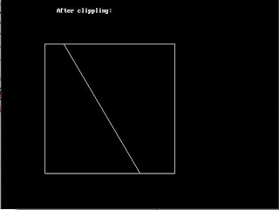
Posted by kannan - admin at 7:36 PM
Labels: cohen sutherland line clipping
Newer PostOlder PostHome
Subscribe to: Post Comments ( Atom )

