
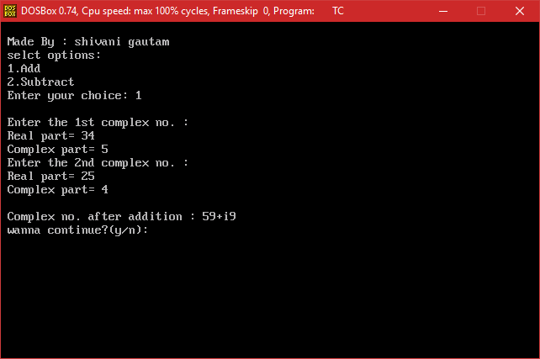
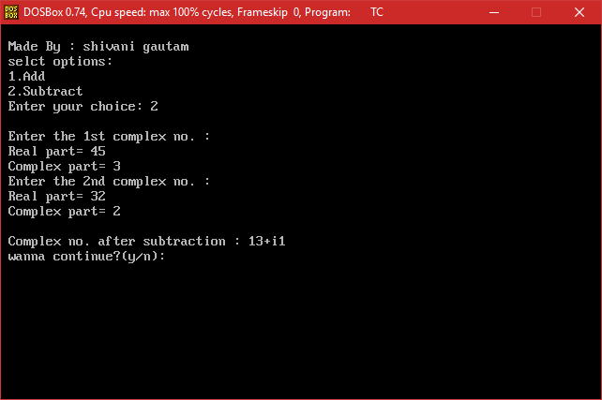
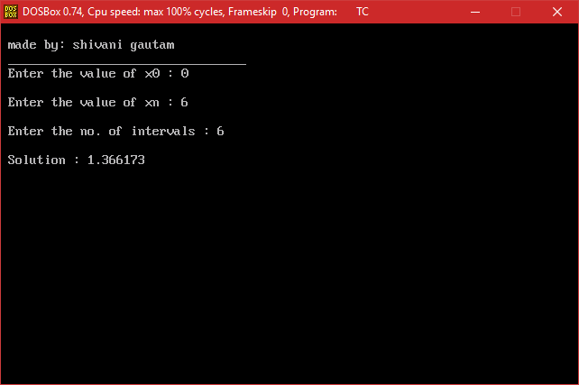
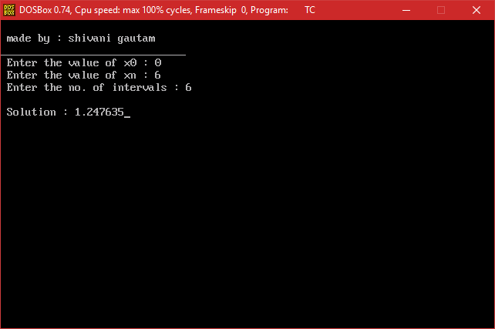

ENAME
Smith
Ward
Jones
Clark

ENAME | SAL | JOB | DEPTNO
King | 5000 | president | 10
Clark | 2450 | manager | 10
Miller | 1300 | clerk | 10
Scott | 3000 | analyst | 20
Ford | 3000 | analyst | 20
Jones | 2975 | manager | 20
Adams | 1100 | clerk | 20
Smith | 800 | clerk | 20
Blake | 2850 | manager | 30
Allen | 1600 | salesman | 30
Turner | 1500 | salesman | 30
Martin | 1250 | salesman | 30
Ward | 1250 | salesman | 30
James | 950 | clerk | 30

EMPNO | ENAME | JOB | MGR | HIREDATE | SAL | COMM | DEPTNO
7369 | Smith | clerk | 7902 | 17-DEC-80 | 800 | - | 20
7566 | Jones | manager | 7839 | 02-APR-80 | 2975 | - | 20
7654 | Martin | salesman | 7698 | 28-SEP-81 | 1250 | - | 30
7782 | Clark | manager | 7839 | 09-JUN-81 | 2450 | - | 10
7788 | Scott | analyst | 7566 | 09-DEC-81 | 3000 | - | 20
7839 | King | president | - | 17-NOV-82 | 5000 | - | 10
7876 | Adams | clerk | 7788 | 12-JAN-83 | 1100 | - | 20
7900 | James | clerk | 7698 | 03-DEC-81 | 950 | - | 30
7902 | Ford | analyst | 7566 | 04-DEC-81 | 3000 | - | 20
7934 | Miller | clerk | 7782 | 23-JAN-82 | 1300 | - | 10

